Know IT All
Go to CONTENTS

This document contains information compiled from the following sources:

Source | Information
Leaving Certificate Biology Syllabus | Need to Know
Biology Resource DVD | PowerPoint Presentations
www.examinations.ie | Past Examination Papers
www.examinations.ie | Marking Schemes

IMPORTANT NOTE

The answers given in the marking schemes are the answers that were required for that particular year. The same answer given to a similar question in a subsequent year may not be sufficient to gain full marks.

Example:

Question
2005 HL
7. (a) (i) What is a bioreactor? ……………………………………………………………………

Answer
7. | (a) | (i) | A vessel / container / named industrial example e.g. vat | 3

Question
2010 HL
14. (b) (iv) 2. Explain the term bioreactor.
Answer
14. | (b) | (iv) | Vessel in which products are made by cells (or organisms) | 3

CONTENTS

UNIT ONE – The Study of Life

Syllabus Section |  |  |  | Examination Paper Section
 |  |  |  | Short Questions | Questions on Practicals | Long Questions
1.1 | The Scientific Method | Need to know | PowerPoint(s) | Section A | Section B | Section C
1.2 | The Characteristics of Life | Need to know | PowerPoint(s) | Section A | Section B | Section C
1.3 | Nutrition | Need to know | PowerPoint(s) | Section A | Section B | Section C
1.4 | General Principles of Ecology | Need to know | PowerPoint(s) | Section A | Section B | Section C
1.5 | A Study of an Ecosystem | Need to know | PowerPoint(s) | Section A | Section B | Section C
UNIT TWO – The Cell

2.1 | Cell Structure | Need to know | PowerPoint(s) | Section A | Section B | Section C
2.2 | Cell Metabolisms | Need to know | PowerPoint(s) | Section A  - Enzymes  - Photosynthesis  - Respiration  - Movement through cell membranes | Section B  - Enzymes  - Photosynthesis  - Respiration  - Movement through cell membranes | Section C  - Enzymes  - Photosynthesis  - Respiration  - Movement through cell membranes
2.3 | Cell Continuity | Need to know | PowerPoint | Section A |  | Section C
2.4 | Cell Diversity | Need to know | PowerPoint | Section A |  | Section C
2.5 | Genetics | Need to know | PowerPoint(s) | Section A | Section B | Section C
UNIT THREE – The Organism

3.1 | Diversity of Organism | Need to know | PowerPoint(s) | Section A | Section B | Section C
3.2 | Organisation and the Vascular Structures | Need to know | PowerPoint(s) | Section A  - Structure of flowering plant  - Circulatory system  - Lymphatic system | Section B  - Structure of flowering plant  - Circulatory system | Section C  - Structure of flowering plant  - Circulatory system  - Lymphatic system
3.3 | Transport and Nutrition | Need to know | PowerPoint(s) | Section A  - Transport in the flowering plant  - Human nutrition  - Digestive system | Section B  - Human Nutrition  - Digestive System | Section C  - Transport in the flowering plant  - Human nutrition  - Digestive system
3.4 | Breathing System and Excretion | Need to know | PowerPoint(s) | Section A  - Homeostasis  - Gaseous exchange in Plants  - Breathing system  - Excretory system | Section B  - Breathing system | Section C  - Homeostasis  - Gaseous exchange in plants  - Breathing system  - Excretory system
3.5 | Responses to Stimuli | Need to know | PowerPoint(s) | Section A  - Plant responses  - Nervous system  - Eye and ear  - Endocrine system  - Musculoskeletal system  - Defence system  - Viruses | Section B  - Plant responses | Section C  - Plant responses  - Nervous system  - Eye and ear  - Endocrine system  - Musculoskeletal system  - Defence system  - Viruses
3.6 | Reproduction and Growth  - Plant  - Human Reproduction | Need to know  Need to know | PowerPoint(s)  PowerPoint(s) | Section A  - Sexual reproduction  - Asexual reproduction  Section A  Human reproduction | Section B  - Plant reproduction | Section C  - Sexual reproduction  - Asexual reproduction  Section C  Human reproduction

Contents
Know IT All 1
UNIT ONE 25
The Study of Life 25
1.1 The Scientific Method 26
Need to Know 26
PowerPoint Presentations 26
Section A 27
Higher Level 27
Ordinary Level 28
Section B 29
Higher Level 29
Ordinary Level 30
Section C 32
Higher Level 32
Ordinary Level 32
1.2 The Characteristics of Life 33
Need to Know 33
PowerPoint Presentations 33
Section A 34
Higher Level 34
Ordinary Level 34
Section B 36
Higher Level 36
Ordinary Level 36
Section C 37
Higher Level 37
Ordinary Level 37
1.3 Nutrition 38
Need to Know 38
PowerPoint Presentations 39
Section A 40
Higher Level 40
Ordinary Level 44
Section B 50
Higher Level 50
Ordinary Level 51
Section C 55
Higher Level 55
Ordinary Level 56
1.4 General Principles of Ecology 57
Need to Know 57
PowerPoint Presentations 58
Section A 59
Higher Level 59
Ordinary Level 63
Section B 69
Higher Level 69
Ordinary Level 69
Section C 70
Higher Level 70
Ordinary Level 78
1.5 A Study of an Ecosystem 86
Need to Know 86
PowerPoint Presentations 86
Section A 87
Higher Level 87
Ordinary Level 88
Section B 89
Higher Level 89
Ordinary Level 92
Section C 97
Higher Level 97
Ordinary Level 99
UNIT TWO 103
2.1 Cell Structure 104
Need to Know 104
PowerPoint Presentations 104
Section A 105
Higher Level 105
Ordinary Level 106
Section B 110
Higher Level 110
Ordinary Level 114
Section C 118
Higher Level 118
Ordinary Level 118
2.2 Cell Metabolism 120
Need to Know 120
Cell Metabolism 120
Enzymes 120
Photosynthesis 120
Respiration 121
Movement Through Cell Membranes 121
Role of ATP and NAD(P) 122
PowerPoint Presentations 122
Section A 123
Higher Level 123
Ordinary Level 123
Enzymes 124
Higher Level 124
Ordinary Level 126
Photosynthesis 126
Higher Level 126
Ordinary Level 127
Respiration 128
Higher Level 129
Ordinary Level 130
Movement through cell membranes 131
Higher Level 131
Ordinary Level 132
Section B 133
Higher Level 133
Ordinary Level 133
Enzymes 133
Higher Level 133
Ordinary Level 140
Photosynthesis 145
Higher Level 145
Ordinary Level 148
Respiration 149
Higher Level 149
Ordinary Level 151
Movement through cell membranes 151
Higher Level 151
Ordinary Level 153
Section C 156
Higher Level 156
Ordinary Level 156
Enzymes 156
Higher Level 156
Ordinary Level 157
Photosynthesis 158
Higher Level 158
Ordinary Level 162
Respiration 166
Higher Level 166
Ordinary Level 169
Movement through cell membranes 174
Higher Level 174
Ordinary Level 175
2.3 Cell Continuity 176
Need to Know 176
PowerPoint Presentations 176
Section A 177
Higher Level 177
Ordinary Level 180
Section C 185
Higher Level 185
Ordinary Level 186
2.4 Cell Diversity 188
Need to Know 188
PowerPoint Presentations 188
Section A 189
Higher Level 189
Ordinary Level 190
Section C 192
Higher Level 192
Ordinary Level 192
2.5 Genetics 193
Need to Know 193
Variation 193
Heredity 193
DNA 193
Protein Synthesis 194
Inheritance 194
Evolution 195
Genetic Engineering 195
Mendel 195
PowerPoint Presentations 196
Section A 197
Higher Level 197
Ordinary Level 201
Section B 205
Higher Level 205
Ordinary Level 207
Section C 210
Higher Level 210
Ordinary Level 216
UNIT THREE 222
3.1 Diversity of Organisms 223
Need to Know 223
Diversity 223
Bacteria 223
Fungi 223
Laboratory Procedures 223
Amoeba 224
Nature of Microorganisms 224
Growth curves 224
PowerPoint Presentations 224
Section A 225
Higher Level 225
Ordinary Level 226
Section B 230
Higher Level 230
Ordinary Level 234
Section C 237
Higher Level 237
Ordinary Level 242
3.2 Organisation and the Vascular Structures 247
Need to Know 247
Flowering Plant Structure 247
Human Circulatory & Lymphatic Systems 247
Blood Cells 248
Heartbeat Control 248
PowerPoint Presentations 248
Section A 249
Structure of Flowering Plant 249
Higher Level 249
Ordinary Level 250
Circulatory System 255
Higher Level 255
Ordinary Level 257
Lymphatic System 258
Higher Level 258
Ordinary Level 259
Section B 260
Structure of Flowering Plant 260
Higher Level 260
Ordinary Level 262
Circulatory System 262
Higher Level 262
Ordinary Level 265
Section C 270
Structure of Flowering Plant 270
Higher Level 270
Ordinary Level 271
Circulatory System 276
Higher Level 276
Ordinary Level 278
Lymphatic System 282
Higher Level 282
Ordinary Level 282
3.3 Transport and Nutrition 283
Need to Know 283
Nutrition in Flowering Plant 283
Modified Plant Food Storage Organs 283
Nutrition in the Human 283
Human Digestive System 283
Balanced Diet 284
Blood transport of Nutrients 284
Cohesion-Tension Model of Xylem Transport 284
PowerPoint Presentations 285
Section A 286
Transport in the Flowering Plant 286
Higher Level 286
Ordinary Level 287
Human Nutrition 288
Higher Level 288
Ordinary Level 288
Digestive System 289
Higher Level 289
Ordinary Level 292
Section B 293
Human Nutrition 293
Higher Level 293
Ordinary Level 293
Digestive System 293
Higher Level 293
Ordinary Level 293
Section C 294
Transport in the Flowering Plant 294
Higher Level 294
Ordinary Level 295
Human Nutrition 295
Higher Level 295
Ordinary Level 296
Digestive System 296
Higher Level 296
Ordinary Level 298
3.4 Breathing System and Excretion 303
Need to Know 303
Homeostasis 303
Plant Exchange System 303
Human Breathing System 303
Plant Excretion 304
CO₂ Gaseous Exchange Control 304
Human Excretory System 304
Nephron of Kidney 305
PowerPoint Presentations 305
Section A 306
Homeostasis 306
Higher Level 306
Ordinary Level 309
Gaseous Exchange in Plants 309
Higher Level 309
Ordinary Level 309
Breathing System 311
Higher Level 311
Ordinary Level 311
Excretory System 312
Higher Level 312
Ordinary Level 313
Section B 315
Breathing System 315
Higher Level 315
Ordinary Level 315
Section C 319
Homeostasis 319
Higher Level 319
Ordinary Level 319
Gaseous Exchange in Plants 320
Higher Level 320
Ordinary Level 320
Breathing System 321
Higher Level 321
Ordinary Level 323
Excretory System 324
Higher Level 325
Ordinary Level 327
3.5 Responses to Stimuli 331
Need to Know 331
Structures for Responses 331
Plant Responses 331
Auxins 332
Defence System 332
Human Immune System 333
Endocrine System 333
Plant Regulators & Animal Hormones 334
Musculoskeletal System 334
Bone Growth & Development 335
Nervous System 335
Eye & Ear 336
Viruses 337
PowerPoint Presentations 337
Section A 338
Plant Responses 338
Higher Level 338
Ordinary Level 339
Nervous System 340
Higher Level 340
Ordinary Level 342
Eye & Ear 342
Higher Level 342
Ordinary Level 342
Endocrine System 345
Higher Level 345
Ordinary Level 345
Musculoskeletal System 346
Higher Level 346
Ordinary Level 347
Defence System 349
Higher Level 349
Ordinary Level 350
Viruses 350
Higher Level 350
Ordinary Level 351
Section B 352
Plant Responses 352
Higher Level 352
Ordinary Level 356
Section C 358
Plant Responses 358
Higher Level 358
Ordinary Level 360
Nervous System 360
Higher Level 360
Ordinary Level 362
Eye & Ear 363
Higher Level 363
Ordinary Level 364
Endocrine System 367
Higher Level 367
Ordinary Level 369
Musculoskeletal System 370
Higher Level 370
Ordinary Level 371
Defence System 372
Higher Level 372
Ordinary Level 373
Viruses 374
Higher Level 374
Ordinary Level 376
3.6 Reproduction and Growth – Plant 378
Need to Know 378
Reproduction in Flowering Plant 378
Vegetative Propagation 378
Sexual Reproduction in Flowering Plants 378
PowerPoint Presentations 379
Section A 380
Sexual Reproduction 380
Higher Level 380
Ordinary Level 380
Asexual Reproduction 381
Higher Level 381
Ordinary Level 382
Section B 383
Plant Reproduction 383
Higher Level 383
Ordinary Level 386
Section C 392
Sexual Reproduction 392
Higher Level 392
Ordinary Level 394
Asexual Reproduction 399
Higher Level 399
Ordinary Level 400
3.6 Reproduction and Growth – Human 401
Need to Know 401
Sexual Reproduction in Human 401
Human Embryo Development 401
Menstrual Cycle and Hormonal Control 401
PowerPoint Presentations 402
Section A 403
Human Reproduction 403
Higher Level 403
Ordinary Level 404
Section C 406
Human Reproduction 406
Higher Level 406
Ordinary Level 410
Answers 414
2004 HL Sample Q1 414
2004 HL Sample Q2 414
2004 HL Sample Q3 414
2004 HL Sample Q4 415
2004 HL Sample Q5 415
2004 HL Sample Q6 415
2004 HL Sample Q7 415
2004 HL Sample Q8 416
2004 HL Sample Q9 416
2004 HL Sample Q10 417
2004 HL Sample Q11 417
2004 HL Sample Q12 418
2004 HL Sample Q13 418
2004 HL Sample Q14 (a) 419
2004 HL Sample Q14 (b) 419
2004 HL Sample Q14 (c) 419
2004 HL Sample Q15 (a) 419
2004 HL Sample Q15 (b) 420
2004 HL Sample Q15 (c) 420
2004 OL Sample Q1 420
2004 OL Sample Q2 420
2004 OL Sample Q3 420
2004 OL Sample Q4 421
2004 OL Sample Q5 421
2004 OL Sample Q6 421
2004 OL Sample Q7 421
2004 OL Sample Q8 422
2004 OL Sample Q9 422
2004 OL Sample Q10 422
2004 OL Sample Q11 423
2004 OL Sample Q12 424
2004 OL Sample Q13 424
2004 OL Sample Q14 (a) 425
2004 OL Sample Q14 (b) 425
2004 OL Sample Q14 (c) 425
2004 OL Sample Q15 (a) 426
2004 OL Sample Q15 (b) 426
2004 OL Sample Q15 (c) 426
2004 HL Q1 427
2004 HL Q2 427
2004 HL Q3 427
2004 HL Q4 427
2004 HL Q5 428
2004 HL Q6 428
2004 HL Q7 429
2004 HL Q8 429
2004 HL Q9 430
2004 HL Q10 430
2004 HL Q11 431
2004 HL Q12 431
2004 HL Q13 432
2004 HL Q14(a) 433
2004 HL Q14(b) 433
2004 HL Q14(c) 433
2004 HL Q15(a) 434
2004 HL Q15(b) 434
2004 HL Q15(c) 435
2004 OL Q1 435
2004 OL Q2 435
2004 OL Q3 435
2004 OL Q4 436
2004 OL Q5 436
2004 OL Q6 437
2004 OL Q7 437
2004 OL Q8 437
2004 OL Q9 438
2004 OL Q10 438
2004 OL Q11 439
2004 OL Q12 439
2004 OL Q13 440
2004 OL Q14(a) 440
2004 OL Q14(b) 441
2004 OL Q14(c) 441
2004 OL Q15(a) 441
2004 OL Q15(b) 442
2004 OL Q15(c) 442
2005 HL Q1 442
2005 HL Q2 443
2005 HL Q3 443
2005 HL Q4 443
2005 HL Q5 444
2005 HL Q6 444
2005 HL Q7 444
2005 HL Q8 445
2005 HL Q9 445
2005 HL Q10 446
2005 HL Q11 446
2005 HL Q12 447
2005 HL Q13 447
2005 HL Q14(a) 448
2005 HL Q14(b) 448
2005 HL Q14(c) 448
2005 HL Q15(a) 449
2005 HL Q15(b) 449
2005 HL Q15(c) 450
2005 OL Q1 450
2005 OL Q2 450
2005 OL Q3 450
2005 OL Q4 451
2005 OL Q5 451
2005 OL Q6 451
2005 OL Q7 452
2005 OL Q8 452
2005 OL Q9 452
2005 OL Q10 453
2005 OL Q11 453
2005 OL Q12 454
2005 OL Q13 454
2005 OL Q14(a) 455
2005 OL Q14(b) 455
2005 OL Q14(c) 455
2005 OL Q15(a) 456
2005 OL Q15(b) 456
2005 OL Q15(c) 456
2006 HL Q1 457
2006 HL Q2 457
2006 HL Q3 457
2006 HL Q4 458
2006 HL Q5 458
2006 HL Q6 458
2006 HL Q7 458
2006 HL Q8 459
2006 HL Q9 459
2006 HL Q10 460
2006 HL Q11 460
2006 HL Q12 461
2006 HL Q13 461
2006 HL Q14(a) 462
2006 HL Q14(b) 462
2006 HL Q14(c) 462
2006 HL Q15(a) 463
2006 HL Q15(b) 463
2006 HL Q15(c) 463
2006 OL Q1 464
2006 OL Q2 464
2006 OL Q3 464
2006 OL Q4 465
2006 OL Q5 465
2006 OL Q6 465
2006 OL Q7 465
2006 OL Q8 466
2006 OL Q9 466
2006 OL Q10 467
2006 OL Q11 467
2006 OL Q12 468
2006 OL Q13 468
2006 OL Q14(a) 469
2006 OL Q14(b) 469
2006 OL Q14(c) 470
2006 OL Q15(a) 470
2006 OL Q15(b) 470
2006 OL Q15(c) 471
2007 HL Q1 471
2007 HL Q2 471
2007 HL Q3 472
2007 HL Q4 472
2007 HL Q5 472
2007 HL Q6 473
2007 HL Q7 473
2007 HL Q8 473
2007 HL Q9 474
2007 HL Q10 474
2007 HL Q11 475
2007 HL Q12 475
2007 HL Q13 476
2007 HL Q14(a) 476
2007 HL Q14(b) 476
2007 HL Q14(c) 477
2007 HL Q15(a) 477
2007 HL Q15(b) 477
2007 HL Q15(c) 478
2007 OL Q1 478
2007 OL Q2 478
2007 OL Q3 478
2007 OL Q4 479
2007 OL Q5 479
2007 OL Q6 479
2007 OL Q7 480
2007 OL Q8 480
2007 OL Q9 480
2007 OL Q10 481
2007 OL Q11 482
2007 OL Q12 482
2007 OL Q13 483
2007 OL Q14(a) 484
2007 OL Q14(b) 484
2007 OL Q14(c) 484
2007 OL Q15(a) 485
2007 OL Q15(b) 485
2007 OL Q15(c) 485
2008 HL Q1 486
2008 HL Q2 486
2008 HL Q3 486
2008 HL Q4 487
2008 HL Q5 487
2008 HL Q6 487
2008 HL Q7 487
2008 HL Q8 488
2008 HL Q9 488
2008 HL Q10 489
2008 HL Q11 489
2008 HL Q12 490
2008 HL Q13 490
2008 HL Q14(a) 491
2008 HL Q14(b) 491
2008 HL Q14(c) 491
2008 HL Q15(a) 492
2008 HL Q15(b) 492
2008 HL Q15(c) 492
2008 OL Q1 493
2008 OL Q2 493
2008 OL Q3 493
2008 OL Q4 493
2008 OL Q5 494
2008 OL Q6 494
2008 OL Q7 494
2008 OL Q8 495
2008 OL Q9 495
2008 OL Q10 495
2008 OL Q11 496
2008 OL Q12 497
2008 OL Q13 497
2008 OL Q14(a) 498
2008 OL Q14(b) 498
2008 OL Q14(c) 498
2008 OL Q15(a) 499
2008 OL Q15(b) 499
2008 OL Q15(c) 499
2009 HL Q1 500
2009 HL Q2 500
2009 HL Q3 500
2009 HL Q4 501
2009 HL Q5 501
2009 HL Q6 501
2009 HL Q7 501
2009 HL Q8 502
2009 HL Q9 502
2009 HL Q10 503
2009 HL Q11 503
2009 HL Q12 504
2009 HL Q13 505
2009 HL Q14(a) 505
2009 HL Q14(b) 506
2009 HL Q14(c) 506
2009 HL Q15(a) 506
2009 HL Q15(b) 507
2009 HL Q15(c) 507
2009 OL Q1 508
2009 OL Q2 508
2009 OL Q3 508
2009 OL Q4 508
2009 OL Q5 509
2009 OL Q6 509
2009 OL Q7 509
2009 OL Q8 510
2009 OL Q9 510
2009 OL Q10 510
2009 OL Q11 511
2009 OL Q12 512
2009 OL Q13 512
2009 OL Q14(a) 513
2009 OL Q14(b) 513
2009 OL Q14(c) 514
2009 OL Q15(a) 514
2009 OL Q15(b) 514
2009 OL Q15(c) 515
2010 HL Q1 515
2010 HL Q2 515
2010 HL Q3 515
2010 HL Q4 516
2010 HL Q5 516
2010 HL Q6 516
2010 HL Q7 516
2010 HL Q8 517
2010 HL Q9 517
2010 HL Q10 517
2010 HL Q11 518
2010 HL Q12 519
2010 HL Q13 519
2010 HL Q14(a) 520
2010 HL Q14(b) 520
2010 HL Q14(c) 520
2010 HL Q15(a) 521
2010 HL Q15(b) 521
2010 HL Q15(c) 521
2010 OL Q1 522
2010 OL Q2 522
2010 OL Q3 522
2010 OL Q4 522
2010 OL Q5 523
2010 OL Q6 523
2010 OL Q7 523
2010 OL Q8 523
2010 OL Q9 524
2010 OL Q10 524
2010 OL Q11 525
2010 OL Q12 525
2010 OL Q13 526
2010 OL Q14(a) 526
2010 OL Q14(b) 527
2010 OL Q14(c) 527
2010 OL Q15(a) 527
2010 OL Q15(b) 528
2010 OL Q15(c) 528
2011 HL Q1 528
2011 HL Q2 528
2011 HL Q3 529
2011 HL Q4 529
2011 HL Q5 529
2011 HL Q6 530
2011 HL Q7 530
2011 HL Q8 530
2011 HL Q9 531
2011 HL Q10 531
2011 HL Q11 532
2011 HL Q12 532
2011 HL Q13 533
2011 HL Q14(a) 534
2011 HL Q14(b) 534
2011 HL Q14(c) 534
2011 HL Q15(a) 535
2011 HL Q15(b) 535
2011 HL Q15(c) 535
2011 OL Q1 536
2011 OL Q2 536
2011 OL Q3 536
2011 OL Q4 536
2011 OL Q5 537
2011 OL Q6 537
2011 OL Q7 537
2011 OL Q8 538
2011 OL Q9 538
2011 OL Q10 538
2011 OL Q11 539
2011 OL Q12 539
2011 OL Q13 540
2011 OL Q14(a) 540
2011 OL Q14(b) 541
2011 OL Q14(c) 541
2011 OL Q15(a) 541
2011 OL Q15(b) 541
2011 OL Q15(c) 542
2012 HL Q1 542
2012 HL Q2 542
2012 HL Q3 543
2012 HL Q4 543
2012 HL Q5 543
2012 HL Q6 544
2012 HL Q7 544
2012 HL Q8 544
2012 HL Q9 545
2012 HL Q10 545
2012 HL Q11 546
2012 HL Q12 546
2012 HL Q13 547
2012 HL Q14(a) 548
2012 HL Q14(b) 548
2012 HL Q14(c) 548
2012 HL Q15(a) 549
2012 HL Q15(b) 549
2012 HL Q15(c) 549
2012 OL Q1 550
2012 OL Q2 550
2012 OL Q3 550
2012 OL Q4 550
2012 OL Q5 551
2012 OL Q6 551
2012 OL Q7 551
2012 OL Q8 551
2012 OLQ 9 552
2012 OL Q10 552
2012 OL Q11 553
2012 OL Q12 554
2012 OL Q13 554
2012 OL Q14(a) 555
2012 OL Q14(b) 555
2012 OL Q14(c) 556
2012 OL Q15(a) 556
2012 OL Q15(b) 556
2012 OL Q15(c) 557
2013 HL Q1 557
2013 HL Q2 557
2013 HL Q3 558
2013 HL Q4 558
2013 HL Q5 558
2013 HL Q6 559
2013 HL Q7 559
2013 HL Q8 559
2013 HL Q9 560
2013 HL Q10 560
2013 HL Q11 561
2013 HL Q12 562
2013 HL Q13 562
2013 HL Q14(a) 563
2013 HL Q14(b) 563
2013 HL Q14(c) 564
2013 HL Q15(a) 564
2013 HL Q15(b) 564
2013 HL Q15(c) 565
2013 OL Q1 565
2013 OL Q2 566
2013 OL Q3 566
2013 OL Q4 566
2013 OL Q5 566
2013 OL Q6 567
2013 OL Q7 567
2013 OL Q8 567
2013 OL Q9 568
2013 OL Q10 568
2013 OL Q11 569
2013 OL Q12 569
2013 OL Q13 570
2013 OL Q14(a) 571
2013 OL Q14(b) 571
2013 OL Q14(c) 572
2013 OL Q15(a) 572
2013 OL Q15(b) 572
2013 OL Q15(c) 572

UNIT ONE

The Study of Life

1.1 The Scientific Method

Need to Know

1.1.1 Biology
1.1.2 Scientific Method
1.1.3 Experimentation

At the end of this section students should be able to:

- Define the term: Biology.
- Name three areas of study incorporated in Biology.
- State the process of the Scientific Method Including Observation, Hypothesis, Design experiment, Collect & Interpret Data, Conclusions,
- Compare to Existing Knowledge Reporting, Developing Theory & Principle
- State the limitations of value of the Scientific Method including extent of basic knowledge, basis of investigation, application to the natural world in a state of change, accidental discovery.
- State some possible sources of errors
- State the principles of experimentation – which include:
Planning & Design, Safety Procedures and Experimental Control,
And explain why:
Sample Size, Random Selection, Replicates and Double-Blind Testing are important.

PowerPoint Presentations

1.1.1 Biology.ppt
1.1.2 Scientific Method.ppt
1.1.3 Experimentation.ppt

1.1 The Scientific Method

Section A

Higher Level Questions Ordinary Level Questions

Higher Level

SEC Sample Paper HL
4. Answer the following in relation to the scientific method.
What is an hypothesis?
………...……………………………………………………..……………………………………
...………………………………………………………..…………………………………………
What might an hypothesis develop into? ............................................................................
Why is a control important in an experiment? ..................................................................
……………………………………………………………..………………………………………
Give an example of a control in a named experiment …………...…………………...….
………………………………………………………..…………………………….………
State two ways in which the results of an experiment may be presented.
1……………....…………………………………………………...……………………
2 …………………………………………………………………………………………
Possible Answer

2005 HL
2. Explain each of the following terms in relation to the scientific method
(a) Hypothesis ……………...……………………………...………………….…..…………
……………………………………………………..…………………………………………...…
(b) Control ………………….………………………………………………..………………
……………………………………………………..………………………………………………
(c) Data ……………………..…………………………………………………………..……
……………………………………………………..………………………………………………
(d) Replicate …………………………………………………..……………………………..
…………………………………………………..………………………………………………...
(e) Theory …………………………………………………………..…..……………………
…………………………………………………..………………………………………………...
Answer

2008 HL
3. Answer the following, which relate to the scientific method, by completing the blank spaces.
(a) As a result of her observations a scientist may formulate a ………………………………………
She will then progress her investigation by devising a series of ……………………………..…
and then carefully analysing the resulting ……………………………………………………….
(b) Why is a control especially important in biological investigations? ……………………………
……………………………………………………………………………………………………
(c) If a scientist wished to determine the effect of a certain herbicide on weed growth she would include a control in the investigation. Suggest a suitable control in this case.
………………………………...………………………………………………………………….
(d) The use of replicates is an important aspect of scientific research. What, in this context, are replicates? …………………….…………………………………………………………………..
……………………………………………………………………………………………………
(e) Suggest where a scientist may publish the results of her investigations …………………………
……………………………………………………………………………………………………
Answer

Ordinary Level

2013 OL
3. Indicate whether the following statements are true (T) or false (F) by drawing a circle around T or F in
each case.
Example: The liver produces bile. T F
(a) Metabolism is the sum of all the chemical reactions in the body. T F
(b) Anabolism is the breaking down of large molecules. T F
(c) Nutrition is the way living organisms get rid of waste. T F
(d) The term abiotic refers to the living factors in an ecosystem. T F
(e) In science, a hypothesis is an educated guess based on observations. T F
(f) In experiments the factor that is changed is called the variable. T F
(g) Grazing food chains begin with animals. T F
Answer

1.1 The Scientific Method

Section B

Higher Level Questions Ordinary Level Questions

Higher Level

2010 HL
8. (a) Answer parts (i) and (ii) in relation to the scientific method.
(i) What is a hypothesis? …………………………………………………………………………
…………………………………………………………………………………………………
…………………………………………………………………………………………………
(ii) Why is a control normally used when carrying out an experiment?
…………………………………………………………………………………………………
…………………………………………………………………………………………………
Answer

2011 HL
7. (a) In relation to the scientific method, explain each of the following.
(i) Experiment. ________________________________________________________________
(ii) Theory. ___________________________________________________________________
(b) Scientists investigated the effect of a certain mineral on the growth of wheat.
Use your knowledge of biology and laboratory procedures to answer the following questions.
(i) Suggest a reason why the seeds used were all taken from one parent plant.
___________________________________________________________________________
(ii) The compost in which the wheat plants were grown was sterilised at the start of the
investigation.
1. Suggest a way in which the scientists may have sterilised the compost.
__________________________________________________________________________
2. State one reason why it was important to sterilise the compost.
__________________________________________________________________________
(iii) Why did the scientists divide the young wheat plants into two equal groups?
__________________________________________________________________________
__________________________________________________________________________
(iv) During the investigation the scientists kept the two groups of plants under identical
conditions. Why was this?
___________________________________________________________________________
(v) Name two conditions you think the scientists would have kept constant during the
investigation.
1. _______________________________________________________________________
2. _______________________________________________________________________
(vi) Why did the scientists repeat the investigation several times before publishing their results in
a scientific journal?
___________________________________________________________________________
Answer

2012 HL
7. (a) In relation to the scientific method, explain each of the following:
(i) Data. _____________________________________________________________________
(ii) Replicates. ________________________________________________________________
Answer

2013 HL
9. (a) (i) Explain the importance of double-blind testing in scientific experimentation.
________________________________________________________________________________
(ii) How does a hypothesis differ from a theory?
________________________________________________________________________________
Answer

Ordinary Level

2011 OL
8. (a) (i) The scientific method involves making a hypothesis, carrying out experiments,
recording results, and forming conclusions.
Why is it a good idea to repeat an experiment many times?
______________________________________________________________________________
______________________________________________________________________________
(ii) Why is a control used when carrying out experiments?
______________________________________________________________________________
______________________________________________________________________________
Answer

2013 OL
8. (b) Answer the following in relation to an activity you carried out to demonstrate osmosis.
(v) What is the purpose of a control in scientific experiments?
………………………………………………………………………………………………...………
……………………………………………………………………………………………...…………
Answer

1.1 The Scientific Method

Section C

Higher Level Questions Ordinary Level Questions

Higher Level

Ordinary Level

1.2 The Characteristics of Life

Need to Know

1.2.1 Search for Definition of Life
1.2.2 Definition of Life
1.2.3 Characteristics of Life

At the end of this section students should be able to:

- Present an outline of the diversity of living things
- Describe the requirements in a search for a definition of Life
- List the common features & behaviours identified as living.
- Define the term: metabolism.
- Define the expression: continuity of life.
- Define the term: life.
- Definition and identification of the "characteristics of life", through fundamental principles and interactions of organisation, nutrition, excretion, response and reproduction.

PowerPoint Presentations

1.2.1 Search for Definition of Life.ppt
1.2.2 Definition of Life.ppt
1.2.3 Characteristics of Life.ppt

1.2 The Characteristics of Life

Section A

Higher Level Questions Ordinary Level Questions

Higher Level

2005 HL
1. (a) Cellulose is an example of a structural ……………………………...…………………….……….
(b) Vitamins are either water-soluble or ……………..-soluble.
- Fats are composed of oxygen, hydrogen and ………………………………...……………………
- When an iodine solution is added to a food sample and remains red-brown in colour,
……………… is absent.
- When two monosaccharides unite they form a ………………………………………...…………
(f) Removal from the body of the waste products of metabolism is called…..………………………
Answer

2011 HL
1. (a) Which food type may be identified in the laboratory by the use of Sudan III or brown paper?
________________________________________________________________________________
(b) Give one role for a named mineral in plants.
________________________________________________________________________________
(c) What colour indicates a strong positive result of the Fehling’s or Benedict’s test for reducing sugar?
________________________________________________________________________________
(d) Give a role of lipids in cells.
________________________________________________________________________________
(e) Give a role of water in the human body other than as a component of cytoplasm and body fluids.
________________________________________________________________________________
(f) How many common amino acids are found in proteins?
________________________________________________________________________________
Answer

Ordinary Level

2010 OL
4. Choose each term from the following list and place it in Column A to match a description from Column B. The first one has been completed as an example.
Dominant Gamete Gene Mutation Genetics Genotype
Column A | Column B
Genetics | The study of biological inheritance
(i) | The genetic make up of an individual
(ii) | A sex cell
(iii) | A change in the structure of DNA
(iv) | A part of DNA with information to make one protein
(v) | The allele expressed in the heterozygous condition
Answer

2013 OL
3. Indicate whether the following statements are true (T) or false (F) by drawing a circle around T or F in
each case.
Example: The liver produces bile. T F
(a) Metabolism is the sum of all the chemical reactions in the body. T F
(b) Anabolism is the breaking down of large molecules. T F
(c) Nutrition is the way living organisms get rid of waste. T F
(d) The term abiotic refers to the living factors in an ecosystem. T F
(e) In science, a hypothesis is an educated guess based on observations. T F
(f) In experiments the factor that is changed is called the variable. T F
(g) Grazing food chains begin with animals. T F
Answer

1.2 The Characteristics of Life

Section B

Higher Level Questions Ordinary Level Questions

Higher Level

Ordinary Level

2010 OL
9. (a) (i) In biology, what is meant by the term organ? ______________________________________
___________________________________________________________________________

(ii) In school, a light microscope is normally used to examine cells and tissues.
Name a more powerful type of microscope that is used to show what cells are made of in much greater detail (cell ultrastructure).
__________________________________________________________________________
Answer

1.2 The Characteristics of Life

Section C

Higher Level Questions Ordinary Level Questions

Higher Level

Ordinary Level

2004 OL
13. (a) What is metabolism? Describe briefly the part played by enzymes in metabolism. (9)
Answer

2009 OL
14. (b) (iv) Explain the term excretion.
(vi) Give two other excretory organs in the human body.
Answer

2010 OL
12. (a) (i) What is meant by metabolism?
(ii) Give two reasons why living things need energy. (9)
Answer

1.3 Nutrition

Need to Know

1.3.1 - 4 Food, Elements, Biomolecules & Sources
1.3.5 Energy Transfer Reactions
1.3.6 - 7 Structural & Metabolic Roles of Biomolecules
1.3.8 - 9 Minerals & Water

At the end of this section students should be able to:

- State the Function of Food
- Name three reasons for requiring food
- Name three reasons for requiring food
- Name six common chemical elements in food: C, H, N, O, P, S
- Name five elements present in dissolved salts: Na, Mg, Cl, K, Ca
- Name 3 trace elements required: Fe, Cu, Zn
- Define Biomolecular Structures
- State that simple biomolecular units are composed of a combination of elements in different ratios, e.g. carbohydrates C_{x}(H₂O)_{y}
- Name the element components, biomolecular components and sources of: carbohydrates, fats & oil and proteins.
- State that carbohydrates are composed of indivisible units and give examples of these, e.g. Monosaccharide – glucose; Disaccharides – maltose; and Polysaccharides - starch/cellulose.
- Explain what a vitamin is.
- Name one water-soluble vitamin. Name one water in-soluble (fat-soluble) vitamin.
- List the sources of these vitamins
- Define of the terms: Anabolic and Catabolic.
- Give an example of each
- State carbohydrates role as cellulose in cell walls
- State proteins role as fibrous protein e.g. keratin or as myosin
- State the role of lipids as Phospholipids in cell membranes
- State that carbohydrates & lipids act as a primary source of energy.
- State that proteins act as enzymes and are made of amino acids
- State that hormones (protein) act as regulators of metabolic activity.
- State that vitamin C & D are used for tissue growth, cell production and health maintenance.
- Name disorders associated with deficiency of a water-soluble and a water in-soluble vitamin.
- State the requirements & use of any 2 minerals in plants.
- State the requirements & use of any 2 minerals in animals.
- State five good reasons why water is important for organisms.

PowerPoint Presentations

1.3.1 – 4 Food, Elements, Biomolecules & Sources.ppt
1.3.5 Energy Transfer Reactions.ppt
1.3.6 – 7 Biomolecules.ppt
1.3.8 – 9 Minerals & Water.ppt

1.3 Nutrition

Section A

Higher Level Questions Ordinary Level Questions

Higher Level

SEC Sample Paper HL
1. Answer any five of the following.
(a) State a function of the cell membrane …………………………………………………………
(b) State one feature that would allow you to identify an eukaryotic cell
…………………………………………………………………………………….……………
(c) Name a human cell that is haploid …………………………………………………………….
(d) What term is used to describe a cellular reaction in which large molecules are broken down to smaller ones? ………………………………………………………………………………..
(e) What term is used to describe an individual’s genetic make up? ……………………………..
(f) Name a scientist responsible for the Theory of Natural Selection
…………………………………………….……………………………………………………
Possible Answer

2004 HL
1. (a) Name an autotrophic organism …………………………………………………………………………
(b) Give an example of a catabolic reaction ………….……………………………………………………
(c) The conversion of atmospheric nitrogen to nitrates by bacteria is called ……………………………...
(d) What is the ratio of hydrogen atoms to oxygen atoms in a carbohydrate? …………………………….
(e) A relationship between two organisms in which both benefit is called ………………………..………
(f) An example of a protein that has a structural role ……………………………………………..………
Answer

2005 HL
1. (a) Cellulose is an example of a structural ……………………………...…………………….……….
(b) Vitamins are either water-soluble or ……………..-soluble.
- Fats are composed of oxygen, hydrogen and ………………………………...……………………
- When an iodine solution is added to a food sample and remains red-brown in colour,
……………… is absent.
- When two monosaccharides unite they form a ………………………………………...…………
(f) Removal from the body of the waste products of metabolism is called…..………………………
Answer

2006 HL
1. Answer five of the following by filling in the blank space.
(a) In the human diet zinc, iron and copper are examples of ……………………………………………..
(b) The walls of xylem vessels are reinforced with ………………………………………………………
(c) Where in a cell would you expect to find phospholipids? ……………………………………
(d) Vitamin …………………….. is an example of a water-soluble vitamin.
(e) Name a disorder associated with a deficiency of the vitamin that you have named in (d) or of
another named vitamin in the human diet ……………………………………………………………
(f) What are the final products of the digestion of a protein? …………………………………………….
Answer

2007 HL
1. Give an example of five of the following;
(a) A catabolic reaction in an animal. ………………………………………………………..
(b) An anabolic reaction in a plant. …………………………………………………………..
(c) A fat-soluble vitamin ………………….………………………………………………….
(d) A reducing sugar. ………………………………………………………………………...
(e) A polysaccharide …………………….…………………………………………………...
(f) A trace element in the human diet …..….………………………………………………...
Answer

2008 HL
1. (a) Biomolecules of the general formula C_{x}(H₂O)_{y} are examples of ………………….………………….
(b) Give two functions of water in a living organism.
1. ………………………………………………………………………………………………..….
2. ………………………………………………………………………………………………..….
(c) Is energy release a feature of anabolic or catabolic reactions? …………………………………...……
(d) How do fats differ from oils at room temperature?..........……………………………………………...
(e) Name the test or give the chemicals used to detect the presence of protein in a food sample
………………………………………………………..………………………………………...............
(f) Name a structural polysaccharide ……………………………………………………………………...
Answer

2009 HL
1. (a) In carbohydrates, which two elements are in the ratio 2:1? _____________________________________
(b) Cellulose is a polysaccharide. Explain the term polysaccharide.
____________________________________________________________________________________
____________________________________________________________________________________
(c) Name a polysaccharide other than cellulose. ________________________________________________
(d) Where precisely in a plant cell would you expect to find cellulose? ______________________________
____________________________________________________________________________________
(e) Name a test or give the chemicals used to demonstrate the presence of a reducing sugar.
____________________________________________________________________________________
(f) In relation to the test referred to in (e) which of the following is correct?
- No heat needed.
- Heat but do not boil.
- Boil.
____________________________________________________________________________________
Answer

2009 HL
3. (d) Name an anabolic process carried out by plants. _________________________________
Answer

2010 HL
1. Answer five of the following by filling in the blank spaces.
(a) In relation to the human diet, what is meant by a trace element? …………………......……………………
……………………………………………….........................………………………………………………
(b) Give an example of a trace element.………………………………………………………………........…...
(c) State one way in which an oil differs from a fat ……………………………………………………............
(d) Vitamins may be divided into two groups depending upon their solubility.
Name these two groups. (i)……………………………………………………………………………………………………............
(ii) ……………………………………………………………………………………………………..........
(e) What is a triglyceride? ………………………………………………………………………………........
(f) Give an example of a catabolic reaction in a cell …………………………………………..........................
Answer

2011 HL
1. (a) Which food type may be identified in the laboratory by the use of Sudan III or brown paper?
________________________________________________________________________________
(b) Give one role for a named mineral in plants.
________________________________________________________________________________
(c) What colour indicates a strong positive result of the Fehling’s or Benedict’s test for reducing sugar?
________________________________________________________________________________
(d) Give a role of lipids in cells.
________________________________________________________________________________
(e) Give a role of water in the human body other than as a component of cytoplasm and body fluids.
________________________________________________________________________________
(f) How many common amino acids are found in proteins?
________________________________________________________________________________
Answer

2012 HL
1. Answer five of the following:
(a) Name a monosaccharide.
________________________________________________________________________________
(b) Give the formula of the monosaccharide referred to in (a).
________________________________________________________________________________
(c) Name a polysaccharide that can be formed from the monosaccharide referred to in (a).
________________________________________________________________________________
(d) Give one way in which an amino acid differs from a monosaccharide, in terms of chemical
composition.
________________________________________________________________________________
(e) What do carbohydrates and fats have in common, in terms of chemical composition?
________________________________________________________________________________
(f) How may one fat differ from another, in terms of chemical composition?
________________________________________________________________________________
Answer

2013 HL
1. In the case of any five of the following pairs of terms, clearly distinguish between the first term and second
term by writing a brief sentence about each.
(a) Starch. _______________________________________________________________________
Glucose. _______________________________________________________________________
(b) Amino acids .______________________________________________________________________
Proteins. _______________________________________________________________________
(c) Cellulose. _______________________________________________________________________
Keratin. ______________________________________________________________________
(d) Enzymes. _______________________________________________________________________
Hormones. ______________________________________________________________________
(e) Biuret test. _______________________________________________________________________
Benedict’s (Fehling’s) test. ___________________________________________________________
(f) Fats. ____________________________________________________________________________
Oils. _ _______________________________________________________________________
Answer

Ordinary Level

SEC Sample Paper OL
5. (a) Name a fat-soluble vitamin …………………………………………………………………………….
State a good source of this vitamin in the human diet …………………………………………………
What disease can you get if this vitamin is absent from your diet? ……………………………………
…………………………………………………………………………………………………………..

(b) Name two minerals required by the human body
1. ________________________________ 2. ________________________________
In the case of one of these minerals, state its function in the body.
Name of mineral _____________________________________________________________
Function ___________________________________________________________________
Possible Answer

2004 OL
5. Fats are composed of fatty acids and …………………..………………….…………….
What name is given to fats that are liquid at room temperature? ……………………….
State two functions of fats in the human body
(i) ….………………………………………………………………………………
(ii) …………………………………….……………………………………………

An example of a fat-soluble vitamin is ………………………………………………….
A good source of this vitamin is ………………………………………………………...
A lack of this vitamin may lead to ………………………………………………………
Answer

2005 OL
5. The table below includes some common elements found in food. Complete the table by putting a tick (✓) in the box if an element is present and a cross (X) if an element is absent. Two boxes have been completed as examples.

 | Carbohydrate | Protein | Fat
Oxygen | ✓
Nitrogen | X
Hydrogen
Carbon
Answer

2006 OL
3. (a) Name the four elements that are always present in protein. ………………………………….
…………………………………………………………………………………………………
- Name one other element that may be present in protein. ………………………………….….
- Give two good sources of protein in the human diet …………………………………….……
- Name a test or the solution(s) that is (are) used to detect protein in a food source ………..…
……………………………………………………………………………………………….…
- State the following in relation to (d).
  - The initial colour of the solution(s) ……………………………………………..……….
  - The final colour if protein is present ……………………………………………..……...
- Answer

2007 OL
1. Complete any four of the following.
(a) A carbohydrate is composed of carbon, hydrogen and ……………………………......................
(b) An example of a water-soluble vitamin is ………………………………………………………..
(c) A chemical that is used to show the presence of starch is ………………………………………..
(d) The liquid in which chemical reactions take place in the cell is ………………………………….
(e) Fats are made from fatty acids and ………………………………………………………………..
Answer

2008 OL
2. Choose a term from the following list and place it in Column B to match the description in Column A.
The first one has been completed as an example:

amino acid, nitrogen, haemoglobin, keratin, enzyme

Column A | Column B
A protein present in blood | haemoglobin
An element always present in proteins along with C, H, O
A protein which changes reaction rates
The end product of protein digestion
A structural protein
Answer

2009 OL
1. (a) Name the chemical elements present in carbohydrates.
_____________________________________________________________________________
(b) Which two of these elements always occur in a 2:1 ratio in carbohydrates?
_____________________________________________________________________________
(c) Name a structural carbohydrate.
_____________________________________________________________________________
(d) Give a function of carbohydrates other than a structural one.
_____________________________________________________________________________
(e) Name a chemical element always present in proteins but not in carbohydrates.
_____________________________________________________________________________
Answer

2010 OL

2. Indicate whether each of the following statements is true (T) or false (F) by drawing a circle around T or F in each case.
Example: Polysaccharide molecules contain many sugar units. F
(i) Cellulose is a protein. T F
(ii) Iodine turns starch to a blue-black colour. T F
(iii) Lipids are made of amino acids. T F
(iv) All vitamins are fat soluble. T F
(v) Eggs are a good source of fat in the diet. T F
(vi) Nitrogen is a trace element. T F
(vii) Glucose is a monosaccharide. T F
Answer

2011 OL
1. Use your knowledge of nutrition to answer the following questions:
(i) Carbohydrates always contain the elements carbon, hydrogen and
____________________________________________________________________________________
(ii) Lipids are made up of fatty acids and
____________________________________________________________________________________
(iii) Name a fat-soluble vitamin.
____________________________________________________________________________________
(iv) Name a structural carbohydrate found in plants.
____________________________________________________________________________________
(v) Name one good source of protein in the human diet.
____________________________________________________________________________________
Answer

2012 OL
1. A student brings a tuna and sweetcorn sandwich, an apple and a bag of crisps for her lunch.
(a) What food in the student’s lunch is:
(i) a good source of protein?_______________________________________________________
(ii) a good source of fat? __________________________________________________________
(b) Vitamins form part of a healthy diet and prevent many disorders.
(i) Name one water-soluble vitamin. ________________________________________________
(ii) Suggest one food in the lunch that contains the water-soluble vitamin you have named.
__________________________________________________________________________________
(c) Name one structural protein in humans. __________________________________________________
(d) Give one function of fat in the human body. ______________________________________________
(e) What term is used to describe all the chemical reactions in the human body? ____________________
Answer

2013 OL
1. Use your knowledge of nutrients to answer the following questions:
(a) Proteins always contain the elements carbon, hydrogen, oxygen and
..........................................................................................................................................................................
(b) Glucose is an example of which type of biomolecule?
..........................................................................................................................................................................
(c) An example of a fat-soluble vitamin is
..........................................................................................................................................................................
(d) A solution used to test for the presence of glucose is
..........................................................................................................................................................................
(e) Calcium and iron are examples of essential
..........................................................................................................................................................................
Answer

2013 OL
3. Indicate whether the following statements are true (T) or false (F) by drawing a circle around T or F in
each case.
Example: The liver produces bile. T F
(a) Metabolism is the sum of all the chemical reactions in the body. T F
(b) Anabolism is the breaking down of large molecules. T F
(c) Nutrition is the way living organisms get rid of waste. T F
(d) The term abiotic refers to the living factors in an ecosystem. T F
(e) In science, a hypothesis is an educated guess based on observations. T F
(f) In experiments the factor that is changed is called the variable. T F
(g) Grazing food chains begin with animals. T F
Answer

2013 OL
5. Choose each term from the following list and place it in Column B to match a description in
Column A. The first one has been completed as an example.
List: Amylase; Temperature; Substrate; Immobilised; Reusable; Protein.

Column A | Column B
An example of an enzyme. | Amylase
(a) The group of biomolecules to which enzymes belong.
(b) Enzyme activity is affected by this.
(c) Enzymes trapped in an inactive material.
(d) The substance with which an enzyme reacts.
(e) Advantage of using immobilised enzymes.
Answer

1.3 Nutrition

Section B

Higher Level Questions Ordinary Level Questions

Higher Level

2006 HL
7. (a) State a use of each of the following in the biology laboratory.
(i) Biuret test (copper sulphate and sodium hydroxide solutions) …………………………..
…………………………………………………………………………………………….
(ii) Benedict’s (or Fehling’s) test …………………………………………………………….
…………………………………………………………………………………………….
Answer

2007 HL
7. (a) (i) What is meant by an enzyme? ……………………….………………………………..
…………………………………………………………………………………………
(ii) Give an example of a protein that has a structural role. ……………………………....
Answer

2009 HL
9. (a) (i) To which group of biomolecules do enzymes belong? ______________________________
(ii) Name a factor that influences the activity of an enzyme.
__________________________________________________________________________
Answer

2010 HL
8. (b) For which purpose did you use each of the following in the course of your practical studies?
(i) Methylene blue or iodine solution when examining cells with the microscope.
…………………………………………………………………………………………………
(ii) An aquatic plant such as pondweed rather than a terrestrial plant when investigating the rate
of photosynthesis.
…………………………………………………………………………………………………
(iii) 1. Washing-up liquid or other detergent while extracting DNA from plant tissue.
…………………………………………………………………………………………………
2. Freezer-cold ethanol while extracting DNA from plant tissue.
…………………………………………………………………………………………………
(iv) 1. Antiseptic wash solution in the investigation of the growth of leaf yeast on agar plates.
…………………………………………………………………………………………………
2. Petroleum jelly in the investigation of the growth of leaf yeast on agar plates.
…………………………………………………………………………………………………
(v) 1. Biuret solution or alkaline copper sulphate in food testing.
…………………………………………………………………………………………………
2. Brown paper or Sudan III in food testing.
…………………………………………………………………………………………………
Answer

2011 HL
8. (a) State a use for each of the following in the biology laboratory:
(i) Buffer solution. ____________________________________________________________
(ii) Biuret test. ________________________________________________________________
(b) (i) In the course of your practical studies you used a solution of iodine in different
investigations. State two different uses of the iodine solution.
Use 1. ____________________________________________________________________
Use 2. ____________________________________________________________________
(ii) State two different uses of a water bath in biological investigations.
Use 1. ____________________________________________________________________
Use 2. ____________________________________________________________________

Answer

Ordinary Level

2007 OL
8. (a) (i) State one reason that your body needs protein.……………………………………………..
………………………………………………………………………………………………
(ii) Name the element, other than carbon, hydrogen and oxygen, which is always found in protein.
………………………………………………………………………………………………
(b) Answer the following questions in relation to tests that you carried out for protein.
(i) Name two foods in which you found protein.
1. …………………………………………………………………………………..............
2. …………………………………………………………………………………..............
(ii) What reagent or chemicals did you use to test for protein?
………………………………………………………………………………………………
………………………………………………………………………………………………
(iii) Was heat necessary in the test that you carried out?………………………………………..
(iv) What was the initial colour of the reagent or chemicals? ………………………………….
(v) What colour change occurred if protein was present?……………………………………...
………………………………………………………………………………………………
………………………………………………………………………………………………
………………………………………………………………………………………………
(vi) Was there a colour change in the control? ..………..……………………………………
Answer

2009 OL
7. (a) The main ingredient in a sports drink is water.
(i) Give one reason why the body needs water.
______________________________________________________________________
(ii) Give one way in which water is lost from the body.
______________________________________________________________________

(b) The composition of a colourless sports drink is to be investigated. Use your knowledge of food testing to answer the following:
1. (i) Name the test or name the chemical used to test the sports drink for the presence of glucose (reducing
sugar).
__________________________________________________________________
(ii) If glucose is present in the drink, what colour change would you expect to see? In your answer give the initial and final colour of the test solution.
__________________________________________________________________
(iii) Is heat necessary for this test?
__________________________________________________________________
2. (i) Name the test or give the chemicals used to test the sports drink for the presence of protein.
__________________________________________________________________
(ii) If protein is present in the drink, what colour change would you expect to see? In your answer give the initial and final colour of the test solution.
__________________________________________________________________
(iii) Is heat necessary for this test?
__________________________________________________________________
Answer

2011 OL
8. (b) For what purpose did you use each of the following in the course of your practical
activities?

(i) Fehling’s solution or Benedict’s solution.
Purpose. _________________________________________________________________
(ii) Anaerobic jar.
Purpose. _________________________________________________________________
(iii) Cover slip.
Purpose. _________________________________________________________________
(iv) Buffer solution.
Purpose. _________________________________________________________________
(v) Methylene blue.
Purpose. _________________________________________________________________
(vi) Sodium alginate.
Purpose. _________________________________________________________________
(vii) IAA.
Purpose. _________________________________________________________________
(viii) Freezer-cold alcohol.
Purpose. _________________________________________________________________
Answer

2012 OL
9. (a) Give two reasons why water is important for all living organisms.
(i) __________________________________________________________________
(ii) __________________________________________________________________

(b) Answer the following questions in relation to food tests that you carried out as part of your practical work.

(i) What chemical did you use to test the food for starch? _______________________________
(ii) Was heat necessary for this test? _________________________________________________
(iii) How did you know that starch was present?
___________________________________________________________________________
(iv) What control did you use in this test?
___________________________________________________________________________
___________________________________________________________________________
(v) Another food was tested for the presence of protein.
What solution was used to test for protein?
___________________________________________________________________________
(vi) What was the initial colour of the protein-testing solution before you put it on the food?
___________________________________________________________________________
(vii) Was heat necessary for this test? _________________________________________________
(viii) What colour indicated that protein was present in the food?
___________________________________________________________________________
Answer

1.3 Nutrition

Section C

Higher Level Questions Ordinary Level Questions

Higher Level

SEC Sample Paper HL
10. (a) (i) The same elements are found in carbohydrates and fats. Name these elements.
(ii) State one way in which carbohydrates differ from fats.
(iii) How do phospholipids differ from other lipids? (9)

- Carbohydrates are classified as monosaccharides, disaccharides and polysaccharides.
- Name a monosaccharide and state a role for it in living organisms.
- What is a disaccharide?
- Cellulose is a polysaccharide. What is it formed from? State a role for cellulose in living organisms.
- Name a polysaccharide that has a different role to cellulose. What is the role of the polysaccharide that you have named?
- Describe a test for a named polysaccharide.

- Answer the following in relation to a test for
1. a reducing sugar 2. a protein
(i) Name the reagent(s) used.
(ii) State the initial colour of the reagent.
(iii) State whether the test requires heat.
(iv) What colour indicates a positive result?
Possible Answer

2009 HL
9. (a) (i) To which group of biomolecules do enzymes belong? ______________________
Answer

2011 HL
14. (b) (i) What is meant by the term metabolism?
(ii) “Enzymes are essential for metabolism”.
Explain why this statement is true.
(iii) In each of the following cases state whether the process is anabolic or catabolic.
1. Protein synthesis.
2. Conversion of ADP to ATP.
3. Reactions in which product molecules are larger than substrate molecules.
(iv) State one way by which an enzyme may be denatured.
(v) Give two features of a denatured enzyme.
(vi) Apart from carbon, hydrogen and oxygen, there is one other element always present in the
building blocks of enzymes. Name that element.
Answer

2013 HL
14. Answer any two of (a), (b), (c). (30, 30)
(b) Write notes on each of the following topics. You are required to make a minimum of three points
concerning each topic. Marks will not be given for word diagrams alone.
(i) Metabolism.
(ii) Krebs Cycle.
(iii) ADP.
Answer

Ordinary Level

2004 OL
10. (a) Water has many functions in the human body. State three of these functions.

(b) (i) Name the chemical elements present in carbohydrates.
(ii) Give an example of a carbohydrate that has a structural role.
Where would you expect to find this carbohydrate in a living organism?
(iii) State a role of carbohydrates other than a structural one.
(iv) Name a test that you would carry out to show the presence of a reducing sugar (e.g.
glucose).
(v) Describe how you would carry out the test that you have named in (iv).

(c) (i) Name a chemical element found in proteins that is not found in carbohydrates.
(ii) State two good sources of protein in the human diet.
(iii) Proteins are digested to simpler substances. What are these simpler substances called?
(iv) State one function of protein in the human body.
(v) Name a test for protein.
(vi) Describe how you would carry out the test that you have named in (v). (27)
Answer

2009 OL
15. (c) (i) To what group of biomolecules do enzymes belong?
(ii) Name the small molecules which are the building blocks for these biomolecules.
Answer

2010 OL
11. (c) (vii) Give one function of proteins in living organisms.
Answer

1.4 General Principles of Ecology

Need to Know

1.4.1 - 4 + 7 Ecology, Etc
1.4.5 Environmental Factors
1.4.6 Energy Flow
1.4.8 Nutrient Recycling
1.4.9 Human Impact on an Ecosystem
1.4.10.H Pyramid of Numbers [ES]
1.4.11.H Ecological Relationships
1.4.12.H Population Dynamics

At the end of this section students should be able to:

- Define the term: ecology.
- Define the term: ecosystem.
- Name a range of ecosystems demonstrating diversity.
- Explain the term: biosphere.
- Define the term: habitat.
- List examples of habitats.
- Define and give examples of the following as applied to terrestrial (land) and aquatic (water) environments: Abiotic, Biotic, Climatic and Edaphic factors
- Name the sun as the primary source of energy.
- Name feeding as the pathway of energy flow.
- Present a grazing food chain.
- Present a food web.
- Construct a pyramid of numbers and explain its use.
- Explain the term: niche and give examples.
- Define the term: nutrient recycling by organisms.
- Outline and draw the Carbon Cycle.
- Outline and draw the Nitrogen Cycle.
- Define the term: Pollution.
- State areas affected by pollution.
- State mechanisms to control pollution.
- Explain the difference between the terms pollutant and pollution.
- Discuss the ecological impact of one human activity.
- Define the term: Conservation.
- Outline any one practice of conservation from agriculture, forestry or fisheries.
- State problems associated with waste management & disposal.
- Explain the importance of waste minimisation.
- Explain the role of micro-organisms in waste management and pollution control

- Explain the limitations of use regarding the size of organisms
- State two inferences that can be made regarding the shape of the pyramid. For example large tree or parasites
- Explain the energy loss shown in the pyramid. Name factors that can control populations.
- Define and give one example of the following factors:
- Competition
- Predation
- Parasitism
- Symbiosis
- Outline the contributory factors or variables in the Predator/Prey Relationships
- State the effects on the Human Population due to:
    - War
    - Famine
    - Contraception
    - Disease

PowerPoint Presentations

1.4.1 – 4 + 7 Ecology, Etc.ppt
1.4.5 Environmental Factors.ppt
1.4.6 Energy Flow.ppt
1.4.8 Nutrient Recycling.ppt
1.4.9 Human Impact on an Ecosystem 1 - Pollution.ppt
1.4.9 Human Impact on an Ecosystem 2 - Conservation.ppt
1.4.9 Human Impact on an Ecosystem 3 - Waste Management.ppt
1.4.10.H Pyramid of Numbers.ppt
1.4.11.H Ecological Relationships.ppt
1.4.12.H Population Dynamics.ppt

1.4 General Principles of Ecology

Section A

Higher Level Questions Ordinary Level Questions

Higher Level

2004 HL
1. (a) Name an autotrophic organism …………………………………………………………………………
(b) Give an example of a catabolic reaction ………….……………………………………………………
(c) The conversion of atmospheric nitrogen to nitrates by bacteria is called ……………………………...
(d) What is the ratio of hydrogen atoms to oxygen atoms in a carbohydrate? …………………………….
(e) A relationship between two organisms in which both benefit is called ………………………..………
(f) An example of a protein that has a structural role ……………………………………………..………
Answer

2004 HL
5. (a) What is meant by pollution? ……………………………..………………………………
…..………………………………………………………………………………………
Give an example of a human activity that results in the pollution of air or water
…..………………………………………………………………………………………
Suggest a means of counteracting this pollution. .…………….…………………………
…..……………………….………………………………………………………………
…..……………………….………………………………………………………………
(b) Explain conservation in relation to wild plants and animals. ……………………………
…..……………………….………………………………………………………………
Suggest two reasons for conserving wild species.
(i) …………………………………………………………………………………….
(ii) ……………………………………………………………………………………...
State one conservation practice from agriculture or fisheries or forestry
……………………………………………………………………………………………
Answer

2006 HL
2. Answer the following questions in relation to your study of ecology.
(a) What is the biosphere?
…………………………………………………………………….....................................
……………………………………………………………………………………………
(b) What is meant by a qualitative survey? …………………………………………………….……
……………………………...……………………………………………………………….……
(c) Construct a grazing food chain containing at least four trophic levels in the space below.

(d) In your food chain in (c) identify each of the following
1. A predator ………………………………………………….……………………………
2. A producer ..…………………………………………………………..…………….…...
3. A secondary (second order) consumer ………………….………………………………
4. A primary (first order) consumer ………………………….………..…………………..
Answer

2007 HL
2. (a) In ecology what is meant by a trophic level? ……………………………………………
……………………………………………………………………………………………
(b) Complete the pyramid of numbers by naming an organism in each case of A, B, C and D.
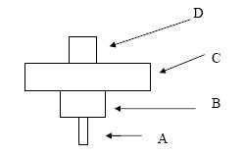
A ………………………………….. B ……………………………………
C ………………………………….. D ……………………………………
(c) Which letter represents the producer in the pyramid? ……………………………………
(d) Comment on the relative sizes of an individual producer and an individual primary consumer in the pyramid.
….…………………………………………………………………………………………
….…………………………………………………………………………………………
……………………………………………………………………………………………
Answer

2009 HL
3. (a) Define predation. __________________________________________________________________
_________________________________________________________________________________
(b) Give an example of predation by naming a predator and its prey.
Predator: _________________________________________________________________________
Its prey: __________________________________________________________________________
(c) Explain the term niche. _____________________________________________________________
________________________________________________________________________________
(d) Name an anabolic process carried out by plants. __________________________________________
(e) Explain the term edaphic. ___________________________________________________________
________________________________________________________________________________
(f) Give an example of an edaphic factor. _________________________________________________
Answer

2010HL
5. Explain each of the following terms from your study of ecology.
(a) Biosphere ……………………………………………………………………………………………....
(b) Ecosystem ……………………………………………………………………………………………..
(c) Habitat …………………………………………………………………………………………………
(d) Symbiosis ……………………………………………………………………………………………...
(e) Biotic factor ……………………………………………………………………………………………
(f) Food Web ……………………………………………………………………………………………..
(g) Fauna ………………………………………………………………………………..…………………
Answer

2011 HL
3. Choose suitable terms from the list below that most closely match each of the following descriptions:
population; producers; competition; predation; community; symbiosis; decomposers; parasitism
(a) A situation in which one organism lives on or in a second species, feeding on it and causing it harm.
________________________________________________________________________________
(b) Organisms capable of making their own food.
________________________________________________________________________________
(c) All the members of a species living in an area.
________________________________________________________________________________
(d) Micro-organisms and other organisms that return nutrients to the environment by decay.
_________________________________________________________________________________
(e) A situation in which two organisms of different species live together and at least one benefits.
________________________________________________________________________________
(f) A struggle between organisms for a scarce resource.
________________________________________________________________________________
(g) One organism killing and eating another organism.
________________________________________________________________________________
Answer

2012 HL
4. (a) (i) What does an ecologist mean by the term conservation?
________________________________________________________________________________
(ii) Suggest a reason why nature reserves are important for conservation.
________________________________________________________________________________

(b) (i) Explain the term pollution. ____________________________________________________
(ii) Pollution may result from domestic, agricultural or industrial sources.
Select one of these areas and state an effect that may be produced by a named pollutant.
Pollutant: _______________________________________________________________________
Effect: _________________________________________________________________________
(iii) How may the pollution referred to in (ii) be controlled?
________________________________________________________________________________

(c) In relation to the incineration of domestic waste, suggest:
(i) an advantage of the process. ___________________________________________________
(ii) a disadvantage of the process. _________________________________________________
Answer

2013 HL
2. Answer the following questions in relation to food chains.
(a) Where in a food chain are primary producers found?
_________________________________________________________________________________
(b) What term is used to describe organisms that feed on primary producers?
_________________________________________________________________________________
(c) Why are most food chains short (i.e. only consist of a few trophic levels)?
_________________________________________________________________________________
(d) What deduction may be made if the organisms at the start of the chain are less numerous than those
that feed upon them?
_________________________________________________________________________________
(e) (i) Can a parasite be the first member of a food chain? __________________________________
(ii) Explain your answer. __________________________________________________________
(f) Energy enters food chains in the form of light. In which form do you think most energy is lost from
food chains?
_________________________________________________________________________________
Answer

Ordinary Level

SEC Sample Paper OL
4. The graph below shows the changes in the number of wrens in a small wood over a twelve month period.

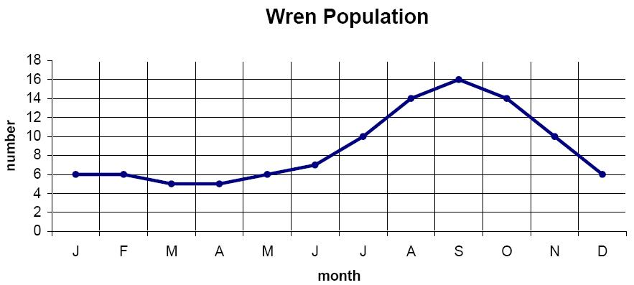
How many wrens were present in the wood in June? …………………………………………..
During which months does the wren’s breeding season occur?
…………………………………………………………………………………………………
Why do you think that breeding takes place during the months that you have mentioned above?
…………………………………………………………………………………………………
…………………………………………………………………………………………………
Suggest two reasons why the number of wrens declines in the autumn.
1. …………………………………………………………………………………………….
.……………………………………………………………………………………………
2. ……….……………………………………………………………………………………
…………………………………………………………………………………………….
Possible Answer

2004 OL
6. Answer the following questions in relation to the food web shown below.

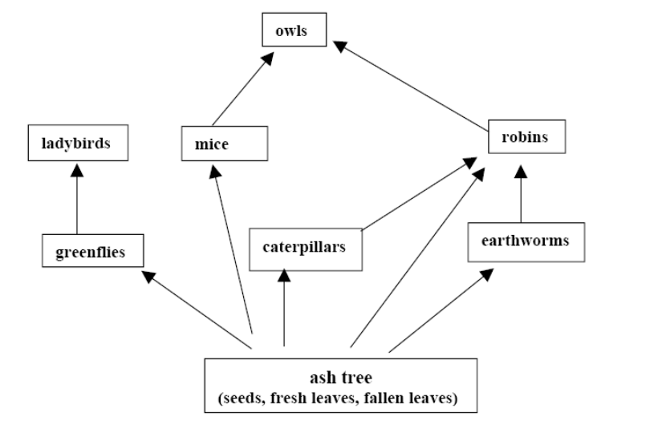

Write out a food chain with four organisms in it ………………………………………………………………………………………………….
………………………………………………………………………………………………….
Name the primary producer in the web. …………………………………………………………………………………………………..
Name two secondary consumers in the web.
1. ………………………………………………………………………………………….
2 …………………………………………………………………………………………..
Name two herbivores in the web.
1 …………………………………………………………………………………………..
2 …………………………………………………………………………………………..
Name one omnivore in the web. …………………………………………………………………………………………………
Name one carnivore in the web.
…………………………………………………………………………………………………
Answer

2005 OL
1. Explain four of the following terms that are used in ecology.
(a) Biosphere ……….………………………………………………………………………………..
……………………………………………………………………………………………………
(b) Habitat …….……………………………………………………………………………………..
……………………………………………………………………………………………………
(c) Consumer …………………..…………………………………………………………………….
……………………………………………………………………………………………………
(d) Producer ………….……….……………………………………………………………………..
……………………………………………………………………………………………………
(e) Niche ………..……………………………………………………………………………………
……………………………………………………………………………………………………
Answer

2006 OL
1. Use your knowledge of ecology to answer four parts of the following.
(a) An organism which makes its own food is called a ……………………………………
(b) An organism that eats another organism is called a …………………………………....
(c) The place where an organism lives is called its …………………………………………..
(d) The primary source of energy in an ecosystem is the …………………………………….
- The parts of the earth and atmosphere in which life is found is called the ..……………..
- Answer

2007 OL
2. Choose a term that is used in ecology from the following list and place it in column A to match the description in column B. The first one has been completed as an example.

predator, habitat, biosphere, niche, ecosystem

Column A | Column B
Predator | Kills and eats other animals
 | All parts of the earth and its atmosphere where life exists
 | A community of organisms and their environment
 | The role of an organism in an ecosystem
 | Place where an organism lives
Answer

2008 OL
1. The following food chain is from a hedgerow.
Complete any four of the following by reference to this food chain.
(a) The primary consumer in this food chain is ___________________________________________
(b) If the number of sparrowhawks increases, the number of blue tits may ______________________
(c) In this food chain the hawthorn leaves represent the ____________________________________
(d) Name a carnivore from this food chain _______________________________________________
(e) The number of trophic (feeding) levels in this food chain is limited by the small transfer of __________ from one level to the next.
Answer

2009 OL
2. Choose each term from the following list and place it in Column B to match a description in Column A. The first one has been done as an example:
trophic level, niche, habitat, ecosystem, biosphere
Column A | Column B
Where an organism lives | habitat
All places where life is possible
Organism’s role in ecosystem
Position in a pyramid of numbers
Organisms and their environment
Answer

2010 OL
1. (a) The diagram shows the carbon cycle.
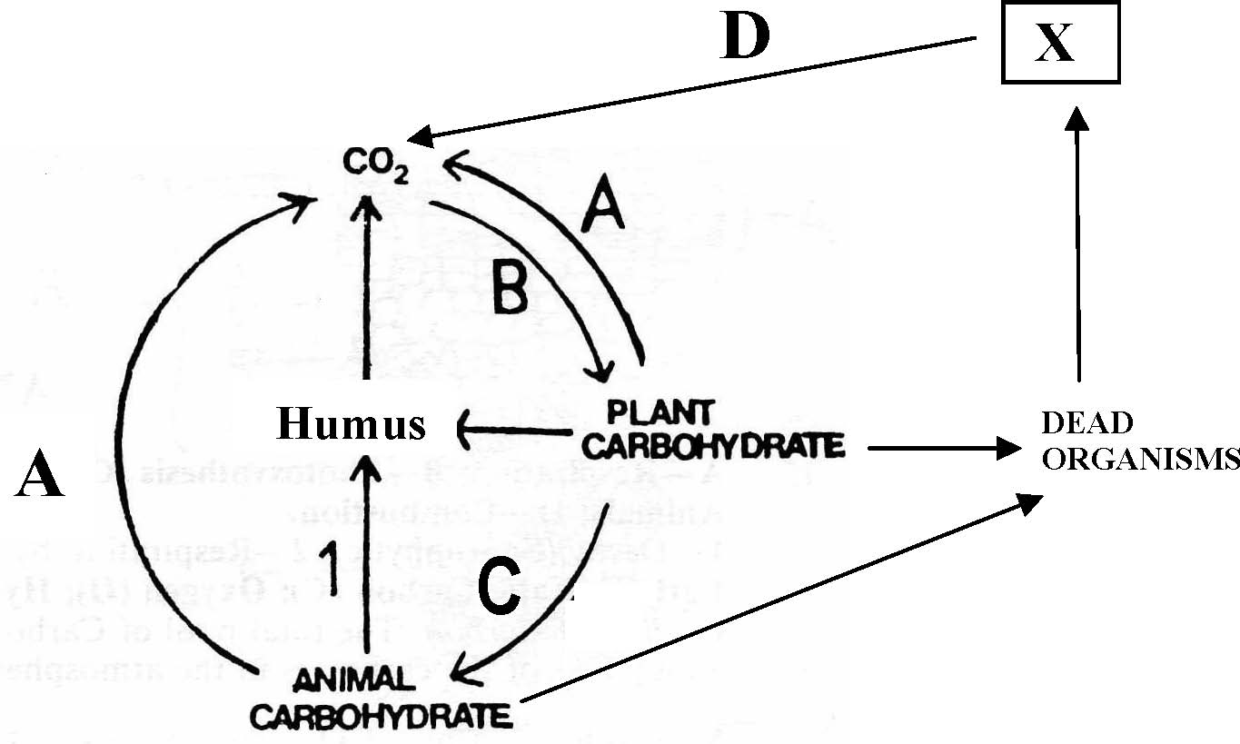

Name the processes A, B, C, and D.
A. ___________________________________ B. _____________________________________
C. ___________________________________ D. _____________________________________
(b) Name the substances labelled X. ____________________________________________________
(c) Why are elements recycled in nature? ________________________________________________ _____________________________________________________________________________________
(d) Name one group of organisms responsible for process 1 in the diagram. ______________________
Answer

2011 OL
2. (i) What is meant by pollution?
____________________________________________________________________________________
(ii) Name one human activity that causes pollution.
____________________________________________________________________________________
(iii) State two problems associated with waste disposal in Ireland.
Problem 1. ___________________________________________________________________________
Problem 2. ___________________________________________________________________________
(iv) List two ways of minimising waste.
1.___________________________________________________________________________________
2.___________________________________________________________________________________
(v) Give one example of the use of microorganisms in waste management.
____________________________________________________________________________________
____________________________________________________________________________________
Answer

2012 OL
5. Place each term from the following list into Column B to match a description in Column A.
The first one has been completed as an example.

List: Pollution; Niche; Recycle; Burning fuel; Conservation; Smell.

Column A | Column B
The role of the organism in the habitat. | Niche
(a) Any harmful addition to the ecosystem.
(b) A problem associated with waste disposal.
(c) A way to minimise waste.
(d) Wise management of an ecosystem.
(e) A possible cause of pollution.
Answer

2013 OL
3. Indicate whether the following statements are true (T) or false (F) by drawing a circle around T or F in
each case.
Example: The liver produces bile. T F
(a) Metabolism is the sum of all the chemical reactions in the body. T F
(b) Anabolism is the breaking down of large molecules. T F
(c) Nutrition is the way living organisms get rid of waste. T F
(d) The term abiotic refers to the living factors in an ecosystem. T F
(e) In science, a hypothesis is an educated guess based on observations. T F
(f) In experiments the factor that is changed is called the variable. T F
(g) Grazing food chains begin with animals. T F
Answer

1.4 General Principles of Ecology

Section B

Higher Level Questions Ordinary Level Questions

Higher Level

2008 HL
7. (a) (i) What is a habitat? …………………………….……………………………………………….
(ii) What is an ecosystem?...………………………………............................................................
Answer

2013 HL
7. (a) Distinguish between the terms habitat and ecosystem by writing a sentence about each.
(i) Habitat. _______________________________________________________________
(ii) Ecosystem. ____________________________________________________________
Answer

Ordinary Level

2013 OL
9. (a) (i) In ecology, what is meant by the term conservation?
....................................................................................................................................................................
(ii) Suggest why conservation is important in an ecosystem.
....................................................................................................................................................................
……………………………………………………………………………………………………………
Answer

1.4 General Principles of Ecology

Section C

Higher Level Questions Ordinary Level Questions

Higher Level

2004 HL
10. (a) Explain the following terms that are used in ecology: biosphere, habitat, niche.
(b) In ecological studies it is found that the distribution of organisms is influenced by abiotic and biotic factors.
(i) Distinguish between the underlined terms.
(ii) Name an ecosystem that you have investigated and give an example of an abiotic factor that influences the distribution of a named plant in the ecosystem.
(iii) In the case of your named ecosystem give an example of a biotic factor that influences the distribution of a named animal.
(iv) What is meant by a pyramid of numbers? Construct a pyramid of numbers from organisms in the ecosystem that you have studied.
(v) What term is used by ecologists to describe the organisms that form the base of the pyramid?
(c) Lemmings are small rodents that are widespread in northern latitudes. The graph shows
the fluctuations in lemming numbers in northern Manitoba between 1929 and 1943.

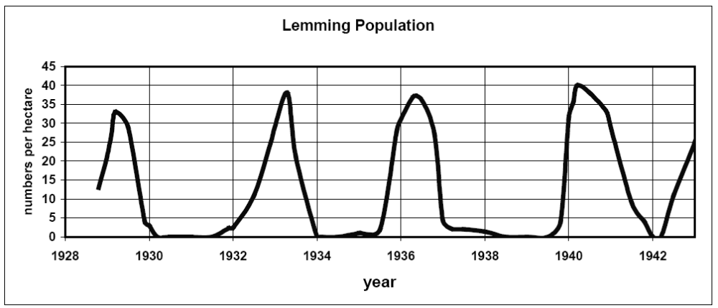

[Adapted from J. P. Finerty (1980). The Population Ecology of Cycles in Small Mammals. Yale University Press,New Haven.]

(i) The graph indicates that population peaks occur at fairly regular intervals. What is the approximate average time between these peaks?
(ii) What is the mean maximum population density (numbers per hectare) for the period covered by the graph?
(iii) What is a predator? The Arctic fox is a predator of the lemming. Copy the graph into you answer book and draw on it a graph to show how you would expect the population of the Arctic fox to have varied in northern Manitoba during the period 1929 – 1943.
(iv) Suggest two factors other than predation that might account for the declines in lemmings shown in the graph.
(v) Suggest two factors that may have been responsible for the fairly regular increase in lemming numbers shown in the graph. (27)
Answer

2005 HL
12. (a) (i) What does an ecologist mean by competition?
(ii) Competition is generally more intense between members of the same species than between members of different species. Comment on the validity of this statement. (9)

(b) Read the following extract and then answer the questions below.
“A migratory flight involves preparation. The initial stimulus for spring migration among birds wintering in European latitudes comes from the increase in day length past an initial threshold. Physiological changes encourage the deposition of fat, particularly beneath the skin (subcutaneous) and inside the abdomen (visceral). Fat is the vital fuel used by migrating birds, which often have to cross long stretches of sea or perhaps desert where feeding opportunities are either non-existent or very limited.
Wildfowl preparing for migration, therefore, increase their food intake in order to lay down that vital fat and this shows itself in increased time spent feeding. Conveniently, for plant-eating species such as the grazing geese and wigeon, the onset of spring growth in the plants means higher levels of nutrients in the growing tips on which the birds feed.”
[From Wildfowl, Ogilvie and Pearson, 1994 Hamlyn Limited]

  - What is the stimulus for spring migration?
  - Suggest two reasons why birds migrate.
  - What is the “vital fuel” used by migrating birds?
  - Give two locations in the body in which this vital fuel may be found.
  - Suggest what happens to this fuel in the body tissues of the birds.
  - In which part of plants do wigeon find the highest level of nutrients?
(vii) Suggest a reason for the nutrient levels being highest in this part of the plant. (27)

(c) (i) Give an account of how you carried out a quantitative survey of a named plant species in an
ecosystem that you have studied. In your answer describe how you recorded the results of your survey.
(ii) As a result of a disease, a species of plant disappeared from an ecosystem.
Suggest three possible effects of the disappearance of this plant on the populations of other plants and animals in the ecosystem.
Answer

2005 HL
13. (c) (iv) Suggest a possible effect on a human population that may result from an increased
availability of contraception.
Answer

2006 HL
10. (a) The figure below shows the relative sizes of a lemming population (histogram or bars) and the
percentage phosphorus in forage (curve) over a number of years.

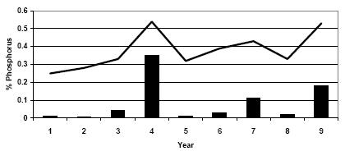

(i) What relationship is indicated between the percentage of phosphorus in forage and the size of the lemming population?
(ii) Suggest an explanation for this relationship. (9)

(b) Describe how you carried out a quantitative survey of a named animal in the ecosystem that you have studied. (27)

(c) (i) Explain what is meant by pollution.
(ii) Give an account of the effects of a named pollutant of domestic, agricultural or industrial
origin.
(iii) Describe one way in which the pollution that you have indicated in (ii) might be controlled.
(iv) Outline the problems associated with the disposal of waste. Suggest two ways of minimising
waste. (24)
Answer

2007 HL
12. (a) Explain the following terms that are used in ecology: niche, edaphic factor, symbiosis.
(b) (i) What is the function of the nitrogen cycle?
(ii) What is meant by nitrogen fixation?
(iii) What is meant by nitrification?
(iv) Describe, using words and/or labelled diagrams, the events of the nitrogen cycle. (27)
(c) (i) What term do ecologists use to describe an animal which kills and eats other
animals?
(ii) What term is used to describe the animal that is killed and eaten?
(iii) If the population of the animals in (ii) declines suggest two possible consequences
for the animals in (i).
(iv) Give four factors that influence the size of the human population. (24)
Answer

2008 HL
10. (a) (i) What does an ecologist mean by competition?
(ii) Distinguish clearly between contest competition and scramble competition. (9)
(b) Read the following extract, study the graph below and answer the questions that follow.
“The application of pesticides to strawberry plants in an attempt to destroy cyclamen mites that were damaging the strawberries killed both the cyclamen mites and the carnivorous mites that preyed on them. But the cyclamen mites quickly re-invaded the strawberry fields while the mites that preyed on them returned much more slowly. The result was that the cyclamen mites rapidly increased in density and did more damage to the strawberries than if the pesticide had never been applied.”
(Adapted from W.T. Keeton and J. L. Gould. Biological Science. New York: W.W. Norton & Co., 1993)
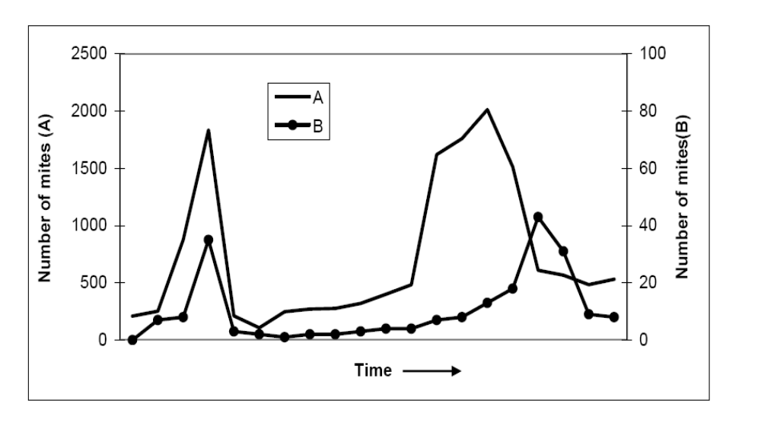
- Which graph, A or B represents the carnivorous mites? Explain your answer.
- What term is used to describe the relationship between the cyclamen mites and the carnivorous mites?
- Suggest two reasons why the cyclamen mite managed to quickly re-invade the strawberry fields.
- Suggest an alternative to the use of pesticides for controlling the cyclamen mite population.
- Draw a pyramid of numbers to include each of the organisms mentioned in the extract above.
(vi) Apart from competition and the factor illustrated in the above example, state another
factor that limits population growth.
(c) (i) Waste management is a matter of growing concern in Ireland as the population expands.
Outline three problems associated with waste disposal.
(ii) Give an example of waste produced in agriculture or fisheries or forestry and describe how it is managed.
(iii) Suggest two methods of waste minimisation.
(iv) Give one example of the use of micro-organisms in waste management.
Answer

2009 HL
11. (a) (i) What does an ecologist mean by the term conservation?
(ii) Give an outline of one conservation practice used in agriculture or fisheries or forestry.
(b) Read the following passage about foxes and answer the questions that follow:
Red foxes are found in many ecosystems. A pair of foxes will occupy a territory and will defend it from other foxes in the breeding season. Territory boundaries are marked with scent and urine. Red foxes are usually solitary and hunt alone except during the breeding season, when they hunt in family groups. The young accompany the parents while hunting and foraging in order to learn skills. Red foxes do not hibernate and are active all year round though they are nocturnal in habit. They are omnivores but they prefer animals such as small rodents, frogs, insects and birds. Preferred plant foods include acorns, grasses, fruits and berries. In urban areas they scavenge for discarded human food. They also eat roadkill whether in a rural or urban setting.
(Adapted from: Ontario Ministry of Natural Resources fact sheet: Red fox ecology, 6th June 2007)

1. Give two activities of adult foxes, apart from breeding itself, which are associated with the breeding season.
2. How is the territorial boundary marked?
3. How do young foxes learn to hunt?
4. Suggest a reason why wheelie bins are making life more difficult for urban foxes.
5. What is meant by the term omnivore?
6. Suggest an advantage to the fox of being “nocturnal in habit”.
7. In general, are urban foxes or rural foxes more successful at finding food? Give a reason for your answer. (27)
Answer

2010 HL
12. (a) (i) Where are primary producers found in a pyramid of numbers?
(ii) Using named examples, construct a simple inverted pyramid of numbers. (9)

(b) A paper factory pumps liquid effluent into a river. The effluent contains sugar.
Oxygen demand is the amount of oxygen needed by organisms living in a river.
Oxygen concentration is the amount of oxygen dissolved in the river water.

Graph A shows changes in water conditions for several kilometres downstream from the factory outflow.

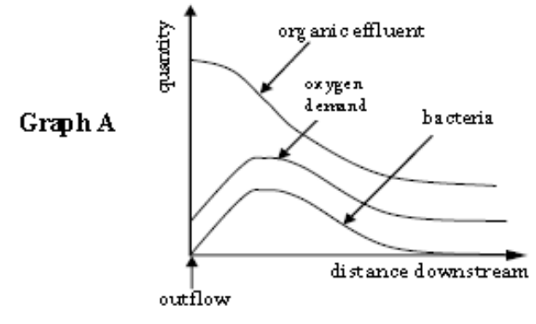

(i) To which kingdom do bacteria belong?
(ii) Give one reason why the number of bacteria increases immediately downstream from the
outflow.
(iii) Give one reason why the number of bacteria then decreases further downstream from the
outflow.
(iv) Describe how the oxygen demand changes as the number of bacteria in the water changes.
(v) Give a reason for your answer to part (iv).

Graph B shows the changes in oxygen concentration and the number of fish in the same river.

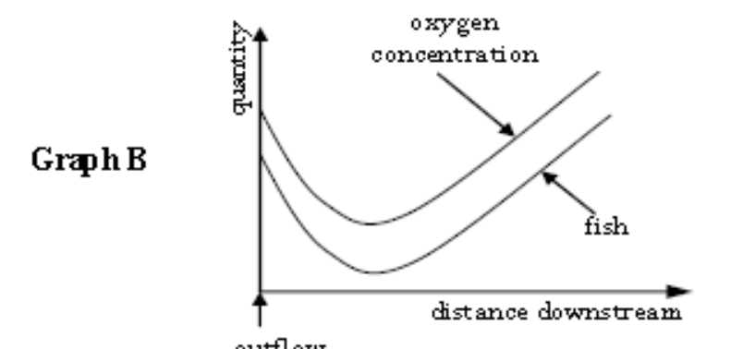

(vi) Explain why the curve for fish numbers is the same shape as that for oxygen concentration.
(vii) The oxygen concentration in the river water eventually increases with distance from the outflow. Suggest two ways by which this oxygen may enter the water.

[Adapted from Biology for You by Gareth Williams; Stanley Thomas (Publishers) Ltd, 2nd edition 2002.] (27)

(c) In your answer book, say whether each of the following statements is true or false and give a reason
for your choice in each case:

(i) Food chains are usually short.
(ii) The herbivores in an ecosystem normally live long lives.
(iii) The only remaining natural ecosystems in Ireland, for example mountain land above the heather
line and salt marsh, are ones for which mankind has no use.
(iv) HIV / AIDS has orphaned many children in sub-Saharan Africa. (24)
Answer

2011 HL
10. (a) (i) Distinguish between contest competition and scramble competition by writing a sentence about
each.
(ii) Name a factor, other than competition, that controls wild populations. (9)

(b) What deduction is it possible to make from each of the following observations?
(i) In a particular area the population of a predator did not decline following a big reduction
in the population of its main prey.
(ii) Mortality levels resulting from infection by a particular virus tend to decline over the years.
(iii) Where some members of a species remain in the same general area throughout life and some
members are migratory, mortality levels tend to be higher in the migratory part of the
population.
(iv) There is a greater variety of herbaceous (non woody) plants in areas where grazing species,
such as rabbits, are more plentiful than in areas where grazing species are less plentiful.
(v) In some species of migratory ducks in the northern hemisphere it is found that the wintering
grounds of the males lie further south than those of the females. (27)

(c) (i) In relation to a study of an ecosystem distinguish clearly between qualitative and
quantitative surveys by writing a sentence about each.
(ii) How were you able to identify the different plants in the ecosystem that you investigated?
(iii) Describe how you carried out a quantitative survey of the major plant species.
(iv) Give two possible sources of error that may have arisen in the course of your survey. (24)
Answer

2012 HL
11. (a) (i) Distinguish between a food chain and a food web.
Include a clear reference to each in your answer.
/(ii) What do ecologists mean by a pyramid of numbers? (9)

(b) Organisms that are introduced into new environments outside their natural ranges are referred to as
exotic species. In some cases these introductions have been deliberate and in other cases accidental
e.g. when a species kept in captivity in a new country escapes and gives rise to a wild population.
Worldwide, the great majority of deliberate attempted introductions have been unsuccessful.
(i) Suggest a reason for attempting to establish an exotic species in a new country.
(ii) Suggest two reasons why the great majority of attempted introductions have been
unsuccessful.
(iii) Use your knowledge of the life cycle of flowering plants to suggest how an exotic plant may
escape from captivity.
(iv) Use the knowledge that you have gained in your studies of ecology to suggest how the
introduction of an exotic species may:
1. impact negatively on an existing community.
2. impact positively on an existing community.
(v) It has been stated that an exotic species has a good chance of becoming established in a new
environment if there is a vacant niche.
1. Explain the term niche in this context.
2. Do you agree with the above statement?
3. Explain your answer. (27)

(c) Name the ecosystem which you investigated during your study of ecology.
(i) Explain th/e terms
1. Flora,
2. Fauna.
(ii) Name one animal from your named ecosystem and describe how you carried out a
quantitative study of that animal.
/(iii) Suggest one way in which marking an animal might endanger it.
(iv) Ecosystems are subject to changes, both natural and artificial.
Mention one of each type of change as it applies to your named ecosystem. (24)
Answer

2013 HL
15. Answer any two of (a), (b), (c). (30, 30)
(a) Read the article below and answer the questions that follow:
Cigarettes are bad for your health. But that’s only if you smoke them. If you use them to line your nest,
they might actually do some good. Scientists have recently found that birds that decorate their nests
with discarded cigarette butts full of nicotine are less bothered by parasites.* When building a nest,
birds tend to make do with the materials at hand. Twigs and leaves are popular choices. Some fresh
green leaves give off strong smells. So how can city birds manage? Apparently, some reach for the
fibres found in used cigarette filters.

Scientists got to wondering whether this habit might provide the birds with benefits other than bedding.
So they investigated the nests of finches and sparrows that were living on the campus of the National
University of Mexico, which is in the heart of Mexico City. The scientists used heat traps to lure the
parasites and then counted them. Most of the nests contained cellulose fibres from broken cigarette
filters. They found that nests with the most used cigarette filter fibres had the lowest number of
parasites, in this case, blood sucking mites. For these birds, a butt a day might keep the mites away!
*[Biology Letters: M. Suarez-Rodriguez, I. Lopez-Rull, C. Macias Garcia ‘Incorporation of cigarette butts into
nests reduces nest ectoparasite load in urban birds: new ingredients for an old recipe.’]
Adapted from Scientific American 60-second podcast by Karen Hopkin 05/12/2012.

(i) Name one bird from the study and name its parasite.
(ii) Explain the term ectoparasite.
(iii) Suggest one negative effect on birds or chicks of living in parasite-infested nests.
(iv) Apart from an effect on parasite numbers, suggest a reason for the use of the filter fibres in
nest building.
(v) State one benefit to a plant of giving off strong smells.
(vi) Suggest what might be trapped in used cigarette filters.
(vii) Suggest how the scientists might have measured the amount of cigarette filter fibre in one
nest.
(viii) The scientists put unused cigarette filters beside the birds’ nests. Suggest a reason for this.
(ix) The nests containing unused filters showed a normal parasite load.
Suggest one reason for this observation.
Answer
(b) (i) Draw a large labelled diagram to illustrate the main features of the nitrogen cycle.
(ii) Outline two biological similarities between the nitrogen cycle and the carbon cycle.
(iii) Suggest why continual monitoring of the environment is valuable.
(iv) In the case of each of the following pairs of terms, distinguish between the members of each
pair by writing a sentence about each term.
1. Contest competition and scramble competition.
2. Edaphic and aquatic.
3. Climate and weather.
Answer
(c) The graph below shows the fluctuations in the population of a predatory species over many years.
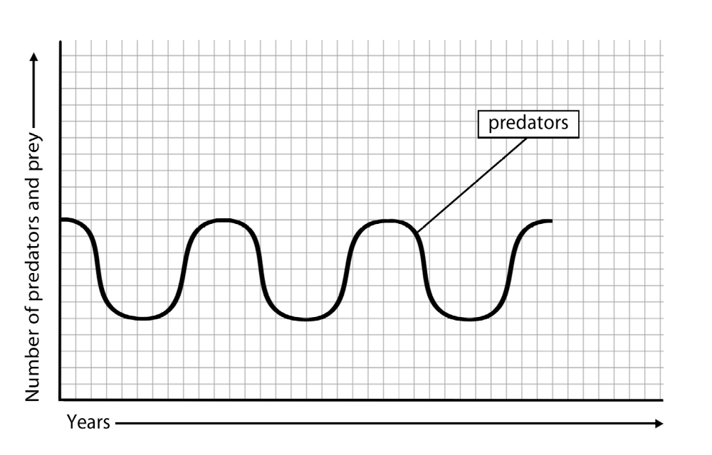

(i) Copy the graph into your answer book.
Then, on the same axes and using a dashed line (- - - -), show how you think the population of
the predator’s main prey species might vary over the same timespan.
(ii) Give an explanation of the graph that you have drawn for the prey species.
(iii) Do you think that population graphs for a host species and its main parasite would show
similar fluctuations? Explain your answer.
(iv) Suggest a role for parasites in the overall scheme of nature.
(v) 1. Name two predators.
2. Give one adaptive technique in the case of each predator.
Answer

Ordinary Level

SEC Sample Paper OL
14. Answer any two of (a), (b), (c). (30, 30)

(a) Study the following word diagram and then answer the questions that follow.

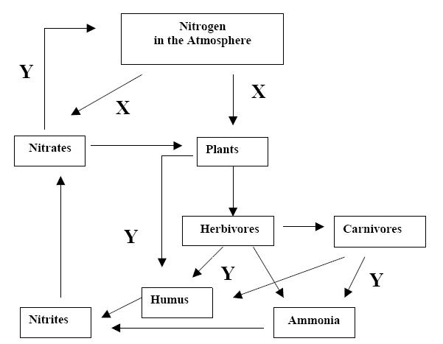

(i) Give the term used to describe the events outlined in the diagram
(ii) Give an example of an herbivore and of a carnivore found in an ecosystem you have studied (not domesticated or farm animals).
(iii) Name an important group of biomolecules that plants make from nitrates.
(iv) Y indicates the return of nitrogen to the environment. State one way in which this happens.
(v) X indicates the change of nitrogen gas to nitrate and other useful compounds. What name is given to this process?
(vi) Name a group of organisms that can carry out X.
(vii) Farmers add nitrates as fertilizers to the soil. They are advised not to spread fertilizers if heavy rain is forecast. Why do you think they are given this warning? (30)
Possible Answer

(b) Answer the following questions in relation to the flow of energy through an ecosystem.
- What is the source of energy for the earth’s ecosystems?
- Name the process that takes place in plants in which this energy is converted to a usable form.
- What substance do plants possess that allows them to carry out this conversion?
- Energy flows along food chains. In the food chain A B C give an example of each from the organisms that you found in a named ecosystem.
- Is there more energy available for organism B or C? Explain your answer.
- A food web can be thought of as a number of interlinked food chains. Using the named organisms A, B, C from (iv) above and three other named organisms, construct a food web that is found in the ecosystem you have studied.
Possible Answer

(c) (i) Explain what is meant by pollution.
(ii) Give an example of pollution and describe how this form of pollution can be controlled.
(iii) Human populations are producing waste materials in ever-increasing amounts.
Many of these wastes are serious threats to the environment.
1. Describe some of the problems associated with waste disposal.
2. Give an outline account of one example of waste management.
- Explain what is meant by conservation.
- Give a brief account of a conservation practice with which you are familiar.
Possible Answer

2005 OL
10. (a) (i) What is an ecosystem?
(ii) Name two ecosystems found in Ireland. (9)

(c) (i) What is meant by pollution?
(ii) Describe a human activity that may result in pollution. Suggest a way in which this pollution could be prevented.
(iii) What do you understand by the term conservation?
(iv) Suggest three reasons for conserving wild animals and plants. (30)
Answer

2006 OL
10. (a) (i) What is a pyramid of numbers?
(ii) Using organisms from the ecosystem that you have investigated draw a pyramid of numbers to show at least three trophic (feeding) levels. (9)

(b) Study the graph, which shows how the number of thrushes in a wood changes in the
course of a year, and then answer the following questions.

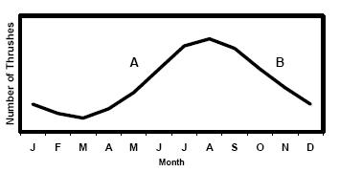

(i) What does the graph tell you about the number of thrushes?
(ii) Suggest one reason for the change in the number of thrushes at A.
(iii) Suggest two reasons for the change in the number of thrushes at B.
(iv) Would you expect similar changes in numbers for other small birds in the wood?
Explain your answer. (27)

(c) Answer the following in relation to waste management in Ireland.
- Waste management is becoming an increasingly difficult matter. Suggest two reasons for this.
- Describe one method of waste management by reference to agriculture, fisheries or forestry.
- Suggest some ways of minimizing waste. (24)
Answer

2007 OL
10. (a) (i) What is the principal source of energy for the Earth’s ecosystems?
(ii) Name the process that converts this energy into chemical energy in plants. (9)

(b) Answer the following questions in relation to the food web shown in the diagram.
(i) Name a producer.
(ii) What does the animal plankton feed on?
(iii) What feeds on the animal plankton?
(iv) Why are periwinkles referred to as primary consumers?
(v) Starting with a producer, complete a food chain with four trophic (feeding) levels, naming each organism involved. (24)

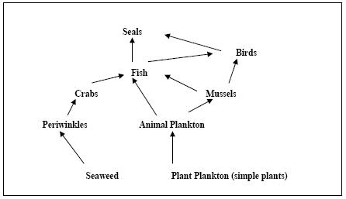

(c) Answer the following questions in relation to a named ecosystem you have investigated.
(i) Name the ecosystem.
(ii) Describe how you collected a named animal.
(iii) State one way in which a named organism was adapted to the ecosystem.
(iv) What is meant by an abiotic factor?
(v) Give two abiotic factors that you investigated.
(vi) In relation to the abiotic factors you have named, describe how you measured each one.
Answer

2008 OL
10. (a) (i) What is meant by nitrogen fixation?
(ii) Name a group of organisms involved in nitrogen fixation. (9)

(b) Answer the following questions by reference to an ecosystem that you have studied.
(i) Name the ecosystem.
(ii) Name two habitats from the ecosystem.
(iii) Name an animal that is present in one of these habitats and describe one way in which it is adapted to that habitat.
(iv) Describe briefly how you carried out a quantitative survey of a named plant found in the ecosystem. (27)

(c) (i) What is meant by pollution?
(ii) Give an example of pollution which may result from domestic (household) or industrial or agricultural activity.
(iii) Suggest two ways to prevent or control pollution.
(iv) Write a short paragraph (about 5 lines) on waste management. (24)
Answer

2009 OL
10. (a) (i) Distinguish between biotic and abiotic factors.
(ii) An edaphic factor is an example of an abiotic factor. Explain the underlined term.
(9)

(c) Read the following extract and answer the questions that follow.
‘Invasion of the jellyfish: Mediterranean on alert as hundreds suffer from stings.’
As thousands of tourists head to the Mediterranean, their holiday enjoyment is being threatened by hordes of jellyfish. French emergency services received more than 500 calls for help in a single day. It is a pattern being repeated along the shores of Mediterranean. Much of the southern – and even northern – coastlines of Spain have been hit. Paddlers and swimmers suffered painful stings from a species commonly known as the mauve stinger.
When a person is stung the venom (poison) from the jellyfish stinging cells causes swelling, redness and oozing. The venom can also cause an allergic response. There is no anti-venom and vinegar is useless. Jellyfish have no autonomy of movement and are swept around the oceans by wind and tide. This is the eighth year in succession that they have stormed the smartest resorts in the Mediterranean.
[Article adapted from the Independent on Sunday (U.K.) 24th July 2008. By Matthew Kay in Paris, Elizabeth Nash in Madrid and Peter Popham in Rome.]
(i) What is meant by the term species?
(ii) Which species of jellyfish was involved in the invasion along Mediterranean shores?
(iii) Name one country that has been affected by this invasion.
(iv) Give two ways in which the jellyfish venom can affect a person.
(v) Suggest why jellyfish produce a venom.
(vi) These jellyfish are usually found in tropical waters. Suggest one reason for their increased occurrence in the Mediterranean in recent years.
(vii) What do you think is meant by the phrase “Jellyfish have no autonomy of movement”? (24)
Answer

2009 OL
12. (a) (i) Decomposition is essential for the addition of nutrients to the soil. Explain the underlined
term.
(ii) Name two groups of micro-organisms in the soil which are responsible for decomposition. (9)
Answer

2010 OL
10. (a) In ecology we study ecosystems, habitats and communities, in which every organism has its own
niche.
Explain what is meant by
(i) an ecosystem
(ii) a habitat
(iii) a niche. (9)

(b) (i) Name an ecosystem you have studied and construct a simple food chain from that ecosystem.
(ii) What is meant by a trophic level?
(iii) Name the trophic levels A, B and C in the pyramid of numbers shown below.
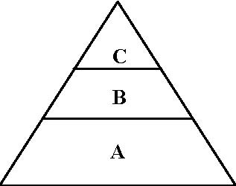

(iv) If all the organisms at C were removed (e.g. by disease) suggest what would happen to the organisms at B?
(27)

(c) The great pressure put on wildlife by the growing human population has caused many species to become extinct. Habitat destruction, over-exploitation and environmental pollution have been the main causes.
There is a clear need for conservation if such a trend is to be halted. Conservation has many practical outcomes from which humans will benefit in future years.

(Adapted from Advanced Biology, 3rd Edition, J. Simpkins, J. I. Williams)

(i) Explain the underlined words from the passage.
(ii) State the effect of any one named pollutant.
(iii) Outline one conservation measure carried out by one of the following industries:
agriculture or forestry or fisheries.
(iv) Name one problem associated with waste disposal.
(v) State one role of microorganisms in waste management. (24)
Answer

2011 OL
11. (a) (i) What is the main source of energy in an ecosystem?
(ii) Explain the following terms used in ecology:
1. Biosphere
2. Habitat. (9)

(b) The food web below was drawn by a group of students following their field work.
Study the web and answer the questions.

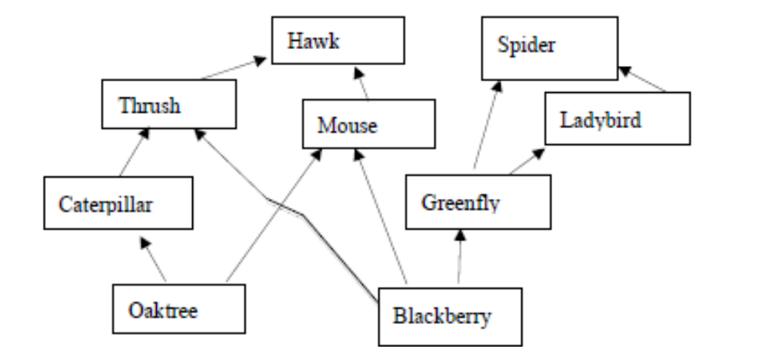

(i) Name one primary producer from the web.
(ii) Name one herbivore and one carnivore from the web.
(iii) Name one omnivore from the web.
(iv) What would happen to the number of caterpillars if all the thrushes died?
(v) What is meant by a quantitative survey of organisms in a habitat?
(vi) Name two pieces of apparatus used to collect animals from an ecosystem. (24)

(c) Read the paragraph below and answer the questions that follow.

Shedding Daylight on Irish Bats.
There are ten species of bat in Ireland. They live in our houses, churches and old
buildings. The most common species of bat in Ireland is the Pipistrelle which is small
enough to fit into a matchbox. The largest species is Leisler’s bat. Bats are not blind.
They use sound to navigate. Bats are the only flying mammals. They generally hunt at
night for moths and other insects. In winter many bat species hibernate in underground
sites and outhouses. Bats have only one baby per year and they can live for up to forty
years. Barn owls may sometimes feed on bats, or they may fall prey to the domestic cat.
According to Bat Conservation Ireland, bat populations are decreasing. This may be due
to loss of hedgerows, pesticide use and the renovation of old buildings.
[Adapted from ‘Science Spin’ Issue 26, January 2008. By Anthony King.]

(i) How many species of bat are found in Ireland?
(ii) What is the name of the most common species found here?
(iii) What do bats feed on?
(iv) What is meant by the term predator?
(v) Name a predator of Irish bats.
(vi) Suggest one reason why many bats hibernate in winter.
(vii) What is meant by the term conservation?
(viii) Suggest one way to help bat conservation in Ireland. (27)
Answer

2012 OL
10. (a) Using organisms from the ecosystem you have studied, draw a pyramid of numbers to show at least three
feeding levels. (9)

(b) (i) All organisms in an ecosystem are influenced by biotic and abiotic factors.
Explain the underlined words.
(ii) Name any two abiotic factors from an ecosystem you have studied and describe how you measured
each one.
(iii) Keys may be used to identify animals. Use the following key to identify animals A, B and C.
The animals are not drawn to scale.

1. Animal has a shell……………………………………………………...Helix.
Animal does not have a shell…………………………………………..Go to 2.
2. Animal has legs …………………………………………………….…Go to 3.
Animal does not have legs…………………………………………......Go to 4.
3. Animal has three pairs of legs…………………………………………Tribolium.
Animal has more than three pairs of legs……………………………...Pieris larva.
4. Animal has long rounded body………………………………………...Nematode.
Animal has flat body with two eye spots………………………………Planarian.

(iv) All organisms are adapted to their own habitat.
1. Name one animal from the ecosystem you have studied.
2. Describe one way in which it is adapted to its habitat./ (27)

(c) (i) Distinguish between a quantitative and a qualitative survey by writing a sentence about each.
(ii) 1. Name one plant from the ecosystem you have studied.
2. Describe how you carried out a quantitative survey to determine its frequency.
(iii) As a result of pollution, a species of plant disappears from an ecosystem.
Suggest two possible effects that the disappearance of this plant might have on the other plants
and animals living in the area. (24)
Answer

2013 OL
11. (a) Explain the following terms as used in ecology:
(i) Producer.
(ii) Niche.
(iii) Habitat. (9)

(b) Climate Change
There is now widespread evidence that the emission of greenhouse gases into the earth’s atmosphere is
causing global climate change. Major changes are expected in terms of temperature and rainfall. One
of the main greenhouse gases is carbon dioxide, released when fossil fuels are burned. Another is
methane gas released by cattle. These gases cause pollution of the air. They are called greenhouse
gases as they have an effect similar to that of a greenhouse - they prevent some of the sun’s heat
escaping back into space.

(i) Name one greenhouse gas.
(ii) Why are greenhouse gases so called?
(iii) What is meant by the term pollution?
(iv) Suggest one way to reduce the levels of greenhouse gases in the air.
(v) The diagram below shows the carbon cycle.

In your answer book match the terms from the list below to the letters A, B, C, D and E in the
diagram.
List: Photosynthesis; Respiration; Eaten by; Combustion; Decay.

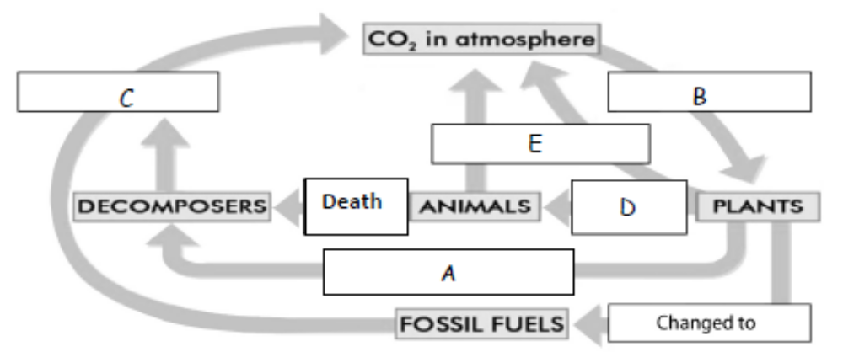
(27)

(c) Improper waste disposal may cause pollution.
(i) State any two types of pollution associated with waste disposal.
(ii) 1. Give one example of a waste associated with agriculture or forestry or fisheries.
2. State how the named waste is managed.
(iii) Give three ways to minimise waste.
(iv) Give one example of the use of micro-organisms in waste management. (24)
Answer

2013 OL
13. (b) The diagram below shows the ultrastructure of a section of cell membrane.

(vi) What is the primary source of energy for plant cells? (27)
Answer

1.5 A Study of an Ecosystem

Need to Know

1.5.1 Broad Overview of a Selected Ecosystem
1.5.2 Observation and Study of Ecosystem
1.5.3 Organism Distribution
1.5.4 Choice of Habitat
1.5.5 Organism Adaptations
1.5.6 Organism Role in Energy Transfer
1.5.7 Analysis

At the end of this section students should be able to:

- Present an overview of diversity of life forms in an ecosystem.
- Identify a number of habitats from the selected ecosystem.
- Identify five plants and animals using simple keys.
- Identify and use various apparatus required for collection methods.
- Explain the difference between a Qualitative & Quantitative study for plants and animals.
- Complete Frequency and Percentage Cover techniques.
- Correlate choice of habitat for organisms to Abiotic Factors.
- Investigate and report on any 3 Abiotic Factors.
- Explain the necessity for and give examples of Structural / Competitive / Behavioural adaptations
- State one adaptation by one organism in the selected ecosystem.
- Explain and identify the role of the organism in energy transfers.
- Draw a food chain of the study area.
- Draw a food web of the study area.
- Draw a food pyramid of the study area.
- Discuss the necessity for analysis and assessments of results obtained.
- Identify local ecological issues related to selected organisms

PowerPoint Presentations

1.5.1 Broad Overview of a Selected Ecosystem.ppt
1.5.2 Ecology Equipment.ppt
1.5.2 Ecosystem Study.ppt
1.5.3 Organism Distribution.ppt
1.5.4 Choice of Habitat.ppt
1.5.5 Organism Adaptations.ppt
1.5.6 Organism Role in Energy Transfer.ppt
1.5.7 Analysis.ppt

1.5 A Study of an Ecosystem

Section A

Higher Level Questions Ordinary Level Questions

Higher Level

SEC Sample Paper HL
5. (a) A 2.5 hectare field was surveyed for clover plants using the quadrat method.
A quadrat of side 0.5 m was used. The results of the survey are shown in the table below.

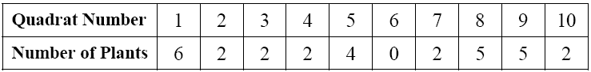

Estimate the number of clover plants in the field. (1 hectare = 10 000 m²)
……………………………………………………………………………………………………
……………………………………………………………………………………………………
……………………………………………………………………………………………………
…………………………………………………………………………………………………….
………………………………………………………………………………………………..…...
………………………………………………………………………………………………...…..

(b) A survey of field mice was carried out in the field mentioned in (a) using the capture/recapture method. The field mice were caught using small mammal traps which were set at random points in the field. Forty field mice were captured, tagged and released at their capture points. One month later the traps were again set at the same locations and forty field mice were caught. Five of these were found to be tagged. Estimate the population density of the field mice in numbers per hectare.
……………………………………………………………………………………………………..
……………………………………………………………………………………………………..
……………………………………………………………………………………………………..
……………………………………………………………………………………………………..
……………………………………………………………………………………………………..
……………………………………………………………………………………………………..
……………………………………………………………………………………………………..
……………………………………………………………………………………………………..
……………………………………………………………………………………………………..
Possible Answer

2006 HL
2. Answer the following questions in relation to your study of ecology.
(b) What is meant by a qualitative survey?
……………………………...……………………………………………………….……
……………………………...……………………………………………………….……
Answer

2010HL
5. Explain each of the following terms from your study of ecology.
(a) Biosphere ……………………………………………………………………………………………....
(b) Ecosystem ……………………………………………………………………………………………..
(c) Habitat …………………………………………………………………………………………………
(d) Symbiosis ……………………………………………………………………………………………...
(e) Biotic factor ……………………………………………………………………………………………
(f) Food Web ……………………………………………………………………………………………..
(g) Fauna ………………………………………………………………………………..…………………
Answer

Ordinary Level

1.5 A Study of an Ecosystem

Section B

Higher Level Questions Ordinary Level Questions

Higher Level

2006 HL
9. (a) (i) What is meant by the term ‘fauna’? ……………………………………………………………
(ii) In ecological studies what is a key? ……………………………………………………………
………………………………………………………………………………………………….
(b) (i) Name five plants in the ecosystem that you have studied.
1.……….…………………………………………………………………………………….….
2.…….……………………………………………………………………………………….….
3.……….………………………………………………………………………………………..
4.……………………………………………………………………………….………………..
5.……..………………………………………………………………………………………….
(ii) In the space below draw up a simple key which could be used to identify each of these plants.

(iii) Name five animals in the ecosystem that you have studied.
1.………………………………………………………..……………………….….
2.…………………………………………………………………..…………….….
3.………………………………………………………………………..……….….
4.……………………………………………………………………..………….….
5.…………………………………………………………………………..…….….
(iv) In the space below draw up a simple key which could be used to identify each of these animals.
Answer

2008 HL
7. (a) (i) What is a habitat? …………………………….……………………………………………….
(ii) What is an ecosystem? ..………………………………............................................................

(b) Answer the following questions by reference to a named ecosystem that you have investigated.
Name of ecosystem………………………………………………………………………………
(i) List three abiotic factors that you investigated.
1. …………………………….. 2. …………………………….. 3. ………………………..
(ii) For each of the three abiotic factors that you have listed describe how you carried out the
investigation.
Factor 1 .………………………………..………………………………………………………..
………….…………………………………….……………………………………………….…
……………………………………………………………………………………………………
……………………………………………………………………………………………………
……………………………………………………………………………………………………
Factor 2 ..........……………………………………… ……………………………………………
……………………………………………………………………………………………………
……………………………………………………………………………………………………
……………………………………………………………………………………………………
……………………………………………………………………………………………………
Factor 3…………………………………………………………………………………..………
……………………………………………………………………………………………………
……………………………………………………………………………………………………
……………………………………………………………………………………………………
……………………………………………………………………………………………………
(iii) In the case of a named organism give an adaptation feature that you noted.
Name of organism .…………………………………………
Adaptation feature …………………………………...……….…………………………….
………………………………………………………………………………………………
………………………………………………………………………………………………
(iv) Briefly explain how the adaptation feature that you have given in (iii) is of benefit to the
organism. ………………………………………………………………………………….
………………………………………………………………………………………………
………………………………………………………………………………………………
Answer

2013 HL
7. (a) Distinguish between the terms habitat and ecosystem by writing a sentence about each.
(i) Habitat. _______________________________________________________________
(ii) Ecosystem. ____________________________________________________________

(b) Answer the following questions in relation to a named ecosystem which you have investigated.
Ecosystem. _______________________________
(i) How did you investigate a named abiotic factor, other than temperature or pH?
Abiotic factor. ____________________________________________________________________
How investigated. _________________________________________________________________
________________________________________________________________________________
________________________________________________________________________________
(ii) How were you able to identify the animals that you found in the ecosystem?
________________________________________________________________________________
(iii) When conducting a quantitative survey of plants, how did you ensure that your sample was
random?
________________________________________________________________________________
________________________________________________________________________________
________________________________________________________________________________
(iv) In the case of a named animal and a named plant give an example of an adaptation to its
habitat that you observed.
Animal. _______________________ Adaptation. __________________________________
Plant. _________________________ Adaptation. __________________________________
(v) As part of your study of your selected ecosystem you constructed a pyramid of numbers.
Name the species that occupied the top of your pyramid.
________________________________________________________________________________
(vi) What is the main prey of the species referred to in part (v)?
________________________________________________________________________________
Answer

Ordinary Level

SEC Sample Paper OL
8. (a) Name an ecosystem that you have studied ………………………………………………
Name three plants that are normally present in this ecosystem
1. ………………………….. 2. …….……….……….…. 3. …….…………………

(b) Answer the following in relation to one of the plants you have named in (a).
Describe how you carried out a survey to find out how many plants of this species were present in your study area.
…………………………………………………………………………………………………………………………………………………………………………………………………………………………………………………………………………………………………………………………………………………………………………………………………………………………………………………………………………………………………………………………………………………………………………………………………………………………………………………………………………………………………………………………………………………………………………………………………………………………………………………………………………………………………………………………………………………………………………………………………………………………………………………………………………………………………………………………………………………………………………………………

How did you present the results of the survey?
……………………………………………………………………………………………………………………………………………………………………………………………………………………………………………………………………………………………………………………………………………………………………………………………………………………………………………………………………………………………………………………………………………………………………………………………

Suggest one possible error that may affect the results of the survey
…………………………………………………………………………………………………………………………………………………………………………………………………………………………………………………………………………………………………………………………………………………………………………………………………………………………………………………………………………
Possible Answer

2004 OL
8. (a) Name an ecosystem that you have studied. ……………………….…………………….
Name three animals that are normally present in this ecosystem
1. ………………………………………………………………………………..………
2. …………………………………………………………………………………………
3. …………………………………………………………………………………………

(b) Select one of the animals that you have named in (a) and answer the following questions in relation to it.

Which animal have you selected? ………………………………………………………
State two features that allowed you to identify the animal
1 …………………………………………………………………………………………
2 …………………………………………………………………………………………
Name an organism on which this animal normally feeds …………………………………………………………………………………………
Explain how you attempted to find out how many of these animals were present in the ecosystem
…………………………………………………………………………………………
…………………………………………………………………………………………
…………………………………………………………………………………………
…………………………………………………………………………………………
…………………………………………………………………………………………
…………………………………………………………………………………………
…………………………………………………………………………………………
…………………………………………………………………………………………
…………………………………………………………………………………………
Using the axes below draw a graph to show how you would expect the numbers of this animal to vary in the ecosystem in the course of a year.
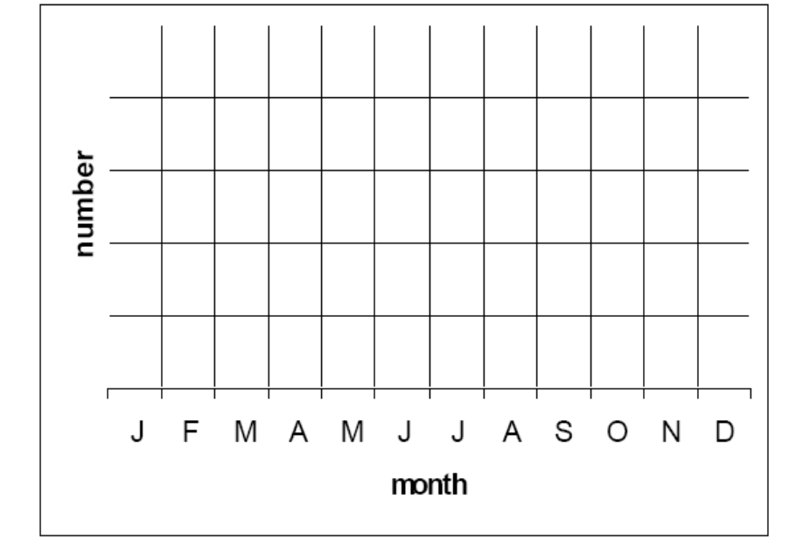

Answer

2006 OL
8. (a) (i) What is meant in ecology by a quantitative survey?
…………………………………………………………………………………..………………………………………………………………..……………………………………………………………………………………..………………………………………………………………………………………
- What is a quadrat frame?
…………………..…………………………………………………………………..………………………………….……………………………………………………………………………………………..

(b) (i) In the case of a named plant describe how you would carry out a quantitative survey in the
ecosystem that you have studied.
……………………………………………………………………………………………………………
……………………………………………………..........................……………………………………..
..........…………………………………....……………………………………………………............…
…………………..............……………………………………………………............…………………..
..…………………………………………………………………………………………………………
……………………………………………………………………………………………………………
……………………………………………………………………………………………………………
………………………………………………………………………………………………………..…
……............……………………………………………………………………………………..……....
……............……………………………………………………………………………………..……....
(ii) Describe how you recorded the results of your survey. ……………………………………………….
…………………………………………………………………………………….……………………
……………………………………………………..........................……………………………………
……………………............……………....…………………………………………………............……
……............……………………………………………………………………………………..……....
……............……………………………………………………………………………………..……....
……............……………………………………………………………………………………..……....
……………………………………………………………………………………………………………
(iii) Suggest a possible source of error in your study………………………………………………………..
……………………………………............……………………………………..............………………
……............……………………………………………………………………………………..……....
……............……………………………………………………………………………………..……....
……............……………………………………………………………………………………..……....
Answer

2007 OL
9. (a) (i) What is meant in ecology by a quantitative survey? ………………………………
………………………………………………………………………………………
………………………………………………………………………………………
(ii) What is a quadrat frame? …………………………………………………………
………………………………………………………………………………………
………………………………………………………………………………………
(b) Answer the following questions in relation to a quantitative survey of plants that you carried out.
(i) How did you use the quadrat frame to carry out the survey? ………………………
………………………………………………………………………………………
………………………………………………………………………………………
………………………………………………………………………………………
………………………………………………………………………………………
………………………………………………………………………………………
………………………………………………………………………………………
………………………………………………………………………………………
(ii) Why did you use a number of quadrats or use the quadrat frame a number of times?
………………………………………………………………………………………
………………………………………………………………………………………
………………………………………………………………………………………
(iii) How did you identify the plants? …………………………………………...….......
………………………………………………………………………………………
………………………………………………………………………………………
(iv) How did you present your results? …………………………………………............
………………………………………………………………………………………
………………………………………………………………………………………
………………………………………………………………………………………
(v) Is the quadrat method suitable for animal populations? ……………………………
Explain your answer ……………….………………………………………………
………………………………………………………………………………………
………………………………………………………………………………………
Answer

2013 OL
9. (a) (i) In ecology, what is meant by the term conservation?
....................................................................................................................................................................
(ii) Suggest why conservation is important in an ecosystem.
....................................................................................................................................................................
……………………………………………………………………………………………………………

(b) (i) As part of your ecosystem study, you used various pieces of apparatus to collect animals for
identification.
Draw labelled diagrams of two pieces of apparatus that you used to collect animals and
in each case name the apparatus and an animal collected.
Name of apparatus 1…………………………. Animal collected………………………………….
Labelled diagram of apparatus 1.

Name of apparatus 2 …………………………….. Animal collected …………………………………
Labelled diagram of apparatus 2.

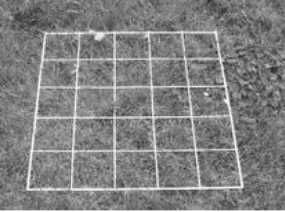
(ii) Name the piece of apparatus shown.
.………………………………………………………………….…

(iii) What is this piece of apparatus used for in your ecology studies?
………………………………………..……………………......................................................................
………………………………………..……………………......................................................................
Answer

1.5 A Study of an Ecosystem

Section C

Higher Level Questions Ordinary Level Questions

Higher Level

2004 HL
10. (c) Lemmings are small rodents that are widespread in northern latitudes. The graph shows
the fluctuations in lemming numbers in northern Manitoba between 1929 and 1943.

[Adapted from J. P. Finerty (1980). The Population Ecology of Cycles in Small Mammals. Yale University Press,New Haven.]

(i) The graph indicates that population peaks occur at fairly regular intervals. What is the approximate average time between these peaks?
(ii) What is the mean maximum population density (numbers per hectare) for the period covered by the graph?
Answer

2005 HL
12. (c) (i) Give an account of how you carried out a quantitative survey of a named plant species in
an ecosystem that you have studied. In your answer describe how you recorded the results of your survey.
Answer

2006 HL
10. (b) Describe how you carried out a quantitative survey of a named animal in the ecosystem
that you have studied. (27)
Answer

2009 HL
11. (c) (i) In relation to ecological surveys, explain the meaning of the terms:
1. Qualitative.
2. Quantitative.
(ii) In the course of your ecological studies you investigated an ecosystem. Name this ecosystem and describe how you conducted a quantitative survey of plants present in it.
(iii) How did you present the results of your survey?
(iv) Suggest a possible source of error in your survey. (24)
Answer

2010 HL
12. (c) In your answer book, say whether each of the following statements is true or false and give a reason
for your choice in each case:

(i) Food chains are usually short.
(ii) The herbivores in an ecosystem normally live long lives.
(iii) The only remaining natural ecosystems in Ireland, for example mountain land above the heather
line and salt marsh, are ones for which mankind has no use.
(iv) HIV / AIDS has orphaned many children in sub-Saharan Africa. (24)
Answer

2011 HL
10. (a) (i) Distinguish between contest competition and scramble competition by writing a sentence about
each.
(ii) Name a factor, other than competition, that controls wild populations. (9)

(b) What deduction is it possible to make from each of the following observations?
(i) In a particular area the population of a predator did not decline following a big reduction
in the population of its main prey.
(ii) Mortality levels resulting from infection by a particular virus tend to decline over the years.
(iii) Where some members of a species remain in the same general area throughout life and some
members are migratory, mortality levels tend to be higher in the migratory part of the
population.
(iv) There is a greater variety of herbaceous (non woody) plants in areas where grazing species,
such as rabbits, are more plentiful than in areas where grazing species are less plentiful.
(v) In some species of migratory ducks in the northern hemisphere it is found that the wintering
grounds of the males lie further south than those of the females. (27)

(c) (i) In relation to a study of an ecosystem distinguish clearly between qualitative and
quantitative surveys by writing a sentence about each.
(ii) How were you able to identify the different plants in the ecosystem that you investigated?
(iii) Describe how you carried out a quantitative survey of the major plant species.
(iv) Give two possible sources of error that may have arisen in the course of your survey. (24)
Answer

2012 HL
11. (a) (i) Distinguish between a food chain and a food web.
Include a clear reference to each in your answer.
(ii) What do ecologists mean by a pyramid of numbers? (9)

/(b) Organisms that are introduced into new environments outside their natural ranges are referred to as
exotic species. In some cases these introductions have been deliberate and in other cases accidental
e.g. when a species kept in captivity in a new country escapes and gives rise to a wild population.
Worldwide, the great majority of deliberate attempted introductions have been unsuccessful.
(i) Suggest a reason for attempting to establish an exotic species in a new country.
(ii) Suggest two reasons why the great majority of attempted introductions have been
unsuccessful.
(iii) Use your knowledge of the life cycle of flowering plants to suggest how an exotic plant may
escape from captivity.
(iv) Use the knowledge that you have gained in your studies of ecology to suggest how the
introduction of an exotic species may:
1. impact negatively on an existing community.
2. impact positively on an existing community.
(v) It has been stated that an exotic species has a good chance of becoming established in a new
environment if there is a vacant niche.
1. Explain the term niche in this context.
2. Do you agree with the above statement?
3. Explain your answer. (27)

(c) Name the ecosystem which you investigated during your study of ecology.
(i) Explain th/e terms
1. Flora,
2. Fauna.
(ii) Name one animal from your named ecosystem and describe how you carried out a
quantitative study of that animal.
(iii) Suggest one way in which marking an animal might endanger it.
(iv) Ecosystems are subject to changes, both natural and artificial.
Mention one of each type of change as it applies to your named ecosystem. (24)
Answer

Ordinary Level

2005 OL
10. (b) Animals A, B, C, D, E, F, G were found in a small lake. They are not drawn to the same
scale.

Use the following key to identify each of these animals. Write down each letter and the animal it represents in your answer book.

(21)

1. Jointed legs present …………………………………………………….………….2
Jointed legs absent ………………………………………………………..…….…3
2. Three pairs of jointed legs….……………………….………………..Diving beetle
Four pairs of jointed legs……………………..…………………………Water mite
3. Body divided into segments………………………………………………….. Leech
Body not divided into segments……………………………………………………4
4. Shell present ….………………………………………………………….Pond snail
Shell absent ………..………………………………………………………………5
5. Ring of tentacles around the mouth……….………………………………....Hydra
No tentacles………………………………………………………………..………6
6. Flat body with eye spots…………………………………………………..Planarian
Round body with pointed ends ………………………………………….Nematode
Answer

2006 OL
10. (a) (ii) Using organisms from the ecosystem that you have investigated draw a pyramid
of numbers to show at least three trophic (feeding) levels.
Answer

2007 OL
10. (c) Answer the following questions in relation to a named ecosystem you have investigated.
(i) Name the ecosystem.
(ii) Describe how you collected a named animal.
(iii) State one way in which a named organism was adapted to the ecosystem.
(iv) What is meant by an abiotic factor?
(v) Give two abiotic factors that you investigated.
(vi) In relation to the abiotic factors you have named, describe how you measured each one.
Answer

2008 OL
10. (b) Answer the following questions by reference to an ecosystem that you have studied.
(i) Name the ecosystem.
(ii) Name two habitats from the ecosystem.
(iii) Name an animal that is present in one of these habitats and describe one way in which it is adapted to that habitat.
(iv) Describe briefly how you carried out a quantitative survey of a named plant found in the ecosystem. (27)
Answer

2009 OL
10. (b)
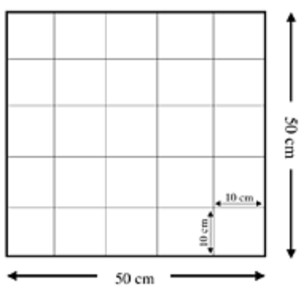

(i) Distinguish between quantitative and qualitative surveys in an ecosystem.
(ii) Name the piece of equipment shown above which is used in a quantitative study of an ecosystem.
(iii) Why is the above piece of apparatus unsuitable for studying most animal populations?
(iv) Suggest a plant that would not be suitable to survey using the above apparatus.
(v) Outline how this piece of apparatus is used for studying plant populations.
(vi) How did you present your results?
(vii) State one possible source of error in a survey of an ecosystem. (27)
Answer

2011 OL
11. (b) The food web below was drawn by a group of students following their field work.
Study the web and answer the questions.

(i) Name one primary producer from the web.
(ii) Name one herbivore and one carnivore from the web.
(iii) Name one omnivore from the web.
(iv) What would happen to the number of caterpillars if all the thrushes died?
(v) What is meant by a quantitative survey of organisms in a habitat?
(vi) Name two pieces of apparatus used to collect animals from an ecosystem. (24)
Answer

2012 OL
10. (a) Using organisms from the ecosystem you have studied, draw a pyramid of numbers to show at least three
feeding levels.
(9)

(b) (i) All organisms in an ecosystem are influenced by biotic and abiotic factors.
Explain the underlined words.
(ii) Name any two abiotic factors from an ecosystem you have studied and describe how you measured
each one.
(iii) Keys may be used to identify animals. Use the following key to identify animals A, B and C.
The animals are not drawn to scale.

1. Animal has a shell……………………………………………………...Helix.
Animal does not have a shell…………………………………………..Go to 2.
2. Animal has legs …………………………………………………….…Go to 3.
Animal does not have legs…………………………………………......Go to 4.
3. Animal has three pairs of legs…………………………………………Tribolium.
Animal has more than three pairs of legs……………………………...Pieris larva.
4. Animal has long rounded body………………………………………...Nematode.
Animal has flat body with two eye spots………………………………Planarian.

(iv) All organisms are adapted to their own habitat.
1. Name one animal from the ecosystem you have studied.
2. Describe one way in which it is adapted to its habitat. (27)

(c) (i) Distinguish between a quantitative and a qualitative survey by writing a sentence about each.
(ii) 1. Name one plant from the ecosystem you have studied.
2. Describe how you carried out a quantitative survey to determine its frequency.
(iii) As a result of pollution, a species of plant disappears from an ecosystem.
Suggest two possible effects that the disappearance of this plant might have on the other plants
and animals living in the area. (24)
Answer

UNIT TWO

The Cell

2.1 Cell Structure

Need to Know

2.1.1 Microscopy
2.1.2 - 3 + 2.1.4.H Cell Structure

At the end of this section students should be able to:

- Identify the parts of a light microscope
- Give the function of each part of the light microscope
- Describe how to use a light microscope
- Distinguish between the light and the Electron Microscope
- Calculate magnification
- Identify the parts of a plant cell as seen under light microscope
- Identify the parts of an animal cell as seen under light microscope
- Give the function of each of the following parts:
Cell wall, cell membrane, nucleus, cytoplasm, vacuole and chloroplast
- Identify the ultra structure and give the function of each of the following cell parts:
Cell membrane, mitochondrion, chloroplast, nucleus, nuclear pores, ribosome and DNA

- Draw the ultra structure of the mitochondrion and the chloroplast
- The existence and definition of prokaryotic and eukaryotic cells

PowerPoint Presentations

2.1.1 The Microscope.ppt
2.1.2 - 2.1.4 Cell strucrure.ppt

2.1 Cell Structure

Section A

Higher Level Questions Ordinary Level Questions

Higher Level

SEC Sample Paper HL
1. Answer any five of the following.
(a) State a function of the cell membrane …………………………………………………………
(b) State one feature that would allow you to identify an eukaryotic cell
…………………………………………………………………………………….……………
(c) Name a human cell that is haploid …………………………………………………………….
(d) What term is used to describe a cellular reaction in which large molecules are broken down to smaller ones? ………………………………………………………………………………..
(e) What term is used to describe an individual’s genetic make up? ……………………………..
(f) Name a scientist responsible for the Theory of Natural Selection
…………………………………………….……………………………………………………
Possible Answer

SEC Sample Paper HL
2. Select the correct term from the following list to match each of the terms in column A and write it in
column B.

protein, enzyme, uracil, sap, ethanol, mutation, thymine, chlorophyll.

A | B
DNA
Ribosome
Vacuole
Fermentation
RNA
Active Site
Variation
Possible Answer

2005 HL
3. (f) A nucleus is absent from human red blood cells. T F
Answer

2006 HL
1. (c) Where in a cell would you expect to find phospholipids? ……………………………
Answer

2010 HL
3. The diagram shows the structure of Amoeba.

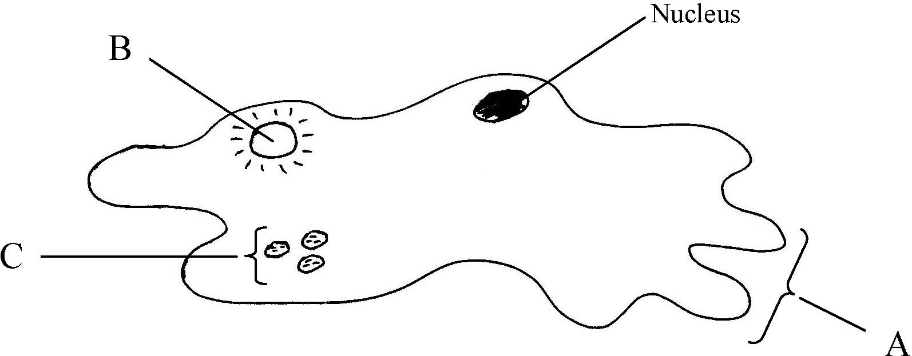

(a) Name the parts labelled A, B and C.
A ………………………………. B ……………………………….. C ……………………………......
(b) To which kingdom does Amoeba belong? ….…………………………………………………………
(c) Is the cell of Amoeba prokaryotic or eukaryotic? ….………………………………………………….
(d) Give a reason for your answer to part (c) ....…………………………………………………………..
(e) Give one function of A in Amoeba ……………………………………………………………............
(f) 1. Give one function of B in Amoeba ………………………………………………………….......
2. Suggest one reason why B is more active in freshwater amoebae than in marine amoebae.
……………………………………………………………………………………………………………
Answer

Ordinary Level

SEC Sample Paper OL
3. Select the correct term from the following list to match each of the terms in column A and write it in column B.
liver, variation, lipid, haploid, sap

A | B
Cell membrane
Vacuole
Mutation
Organ
Gamete
Possible Answer

2004 OL
2. Select the correct cell component from the following list and write it opposite its partner in column B.
ribosome, vacuole, chloroplast, cell membrane, mitochondrion
Column A | Column B
Contains chlorophyll
Site of protein formation
Site of energy release
Site of storage of water, salts and sugars
Allows osmosis to occur
Answer

2005 OL
2. Use ticks (✓) to show if the named structure is present in an animal cell, in a plant cell or in both.
The first has been completed as an example.

Structure | Cytoplasm | Cell Wall | Chloroplast | Nucleus | Vacuole
Animal Cell | ✓
Plant Cell | ✓
Answer

2006 OL
2. The diagram shows a plant cell.

(a) Label A, B, C and D.
(b) Name two features shown in the diagram which are not normally associated with an animal cell.
1. ……………………………………………………………………………………………….
2 ………………………………………………………………………...…………………….
(c) What is usually found in D? …………………………………………………..……………………
(d) Name a carbohydrate found in A. ……………………………………………...…………………..
Answer

2007 OL
1. Complete any four of the following.
(a) A carbohydrate is composed of carbon, hydrogen and ……………………………......................
(b) An example of a water-soluble vitamin is ………………………………………………………..
(c) A chemical that is used to show the presence of starch is ………………………………………..
(d) The liquid in which chemical reactions take place in the cell is ………………………………….
(e) Fats are made from fatty acids and ………………………………………………………………..
Answer

2007 OL
3. Indicate whether the following are true (T) or false (F) by drawing a circle around T or F.

Example: The pulmonary artery carries blood to the lungs T F

(a) If the eyepiece lens of a microscope is marked X10 and the objective lens
is marked X4, the total magnification is X14 T F
(b) Plant cells have chloroplasts, animal cells do not have chloroplasts T F
(c) Humans receive oxygen from the air they inhale T F
(d) Cell membranes let only some molecules pass through T F
(e) Human chromosomes are found in the nucleus T F
Answer

2010 OL
3. The diagram shows a cell.
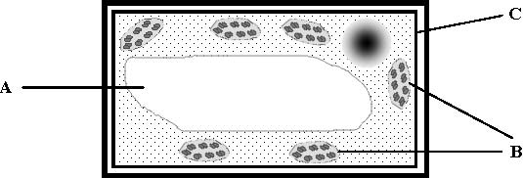

- Is this a plant cell or an animal cell? ___________________________________________________
Give two reasons for the answer given above.
- ____________________________________________________________________________
- ____________________________________________________________________________
(b) Name the structures labelled A, B and C in the diagram.
A. _________________________________________________
B. _________________________________________________
C. _________________________________________________
(c) Name a substance found in A. ________________________________________________________
Answer

2012 OL
3. Indicate whether each of the following statements is true (T) or false (F) by drawing a circle around T or F in
each case.
Example: DNA is a double helical shape. T F
(a) The base Uracil is found in DNA. T F
(b) Chloroplasts contain DNA. T F
(c) The microscope lenses closest to the stage are the eyepiece lenses. T F
(d) Sodium alginate is used to immobilise enzymes. T F
(e) Plant cell walls are fully permeable. T F
(f) Animal cells do not have membranes. T F
(g) An organ is a group of systems. T F
Answer

2.1 Cell Structure

Section B

Higher Level Questions Ordinary Level Questions

Higher Level

2006 HL
8. (a) State a function of each of the following components of a cell.
(i) Ribosome ……………………………………………………………………...
(ii) Cell membrane …………………………………………………………………

(b) Answer the following questions in relation to the preparation, staining and microscopic observation
of a slide of an animal cell.
(i) What type of animal cell did you use? ..................................................................................................
How did you obtain the cell? ……………...………………………………………………….………
…………………………………...……………………………………………………………………….…………….………………………………………………………………………………………..
(ii) Name the stain that you used …………………….… ………………………………………………
Describe how you applied the stain …………………………………………………………………
………..………………………………………………….……………………………………………
………..………………………………………………….……………………………………………
………..………………………………………………….……………………………………………
(iii) After staining, a cover slip is placed on the slide. Give a reason for this
………………………..……………….………………………………………………………………
………..…………..…..……………….………………………………………………………………
(iv) How did you apply the cover slip …………………………………………………………………….
………..…………..…..……………….………………………………………………………………
………..…………..…..……………….………………………………………………………………
………..…………..…..……………….………………………………………………………………
………..…………..…..……………….………………………………………………………………
Why did you apply it in this way? ………………………………………………………………….
………..…………..…..……………….………………………………………………………………
………..…………..…..……………….………………………………………………………………
………..…………..…..……………….………………………………………………………………
………..…………..…..……………….………………………………………………………………
(v) Describe the difference in colour or depth of colour, if any, between the nucleus and cytoplasm when the stained cell was viewed under the microscope
………..…………..…..……………….………………………………………………………………
………..…………..…..……………….………………………………………………………………
Answer

2010 HL
8. (b) For which purpose did you use each of the following in the course of your practical studies?
(i) Methylene blue or iodine solution when examining cells with the microscope.
…………………………………………………………………………………………………
(ii) An aquatic plant such as pondweed rather than a terrestrial plant when investigating the rate
of photosynthesis.
…………………………………………………………………………………………………
(iii) 1. Washing-up liquid or other detergent while extracting DNA from plant tissue.
…………………………………………………………………………………………………
2. Freezer-cold ethanol while extracting DNA from plant tissue.
…………………………………………………………………………………………………
(iv) 1. Antiseptic wash solution in the investigation of the growth of leaf yeast on agar plates.
…………………………………………………………………………………………………
2. Petroleum jelly in the investigation of the growth of leaf yeast on agar plates.
…………………………………………………………………………………………………
(v) 1. Biuret solution or alkaline copper sulphate in food testing.
…………………………………………………………………………………………………
2. Brown paper or Sudan III in food testing.
…………………………………………………………………………………………………
Answer

2011 HL
8. (b) (i) In the course of your practical studies you used a solution of iodine in different
investigations. State two different uses of the iodine solution.
Use 1. ____________________________________________________________________
Use 2. ____________________________________________________________________
(ii) State two different uses of a water bath in biological investigations.
Use 1. ____________________________________________________________________
Use 2. ____________________________________________________________________
Answer

2012 HL
7. (a) In relation to the scientific method, explain each of the following:
(i) Data. _____________________________________________________________________
(ii) Replicates. ________________________________________________________________
(b) Answer the following by reference to some of the investigations that you carried out in the course of
your studies.
(i) How did you expose the semi-lunar valves when dissecting the sheep’s or ox’s heart?
________________________________________________________________________________
(ii) How did you show that alcohol was present when investigating the production of alcohol by
yeast?
________________________________________________________________________________
________________________________________________________________________________
(iii) What type of agar plates did you use when investigating the digestive activity of seeds?
________________________________________________________________________________
(iv) How did you demonstrate that digestive activity had taken place in the investigation referred
to in part (iii)?
________________________________________________________________________________
________________________________________________________________________________
(v) How did you demonstrate the requirement for oxygen when investigating the factors
necessary for seed germination?
________________________________________________________________________________
________________________________________________________________________________
(vi) What did you use as the selectively permeable membrane in your investigation of
osmosis?
________________________________________________________________________________
(vii) What growth regulator did you use when investigating plant growth?
________________________________________________________________________________
(viii) A microscope has an eyepiece lens marked ×10 and an objective lens marked ×20.
What is the total magnification of the image?
________________________________________________________________________________
Answer

2012 HL
8. (a) (i) Are fungi prokaryotic or eukaryotic? ___________________________________________
(ii) Name one structure in plant cells not found in fungi.
________________________________________________________________________________
Answer

2012 HL
12. (a) (i) From the following list, write into your answer book any term that describes the nutrition of a
typical plant:

parasitic; heterotrophic; saprophytic; autotrophic.

(ii) Identify, in your answer book, the cell organelles A and B.

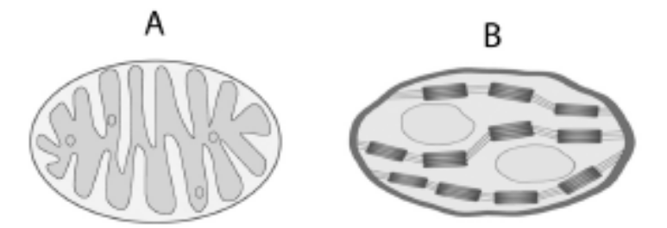 (9)
Answer

2013 HL
9. (a) (i) Explain the importance of double-blind testing in scientific experimentation.
________________________________________________________________________________
(ii) How does a hypothesis differ from a theory?
________________________________________________________________________________

(b) Answer the following in relation to investigations that you carried out in the course of your
practical studies.
(iii) In the microscopic examination of a plant cell:
1. Name the stain that you used and the colour it imparted to the cell wall.
_________________________________________________________________________
2. How did you apply the stain to the cells on the slide?
_________________________________________________________________________
Answer

Ordinary Level
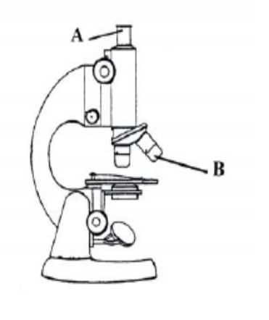
2004 OL
7. (a) Name the parts of the light microscope labelled A and B.
A ……………………………………….
B ……………..…………………………
If the magnification of A is X 10 and the magnification of B
is X 40, what magnification results when a slide is viewed using B?

(b) Answer the following in relation to preparing a slide of stained plant cells and viewing them under the microscope.
(i) From what plant did you obtain the cells? ………………………………………….…………
(ii) Describe how you obtained a thin piece of a sample of the cells.
…………………………………………………………………………………………………………………………………………………………………………………………………………………………………………………………………………………………………………………………………………………………………………………………………………………………………………
What stain did you use for the cells on the slide?
…………………………………………………………………………………………………………
Describe how you applied this stain …………………………………………………………….…….
…………………………………………………………………………………………………………
…………………………………………………………………………………………………………
What did you do before placing the slide with the stained cells on the microscope platform?
………………….………………………………………………………….…………………………..
…………………………………………………………………………………………………………
State two features of these cells that indicate that they are typical plant cells.
1. …………………………………………………………………….…………………………….
2. …………………………………………………………………..………………………..
Answer

2005 OL
7. (a) (ii) What is a selectively permeable (semi-permeable) membrane? …………………….
…………………………………………………….……………………………………
Answer

2010 OL
7. In one of your laboratory activities you isolated DNA from a plant tissue.
(a) (i) Where in plant cells is DNA found? ______________________________________________
(ii) What is meant by DNA profiling? ________________________________________________
_____________________________________________________________________
_____________________________________________________________________
Answer

2010 OL
9. (a) (i) In biology, what is meant by the term organ? ______________________________________
___________________________________________________________________________

(ii) In school, a light microscope is normally used to examine cells and tissues.
Name a more powerful type of microscope that is used to show what cells are made of in much greater detail (cell ultrastructure).
___________________________________________________________________________
Answer

2011 OL
8. (b) For what purpose did you use each of the following in the course of your practical
activities?

(i) Fehling’s solution or Benedict’s solution.
Purpose. _________________________________________________________________
(ii) Anaerobic jar.
Purpose. _________________________________________________________________
(iii) Cover slip.
Purpose. _________________________________________________________________
(iv) Buffer solution.
Purpose. _________________________________________________________________
(v) Methylene blue.
Purpose. _________________________________________________________________
(vi) Sodium alginate.
Purpose. _________________________________________________________________
(vii) IAA.
Purpose. _________________________________________________________________
(viii) Freezer-cold alcohol.
Purpose. _________________________________________________________________
Answer

2011 OL
9. (a) Name the parts of the light microscope labelled A and B.
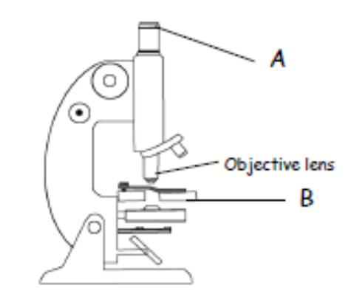
A. _________________________________________
B. _________________________________________

(b) Answer the following questions in relation to obtaining and staining a sample of plant
cells and viewing them under the microscope.

(i) From what plant did you obtain the cells?
__________________________________________________________________________
(ii) How did you obtain a thin piece of a sample of the cells and prepare it for
examination?
__________________________________________________________________________
__________________________________________________________________________
__________________________________________________________________________
__________________________________________________________________________
(iii) What stain did you use on the cells?
__________________________________________________________________________
(iv) Describe how you applied the stain.
__________________________________________________________________________
__________________________________________________________________________
__________________________________________________________________________
(v) The objective lenses on a microscope are usually labelled 40X, 10X, and 4X.
Which objective lens should you begin with when using the microscope?
__________________________________________________________________________
(vi) Give one cell structure that you observed that indicated that the cells were plant cells.
__________________________________________________________________________
Answer

2013 OL
7. (a) (i) Where in a plant cell does photosynthesis take place?.......................................................................
(ii) Name the gas released during photosynthesis…………………………………………………. …..
Answer

2.1 Cell Structure

Section C

Higher Level Questions Ordinary Level Questions

Higher Level

2009 HL
14. (c) (vi) The cells of this organism are described as eukaryotic.
Give two characteristic features of eukaryotic cells.
(vii) What corresponding term is used to describe bacterial cells?
Answer

2011 HL
14. (c) (i) State the precise location of the cell membrane in plant cells.
(ii) With what type of cell do you associate membrane-bound organelles?
(iii) What corresponding term is used to describe bacterial cells?
(iv) The cell membrane is described as being selectively permeable. What does this mean?
(v) Why is diffusion alternatively known as passive transport?
(vi) Osmosis may be described as “a special case of diffusion”. Explain why.
(vii) Describe, with the aid of a labelled diagram, how you demonstrated osmosis in the laboratory.
(viii) Name the structure by which Amoeba gets rid of excess water that has entered by osmosis.
Answer

Ordinary Level

2013 OL
13. (a) (i) Draw a labelled diagram of an animal cell as seen using a light microscope.
(ii) Name another type of microscope that gives greater detail than a light microscope. (9)

(b) The diagram below shows the ultrastructure of a section of cell membrane.

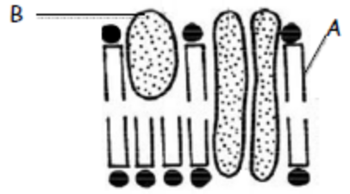

(i) Give two functions of the cell membrane.
(ii) Name the parts labelled A and B.
(iii) Which organelle is known as “the powerhouse of the cell”?
(iv) Why does the nucleus of a cell have many pores?
(v) List two differences between a plant cell and an animal cell.
(vi) What is the primary source of energy for plant cells? (27)
Answer

(c) Answer the following questions in relation to an investigation you carried out into fermentation by
yeast cells.
(i) Explain what is meant by anaerobic respiration.
(ii) Where in the cell does anaerobic respiration occur?
(iii) Describe, with the aid of a diagram, how you kept the yeast under anaerobic conditions during the
investigation.
(iv) Name the two substances produced by the yeast in the process of fermentation.
(v) How did you know that fermentation had ceased? (24)

2.2 Cell Metabolism

Need to Know

2.2.1 – 2 Cell Metabolism - Energy
2.2.3 + 2.2.7.H Enzymes
2.2.4 + 2.2.9 H Photosynthesis
2.2.5 + 2.2.10.H Respiration
2.2.6 Movement through Cell Membranes
2.2.8.H Role of ATP and NAD

At the end of this section students should be able to:

Cell Metabolism
- Define the term: metabolism.
- State that solar energy is source of energy on Earth.
- State that cellular energy sourced from chemical energy in ATP.

Enzymes
- Define the term: enzymes
- State the nature, folded shape & functions of enzymes.
- Explain the role of enzymes in plants and animals including role in metabolism
- Explain the effects of pH & temperature on enzyme activity.
- State the procedure and advantages of Bio-processing.
- State the use of Bio-processing.

- Explain the active site theory to examine enzyme function & specificity.
- Explain the term optimum activity with reference to pH.
- Explain the nature of heat denaturation

Photosynthesis
- Define the term: photosynthesis.
- Express photosynthesis as a balanced reaction.
- State the nature of photosynthesis from the syllabus – what are the main events?
- State the role & location of chlorophyll.
- Explain the nature of electron carriage.
- Identify the sources of light, CO₂ & water for photosynthesis.
- Explain how human intervention can play a role in photosynthesis.

- Explain the role of ATP
- Explain the production of ATP from ADP
- Explain the role NADP+ in trapping & transferring electrons & H ions.
- Explain the Light Stage/Dark Stage
- State the two-pathway system of electron carriage.
1. Direct to chlorophyll
2. Trapped by NADP+
- Explain the photolysis of water producing protons and electrons and releasing oxygen
- Explain what happens during the Dark stage
- Explain the regeneration of ADP and NADP+

Respiration
- Definition of the term: aerobic respiration.
- Explain the role of aerobic respiration – what does it do for organisms?
- Express aerobic respiration by a balanced equation.
- State the nature of respiration from syllabus – 2 stages, where do these take place, what happens in each, and how much energy is released
- Definition of the term: anaerobic respiration.
- Know that anaerobic respiration is a first-stage process. and the products are lactic acid or alcohol and carbon dioxide
- State the nature and role of fermentation.
- Know that aerobic respiration uses oxygen and is described as a two-stage process.
- State the cellular location of the first & second stage.
The first stage process occurs in the cytosol (the cytoplasm minus the organelles).
The second stage process occurs in the mitochondrion.
- Explain the role of microorganisms in industrial fermentation.
- Explain the role of microorganisms in bioprocessing with immobilised cells
- Explain the role of microorganisms in Bioreactors

- Describe what happens during the first stage reaction: Glycolysis
- Explain the difference in the fermentation [anaerobic conditions] option.
- Describe the second stage process – under aerobic conditions, a series of reactions occurs:
- the pyruvate molecule is broken down
- Acetyl Co. A enters Krebs Cycle
- an electron transport system removes electrons from intermediates and these are transferred to oxygen
- the energy released by these electrons is used to produce ATP

Movement Through Cell Membranes
- Define the term: Selectively permeable
- Explain the role of selectively permeable membranes.
- Define the terms: diffusion and osmosis.
- Give examples of diffusion and osmosis.
- Define the term: turgor.
- Explain turgidity in plant cells.
- Describe the application of high salt or sugar concentration in food preservation.

Role of ATP and NAD(P)
- Give the word structure of ATP
- Explain the role of ATP in the trapping and transferring of energy for cell activities
- Describe how ATP is formed from ADP + P
- Explain the role of NADP+ in trapping and transferring electrons and hydrogen ions in cell activities

PowerPoint Presentations

2.2.1 – 2 Metabolism and Sources of energy.ppt
2.2.3 Enzymes.ppt
2.2.4 Photosynthesis.ppt
2.2.5 Respiration.ppt
2.2.6 Movement through cell membranes.ppt
2.2.7.H Enzymes.ppt
2.2.8.H Role of ATP and NAD.ppt
2.2.9.H Photosynthesis.ppt
2.2.10.H Respiration.ppt

2.2 Cell Metabolism

Section A

Higher Level Questions Ordinary Level Questions

Higher Level

Ordinary Level

2010 OL
3. The diagram shows a cell.

- Is this a plant cell or an animal cell? ___________________________________________________
Give two reasons for the answer given above.
- ____________________________________________________________________________
- ____________________________________________________________________________
(b) Name the structures labelled A, B and C in the diagram.
A. _________________________________________________
B. _________________________________________________
C. _________________________________________________
(c) Name a substance found in A. ________________________________________________________
Answer

2012 OL
1. A student brings a tuna and sweetcorn sandwich, an apple and a bag of crisps for her lunch.
(a) What food in the student’s lunch is:
(i) a good source of protein?_______________________________________________________
(ii) a good source of fat? __________________________________________________________
(b) Vitamins form part of a healthy diet and prevent many disorders.
(i) Name one water-soluble vitamin. ________________________________________________
(ii) Suggest one food in the lunch that contains the water-soluble vitamin you have named.
__________________________________________________________________________________
(c) Name one structural protein in humans. __________________________________________________
(d) Give one function of fat in the human body. ______________________________________________
(e) What term is used to describe all the chemical reactions in the human body? ____________________
Answer

2012 OL
3. Indicate whether each of the following statements is true (T) or false (F) by drawing a circle around T or F in
each case.
Example: DNA is a double helical shape. T F
(a) The base Uracil is found in DNA. T F
(b) Chloroplasts contain DNA. T F
(c) The microscope lenses closest to the stage are the eyepiece lenses. T F
(d) Sodium alginate is used to immobilise enzymes. T F
(e) Plant cell walls are fully permeable. T F
(f) Animal cells do not have membranes. T F
(g) An organ is a group of systems. T F
Answer

Enzymes
Higher Level Questions Ordinary Level Questions

Higher Level

SEC Sample Paper HL
2. Select the correct term from the following list to match each of the terms in column A and write it in
column B.

protein, enzyme, uracil, sap, ethanol, mutation, thymine, chlorophyll.

A | B
DNA
Ribosome
Vacuole
Fermentation
RNA
Active Site
Variation
Possible Answer

2004 HL
1. (b) Give an example of a catabolic reaction ………………
Answer

2006 HL
3. The graph shows how the rate of reaction of a carbohydrate-digesting enzyme in the human alimentary canal varies with pH.
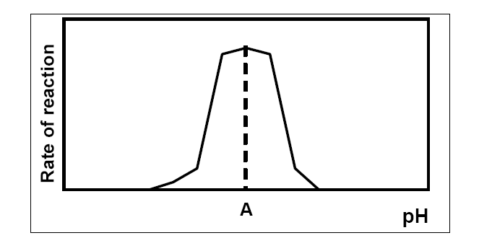
(a) Name a carbohydrate-digesting enzyme in the human alimentary canal ………………
(b) Where in the alimentary canal does this enzyme act? ……………………………….….
(c) State the enzyme’s product (s) …………………………………………………………..
(d) What is the pH at A? ……………………………………………………………………
(e) A is said to be the enzyme’s ………………………….pH
(f) Suggest a temperature at which human enzymes work best ……..……………………..
(g) What term best describes the shape of an enzyme? …………………………….………
Answer

2013 HL
1. In the case of any five of the following pairs of terms, clearly distinguish between the first term and second
term by writing a brief sentence about each.
(d) Enzymes. _______________________________________________________________________
Hormones. ______________________________________________________________________
Answer

Ordinary Level

2004 OL
3. Indicate whether each of the following statements is true (T) or false (F) by drawing a circle around T or F.

Example: The pulmonary artery carries blood to the lungs T F

Mitosis is the division of a nucleus into two identical nuclei T F
A sperm contains the haploid number of chromosomes T F
Chromosomes are made of DNA and lipid T F
Organisms of the same species can usually produce fertile offspring T F
Aerobic respiration is the release of energy in the absence of oxygen T F
RNA is not found in ribosomes T F
Immobilised enzymes can act as catalysts T F
Answer

2013 OL
5. Choose each term from the following list and place it in Column B to match a description in
Column A. The first one has been completed as an example.
List: Amylase; Temperature; Substrate; Immobilised; Reusable; Protein.

Column A | Column B
An example of an enzyme. | Amylase
(a) The group of biomolecules to which enzymes belong.
(b) Enzyme activity is affected by this.
(c) Enzymes trapped in an inactive material.
(d) The substance with which an enzyme reacts.
(e) Advantage of using immobilised enzymes.
Answer

Photosynthesis
Higher Level Questions Ordinary Level Questions

Higher Level

2005 HL
4. The following graph shows how the rate of photosynthesis varied when a plant was subjected
to varying levels of light intensity or carbon dioxide concentration.
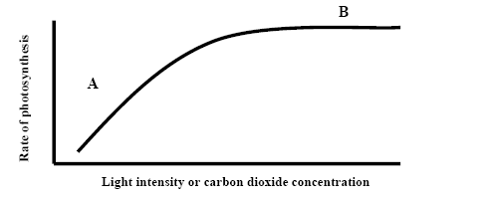
(a) What is happening at A? …………………………………….
(b) What is happening at B? ………………………………………
(c) Suggest a reason for your answer in (b) ……………...…………
(d) Where in a cell does photosynthesis take place? ……………
(e) Give two sources of the carbon dioxide that is found in the atmosphere.
(i) ………………………..…………………………………………………………
(ii) ……………..……………………………………………………………………
(f) Suggest one way in which the rate of photosynthesis of plants in a greenhouse could
be increased…………………………………………………..
Answer

Ordinary Level

2006 OL
4. The diagram shows part of a section through a leaf.
[Adapted from Livingstone © BIODIDAC]

(a) Use the letter A to show a point of entry of carbon dioxide.
Name this point …………..………………………………………………………………...
(b) Name a gas that leaves the leaf at this point ………………………………………………..
(c) Use the letter B to show the part of the leaf in which most photosynthesis occurs.
(d) Name the structures in plant cells in which photosynthesis occurs. ………………………...
(e) In addition to carbon dioxide another small molecule is needed for photosynthesis.
Name this other molecule …………………………………………………..………………..
Answer

2010 OL
6. The diagram below shows the internal structure of a leaf.
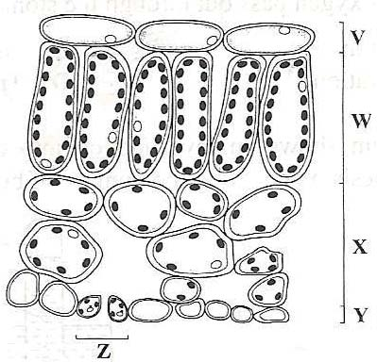

(i) Name the one tissue type that is found at both V and Y. _________________________________________________________________________________
(ii) The cells at W contain many organelles that carry out photosynthesis.
Suggest why the cells at W contain more of these organelles than the cells at X.
_________________________________________________________________________________ _________________________________________________________________________________
(iii) In layer X, gases can diffuse throughout the leaf. Name one such gas. ________________________________________________________________
(iv) State one function of the opening at Z. _________________________________________________________________________________
(v) Name the cells which are responsible for controlling the size of the opening at Z. _________________________________________________________________________________
Answer

Respiration
Higher Level Questions Ordinary Level Questions

Higher Level

SEC Sample Paper HL
2. Select the correct term from the following list to match each of the terms in column A and write it in
column B.

protein, enzyme, uracil, sap, ethanol, mutation, thymine, chlorophyll.

A | B
DNA
Ribosome
Vacuole
Fermentation
RNA
Active Site
Variation
Possible Answer

2006 HL
4. (a) What is the first stage process of respiration called? ……………………………
(b) In this first stage there is a release of ATP as glucose is converted to another substance.
Name this other substance ……………………………………….
(c) To what is the substance you have named in (b) converted under anaerobic conditions in:
1. Yeast? ……………….……………………..
2. A human muscle cell?………………………
(d) Under aerobic conditions the substance that you have named in (b) is converted to an acetyl
group and in the process a small molecule is released.
Name this small molecule. ………………………………………………….
(e) The acetyl group now enters a cycle of reactions.
What name is given to this cycle?...........................................................................
(f) Where in the cell does this cycle take place? ……………………......................
Answer

2008 HL
5. (a) Write a balanced equation on the line below to represent aerobic respiration.
……………………………………………………………………………………………………….
(b) The first stage of respiration takes place in the cytosol. What is the cytosol?
……………………………………………………………………………………………………….
(c) Does the first stage of respiration release a small or large amount of energy? ……………………….
(d) What is fermentation? …………………………………………………………………………………
…………………………………………………………………………………………………………
(e) Where in the cell does the second stage of aerobic respiration take place?..………………………….
(f) Is oxygen required for the second stage of aerobic respiration? ……………………………………..
(g) Suggest a situation in which some cells in the human body may not be able to engage in the second stage of aerobic respiration…………………………………………..…………………………………………
Answer

2011HL
6. Cellular respiration may occur in one stage or two stages.
(a) Give two differences, other than location, between Stage 1 and Stage 2.
(i) ______________________________________________________________________________
(ii) _____________________________________________________________________________
(b) Where in a cell does Stage 1 occur?
________________________________________________________________________________
(c) What term is used to describe respiration in which only Stage 1 occurs?
________________________________________________________________________________
(d) Name a chemical end product of the type of respiration referred to in (c).
________________________________________________________________________________
(e) In Stage 2 of respiration electrons pass along an electron transport chain, releasing energy. In what
molecule is this energy stored in the cell?
________________________________________________________________________________
(f) To what are these electrons transferred at the end of the electron transport chain?
________________________________________________________________________________
Answer

Ordinary Level

2004 OL
3. Indicate whether each of the following statements is true (T) or false (F) by drawing a circle around T or F.

Mitosis is the division of a nucleus into two identical nuclei T F
A sperm contains the haploid number of chromosomes T F
Chromosomes are made of DNA and lipid T F
Organisms of the same species can usually produce fertile offspring T F
Aerobic respiration is the release of energy in the absence of oxygen T F
RNA is not found in ribosomes T F
Immobilised enzymes can act as catalysts T F
Answer

2008 OL
3. Indicate whether the following are true (T) or false (F) by drawing a circle around T or F.
Example: Carbon dioxide is produced during respiration. T F
(a) Stage 1 of respiration requires oxygen T F
(b) Stage 1 of respiration takes place in the cytoplasm T F
(c) Stage 2 of respiration also takes place in the cytoplasm T F
(d) Some of the energy released in respiration is lost as heat T F
(e) Lactic acid is a product of anaerobic respiration T F
Answer

2011 OL
5. Choose each term from the following list and place it in Column B to match a description in
Column A. The first one has been completed as an example.

Alcohol, Oxygen, Water, Mitochondria, Lactic acid, Large

Column A | Column B
The amount of energy released in aerobic respiration. | Large
(i) A substance required for aerobic respiration.
(ii) A product of anaerobic respiration in muscles.
(iii) A product of aerobic respiration.
(iv) A product of anaerobic respiration in yeast.
(v) The cell structures in which Stage 2 of aerobic respiration
takes place.
Answer

Movement through cell membranes
Higher Level Questions Ordinary Level Questions

Higher Level

2013 HL
5. (a) (i) In relation to structures such as the cell membrane, explain the term selective permeability.
____________________________________________________________________________
(ii) Suggest an advantage to the cell of having a selectively permeable membrane.
____________________________________________________________________________
(iii) Name two substances that enter a human muscle cell by diffusion.
____________________________________________________________________________

(b) (i) Explain the term turgor.
____________________________________________________________________________
(ii) Give a feature of a plant cell that allows it to remain turgid for long periods.
____________________________________________________________________________
(iii) Suggest a way in which turgor is of value to plants.
____________________________________________________________________________
Answer

Ordinary Level

2.2 Cell Metabolism

Section B

Higher Level Questions Ordinary Level Questions

Higher Level

Ordinary Level

Enzymes
Higher Level Questions Ordinary Level Questions

Higher Level

SEC Sample Paper HL
7. (a) To which group of molecules do enzymes belong? ………………………………………………
What is a denatured enzyme? ……………………………………………………………………..
(b) Answer the following by reference to an experiment that you carried out to investigate the effect of pH on the rate of enzyme action.
Name the enzyme and substrate that you used. ……………………………………………………….
Draw a labelled diagram of the apparatus that you used.

Explain how you varied the pH. .…….………………………………………………………
………..………………………………………………………..……………………………….
State one factor that you kept constant in this experiment. …...……………………………..
How did you ensure that this factor was kept constant? ……….……………………………
……….…………………………………………………………………………………………
Label the axes and draw a graph of the results that you obtained.


Possible Answer

2005 HL
7. (a) Immobilised enzymes are sometimes used in bioreactors.
(i) What is a bioreactor? ………………………………………………………………………………
(ii) State one advantage of using an immobilised enzyme in a bioreactor. …………………………………………………………………………………….………………
(b) Answer the following questions in relation to an experiment that you carried out to immobilize an enzyme and use that immobilised enzyme.
(i) Name the enzyme that you used ………………………………………………………………..…
- Draw a labelled diagram of the apparatus that you used to immobilise the enzyme.

- Describe how you used this apparatus to immobilise the enzyme. In your answer name the solutions that you used and explain their purpose.
…………………………………………………………………………………..………………………
…………………………………………………………………………………………………………………………………………………………………………………………………………………………………………………………………………………………………………………………………………………………………………………………………………………………………………………..
(iv) Describe briefly how you used the immobilised enzyme.
…………………………………………………………………………………………………………………………………………………………………………………………………………………………………………………………………………………………………………………………………………………………………………………………………………………………………………………..
Answer

2007 HL
7. (a) (i) What is meant by an enzyme? ……………………….………………………………..
…………………………………………………………………………………………
(ii) Give an example of a protein that has a structural role. ……………………………....

(b) Answer the following questions in relation to an investigation that you carried out to determine the effect of temperature on enzyme action.
(i) Name the enzyme that you used. ………………………………………………………..
(ii) Name the substrate of the enzyme. ………………………………………………..……
- State one factor that you kept constant during the investigation ………….…………..
…………………………………………………………………………………………
- How did you keep this factor constant?
…………………………………………………………………………………………………
…………………………………………………………………………………………………
…………………………………………………………………………………………………
- How did you vary the temperature? ……………………………………………………
…………………………………………………………………………………………………
…………………………………………………………………………………………………
…………………………………………………………………………………………………
………………………………………………………………………………………………
- How did you measure the rate of activity of the enzyme? ………………………..…
…………………………………………………………………………………………………
…………………………………………………………………………………………………
…………………………………………………………………………………………………
…………………………………………………………………………………………………
…………………………………………………………………………………………………
…………………………………………………………………………………………………

- What was the result of your investigation?
…………………………………………………………………………………………………
…………………………………………………………………………………………………
…………………………………………………………………………………………………
…………………………………………………………………………………………………
Answer

2008 HL
9. (a) (i) What is meant by an enzyme’s optimum pH? ………………………………………………..
…………………………………………………………………………………………………
(ii) What is a denatured enzyme?....……………………………………………………………….
…………………………………………………………………………………………………
…………………………………………………………………………………………………

(b) In the course of your studies you investigated the effect of denaturation by heat application on the
activity of an enzyme.
(i) Name the enzyme that you used………………………………………………………………
(ii) What substrate did you use? ………………………………………………………………….
(iii) Describe how you carried out the investigation. In your answer you must refer to the way that you measured the enzyme’s activity..…………………………………………………...............
…………………………………………………………………………………………………………
…………………………………………………………………………………………………………
…………………………………………………………………………………………………………
……….………………………………………………………………………………………………...
..………………………………………………………………………………………………………..
…………………………………………………………………………………………………………
…………………………………………………………………………………………………………
…………………………………………………………………………………………………………
…………………………………………………………………………………………………………
…………………………………………………………………………………………………………
…………………………………………………………………………………………………………
…………………………………………………………………………………………………………
…………………………………………………………………………………………………………
…………………………………………………………………………………………………………
…………………………………………………………………………………………………………
…………………………………………………………………………………………………………
…………………………………………………………………………………………………………
…………………………………………………………………………………………………………
…………………………………………………………………………………………………………
…………………………………………………………………………………………………………
(iv) State the results that you obtained.
…………………….……………………………………………………………………...……………
………………………………………………………………………………………………...……….
…………………………………………………………………………………………………………
…………………………………………………………………………………………………………
…………………………………………………………………………………………………………
…………………………………………………………………………………………………………
…………………………………………………………………………………………………………
Answer

2009 HL
9. (a) (i) To which group of biomolecules do enzymes belong? ______________________________
(ii) Name a factor that influences the activity of an enzyme.
__________________________________________________________________________
(b) In the course of your practical investigations you prepared an enzyme immobilisation.
Answer the following questions in relation to that investigation.
- Describe how you carried out the immobilisation.
__________________________________________________________________________
__________________________________________________________________________
__________________________________________________________________________
__________________________________________________________________________
__________________________________________________________________________
__________________________________________________________________________
(ii) In the space provided draw a labelled diagram of the apparatus that you used to investigate
the activity of the immobilised enzyme.

(iii) Briefly outline how you used the apparatus referred to in (b) (ii) above.
__________________________________________________________________________
__________________________________________________________________________
__________________________________________________________________________
__________________________________________________________________________
__________________________________________________________________________
__________________________________________________________________________
Answer

2011 HL
8. (a) State a use for each of the following in the biology laboratory:
(i) Buffer solution. ____________________________________________________________
(ii) Biuret test. ________________________________________________________________
Answer

2012 HL
9. (a) Answer the following in relation to enzymes.
(i) What is their chemical nature? _________________________________________________
(ii) Comment upon their molecular shape. ___________________________________________

(b) Answer the following in relation to an investigation that you carried out into the effect of
temperature on the rate of enzyme action.
(i) Name the enzyme that you used.
________________________________________________________________________________
(ii) Name the substrate of this enzyme.
________________________________________________________________________________
(iii) Why was it necessary to keep the pH constant in the course of the investigation?
________________________________________________________________________________
(iv) How did you keep the pH constant?
________________________________________________________________________________
(v) How did you vary the temperature in the course of the investigation?
________________________________________________________________________________
(vi) How did you know that the enzyme was working?
________________________________________________________________________________
(vii) Use the axes below to summarise the results of your investigation.
Do this by
1. labelling the axes,
2. drawing a graph to show how the rate of enzyme action varied with temperature.


Answer

2013 HL
8. (a) (i) What term is used for the substance(s) that result(s) from the action of an enzyme on its
substrate? _______________________________________________________________________
(ii) In relation to an enzyme, explain the term optimum activity.
________________________________________________________________________________

(b) Answer the following in relation to an activity that you carried out to investigate the effect of
heat denaturation on the activity of an enzyme.
(i) Name the enzyme and the substrate that you used.
Enzyme. _________________________________________________________________________
Substrate. ________________________________________________________________________
(ii) Describe how you carried out the investigation.
In your description outline how you measured the activity of the enzyme.
________________________________________________________________________________
________________________________________________________________________________
________________________________________________________________________________
________________________________________________________________________________
________________________________________________________________________________
(iii) Using suitably labelled axes, draw a graph of the results that you obtained.

Answer

Ordinary Level

SEC Sample Paper OL
7. (a) What is an enzyme? …………………………………………………..……………………………….
What name is given to the substance that an enzyme acts on? ……………..…………………………

(b) Answer the following questions about an experiment that you carried out to investigate the effect of
temperature on the rate of action of an enzyme.
Name an enzyme that you used ………………………………………………………………………
Name the substance that this enzyme acted on ……………………………………………………….
Draw a labelled diagram of the apparatus that you used.

How did you vary the temperature?
………………………………………………………………………………………………….…………………………………………………………………………………………………………………………………………………………………………………………………………………………………………………………………………………………………………………………………………………………………………………………………………………………………………..….
How did you measure the rate of the enzyme’s action?
……………………………………………………………………………………………………………………………………………………………………………………………………………………………………………………………………………………………………………………………………………………………………………………………………………………………………………………………………………………………………………………………………………………
Possible Answer

2005 OL
8. (a) (i) What is an enzyme? ……………………………………………………………………………
……….………………………………………………………………………………………….
(ii) Comment on the shape of enzyme molecules. ………….……………………………………..
………………………………………………………………………………………………….

(b) Answer the following questions in relation to an experiment that you carried out to investigate the effect of temperature on enzyme activity.
(i) What enzyme did you use? ……………………………………………………………………
(ii) What substrate did you use? …………………………………………………………………..
(iii) Draw a labelled diagram of the apparatus that you used.

(iv) How did you know that the enzyme had completed its activity?
………………………………………………………………………………………………..
………………………………………………………………………………………………..
(v) How did you vary the temperature in your experiment?
………………………………………………………………………………………………..
………………………………………………………………………………………………..
(vi) Draw an outline graph of the results that you obtained.

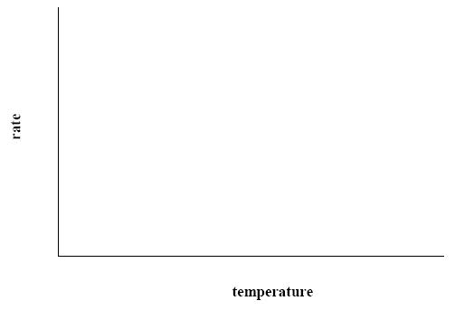
Answer

2007 OL
7. (a) (i) Is an enzyme a lipid, a protein or a carbohydrate? …………………………………………...
(ii) Where in a cell are enzymes produced? ………………………………………………

(b) As part of your practical activities you investigated the effect of temperature on the rate of
activity of an enzyme.
(i) Name the enzyme that you used ……………………………………………………………
(ii) Name the substrate with which the enzyme reacts …………………………………………
(iii) How did you vary the temperature? ………………………..…………………....................
……………………………......................………………………………………………….
……………………………......................………………………………………………….
……………………………......................………………………………………………….
……………………………………………………………………………………………...
(iv) How did you keep a constant pH during the investigation?
……………………………......................…………………………………………………
……………………………......................…………………………………………………
……………………………………………………………………………………………..
(v) How did you measure the rate of activity of the enzyme?
……………………………......................…………………………………………………
……………………………......................…………………………………………………
……………………………......................…………………………………………………
……………………………………………………………………………………………..
……………………………………………………………………………………………..
……………………………………………………………………………………………..
……………………………………………………………………………………………..
(vi) What was the result of your investigation?
……………………………......................…………………………………………………
……………………………......................…………………………………………………
……………………………......................…………………………………………………
……………………………......................…………………………………………………
……………………………......................…………………………………………………
Answer

2010 OL
8. (a) (i) What is an enzyme? __________________________________________________________
(ii) Explain what is meant by the term pH. ___________________________________________
__________________________________________________________________________

(b) Answer the following questions in relation to your investigation into the effect of pH on the rate of
enzyme activity.
(i) Name the enzyme you used in this investigation. ____________________________________
(ii) Name
1. The substrate of this enzyme. _________________________________________________
2. The product of this enzyme. __________________________________________________
(iii) Draw a labelled diagram of the apparatus you used in your investigation

(iv) How did you vary the pH? _____________________________________________________
___________________________________________________________________________
(v) Name one factor you kept constant. _____________________________________________
(vi) How did you keep the named factor constant? _____________________________________
___________________________________________________________________________
(vii) Draw a graph, on the axes given below, to show the results of this investigation.

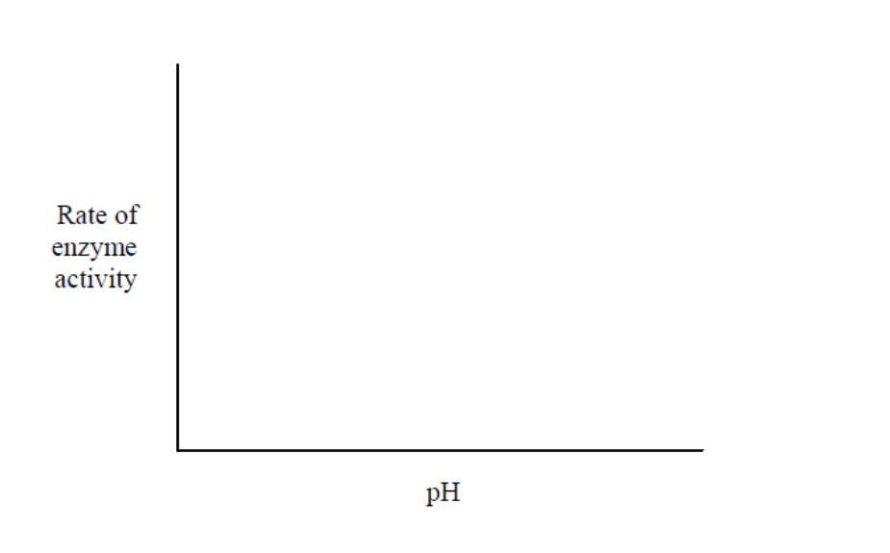
Answer

2011 OL
8. (b) For what purpose did you use each of the following in the course of your practical
activities?

(i) Fehling’s solution or Benedict’s solution.
Purpose. _________________________________________________________________
(ii) Anaerobic jar.
Purpose. _________________________________________________________________
(iii) Cover slip.
Purpose. _________________________________________________________________
(iv) Buffer solution.
Purpose. _________________________________________________________________
(v) Methylene blue.
Purpose. _________________________________________________________________
(vi) Sodium alginate.
Purpose. _________________________________________________________________
(vii) IAA.
Purpose. _________________________________________________________________
(viii) Freezer-cold alcohol.
Purpose. _________________________________________________________________
Answer

2012 OL
8. (a) (i) What is an enzyme? _____________________________________________________________
(ii) On what structures in the cytoplasm are enzymes made? ________________________________

(b) Answer the following questions in relation to an investigation that you carried out into the effect of
temperature on the rate of activity of an enzyme.
(i) What enzyme did you use? _______________________________________________________
(ii) What substrate did you use? ______________________________________________________
(iii) How did you vary the temperature during the investigation?_____________________________
_____________________________________________________________________________
_____________________________________________________________________________
(iv) How did you measure the rate of enzyme activity? ____________________________________
_____________________________________________________________________________
_____________________________________________________________________________
(v) During this investigation pH was kept constant. How did you keep the pH constant?
_____________________________________________________________________________
_____________________________________________________________________________
(vi) What was the result of your investigation?
_____________________________________________________________________________
_____________________________________________________________________________
_____________________________________________________________________________
Answer

Photosynthesis
Higher Level Questions Ordinary Level Questions

Higher Level

2007 HL
9. (a) State a precise role for each of the following in photosynthesis:
(i) Carbon dioxide ………………………………………………………………………………..
…………………………………………………………………………………………………
…………………………………………………………………………………………………
(ii) Water ………………………………………………………………………………………….
…………………………………………………………………………………………………
…………………………………………………………………………………………………

(b) Answer the following questions in relation to an activity that you carried out to investigate the influence of light intensity OR carbon dioxide concentration on the rate of photosynthesis.
(i) Name the plant that you used. …………………………………………………………………
(ii) How did you vary light intensity OR carbon dioxide concentration?
…………………………………………………………………………………………………
…………………………………………………………………………………………………
…………………………………………………………………………………………………
(iii) State a factor that you kept constant during the investigation.
…………………………………………………………………………………………………
(iv) How did you ensure that the factor that you mentioned in (iii) remained constant?
…………………………………………………………………………………………………
…………………………………………………………………………………………………
…………………………………………………………………………………………………
(v) How did you measure the rate of photosynthesis? ……………………………………………
…………………………………………………………………………………………………
…………………………………………………………………………………………………
…………………………………………………………………………………………………
…………………………………………………………………………………………………
…………………………………………………………………………………………………
…………………………………………………………………………………………………
(vi) Using labelled axes, sketch a graph to show how the rate of photosynthesis varied with the factor mentioned in (ii) above.
Answer

2010 HL
8. (b) For which purpose did you use each of the following in the course of your practical studies?
(i) Methylene blue or iodine solution when examining cells with the microscope.
…………………………………………………………………………………………………
(ii) An aquatic plant such as pondweed rather than a terrestrial plant when investigating the rate
of photosynthesis.
…………………………………………………………………………………………………
(iii) 1. Washing-up liquid or other detergent while extracting DNA from plant tissue.
…………………………………………………………………………………………………
2. Freezer-cold ethanol while extracting DNA from plant tissue.
…………………………………………………………………………………………………
(iv) 1. Antiseptic wash solution in the investigation of the growth of leaf yeast on agar plates.
…………………………………………………………………………………………………
2. Petroleum jelly in the investigation of the growth of leaf yeast on agar plates.
…………………………………………………………………………………………………
(v) 1. Biuret solution or alkaline copper sulphate in food testing.
…………………………………………………………………………………………………
2. Brown paper or Sudan III in food testing.
…………………………………………………………………………………………………
Answer

2013 HL
9. (a) (i) Explain the importance of double-blind testing in scientific experimentation.
________________________________________________________________________________
(ii) How does a hypothesis differ from a theory?
________________________________________________________________________________

(b) Answer the following in relation to investigations that you carried out in the course of your
practical studies.
(i) When investigating the effect of either carbon dioxide concentration or light intensity
on the rate of photosynthesis:
1. How did you vary your chosen factor?
__________________________________________________________________________
2. Using suitably labelled axes, draw a graph of the results that you obtained.

Answer

Ordinary Level

2013 OL
7. (a) (i) Where in a plant cell does photosynthesis take place?.......................................................................
(ii) Name the gas released during photosynthesis…………………………………………………. …..
(b) Answer the following questions in relation to an investigation that you carried out to study the effect
of light intensity or carbon dioxide concentration on the rate of photosynthesis.
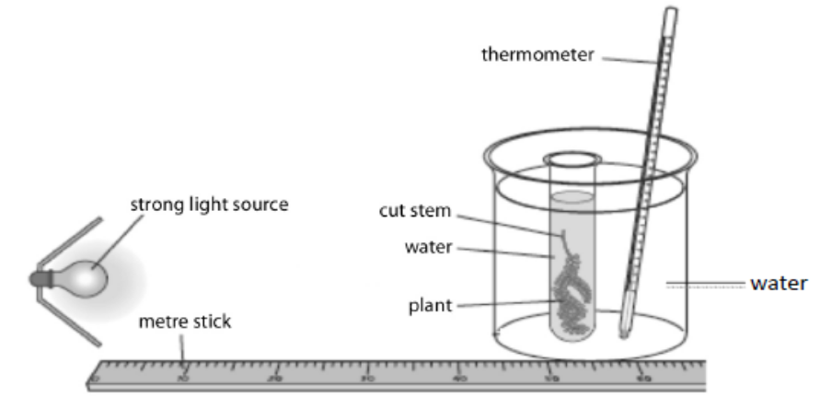
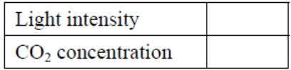
Tick the factor you will refer to.

(i) Name the plant that you used.....................................................................................................................
(ii) How did you vary the light intensity or the carbon dioxide concentration?
....................................................................................................................................................................
(iii) Name one factor that you kept constant during the investigation.
....................................................................................................................................................................
(iv) How did you keep that factor constant?
....................................................................................................................................................................
(v) How did you measure the rate of photosynthesis?
....................................................................................................................................................................
....................................................................................................................................................................
(vi) What was the result of your investigation?
....................................................................................................................................................................
....................................................................................................................................................................

Respiration
Higher Level Questions Ordinary Level Questions

Higher Level

2004 HL
7. (a) Yeast cells produce ethanol (alcohol) in a process called fermentation.
Is this process affected by temperature? …………………………………….……………………..
Explain your answer ……………………………………………………….………………………
………………………………………………………………………………………………………
………………………………………………………………………………………………………
……………………………………....................................................................................................
(b) Answer the following in relation to an experiment to prepare and show the presence of ethanol using yeast.
Draw a labelled diagram of the apparatus that you used.

Name a substance that yeast can use to make ethanol. ………………………………………………………………………………………………………………………………………………………………………………………………
What substance, other than ethanol, is produced during fermentation? ………………………………………………………………………………………………
Describe the control that you used in this experiment. ………………………………………………………………………………………………………………………………………………………………………………………………………………………………………………………………………………………………
Explain the purpose of a control in a scientific experiment. ………………………………………………………………………………………………………………………………………………………………………………………………………………………………………………………………………………………………
How did you know when the fermentation was finished? ………………………………………………………………………………………………………………………………………………………………………………………………………………………………………………………………………………………………
Why were solutions of potassium iodide and sodium hypochlorite added to the reaction vessels after a certain period of time? ……………………………………….
Name a substance produced during aerobic respiration that is not produced during fermentation. ………………………………………..
Answer

2006 HL
7. (b) In the case of each of the following state:
1. An investigation in which you used it,
2. The precise purpose for its use in the investigation that you have indicated.

(iv) Alkaline pyrogallol or anaerobic jar
1…………………….……………………………………………………………
2………………..…………………………...........................................................
Answer

2012 HL
7. (a) In relation to the scientific method, explain each of the following:
(i) Data. _____________________________________________________________________
(ii) Replicates. ________________________________________________________________
(b) Answer the following by reference to some of the investigations that you carried out in the course of
your studies.
(i) How did you expose the semi-lunar valves when dissecting the sheep’s or ox’s heart?
________________________________________________________________________________
(ii) How did you show that alcohol was present when investigating the production of alcohol by
yeast?
________________________________________________________________________________
________________________________________________________________________________
(iii) What type of agar plates did you use when investigating the digestive activity of seeds?
________________________________________________________________________________
(iv) How did you demonstrate that digestive activity had taken place in the investigation referred
to in part (iii)?
________________________________________________________________________________
________________________________________________________________________________
(v) How did you demonstrate the requirement for oxygen when investigating the factors
necessary for seed germination?
________________________________________________________________________________
________________________________________________________________________________
(vi) What did you use as the selectively permeable membrane in your investigation of
osmosis?
________________________________________________________________________________
(vii) What growth regulator did you use when investigating plant growth?
________________________________________________________________________________
(viii) A microscope has an eyepiece lens marked ×10 and an objective lens marked ×20.
What is the total magnification of the image?
________________________________________________________________________________
Answer

Ordinary Level

Movement through cell membranes
Higher Level Questions Ordinary Level Questions

Higher Level

2012 HL
7. (a) In relation to the scientific method, explain each of the following:
(i) Data. _____________________________________________________________________
(ii) Replicates. ________________________________________________________________
(b) Answer the following by reference to some of the investigations that you carried out in the course of
your studies.
(i) How did you expose the semi-lunar valves when dissecting the sheep’s or ox’s heart?
________________________________________________________________________________
(ii) How did you show that alcohol was present when investigating the production of alcohol by
yeast?
________________________________________________________________________________
________________________________________________________________________________
(iii) What type of agar plates did you use when investigating the digestive activity of seeds?
________________________________________________________________________________
(iv) How did you demonstrate that digestive activity had taken place in the investigation referred
to in part (iii)?
________________________________________________________________________________
________________________________________________________________________________
(v) How did you demonstrate the requirement for oxygen when investigating the factors
necessary for seed germination?
________________________________________________________________________________
________________________________________________________________________________
(vi) What did you use as the selectively permeable membrane in your investigation of
osmosis?
________________________________________________________________________________
(vii) What growth regulator did you use when investigating plant growth?
________________________________________________________________________________
(viii) A microscope has an eyepiece lens marked ×10 and an objective lens marked ×20.
What is the total magnification of the image?
________________________________________________________________________________
Answer

2013 HL
9. (a) (i) Explain the importance of double-blind testing in scientific experimentation.
________________________________________________________________________________
(ii) How does a hypothesis differ from a theory?
________________________________________________________________________________

(b) Answer the following in relation to investigations that you carried out in the course of your
practical studies.
(ii) When demonstrating osmosis:
1. For what purpose did you use Visking tubing, potato tissue or some similar material?
__________________________________________________________________________
2. At the end of the demonstration, how did you conclude that osmosis had occurred?
__________________________________________________________________________
Answer

Ordinary Level

2005 OL
7. (a) (i) What is osmosis? ….……………………………………………………………………………
………..…………………………………………………………………………………………
(ii) What is a selectively permeable (semi-permeable) membrane? ……………………………….
…………………….…………………………………………………….………………………
(b) (i) Draw a labelled diagram of the apparatus that you used to demonstrate osmosis.

(ii) Describe how you carried out the experiment to demonstrate osmosis.
………………………………………………………………………………………………….…………………………………………………………………………………………………….…………………………………………………………………………………………………….…………………………………………………………………………………………………….…………………………………………………………………………………………………….…………………………………………………………………………………………………….…………………………………………………………………………………………………………………………………………………………………………………………………………………………………………………………………………………………………………………………………………………………………………………………………………………………………………………………………………..………………….
(iii) How were you able to tell that osmosis had taken place?
……………………………………………………………………………………………………..………………………………………………………………………………………………………………………………..……………………………………….……………………………………………………
Answer

2009 OL
8. (a) (i) Define the term osmosis. ___________________________________________________
________________________________________________________________________
(ii) Give an example of osmosis in plants. ________________________________________
_______________________________________________________________________
(b) Answer the following questions in relation to practical work you carried out to investigate osmosis.
(i) In the space below draw a labelled diagram of the apparatus you used in the investigation.

(ii) Describe how you used this apparatus to carry out the investigation.
_______________________________________________________________________
_______________________________________________________________________
_______________________________________________________________________
_______________________________________________________________________
_______________________________________________________________________
(iii) State the result(s) of your investigation.
_______________________________________________________________________
_______________________________________________________________________
(iv) Briefly explain the result(s) you have given in part (iii).
_______________________________________________________________________
_______________________________________________________________________
_______________________________________________________________________
Answer

2013 OL
8. (a) (i) Which substance moves through cell membranes by osmosis?
..............................................................................................................................................................
(ii) Name one other term used in biology to describe the movement of substances through cell
membranes.
...............................................................................................................................................................
(b) Answer the following in relation to an activity you carried out to demonstrate osmosis.
(i) In the space below, draw a labelled diagram of the apparatus you used in your demonstration.

(ii) Suggest a control that you might use in this activity.
...............................................................................................................................................................
...............................................................................................................................................................
(iii) State the result(s) of your investigation.
...............................................................................................................................................................
...............................................................................................................................................................
...............................................................................................................................................................
...............................................................................................................................................................
(iv) Briefly explain the result(s) referred to in part (iii).
…………………………………………………………………………………………………...……
………………………………………………………………………………………………...………
(v) What is the purpose of a control in scientific experiments?
………………………………………………………………………………………………...………
……………………………………………………………………………………………...…………
Answer

2.2 Cell Metabolism

Section C

Higher Level Questions Ordinary Level Questions

Higher Level

2007 HL
11. (a) (i) For what is ATP an abbreviation?
(ii) What is the role of ATP in cells?
Answer

2009 HL
12. (a) ATP and NAD / NADP+ play important roles in cell activities.
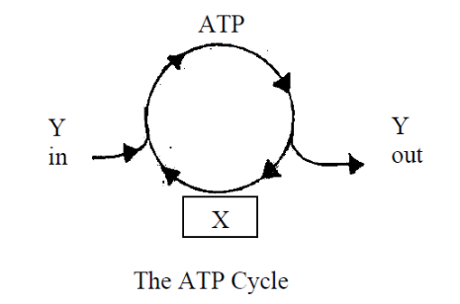

(i) Name the substance X, formed by the loss of a phosphate group.
(ii) The ATP cycle is kept going by Y. What is Y?
(iii) Suggest a role for NAD / NADP+ in cell activities. (9)
Answer

Ordinary Level

2009 OL
12. (b) (v) Some bacteria are anaerobic. What does this mean?
Answer

Enzymes
Higher Level Questions Ordinary Level Questions

Higher Level

2007 HL
11 (c) Enzymes can be immobilised and then used in bioprocessing.
(i) What is meant by immobilisation?
(ii) Name a substance that is used to immobilise enzymes.
(iii) Give two advantages of using immobilised enzymes.
(iv) Give one application of a named immobilised enzyme. In your answer, refer to substrate, enzyme and product. (24)
Answer

2010 HL
14. Answer any two of (a), (b), (c). (30, 30)
(b) (i) What is an enzyme?
(ii) What is meant by the specificity of an enzyme?
(iii) Explain how the Active Site Theory may be used to explain the specificity of enzymes.
(iv) Bioprocessing often involves the use of immobilised enzymes in a bioreactor.
- What does the term immobilisation refer to when used about enzymes?
- Explain the term bioreactor.
(v) Give one example of the use of immobilised enzymes in bioreactors.
In your answer name the enzyme, the substrate and the product.
Answer

2011 HL
14. (b) (i) What is meant by the term metabolism?
(ii) “Enzymes are essential for metabolism”.
Explain why this statement is true.
(iii) In each of the following cases state whether the process is anabolic or catabolic.
1. Protein synthesis.
2. Conversion of ADP to ATP.
3. Reactions in which product molecules are larger than substrate molecules.
(iv) State one way by which an enzyme may be denatured.
(v) Give two features of a denatured enzyme.
(vi) Apart from carbon, hydrogen and oxygen, there is one other element always present in the
building blocks of enzymes. Name that element.
Answer

Ordinary Level

2004 OL
13. (a) What is metabolism? Describe briefly the part played by enzymes in metabolism. (9)
Answer

2009 OL
15. (c) (i) To what group of biomolecules do enzymes belong?
(ii) Name the small molecules which are the building blocks for these biomolecules.
(iii) The action of the enzyme amylase on its substrate starch is an example of a catabolic
reaction. Explain each of the underlined terms.
(iv) What is meant by immobilisation of an enzyme?
(v) Describe how you immobilised an enzyme in the course of your practical work.
(vi) Give one advantage of bioprocessing using an immobilised enzyme.
(vii) Suggest one reason why enzymes are not found in body soap or shampoo.
Answer

2011 OL
12. (c) Enzymes are used in many processes in both plants and animals.
(i) What is an enzyme?
(ii) Name any one enzyme, and its substrate, and its product.
(iii) The rate of activity of enzymes can be affected by various factors.
Name any two factors that can affect enzyme activity.
(iv) Enzymes are sometimes immobilised in industrial processes.
What is meant by the term immobilised in relation to enzymes?
(v) Give one advantage of using immobilised enzymes. (27)

Photosynthesis
Higher Level Questions Ordinary Level Questions

Higher Level

SEC Sample Paper HL
12. (a) (i) Write a balanced equation to summarise the process of photosynthesis.
(ii) Name the organelle (component) of the cell in which photosynthesis takes place. (9)
(b) Two stages are recognised in photosynthesis, the light stage and the dark stage.
(i) Give a brief explanation of the division of photosynthesis into these two stages.
(ii) What do the letters ATP stand for? In which of the stages of photosynthesis does ATP form?
(iii) Energised electrons play a central role in ATP formation during photosynthesis.
What is an energised electron?
(iv) Explain the part played by NADP- in photosynthesis.
(v) In which stage of photosynthesis does carbon dioxide provide carbon for carbohydrate formation? (27)
(c) The apparatus in the diagram may be used to investigate the effect of varying an environmental factor on the rate of photosynthesis.
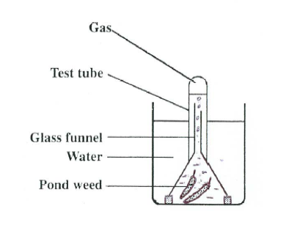
(i) An aquatic plant, such as the pond weed Elodea, is usually used for such an experiment. Explain why an aquatic plant is used in preference to a land plant such as a geranium.
(ii) Explain how you varied the environmental factor that you were investigating in the course of your practical work.
(iii) In what units did you express the rate of photosynthesis?
(iv) Using labelled axes sketch a graph to illustrate the results that you obtained. (24)
Possible Answer

2004 HL
11. (a) ATP is an abbreviation. What does it stand for? Explain briefly the role of ATP in the energy exchanges of a
cell. (9)
(b) (i) The first stage of photosynthesis is commonly known as the light-dependent stage. It involves the
energising of electrons and their subsequent passage along two possible pathways. Give an account of what happens on each of these pathways.
(ii) What is the fate of each of the products of the light-dependent stage? (27)
(c) The effect of changing light intensity or carbon dioxide concentration on the rate of photosynthesis may be investigated by using the pondweed Elodea. Answer the following in relation to this investigation.
(i) Why is a water plant rather than a land plant used in this experiment?
(ii) How is the temperature kept constant in this experiment?
(iii) If pond water is used in the experiment, it is likely to contain dissolved carbon dioxide.
Suggest two possible sources of carbon dioxide in pond water.
(iv) Explain how light intensity or carbon dioxide concentration may be varied.
(v) Each time light intensity or carbon dioxide concentration is varied a precaution is necessary. What is this precaution and why is it necessary? (24)
Answer

2006 HL
11. (a) (i) What is the primary role of chlorophyll in photosynthesis?
(ii) Write an equation to summarize photosynthesis. (9)
(b) The second stage of photosynthesis is called the dark stage or light-independent stage.
(i) Why is the dark stage given the alternative name of the light-independent stage?
(ii) Name a gas that is essential for the dark stage.
(iii) Two products of the light stage are vital for the dark stage. Name each of them.
(iv) State the precise role in the dark stage of each of the substances that you named in (iii).
(v) To what group of biomolecules do the main products of the dark stage belong? (24)
(c) (i) Water is essential for photosynthesis. Briefly outline how water from the soil reaches the leaf.
(ii) What happens to water molecules when they reach the sites of photosynthesis? (27)
Answer

2008 HL
14. (a) (i) Name the openings in the leaf which allow the entry of carbon dioxide for photosynthesis.
State a factor which influences the diameter of these openings.
(ii) During photosynthesis oxygen is produced.
1. From what substance is oxygen produced?
2. In which stage of photosynthesis is oxygen produced?
3. Give two possible fates of oxygen following its production
(iii) Give an account of the role of each of the following in photosynthesis:
1. ATP, 2. NADP.
Answer

2009 HL
12. (c) One laboratory activity that you carried out demonstrated the influence of light intensity or
of carbon dioxide concentration on the rate of photosynthesis. Answer the following in relation to this activity:
(i) Explain how you measured the rate of photosynthesis.
(ii) Explain how you varied light intensity or carbon dioxide concentration.
(iii) State how you kept another named factor constant.
(iv) Draw a graph with labelled axes to show the results that you obtained.
(v) Briefly explain the trend in your graph. (24)
Answer

2010 HL
14. Answer any two of (a), (b), (c). (30, 30)
(a) (i) Where in a plant cell does photosynthesis take place?
(ii) Give the alternative name of the first stage of photosynthesis.
(iii) During the first stage of photosynthesis energised electrons enter two pathways.
1. Where do the energised electrons come from?
2. Briefly describe the main events of each of these pathways.
(iv) 1. In the second stage of photosynthesis compounds of the general formula Cx(H2O)y are
formed. What name is given to this group of compounds?
2. From which simple compound does the plant obtain the H used to make compounds of
general formula Cx(H2O)y?
(v) Name the simple compound that supplies the necessary energy for the second stage
reactions.
Answer

2011 HL
14. (a) The graph shows the results of a classroom investigation into the factors affecting the rate of
photosynthesis. The variable investigated was either light intensity or CO2 concentration.

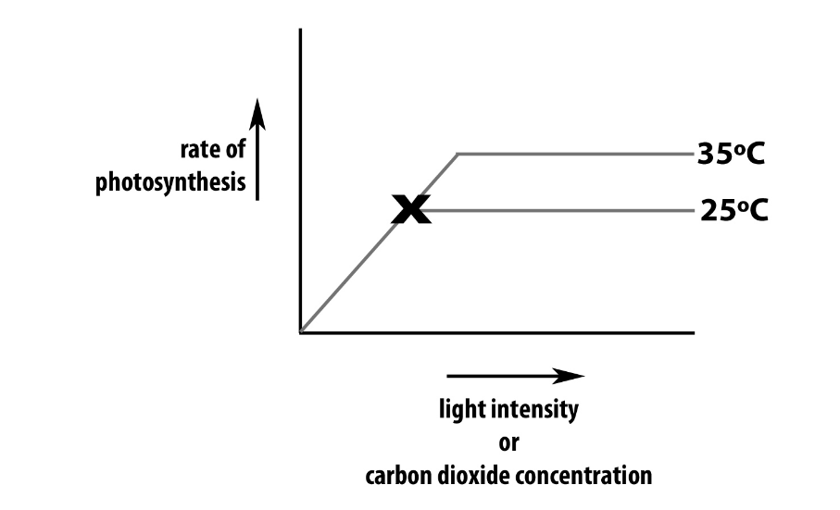

In your answer book, indicate clearly which factor you choose to address and answer the
following questions:

(i) Suggest a suitable plant for such an investigation.
(ii) How was the rate of photosynthesis measured?
(iii) Name a factor that must be kept constant during this investigation.
(iv) Explain how you would keep constant the factor referred to in (iii).
(v) Why is it necessary to keep that factor constant?
(vi) 1. What happens to the rate of photosynthesis at X when the investigation is
A. carried out at 25oC?
B. carried out at 35oC?
2. Give a reason for each answer.
Answer

2012 HL
12. (a) (i) From the following list, write into your answer book any term that describes the nutrition of a
typical plant:
parasitic; heterotrophic; saprophytic; autotrophic.
(ii) Identify, in your answer book, the cell organelles A and B.
(9)

(b) Chlorophyll is composed of various pigments.
Two of these pigments are chlorophyll a and chlorophyll b.
The graph below shows the amount of light of different colours absorbed by chlorophyll a
and chlorophyll b.
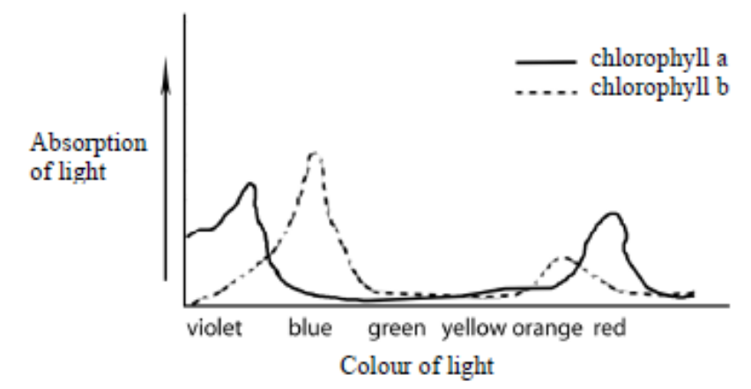
(i) 1. What colours of light are absorbed most by chlorophyll a?
2. What colour of light is absorbed most by chlorophyll b?
(ii) What happens to yellow light when it strikes a leaf?
(iii) Suggest one possible benefit to plants of having more than one chlorophyll pigment.
(iv) From the information provided by the graph suggest how a commercial grower
might try to increase crop yield in his glasshouses or tunnels.
(v) 1. What is the main source of carbon dioxide used by plants in the dark stage of
photosynthesis?
2. State one role of NADP and one role of ATP in the dark stage of photosynthesis.
(27)

(c) Write a brief note on each of the following items in relation to respiration.
/(i) Glycolysis.
(ii) Acetyl Co-enzyme A.
(iii) Adenosine triphosphate.
(iv) Electron transport chain. (24)
Answer

2013 HL
14. Answer any two of (a), (b), (c). (30, 30)
(a) The scheme below summarises the process of photosynthesis.
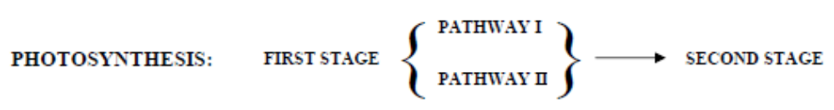
(i) Give the name of the first stage.
(ii) In the first stage, pathways I and II relate to the passage of energised electrons.
1. Explain what happens to these electrons in pathway I.
2. Describe the events of pathway II.
(iii) Give the name of the second stage.
(iv) Explain why the second stage is given the name referred to in part (iii).
(v) Give one reason why the second stage cannot happen without the first stage.
(vi) Outline the major events of the second stage.
Answer
(b) Write notes on each of the following topics. You are required to make a minimum of three points
concerning each topic. Marks will not be given for word diagrams alone.
(i) Metabolism.
(ii) Krebs Cycle.
(iii) ADP.

(c) (i) Explain the term fermentation.
(ii) Name an organism that is used in industrial fermentation.
(iii) To which kingdom does this organism belong?
(iv) Name a compound which is used as a carbon source in the fermentation referred to in part (ii).
(v) In industrial fermentations bioprocessing with immobilised cells is sometimes used.
1. Explain the terms bioprocessing and immobilised.
2. Give an advantage of using immobilised cells.
3. Name the compound from which the immobilising beads are formed in the laboratory.
4. Give the general name for the vessel used for such reactions.

Ordinary Level

2004 OL
13. (a) What is metabolism? Describe briefly the part played by enzymes in metabolism. (9)

(b) The following equation summarises the process of photosynthesis.
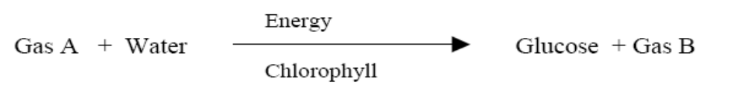
(i) Name Gas A.
(ii) Name Gas B.
(iii) Name the energy source.
(iv) Plants obtain Gas A from the air. Name two processes that release this gas into the air.
(v) Suggest two possible fates for Gas B, following its production in the plant.
(vi) Where in a leaf would you expect to find cells with most chlorophyll?
(vii) What term is used to describe the nutrition of plants?
(27)

(c) The apparatus shown below may be used to investigate the effect of an environmental factor on the rate of photosynthesis.
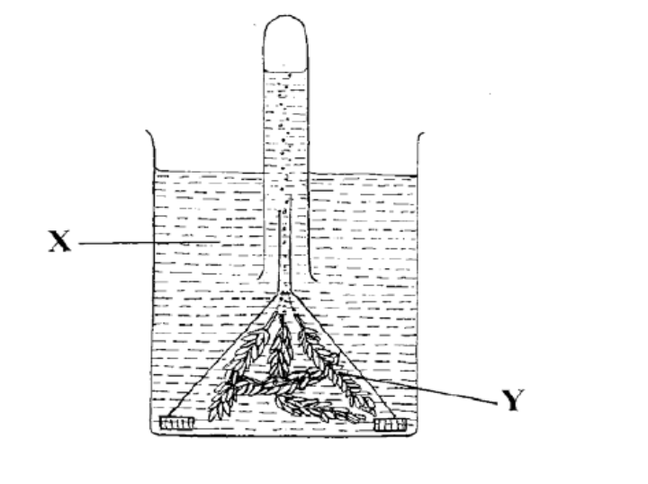

(i) Name X and Y.
(ii) How would you measure the rate of photosynthesis?
(iii) Name an environmental factor that you would vary in this experiment.
(iv) Explain how you would vary the factor that you have named in (iii).
(v) Other environmental factors should be kept constant during the experiment. Name one of these factors. (24)
Answer

2005 OL
11. (a) (i) Complete the following equation, which is a summary of photosynthesis.
6CO2 + 6H2O + light + chlorophyll →
(ii) Where in the cells of a leaf is chlorophyll found? (9)

(b) (i) Light energy trapped by chlorophyll is used to split water. List three products that result
when water is split.
(ii) Describe what happens to each of the three products that you have listed in (i).
(iii) Carbon dioxide is essential for photosynthesis. Where does it enter the leaf?
(iv) From your knowledge of photosynthesis suggest a way to increase the yield of plants such as
lettuces in a greenhouse. (24)

(c) (i) Some of the carbohydrates produced in photosynthesis are used in respiration. What is
respiration?
(ii) Suggest one reason why living organisms need to respire.
(iii) What is aerobic respiration?
(iv) Respiration can also be anaerobic. Which of the two types of respiration releases more energy?
(v) Anaerobic respiration by micro-organisms is called fermentation. Give one example of industrial fermentation, including the type of micro-organism and the substance produced. (27)
Answer

2008 OL
12. (a) (i) In what main part of a plant does most photosynthesis take place?
(ii) In what cell structure does photosynthesis take place? (9)

(b) (i) What is the main source of energy for photosynthesis?
(ii) Suggest two reasons why life on earth might not continue without photosynthesis.
(iii) In photosynthesis water (H₂O) is split into three products.
1. Name these three products.
2. State what happens to each of these products. (27)

(c) Describe an activity that you carried out to investigate the influence of light intensity or carbon dioxide concentration on the rate of photosynthesis. Include a diagram of the apparatus that you used in your answer. (24)
Answer

2009 OL
15. Answer any two of (a), (b) and (c) (30, 30)

(a) (i) Write the balanced equation for photosynthesis.
(ii) What is the main source of light for photosynthesis?
(iii) During photosynthesis water molecules are split into three products.
Name each of these products.
(iv) Describe what happens to each of the products referred to in (iii).
(v) Name the structures in which photosynthesis occurs in plant cells.
Answer

2010 OL
12. (a) (i) What is meant by metabolism?
(ii) Give two reasons why living things need energy. (9)

(b) (i) Which biological process is represented by the following word equation:
glucose + oxygen → carbon dioxide + water + energy?
(ii) The above process occurs in two stages, Stage 1 and Stage 2, that take place in different
parts of the cell.
Say where in the cell Stage 1 occurs and where in the cell Stage 2 occurs.
(iii) Does the whole process release a large amount or a small amount of energy?
(iv) Write a word equation to show what happens when yeast breaks down glucose
in the absence of oxygen.
(v) Give one industrial application of this process.
(vi) When muscles break down glucose in the absence of oxygen, one main product is
produced. Name this product. (27)

(c) (i) Draw a labelled diagram of the apparatus you used to investigate the effect of light
intensity or carbon dioxide concentration on the rate of photosynthesis.
(ii) How did you vary the light intensity or the carbon dioxide concentration?
(iii) How did you measure the rate of photosynthesis?
(iv) What is the relationship between the rate of photosynthesis and either the light intensity
or the carbon dioxide concentration.
(v) Most Irish tomatoes are grown in greenhouses. State two ways a commercial producer
could increase her/his crop yield of tomatoes. (24)
Answer

2011 OL
12. (a) (i) What is meant by the term photosynthesis?
(ii) A gas from the air is needed for photosynthesis.
Name this gas.
(iii) Name the part of a plant cell in which photosynthesis takes place. (9)

(b) (i) Write a balanced equation for photosynthesis.
(ii) Plants contain the green pigment chlorophyll.
What is the role of chlorophyll in photosynthesis?
(iii) The apparatus shown below may be used to investigate the effect of an
environmental factor on the rate of photosynthesis.
1. Name any two environmental factors affecting photosynthesis that could be
investigated using the apparatus shown.
2. How would you measure the rate of photosynthesis using the apparatus below?

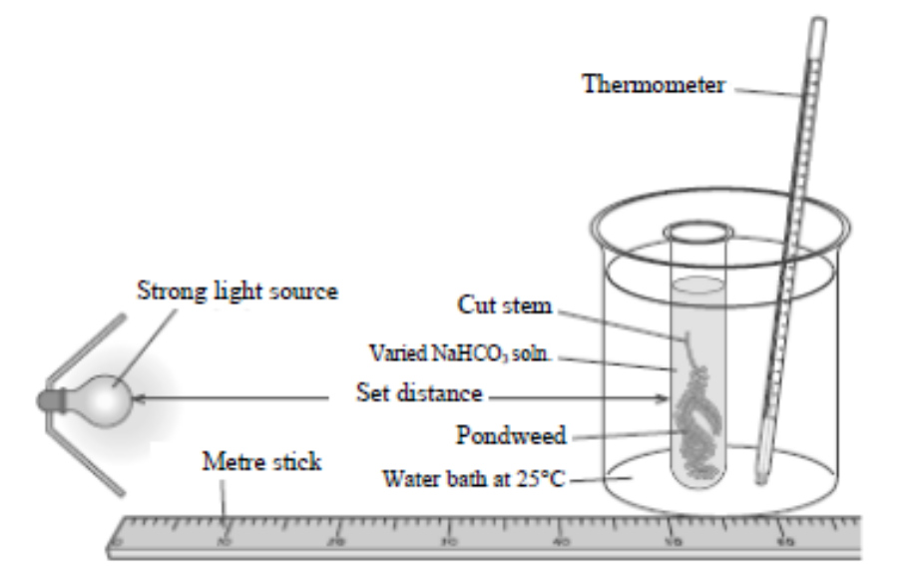

(24)
Answer

2012 OL
14. Answer any two of the parts (a), (b), (c). (30, 30)

(a) (i) What is meant by aerobic respiration?
(ii) Aerobic respiration takes place in two stages.
1. Where in a cell does stage 1 occur?
2. Where in a cell does stage 2 occur?
(iii) Which type of respiration, aerobic or anaerobic, produces more energy?
(iv) In yeast cells, alcohol is produced by fermentation.
Draw a labelled diagram showing how alcohol may be produced in the laboratory.
Answer the following questions in relation to the activity:
1. Name another substance that is produced during the fermentation process.
2. How would you detect this other substance?
3. How would you know when fermentation had finished?

(b) (i) In leaf cells, which chemical traps light energy for photosynthesis?
(ii) Water for photosynthesis enters the roots of plants by osmosis.
What is meant by osmosis?
(iii) During photosynthesis water is split into three products.
1. Name each of these three products.
2. Name the stage of photosynthesis during which water molecules are split.
(iv) Carbon dioxide (CO2) is also needed for photosynthesis.
Where does CO2 enter the leaf?
(v) A market gardener wants to increase the vegetable yield in his greenhouses.
Suggest two ways he may achieve this.

(c) Tissue culture can be used to grow new tissues in the laboratory.
(i) What is a tissue?
(ii) Name a gas that would be needed for the growth of tissue in the laboratory.
(iii) Why are sterile conditions needed to grow the tissue?
(iv) What type of cell division, mitosis or meiosis, is involved in tissue culture?
(v) What medical term is used to describe the disease caused by uncontrolled mitosis in human cells?
(vi) Give two causes of this uncontrolled cell division.
(vii) Draw a labelled diagram to show the normal cell cycle.
(viii) What is the function of meiosis?
Answer

Respiration
Higher Level Questions Ordinary Level Questions

Higher Level

2005 HL
11. (a) (i) Distinguish between aerobic and anaerobic respiration.
(ii) Write a balanced equation to summarise aerobic respiration. (9)

(b) Answer the following questions in relation to the first stage of respiration.
(i) Where in the cell does this stage occur?
(ii) During this stage a small amount of energy is released. Explain the role of ADP in relation to this released energy.
(iii) What is the final product of this stage under aerobic conditions?
(iv) If conditions in the cell remain aerobic the product you have named in (iii) is used for the second stage of respiration. Where does this second stage take place?
(v) If conditions in a human cell (e.g. muscle) become anaerobic the product named in (iii) is converted to another substance. Name this other substance.
(vi) When the substance named in (v) builds up in the blood, a person is said to be in oxygen debt. This debt must eventually be paid. Suggest how the debt is paid. (24)

(c) If yeast cells are kept in anaerobic conditions alcohol (ethanol) and another substance are produced.
(i) Describe, with the aid of a diagram, how you would keep yeast under anaerobic conditions in the laboratory.
(ii) Name a carbohydrate that you would supply to the yeast as an energy source.
(iii) Give an account of a chemical test to demonstrate that alcohol (ethanol) has been produced. Include the initial colour and final colour of the test.
(iv What is the other substance produced under anaerobic conditions?
(v) Alcohol (ethanol) production is an example of fermentation. How would you know when fermentation has ceased?
(vi) Why does fermentation eventually cease? (27)
Answer

2007 HL
11. (a) (i) For what is ATP an abbreviation?
(ii) What is the role of ATP in cells? (9)

(b) (i) What name is given to the first stage of respiration?
(ii) Where in a cell does this first stage take place?
(iii) To what substance is glucose normally converted in this first stage of respiration?
(iv) Is oxygen required for this conversion?
(v) Name a compound to which the substance that you have named in (iii) may be converted, in the absence of oxygen.
(vi) In aerobic respiration, the product of the first stage moves to the mitochondrion.
Outline subsequent events in the total breakdown of this product. (27)
Answer

2009 HL
12. (b) (i) What name is given to the first stage of respiration?
(ii) The first stage ends with the formation of pyruvate (pyruvic acid).
In anaerobic conditions, what is produced from this pyruvate:
1. In muscle cells?
2. In yeast cells?
(iii) If conditions are aerobic, pyruvate next passes to an organelle in which the second stage of
respiration takes place. Name this organelle.
(iv) In this organelle pyruvate is broken down to CO₂ and a two-carbon compound. Name this two-carbon compound.
(v) This two-carbon compound passes directly into a series of reactions in the second stage of respiration.
Name this series of reactions and give one product, other than electrons, of these reactions.
(vi) The electrons released from the above reactions pass along a transport chain and in the process energy is releasd.
1. To what use is this energy put?
2. At the end of the transport chain what happens to the electrons?
Answer

2012 HL
12. (a) (i) From the following list, write into your answer book any term that describes the nutrition of a
typical plant:
parasitic; heterotrophic; saprophytic; autotrophic.
(ii) Identify, in your answer book, the cell organelles A and B.
(9)

(b) Chlorophyll is composed of various pigments.
Two of these pigments are chlorophyll a and chlorophyll b.
The graph below shows the amount of light of different colours absorbed by chlorophyll a
and chlorophyll b.
(i) 1. What colours of light are absorbed most by chlorophyll a?
2. What colour of light is absorbed most by chlorophyll b?
(ii) What happens to yellow light when it strikes a leaf?
(iii) Suggest one possible benefit to plants of having more than one chlorophyll pigment.
(iv) From the information provided by the graph suggest how a commercial grower
might try to increase crop yield in his glasshouses or tunnels.
(v) 1. What is the main source of carbon dioxide used by plants in the dark stage of
photosynthesis?
2. State one role of NADP and one role of ATP in the dark stage of photosynthesis.
(27)

(c) Write a brief note on each of the following items in relation to respiration.
(i) Glycolysis.
(ii) Acetyl Co-enzyme A.
(iii) Adenosine triphosphate.
(iv) Electron transport chain. (24)
Answer

2013 HL
14. Answer any two of (a), (b), (c). (30, 30)
(a) The scheme below summarises the process of photosynthesis.
(i) Give the name of the first stage.
(ii) In the first stage, pathways I and II relate to the passage of energised electrons.
1. Explain what happens to these electrons in pathway I.
2. Describe the events of pathway II.
(iii) Give the name of the second stage.
(iv) Explain why the second stage is given the name referred to in part (iii).
(v) Give one reason why the second stage cannot happen without the first stage.
(vi) Outline the major events of the second stage.

(b) Write notes on each of the following topics. You are required to make a minimum of three points
concerning each topic. Marks will not be given for word diagrams alone.
(i) Metabolism.
(ii) Krebs Cycle.
(iii) ADP.
Answer
(c) (i) Explain the term fermentation.
(ii) Name an organism that is used in industrial fermentation.
(iii) To which kingdom does this organism belong?
(iv) Name a compound which is used as a carbon source in the fermentation referred to in part (ii).
(v) In industrial fermentations bioprocessing with immobilised cells is sometimes used.
1. Explain the terms bioprocessing and immobilised.
2. Give an advantage of using immobilised cells.
3. Name the compound from which the immobilising beads are formed in the laboratory.
4. Give the general name for the vessel used for such reactions.
Answer

Ordinary Level

SEC Sample Paper OL
13. (a) (i) Complete the following equation, which is a summary of aerobic respiration.
C₆H₁₂O₆ + 6O₂
(ii) Aerobic respiration is a two-stage process. The first stage takes place in the cytoplasm. Where does the second stage take place? (9)

(b) The apparatus below may be used to demonstrate aerobic respiration. Air is drawn through the apparatus by attaching it to a vacuum pump at X. Sodium hydroxide is placed in flask 1 to remove carbon dioxide.

(i) What is the purpose of removing carbon dioxide?
(ii) Limewater is put in flasks 2 and 3. Suggest a reason for putting it in each flask.
(iii) What is the purpose of a control in an experiment? Suggest a suitable control for this experiment.
(iv) If the animal in the apparatus were replaced by a plant, and the experiment carried out in daylight, would you expect a similar result? Explain your answer.
(24)

(c) The apparatus below may be used to demonstrate anaerobic respiration in yeast.
The water was boiled and cooled before adding the yeast.

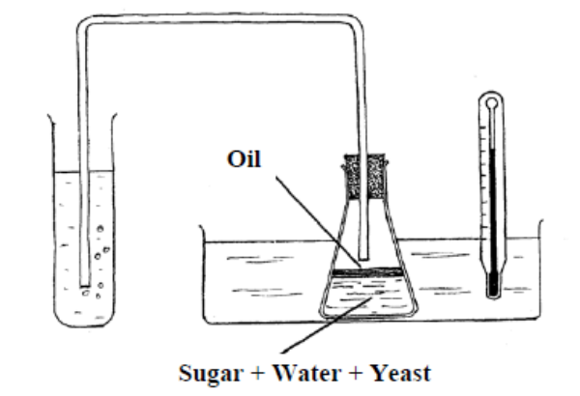

(i) Why was the water boiled before adding the yeast?
(ii) Why do you think a layer of oil has been put on top of the water?
(iii) Would the same apparatus containing water and yeast but without sugar be a suitable control? Explain your answer.
(iv) Give two industrial uses of the anaerobic respiration of yeast. (27)
Possible Answer

2005 OL
11. (a) (i) Complete the following equation, which is a summary of photosynthesis.
6CO2 + 6H2O + light + chlorophyll →
(ii) Where in the cells of a leaf is chlorophyll found? (9)

(b) (i) Light energy trapped by chlorophyll is used to split water. List three products that
result when water is split.
(ii) Describe what happens to each of the three products that you have listed in (i).
(iii) Carbon dioxide is essential for photosynthesis. Where does it enter the leaf?
(iv) From your knowledge of photosynthesis suggest a way to increase the yield of plants such as lettuces in a greenhouse. (24)

(c) (i) Some of the carbohydrates produced in photosynthesis are used in respiration. What is
respiration?
(ii) Suggest one reason why living organisms need to respire.
(iii) What is aerobic respiration?
(iv) Respiration can also be anaerobic. Which of the two types of respiration releases more energy?
(v) Anaerobic respiration by micro-organisms is called fermentation. Give one example of industrial fermentation, including the type of micro-organism and the substance produced. (27)
Answer

2006 OL
13. (a) (i) Identify X and Y in the following equation which is a summary of aerobic respiration.
C₆H₁₂O₆ + 6X → 6Y + 6H₂O
(ii) What is anaerobic respiration? (9)

(b) Answer the following questions in relation to aerobic respiration as a two stage process.
(i) Where in the cell does the first stage take place?
(ii) Does the first stage require oxygen?
(iii) Comment on the amount of energy released in the first stage.
(iv) Where in the cell does the second stage take place?
(v) Does the second stage require oxygen?
(vi) Comment on the amount of energy released in the second stage.
(vii) State two ways in which the energy that is released is used in the human body.
(24)

(c) (i) Describe how you used yeast to produce alcohol (ethanol). Include a labelled diagram of the
apparatus that you used.
(ii) How did you show that alcohol had been produced? (27)
Answer

2007 OL
12. (a) (i) Explain briefly what is meant by respiration.
(ii) Distinguish between aerobic and anaerobic respiration. (9)

(b) (i) Copy the table below into your answer book and complete the final column.

Type of Respiration | Energy Source | End Products
Aerobic respiration | Glucose
Anaerobic respiration in muscle | Glucose
Anaerobic respiration in yeast | Glucose

(ii) In stage 1 of respiration, glucose is partly broken down. Where in the cell does this happen?
(iii) Name the cell component shown in the diagram in which stage 2 of respiration takes place.

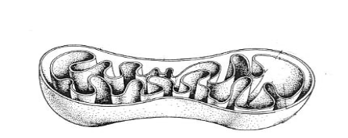

(iv) Which stage of respiration releases more energy? (24)

(c) (i) Draw a labelled diagram of the apparatus in which you used yeast to produce alcohol.
(ii) The water that you used in the apparatus was previously boiled and cooled. Why was this?
(iii) In your investigation it was necessary to exclude air. How was this done?
(iv) Describe briefly a test to show that alcohol had been produced. (27)
Answer

2009 OL
12. (b) (v) Some bacteria are anaerobic. What does this mean?
Answer

2009 OL
15. (b) (i) What is meant by the term aerobic respiration?
(ii) Aerobic respiration takes place in two main stages – stage 1 and stage 2.
Indicate clearly in your answer book whether each of the following statements refers to stage 1 or to stage 2.
A. Takes place in the mitochondria.
B. Produces a large amount of energy.
C. Takes place in the cytoplasm.
D. Does not require oxygen.
(iii) One of your practical activities was to prepare alcohol using yeast. In your answer book answer the following questions in relation to this activity:
A. Name the solution in which you placed the yeast at the start of the activity.
B. Give the temperature at which you then kept the solution.
C. How did you know that alcohol production had ceased?
D. Name the test or chemical(s) used to show that alcohol had been produced.
Answer

2010 OL
12. (a) (i) What is meant by metabolism?
(ii) Give two reasons why living things need energy. (9)

(b) (i) Which biological process is represented by the following word equation:
glucose + oxygen → carbon dioxide + water + energy?
(ii) The above process occurs in two stages, Stage 1 and Stage 2, that take place in different
parts of the cell.
Say where in the cell Stage 1 occurs and where in the cell Stage 2 occurs.
(iii) Does the whole process release a large amount or a small amount of energy?
(iv) Write a word equation to show what happens when yeast breaks down glucose
in the absence of oxygen.
(v) Give one industrial application of this process.
(vi) When muscles break down glucose in the absence of oxygen, one main product is
produced. Name this product. (27)

(c) (i) Draw a labelled diagram of the apparatus you used to investigate the effect of light
intensity or carbon dioxide concentration on the rate of photosynthesis.
(ii) How did you vary the light intensity or the carbon dioxide concentration?
(iii) How did you measure the rate of photosynthesis?
(iv) What is the relationship between the rate of photosynthesis and either the light intensity
or the carbon dioxide concentration
(v) Most Irish tomatoes are grown in greenhouses. State two ways a commercial producer
could increase her/his crop yield of tomatoes. (24)
Answer

2012 OL
14. Answer any two of the parts (a), (b), (c). (30, 30)

(a) (i) What is meant by aerobic respiration?
(ii) Aerobic respiration takes place in two stages.
1. Where in a cell does stage 1 occur?
2. Where in a cell does stage 2 occur?
(iii) Which type of respiration, aerobic or anaerobic, produces more energy?
(iv) In yeast cells, alcohol is produced by fermentation.
Draw a labelled diagram showing how alcohol may be produced in the laboratory.
Answer the following questions in relation to the activity:
1. Name another substance that is produced during the fermentation process.
2. How would you detect this other substance?
3. How would you know when fermentation had finished?

(b) (i) In leaf cells, which chemical traps light energy for photosynthesis?
(ii) Water for photosynthesis enters the roots of plants by osmosis.
What is meant by osmosis?
(iii) During photosynthesis water is split into three products.
1. Name each of these three products.
2. Name the stage of photosynthesis during which water molecules are split.
(iv) Carbon dioxide (CO2) is also needed for photosynthesis.
Where does CO2 enter the leaf?
(v) A market gardener wants to increase the vegetable yield in his greenhouses.
Suggest two ways he may achieve this.

(c) Tissue culture can be used to grow new tissues in the laboratory.
(i) What is a tissue?
(ii) Name a gas that would be needed for the growth of tissue in the laboratory.
(iii) Why are sterile conditions needed to grow the tissue?
(iv) What type of cell division, mitosis or meiosis, is involved in tissue culture?
(v) What medical term is used to describe the disease caused by uncontrolled mitosis in human cells?
(vi) Give two causes of this uncontrolled cell division.
(vii) Draw a labelled diagram to show the normal cell cycle.
(viii) What is the function of meiosis?
Answer

2013 OL
13. (a) (i) Draw a labelled diagram of an animal cell as seen using a light microscope.
(ii) Name another type of microscope that gives greater detail than a light microscope. (9)

(b) The diagram below shows the ultrastructure of a section of cell membrane.

(i) Give two functions of the cell membrane.
(ii) Name the parts labelled A and B.
(iii) Which organelle is known as “the powerhouse of the cell”?
(iv) Why does the nucleus of a cell have many pores?
(v) List two differences between a plant cell and an animal cell.
(vi) What is the primary source of energy for plant cells? (27)

(c) Answer the following questions in relation to an investigation you carried out into fermentation by
yeast cells.
(i) Explain what is meant by anaerobic respiration.
(ii) Where in the cell does anaerobic respiration occur?
(iii) Describe, with the aid of a diagram, how you kept the yeast under anaerobic conditions during the
investigation.
(iv) Name the two substances produced by the yeast in the process of fermentation.
(v) How did you know that fermentation had ceased? (24)
Answer

Movement through cell membranes
Higher Level Questions Ordinary Level Questions

Higher Level

2008 HL
14. (c) (i) Draw a large labelled diagram of a transverse section through a young root.
(ii) Water enters the outermost cells of the root by osmosis. What does this tell you about the cell
sap of these outermost cells?
(iii) Osmosis has been described as a special case of diffusion. Explain why.
(iv) Describe an investigation that you carried out to demonstrate osmosis.
(v) Describe how minerals such as nitrates enter the root of a plant from the soil.
Answer

2010 HL
14. Answer any two of (a), (b), (c). (30, 30)
(c) (i) In relation to membranes in cells, explain what is meant by selective permeability.
(ii) Give two locations in a cell at which there is a selectively permeable membrane.
(iii) 1. What is diffusion?
2. In the case of a named molecule, give a precise location at which it diffuses in the human
body.
(iv) Explain the biological basis for the use of high sugar or high salt concentrations in the
preservation of food.
Answer

2011 HL
14. (c) (i) State the precise location of the cell membrane in plant cells.
(ii) With what type of cell do you associate membrane-bound organelles?
(iii) What corresponding term is used to describe bacterial cells?
(iv) The cell membrane is described as being selectively permeable. What does this mean?
(v) Why is diffusion alternatively known as passive transport?
(vi) Osmosis may be described as “a special case of diffusion”. Explain why.
(vii) Describe, with the aid of a labelled diagram, how you demonstrated osmosis in the laboratory.
(viii) Name the structure by which Amoeba gets rid of excess water that has entered by osmosis.
Answer

2012 HL
15. Answer any two of (a), (b), (c). (30, 30)

(c) (i) Explain the term homeostasis.
(ii) Homeostasis often requires an organism to exchange materials between different
tissues, or between itself and the external environment by diffusion, osmosis, and
active transport. Explain each of the underlined terms.
(iii) State one way in which each of the following contributes to homeostasis.
1. Liver.
2. Lungs.
3. Nephrons of kidneys.
(iv) Describe the role of the skin in controlling body temperature.
Answer

Ordinary Level

2008 OL
15 (a) (i) Water enters the roots of plants by osmosis. Explain what is meant by osmosis.
(ii) Describe how you demonstrated osmosis as part of your practical activities.
Answer

2.3 Cell Continuity

Need to Know

2.3.1 Cell Continuity and Chromosome
2.3.2 Haploid, Diploid
2.3.3 The Cell Cycle
2.3.4 Mitosis
2.3.5 Function of Mitosis
2.3.6 Meiosis
2.3.7 Functions of Meiosis
H.2.3.8 Stages of Mitosis [ES]

At the end of this section students should be able to:

- Explain the terms: cell continuity & chromosomes.
- Define the terms: haploid number & diploid number.
- Describe the cell cycle in the state of non-division (Interphase) and division (mitosis).
- Define the term: mitosis.
- Explain the process of mitosis in simple terms, with the aid of diagrams to show chromosome behaviour.
- Define cancer and state two possible causes.
- State the primary function of mitosis for single-celled and multicellular organisms.
- Define the term: meiosis.
- State the functions of meiosis.

- Explain the process in more detailed terms with diagrams (be able to name each stage and chromosome parts).

PowerPoint Presentations

2.3 Cell continuity & Mitosis.ppt

2.3 Cell Continuity

Section A

Higher Level Questions Ordinary Level Questions

Higher Level

SEC Sample Paper HL
1. Answer any five of the following.
(a) State a function of the cell membrane …………………………………………………………
(b) State one feature that would allow you to identify an eukaryotic cell
…………………………………………………………………………………….……………
(c) Name a human cell that is haploid …………………………………………………………….
(d) What term is used to describe a cellular reaction in which large molecules are broken down to smaller ones? ………………………………………………………………………………..
(e) What term is used to describe an individual’s genetic make up? ……………………………..
(f) Name a scientist responsible for the Theory of Natural Selection
…………………………………………….……………………………………………………
Possible Answer

2005 HL
5. (a) In the space below draw a diagram of a nucleus during metaphase of mitosis where 2n = 6.
Label the spindle and a centromere in your diagram.

(b) State a function of mitosis in a single-celled organism. ……………………………
(c) State a function of mitosis in a multicellular organism. ……………………………
(d) State one way in which mitosis differs from meiosis. ……………………………...
(e) When the normal control of mitosis in a cell is lost, cancer may result. Suggest two possible causes of cancer.
1. …………………………………………………….
2. …………………………………………………….
Answer

2007 HL
3. Study the diagram of a stage of mitosis in a diploid cell and then answer the questions below.

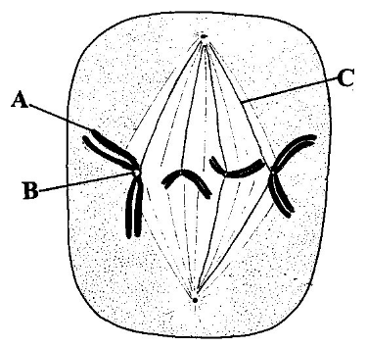

(a) Name A, B and C.
A ..…………………….. B …………………….. C ……..………………….
(b) What stage of mitosis is shown? …………………………………...
Give a reason for your answer. ……………………………………………………………………….
(c) What is the diploid number of this nucleus which is undergoing mitosis? …………………………
(d) Give a role of structure A. …………………………………………………………………………….
(e) Some cells in the human body undergo meiosis. Give one function of meiosis …………………….
……………………………………………………………………………………………………….
Answer

2008 HL
2. The diagram represents the cell cycle.

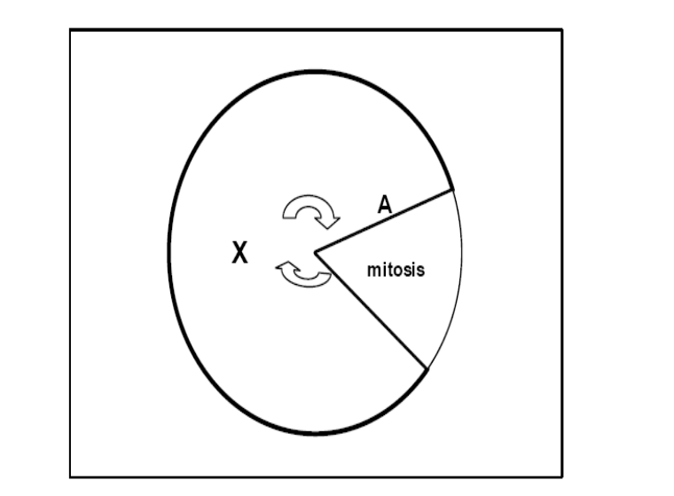
(a) What stage of the cycle is represented by X? ………………………………………………………
(b) Give the names of the two processes involving DNA which take place during stage X.
1.…………………………………………………….. 2 …….……………………………………..…
(c) For convenience of study, mitosis is divided into four stages. List these in order starting at A.
…………………………………………………………………………….…………………
(d) In which of the stages of mitosis that you have listed in (c) would you expect to see the spindle fibres contracting? ……………………………………………………………………...……………
(e) Explain the term diploid number …………………………………………………………………... ……………………………………………………………………………………………………….
(f) What term is used to describe a group of disorders of the body in which cells lose the normal regulation of mitosis? ……………………………………………………………………………….
Answer

2009 HL
5. The diagram shows a stage of mitosis.

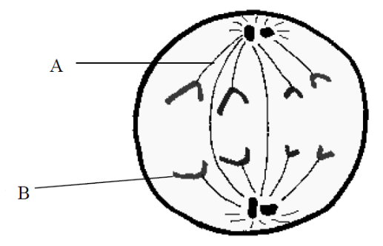

(a) Name this stage of mitosis. ___________________________________________________
(b) Give a feature from the diagram which allowed you to identify this stage.
_________________________________________________________________________
(c) Name the parts of the diagram labelled A and B.
A. _____________________________________________
B. _____________________________________________
(d) What is the function of mitosis in single-celled organisms? _______________________
(e) Give one function of mitosis in multicellular organisms. __________________________
(f) Give one location where mitosis occurs in flowering plants. ________________________________
Answer

2011 HL
2. Use your knowledge of mitosis to answer the following questions:
(a) What is the role of mitosis in single-celled organisms?
________________________________________________________________________________
(b) What medical term is used for the group of disorders in which certain cells lose normal control of
mitosis?
________________________________________________________________________________
(c) Suggest a possible cause of one of the group of disorders referred to in (b).
________________________________________________________________________________
(d) Name the stage of mitosis in which the chromosomes are located at the equator of the cell and
before they begin to separate.
________________________________________________________________________________
(e) To what are the chromosomes attached in the stage of mitosis referred to in (d)?
_____ ___________________________________________________________________________
(f) Towards the end of mitosis, in what type of cell does a cell plate form?
________________________________________________________________________________
(g) Give one way in which mitosis differs from meiosis.
________________________________________________________________________________
Answer

Ordinary Level

SEC Sample Paper OL
3. Select the correct term from the following list to match each of the terms in column A and write it in column B.
liver, variation, lipid, haploid, sap

A | B
Cell membrane
Vacuole
Mutation
Organ
Gamete
Possible Answer

SEC Sample Paper OL
6. The diagram shows a body cell of an animal at an early stage of mitosis.

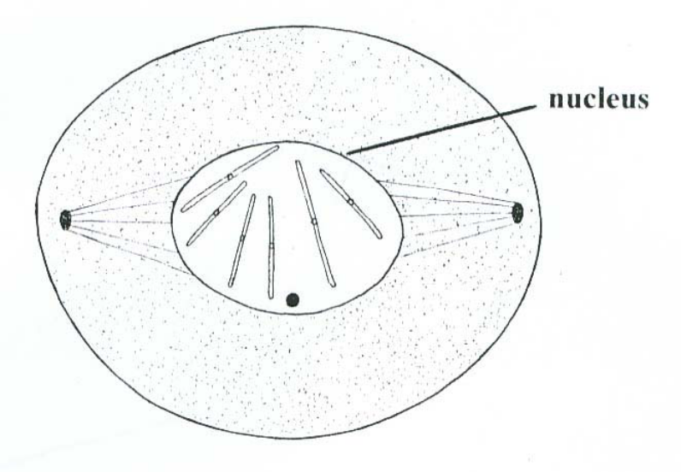

What is the diploid number of the animal in which this cell is found? ………………..…………………
When the cell division is completed how many new cells will there be? ……………..…………………
If this cell were to divide by meiosis how many chromosomes would there be in each of the new cells?
………………………………………………………………………………………………………………
State a function of mitosis in each of the following:
1. Single-celled organisms ………………………………………………………………………………
………………………………………………………………………………………………………………………………………………………………………………………………………………………………
2. Multicellular organisms ………………………….……………………………………………………
………………………………………………………………..………………….…………………………………………………………………………………………………………………………………………
Possible Answer

2004 OL
3. Indicate whether each of the following statements is true (T) or false (F) by drawing a circle around T or F.

Example: The pulmonary artery carries blood to the lungs T F

Mitosis is the division of a nucleus into two identical nuclei T F
A sperm contains the haploid number of chromosomes T F
Chromosomes are made of DNA and lipid T F
Organisms of the same species can usually produce fertile offspring T F
Aerobic respiration is the release of energy in the absence of oxygen T F
RNA is not found in ribosomes T F
Immobilised enzymes can act as catalysts T F
Answer

2005 OL
4. The diagram shows a stage of mitosis
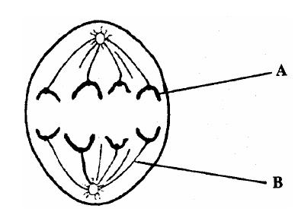

(a) Name A and B
A ………………………………….…… B ……….…………………………………
(b) What is happening during this stage of mitosis? ...……………………………………………………
…………………………………………………………………………………………………………
(c) How many cells are formed when a cell divides by mitosis? …………………………………………
(d) For what purpose do single-celled organisms use mitosis? …………….……………………………
……………………………………………………………………………………………………….
Answer

2007 OL
4. Complete the following sentences by adding the missing word or symbols or number.
(a) Genetics is the study of ………………………………………………………………………………
(b) In a woman the sex chromosomes are XX; in a man they are ………………………………………
(c) If the diploid number in a cell is 46, the haploid number is …………………………………………
(d) In order to make proteins, DNA is first transcribed as messenger ………………………………….
(e) A change in the genetic material of an organism is called a …………….…….…………………….
Answer

2009 OL
4. Indicate whether the following are true (T) or false (F) by drawing a circle around T or F in each case.
Example: The cells produced by meiosis are haploid T F
The cells produced by mitosis are identical. T F
Meiosis gives rise to variation. T F
Mitosis always produces four new cells. T F
Meiosis is never involved in gamete formation. T F
Single-celled organisms use mitosis for reproduction. T F
Answer

2011 OL
3. The diagram shows a cell undergoing cell division.

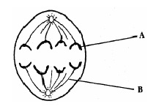

(a) Genes are found on structure A. Name structure A.
____________________________________________________________________________________
(b) What is the function of structure B?
____________________________________________________________________________________
(c) Tissues grow by cell division. Name the type of cell division by which tissues grow.
____________________________________________________________________________________
(d) Organs are found in both plants and animals. What is meant by the term organ?
____________________________________________________________________________________
(e) Name one organ found in plants.
____________________________________________________________________________________
Answer

2013 OL
4. The diagram shows the cell cycle.
(a) There are two parts in the cell cycle – cell division and interphase.
Match these two parts to the letters in the diagram.
Cell division ………………….. Interphase ……………………..
(b) Name the two types of cell division.
1…………………………… 2…………………………
(c) Cancer is the uncontrolled multiplication of abnormal cells. Give two causes of cancer.
1………………………………………………………………………
2………………………………………………………………………
(d) Suggest a possible treatment for cancer………………………………………………………………….......
………………………………………………………………………………………………………………..
Answer

2.3 Cell Continuity

Section C

Higher Level Questions Ordinary Level Questions

Higher Level

2010 HL
10. (c) Distinguish between the terms in the following pairs by writing one sentence about each
member of each pair.
(i) Haploid and diploid
(ii) Homozygous and heterozygous
(iii) Genotype and phenotype
(iv) Segregation and independent assortment. (24)
Answer

2013 HL
11. (a) (i) Give a source of evidence for evolution.
(ii) Briefly outline the evidence from the source referred to in (i).

(b) (i) Human males and females differ in one of their twenty three pairs of chromosomes.
What name is given to this pair of chromosomes?
(ii) Draw this pair of chromosomes for a human male and for a human female and label them
appropriately.
(iii) Using the chromosomes referred to in part (b) (ii), show, using a Punnett square or
otherwise, that a child stands an equal chance of being male or female.
(iv) 1. What is meant in genetics by the term sex linkage?
2. Name two common sex-linked traits.

(c) Answer the following questions, which relate to events in the cell cycle.
(i) What name is applied to the period of the cell cycle in which division is not taking place?
(ii) Give a cellular process that occurs during this period in which the nucleus is not dividing.
(iii) Draw a labelled diagram to show the position of the chromosomes during metaphase of
mitosis in a nucleus in which 2n = 6.
(iv) 1. State a function of one of the structures, other than chromosomes, that you have labelled
in your diagram of metaphase.
2. How does the structure carry out this function?
(v) What term is used for the group of disorders in which control has been lost over the rate of
mitosis?
Answer

Ordinary Level

2008 OL
11. (a) (ii) The haploid number of chromosomes is found in the human egg and sperm.
Explain the underlined term.
Answer

2010 OL
11. (a) Many characteristics are passed on to children by their parents.
(i) Give one example of an inherited human characteristic.
(ii) Give one example of a non-inherited human characteristic.
(iii) Which structures in sperm and egg nuclei are responsible for biological inheritance? (9)
Answer

2011 OL
10. (c) (i) Explain, in terms of what happens to body cells, what is meant by the term cancer.
(ii) Give two possible causes of cancer.
(iii) Some people choose to be screened to determine their risk of getting a particular
type of cancer.
What is meant by genetic screening?
(iv) Blood samples taken from a crime scene were put through a process called DNA
profiling. During the process cells were broken down to release the DNA,
which was then cut into fragments. The fragments were then separated.
1. What was used to cut the DNA?
2. On what basis were the DNA fragments separated?
3. Give an application of DNA profiling other than solving crime.
(v) The following are the results of the DNA profiling process. Using these results,
identify which suspect, A, B or C committed the crime. (27)

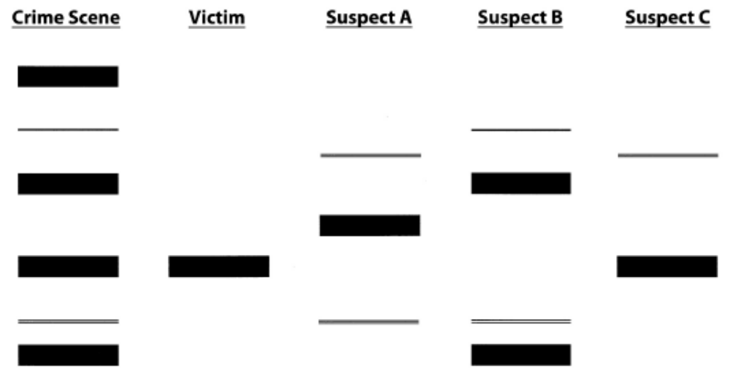
Answer

2012 OL
11. (a) (i) In genetics, what is meant by the term haploid?
(ii) What is a chromosome? (9)
Answer

2012 OL
14. Answer any two of the parts (a), (b), (c). (30, 30)

(c) Tissue culture can be used to grow new tissues in the laboratory.
(i) What is a tissue?
(ii) Name a gas that would be needed for the growth of tissue in the laboratory.
(iii) Why are sterile conditions needed to grow the tissue?
(iv) What type of cell division, mitosis or meiosis, is involved in tissue culture?
(v) What medical term is used to describe the disease caused by uncontrolled mitosis in human cells?
(vi) Give two causes of this uncontrolled cell division.
(vii) Draw a labelled diagram to show the normal cell cycle.
(viii) What is the function of meiosis?
Answer

2.4 Cell Diversity

Need to Know

2.4.1 Tissues
2.4.2 Organs
2.4.3 Organ System

At the end of this section students should be able to:

- Define the term: tissue
- Name two plant tissues.
- Name two animal tissues
- Explain the term: Tissue culture
- State two applications of tissue culture
- Define the term: organ
- Name one plant organ
- Name one animal organ
- Define the term: organ system.
- Name any two animal systems.

PowerPoint Presentations

2.4 Cell Diversity.ppt

2.4 Cell Diversity

Section A

Higher Level Questions Ordinary Level Questions

Higher Level

2010HL
4. (a) What is a tissue? ....................................................................................................................................
(b) Name a tissue found in plants ...……………………………………………………………………….
(c) Give a function of the tissue referred to in part (b) …………………………………………………….
(d) Name a tissue found in animals………………………………………………………………………...
(e) Give a function of the tissue referred to in part (d)………………………………………………….....
(f) Explain what is meant by the term tissue culture ……………………………………………………… ………………………………………………………………………………………………………......
(g) Give one application of tissue culture …………………………………………………………………
Answer

2012 HL
2. (a) (i) What is a tissue?
_________________________________________________________________________________
(ii) Give an example of an animal tissue.
_________________________________________________________________________________
(iii) State a role of the animal tissue referred to in (ii).
_________________________________________________________________________________
(iv) Give one way in which the tissue referred to in (ii) is adapted to carry out its function(s).
_________________________________________________________________________________
(b) (i) Explain the term tissue culture.
________________________________________________________________________________
_______________________________________________________________________________
(ii) Give two examples of the use of tissue culture.
1. ______________________________________________________________________________
2. ______________________________________________________________________________
Answer

Ordinary Level

SEC Sample Paper OL
3. Select the correct term from the following list to match each of the terms in column A and write it in column B.
liver, variation, lipid, haploid, sap

A | B
Cell membrane
Vacuole
Mutation
Organ
Gamete
Possible Answer

2011 OL
3. The diagram shows a cell undergoing cell division.

(a) Genes are found on structure A. Name structure A.
____________________________________________________________________________________
(b) What is the function of structure B?
____________________________________________________________________________________
(c) Tissues grow by cell division. Name the type of cell division by which tissues grow.
____________________________________________________________________________________
(d) Organs are found in both plants and animals. What is meant by the term organ?
____________________________________________________________________________________
(e) Name one organ found in plants.
____________________________________________________________________________________
Answer

2012 OL
3. Indicate whether each of the following statements is true (T) or false (F) by drawing a circle around T or F in
each case.
Example: DNA is a double helical shape. T F
(a) The base Uracil is found in DNA. T F
(b) Chloroplasts contain DNA. T F
(c) The microscope lenses closest to the stage are the eyepiece lenses. T F
(d) Sodium alginate is used to immobilise enzymes. T F
(e) Plant cell walls are fully permeable. T F
(f) Animal cells do not have membranes. T F
(g) An organ is a group of systems. T F
Answer

2.4 Cell Diversity

Section C

Higher Level Questions Ordinary Level Questions

Higher Level

Ordinary Level

SEC Sample Paper OL
12. (a) (i) What is a tissue?
(ii) Name two vascular tissues found in flowering plants. (9)
Possible Answer

2007 OL
11. (a) (i) What is a tissue?
(ii) Name two tissues found in animals. (9)

(b) Tissue culture is used to make a skin graft for patients who have been severely burned.
(i) What is meant by tissue culture?
(ii) Name the gas needed to release energy to make a skin graft.
(iii) Suggest the most suitable temperature to make skin cells grow.
(iv) Suggest a reason why sterile conditions are needed in tissue culture.
(v) What type of cell division, mitosis or meiosis, is involved in tissue culture?
(vi) Give one other application of tissue culture apart from skin grafting. (24)

(c) (i) Explain briefly what is meant by a gene.
(ii) Where in the nucleus would you find genes?
(iii) The allele for brown eye (B) is dominant to the allele for blue eye (b).
Explain each of the underlined terms.
(iv) Use a Punnet square to find the possible genotypes of children of parents who are both
heterozygous for brown eye. State the eye colour resulting from each of these genotypes. (27)
Answer

2012 OL
14. Answer any two of the parts (a), (b), (c). (30, 30)

(c) Tissue culture can be used to grow new tissues in the laboratory.
(i) What is a tissue?
(ii) Name a gas that would be needed for the growth of tissue in the laboratory.
(iii) Why are sterile conditions needed to grow the tissue?
(iv) What type of cell division, mitosis or meiosis, is involved in tissue culture?
(v) What medical term is used to describe the disease caused by uncontrolled mitosis in human cells?
(vi) Give two causes of this uncontrolled cell division.
(vii) Draw a labelled diagram to show the normal cell cycle.
(viii) What is the function of meiosis?
Answer

2.5 Genetics

Need to Know

2.5.1 Variation
2.5.2 - 3 Heredity, Gene Expression, Genetic code
2.5.4 + 2.5.14.H DNA, Replication, Profiling & Screening
2.5.5 + 2.5.15.H Protein synthesis
2.5.6 Genetic Inheritance
2.5.7 - 8 Variation and Evolution
2.5.9 Genetic Engineering
2.5.10.H - 13.H Mendelian Genetics

At the end of this section students should be able to:

Variation
- Discuss the diversity of organisms.
- Define the term species.
- Distinguish between inherited and acquired variation.
- Give examples of inherited and acquired variations.

Heredity
- Define the term heredity.
- Define the term gene .
- Outline the role of a gene.
- Define the term gene expression.

DNA
- Describe the structure of a chromosome [DNA and protein]
- Name the four bases and the complementary base pairs in DNA
- Distinguish between coding and non coding structures
- Explain why RNA as a complementary structure to DNA.
- Name the bases in RNA
- Outline the structure of RNA
- Outline the replication of DNA to form 2 helices
- Define DNA profiling
- Outline the 4 stages involved in DNA profiling
- Give two applications of DNA profiling
- Explain the need and a use for genetic screening

- Describe the structure of a Nucleotide
- Outline the specific purine and pyrimidine couples – complementary base pairs.
- Explain Hydrogen bonding
- Explain the function of mRNA
- Describe the triplet base code
- Outline Chromosome sequencing of coding and non coding (junk DNA) sequences.

Protein Synthesis
- Outline the steps in protein synthesis
- Understand DNA contains the code for protein
- Understand this code is transcribed to mRNA
- Know the code is translated on the ribosome
- Understand the amino acids are assembled in the correct order to synthesise the protein
- Know that the protein folds into its functional shape
- Know that genes control cell activities by producing proteins
- Understand that enzymes unwind the DNA
- Know the role of RNA polymerase
- Know what a codon is
- Know the ribosome is composed of subunits
- Understand the amino acids are assembled in the correct order determined by the codons on mRNA to synthesise the protein
- Understand a stop codon on mRNA signals the release of the protein
- Know that the protein folds into its functional shape
- Understand the molecular involvement of DNA, mRNA, tRNA, rRNA and amino acids in the process of protein synthesis

Inheritance
- Define a gamete
- Outline gamete formation
- Define fertilisation
- Explain sex determination
- Define allele
- Differentiate between the terms homozygous and heterozygous
- Differentiate between genotype and phenotype
- Differentiate between dominant and recessive
- Define incomplete dominance
- Show the inheritance to the F1 generation in a cross involving:
- Homozygous parents
- Heterozygous parents
- Sex determination
(Show the genotypes of parents, gametes and offspring)
- Understand the 3:1 ratio for heterozygous crosses

Evolution
- Define variation and mutation
- List the causes of variations and mutations
- List the types of mutations
- Discuss the causes for and effects of increased mutation rates
- Define evolution
- Outline the Darwin and Wallace Theory of natural selection
- Discuss the evidence of evolution from one source (e.g. fossils, comparative anatomy, the study of embryos)

Genetic Engineering
- Define Genetic Engineering
- Understand that GE alters DNA
- Understand the function of restriction enzymes
- Be able to explain the following processes
- isolation
- cutting
- insertion
- transformation
- expression
- Discuss three applications of GE [one plant, one animal, one microorganism]
- Discuss the ethical issues of genetic engineering

Mendel
- Discuss the work of Gregor Mendel leading to the expression of his findings in two laws
- State the Law of Segregation
- Explain the Law of Segregation
- State the Law of Independent Assortment
- Explain the Law of Independent Assortment
- Show the inheritance to the second filial generation (F2) of two unlinked traits using the Punnet square technique.
- Define linkage
- Explain the change in 1:1:1:1 probability for a dihybrid heterozygote crossed with a dihybrid recessive organism. (Knowledge of crossing over is not required).
- Explain sex linkage of genes
- Give examples of common sex-linked traits
- Discuss non nuclear inheritance, e.g. mitochondrial and chloroplast DNA.

PowerPoint Presentations

2.5.1 Variation.ppt
2.5.2 - 2.5.3 Heredity & Gene Expression.ppt
2.5.4 + 2.5.14.H DNA Structure, Replication.ppt
2.5.4 DNA Profiling.ppt
2.5.5 + 2.5.15.H Protein Synthesis HL.ppt
2.5.5 Protein Synthesis OL.ppt
2.5.6 Genetic Inheritance.ppt
2.5.7 Causes of variation.ppt
2.5.8 Evolution.ppt
2.5.9 Genetic Engineering.ppt
2.5.10.H – 13.H Genetics & Mendel.ppt

2.5 Genetics

Section A

Higher Level Questions Ordinary Level Questions

Higher Level

SEC Sample Paper HL
1. Answer any five of the following.
(a) State a function of the cell membrane …………………………………………………………
(b) State one feature that would allow you to identify an eukaryotic cell
…………………………………………………………………………………….……………
(c) Name a human cell that is haploid …………………………………………………………….
(d) What term is used to describe a cellular reaction in which large molecules are broken down to smaller ones? ………………………………………………………………………………..
(e) What term is used to describe an individual’s genetic make up? ……………………………..
(f) Name a scientist responsible for the Theory of Natural Selection
…………………………………………….……………………………………………………
Possible Answer

SEC Sample Paper HL
2. Select the correct term from the following list to match each of the terms in column A and write it in
column B.

protein, enzyme, uracil, sap, ethanol, mutation, thymine, chlorophyll.

A | B
DNA
Ribosome
Vacuole
Fermentation
RNA
Active Site
Variation
Possible Answer

2004 HL
2. The diagram shows the distribution of heights in a group of men between the ages of 18 and 23
Distribution of human heights
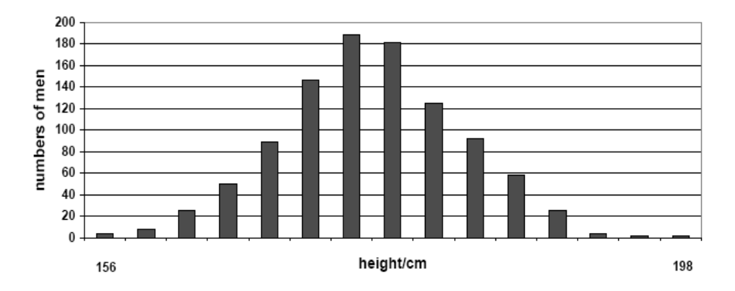

What term is used by biologists to describe differences within a population with respect to features such as height? …………………….………...
State two factors that could be responsible for the differences shown.
1. …………………………………………………………………………………………….
2. …………………………………………………………………………………………….
Would you expect a similar distribution if the students were weighed instead of being measured for height?
………………………………………………………………………………………………………………
Explain your answer. ………………………………………………………………………………………
………………………………………………………………………………………………………………
What is a mutation? ………….……………………………………………………………………………
State one cause of mutation. ………………………………………………………………………………
Give an example of a condition, found in the human population, that results from a mutation.
……………………………………………………………………………………..………………………
Answer

2004 HL
3. In tomato plants the allele responsible for purple stem (P) is dominant to that for green stem (p) and the allele for cut leaf (C) is dominant to the allele for potato type leaf (c). A plant with a purple stem and cut leaves was crossed with a plant with a green stem and potato type leaves. A total of 448 seeds was obtained. When the seeds were germinated four types of progeny resulted and they had the following phenotypes;
110 purple stem and cut leaves
115 green stem and potato type leaves
114 purple stem and potato type leaves
109 green stem and cut leaves

What were the genotypes of the tomato plants that gave rise to these progeny?
……………………………………………………………………………………………………………….
Do the progeny of this cross illustrate the Law of Independent assortment?………………………………..
Explain your answer ………………………………………………………………………………………….……………………….……………………………………………………………………………………….………………………………………………………………………………………………………………..…………………………………………………………………………………………………………………………………….
Answer

2007 HL
5. (a) In genetics, what is meant by sex linkage? …………………………………………………….
…………………………………………………………………………………………………
(b) In humans a sex-linked recessive allele c is responsible for red-green colour blindness.
Complete the blank spaces above the lines in the following cross.
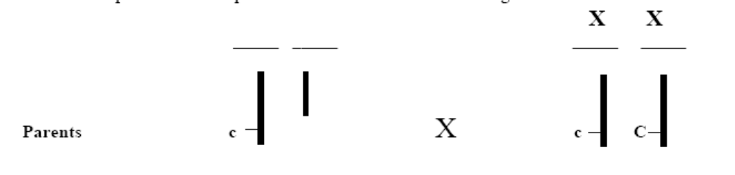
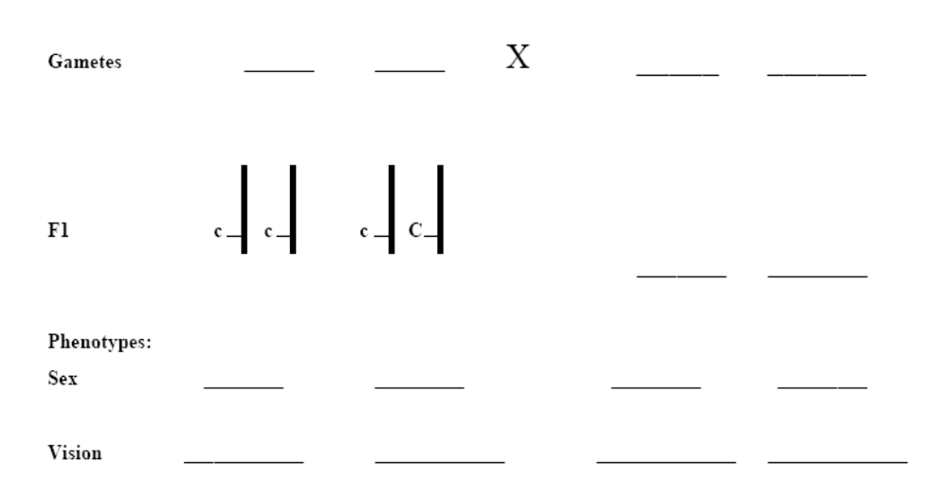
Answer

2009 HL
6. (a) What is genetic engineering? _____________________________________________________
_____________________________________________________________________________
(b) Name three processes involved in genetic engineering.
1. _____________________________________________
2. ______________________________________________
3. ______________________________________________
(c) Give an example of an application of genetic engineering in each of the following cases:
1. A micro-organism. ___________________________________________________________
2. An animal. __________________________________________________________________
3. A plant. ____________________________________________________________________
Answer

2010 HL
2. In each of the following cases read the information provided and then, from the list below, choose the correct percentage chance of obtaining the indicated offspring in each case.
0% 10% 25% 50% 75% 100%
(a) In the fruit fly Drosophila the allele for full wing is dominant to the allele for vestigial wing. One parent was homozygous in respect of full wing and the other parent was heterozygous.
What is the % chance of obtaining offspring with full wing?
% =
(b) In roses there is incomplete dominance between the allele governing red petals and the allele governing white petals. Heterozygous individuals have pink petals. A plant with pink petals was crossed with a plant with white petals.
What is the % chance of obtaining offspring with white petals?
% =
(c) In Dalmatian dogs the allele for brown spots is recessive to the allele for black spots. The two parents were heterozygous in respect of spot colour.
What is the % chance of obtaining offspring with black spots?
% =

(d) Red hair in humans is recessive to all other hair colours. A red-haired woman and a black-haired man, whose own father was red-haired, started a family.
What is the % chance of obtaining offspring with red hair?
% =
Answer

2010 HL
6. (a) In genetics, what is meant by the term variation?
_______________________________________________________________________________________
(b) Variation can result from mutation. Name one other cause of variation.
_______________________________________________________________________________________
(c) Name two types of mutation.
(i) ____________________________________ (ii) _____________________________________
(d) Name two agents responsible for increased rates of mutation.
(i) ____________________________________ (ii) _____________________________________
(e) Briefly explain the significance of mutation in relation to natural selection.
_______________________________________________________________________________________
_______________________________________________________________________________________
Answer

2013 HL
6. (a) (i) In DNA, nitrogenous bases occur in complementary pairs. Explain the term complementary as
used here.
____________________________________________________________________________
(ii) In each case, name the complementary base in RNA for:
1. Adenine _____________________
2. Cytosine _____________________
(iii) Name a carbohydrate that is a component of nucleotides.
____________________________________________________________________________
(iv) Name a component of a nucleotide that is neither a carbohydrate nor a nitrogenous base.
____________________________________________________________________________

(b) (i) What does the ‘m’ stand for in mRNA? ____________________________________________
(ii) Give one difference between RNA and DNA, other than the nitrogenous bases.
____________________________________________________________________________
(iii) Give the role of the enzyme RNA polymerase.
____________________________________________________________________________
Answer

Ordinary Level

SEC Sample Paper OL
3. Select the correct term from the following list to match each of the terms in column A and write it in column B.
liver, variation, lipid, haploid, sap

A | B
Cell membrane
Vacuole
Mutation
Organ
Gamete
Possible Answer

2004 OL
3. Indicate whether the following are true (T) or false (F) by drawing a circle around T or F.
Mitosis is the division of a nucleus into two identical nuclei T F
A sperm contains the haploid number of chromosomes T F
Chromosomes are made of DNA and lipid T F
Organisms of the same species can usually produce fertile offspring T F
Aerobic respiration is the release of energy in the absence of oxygen T F
RNA is not found in ribosomes T F
Immobilised enzymes can act as catalysts T F
Answer

2007 OL
4. Complete the following sentences by adding the missing word or symbols or number.
(a) Genetics is the study of ………………………………………………………………………………
(b) In a woman the sex chromosomes are XX; in a man they are ………………………………………
(c) If the diploid number in a cell is 46, the haploid number is …………………………………………
(d) In order to make proteins, DNA is first transcribed as messenger ………………………………….
(e) A change in the genetic material of an organism is called a …………….…….…………………….
Answer

2008 OL
5. The diagram represents a part of a DNA molecule. A and C represent nitrogenous bases.

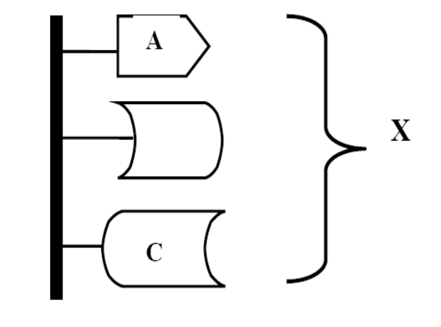
Complete the following in relation to DNA.
(a) Name the nitrogenous bases whose first letters are A and C.
A _____________________________ C ________________________________
(b) The structure labelled X is called a _________________________________________________
(c) Where in the cell would you expect to find most DNA? ________________________________
(d) DNA contains the instructions needed to make protein.
These instructions are called the _________________ code.
Answer

2009 OL
3. Natural selection is an important aspect of the study of evolution. Answer the following parts in relation to
evolution and natural selection.
(a) What is meant by natural selection? ___________________________________________________
________________________________________________________________________________
(b) Name a scientist who is associated with the Theory of Natural Selection.
________________________________________________________________________________
(c) Variation is essential for natural selection. Mutation can give rise to variation.
Give two causes of mutation.
(i) __________________________________________________________________________
(ii) __________________________________________________________________________
(d) Give one source of evidence for the occurrence of evolution.______________________________
_______________________________________________________________________________
Answer

2010 OL
4. Choose each term from the following list and place it in Column A to match a description from Column B. The first one has been completed as an example.
Dominant Gamete Gene Mutation Genetics Genotype
Column A | Column B
Genetics | The study of biological inheritance
(i) | The genetic make up of an individual
(ii) | A sex cell
(iii) | A change in the structure of DNA
(iv) | A part of DNA with information to make one protein
(v) | The allele expressed in the heterozygous condition
Answer

2012 OL
3. Indicate whether each of the following statements is true (T) or false (F) by drawing a circle around T or F in
each case.
Example: DNA is a double helical shape. T F
(a) The base Uracil is found in DNA. T F
(b) Chloroplasts contain DNA. T F
(c) The microscope lenses closest to the stage are the eyepiece lenses. T F
(d) Sodium alginate is used to immobilise enzymes. T F
(e) Plant cell walls are fully permeable. T F
(f) Animal cells do not have membranes. T F
(g) An organ is a group of systems. T F
Answer

20120OL
6. In pea plants the allele for tall (T) is dominant over the allele for dwarf (t).
A heterozygous tall plant is crossed with a dwarf plant.

Complete the blank spaces below.

Genotypes of parents (Tt) × (tt)

(a) Possible gametes ( ) ( ) × ( )

(b) Genotypes of offspring ( ) ( )

(c) Phenotypes of offspring ----------- ----------
Answer

2.5 Genetics

Section B

Higher Level Questions Ordinary Level Questions

Higher Level

2005 HL
8. (a) Explain each of the following terms in relation to DNA.
(i) Replication ……………………………………………………………………………….………
……………………………………………………………………………………………………
(ii) Transcription ………………………………………………………………………………….…
….………………………………………………………………………………………………..
(b) As part of your practical activities you extracted DNA from a plant tissue. Answer the following
questions in relation to this experiment.
(i) What plant did you use? ………………………………………………………………………..
(ii) It is usual to chop the tissue and place it in a blender. Suggest a reason for this.
…………………………………………………………………………..………………………
…………………………………………………………………………………………….……
……………………………………………………………………………………….…………
……………………………………………………………………………………………….…
(iii) For how long should the blender be allowed to run? ……………………………….………....
………………………………………………………………………………………………….
(iv) Washing-up liquid is normally used in this experiment. What is its function?
………………………………………………………………………………………………..…
……………………………………………………………………………………………..……
………………………………………………………………………………………….………
………………………………………………………….………………………………………
(v) Sodium chloride (salt) is also used. Explain why. ………..……………………………………
…….……………………………………………………………………………………………
.…………………………………………………………………………………………………
.…………………………………………………………………………………………………
(vi) What is a protease enzyme? ……………………………………………………………………
(vii) Why is a protease enzyme used in this experiment? …………………………………………...
……………………………………………………………………………………………….…
……………………………………………………………………………………………….…
……………………………………………………………………………………………….…
(viii) The final separation of the DNA involves the use of alcohol (ethanol). Under what condition is the alcohol used? …………………………………………………………………………………..
……………………………………………..……………………………………………………
Answer

2006 HL
7. (b) In the case of each of the following state:
1. An investigation in which you used it,
2. The precise purpose for its use in the investigation that you have indicated.

(iii) Cold alcohol (ethanol)
1…………………….…………………………………………………………………………………
2………………………………………………………………………………………………………
…………………………………………………………………………………………………………
…………………………………………………………………………………………………………
Answer

2010 HL
8. (b) For which purpose did you use each of the following in the course of your practical studies?
(i) Methylene blue or iodine solution when examining cells with the microscope.
…………………………………………………………………………………………………
(ii) An aquatic plant such as pondweed rather than a terrestrial plant when investigating the rate
of photosynthesis.
…………………………………………………………………………………………………
(iii) 1. Washing-up liquid or other detergent while extracting DNA from plant tissue.
…………………………………………………………………………………………………
2. Freezer-cold ethanol while extracting DNA from plant tissue.
…………………………………………………………………………………………………
(iv) 1. Antiseptic wash solution in the investigation of the growth of leaf yeast on agar plates.
…………………………………………………………………………………………………
2. Petroleum jelly in the investigation of the growth of leaf yeast on agar plates.
…………………………………………………………………………………………………
(v) 1. Biuret solution or alkaline copper sulphate in food testing.
…………………………………………………………………………………………………
2. Brown paper or Sudan III in food testing.
…………………………………………………………………………………………………
Answer

2011 HL
9. (a) (i) How are the two strands of a DNA molecule joined together? ________________________
(ii) What is ‘junk’ DNA? ________________________________________________________

(b) Answer the following questions by referring to the procedures that you used to isolate DNA from a
plant tissue.
(i) Having obtained a plant tissue e.g. onion,
1. What was the first procedure that you followed?
_________________________________________________________________________
2. What was the reason for that procedure?
_________________________________________________________________________
(ii) Washing-up liquid is then used in the isolation. Give a reason for its use.
__________________________________________________________________________
(iii) Salt (sodium chloride) is also used in the isolation. Give a reason for its use.
__________________________________________________________________________
(iv) 1. What is a protease?
__________________________________________________________________________
2. Why is a protease necessary when isolating DNA?
__________________________________________________________________________
(v) The final stage of the isolation involves the use of freezer-cold ethanol.
1. Describe how it is used. ___________________________________________________
2. For what purpose is it used? _______________________________________________
Answer

Ordinary Level

2007 OL
7. (a) (i) Is an enzyme a lipid, a protein or a carbohydrate? …………………………………………...
(ii) Where in a cell are enzymes produced? ………………………………………………
Answer

2010 OL
7. In one of your laboratory activities you isolated DNA from a plant tissue.
(a) (i) Where in plant cells is DNA found? ______________________________________________
(ii) What is meant by DNA profiling? ________________________________________________
_____________________________________________________________________
_____________________________________________________________________

(b) (i) Give one reason why you first chopped the plant material into very small pieces.
_____________________________________________________________________
(ii) Detergent and salt were added to the chopped plant material, which was then heated.
Explain why the detergent was used. ______________________________________________
_____________________________________________________________________
(iii) How was this mixture heated? _____________________________________________________________________
(iv) Why was this mixture heated?
_______________________________________________________________________
(v) Later in the activity the mixture was blended for a maximum of 3 seconds.
What would happen to the DNA if the mixture was blended for longer than 3 seconds?
_____________________________________________________________________
(vi) Protease was then added to the mixture.
Why was protease added?
_____________________________________________________________________
(vii) The mixture was then filtered.
After filtration, where was the DNA of your plant tissue to be found?
_____________________________________________________________________
(viii) What should you do next to make the DNA visible?
_____________________________________________________________________
Answer

2011 OL
8. (b) For what purpose did you use each of the following in the course of your practical
activities?

(i) Fehling’s solution or Benedict’s solution.
Purpose. _________________________________________________________________
(ii) Anaerobic jar.
Purpose. _________________________________________________________________
(iii) Cover slip.
Purpose. _________________________________________________________________
(iv) Buffer solution.
Purpose. _________________________________________________________________
(v) Methylene blue.
Purpose. _________________________________________________________________
(vi) Sodium alginate.
Purpose. _________________________________________________________________
(vii) IAA.
Purpose. _________________________________________________________________
(viii) Freezer-cold alcohol.
Purpose. _________________________________________________________________
Answer

2012 OL
8. (a) (i) What is an enzyme? _____________________________________________________________
(ii) On what structures in the cytoplasm are enzymes made? ________________________________
Answer

2.5 Genetics

Section C

Higher Level Questions Ordinary Level Questions

Higher Level

SEC Sample Paper HL
11. (a) (i) What is meant by the term segregation as used in genetics?
(ii) State the products of segregation when an organism is heterozygous in respect of the dominant allele A. (9)

(b) (i) State the Law of Independent Assortment.
(ii) In cattle the allele for red coat (R) is dominant to the allele for black coat (r) and the allele for straight coat (S) is dominant to the allele for curly coat (s). When a bull with a red, straight coat was mated with cows with curly, black coats it was found that calves with four different phenotypes resulted. These four phenotypes occurred in equal numbers.
1. State the genotypes of the bull and of the cows.
2. State the phenotypes of the calves.
3. Which phenotypes of the calves suggest that independent assortment has taken place?
4. Would you expect different phenotypes if the genes for coat colour and coat type were located on the same chromosome? Explain your answer. (27)

(c) Answer the following in relation to protein synthesis.
(i) Outline the main events of transcription.
(ii) What is a triplet? State the role of a triplet.
(iii) Describe the role of tRNA. (24)
Possible Answer

2004 HL
13. (a) Copy the diagram into your answer book and then complete it to show the complementary base
pairs of the DNA molecule. Label all parts not already labelled. (9)
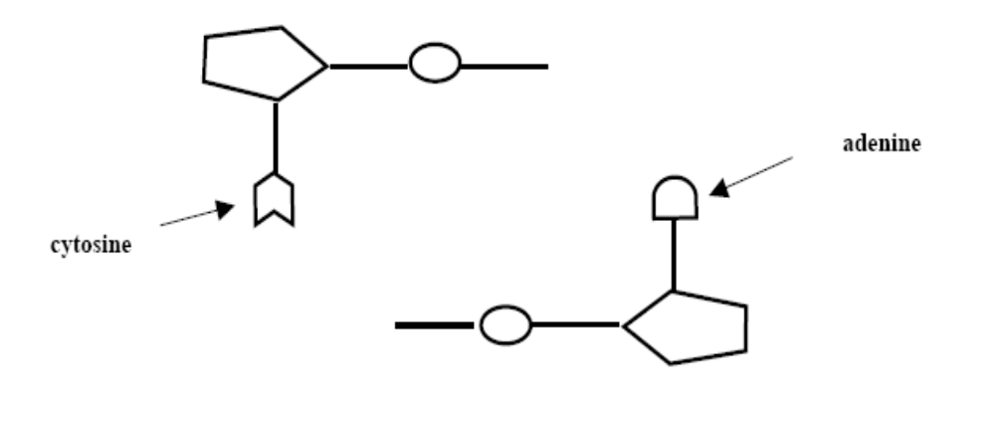
(b) The genetic code incorporated into the DNA molecule finds its expression in part in the formation of protein. This formation requires the involvement of a number of RNA molecules. List these RNA molecules and briefly describe the role of each of them. (24)

(c) Read the following passage and answer the questions that follow.
Dolly, the most famous sheep in the world, was cloned in the Roslin Institute in Scotland in 1996. When this was announced in February 1997 it caused a sensation, because until then many scientists thought that such cloning was impossible. Such cloning is the production of one or more animals that are genetically identical to an existing animal. This cloning technique is based on the fact that, with the exception of the sperm and the egg, every cell in the body contains in its DNA all of the genetic material needed to make an exact replica of the original body. During the normal development process from embryo to fully-fledged animal, all of the cells in the body are differentiated to perform specific physiological functions.

Before Dolly, the majority view was that such differentiated cells could not be reprogrammed to be able to behave as fertilised eggs. Dolly was produced by a process known as "adult DNA cloning", which produces a duplicate of an existing animal. The technique is also known as "cell nuclear replacement". During adult DNA cloning, the DNA is sucked out from a normal unfertilised egg cell, using a device that acts somewhat like a miniature vacuum cleaner. DNA that has already been removed from a cell of the adult to be copied is then inserted in place of the original DNA. Following this stage, the cell containing the inserted DNA is implanted in the womb of an animal of the same species, and gestation may begin.

To make Dolly, a cell was taken from the mammary tissue of a six-year-old sheep. Its DNA was added to a sheep ovum (egg) from which the nucleus had been removed. This artificially fertilized cell was then stimulated with an electric pulse and implanted in an ewe.
{Adapted from www.biotechinfo.ie}

(i) What is the difference between a nucleus of an egg cell and that of a somatic (body) cell of an animal?
(ii) Suggest an advantage of producing genetically identical animals.
(iii) Suggest a disadvantage of producing genetically identical animals.
(iv) “Every cell in the body contains in its DNA all of the genetic material needed to make an exact replica of the original body”. Comment on this statement.
(v) What is the precise meaning of the term “implanted” in the extract above?
(vi) Suggest a purpose for stimulating the fused egg with an electric pulse.
(vii) What do you think is meant by the phrase “artificially fertilised cell”? (27)
Answer

2005 HL
10. (a) (i) What is meant by genetic engineering?
(ii) State two applications of genetic engineering, one involving a micro-organism and one involving a plant. (9)

(b) Cystic fibrosis is a serious condition that affects the lungs and digestive system. The condition results from
the inheritance of a single pair of recessive alleles.
(i) Explain each of the underlined terms.
(ii) Suggest why a person with a heterozygous allele pair does not suffer from the condition.
(iii) If both parents are heterozygous what is the percentage chance that one of their children may inherit the condition? Explain how you obtained your answer.
(iv) What is meant by genetic screening?
(v) Parents who are suspected of being carriers of disease-causing alleles may be advised to consider a genetic test. Suggest a role for such a test after in-vitro fertilisation.

(c) (i) Define the following terms as used in genetics; linkage, sex linkage.
(ii) Explain why linked genes do not assort independently.
(iii) Red-green colour blindness is a sex (X)-linked condition. Normal red-green vision results from the possession of a dominant allele (C). In each of the following cases give the genotypes of the mother and of the father.
1. A family in which one daughter is red-green colour blind and one daughter has normal colour vision.
2. A family in which all the sons are red-green colour blind and all the daughters are carriers (heterozygous). (24)
Answer

2006 HL
12. (a) (i) Explain the following terms as used in genetics: species, variation.
(ii) Give one cause of genetic variation. (9)

(b) The diagram shows some of the chromosomes in the nucleus of a cell taken from a small mammal.
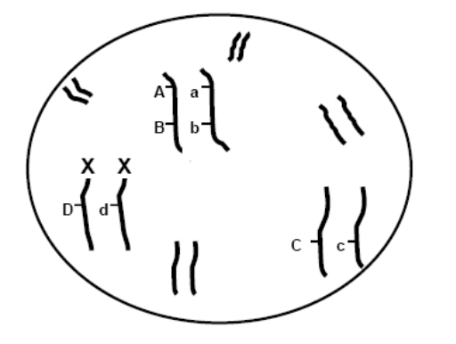

(i) What is the sex of this individual?
(ii) How many loci are marked in the diagram?
(iii) “A is linked to B but not to C”. Is this statement correct? Explain your answer.
(iv) Is D linked to d? Explain your answer.
(v) What term is used to describe the allele pair Dd?
(vi) Draw a diagram, similar to the one above, but in which A, B, and C are homozygous and the cell is taken from an individual of the opposite sex. (27)

(c) Give an account of the Theory of Natural Selection. Name the scientists who are associated with the theory and refer to any one observation that prompted its development. (24)
Answer

2007 HL
10. (a) (i) The DNA molecule is composed of two strands held together by paired bases.
1. Which base can link only to thymine?
2. Which base can link only to cytosine?
(ii) Name the type of bonding which occurs between members of a base pair. (9)

(b) (i) Explain what is meant by the term DNA profiling.
(ii) Give a brief account of the stages involved in DNA profiling.
(iii) Give two applications of DNA profiling.
(iv) What is genetic screening? (27)

(c) “The same amount of DNA is present in nuclei of cells taken from the liver, heart, pancreas and
muscle of a rat.”
(i) Use your knowledge of DNA and mitosis to explain this statement.
(ii) Name a cell produced by the rat which will contain a different amount of DNA in its nucleus to those mentioned above.
(iii) Briefly outline how you isolated DNA from a plant tissue. (24)
Answer

2008 HL
11. (a) Explain the following terms which are used in genetics: homozygous, recessive, phenotype. (9)

(b) In the fruit fly, Drosophila, the allele for grey body (G) is dominant to the allele for ebony
body (g) and the allele for long wings (L) is dominant to the allele for vestigial wings (l). These two pairs of alleles are located on different chromosome pairs.
(i) Determine all the possible genotypes and phenotypes of the progeny of the following cross: grey body, long wings (heterozygous for both) X ebony body, vestigial wings.
(ii) What is the significance of the fact that the two allele pairs are located on different chromosome pairs?
(27)
(c) Haemophilia in humans is governed by a sex-linked allele. The allele for normal blood clotting (N) is dominant to the allele for haemophilia (n).
(i) What is meant by sex-linked?
(ii) Determine the possible genotypes and phenotypes of the progeny of the following cross: haemophilic male X heterozygous normal female. (24)
Answer

2008 HL
14. (b) (i) DNA is made of units called nucleotides. Draw a labelled diagram of a nucleotide to show
its three constituent parts.
(ii) Which of the labelled parts in your diagram in (i) may vary from nucleotide to nucleotide?
(iii) The genetic code is contained within the DNA of chromosomes. Briefly describe the nature of this code.
(iv) What is meant by non-coding DNA?
(v) Give one structural difference between DNA and RNA.
(vi) Name a cell organelle, apart from the nucleus, in which DNA is found.
Answer

2009 HL
10. (a) (i) State Mendel’s Law of Segregation.
(ii) Name two cell organelles, other than the nucleus, that contain DNA. ( 9)

(b) In guinea pigs the allele for black hair (B) is dominant to the allele for brown hair (b) and the allele for short hair (S) is dominant to the allele for long hair (s). The alleles governing hair colour are located on a different chromosome pair to those governing hair length.
(i) Explain the terms alleles and dominant.
(ii) What term is used to describe alleles that lie on the same chromosome?
(iii) Why is it significant that the two pairs of alleles, mentioned above in relation to guinea pigs, are located on different chromosome pairs?
(iv) Determine all the possible genotypes and phenotypes of the offspring of a cross between the following guinea pigs:

Brown hair, heterozygous short hair X Heterozygous black hair, long hair

(c) (i) Explain the term species.
(ii) Within a species a considerable degree of variation is usually seen.
- What is meant by variation?
- State two causes of variation.
(iii) What is the significance of inherited variation in the evolution of species?
(iv) State two types of evidence used to support the theory of evolution.
Answer

2010 HL
10. Part (a) deals with DNA structure and replication.
(a) (i) Name the base in DNA that pairs with cytosine.
(ii) What are the two main events in the replication of DNA? (9)

Part (b) deals with protein synthesis.
(b) (i) Explain the terms transcription and translation.
(ii) In which structures in the cell does translation occur?
(iii) How many bases in sequence make up a codon in mRNA?
(iv) Each mRNA codon specifies one of three possible outcomes during protein synthesis.
Name these three possible outcomes.
(v) What does the letter ‘t’ stand for in tRNA?
(vi) During translation one end of a tRNA molecule attaches to an mRNA codon.
What is usually attached to the other end of the tRNA molecule? (27)

(c) Distinguish between the terms in the following pairs by writing one sentence about each
member of each pair.
(i) Haploid and diploid
(ii) Homozygous and heterozygous
(iii) Genotype and phenotype
(iv) Segregation and independent assortment. (24)
Answer

2011 HL
13. (a) (i) What is meant by the term evolution?
(ii) Name either of the scientists responsible for the Theory of Natural Selection. (9)

(b) In the antirrhinum (snapdragon) there is no dominance between the allele for red flower and the allele
for white flower. Heterozygous individuals have pink flowers.
The allele for tall stem is dominant to the allele for short stem.
These pairs of alleles are located on different chromosome pairs.
(i) What is the significance of the fact that the two allele pairs are located on different
chromosome pairs?
(ii) A plant which had pink flowers and was heterozygous in respect of stem height was crossed
with one which had white flowers and a short stem.
1. Using suitable symbols determine the genotypes of all the possible offspring of this cross.
2. For each of your answers, state the phenotype that would result. (27)

(c) Distinguish between the members of each of the following pairs of terms, by writing a sentence
about each member of each pair.
(i) Gene and allele.
(ii) Homozygous and heterozygous.
(iii) Genotype and phenotype.
(iv) Linkage and sex linkage. (24)
Answer

2012 HL
10. (a) (i) Nucleic acids are composed of subunits called nucleotides. Each nucleotide is formed from a
sugar, a phosphate group and a nitrogenous base.
Name the two types of nitrogenous base found in DNA.
(ii) Give both of the specific base pairs in DNA structure. (9)

(b) In the sweet pea plant the texture and colour of the testa (seed coat) are governed by two pairs of
alleles, which are not linked. The allele for smooth (S) is dominant to the allele for wrinkled (s) and
the allele for yellow (Y) is dominant to the allele for green (y).
(i) State the Law of Segregation and the Law of Independent Assortment.
(ii) Using the above symbols, and taking particular care to differentiate between upper case and
lower case letters:
1. give the genotype of a pea plant that is homozygous in respect of seed texture and
heterozygous in respect of seed colour.
2. state the phenotype that will result from the genotype referred to in 1.
(iii) What phenotype will be produced by the genotype SsYy?
Give another genotype that will produce the same phenotype. Do not use a genotype
that you have already given in response to part (ii) 1.
/(iv) If the allele for smooth were linked to the allele for green and the allele for wrinkled were
linked to the allele for yellow, give the genotypes of the two gametes that parent SsYy
would produce in the greatest numbers. (27)

(c) (i) What is meant by the term genetic engineering?
(ii) In genetic engineering all or some of the following procedures may be involved.
Isolation;
Cutting (restriction);
Transformation (ligation);
Introduction of base sequence changes;
Expression.
Briefly explain each of the above terms in the context of genetic engineering.

(iii) Give one application of genetic engineering in any two of the following.
1. An animal.
2. A plant.
3. A micro-organism.
(24)
Answer

2013 HL
11. (a) (i) Give a source of evidence for evolution.
(ii) Briefly outline the evidence from the source referred to in (i).

(b) (i) Human males and females differ in one of their twenty three pairs of chromosomes.
What name is given to this pair of chromosomes?
(ii) Draw this pair of chromosomes for a human male and for a human female and label them
appropriately.
(iii) Using the chromosomes referred to in part (b) (ii), show, using a Punnett square or
otherwise, that a child stands an equal chance of being male or female.
(iv) 1. What is meant in genetics by the term sex linkage?
2. Name two common sex-linked traits.
Answer
(c) Answer the following questions, which relate to events in the cell cycle.
(i) What name is applied to the period of the cell cycle in which division is not taking place?
(ii) Give a cellular process that occurs during this period in which the nucleus is not dividing.
(iii) Draw a labelled diagram to show the position of the chromosomes during metaphase of
mitosis in a nucleus in which 2n = 6.
(iv) 1. State a function of one of the structures, other than chromosomes, that you have labelled
in your diagram of metaphase.
2. How does the structure carry out this function?
(v) What term is used for the group of disorders in which control has been lost over the rate of
mitosis?

Ordinary Level

SEC Sample Paper OL
11. (a) (i) What is meant by the term DNA profiling?
(ii) State two uses of DNA profiling. (9)

(b) In humans an individual’s sex is determined by genes located on pairs of chromosomes called sex chromosomes. The male pair is shown as XY and the female pair as XX.
Show that there is an equal chance of a child being male or female by copying and completing the Punnett square in your answer book. Give the gametes of each parent and the genotypes of the offspring. (24)

(c) (i) What is meant by the term evolution?
(ii) Describe the process of natural selection.
(iii) Give an account of the evidence for evolution from a named source. (27)
Possible Answer

2004 OL
12. (a) Explain the following terms that are used in genetics; dominance, genotype, phenotype. (9)
(b) In Aberdeen Angus cattle, the polled (P) condition (absence of horns) is dominant to the horned (p)
condition. A heterozygous polled bull was crossed with a horned cow. Use the following layout in your answer book to find the possible genotypes and phenotypes of the calves that may result from this cross.

Heterozygous polled bull X Horned cow
Genotypes of parents …………. …………..
Gametes …….. …….. ……..
Genotypes of calves ………………… ……….……………
Phenotypes of calves ………………… ……….…………… (27)
(c) (i) What is meant by DNA profiling?
(ii) Describe briefly how DNA profiling is carried out.
(iii) Give two uses of DNA profiling. (24)
Answer

2005 OL
13. (a) For each of the following parents give the genotypes of all the possible gametes that it can produce.
(i) Parent Aa.
(ii) Parent AaBb. (9)

(b) (i) Name the four bases that are found in DNA.
(ii) These bases form a triplet code. What is meant by a triplet code?
(iii) The triplet code is transcribed into mRNA. What does this statement mean?
(iv) To which structures in the cell does mRNA carry the code? (24)

(c) (i) What is evolution?
(ii) What is Natural Selection?
(iii) Name one of the scientists who developed the Theory of Natural Selection.
(iv) Give a brief account of the evidence for evolution from one named source. (27)
Answer

2006 OL
11. (a) Explain the following terms, which are used in genetics: allele, homozygous, genotype. (9)

(b) (i) Name or draw the sex chromosomes that are present in a human body cell in the case of:
1. A male,
2. A female.
(ii) Use a Punnet square to show that there is a fifty percent chance that fertilization will lead to a male and fifty percent chance that it will lead to a female. (27)

(c) (i) What is genetic engineering?
(ii) Give one example of genetic engineering involving an animal and one example involving a plant. (24)
Answer

2007 OL
11. (c) (i) Explain briefly what is meant by a gene.
(ii) Where in the nucleus would you find genes?
(iii) The allele for brown eye (B) is dominant to the allele for blue eye (b).
Explain each of the underlined terms.
(iv) Use a Punnet square to find the possible genotypes of children of parents who are both heterozygous for brown eye. State the eye colour resulting from each of these genotypes. (27)
Answer

2008 OL
11. (a) (i) What is a chromosome?
(ii) The haploid number of chromosomes is found in the human egg and sperm.
Explain the underlined term.

(b) Hair colour in humans is genetically controlled. The allele for brown hair (B) is dominant to the
allele for red hair (b).
(i) Explain the underlined terms.
(ii) For hair colour Seán is heterozygous (Bb) and Máire is homozygous (bb).
1. What colour is Seán’s hair?
2. What colour is Máire’s hair?
(iii) Use a Punnet square or other means to show the following:
1. the genotypes of all the gametes that Seán and Máire can produce.
2. the genotypes of the children that Seán and Máire may have.
(iv) What is the probability that one of their children may have red hair? (Give your answer as a ratio or a percentage). (27)

(c) (i) What is meant by evolution?
(ii) Name one of the scientists associated with the Theory of Natural Selection.
(iii) Give a brief account of the Theory of Natural Selection.
(iv) Outline the evidence for evolution from any one named source. (24)
Answer

2009 OL
10. (c) (i) What is meant by the term species?
Answer

2009 OL
11. (a) Explain the following terms as used in genetics:
(i) heterozygous
(ii) incomplete dominance
(iii) phenotype. (9)

(b) In snapdragon plants the allele for red flower (R) is incompletely dominant to the allele for white flower (r). Heterozygous plants have pink flowers.

(i) Using a Punnett square, or otherwise, give the genotypes of the parents and find the genotypes and phenotypes of the offspring of the following cross:
Pink-flowered snapdragon x Pink-flowered snapdragon
(ii) If 120 new plants were produced in this cross, how many of them would you expect to have pink flowers?
Explain how you got this answer. (27)

(c) (i) What is meant by DNA profiling?
(ii) In DNA profiling, what are used to cut DNA strands into fragments?
(iii) On what basis are these fragments then separated?
(iv) Give two applications (uses) of DNA profiling.
(v) Name the plant from which you isolated DNA in your practical studies.
(vi) For what precise purpose did you use freezer-cold ethanol (alcohol) in your isolation of DNA?
(24)
Answer

2010 OL
11. (a) Many characteristics are passed on to children by their parents.
(i) Give one example of an inherited human characteristic.
(ii) Give one example of a non-inherited human characteristic.
(iii) Which structures in sperm and egg nuclei are responsible for biological inheritance? (9)
(b) When a pure-breeding black cat was mated with a pure-breeding white cat, all the kittens were black.
(i) Which fur colour, black or white, is recessive in these cats?
(ii) Using capital letters for dominant and lower case letters for recessive, give:
1. The genotypes of the parent cats.
2. The genotype of the kittens.
(iii) Is the genotype of the kittens referred to as homozygous or heterozygous?
(iv) Give a reason for your answer to part (iii).
(v) In relation to fur colour, what will be the genotypes of the gametes that these kittens will produce?
(vi) What are alleles? (27)
(c) The diagram shows a short section of a DNA molecule.
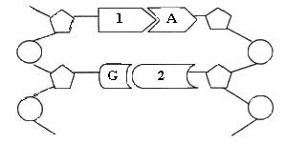
(i) Name the bases numbered 1 and 2 in the diagram above.
(ii) Protein synthesis involves both transcription and translation.
Where in a cell does transcription occur?
(iii) What type of RNA is involved in transcription?
(iv) In what organelle does translation occur?
(v) Name the small biomolecules that are joined together to make a protein.
(vi) What must happen to the newly formed protein before it can begin to work?
(vii) Give one function of proteins in living organisms. (24)
Answer

2011 OL
10. (a) Explain the following terms that are used in genetics:

(i) Allele
(ii) Heterozygous
(iii) Phenotype. (9)

(b) In humans, brown eye (B) is dominant to blue eye (b). Two parents, one heterozygous for
eye colour and the other with blue eyes, start a family.

(i) What is the genotype of the blue-eyed parent?
(ii) What are the possible gametes that each parent can produce?
(iii) Using a Punnett square or another method work out the possible genotypes and
phenotypes of their children. (24)

(c) (i) Explain, in terms of what happens to body cells, what is meant by the term cancer.
(ii) Give two possible causes of cancer.
(iii) Some people choose to be screened to determine their risk of getting a particular
type of cancer.
What is meant by genetic screening?
(iv) Blood samples taken from a crime scene were put through a process called DNA
profiling. During the process cells were broken down to release the DNA,
which was then cut into fragments. The fragments were then separated.
1. What was used to cut the DNA?
2. On what basis were the DNA fragments separated?
3. Give an application of DNA profiling other than solving crime.
(v) The following are the results of the DNA profiling process. Using these results,
identify which suspect, A, B or C committed the crime. (27)

Answer

2012 OL
11. (a) (i) In genetics, what is meant by the term haploid?
(ii) What is a chromosome? (9)
/
(b) Read the paragraph below and answer the questions that follow.

The rabbit in the photograph has no pigment in its skin, fur or eyes. This is due to
an inherited condition known as albinism. Such animals are unable to produce
melanin, a protein pigment that gives colour to the skin, eyes, fur or hair. This
condition makes an animal more likely to be preyed upon.
Albinism is caused by genetic mutation. The gene that causes albinism (lack of
pigment) is a recessive gene. If an animal has one gene for albinism and one gene
for pigmentation, it will have enough genetic information to make pigment and
the animal will not have this disorder. However, if both genes are recessive the
result is albinism. At least 300 species of animal have albino individuals e.g.
rabbits, turtles, squirrels, deer and frogs.

(i) What are the main characteristics of albinism?
(ii) What is meant by the term recessive gene?
(iii) What is a mutation?
(iv) Mutations can lead to variation in organisms. Variations that make an organism better adapted to its
environment can lead to evolution.
/1. What is meant by evolution?
2. Name one of the scientists who first explained how evolution occurs by natural selection.
3. Give one source of evidence for evolution.
(v) People with albinism should always apply a high-factor sunscreen when going outdoors and must avoid strong sunshine. Suggest a reason for these precautions. (27)

(c) (i) Genetic engineering is regularly used in animals, plants and micro-organisms.
What is meant by genetic engineering?
(ii) List three of the main procedures used in genetic engineering.
(iii) Give two examples of how genetic engineering is used. (24)
Answer

2013 OL
10. (a) Explain the following terms used in genetics:
(i) Gene.
(ii) Allele.
(iii) Genotype. (9)

(b) There are four bases in DNA structure.
These are adenine (A), cytosine (C), thymine (T) and guanine (G).

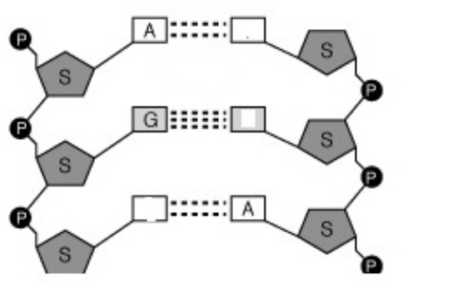

(i) Name the bases at positions X and Y in the diagram.
(ii) Where in a human cell would you expect to find most DNA?
(iii) Proteins are made in the ribosomes using a code from DNA. Name the molecule that
carries the DNA code to the ribosomes.
(iv) What is meant by DNA profiling?
(v) In DNA profiling, what is used to cut the DNA strands into fragments?
(vi) Give two applications of DNA profiling. (27)

(c) In humans, sex is determined by genes located on pairs of chromosomes called sex chromosomes.

Using a Punnett square or otherwise, show that there is an equal chance of a child being male or
female.
In your answer give:
(i) The genotypes and matching phenotypes of the parents.
(ii) The possible genotypes of the gametes that can be produced by each parent.
(iii) The genotypes of the offspring. (24)
Answer

UNIT THREE

The Organism

3.1 Diversity of Organisms

Need to Know

3.1.1 (+ 3.1.7 - 8) Diversity of organisms
3.1.3 Monera e.g. Bacteria
3.1.4 Fungi
3.1.5 (+ 3.1.2) Laboratory procedures - Microorganisms
3.1.6 Protista e.g. Amoeba
3.1.9.H Nature of Bacteria and Fungi
3.1.10.H Growth Curves

At the end of this section students should be able to:

Diversity
- List the five kingdoms used to classify plant and animals
- Discuss the plant kingdom with the flowering plant as an example
- Discuss the animal kingdom with the human as an example

Bacteria
- Outline the distribution of fungi & bacteria in nature
- Name 3 main types of bacterial cells.
- Explain the structure of each type , including plasmids
- Explain reproduction of bacteria.
- Explain nutrition of bacteria.
- State the factors affecting growth of micro-organisms.
- Define the term: Pathogenic
- Define the term: antibiotics
- State the role of antibiotics.
- Outline the potential abuse of antibiotics
- Name two Beneficial and two harmful bacteria

Fungi
- Define the terms: saprophytic & parasitic.
- Explain nutrition in fungi.
- State the structure & life cycle of Rhizopus.
- Identify and state functions for the following structures: rhizoid, sporangium, gametangium, zygospore.
- Outline the structure & reproduction of Yeast.
- Name 2 Beneficial & 2 Harmful fungi.
- Give examples of Edible and Poisonous fungi.

Laboratory Procedures
- Outline the distribution of fungi & bacteria in nature
- Outline the Laboratory Procedures for Micro-organisms
- State precautions used when working with micro-organisms.
- Define the term Asepsis
- Define the term Sterility
- Outline containment & disposal methods in relation to microbes.

Amoeba
- Draw a labelled diagram of Amoeba
- Explain the function of the labelled parts of Amoeba

Nature of Microorganisms
- Explain the prokaryotic nature of bacteria
- Explain the eukaryotic nature of fungi

Growth curves
- Discuss the growth curves of micro organisms
- Compare Batch and Continuous Flow Food Processing

PowerPoint Presentations

3.1.1 (+3.1.7 – 8) Diversity of organisms.ppt
3.1.3 Monera.ppt
3.1.4 Fungi.ppt
3.1.5 (+3.1.2) Handling Micro-organisms.ppt
3.1.6 Amoeba.ppt
3.1.9.H Nature of Bacteria & Fungi.ppt
3.1.10.H Growth Curves.ppt

3.1 Diversity of Organisms

Section A

Higher Level Questions Ordinary Level Questions

Higher Level

2004 HL
1. (a) Name an autotrophic organism …………………………………………………………………………
(b) Give an example of a catabolic reaction ………….……………………………………………………
(c) The conversion of atmospheric nitrogen to nitrates by bacteria is called ……………………………...
(d) What is the ratio of hydrogen atoms to oxygen atoms in a carbohydrate? …………………………….
(e) A relationship between two organisms in which both benefit is called ………………………..………
(f) An example of a protein that has a structural role ……………………………………………..………
Answer

2006 HL
6. (c) Distinguish between the members of each of the following pairs by making a brief comment on each.
Hypha and mycelium ……………………..……………………………………………………….……………………………
……..………………………………………………………………………….…………………………
……….…………..…………………………………………………………………………...………….
Answer

2010 HL
3. The diagram shows the structure of Amoeba.

(a) Name the parts labelled A, B and C.
A ………………………………. B ……………………………….. C ……………………………......
(b) To which kingdom does Amoeba belong? ….…………………………………………………………
(c) Is the cell of Amoeba prokaryotic or eukaryotic? ….………………………………………………….
(d) Give a reason for your answer to part (c) ....…………………………………………………………..
(e) Give one function of A in Amoeba ……………………………………………………………............
(f) 1. Give one function of B in Amoeba ………………………………………………………….......
2. Suggest one reason why B is more active in freshwater amoebae than in marine amoebae.
……………………………………………………………………………………………………………
Answer

Ordinary Level

SEC Sample Paper OL
2. Bacterial cells have three main shapes. Two of these are shown below. Name each shape.
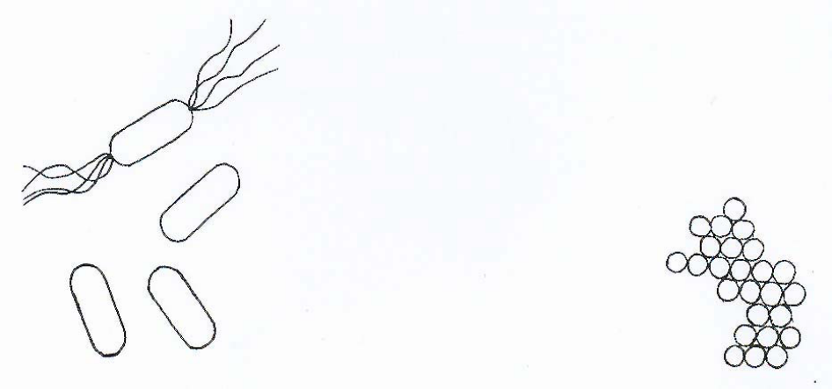

Name ………………… …………………… Name …………………………………………
Bacteria reproduce asexually by dividing in two. What term is used for this form of asexual reproduction? ………………………………………………………………………………………………………………
What do bacteria form when environmental conditions become unfavourable?
…………………………..……………………………………………………………………………………
What does the term pathogenic mean in relation to bacteria?
…………………………………………………………………..……………………………………………
Possible Answer

2005 OL
6. (a) The diagram shows the structure of Amoeba.

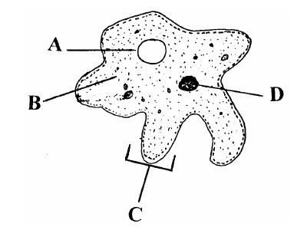

(i) Name A, B, C, D.
A ……………………………. B ……………………………….
C ……………………………. D ……………………………….
(ii) To which kingdom does Amoeba belong? ….…………………………………..

(b) The diagram shows the structure of a typical bacterium.

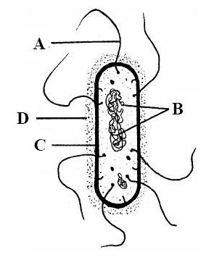

(i) Name A, B, C, D.
A …………………………..……. B ………..…………………….
C ……………………..…………. D ………..…………………….
(ii) To which kingdom do bacteria belong? ……………………………………………
Answer

2006 OL
6. The diagram shows a yeast cell, which is undergoing asexual reproduction.
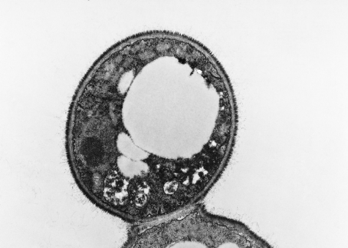
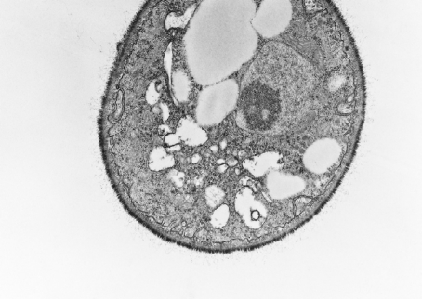
A.B. DOWSETT/SCIENCE PHOTO LIBRARY

(a) Name A and B
A ………………………………… B ………………………………………
(b) What type of asexual reproduction is shown in the diagram? ………...………………………………
…………………………………………………………………………………………………………
(c) Which type of division, mitosis or meiosis, is involved in this form of reproduction?
…………………………………………………………………………………………………………
(d) If yeast cells are kept under anaerobic conditions, alcohol (ethanol) and another substance are produced.
(i) What are anaerobic conditions? ………………………….………………………………….…
…………………………………………………………………………………………….……
(ii) Name the other substance produced. …………………………………………………………...
…………………………………………………………………………………………………..
Answer

2011 OL
4. Indicate whether each of the following statements is true (T) or false (F) by drawing a circle
around T or F in each case.

Example: The liver produces bile T F

(a) The semicircular canals in the ear are involved in balance. T F
(b) The growth response of a plant to light is called phototropism. T F
(c) Tendons attach bone to bone. T F
(d) A motor neuron carries impulses to the brain. T F
(e) Rhizopus is a member of the animal kingdom. T F
(f) Xylem transports water in plants. T F
(g) A potato is a modified stem. T F
Answer

2012 OL
2. Amoeba is a tiny, one-celled organism.
This diagram shows the structure of a freshwater Amoeba as seen through a microscope.

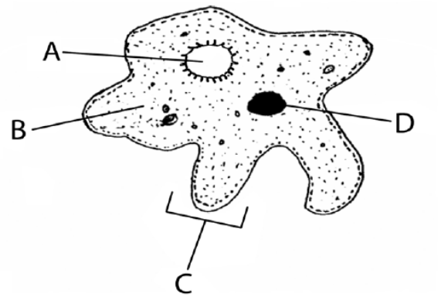

(a) Name the parts labelled A, B, C and D.
A. ____________________________ B. ______________________________
C. _____________________________ D. ______________________________
(b) State:
one function of part A. ______________________________________________________________
one function of part C. ______________________________________________________________
(c) Give one difference between a plant cell and an amoeba.
_____________________________________________________________________________________
Answer

3.1 Diversity of Organisms

Section B

Higher Level Questions Ordinary Level Questions

Higher Level

SEC Sample Paper HL
8. (a) To which kingdom do yeasts belong? ………………………………………………… ………………
State one way in which yeast is beneficial to humans ………………………………………………….

(b) Answer the following by reference to an experiment that you have carried out to investigate the growth of leaf yeast.
Name the nutrient medium on which you grew the yeast……………………………………..
Why was a nutrient medium necessary? …………………………………….………………..
……………..…………………………………………………………………………………..
From what plant did you obtain the yeast? ……………...…………………………………….
Describe how you transferred the yeast to the nutrient medium
…………………………………………………………………………………….……………
………………………………………………………………………………………………….
………………………………………………………………………………………………….
………………………………………………………………………………………………….
Outline the procedures that you followed after you transferred the yeast to the nutrient medium.
………………………………………………………………………………………………….
………………………………………………………………………………………………….
………………………………………………………………………………………………….
………………………………………………………………………………………………….
………………………………………………………………………………………………….
………………………………………………………………………………………………….
………………………………………………………………………………………………….
……………………………………………………………………………………………….…
………………………………………………………………….………………………………
……………………………………………………………………………………………….…
…………………………………………………………………………………………………
………………………………………………………………………………………………….
…………………………………………………………………………………………………
…………………………………………………………………………………………………
………………………………………………………………….………………………………
Possible Answer

2005 HL
9. (a) (i) Yeasts are eukaryotic organisms. What does this mean? ………………………………………
………………………………………………………………………………………………………...
(ii) To which kingdom do yeasts belong? ....………………………………………………………
(b) Answer the following questions in relation to an experiment that you carried out to investigate the growth of leaf yeast.
(i) From which plant did you collect the leaf sample? …………………………...……………….
(ii) Describe how you collected the leaf sample. ……..………………………………………..….
…………………………………………………………………………………………………
…………………………………………………………………………………………………
……………………………………………….…………………………………………………
(iii) What did you do with the leaves when you returned to the laboratory? …………………………
……………………………………………………………………………………………………
……………………………………………………………………………………………………
……………………………………………………………………………………………………
……………………………………………………………………………………………………
……………………………………………………………………………………………………
(iv) Nutrient agar plates are used in this experiment. What are nutrient agar plates and what is their purpose? …………………………………………………………………………………………
……………………………………………………………………………………………………
……………………………………………………………………………………………………
(v) What did you observe in the agar plates at the end of the experiment? ………………………….
……………………………………………………………………………………………………
……………………………………………………………………………………………………
……………………………………………………………………………………………………
……………………………………………………………………………………………………
(vi) Having finished the experiment, what did you do with the agar plates?
……………………………………………………………………………………………………
……………………………………………………………………………………………………
……………………………………………………………………………………………………
Answer

2007 HL
8. (a) (i) Name a fungus, other than yeast, that you studied during your course.
…………………………………………………………………………………………………
(ii) Give one way in which the fungus that you have named in (i) differs from yeast.
…………………………………………………………………………………………………

(b) Answer the following questions in relation to your investigation of the growth of leaf yeast.
(i) It was necessary to use a nutrient medium. What is a nutrient medium?
…………………………………………………………………………………………………
…………………………………………………………………………………………………
…………………………………………………………………………………………………
(ii) Name the nutrient medium that you used. …………………………………………………….
(iii) The nutrient medium should be sterile. Explain the underlined term.
…………………………………………………………………………………………………
…………………………………………………………………………………………………
(iv) Describe, in words and/or labelled diagram(s), how you conducted the investigation.
…………………………………………………………………………………………………
…………………………………………………………………………………………………
…………………………………………………………………………………………………
…………………………………………………………………………………………………
…………………………………………………………………………………………………
…………………………………………………………………………………………………
…………………………………………………………………………………………………
…………………………………………………………………………………………………
…………………………………………………………………………………………………
…………………………………………………………………………………………………
…………………………………………………………………………………………………
…………………………………………………………………………………………………
…………………………………………………………………………………………………
…………………………………………………………………………………………………
…………………………………………………………………………………………………
…………………………………………………………………………………………………
…………………………………………………………………………………………………
(v) What was the result of your investigation?
…………………………………………………………………………………………………
…………………………………………………………………………………………………
…………………………………………………………………………………………………
…………………………………………………………………………………………………
Answer

2010 HL
8. (b) For which purpose did you use each of the following in the course of your practical studies?
(i) Methylene blue or iodine solution when examining cells with the microscope.
…………………………………………………………………………………………………
(ii) An aquatic plant such as pondweed rather than a terrestrial plant when investigating the rate
of photosynthesis.
…………………………………………………………………………………………………
(iii) 1. Washing-up liquid or other detergent while extracting DNA from plant tissue.
…………………………………………………………………………………………………
2. Freezer-cold ethanol while extracting DNA from plant tissue.
…………………………………………………………………………………………………
(iv) 1. Antiseptic wash solution in the investigation of the growth of leaf yeast on agar plates.
…………………………………………………………………………………………………
2. Petroleum jelly in the investigation of the growth of leaf yeast on agar plates.
…………………………………………………………………………………………………
(v) 1. Biuret solution or alkaline copper sulphate in food testing.
…………………………………………………………………………………………………
2. Brown paper or Sudan III in food testing.
…………………………………………………………………………………………………
Answer

2012 HL
8. (a) (i) Are fungi prokaryotic or eukaryotic? _____________________________________________
(ii) Name one structure in plant cells not found in fungi.
________________________________________________________________________________

(b) (i) What is the purpose of using agar when growing fungi or bacteria in the laboratory?
________________________________________________________________________________
(ii) Suggest one reason why leaf yeasts are more plentiful in July than in March.
________________________________________________________________________________
(iii) Describe how you introduced the leaf yeasts into agar plates.
________________________________________________________________________________
________________________________________________________________________________
________________________________________________________________________________
(iv) What was the precise purpose of a control in this investigation?
________________________________________________________________________________
________________________________________________________________________________
(v) How did you recognise the leaf yeasts when they appeared on the agar?
________________________________________________________________________________
(vi) How did you safely dispose of the plates at the end of the investigation?
________________________________________________________________________________
________________________________________________________________________________
(vii) Using the axes below, draw a graph to show how the number of leaf yeasts varied
following their introduction into the plate.

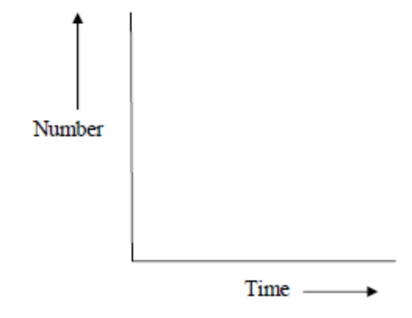
Answer

Ordinary Level

2008 OL
7. It is important to use sterile apparatus when working with micro-organisms.
(a) (i) What is meant by sterile? ___________________________________________________
(ii) How may apparatus be sterilised? ____________________________________________
________________________________________________________________________

(b) Answer the following questions about an investigation that you carried out to show the growth of
leaf yeast.
(i) Name the container in which you grew the leaf yeast.______________________________
________________________________________________________________________
(ii) What was present in this container to provide food for the yeast?
________________________________________________________________________
________________________________________________________________________
(iii) Describe how you put leaf yeast into the container. _______________________________
________________________________________________________________________
________________________________________________________________________
________________________________________________________________________
________________________________________________________________________
________________________________________________________________________
________________________________________________________________________
________________________________________________________________________
________________________________________________________________________
________________________________________________________________________
(iv) How long did it take for the leaf yeast to appear? ________________________________
________________________________________________________________________
(v) Describe the appearance of the leaf yeast in the container.
________________________________________________________________________
________________________________________________________________________
________________________________________________________________________
Answer

2011 OL
7. (a) Draw a labelled diagram of a single, reproducing, yeast cell.

(b) Answer the following questions in relation to your investigation into the growth of leaf
yeast.

(i) From what plant did you obtain the yeast?
______________________________________________________________________________
(ii) Name the nutrient medium on which you grew the yeast.
______________________________________________________________________________
(iii) Outline the steps you followed to get the yeast cells onto the nutrient medium.
______________________________________________________________________________
______________________________________________________________________________
______________________________________________________________________________
______________________________________________________________________________
(iv) How long did it take for the yeast to become visible on the nutrient medium?
______________________________________________________________________________
(v) How did you recognise the yeast?
______________________________________________________________________________
(vi) Describe one aseptic technique you carried out during this investigation.
______________________________________________________________________________
______________________________________________________________________________
Answer

3.1 Diversity of Organisms

Section C

Higher Level Questions Ordinary Level Questions

Higher Level

2004 HL
15. (c) (i) Draw a labelled diagram to show the structure of Rhizopus. State one feature in your diagram
that indicates that Rhizopus belongs to the kingdom Fungi.
(ii) Sexual reproduction in Rhizopus leads to the formation of a zygospore. Show, by means of labelled diagrams, the stages involved in the production of the zygospore.
(iii) Explain what happens when the zygospore reaches a location at which conditions for its germination are suitable.
Answer

2005 HL
15. (b) (i) Draw and label a diagram to show the basic structure of a typical bacterial cell.
(ii) Other than being prokaryotic, state two ways in which a typical bacterial cell differs from a typical human cell (e.g. cell from cheek lining).
(iii) Describe how some bacteria respond in order to survive when environmental conditions become unfavourable.
(iv) What is meant when a bacterium is described as being pathogenic?
(v) What are antibiotics? Use your knowledge of the Theory of Natural Selection to explain the possible danger involved in the misuse of antibiotics. (30)
Answer

(c) Saprophytic and parasitic fungi are widespread in nature.
(i) Explain each of the underlined terms.
(ii) State a role of each of these types of fungus in the overall scheme of nature.
(iii) Give one example of a beneficial fungus and one example of a harmful fungus.
(iv) State a function for each of the following structures that are found in fungi; rhizoid, sporangium, gametangium, zygospore. (30)
Answer

2006 HL
15. (b) Answer the following in relation to bacteria.
(i) Distinguish between photosynthetic and chemosynthetic bacteria. Give an example of each type.
(ii) Name two forms of heterotrophic nutrition found in bacteria.
(iii) What are antibiotics? For what purpose are they used?
(iv) Explain what is meant by antibiotic resistance and suggest how it may develop. (30)
Answer

2007 HL
14. Answer any two of (a), (b) and (c). (30, 30)

(b) (i) Comment on the difficulty of defining viruses as living organisms.
(ii) What are the two main biochemical components of a virus particle?
(iii) Name two diseases caused by viruses.
(iv) Give an example of a beneficial application of a virus.
(v) What is an antibiotic?
(vi) Antibiotics should not be prescribed for a person suffering from a viral infection.
Suggest a reason for this.
Answer

2008 HL
15. (c) The diagram shows a bacterial growth curve.

(i) A and B represent the labels on the axes. What does each of them stand for?
(ii) What term is applied to the part of the curve labelled x? What is happening during x?
(iii) What term is applied to the part of the curve labelled y? What is happening during y?
(iv) Copy the diagram into your answer book and continue the curve to show the next phase. Explain why you have continued the curve in this way.
(v) Distinguish between batch and continuous flow food processing using micro-organisms in the food industry.
Answer

2009 HL
14. (c)
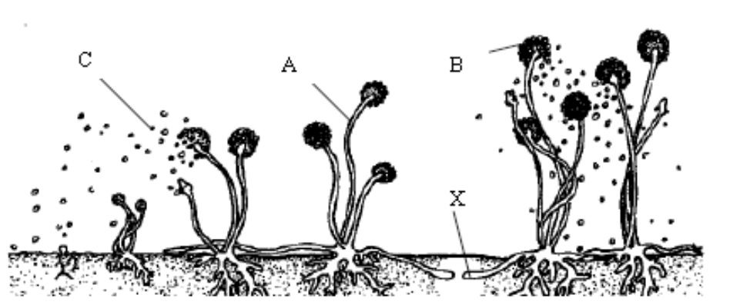

- Identify the organism shown in the diagram.
- To which kingdom does this organism belong?
- Name the parts labelled A, B and C.
(iv) 1. Give a role, other than anchorage, for structure X.
2. Describe how X carries out this role.
(v) Which term describes the mode of nutrition of this organism.
(vi) The cells of this organism are described as eukaryotic.
Give two characteristic features of eukaryotic cells.
(vii) What corresponding term is used to describe bacterial cells?
Answer

2010 HL
12. (a) (i) Where are primary producers found in a pyramid of numbers?
(ii) Using named examples, construct a simple inverted pyramid of numbers. (9)

(b) A paper factory pumps liquid effluent into a river. The effluent contains sugar.
Oxygen demand is the amount of oxygen needed by organisms living in a river.
Oxygen concentration is the amount of oxygen dissolved in the river water.

Graph A shows changes in water conditions for several kilometres downstream from the factory outflow.

(i) To which kingdom do bacteria belong?
(ii) Give one reason why the number of bacteria increases immediately downstream from the
outflow.
(iii) Give one reason why the number of bacteria then decreases further downstream from the
outflow.
(iv) Describe how the oxygen demand changes as the number of bacteria in the water changes.
(v) Give a reason for your answer to part (iv).
Answer

2010 HL
15. Answer any two of (a), (b), (c). (30, 30)
(c) Suggest a biological explanation for each of the following observations:

(i) As long as a baby feeds regularly from its mother’s breast (or if a breast pump is regularly
used) the milk will continue to flow.
(ii) Doctors are reluctant to prescribe antibiotics to patients suffering from common cold-like
symptoms.
(iii) A person who has suffered from constipation may be advised to increase the amount
of wholegrain cereal in her/his diet.
(iv) After a long session of heavy exercise, an athlete’s urine is likely to be concentrated and
low in volume.
(v) A person’s fingers may turn white when exposed to low temperature for a period of time.
Answer

2011 HL
14. (c) (i) State the precise location of the cell membrane in plant cells.
(ii) With what type of cell do you associate membrane-bound organelles?
(iii) What corresponding term is used to describe bacterial cells?
(iv) The cell membrane is described as being selectively permeable. What does this mean?
(v) Why is diffusion alternatively known as passive transport?
(vi) Osmosis may be described as “a special case of diffusion”. Explain why.
(vii) Describe, with the aid of a labelled diagram, how you demonstrated osmosis in the laboratory.
(viii) Name the structure by which Amoeba gets rid of excess water that has entered by osmosis.
Answer

2011 HL
15. (c) The diagram below shows part of the mycelium of the fungus Rhizopus.

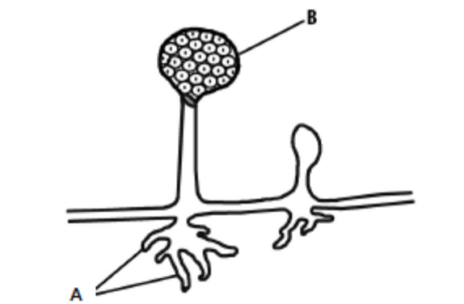

(i) Give the name and state a function of the part labelled A.
(ii) Name part B and explain why the reproduction associated with it is asexual.
(iii) The nutrition of Rhizopus is described as being saprophytic.
1. What does the term saprophytic mean?
2. Explain the importance of saprophytic nutrition in the overall scheme of nature.
(iv) Saprophytic nutrition is a form of heterotrophic nutrition.
What does the term heterotrophic mean?
(v) Name another form of nutrition employed by some fungi.
(vi) Give two examples of harmful members of the kingdom Fungi.
Answer

2012 HL
14. Answer any two of (a), (b), (c). (30, 30)

(a) (i) Give a brief account of the role of each of the following in flowering plant reproduction.
1. Petal.
2. Anther.
3. Stigma.
(ii) Name one structure through which the pollen tube grows in order to reach the embryo sac.
(iii) Within the pollen tube the generative nucleus divides to form two male gametes.
1. What type of division takes place?
2. With what does each male gamete fuse in the embryo sac?
3. Name the product of each fusion.
(iv) As the seed forms following fertilisation, a food store develops in one of two structures.
Name any one of these structures.

(b) Answer the following questions from your knowledge of early human development in the womb.
(i) 1. Name the three germ layers in the early human embryo.
2. For each germ layer name a structure in the adult body that develops from it.
(ii) From which tissues does the placenta develop?
(iii) 1. What is the amnion?
2. Explain the importance of the amnion for the foetus.

(c) (i) Answer the following questions in relation to sexual reproduction in the mould Rhizopus.
1. Sexual reproduction in Rhizopus is normally triggered by an adverse environmental
stimulus. Suggest one such stimulus.
2. Draw diagrams to show the main events of sexual reproduction in Rhizopus.
In your diagrams label three structures other than the zygospore.
3. Give two advantages to Rhizopus of zygospore formation.
(ii) Answer the following questions in relation to asexual reproduction in yeast.
1. What term is used to describe the process of asexual reproduction in yeast?
2. What happens to the new cells formed in the process?
3. How does asexual reproduction in Rhizopus differ from that in yeast?
Answer

2013 HL
12. (a) (i) A virus has been described as a piece of genetic material that has escaped from a cell.
Give one piece of evidence that supports this description.
(ii) Viruses are examples of obligate parasites. Explain why this is the case.
(iii) Give an example of how a virus might be beneficial to mankind.

(b) (i) Name the kingdom to which bacteria belong.
(ii) Draw a large diagram of a bacterial cell to show:
1. The relative positions of the cell wall, cell membrane and capsule.
2. A plasmid.
Label each of the above structures.
(iii) 1. Under what circumstances does a bacterial cell form an endospore?
2. Describe briefly how an endospore forms.
(iv) Name two types of heterotrophic nutrition used by bacteria.

(c) (i) Distinguish clearly between antibodies and antibiotics by writing a note about each.
(ii) In relation to antibodies, distinguish between active and passive immunity.
(iii) Using your knowledge of antibiotics and bacteria, suggest why a person is more likely to pick up an
infection in hospital than at home.
Answer

2013 HL
14. Answer any two of (a), (b), (c). (30, 30)
(c) (i) Explain the term fermentation.
(ii) Name an organism that is used in industrial fermentation.
(iii) To which kingdom does this organism belong?
(iv) Name a compound which is used as a carbon source in the fermentation referred to in part (ii).
(v) In industrial fermentations bioprocessing with immobilised cells is sometimes used.
1. Explain the terms bioprocessing and immobilised.
2. Give an advantage of using immobilised cells.
3. Name the compound from which the immobilising beads are formed in the laboratory.
4. Give the general name for the vessel used for such reactions.
Answer

Ordinary Level

SEC Sample Paper OL
15. (b) The diagram shows part of Rhizopus.

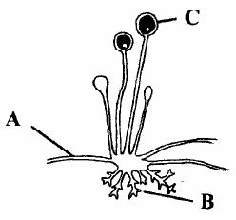

(i) To which kingdom does Rhizopus belong?
(ii) Name the parts A, B, C.
(iii) State a function of part B.
(iv) What takes place in part C?
(v) Name another member of the kingdom to which Rhizopus belongs, other than yeast, and explain how it is of benefit to humans.
(vi) Name another member of the kingdom to which Rhizopus belongs, other than yeast, and explain how it is harmful to humans. (30)
Possible Answer

2005 OL
15. Answer any two of (a), (b), (c). (30,30)
(c) The diagram shows part of the mycelium of Rhizopus.

(i) Identify A, B, C.
(ii) State a function of B.
(iii) State a function of C.
(iv) What term is used to describe the nutrition of Rhizopus? Explain the importance of this type of nutrition in nature.
(v) To what kingdom does Rhizopus belong?
(vi) Name another organism that you have studied in your biology course that belongs to the same kingdom as Rhizopus.
Answer

2007 OL
13. (a) The diagram shows a typical bacterial cell.

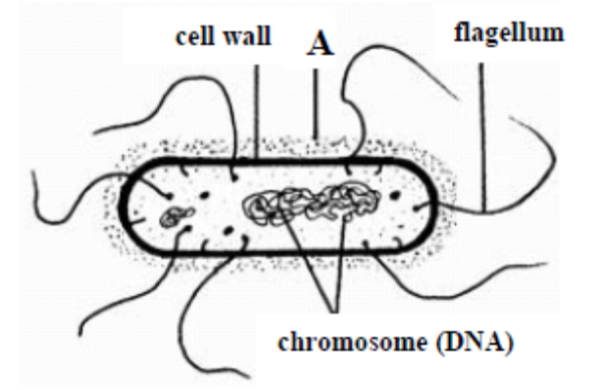

(i) Some bacteria have a layer outside the cell wall (labelled A in diagram).
Name this layer and state its function
(ii) Name a structure, other than A, which is not found in all bacteria. (9)

(b) The table below shows ways in which bacteria obtain their food. Study the table and then answer the questions that follow.
Autotrophic | Heterotrophic
Photosynthetic | Parasitic
Chemosynthetic | Saprophytic
(i) Distinguish between autotrophic and heterotrophic nutrition.
(ii) What is saprophytic nutrition?
(iii) Why are saprophytic bacteria important in nature?
(iv) Briefly explain chemosynthesis.
(v) What term is used for the organism from which a parasite obtains its food?
(vi) Give examples of two harmful bacteria. (24)

(c) (i) Draw a labelled diagram to show the structure of Rhizopus.
(ii) Rhizopus uses both sexual and asexual reproduction. Give a brief account of its asexual reproduction, using diagrams.
(iii) The diagrams show stages of sexual reproduction of Rhizopus. Name the parts labeled
A and B.
(iv) What is the function of B? (27)

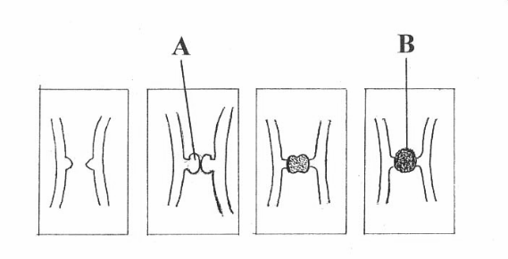
Answer

2008 OL
15. (c) Answer the following by reference to Rhizopus.
(i) To which kingdom does Rhizopus belong?
(ii) Draw a diagram to show the structure of Rhizopus and label three parts.
(iii) Describe, using labelled diagrams, sexual reproduction in Rhizopus.
(iv) Give an example of a beneficial organism and of a harmful organism that belong to the same kingdom as Rhizopus.
Answer

2009 OL
12. (b) The diagram shows the structure of a typical bacterial cell.

(i) Name the bacterial cell parts A, B and C.
(ii) What is the function of C?
(iii) Name any two of the main bacterial types (shapes).
(iv) By which method do bacterial cells reproduce?
(v) Some bacteria are anaerobic. What does this mean?
(vi) What are pathogenic bacteria?
(vii) Give two example of the economic importance of bacteria.
Answer

2010 OL
13. (a) (i) What is meant by a ‘balanced’ diet?
(ii) Distinguish between autotrophic nutrition and heterotrophic nutrition. (9)
Answer

2010 OL
15. Answer any two of the parts (a), (b), (c). (30, 30)
(c) Rhizopus is a type of mould often found growing on stale bread.
(i) Draw a diagram of Rhizopus and on it label a hypha, a sporangium and a sporangiophore.
(ii) Explain how Rhizopus gets its food.
(iii) What form of heterotrophic nutrition does Rhizopus have?
(iv) Outline the importance of this type of nutrition in nature.
(v) To what kingdom does Rhizopus belong?
(vi) Name one economically harmful member of this kingdom.
(vii) Mushrooms also belong to this kingdom. A restaurant owner decides to collect and cook wild
mushrooms from a local forest.
Suggest one reason why this may not be a good idea.
Answer

2012 OL
13. (a) All organisms may be classified (grouped) into five kingdoms.
(i) Suggest one advantage of classifying organisms.
(ii) Name the kingdom to which bacteria belong.
(iii) Give one example of the economic importance of bacteria. (9)

(b) (i) Draw a large labelled diagram of a typical bacterial cell.
(ii) Bacteria may be classified by their shape.
Name any two bacterial shapes.
(iii) Name the method by which bacteria reproduce.
(iv) What are pathogenic bacteria?
(v) State two factors affecting the growth of bacteria. (27)

(c) The diagram shows part of the fungus Rhizopus.
(i) Name the parts labelled A and B.
(ii) Give two functions of structure B.
(iii) Describe the role of part C in the reproduction of Rhizopus.
(iv) What is meant by saprophytic nutrition?
(v) Give one beneficial use of fungi. (24)
Answer

3.2 Organisation and the Vascular Structures

Need to Know

3.2.1 Organisational complexity of the Flowering Plant
3.2.2 Organisational Complexity of the Human
(Human Circulatory & Lymphatic Systems)
3.2.3.H Blood Cells
3.2.4.H Heartbeat Control

At the end of this section students should be able to:

Flowering Plant Structure
- Label a diagram of the external parts of a typical flowering plant
Shoot, root, stem, leaves, flower, fruit, seed.
- State the function of the root and shoot.
- Identify tap and fibrous root systems.
- Explain the term Meristem and give its location in the stem and root.
- Name and give the function of four zones in a longitudinal section [LS] of a root.
- State the function of Vascular Tissue.
- Give the location of three tissue types, Dermal, Ground and Vascular, in transverse sections [TS] of the root, stem and leaf.
- Give the location of three tissue types, Dermal, Ground and Vascular, in longitudinal sections [LS] of the root and stem.
- Identify and draw the structure of Xylem and Phloem and state their function.
- Distinguish between Xylem Vessels and Xylem tracheids, and between Phloem Sieve Tube Cells and Companion Cells.
- Identify Monocots and Dicots under the headings
- Arrangements of flower parts
- Vein pattern in leaf
- Arrangement of Vascular Bundles
- Number of Cotyledons [seed leaves] in the seed
- Woody or Herbaceous
- Mandatory Practical: Prepare and examine a transverse section of a Dicot stem under the microscope.

Human Circulatory & Lymphatic Systems
- Understand what is meant by the term Closed Circulation System in humans
- Describe the structure and organisation of the human Closed Circulation System, i.e. strong muscular heart, arteries, venules, capillaries, venules, veins.
- Identify the two circuits in the human system circulation system (1) Pulmonary Circuit, (2) Systemic Circuit.
- Draw and label the structure of the heart.
- Mark the pathway of blood in a diagram of the heart and through the systemic and pulmonary circuits.
- Explain the term Portal System and identify the Hepatic Portal Vein in a diagram.
- Explain the role of muscles and valves in the heart and blood vessels.
- Explain how the heart supplies blood to the heart wall through the Coronary arteries and Cardiac veins.
- Understand and explain Pulse.
- Understand and explain Blood Pressure.
- Explain the effect of exercise on the circulation system.
- Explain the effect of salt, fat and being overweight on the circulation system.
- Give a simple explanation of the heart beat and how it is controlled.
- Mandatory Practical: Investigate the effect of exercise on pulse rate (or breathing rate)
- Mandatory Practical: Dissect and display and identify the dissected parts in a Sheep or Ox heart.
- Describe the structure of the Lymphatic System and describe three functions of the system.
- State the four main parts in blood and give the function of each part.
- Name the four common blood groups and name the two rhesus blood types.

Blood Cells
- Describe the structure of red blood cells in detail.
- Describe the structure of white blood cells.
- Classify white blood cells as Lymphocytes or monocytes.

Heartbeat Control
- Know the location of the Pacemaker (SA Node) (sinoatrial node).
- Know the location of the Pacemaker (AV Node) (atrioventricular node).
- Understand that the heart has specialised Cardiac Muscle.
- Explain the stages in the cardiac Cycle.
- Understand the terms Systole and Diastole.
- Explain how the AV and SA nodes function in relation to the heart cycle.

PowerPoint Presentations

3.2.1 Flowering plant structure and root structure.ppt
3.2.2 Organisational complexity of the human.ppt
3.2.3.H Blood Cells extended study.ppt
3.2.4.H Heartbeat control.ppt

3.2 Organisation and the Vascular Structures

Section A

Structure of Flowering Plant
Higher Level Questions Ordinary Level Questions

Higher Level

2005 HL
3. Indicate whether the following are true (T) or false (F) by drawing a circle around T or F.
(a) Urea is formed in the kidneys. T F
(b) Motor neurons conduct impulses towards the central nervous system. T F
(c) Endocrine glands secrete hormones. T F
(d) Tendons join muscles to bones. T F
(e) The sino-atrial node (pacemaker) is located on the right side of the heart. T F
(f) A nucleus is absent from human red blood cells. T F
(g) Light is essential for the germination of seeds. T F
(h) Lenticels serve the same function as stomata. T F
(i) Parallel leaf veins are characteristic of monocotyledonous plants. T F
(j) Endosperm is a food reserve in some seeds. T F
Answer

2006 HL
1. (b) The walls of xylem vessels are reinforced with ……………………………………………………
Answer

2007 HL
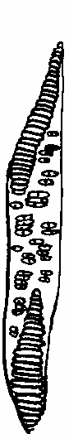
6. The diagrams represent two forms of a vascular plant tissue, as seen under the microscope.
A
B
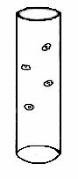

- Name this vascular tissue ……………………………………….
- Identify the two forms of this tissue.
A ………………………………………………….. B ………………………………………..……
- The walls of A and B are reinforced with a hard material. Name this material ...……………….…
- Where precisely is this vascular tissue found in the stem of a young dicotyledonous plant?
………………………………………………………………….…………………………………...
- Name another vascular tissue ...………………………………………………………………….....
Answer

2009 HL
5. (f) Give one location where mitosis occurs in flowering plants. _________________________
Answer

2012 HL
3. (a) The diagram shows the macroscopic structure of part of a long bone.
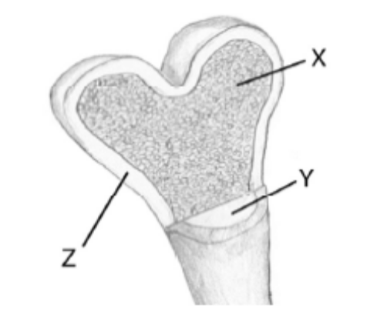
(i) Name a long bone in the human body. __________________________________________
(ii) Name parts X, Y and Z in the diagram. X. _____________________________________
Y. _____________________________________
Z. _____________________________________
(iii) State a function of X. ________________________________________________________
(iv) State a function of Y. ________________________________________________________

(b) (i) Show clearly on the diagram where you would expect to find cartilage.
(ii) State one role of this cartilage. _________________________________________________
Answer

Ordinary Level

2007 OL
5. The diagram represents a tomato plant.

(a) Name the parts labelled B, C, and E.
Name of part B ……………………………..................................................................................
Name of part C …………………………………………………………………………………..
Name of part E …………………………………………………………………………………..

(b) Give one main function each for the parts labelled A and D:
Function for part A ………………………………………………………………..……………...
Function for part D ……………………………………………………………………………….

(c) What is the role of part E?
Role of part E ………………………………………………..…………………………………..

(d) Name the tube-like tissue found in part C in which water moves through the plant.
……………………………………………………………………………………………………
Answer

2010 OL
6. The diagram below shows the internal structure of a leaf.

(i) Name the one tissue type that is found at both V and Y. _________________________________________________________________________________
(ii) The cells at W contain many organelles that carry out photosynthesis.
Suggest why the cells at W contain more of these organelles than the cells at X.
_________________________________________________________________________________ _________________________________________________________________________________
(iii) In layer X, gases can diffuse throughout the leaf. Name one such gas. ________________________________________________________________
(iv) State one function of the opening at Z. _________________________________________________________________________________
(v) Name the cells which are responsible for controlling the size of the opening at Z. _________________________________________________________________________________
Answer

2010 OL
9. (a) (i) In biology, what is meant by the term organ? _____________________________________
__________________________________________________________________________

(ii) In school, a light microscope is normally used to examine cells and tissues.
Name a more powerful type of microscope that is used to show what cells are made of in much greater detail (cell ultrastructure).
__________________________________________________________________________

(b) Answer the following questions in relation to how you prepared and examined with a microscope a
transverse section (T.S.) of a dicotyledonous stem.

(i) Name the plant that you used. __________________________________________________
(ii) How did you make a section of the stem and prepare it for examination?
__________________________________________________________________________
__________________________________________________________________________
__________________________________________________________________________
__________________________________________________________________________
__________________________________________________________________________
__________________________________________________________________________
(iii) Describe how you examined your section of stem once you had placed the slide on the stage of the microscope.
__________________________________________________________________________
__________________________________________________________________________
__________________________________________________________________________
__________________________________________________________________________
(iv) Which of the following diagrams, A or B, best represents what was seen on your slide?
__________________________________________________________________________

Answer

2011 OL
4. Indicate whether each of the following statements is true (T) or false (F) by drawing a circle
around T or F in each case.

Example: The liver produces bile T F

(a) The semicircular canals in the ear are involved in balance. T F
(b) The growth response of a plant to light is called phototropism. T F
(c) Tendons attach bone to bone. T F
(d) A motor neuron carries impulses to the brain. T F
(e) Rhizopus is a member of the animal kingdom. T F
(f) Xylem transports water in plants. T F
(g) A potato is a modified stem. T F
Answer

2012 OL
4. The diagram below represents a transverse section through part of a plant.

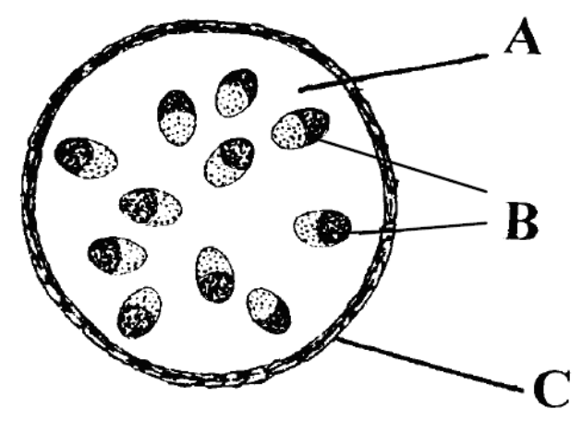

(a) Does the diagram represent a root or a stem? ___________________________________
(b) The letters A, B, C in the diagram, represent three different tissue types.
Match each letter with its correct tissue type in the following list:
Ground tissue. ___________________________________
Dermal tissue. ___________________________________
Vascular tissue. __________________________________
(c) State a function of vascular tissue. ___________________________________________
_______________________________________________________________________
(d) Name the two types of vascular tissue in plants.
1. ___________________________________
2. ___________________________________
Answer

2013 OL
2. The diagram shows the structure of a flowering plant.
(a) Name the parts labelled A, B, and C.
Part A ………………………… Part B ……………………… Part C ……………………
(b) Give one main function of each of the parts labelled A, B and C.
Function of part A ………………………………………………………………..……………...
Function of part B ……………………………………………………………………………….
Function of part C ……………………………………………………………………………….
(c) Flowers are the organs of which type of reproduction in the plant
Answer

Circulatory System
Higher Level Questions Ordinary Level Questions

Higher Level

SEC Sample Paper HL
3. The diagram shows a section of human tissue containing an artery and a vein.

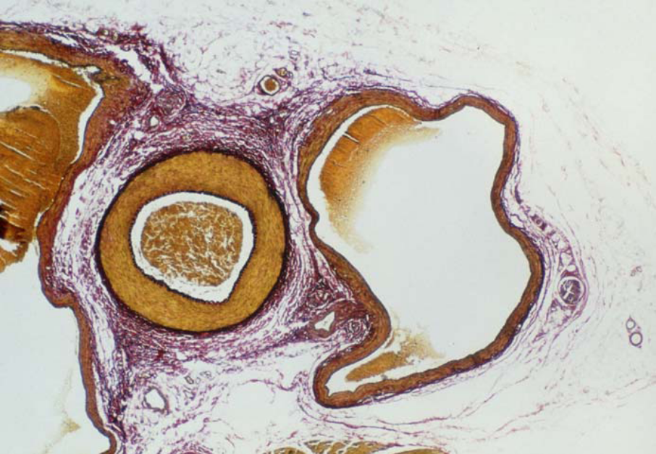
[BIOPHOTO ASSOCIATES/SCIENCE PHOTO LIBRARY LTD.]
Identify the artery by writing A on it and the vein by writing B on it.
State two features of the artery that can be seen in the diagram which allowed you to identify it.
1 …………………………………………………………………………………………………
2 …………………………………………………………………………………………………
Name two tissues that are present in the walls of arteries and veins and give a function of each of
these tissues.
Tissue ………………………….….. Function …………………………………..
Tissue ………….………………….. Function …………………………………..
Veins contain valves whereas arteries do not. What is the function of the valves?
…………..…….……………………………………………………………………………………
Possible Answer

2005 HL
3. Indicate whether the following are true (T) or false (F) by drawing a circle around T or F.
(a) Urea is formed in the kidneys. T F
(b) Motor neurons conduct impulses towards the central nervous system. T F
(c) Endocrine glands secrete hormones. T F
(d) Tendons join muscles to bones. T F
(e) The sino-atrial node (pacemaker) is located on the right side of the heart. T F
(f) A nucleus is absent from human red blood cells. T F
(g) Light is essential for the germination of seeds. T F
(h) Lenticels serve the same function as stomata. T F
(i) Parallel leaf veins are characteristic of monocotyledonous plants. T F
(j) Endosperm is a food reserve in some seeds. T F
Answer

2006 HL
5. Study the diagram and then answer the following questions.

(a) Name X and Y
X ……………………………….………. Y ……………………………………………
(b) Place arrows on Y, the hepatic artery and the hepatic vein to indicate the direction of blood flow.
(c) State the precise location of organ X in the human body …………………………………...…….
(d) State a role that organ X plays in the digestive process …………………………………………...
………………………………………………………………………………………………………
Answer

Ordinary Level

2004 OL
1. (a) The hepatic portal vein carries blood from the alimentary canal to the …………………………..
(b) A tendon joins ………………………………………… to bone.
(c) Phototropism is the growth response of a plant to ………………………………….…………….
(d) Hormones are secreted by ……………………………………………………………..… glands.
(e) Gas exchange between a leaf and the atmosphere takes place through the ………………………
Answer

2008 OL
4. The diagram shows a section through a human heart.

(a) Name blood vessel A. __________________________________________________________
(b) Is the blood in A oxygenated or deoxygenated? ______________________________________
(c) Name the chamber of the heart labelled B. __________________________________________
(d) Give one reason why the wall of chamber B is thicker than the wall of chamber C.
____________________________________________________________________________
(e) What is the role of the bicuspid valve? _____________________________________________
____________________________________________________________________________
Answer

2009 OL
5. (a) Name the liquid part of blood.
_____________________________________________________________________________
(b) Give two components of this liquid.
(i) ________________________________________________________________________
(ii) ________________________________________________________________________

(c) Complete the following table in relation to blood cells:
Cell type | One function
Red blood cell
White blood cell
Platelet

Answer

Lymphatic System
Higher Level Questions Ordinary Level Questions

Higher Level

Ordinary Level

3.2 Organisation and the Vascular Structures

Section B

Structure of Flowering Plant
Higher Level Questions Ordinary Level Questions

Higher Level

2004 HL
8. (a) Observation of a transverse section of a dicotyledonous stem reveals vascular and other
tissues.
Name two of the tissues that are not vascular tissues.
1 …….…………………………..…………. 2 ………………..……..………………….

(b) Answer the following questions in relation to the preparation of a microscope slide of a transverse section of a dicotyledonous stem.
State one reason why you used an herbaceous stem rather than a woody one.
………………………………………………………………...………………………………
………………………………………………………………...………………………………
Explain how you cut the section.
………………………………………………………………...………………………………
………………………………………………………………...………………………………
………………………………………………………………...………………………………
………………………………………………………………...………………………………
Why is it desirable to cut the section as thinly as possible? ………………………………….
………………………………………………………………...………………………………
………………………………………………………………...………………………………
Draw a diagram of the section as seen under the microscope. Label the vascular tissues that can be seen.

State one precise function of each of the vascular tissues labelled in your diagram.
………………………………………………………………...………………………………
………………………………………………………………...………………………………
………………………………………………………………...………………………………
………………………………………………………………...………………………………
Answer

2009 HL
7. (a) (i) Why is a dicotyledonous (dicot) plant so called? ____________________________
(ii) Name a dicotyledonous plant. ___________________________________________

(b) (i) Describe in detail how you prepared a microscope slide of a transverse section of the
stem of a dicotyledonous plant.
___________________________________________________________________
___________________________________________________________________
___________________________________________________________________
___________________________________________________________________
___________________________________________________________________
___________________________________________________________________

(ii) Give an account of the procedures that you followed in order to view your slide under the microscope.
____________________________________________________________________
____________________________________________________________________
____________________________________________________________________
____________________________________________________________________
____________________________________________________________________
____________________________________________________________________

(iii) In the space below draw enough of your section to show and label the location of each of the following:
1. Phloem. 2. Xylem. 3. Ground tissue.
Answer

2011 HL
8. (iv) In the course of your practical work you prepared a transverse section (T.S.) of a dicot stem
for microscopic examination.
How did you prepare the T.S.?
__________________________________________________________________________
__________________________________________________________________________
__________________________________________________________________________
Answer

Ordinary Level

Circulatory System
Higher Level Questions Ordinary Level Questions

Higher Level

2004 HL
9. (a) (i) Cardiac muscle may be described as a contractile tissue. Explain the meaning of the
underlined term.
……………………………………………………………………………………….
(ii) Which chamber of the heart has the greatest amount of muscle in its wall?
……………………………………………………………………………………….

(b) Describe how you dissected a mammalian heart in order to investigate the internal structure of atria and ventricles.
……………………………………………………………………………………………….….
……………………………………………………………………………………………….….
……………………………………………………………………………………………….….
……………………………………………………………………………………………….….
……………………………………………………………………………………………….….
……………………………………………………………………………………………….….
……………………………………………………………………………………………….….
……………………………………………………………………………………………….….
Draw a labelled diagram of your dissection to show the location and structure of the bicuspid and tricuspid valves.

State the procedure that you followed to expose a semilunar valve.
……………………………………………………………………………………………….….
……………………………………………………………………………………………….….
……………………………………………………………………………………………….….
……………………………………………………………………………………………….….
What is the function of a semilunar valve? ………………………………………………….….
……………………………………………………………………………………………….….
Where in your dissection did you find the origin of the coronary artery? ……………………...
……………………………………………………………………………………………….….
Answer

2010 HL
7. (a) (i) Name the cavity of the body in which the heart and lungs are located…………………………..
(ii) State one way in which heart muscle differs from other muscles in the body………….………. ………………………………………………………………………………………………………....

(b) Answer the following questions in relation to a dissection that you carried out to investigate the
structure of an ox’s or a sheep’s heart.

(i) Describe the steps that you followed in order to identify and display the inner structures of the
heart. Use suitably labelled diagrams if necessary
……………………………………………………
……………………………………………………
……………………………………………………
……………………………………………………
……………………………………………………
……………………………………………………
……………………………………………………
……………………………………………………
……………………………………………………
……………………………………………………
(ii) What did you do in order to expose a semi-lunar valve?
……………………………………...……….………………………………………………………… ………………………………………………………………………….................................................
(iii) In the space below draw and label sufficient of your dissection to show the tricuspid valve,
the right atrium and the right ventricle.

Answer

2011 HL
8. (iii) In the course of your practical studies you found that heart rate and breathing rate increase
with exercise.
Explain why this is the case.
__________________________________________________________________________
__________________________________________________________________________
__________________________________________________________________________
Answer

2012 HL
7. (a) In relation to the scientific method, explain each of the following:
(i) Data. _____________________________________________________________________
(ii) Replicates. ________________________________________________________________
(b) Answer the following by reference to some of the investigations that you carried out in the course of
your studies.
(i) How did you expose the semi-lunar valves when dissecting the sheep’s or ox’s heart?
________________________________________________________________________________
(ii) How did you show that alcohol was present when investigating the production of alcohol by
yeast?
________________________________________________________________________________
________________________________________________________________________________
(iii) What type of agar plates did you use when investigating the digestive activity of seeds?
________________________________________________________________________________
(iv) How did you demonstrate that digestive activity had taken place in the investigation referred
to in part (iii)?
________________________________________________________________________________
________________________________________________________________________________
(v) How did you demonstrate the requirement for oxygen when investigating the factors
necessary for seed germination?
________________________________________________________________________________
________________________________________________________________________________
(vi) What did you use as the selectively permeable membrane in your investigation of
osmosis?
________________________________________________________________________________
(vii) What growth regulator did you use when investigating plant growth?
________________________________________________________________________________
(viii) A microscope has an eyepiece lens marked ×10 and an objective lens marked ×20.
What is the total magnification of the image?
________________________________________________________________________________
Answer

Ordinary Level

2004 OL
9. (a) Answer the following in relation to human breathing rate OR pulse rate.
State which of these you will refer to ……………………………………………………………
What is the average rate at rest? ………………………………………………………………….
State a possible effect of smoking on the resting rate ………………………………………….
……………………………………………………………………………………………………

(b) How did you measure the resting rate? …………………….…………………………………….
.………………………….…………………………………………………………………………
……………………………………………………………………………………………………
……………………………………………………………………………………………………
……………………………………………………………………………………………………
Describe how you investigated the effect of exercise on this rate.
………………………………………………………….…………………………………………
……………………………………………………………………………..…………………….………………………………………………………………..………………………………….
……………………………………………………………………………………………………
……………………………………………………………………………………………………
……………………………………………………………………………………………………
……………………………………………………………………………………………………
……………………………………………………………………………………………………
Using the axes below draw a graph to show how rate is likely to vary as the exercise level increases.

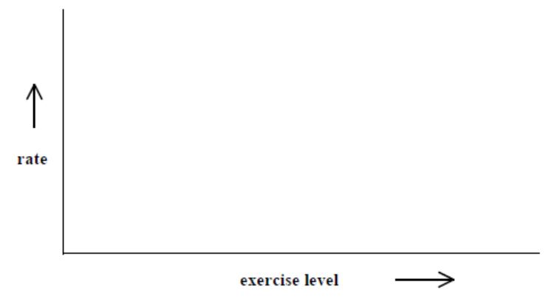
Answer

2006 OL
7. (a) (i) Name the chamber of the heart that receives blood back from the lungs.
…………………………………………………………………………………………
(ii) Name the blood vessels that bring this blood back from the lungs.
……………………….……………………………………………………………………

(b) Answer the following in relation to the dissection of a heart.
(i) What instrument did you use for the dissection? ………………………………………...
(ii) Describe how you carried out the dissection. ……………………………………………
…………………………………………………………………………………………………….
…………………………………………………………………………………………………….
…………………………………………………………………………………………………….
…………………………………………………………………………………………………….
…………………………………………………………………………………………………….
…………………………………………………………………………………………………….
………………………………………………………………………………………………….…
…………………………………………………………………………………………………….
…………………………………………………………………………………………………….
(iii) Draw a diagram of the dissected heart and on it label the following:
bicuspid valve, left ventricle, right atrium, tricuspid valve.
Answer

2008 OL
8. (a) State the location in the human body of the following muscles which are used for breathing:
(i) diaphragm _____________________________________________________
(ii) intercostals _____________________________________________________

(b) Answer the following questions about an activity that you carried out to investigate the effect of
exercise on the breathing rate or pulse of a human.
(i) At the start of the investigation you asked the person who was about to do the exercise to sit down for a few minutes. Explain the purpose of this. ___________________________
_____________________________________________________________________________
_____________________________________________________________________________

(ii) How did you measure the breathing rate or the pulse?
_____________________________________________________________________________
_____________________________________________________________________________
_____________________________________________________________________________
_____________________________________________________________________________

(iii) Describe how you conducted the investigation after the period of rest.
_____________________________________________________________________________
_____________________________________________________________________________
_____________________________________________________________________________
_____________________________________________________________________________
_____________________________________________________________________________
_____________________________________________________________________________
_____________________________________________________________________________
_____________________________________________________________________________
_____________________________________________________________________________
_____________________________________________________________________________
_____________________________________________________________________________
_____________________________________________________________________________

(iv) State the results of your investigation. _________________________________________
_____________________________________________________________________________
_____________________________________________________________________________
_____________________________________________________________________________
Answer

2012 OL
7. (a) (i) Name one disorder of the human breathing system. ___________________________________
(ii) Give one possible treatment for the disorder referred to above. __________________________
_______________________________________________________________________________
(b) Answer the following questions about an activity that you carried out to investigate the effect of
exercise on your breathing rate or your pulse rate.
/Tick the rate you will refer to. | Breathing Rate
/Tick the rate you will refer to. | Pulse Rate

(i) The investigation starts by measuring the resting rate. How did you measure the resting rate?
__________________________________________________________________________
__________________________________________________________________________
(ii) After measuring your resting rate, what other steps did you carry out to complete the investigation?
___________________________________________________________________________
___________________________________________________________________________
___________________________________________________________________________
___________________________________________________________________________
___________________________________________________________________________
(iii) What was the result of your investigation?
___________________________________________________________________________
___________________________________________________________________________
___________________________________________________________________________
(iv) Does this investigation give the same result for both fit and non-fit people? ______________
(v) Give a reason for your answer.
___________________________________________________________________________
___________________________________________________________________________
___________________________________________________________________________
Answer

3.2 Organisation and the Vascular Structures

Section C

Structure of Flowering Plant
Higher Level Questions Ordinary Level Questions

Higher Level

2005 HL
14 (a) The passage of water through a plant is known as the transpiration stream. Answer the following
questions in relation to the transpiration stream.
(i) Explain how water enters the plant at the root hair.
(ii) Do minerals enter the plant by the process that you have indicated in (i)? Explain your answer.
(iii) How is xylem adapted for its role in water transport?
(iv) Strong forces of attraction exist between water molecules. Give an account of the importance of these forces in raising water to great height in trees.
Answer

2006 HL
14. (c) The diagram shows part of a transverse section through a dicotyledonous stem.
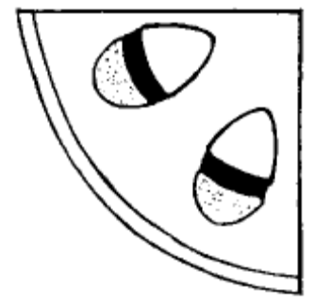
- Copy the diagram into your answer book and identify each of the following by placing the appropriate letter on your diagram:
phloem P, ground tissue G, xylem X, dermal tissue D.
- In which of the tissues that you have identified are sugars mainly transported?
- State a function of D.
- In the course of your practical work you cut and observed a transverse section of a stem.
Answer the following in relation to that procedure.
1. What did you use to cut the section?
2. How did you support the stem while you were cutting the section?
3. How did you transfer the section to a microscope slide?
(v) State one way in which a transverse section through a monocotyledonous stem differs from the one that you cut.
Answer

2008 HL
14. (c) (i) Draw a large labelled diagram of a transverse section through a young root.
Answer

2011 HL
15. (b) (i) Name the tissue in plant stems through which water rises to the leaves.
(ii) Give one way in which this tissue is adapted for the transport of water.
(iii) Give a precise location of this tissue in the stem.
(iv) State another function of the tissue referred to in (i).
(v) The cohesion-tension model of transport attempts to explain water movement in
plants against a particular force. Name this force.
(vi) Describe the principal features of the cohesion-tension model.
(vii) Name the two scientists mainly associated with the cohesion-tension model of transport.
Answer

Ordinary Level

SEC Sample Paper OL
12. (b) The diagram shows part of a root of a young plant.

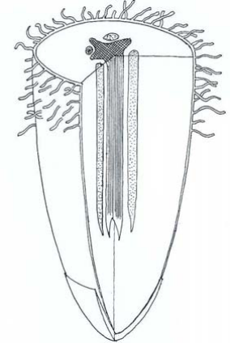

(i) Make an outline copy of the diagram in your answer book and place the letters A, B, C on it to show the location of each of the following;
A = dermal tissue
B = ground tissue
C = vascular tissue
(ii) State three functions of a root.
(iii) From what part of the embryo plant within the seed does the root develop?
(iv) Where would you find a meristem in a root? (24)
Possible Answer

2004 OL
15. (c) Diagrams A and B are of plant vascular tissues.

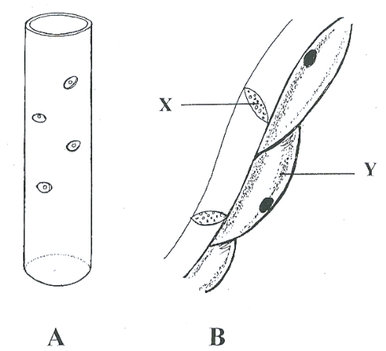

(i) Identify A and B.
(ii) What is meant by a vascular tissue?
(iii) Name X and Y.
(iv) State a function of A.
(v) State a function of B.
(vi) Where would you expect to find A and B in a leaf?
(vii) Name one substance found in the walls of A but not found in the walls of B.
Answer

2005 OL
15. Answer any two of (a), (b), (c). (30, 30)

(a) (i) Which of the two diagrams 1 or 2 represents a transverse section of a young root?
(ii) State two features of the diagram that indicate it is a root.
(iii) The letters A, B, C in the diagram represent three different tissue types. State which tissue type in the following list is represented by each letter;
ground tissue, vascular tissue, dermal tissue.
(iv) Name two vascular tissues and give one way in which they differ.
(v) State a function of ground tissue.

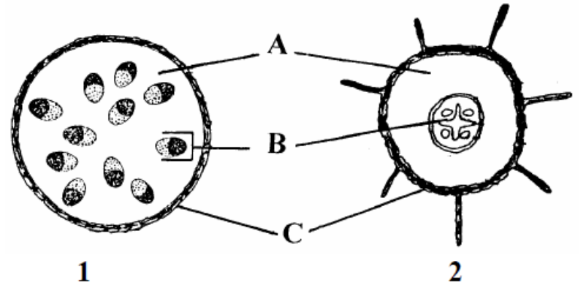

Answer

2006 OL
14. Answer any two of (a), (b), (c). (30, 30)

(a) The diagram shows the structure of part of a stem.

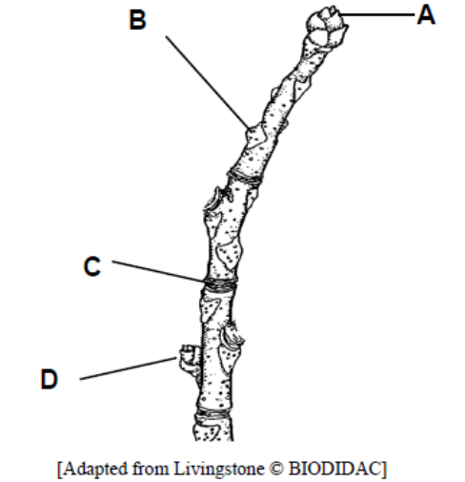

(i) Identify A, B, C and D.
(ii) What is a meristem?
(iii) Give a location of a meristem in the diagram.
(iv) How many years’ growth are shown in the diagram? Explain your answer.
(v) Give two functions of a stem.
Answer

(b) The diagrams are of two tissues of a flowering plant.

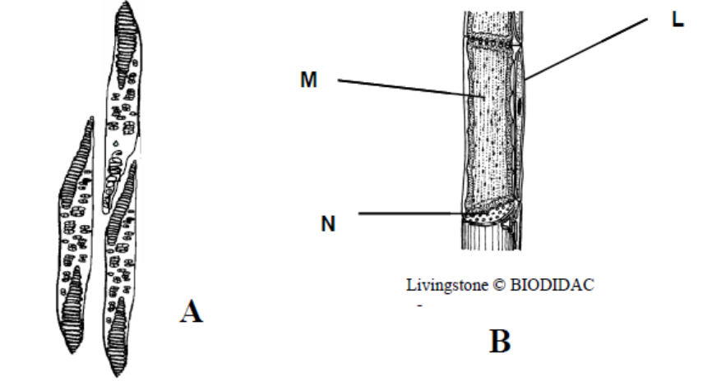

(i) Identify tissues A and B.
(ii) To which tissue type do A and B belong?
(iii) Identify cells L and M and part N in tissue B.
(iv) Name a substance transported in tissue A.
(v) Name a substance transported in tissue B.
(vi) Tissue A has another function in addition to transport. What is this other function?
(vii) Where in a young root would you find tissues A and B?
Answer

2007 OL
14. Answer any two of (a), (b), (c). (30, 30)
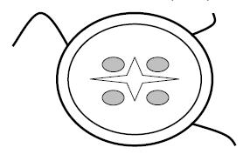
(a) (i) What is meant by ground tissue?
(ii) Give a function of ground tissue.
(iii) What is a meristem?
(iv) Give a location for a meristem.
(v) The diagram shows a transverse section through part of a plant.
Is this part the root or the stem? Give two reasons for your answer.
(vi) Copy the diagram into your answer book. Place an X where you would find vascular tissue and place a Y where you would find ground tissue.
Answer

2007 OL
15. (b) (i) Draw a diagram of a section through a leaf. Label a stoma and a guard cell.
(ii) Give a function of the guard cell.
(iii) Name two gases that enter or leave the leaf.
(iv) Name the process by which the gases move in or out of the leaf.
Answer

2008 OL
15. (a) (i) Water enters the roots of plants by osmosis. Explain what is meant by osmosis.
(ii) Describe how you demonstrated osmosis as part of your practical activities.
(iii) Name the tissue that transports water from the root to the leaves.
(iv) Mention one way in which the tissue you have named in (iii) is adapted for the transport of water.
(v) The diagram below shows another tissue that is involved in transport in plants.
Name this tissue and name a substance that is transported in it.
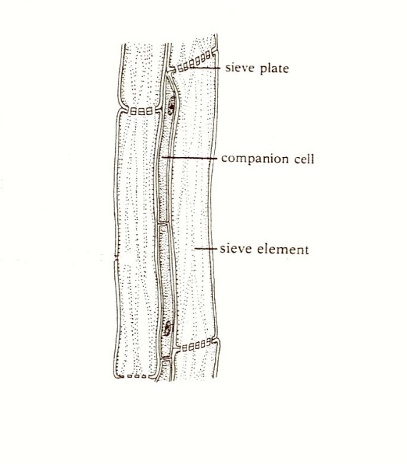

Answer

2009 OL
14. Answer any two of (a), (b) and (c) (30, 30)

(a) The photograph below shows the tissues in a transverse section of a dicotyledonous (dicot) stem.
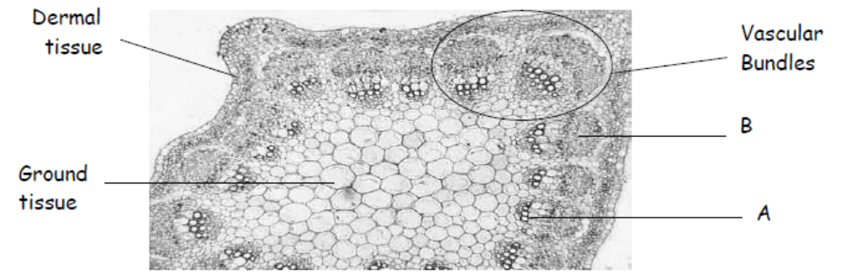

(i) Give one feature shown in the photograph that allows you to identify the section as a stem and not a root.
(ii) Name the two vascular tissues, A and B, found in a vascular bundle.
(iii) Draw a labelled diagram to show a longitudinal section of tissue B.
Include the following labels in your diagram:
sieve tube; sieve plate; companion cell.
(iv) Give one function of each of the following:
1. Dermal tissue.
2. Ground tissue.
(v) 1. In which of the vascular tissues does water transport occur?
2. State one way in which this tissue is adapted for water transport.
3. In which direction does this transport take place?
Answer

2011 OL
15. Answer any two of (a), (b0, (c) (30,30)

(b) The diagram shows a transverse section through a dicotyledonous (dicot) root.

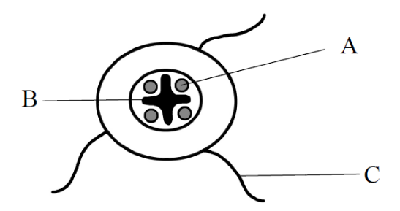

(i) Name the parts labelled A, B and C.
(ii) State two functions of a root.
(iii) From what part of a seed does the root develop?
(iv) Give one example of a root modified for food storage.
(v) Plants can be monocotyledonous or dicotyledonous.
Give any one difference between a monocotyledonous plant and a dicotyledonous
plant.
(vi) Give one example of a monocotyledonous plant and one example of a
dicotyledonous plant.
Answer

2013 OL
15. Answer any two of (a), (b), (c). (30, 30)

(c) The diagrams show two types of vascular tissue in plants.

A B
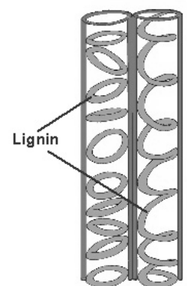

(i) Name the tissues A and B.
(ii) Which of the above tissues transports water from the roots?
(iii) Which of the above tissues transports food from the leaves?
(iv) Is tissue A living or dead?
(v) Suggest a role of the lignin in tissue A.
(vi) Name one process that causes water to move upwards through a plant.
(vii) Name the structures in the leaves through which water exits the plant.
(viii) Vascular tissue is one type of plant tissue. Name two other plant tissues.
Answer

Circulatory System
Higher Level Questions Ordinary Level Questions

Higher Level

2006 HL
13. (a) (i) State a precise location in the human body at which red blood cells are made.
(ii) State two ways in which red blood cells differ from typical body cells e.g. from
the cheek lining. (9)

(b) Use your knowledge of the human vascular and excretory systems to answer the following.
(i) Explain the terms, plasma, glomerular filtrate.
(ii) Explain why red blood cells are normally absent from glomerular filtrate.
(iii) The concentration of glucose is the same in plasma and glomerular filtrate.
Why is this?
(iv) Why is glucose normally absent from urine?
(v) Following a period of heavy exercise an athlete may produce only a small volume of concentrated urine. Explain this observation and give an account of the process that concentrates the urine. (27)

(c) (i) Describe the structure of the lymphatic system.
(ii) Give an account of three functions of the lymphatic system. (24)
Answer

2007 HL
13. (a) (i) Name the blood vessel that returns blood to the heart from the lungs.
(ii) Name the main gas transported in the blood vessel that you have named in (i).
How is this gas transported? (9)
Answer

2009 HL
13. (a) The human circulatory system has two circuits.
(i) Give the name of each of these circuits.
(ii) Which of these circuits involves the pumping of blood by the left ventricle? (9)

(b) (i) Write a short note on each of the following:
1. Pulse.
2. Blood pressure.
(ii) Comment on the effect of each of the following on the circulatory system:
1. Diet.
2. Exercise
(iii) Give two ways, other than colour, in which a red blood cell differs in structure or
composition from a typical body cell such as one in the cheek lining.
(iv) What is the role of the SA (sinoatrial) and AV (atrioventricular) nodes in the heart?
(v) Give the precise locations of both the SA and the AV nodes in the heart.
Answer

2010 HL
5. Answer any two of (a), (b), (c). (30, 30)
(b) (i) Draw a labelled diagram to show the relationship between the liver, the small intestine and
the hepatic portal vein.
(ii) Name a substance transported to the liver by the blood in the hepatic portal vein.
(iii) Name the blood vessel that brings oxygenated blood to the liver.
(iv) Where in the human body is the liver located in relation to the stomach?
(v) Where is bile stored after it has been made in the liver?
(vi) Give one role that the bile salts play in the digestive process.
(vii) Give two further functions of the liver, other than the manufacture of bile.
Answer

2012 HL
15. Answer any two of (a), (b), (c). (30, 30)

(a) The diagram shows part of a transverse section through the small intestine.
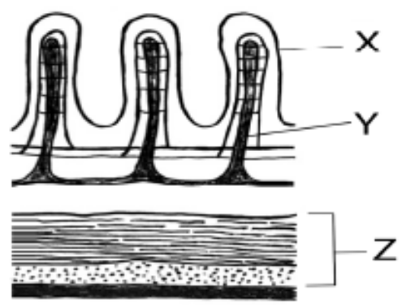
(i) Name structures X and Y.
(ii) What process results from the contraction of the two parts of tissue Z?
(iii) In your answer book, indicate which of the following most accurately represents the pH of
the contents of the small intestine.
Acidic. Neutral. Alkaline.
(iv) Name two glands that pass their secretions into the small intestine.
(v) 1. What are symbiotic bacteria?
2. Give two functions of symbiotic bacteria in the human alimentary canal.
(vi) Where in the human alimentary canal is most water absorbed?

(b) (i) State two ways, other than colour, in which red blood cells differ from white blood cells.
(ii) Name a group of white blood cells, other than lymphocytes.
(iii) Lymphocytes may be divided into B cells and T cells. B cells produce antibodies.
1. What is the role of antibodies in the body?
2. Name any three types of T cell.
3. State a role of each of the T cell types that you named in part 2.

(c) (i) Explain the term homeostasis.
(ii) Homeostasis often requires an organism to exchange materials between different
tissues, or between itself and the external environment by diffusion, osmosis, and
active transport. Explain each of the underlined terms.
(iii) State one way in which each of the following contributes to homeostasis.
1. Liver.
2. Lungs.
3. Nephrons of kidneys.
(iv) Describe the role of the skin in controlling body temperature.
Answer

Ordinary Level

SEC Sample Paper OL
10. (a) (i) What is the average resting rate of the human heart in beats per minute?
(ii) State one factor that decreases heart rate and one factor that increases it. (9)

(b) The diagram shows a vertical section through the human heart.

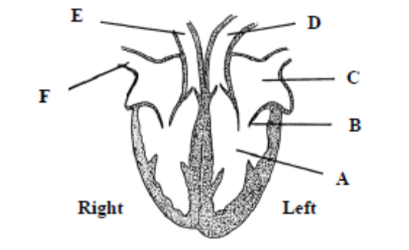

(i) Name the parts A, B, C, D, E and F.
(ii) To where does E carry blood?
(iii) What is the function of B?
(iv) Name the artery that supplies the heart muscle with blood. (27)

(c) (i) Name the liquid part of blood.
(ii) Name two substances that are dissolved in the liquid part of blood.
(iii) State one function of the liquid part of blood.
(iv) Blood contains red cells and white cells. State one function for each of these.
(v) Name two common blood-grouping systems. (24)
Possible Answer

2005 OL
12. (a) (i) Name the major blood vessels that carry blood
1. from the heart to the lungs
2. from the lungs to the heart.
Answer

2005 OL
14. (c) Answer the following questions in relation to blood vessels in the human body.
(i) Valves are present in veins. What is their function?
(ii) Why are valves not needed in arteries?
(iii) Which has the bigger lumen (cavity), an artery or a vein?
(iv) The wall of capillaries is only one cell thick. How is this related to their function?
(v) How does a portal vein differ from other veins?
(vi) Name the following blood vessels;
1. the vessels that carry blood from the aorta to the kidneys.
2. the vessels that supply the heart’s muscle with blood.
Answer

2008 OL
15. (b) Answer the following questions in relation to blood.
(i) What is blood plasma? Give a role for blood plasma.
(ii) Name two types of cell found in the blood and give a function for each of them.
(iii) The ABO blood group system has four blood groups. What are these four groups?
(iv) Suggest a reason why it is important to know a person’s blood group.
Answer

2009 OL
13. (a) Name the blood vessel referred to in each of the following cases:
(i) The vein connected to the lungs.
(ii) The artery connected to the kidneys.
(iii) The vein that joins the intestine to the liver. (9)

(b) The following questions relate to the human heart.
(i) Give the precise location of the heart in the human body.
(ii) What structure(s) protects the heart?
(iii) Name the upper chambers of the heart.
(iv) Name the valve between the upper and lower chambers on the left-hand side.
(v) What is the average resting human heart rate?
(vi) Give two factors which cause an increase in heart rate.
(vii) Name the blood vessels that bring oxygen to the heart muscle.
(viii) Explain why the walls of the lower chambers of the heart are thicker than the walls of the upper chambers. (27)

(c) Copy the table below into your answerbook and use your knowledge of blood vessels and the information in diagrams A, B and C to complete the table. Some boxes have been filled as examples.

Vessel | A | B | C
Name |  | Vein
Lumen | Small
Wall
Direction of blood flow
Valves present
(24)
Answer

2011 OL
13. (a) (i) Name the liquid part of the blood.
(ii) Different lifestyle factors have an effect on the health of our circulatory system.
Name any two of these factors. (9)

(b) The diagram shows a section through the human heart.

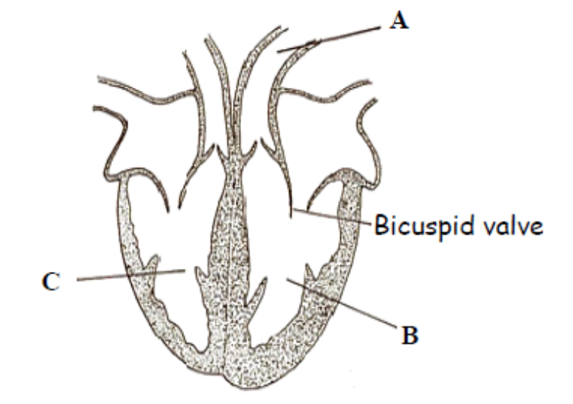
(i) Name the blood vessel labelled A.
(ii) Does A carry blood towards or away from the heart?
(iii) Name the chamber of the heart labelled C.
(iv) Why is the wall of chamber B thicker than the wall of chamber C?
(v) Name the arteries that supply the heart wall with blood.
(vi) What is the role of valves in the heart?
(vii) The lymphatic system is another series of vessels carrying fluid in the body.
Give any two functions of the lymphatic system. (24)
Answer

2013 OL
14. Answer any two of (a), (b), (c). (30, 30)

(a) The diagram shows a synovial joint.

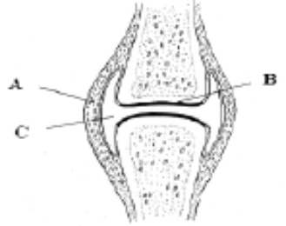
(i) Name the parts labelled A, B and C.
(ii) Give two functions of the human skeleton.
(iii) Vertebrae in the neck are called the cervical vertebrae.
Name and give the exact location of two other types of vertebrae.
(iv) Name one disorder of the musculoskeletal system.

(b) (i) Blood is made up of plasma and blood cells. What is plasma?
(ii) What is the function of white blood cells?
(iii) Where in the body are white blood cells produced?
(iv) Some people may have the blood group B Positive (B+).
What factor is present in their blood that makes it positive?
(v) The heart pumps blood around the body.
1. Name the structure in the heart that controls the heartbeat.
2. Where is this structure located in the heart?
(vi) What causes the sound of a heartbeat?
(vii) Name the blood vessels that supply the heart cells with blood.
(viii) Mention two ways to maintain a healthy heart.
Answer

(c) The diagram shows the human ear.

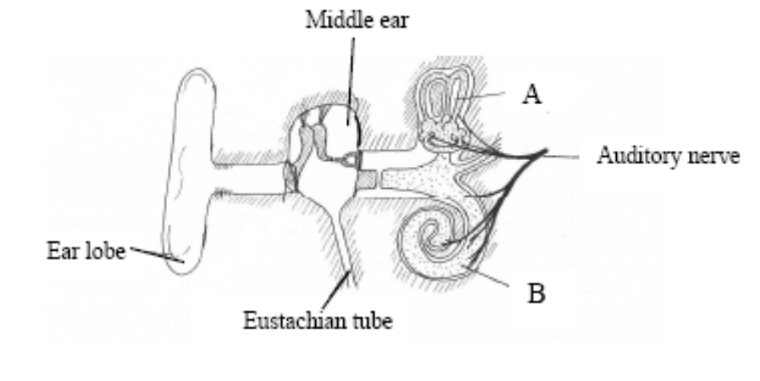

(i) Name the parts labelled A and B.
(ii) What is the function of part A?
(iii) What is the function of part B?
(iv) What is connected to the middle ear by the Eustachian tube?
(v) What surrounds the bones in the middle ear?
(vi) The ear is an example of a sense organ.
Name two sense organs, other than the ear and the eye, in the human body.
(vii) Name one disorder of the ear or of the eye and give a corrective measure for the
disorder referred to.

Lymphatic System
Higher Level Questions Ordinary Level Questions

Higher Level

2006 HL
13. (a) (i) State a precise location in the human body at which red blood cells are made.
(ii) State two ways in which red blood cells differ from typical body cells e.g. from
the cheek lining. (9)

(b) Use your knowledge of the human vascular and excretory systems to answer the following.
(i) Explain the terms, plasma, glomerular filtrate.
(ii) Explain why red blood cells are normally absent from glomerular filtrate.
(iii) The concentration of glucose is the same in plasma and glomerular filtrate.
Why is this?
(iv) Why is glucose normally absent from urine?
(v) Following a period of heavy exercise an athlete may produce only a small volume of concentrated urine. Explain this observation and give an account of the process that concentrates the urine. (27)

(c) (i) Describe the structure of the lymphatic system.
(ii) Give an account of three functions of the lymphatic system. (24)
Answer

Ordinary Level

3.3 Transport and Nutrition

Need to Know

3.3.1 Nutrition in the Flowering Plant
3.3.2 Modified Plant Food Storage Organs
3.3.3 Nutrition in the Human
3.3.4 Human Digestive System
3.3.5 Blood Transport of Nutrients
3.3.6 Balanced Human Diet
3.3.7.H Cohesion-Tension Model of Xylem Transport

At the end of this section students should be able to:

Nutrition in Flowering Plant
- Explain why plants are called autotrophs.
- List the substances that are transported through a plant.
- Explain why plants need a transport system.
- Describe how water is absorbed by the roots including the role of the root hairs.
- Describe how water moves through the root cortex to the Xylem.
- Describe how water travels from the root to the leaf.
- Explain how Root pressure and Transpiration help bring water to the leaf.
- Explain the role of the stomata in water movement.
- Explain how minerals are absorbed by the roots.
- Explain how minerals move from the root to the leaf.
- Explain how the leaf gets Carbon dioxide.
- Explain how the carbohydrates, produced in photosynthesis, are transported.
- Explain how oxygen, produced in photosynthesis, is transported.

Modified Plant Food Storage Organs
- Describe one example of a modified Root, Stem and Leaf used for storing food.

Nutrition in the Human
- Define the following terms Heterotrophic nutrition, Autotrophic nutrition, Herbivore, Carnivore, Omnivore.
- Explain why organisms need to digest food.
- Explain why organisms need a digestive system.
- Explain the terms Ingestion, Digestion, Absorption, Egestion and relate them to specific parts of the digestive system

Human Digestive System
- Label a diagram of the human alimentary canal and its associated glands.
- Know the function(s) in digestion of each part of the alimentary canal including the associated glands.
- Define Peristalsis.
- Explain Dental Formula.
- Write out the Human dental formula.
- Give the function of incisors, canines, pre molars and molars.
- Describe how food is mechanically broken down by (a) Teeth, (b) Contractions of the stomach wall, (c) Peristalsis.
- Explain the role of Bile Salts in Chemical digestion.
- Name one Amylase enzyme and give its (a) Role in chemical digestion (b) Production Site (c) pH at the site of action (d) Products.
- Name one protease enzyme and give its (a) Role in chemical digestion (b) Production Site (c) pH at the site of action (d) Products.
- Name one Lipase enzyme and give its (a) Role in chemical digestion (b) Production Site (c) pH at the site of action (d) Products.
- Describe how the structure of the small intestine is suited to its function in digestion of food.
- Describe how the structure of the small intestine is suited to its function in absorption of digested food.
- Outline the role of the large intestine in (1) Reabsorbing water (2) Eliminating faeces.
- Give two functions of Symbiotic bacteria in the digestive tract.
- Outline the benefits of dietary fibre.
- Label a diagram of a single villus and give the functions of the labelled parts.

Balanced Diet
- Learn the five main food groups.
- Explain the concept of a balanced diet, variety and moderation.
- Learn to draw a human food pyramid.
- State the recommended average daily portions of each of the main food groups in the diet of an average adult.
- Learn two general approaches to diet that can help a person to have a balanced diet.
- Understand how age, gender and activity level can affect the dietary needs.

Blood transport of Nutrients
- Describe the composition of blood fluid as a transport system of nutrients in the human body.
- Describe the absorption of Fatty acids and Glycerol into the lacteals of the villi.
- Describe the absorption of Glucose, Amino acids, Vitamins and Minerals into the blood vessels of the villi.
- Name the three blood vessels associated with the liver.
- Describe the transfer of absorbed nutrients through the hepatic portal vein to the liver.
- Describe the functions of the liver
- Explain the need to transport nutrients to cells of the body.
- Explain the need to transport waste products to the kidney for excretion.

Cohesion-Tension Model of Xylem Transport
- Know the names of the two Irish Scientists that proposed the Cohesion-tension model.
- Explain the terms Osmosis, Transpiration, cohesion and adhesion.
- Explain how tension arises in a column of water.
- Give the main points of Dixon and Joly’s proposal on water transport.
- Draw and label xylem vessels and xylem tracheids.
- Know how xylem is adapted to its function.
- Explain how water can move up a plant to great heights against the force of gravity.

PowerPoint Presentations

3.3.1 Nutrition in the flowering plant.ppt
3.3.2 Modified plant storage organs.ppt
3.3.3 Nutrition in the Human.ppt
3.3.4 Human Digestive System.ppt
3.3.5 Blood Transport of Nutrients.ppt
3.3.6 Balanced Human Diet.ppt
3.3.7.H Cohesion-Tension Model of Xylem Transport.ppt

3.3 Transport and Nutrition

Section A

Transport in the Flowering Plant
Higher Level Questions Ordinary Level Questions

Higher Level

2004 HL
1. (a) Name an autotrophic organism ………………………………………………………………………..
- The conversion of atmospheric nitrogen to nitrates by bacteria is called ……………………….……
(e) A relationship between two organisms in which both benefit is called ………………………………
Answer

2004 HL
4. (a) The diagram shows part of the under surface of a leaf as seen through the microscope.
A is an aperture. B and C are cells.
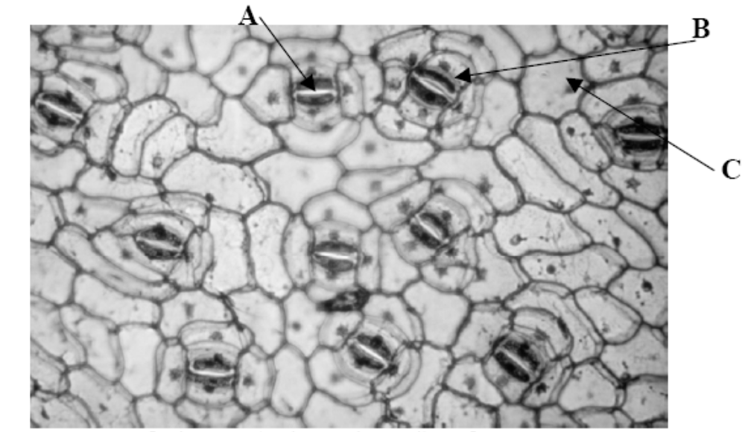

Name A, B, C.
A ………………….……. B ….……..……………… C ……………………………
What is the function of A? ……………………………………………….…………………….
Name a factor that influences the diameter of A…………………………………...…………….…..
Name the apertures in stems that are equivalent to A...…….………………………………………..

(b) In some species of flowering plants the leaves are modified for the storage of food.
Name a plant in which the leaves are modified for food storage …………...…………………..…
Name a carbohydrate that you would expect to find in the modified leaves of the plant that you named above …………………………………………………………………………………………..…………
Name a type of modified stem that functions in food storage….………………………………….
Answer

2006 HL
6. Distinguish between the members of each of the following pairs by making a brief comment on each.
(a) Tuber and bulb …………………………………………………………….………………………
……………………………………………………………………………………………………..
……………………………………………………………………………………………………..
Answer

Ordinary Level

2004 OL
1. (a) The hepatic portal vein carries blood from the alimentary canal to the …………………………..
(b) A tendon joins ………………………………………… to bone.
(c) Phototropism is the growth response of a plant to ………………………………….…………….
(d) Hormones are secreted by ……………………………………………………………..… glands.
(e) Gas exchange between a leaf and the atmosphere takes place through the ………………………
Answer

2006 OL
1. (a) An organism which makes its own food is called a(n) ……………………………………
Answer

2006 OL
4. The diagram shows part of a section through a leaf.

[Adapted from Livingstone © BIODIDAC]
(a) Use the letter A to show a point of entry of carbon dioxide
Name this point ……………..………………………………………………………………...
(b) Name a gas that leaves the leaf at this point …………………………………………………..
(c) Use the letter B to show the part of the leaf in which most photosynthesis occurs.
(d) Name the structures in plant cells in which photosynthesis occurs. ………………………...
(e) In addition to carbon dioxide another small molecule is needed for photosynthesis.
Answer

2011 OL
4. Indicate whether each of the following statements is true (T) or false (F) by drawing a circle
around T or F in each case.

Example: The liver produces bile T F

(a) The semicircular canals in the ear are involved in balance. T F
(b) The growth response of a plant to light is called phototropism. T F
(c) Tendons attach bone to bone. T F
(d) A motor neuron carries impulses to the brain. T F
(e) Rhizopus is a member of the animal kingdom. T F
(f) Xylem transports water in plants. T F
(g) A potato is a modified stem. T F
Answer

Human Nutrition
Higher Level Questions Ordinary Level Questions

Higher Level

2004 HL
1. (a) Name an autotrophic organism …………………………………………………………………..
Answer

Ordinary Level

SEC Sample Paper OL
1. Complete the following sentence by putting one word in the blank space.
(a) The hammer (malleus) is a very small bone located in the ……………………………………
(b) Bile is secreted by the …………………………………………………………………….……
(c) Tiny holes called …………………………………… allow gases to enter and leave the leaf.
(d) Bones are joined to other bones by ..……………………………………………………..……
(e) An animal that eats both plants and animals is called an ………………………………….…..
Possible Answer

2006 OL
1. Use your knowledge of ecology to answer four parts of the following.
(a) An organism which makes its own food is called a(n) …………………………………………
(b) An organism that eats another organism is called a ……………………………………………....
Answer

Digestive System
Higher Level Questions Ordinary Level Questions

Higher Level

2004 HL
6. Answer the following questions in relation to the human alimentary canal.
What is peristalsis? ………………………………………………………………….……………………
State one reason why a low pH is important in the stomach ……………………………………………..
……………………………………………………………………………………………………………..
Why is fibre important? …………………………………………………………………………..………
……………………………………………………………………………………………………………..
Name an enzyme that is involved in the digestion of fat …………………………………………………
What are the products of fat digestion? …………………………………………………………………..
What is the role of bile in fat digestion? ………………………………………………………………….
State a role of beneficial bacteria in the alimentary canal ……………………………………………….
…………………………………………………………………………………………………………….
Answer

2005 HL
3. Indicate whether the following are true (T) or false (F) by drawing a circle around T or F.
(a) Urea is formed in the kidneys. T F
(b) Motor neurons conduct impulses towards the central nervous system. T F
(c) Endocrine glands secrete hormones. T F
(d) Tendons join muscles to bones. T F
(e) The sino-atrial node (pacemaker) is located on the right side of the heart. T F
(f) A nucleus is absent from human red blood cells. T F
(g) Light is essential for the germination of seeds. T F
(h) Lenticels serve the same function as stomata. T F
(i) Parallel leaf veins are characteristic of monocotyledonous plants. T F
(j) Endosperm is a food reserve in some seeds. T F
Answer

2005 HL
6. The diagram shows part of a section of the human small intestine.

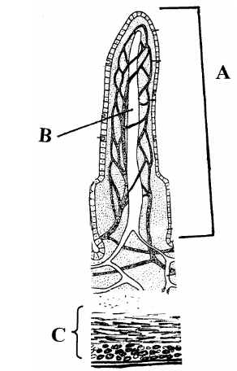

(a) Name A, B, C.
A ………………………………....
B …………….……………………
C ……………………………..…..
(b) State two ways in which A is adapted for the absorption of soluble foods.
1. ….………………………………………………………..………………………………….….
2. …………………………………………………………….…………………………………….
(c) Name a process by which soluble foods are absorbed into the blood from the small intestine.
.……………………………………………………….……………………………………………….
(d) What type of food is mainly absorbed into B?
………………………………………………………………….……………………………………..
Answer

2006 HL
1. (f) What are the final products of the digestion of a protein? …………………………………………….
Answer

2006 HL
3. The graph shows how the rate of reaction of a carbohydrate-digesting enzyme in the human alimentary canal varies with pH

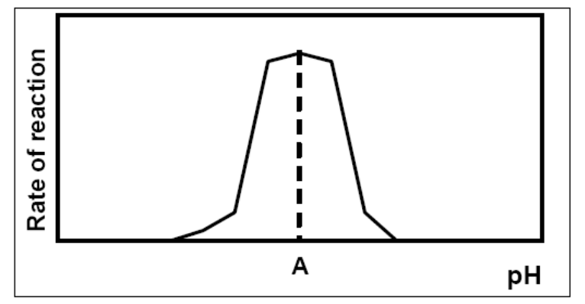

(a) Name a carbohydrate-digesting enzyme in the human alimentary canal ………………………
(b) Where in the alimentary canal does this enzyme act? ………………………………………….
(c) State the enzyme’s product (s) …………………………………………………………………
(d) What is the pH at A? …………..……………..
(e) A is said to be the enzyme’s ………………………….pH
(f) Suggest a temperature at which human enzymes work best……………………………………
(g) What term best describes the shape of an enzyme?.……………………………………………
Answer

2006 HL
5. Study the diagram and then answer the following questions.

(a) Name X and Y
X ……………………………….………. Y ……………………………………………
(b) Place arrows on Y, the hepatic artery and the hepatic vein to indicate the direction of blood flow.
(c) State the precise location of organ X in the human body …………..……………………………….
(d) State a role that organ X plays in the digestive process …………………………………………….
……………………………………………………………………………………………………….
Answer

2011 HL
5. (a) (i) What is meant by the term digestion? ______________________________________________
(ii) Why is digestion necessary? _____________________________________________________
(iii) Distinguish between mechanical and chemical digestion by writing a sentence about each.
_____________________________________________________________________________
_____________________________________________________________________________
(b) The diagram shows part of the human alimentary canal and associated structures.
X
W
(i) What part of the alimentary canal is labelled W? _____________________________________
(ii) The bile duct is connected to X. Name X. ___________________________________________
(iii) From which part of the alimentary canal does food arrive into W? _______________________
(iv) State one digestive function of the pancreas. ________________________________________
Answer

Ordinary Level

SEC Sample Paper OL
1. Complete the following sentence by putting one word in the blank space.
(a) The hammer (malleus) is a very small bone located in the ……………………………………
(b) Bile is secreted by the …………………………………………………………………….……
(c) Tiny holes called …………………………………… allow gases to enter and leave the leaf.
(d) Bones are joined to other bones by ..……………………………………………………..……
(e) An animal that eats both plants and animals is called an ………………………………….…..
Possible Answer

2004 OL
1. (a) The hepatic portal vein carries blood from the alimentary canal to the .………………………
Answer

3.3 Transport and Nutrition

Section B

Human Nutrition
Higher Level Questions Ordinary Level Questions

Higher Level

2012 HL
12. (a) (i) From the following list, write into your answer book any term that describes the nutrition of a
typical plant:

parasitic; heterotrophic; saprophytic; autotrophic.

(ii) Identify, in your answer book, the cell organelles A and B.

(9)
Answer

Ordinary Level

2009 OL
9. (a) (i) What is meant by the term digestion?
_________________________________________________________________________
Answer

Digestive System
Higher Level Questions Ordinary Level Questions

Higher Level

2005 HL
8. (b) (vi) What is a protease enzyme? ………………………………………………………………..
Answer

Ordinary Level

3.3 Transport and Nutrition

Section C

Transport in the Flowering Plant
Higher Level Questions Ordinary Level Questions

Higher Level

SEC Sample Paper HL
15. (a) (i) Where precisely does water enter a plant?
(ii) Name the process responsible for this entry of water.
(iii) Is the process you have named in (ii) also responsible for the uptake of minerals?
Explain your answer.
(iv) In which tissue does water ascend through the plant? State one way in which the tissue is adapted for this purpose.
(v) Explain how water may be raised to great heights in a tree against the force of gravity.
Possible Answer

2005 HL
14 (a) The passage of water through a plant is known as the transpiration stream. Answer the following
questions in relation to the transpiration stream.
(i) Explain how water enters the plant at the root hair.
(ii) Do minerals enter the plant by the process that you have indicated in (i)? Explain your answer.
(iii) How is xylem adapted for its role in water transport?
(iv) Strong forces of attraction exist between water molecules. Give an account of the importance of these forces in raising water to great height in trees.
Answer

2006 HL
11. (c) (i) Water is essential for photosynthesis. Briefly outline how water from the soil reaches the leaf.
(ii) What happens to water molecules when they reach the sites of photosynthesis?
Answer

2008 HL
14. (a) (i) Name the openings in the leaf which allow the entry of carbon dioxide for photosynthesis.
State a factor which influences the diameter of these openings.
Answer

(c) (v) Describe how minerals such as nitrates enter the root of a plant from the soil.
Answer

2011 HL
15. (b) (i) Name the tissue in plant stems through which water rises to the leaves.
(ii) Give one way in which this tissue is adapted for the transport of water.
(iii) Give a precise location of this tissue in the stem.
(iv) State another function of the tissue referred to in (i).
(v) The cohesion-tension model of transport attempts to explain water movement in
plants against a particular force. Name this force.
(vi) Describe the principal features of the cohesion-tension model.
(vii) Name the two scientists mainly associated with the cohesion-tension model of transport.
Answer

Ordinary Level

2010 OL
15. Answer any two of the parts (a), (b), (c). (30, 30)
(a) Water is vital for the survival of living things. Plants absorb water from the soil.
(i) Through which microscopic structures does water enter a plant from the soil?
(ii) By what process does water enter a plant?
(iii) Name the tissue that water travels through in a plant.
(iv) Draw a labelled diagram of one cell of the tissue referred to in (iii) above.
(v) Name one process that causes water to move upwards in a plant.
(vi) Consider that night has fallen and the plant is in darkness.
Suggest what will happen to the amount of water moving through the plant and give a reason
for your answer.
(vii) State two ways by which plants have adapted to protect themselves.
Answer

2011 OL
15. Answer any two of (a), (b0, (c) (30,30)

(b) The diagram shows a transverse section through a dicotyledonous (dicot) root.

(i) Name the parts labelled A, B and C.
(ii) State two functions of a root.
(iii) From what part of a seed does the root develop?
(iv) Give one example of a root modified for food storage.
(v) Plants can be monocotyledonous or dicotyledonous.
Give any one difference between a monocotyledonous plant and a dicotyledonous
plant.
(vi) Give one example of a monocotyledonous plant and one example of a
dicotyledonous plant.
Answer

Human Nutrition
Higher Level Questions Ordinary Level Questions

Higher Level

2010 HL
15. Answer any two of (a), (b), (c). (30, 30)
(b) (i) Draw a labelled diagram to show the relationship between the liver, the small intestine and
the hepatic portal vein.
(ii) Name a substance transported to the liver by the blood in the hepatic portal vein.
(iii) Name the blood vessel that brings oxygenated blood to the liver.
(iv) Where in the human body is the liver located in relation to the stomach?
(v) Where is bile stored after it has been made in the liver?
(vi) Give one role that the bile salts play in the digestive process.
(vii) Give two further functions of the liver, other than the manufacture of bile.
Answer

Ordinary Level

2006 OL
12. (c) (i) What is meant by absorption?
Answer

2007 OL
13. (b) (i) Distinguish between autotrophic and heterotrophic nutrition.
Answer

2007 OL
15. (c) (i) Copy the following passage into your answer book and fill in the blank spaces.
“The passage of the products of digestion from the intestine to the blood is called ………….
Answer

2010 OL
13. (c) The liver, the gall bladder and the pancreas all play a part in digestion. Digested food is
carried to the liver where it is processed. Undigested food enters the large intestine.
(i) State
1. One role of the pancreas in digestion.
2. One role of the gall bladder in digestion.
(ii) From what part of the digestive system does the digested food enter the blood?
(iii) Name the blood vessel that carries the digested food to the liver.
(iv) State two functions of the liver – other than the processing of digested food.
(v) The colon contains many symbiotic bacteria – mostly ‘good’ bacteria.
State two benefits we get from these bacteria. (24)
Answer

Digestive System
Higher Level Questions Ordinary Level Questions

Higher Level

2008 HL
12. (a) (i) Distinguish between mechanical and chemical digestion.
(ii) Name a structure in the human digestive system, other than teeth, which is involved in mechanical digestion. (9)

(b) The diagram shows the human digestive system.
(i) Name the parts A, B, C, D, E and F.
(ii) Describe two functions of bile in relation to digestion.
(iii) Answer the following in relation to a lipase:
1. Where is it secreted?
2. Where does it act?
3. What is the approximate pH at its site of action? (27)

(c) (i) What are symbiotic bacteria?
(ii) Give two activities of symbiotic bacteria in the human digestive system.
(iii) Name the part(s) of the digestive system in which the following are absorbed into the blood.
1. the products of digestion,
2. water.
(iv) Name a process involved in the passage of the products of digestion into the blood.
(v) Explain how the structure that you have named in (iii) 1. is adapted for the absorption of the products of digestion.
Answer

2010 HL
15. Answer any two of (a), (b), (c). (30, 30)
(b) (i) Draw a labelled diagram to show the relationship between the liver, the small intestine and
the hepatic portal vein.
(ii) Name a substance transported to the liver by the blood in the hepatic portal vein.
(iii) Name the blood vessel that brings oxygenated blood to the liver.
(iv) Where in the human body is the liver located in relation to the stomach?
(v) Where is bile stored after it has been made in the liver?
(vi) Give one role that the bile salts play in the digestive process.
(vii) Give two further functions of the liver, other than the manufacture of bile.
Answer

(c) Suggest a biological explanation for each of the following observations:

(i) As long as a baby feeds regularly from its mother’s breast (or if a breast pump is regularly
used) the milk will continue to flow.
(ii) Doctors are reluctant to prescribe antibiotics to patients suffering from common cold-like
symptoms.
(iii) A person who has suffered from constipation may be advised to increase the amount
of wholegrain cereal in her/his diet.
(iv) After a long session of heavy exercise, an athlete’s urine is likely to be concentrated and
low in volume.
(v) A person’s fingers may turn white when exposed to low temperature for a period of time.
Answer

Ordinary Level

2004 OL
10. (c) (iii) Proteins are digested to simpler substances. What are these simpler substances called?
Answer

2006 OL
12. (a) (i) Write the dental formula for an adult human.
(ii) Give a function of any one of the teeth indicated in the dental formula. (9)

(b) The diagram shows the human digestive system.
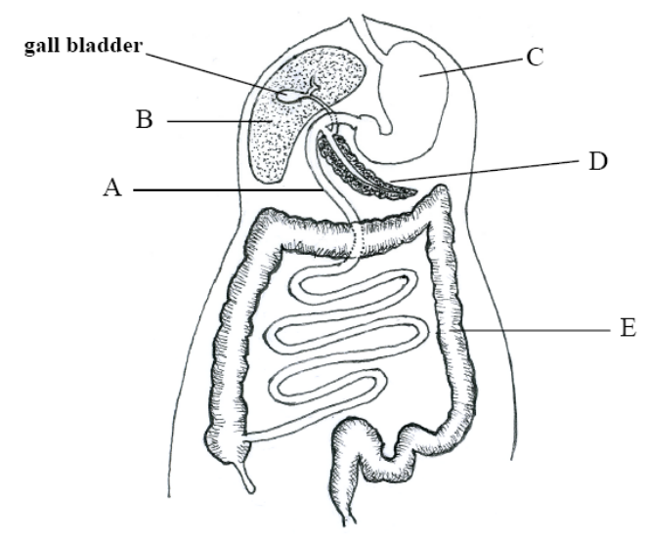
(i) Identify A, B, C, D and E in the diagram.
(ii) What is an amylase? Name a site of amylase action. What is the approximate pH value at this site?
(iii) Give one function of symbiotic bacteria in the human digestive system.
(iv) State a benefit of dietary fibre. (27)

(c) (i) What is meant by absorption?
(ii) Where in the digestive system are the products of digestion absorbed? State one way in which this part of the system is adapted for absorption.
(iii) Name the blood vessel that joins the part of the digestive system that you have named in (ii) to B in the diagram.
(iv) In which part of the digestive system is water absorbed? Give another function of this part of the digestive system.
Answer

2007 OL
15. (c) (i) Copy the following table into your answer book. Complete the table by inserting the correct
terms from the following list:

molar teeth, symbiotic bacteria, peristalsis, bile salts, lipase, stomach

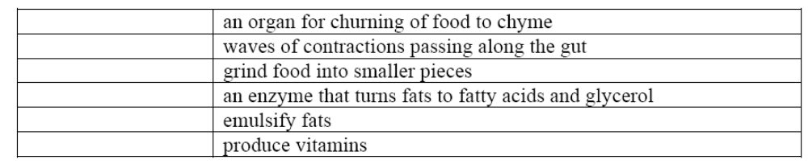

(ii) Copy the following passage into your answer book and fill in the blank spaces.

“The passage of the products of digestion from the intestine to the blood is called …………. Folds in the lining of the intestine, called …………., increase the surface area for this passage. Amino acids from the digestion of ………….. and monosaccharides from the digestion of ……….. enter the blood in this process.”
Answer

2008 OL
13. (a) Bile is involved in digestion in the human body.
(i) 1. Where is bile produced?
2. Where is bile stored?
(ii) Where does bile act in the alimentary canal? (9)

(b) The diagram shows the digestive system of the human.
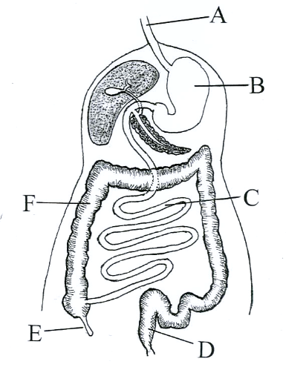
(i) Name the parts labelled A, B, C, D, E and F.
(ii) What is the role of peristalsis in the digestive system?
(iii) Where do the products of digestion enter the blood?
(iv) How do these products of digestion pass into the blood? (27)

(c) (i) For each of the parts labelled B and C in the diagram above, state whether the contents are
acidic, neutral or alkaline.
(ii) Amylase is an enzyme that is found in saliva. State the substrate and the product of this enzyme.
(iii) State two functions of symbiotic bacteria in the alimentary canal.
(iv) What is meant by egestion? From which labelled part of the diagram does egestion occur?
(24)
Answer

2010 OL
13. (a) (i) What is meant by a ‘balanced’ diet?
(ii) Distinguish between autotrophic nutrition and heterotrophic nutrition. (9)

(b) (i) Explain the word digestion.
(ii) Give one role for each of the following types of teeth:
1. Incisors
2. Molars.
(iii) Peristalsis begins when food enters the oesophagus.
What is meant by peristalsis?
(iv) Describe the following changes that happen to food in the stomach:
1. Mechanical changes
2. Chemical changes.
(v) What is the pH of the stomach contents?
(vi) Where does the partially digested food go when it leaves the stomach? (27)

(c) The liver, the gall bladder and the pancreas all play a part in digestion. Digested food is
carried to the liver where it is processed. Undigested food enters the large intestine.
(i) State
1. One role of the pancreas in digestion.
2. One role of the gall bladder in digestion.
(ii) From what part of the digestive system does the digested food enter the blood?
(iii) Name the blood vessel that carries the digested food to the liver.
(iv) State two functions of the liver – other than the processing of digested food.
(v) The colon contains many symbiotic bacteria – mostly ‘good’ bacteria.
State two benefits we get from these bacteria. (24)
Answer

2012 HL
15. Answer any two of (a), (b), (c). (30, 30)

(a) The diagram shows part of a transverse section through the small intestine.
(i) Name structures X and Y.
(ii) What process results from the contraction of the two parts of tissue Z?
(iii) In your answer book, indicate which of the following most accurately represents the pH of
the contents of the small intestine.
Acidic. Neutral. Alkaline.
(iv) Name two glands that pass their secretions into the small intestine.
(v) 1. What are symbiotic bacteria?
2. Give two functions of symbiotic bacteria in the human alimentary canal.
(vi) Where in the human alimentary canal is most water absorbed?

(b) (i) State two ways, other than colour, in which red blood cells differ from white blood cells.
(ii) Name a group of white blood cells, other than lymphocytes.
(iii) Lymphocytes may be divided into B cells and T cells. B cells produce antibodies.
1. What is the role of antibodies in the body?
2. Name any three types of T cell.
3. State a role of each of the T cell types that you named in part 2.

(c) (i) Explain the term homeostasis.
(ii) Homeostasis often requires an organism to exchange materials between different
tissues, or between itself and the external environment by diffusion, osmosis, and
active transport. Explain each of the underlined terms.
(iii) State one way in which each of the following contributes to homeostasis.
1. Liver.
2. Lungs.
3. Nephrons of kidneys.
(iv) Describe the role of the skin in controlling body temperature.
Answer

2012 OL
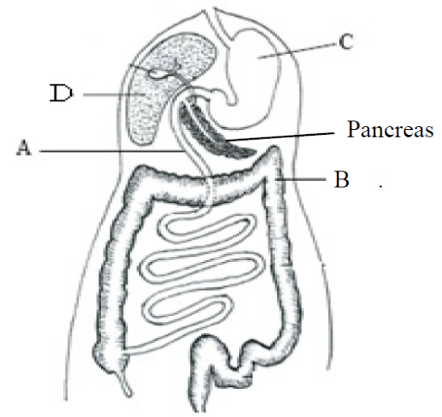
15. Answer any two of the parts (a), (b), (c). (30, 30)

(c) The diagram shows the human digestive system.
(i) Name the parts labelled A, B and C.
(ii) Explain the term digestion?
(iii) Name one human tooth type and give its function.
(iv) Part C secretes hydrochloric acid onto the ingested food.
Give one function of this acid.
(v) Give one digestive function of part D.
(vi) Give one digestive function and one non-digestive
function of the pancreas.
Answer

3.4 Breathing System and Excretion

Need to Know

3.4.1 - 2 Homeostasis
3.4.3 Plant Exchange System
3.4.4 Human Breathing System
3.4.5 Plant Excretion
3.4.6 Human Excretory System
3.4.7.H CO₂ Gaseous Exchange
3.4.8.H Nephron of Kidney

At the end of this section students should be able to:

Homeostasis
- Define Homeostasis.
- Say why homeostasis is necessary in living organisms.
- Relate homeostasis to temperature, fluid balance and chemistry of cells.
- Relate homeostasis to temperature, fluid balance and chemistry of organisms.
- Explain why organisms must maintain constant conditions in their cells and bodies.
- Explain diffusion.
- Explain how organisms need to develop exchange systems which include the respiratory and excretory systems.
- Explain how gases, nutrients and toxic wastes are exchanged by diffusion between cells and their environment.
- Understand that the efficiency of exchange is proportional to the surface area over which diffusion can take place.
- Understand that large organisms have problems with diffusion.
- Explain how these problems of size can be overcome.
- Explain why large active animals such as humans also require a circulatory system.

Plant Exchange System
- Draw the structure of the leaf in relation to gaseous exchange.
- Identify the stomata in a leaf [in TS and lower surface].
- Give the role of stomata.
- Identify lenticels on a stem.
- Give the role of lenticels.
- Identify the TS of a leaf blade under the microscope.
- Explain the need for intercellular air spaces in the leaf.

Human Breathing System
- Draw and label the breathing system in humans.
- Give the function of the parts: Nasal and buccal cavities, pharynx, epiglottis, glottis, larynx, trachea, bronchi, bronchioles, alveoli.
- Explain the essential features of the alveoli and capillaries as surfaces over which gas exchange takes place.
- Describe the mechanism of breathing – how we inhale and exhale air.
- Give the role of the diaphragm, the intercostal muscles and brain (exclude CO₂, levels) in breathing.
- Explain pressure changes in the thoracic cavity during breathing.
- Outline gaseous exchange in alveoli.
- Give the role of haemoglobin in oxygen transport.
- Explain source of the carbon dioxide that is in the plasma .
- Explain why we exhale water vapour.
- Describe the experiment to show the effect of exercise on the breathing rate.
- Explain one breathing disorder – choose either asthma or bronchitis.
- Give possible causes of the disorder.
- Describe prevention and treatment of the disorder.

Plant Excretion
- Say why plant leaves are flattened.
- Give the role of leaves as excretory organs of plants.
- Give the role of lenticels as excretory organs of plants.

CO₂ Gaseous Exchange Control
- Explain how CO2 levels are a controlling factor in the human breathing (respiratory) system.
- Identify the brain parts concerned with CO2 detection.
- Explain why CO2 levels rise in the body.
- Explain the idea of oxygen debt.
- Explain how CO2 levels are a controlling factor in stomatal opening and gas exchange.
- Explain why CO2 levels change in the leaf.

Human Excretory System
- Explain the role of the excretory system in homeostasis.
- Explain why temperature influences the rate of the chemical reactions that sustain life.
- Outline the different methods of temperature regulation in animals.
- Explain the terms Ectotherms and Endotherms.
- Explain temperature regulation in humans:
- Responses to cold conditions – reference to piloerection, vasoconstriction and brain initiated increased metabolic rate.
- Responses to warm conditions – reference to perspiration, including the evaporation of sweat, position of sweat glands in the skin, components of sweat and the necessity to drink water before, during and after exercising to maintain the balance of water and salts in the body.
- Recognise and label a T.S of human skin.
- Describe the macrostructure and basis function of the urinary excretory system in humans (kidney, ureters, urinary bladder, and urethra).
- Give the function, location and excretory products of the lungs, skin and urinary system.
- Explain the role of the kidney in regulating body fluids: extracting wastes and toxins from the blood and recycling valuable substances by filtration, reabsorption and secretion - thus regulating the body fluids and chemistry of the body.
- Identify the positions of filtration, reabsorption and secretion in the kidney [by reference only to the cortex, medulla and renal pelvis].
- Describe of the pathway of urine from the kidney to the urethra.
- Outline bacterial urinary tract infections, formation of kidney stones, renal tubule failure, dialysis and kidney transplants.

Nephron of Kidney
- Draw the Nephron and its associated blood supply.
- Explain the formation of urine:
- Blood enters the glomerulus under pressure which force-filters the plasma minus proteins and other large molecules into the lumen of the Bowman's capsule.
- The glomerular filtrate passes from the Bowman's capsule into the proximal convoluted tubule where reabsorption of substances needed by the body takes place - glucose, amino acids, some salts and water reabsorbed into the blood by osmosis, diffusion, and active transport.
- More water reabsorbed in the Loop of Henle and the distal convoluted tubule. The remainder, now called urine, passes into the pelvis of the kidney and to the bladder for storage.
- Explain how reabsorption of water in the collecting duct is under hormonal influence (ADH). Its secretion [action] depends on the water content of the blood. (No further details required).

PowerPoint Presentations

3.4.1 - 2 Homeostasis.ppt
3.4.3 The Exchange System in Plants.ppt
3.4.4 Lungs & Breathing.ppt
3.4.5 Plant Excretion.ppt
3.4.6 The Excretory System in the Human.ppt
3.4.7.H CO₂ Gaseous Exchange.ppt
3.4.8.H The Nephron.ppt

3.4 Breathing System and Excretion

Section A

Homeostasis
Higher Level Questions Ordinary Level Questions

Higher Level

SEC Sample Paper HL
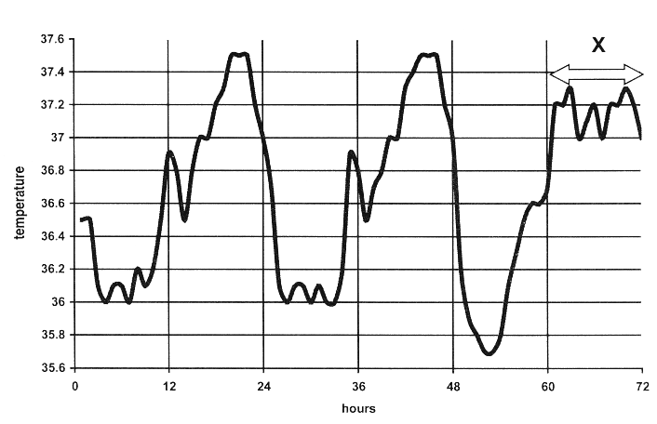
6. The graph shows the variations in human body temperature over a number of days.
What was the minimum temperature recorded? ............................................................
What was the maximum temperature recorded?............................................................
Suggest a reason for the difference between body temperature during period X and the
same period on the previous days...........................................................................................
What is the source of the heat that keeps the body at a fairly constant temperature?
State two responses that result when body temperature begins to drop.
1 ………………………….............................................................................................................
……………………………………………………………………………………………….
2 .......................................................................................................................................................
.......................................................................................................................................................
Explain briefly how sweating assists in the shedding of excess heat . ............................................................
…..…………………………………………………………………………………………………………
………..……………………………………………………………………………………………………
……………..………………………………………………………………………………………………
………………..……………………………………………………………………………………………
Possible Answer

2011 HL
4. (a) (i) What is an endotherm? __________________________________________________________
(ii) What word is used to describe animals which are not endotherms?
____________________________________________________________________________
(iii) Suggest an advantage of being an endotherm. ________________________________________
(b) The graph shows daily variations of human body temperature over three days.
DAY 1 DAY 2 DAY 3
(i) What is the maximum range of body temperature under normal conditions as shown in the
graph?
_____________________________________________________________________________
(ii) At what time each day does body temperature drop to its lowest level? ____________________
(iii) Suggest a reason for the drop in temperature at the time referred to in (ii).
_____________________________________________________________________________
(iv) Children typically have higher body temperatures than adults. Suggest a reason for this.
_____________________________________________________________________________
Answer

2013 HL
3. The relationship between body temperature and environmental temperature for two animals is
plotted below.
One of these animals is a dog and the other is a lizard.

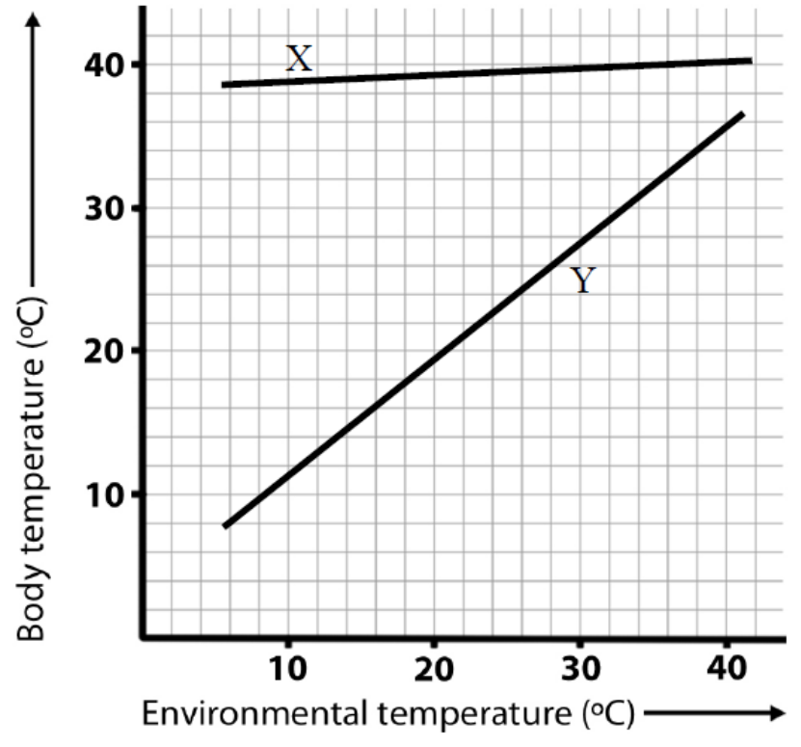

(a) Which of the plots, X or Y, relates to the dog? ___________________________________________
Explain your answer. _______________________________________________________________
________________________________________________________________________________
(b) In relation to body temperature, what term is used to describe animals such as the dog?
________________________________________________________________________________
(c) What is the main source of the dog’s body heat?
________________________________________________________________________________
(d) Suggest a value to dogs of the relationship between their body temperature and environmental
temperature.
________________________________________________________________________________
________________________________________________________________________________
(e) In relation to body temperature, what term is used to describe animals such as the lizard?
________________________________________________________________________________
(f) What is the main source of the lizard’s body heat?
________________________________________________________________________________
Answer

Ordinary Level

Gaseous Exchange in Plants
Higher Level Questions Ordinary Level Questions

Higher Level

2004 HL
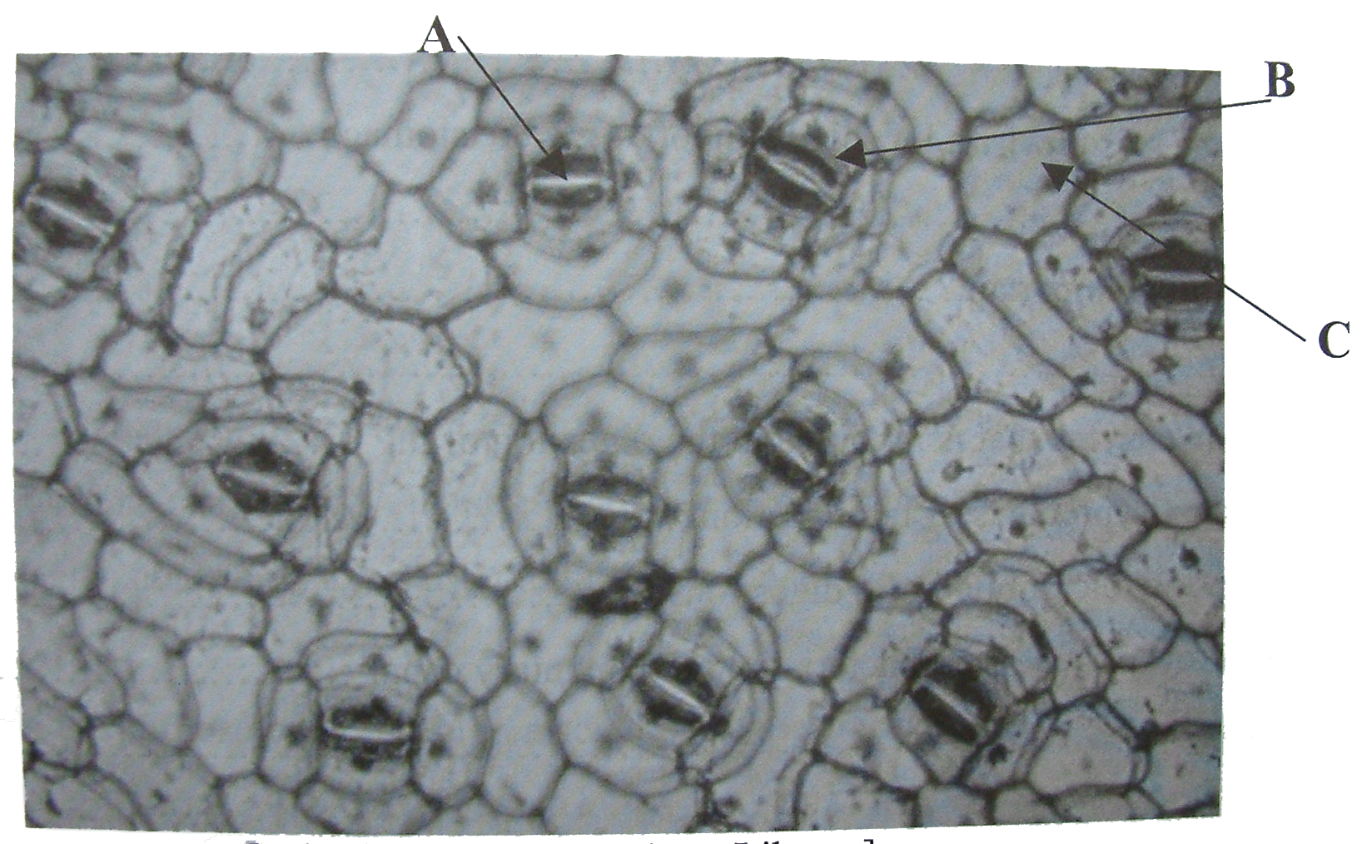
4. (a) The diagram shows part of the under surface of a leaf as seen through the microscope.
A is an aperture. B and C are cells.

Name A, B, C.
A ………..………………… B ……..….……..………. C ………………..……….
What is the function of A? ......................................................................................................................
Name a factor that influences the diameter of A ………………..............................................................
Name the apertures in stems that are equivalent to A ..............................................................................

(b) In some species of flowering plants the leaves are modified for the storage of food.
Name a plant in which the leaves are modified for food storage .............................................................
Name a carbohydrate that you would expect to find in the modified leaves of the plant that you named above .........................................................................................................................................................
Name a type of modified stem that functions in food storage ...................................................................

Answer

Ordinary Level

SEC Sample Paper OL
1. Complete the following sentence by putting one word in the blank space.
(a) The hammer (malleus) is a very small bone located in the ……………………………………
(b) Bile is secreted by the …………………………………………………………………….……
(c) Tiny holes called …………………………………… allow gases to enter and leave the leaf.
(d) Bones are joined to other bones by ..……………………………………………………..……
(e) An animal that eats both plants and animals is called an ………………………………….…..
Possible Answer

2006 OL
4. The diagram shows part of a section through a leaf.

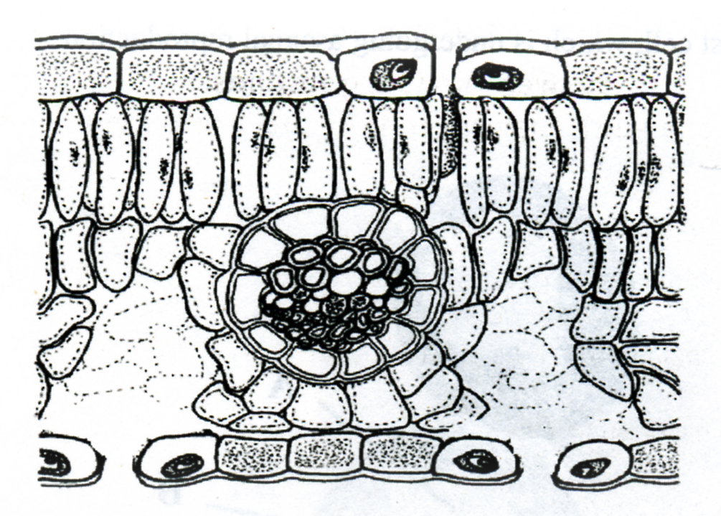
(a) Use the letter A to show a point of entry of carbon dioxide. Name this point
(b) Name a gas that leaves the leaf at this point ………………………………………….
(c) Use the letter B to show the part of the leaf in which most photosynthesis occurs.
(d) Name the structures in plant cells in which photosynthesis occurs ……………………..
(e) In addition to carbon dioxide another small molecule is needed for photosynthesis.
Name this other molecule ……………………………………………………………….
Answer

2010 OL
6. The diagram below shows the internal structure of a leaf.

(i) Name the one tissue type that is found at both V and Y. _________________________________________________________________________________
(ii) The cells at W contain many organelles that carry out photosynthesis.
Suggest why the cells at W contain more of these organelles than the cells at X.
_________________________________________________________________________________ _________________________________________________________________________________
(iii) In layer X, gases can diffuse throughout the leaf. Name one such gas. ________________________________________________________________
(iv) State one function of the opening at Z. _________________________________________________________________________________
(v) Name the cells which are responsible for controlling the size of the opening at Z. _________________________________________________________________________________
Answer

Breathing System
Higher Level Questions Ordinary Level Questions

Higher Level

Ordinary Level

2007 OL
3. Indicate whether the following are true (T) or false (F) by drawing a circle around T or F.

Example: The pulmonary artery carries blood to the lungs T F

(a) If the eyepiece lens of a microscope is marked X10 and the objective lens
is marked X4, the total magnification is X14 T F
(b) Plant cells have chloroplasts, animal cells do not have chloroplasts T F
(c) Humans receive oxygen from the air they inhale T F
(d) Cell membranes let only some molecules pass through T F
(e) Human chromosomes are found in the nucleus T F
Answer

Excretory System
Higher Level Questions Ordinary Level Questions

Higher Level

SEC Sample Paper HL
6. The graph shows the variations in human body temperature over a number of days.

What was the minimum temperature recorded? ..............................................................................................
What was the maximum temperature recorded?..............................................................................................
Suggest a reason for the difference between body temperature during period X and the same period on the previous days......................................................................................................................................................
…………………………………………………………………………………………………………….
What is the source of the heat that keeps the body at a fairly constant temperature?
…………………………………………………………………………………………………………….
State two responses that result when body temperature begins to drop.
1 ………………………….............................................................................................................
……………………………………………………………………………………………….
2 .......................................................................................................................................................
.......................................................................................................................................................
Explain briefly how sweating assists in the shedding of excess heat . ............................................................
…..…………………………………………………………………………………………………………
………..……………………………………………………………………………………………………
……………..………………………………………………………………………………………………
………………..……………………………………………………………………………………………
Possible Answer

2006 HL
6. Distinguish between the members of each of the following pairs by making a brief comment on each.
(a) Tuber and bulb ………………………………………………………………………………
………………………………………………………………………………………………..
………………………………………………………………………………………………..
(b) Ureter and urethra …………………………………………………………………………….
…………………………………………………………………………………………………
…………………………………………………………………………………………………
(c) Hypha and mycelium …………………………………………………………………………
…………………………………………………………………………………………………
…………………………………………………………………………………………………
(g) Thigmotropism and chemotropism ……………………………………………………………
…………………………………………………………………………………………………
…………………………………………………………………………………………………
(e) Antigen and antibody …………………………………………………………………………
…………………………………………………………………………………………………
…………………………………………………………………………………………………
Answer

Ordinary Level

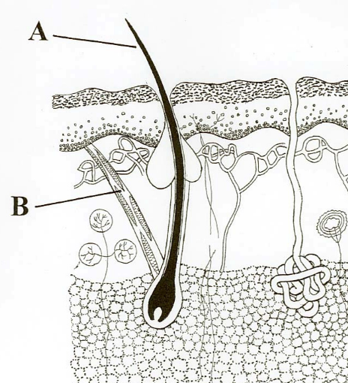
2008 OL
6. The diagram shows a section through human skin.
(a) Name parts A and B.
A ____________________________
B ____________________________
(b) Place X on the diagram to show where sweat
reaches the skin surface.
(c) Apart from water, name one other substance
which is found in sweat ____________________
(d) Describe briefly one way by which the skin helps
to retain heat in cold conditions.
___________________________________________________________________________
___________________________________________________________________________
Answer

2013 OL
6. The diagram shows a vertical section through a human kidney.
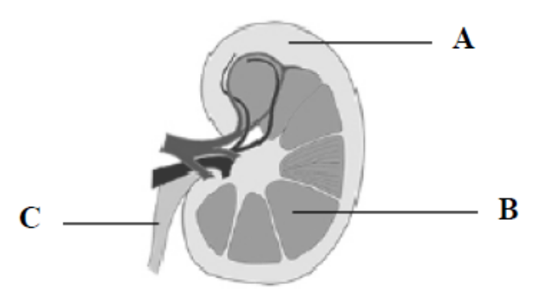
(a) Name the parts labelled A, B and C.
A ……………………………………………….
B ……………………………………………….
C ……………………………………………….
(b) Name the organ that is attached to the kidney by part C.………………………………………….
(c) Name one substance excreted by the kidneys.……………………………..………………………
(d) Name the site in the kidney where filtration takes place……………………..…………………….
(e) Suggest one possible treatment for kidney failure……………………………...…………………..
Answer

3.4 Breathing System and Excretion

Section B

Breathing System
Higher Level Questions Ordinary Level Questions

Higher Level

Ordinary Level

2004 OL
9. (a) Answer the following in relation to human breathing rate OR pulse rate.
State which of these you will refer to ……………………………………………………………
What is the average rate at rest? ………………………………………………………………….
State a possible effect of smoking on the resting rate ………………………………………….
……………………………………………………………………………………………………

(b) How did you measure the resting rate? …………………….…………………………………….
.………………………….…………………………………………………………………………
……………………………………………………………………………………………………
……………………………………………………………………………………………………
……………………………………………………………………………………………………
Describe how you investigated the effect of exercise on this rate.
………………………………………………………….…………………………………………
……………………………………………………………………………..…………………….………………………………………………………………..………………………………….
……………………………………………………………………………………………………
……………………………………………………………………………………………………
……………………………………………………………………………………………………
……………………………………………………………………………………………………
……………………………………………………………………………………………………
Using the axes below draw a graph to show how rate is likely to vary as the exercise level increases.

Answer

2008 OL
8. (a) State the location in the human body of the following muscles which are used for breathing:
(i) diaphragm _____________________________________________________
(ii) intercostals _____________________________________________________

(b) Answer the following questions about an activity that you carried out to investigate the effect of exercise on the breathing rate or pulse of a human.
(i) At the start of the investigation you asked the person who was about to do the exercise to sit down for a few minutes. Explain the purpose of this. ____________________________
___________________________________________________________________________
___________________________________________________________________________

(ii) How did you measure the breathing rate or the pulse?
___________________________________________________________________________
___________________________________________________________________________
___________________________________________________________________________
___________________________________________________________________________

(iii) Describe how you conducted the investigation after the period of rest.
___________________________________________________________________________
___________________________________________________________________________
___________________________________________________________________________
___________________________________________________________________________
___________________________________________________________________________
__________________________________________________________________________
___________________________________________________________________________
___________________________________________________________________________
___________________________________________________________________________
___________________________________________________________________________
___________________________________________________________________________
___________________________________________________________________________

(iv) State the results of your investigation. _____________________________________
___________________________________________________________________________
___________________________________________________________________________
___________________________________________________________________________
Answer

2009 OL
7. (a) (ii) Give one way in which water is lost from the body.
______________________________________________________________________
Answer

2012 OL
7. (a) (i) Name one disorder of the human breathing system. ___________________________________
(ii) Give one possible treatment for the disorder referred to above. __________________________
__________________________________________________________________________________
(b) Answer the following questions about an activity that you carried out to investigate the effect of
exercise on your breathing rate or your pulse rate.
/Tick the rate you will refer to. | Breathing Rate
/Tick the rate you will refer to. | Pulse Rate

(i) The investigation starts by measuring the resting rate. How did you measure the resting rate?
__________________________________________________________________________
__________________________________________________________________________
(ii) After measuring your resting rate, what other steps did you carry out to complete the investigation?
___________________________________________________________________________
___________________________________________________________________________
___________________________________________________________________________
___________________________________________________________________________
___________________________________________________________________________
(iii) What was the result of your investigation?
___________________________________________________________________________
___________________________________________________________________________
___________________________________________________________________________
(iv) Does this investigation give the same result for both fit and non-fit people? ______________
(v) Give a reason for your answer.
___________________________________________________________________________
___________________________________________________________________________
___________________________________________________________________________
Answer

3.4 Breathing System and Excretion

Section C

Homeostasis
Higher Level Questions Ordinary Level Questions

Higher Level

2004 HL
12. (a) What is homeostasis? State the role of the kidneys in homeostasis. (9)
Answer

2007 HL
15. (c) (i) What is homeostasis? Note one reason why it is important in the human body.
(ii) Draw a diagram of a section through human skin to show two structures involved in temperature regulation. Label each of these structures.
(iii) For one of the structures that you have labelled in your diagram briefly describe its role in temperature regulation.
(iv) What is meant by an ectotherm? [30]
Answer

2009 HL
15. (c) Write notes on three of the following topics:
(iii) Homeostasis.
Answer

2012 HL
15. Answer any two of (a), (b), (c). (30, 30)

(c) (i) Explain the term homeostasis.
(ii) Homeostasis often requires an organism to exchange materials between different
tissues, or between itself and the external environment by diffusion, osmosis, and
active transport. Explain each of the underlined terms.
(iii) State one way in which each of the following contributes to homeostasis.
1. Liver.
2. Lungs.
3. Nephrons of kidneys.
(iv) Describe the role of the skin in controlling body temperature.
Answer

Ordinary Level

2012 OL
15. Answer any two of the parts (a), (b), (c). (30, 30)

- The diagram shows a section through human skin.

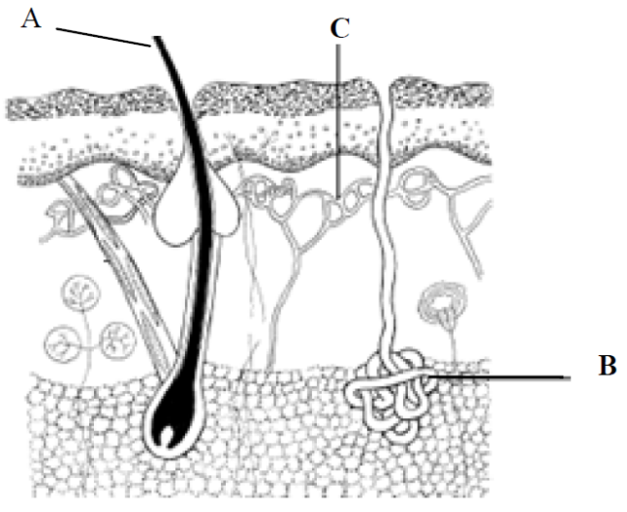

(i) Name the parts labelled A, B, and C.
(ii) The skin is one of the excretory organs in humans.
Name one substance excreted by the skin.
(iii) List two other functions of the skin.
(iv) Name another organ of excretion and state one substance it excretes.
(iv) What is meant by the term homeostasis?
(vi) The human being is an endotherm. What does this mean?
Answer

Gaseous Exchange in Plants
Higher Level Questions Ordinary Level Questions

Higher Level

2008 HL
14. (a) (i) Name the openings in the leaf which allow the entry of carbon dioxide for photosynthesis.
State a factor which influences the diameter of these openings.
Answer

Ordinary Level

2006 OL
14. Answer any two of (a), (b), (c). (30,30)
(a) The diagram shows the structure of part of a stem.

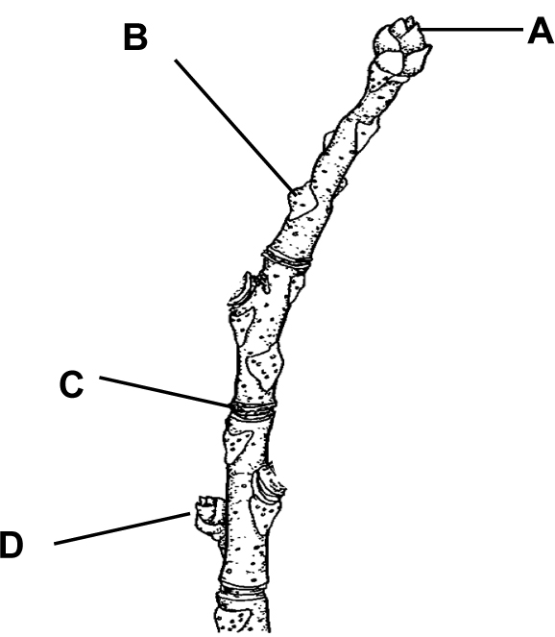

(i) Identify A, B, C and D.
(ii) What is a meristem?
(iii) Give a location of a meristem in the diagram.
(iv) How many years' growth are shown in the diagram?
Explain your answer.
(v) Give two functions of a stem.
Answer

2007 OL
15. (b) (i) Draw a diagram of a section through a leaf. Label a stoma and a guard cell.
(ii) Give a function of the guard cell.
(iii) Name two gases that enter or leave the leaf.
(iv) Name the process by which the gases move in or out of the leaf.
Answer

Breathing System
Higher Level Questions Ordinary Level Questions

Higher Level

SEC Sample Paper HL
13. (a) (i) Distinguish between breathing and respiration.
(ii) Breathing rate in humans is controlled by the concentration of a gas dissolved in blood. Which gas is this? (9)

(b) The diagram shows the human breathing system

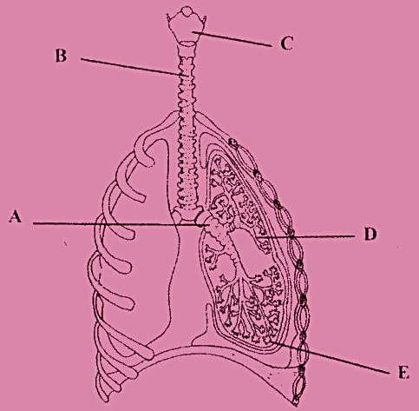

- Name the parts labelled A, B, C, D, E.
- Where do cilia occur in this system? What is their function
- State precisely the events that take place at E. How is E adapted for these events? (27)

(c) Asthma and bronchitis are common disorders of the breathing system. Answer the following
in relation to one of these disorders. State the disorder to which you refer.
(i) State one possible cause of the disorder.
(ii) Suggest one way in which a person might adapt his/her lifestyle to minimise the
effects of the disorder.
(iii) Give an example of a treatment for the disorder. (24)
Possible Answer

2007 HL
13. (a) (i) Name the blood vessel that returns blood to the heart from the lungs.
(ii) Name the main gas transported in the blood vessel that you have named in (i).
How is this gas transported? (9)

(b) (i) Draw a large diagram of the human breathing system. Label the trachea, bronchus and lung.
(ii) State the function of the following: epiglottis, larynx.
(iii) Describe briefly the role of the diaphragm and intercostal muscles in inhalation.
In your answer refer to volume and thoracic air pressure. (27)

(c) (i) Give three ways in which an alveolus is adapted for efficient gas exchange.
(ii) Name the process involved in the passage of gas between the alveolus and the blood.
(iii) Name a breathing disorder.
- In the case of the breathing disorder that you have named in (iii) state:
- a cause,
- a means of prevention,
3. a treatment. (24)
Answer

2009 HL
13. (c)

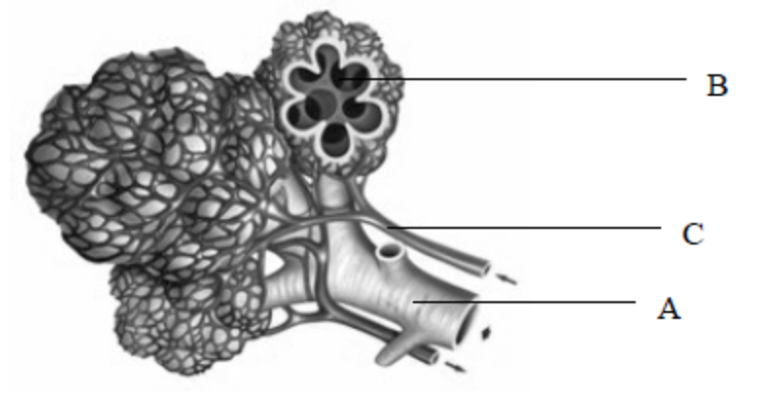

The diagram shows microscopic detail from a human lung.
- Name the parts labelled A, B and C.
- Give two features of the structures in the diagram that allow for efficient gas exchange.
(iii) Name a disorder of the breathing system and say how it may be:
1. Caused.
2. Prevented.
3. Treated.
(iv) Which gas, dissolved in the blood, can trigger deeper or faster breathing?
Answer

Ordinary Level

2005 OL
12. (a) (i) Name the major blood vessels that carry blood
1. from the heart to the lungs
2. from the lungs to the heart.
(ii) What gas is released from the blood when it reaches the lungs?

(b) The diagram shows part of the human breathing system.

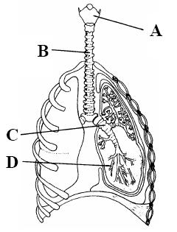

(i) Name A, B, C, D.
(ii) D ends in a small sac. What is the name of this sac?
(iii) What is the function of A?
(iv) B contains rings of cartilage. Suggest a function of this cartilage.
(v) Where is the epiglottis? What is its function? (27)

(c) (i) Name the muscles that are used in breathing.
(ii) Breathing causes pressure changes in the thoracic cavity. Describe briefly how these pressure changes are brought about.
(iii) Name a breathing disorder. Give a possible cause of this disorder and suggest a means of prevention or treatment. (24)
Answer

2008 OL
14. (c) (i) Draw a large labelled diagram of the human breathing tract and label the following parts;
larynx, trachea, bronchus, bronchiole.
(ii) What is the role of alveoli in the lungs?
(iii) Name a breathing disorder.
(iv) Suggest a possible cause of the breathing disorder that you have named in (iii) and state how it may be treated.
Answer

2011 OL
13. (c) The diagram shows part of the human breathing system.
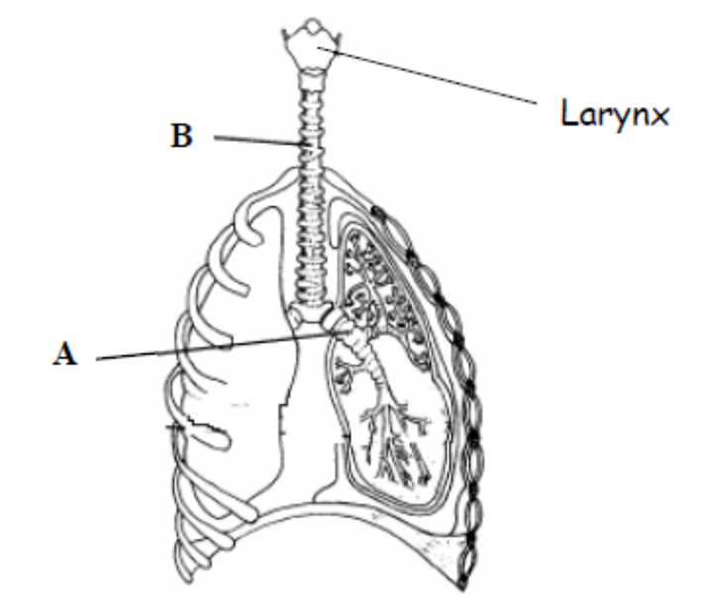

(i) Name the parts labelled A and B.
(ii) In what structures in the lungs does gaseous exchange take place?
(iii) Give one feature of the structure referred to in (ii) that allows efficient exchange of
gases.
(iv) What is the function of the larynx?
(v) Outline the steps involved in inhalation. (27)

Excretory System
Higher Level Questions Ordinary Level Questions

Higher Level

2004 HL
12. (a) What is homeostasis? State the role of the kidneys in homeostasis. (9)

(b) (i) Draw a labelled diagram of a nephron. Include blood vessels in your diagram.
(ii) Filtration and reabsorption are vital processes that take place in the nephron. Describe how each of these processes occurs. (27)

(c) Answer the following questions in relation to human body temperature.
(i) What is the source of the heat that allows the body to maintain a constant internal temperature?
(ii) State two ways in which the body is insulated against loss of heat.
(iii) Describe the ways in which the body responds when its internal temperature rises above the normal level.
(iv) Describe briefly the hormonal and nervous responses that occur when internal body temperature drops. (24)
Answer

2006 HL
13. (b) Use your knowledge of the human vascular and excretory systems to answer the following.
(i) Explain the terms, plasma, glomerular filtrate.
(ii) Explain why red blood cells are normally absent from glomerular filtrate.
(iii) The concentration of glucose is the same in plasma and glomerular filtrate.
Why is this?
(iv) Why is glucose normally absent from urine?
(v) Following a period of heavy exercise an athlete may produce only a small volume of concentrated urine. Explain this observation and give an account of the process that concentrates the urine. (27)
Answer

2007 HL
15. (c) (i) What is homeostasis? Note one reason why it is important in the human body.
(ii) Draw a diagram of a section through human skin to show two structures involved in temperature regulation. Label each of these structures.
(iii) For one of the structures that you have labelled in your diagram briefly describe its role in temperature regulation.
(iv) What is meant by an ectotherm? (30)
Answer

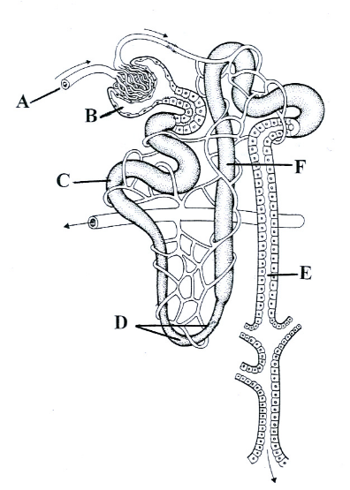
2008 HL
13 (a) (i) What is meant by excretion?
(ii) Urea and carbon dioxide are excretory products of the human body. In the case of each product name a substance from which it is derived. (9)

(b) The diagram shows the structure of a nephron and its associated blood supply.

(i) Name the parts A, B, C, D, E and F.
(ii) From which blood vessel is A derived?
(iii) Where in the kidney is B located?
(iv) Give the part of the nephron in which each of the
following takes place:
1. filtration, 2. reabsorption of amino acids.
(v) Give two features of the nephron that aid filtration.
(vi) Name a group of biomolecules in the blood which
are too large to pass through the filtration system
of the nephron. (27)

(c) (i) Suggest two situations which may result in a drop in the water content of the blood.
(ii) When the water content of the blood drops a hormone is released.
Name this hormone and the endocrine gland from which it is secreted.
(iii) Give a precise target area for this hormone. How does the hormone reach the target area?
(iv) Explain the role of the hormone at its target area, when the water content of the blood is low. (24)
Answer

2010 HL
15. Answer any two of (a), (b), (c). (30, 30)
(c) Suggest a biological explanation for each of the following observations:

(i) As long as a baby feeds regularly from its mother’s breast (or if a breast pump is regularly
used) the milk will continue to flow.
(ii) Doctors are reluctant to prescribe antibiotics to patients suffering from common cold-like
symptoms.
(iii) A person who has suffered from constipation may be advised to increase the amount
of wholegrain cereal in her/his diet.
(iv) After a long session of heavy exercise, an athlete’s urine is likely to be concentrated and
low in volume.
(v) A person’s fingers may turn white when exposed to low temperature for a period of time.
Answer

2011 HL
12. (a) (i) What is meant by the term excretion?
(ii) Mention one method of excretion in flowering plants. (9)

(b) (i) Draw a large labelled diagram of a vertical section through a human kidney.
Label the following parts of your diagram: cortex, medulla, pelvis.
(ii) Indicate clearly on your diagram where re-absorption takes place.
(iii) 1. Name the blood vessel that supplies blood to a kidney.
2. From which blood vessel does the blood vessel referred to in (iii)1 arise?
(iv) In which cavity of the body are the kidneys located?
(v) Name one substance, other than water, excreted in the urine.
(vi) Give a feature of the kidney which indicates that it is an exocrine gland. (27)

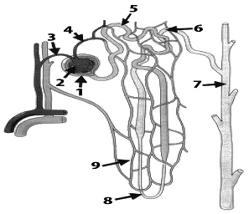

(c) (i) The diagram above shows the structure of a nephron and its associated blood supply.
1. Name the parts numbered 1 to 6.
2. Indicate clearly by number where filtration takes place.
3. Name the hormone associated with changing the permeability of the structure at 7.
(ii) A sample of urine was found to contain protein.
1. Would you consider this to be normal?
2. Explain your answer.
(iii) A sample of urine was found to contain glucose.
1. Would you consider this to be normal?
2. Explain your answer. (24)
Answer

Ordinary Level

SEC Sample Paper OL
15. (a) The diagram shows a vertical section through a human kidney.
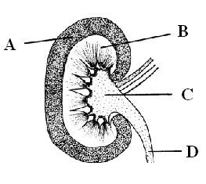
(i) Name the parts A, B, C, D.
(ii) To what structure does D link the kidney?
(iii) Where does filtration occur in the kidney?
(iv) Filtration ensures that cells and valuable substances are not lost from the body when urine is being formed. Name two of these substances or cells.
(v) Suggest a treatment that may be used for a person whose kidneys are not carrying out their normal functions.
(vi) Name an organ in the human body, other than the kidney, in which excretion takes place.
Possible Answer

2005 OL
14. (a) The diagram shows a section through a human kidney.

(i) Name A, B, C, D.
(ii) To what structure does D connect the kidney?
(iii) Filtration is an essential process in the formation of urine. In what part of the kidney does it take place?
(iv) Reabsorption of useful substances takes place in the kidney. In what part does this occur?
(v) Name an excretory substance present in urine.
(vi) Name an excretory organ in the human body other than the kidney. Name a substance, other than the one you have named in (v), excreted by this organ. (30)
Answer

2006 OL
15. Answer any two of (a), (b), (c). (30,30)

(a) The diagram shows a vertical section through human skin.

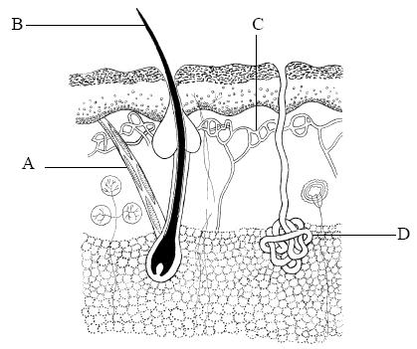

(i) Identify parts A, B, C and D on the diagram.
(ii) The human being is an endotherm. What does this mean?
(iii) What is the main source of body heat in endotherms?
(iv) Describe the role of D in relation to body temperature.
(v) What happens to the small arteries (arterioles) in the skin when the external temperature drops?
Answer

2007 OL
14. (b) (i) What is meant by excretion?
(ii) Name two products excreted by the human.
(iii) Name one organ of excretion, other than the kidney, in the human body.
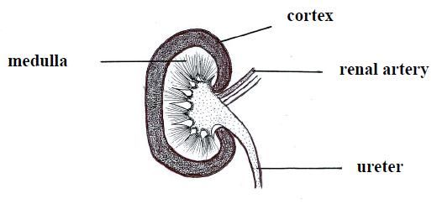
(iv) What is meant by osmoregulation?
(v) Study the diagram of a section through the kidney
and answer the following questions.
1. Where does filtration of blood take place?
2. Where does reabsorption of salt take place?
3. To what organ does the ureter link the kidney?
4. To which main blood vessel does the renal
artery link the kidney?
(vi) Name the fluid present in the ureter.
Answer

2009 OL
14. (b) The diagram shows a vertical section through a human kidney.

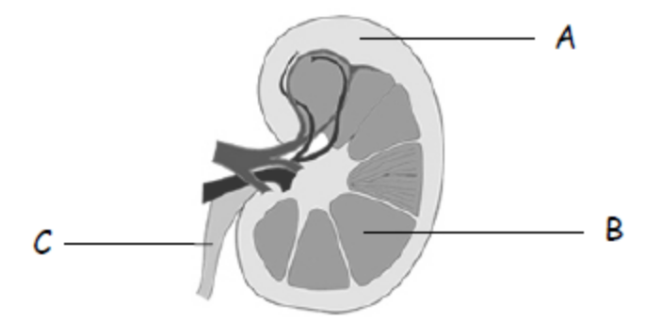

(i) Name the parts labelled A, B and C.
(ii) Which organ is attached to the kidney by part C?
(iii) In which of the three labelled parts does filtration of the blood occur?
(iv) Explain the term excretion.
(v) Name two substances excreted by the kidneys.
(vi) Give two other excretory organs in the human body.
Answer

2011 OL
14. Answer any two of (a), (b0, (c) (30,30)

(c) (i) Explain the term excretion.
(ii) Name two substances excreted by the kidneys.
(iii) The diagram shows the human urinary system.
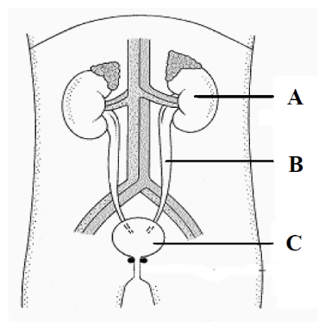
Name the parts labelled A, B and C.
(iv) Name the parts of the kidney in which each of the
following takes place:
1. Filtration
2. Reabsorption.
(v) Name one other excretory organ in the body.
Answer

2012 OL
15. Answer any two of the parts (a), (b), (c). (30, 30)

- The diagram shows a section through human skin.

(i) Name the parts labelled A, B, and C.
(ii) The skin is one of the excretory organs in humans.
Name one substance excreted by the skin.
(iii) List two other functions of the skin.
(iv) Name another organ of excretion and state one substance it excretes.
(iv) What is meant by the term homeostasis?
(vi) The human being is an endotherm. What does this mean?
Answer

3.5 Responses to Stimuli

Need to Know

3.5.1 Structures for Response
3.5.2 Plant Responses
3.5.3 Human Responses
- Defence
- Endocrine
- Musculoskeletal
- Nervous
- Eye & Ear)
3.5.4 Viruses
3.5.5.H Auxins
3.5.6.H Plant Regulators & Animal Hormones
3.5.7.H Human Immune System
3.5.8.H Bone Growth & Development

At the end of this section students should be able to:

Structures for Responses
- Explain why organisms need to sense and respond to environmental changes
- Explain why response is a form of defence that allows organisms to survive
- Say why/how plants respond by growth
- Say why/how animals respond by movement
- Outline these structures of behaviour and response - chemical or hormonal system, nerve and sense organ system, muscular and skeletal systems, an immune system e.g. response to viral infection.

Plant Responses
- Name four external factors that regulate the growth of plants – light intensity, day length, gravity, temperature.
- Name the main internal factor that regulates these responses in plants – growth regulators.
- Explain what a growth regulator is.
- Explain where growth regulators are made in a plant.
- Explain what a meristem is.
- Draw the external structure of a flowering plant and highlight and identify meristematic regions.
- Explain the term "Tropism".
- Define the terms “phototropism", "geotropism', "thigmotropism", "hydrotropism", "chemotropism”.
- Say why phototropism is an important response for a plant, and give examples.
- Say why geotropism is an important response for a plant, and give examples.
- Devise a simple experiment to demonstrate phototropism.
- Say how growth regulators are transported within a plant – through the vascular system.
- Explain the difference between a growth promoter and growth inhibitor.
- Give an example of a regulator promoting growth - auxins.
- Give an example of a regulator inhibiting growth - ethene and abscisic acid.
- Describe any four methods by which plants protect themselves from adverse external environments e.g. anatomical/chemical - heat shock proteins or stress proteins.
- List a variety of effects of plant growth regulators.
- Explain how plant tissue cutting are taken and why.
- Give a use of rooting powders in horticulture.
- Identify a number of plant protective measures (using live samples or pictures).
- Give two examples of the use of plant growth regulators.

Auxins
- Explain what an auxin is.
- What the initials IAA stand for.
- Where auxin is made in a plant.
- How it travels through a plant.
- List the function of auxins within cells.
- Describe the overall effect it has on plant tissues.

HUMAN RESPONSES

Defence System
- Name our two main lines of Defence.
- List the parts of the body involved in the general defence system.
- Outline the defensive nature of the skin.
- Give the defensive functions of the respiratory and digestive tracts.
- Explain what a phagocyte is.
- Explain a possible advantage of fever [high temperature] as a defence response.
- Explain the term "Specific defence system”.
- Explain what immunity means.
- Explain what is meant by the term "Antigen-antibody response".
- Name 3 functions of the lymphatic system.
- Give the roles of lymphocytes and monocytes.
- Say what an antigen is and give some examples of antigens.
- Say what an antibody is.
- Define "Induced immunity”.
- Name two types of induced immunity.
- Explain what is meant by Active immunity.
- Explain what vaccination is.
- Explain what is meant by passive immunity.
- Give two examples of passive immunity.
- Say why passive immunity only provides short term protection.
- Outline the work of Edward Jenner.

Human Immune System
- Explain the role of lymphocytes: B and T cell types.
- Explain the role of B cells in antibody production.
- Explain the role of T cells as helpers, killers, suppressors, and memory T cells.
- Know that B cells produce antibodies—proteins capable of combining with and inactivating antigens by surface recognition.
- Know that each B cell produces just one type of antibody.
- Know that T cells do not produce antibodies ; instead they act in one of four processes:
- as helper T cells which recognise antigens, enlarge, and secrete chemicals, such as interferon, which stimulate the production of B cells.
- as killer T cells which attack cells containing a foreign antigen, secrete a chemical called perforin that perforates the membranes of cells.
- as suppressor T cells which stop immune responses.
- as memory T cells which can memorise the immunity, even for life.
- Explain what a pathogen is.
- Explain what receptor molecules are.
- Explain what happens when B cell encounters matching antigen.
- Explain what plasma cells are.
- Explain the idea that antibodies are specific.

Endocrine System
- Say what an Endocrine system is.
- Define the term "hormone".
- Understand the protein nature of many hormones.
- Give four differences between hormone action as compared with nerve action.
- Distinguish between exocrine and endocrine glands, with examples.
- Draw an outline of the body to show the location of the principal endocrine glands.
- For each of the glands:
    - name one hormone it produces
    - give the function(s) of that hormone
- For one hormone, describe its:
    - deficiency symptoms,
    - excess symptoms,
    - corrective measures.
- Explain what is meant by hormone supplements.
- Give two examples of the use of hormone supplements.

Plant Regulators & Animal Hormones
- Explain how a plant responds to any one external stimulus.
- Explain the term feedback with reference to an animal hormonal system.
- Explain the term negative feedback.
- Give an everyday example of negative feedback.

Describe the feedback mechanism of any one animal hormonal system
- Define the term "osmoregulation".
- Explain how the body regulates its water levels.
- Use a simple diagram of the nephron to explain how it functions in osmoregulation.
- Say what ADH stands for.
- Say where ADH is made and where it acts.
OR
- Explain the term "metabolism".
- Explain the function of Thyroxine in the body.
- Say what TSH stands for.
- Say where TSH is made and where it acts.
OR
- Explain the function of Insulin in the body.
- Say where insulin is made and where it acts.
- Explain what diabetes is and give some symptoms.

Musculoskeletal System
- Give four functions of the skeleton.
- Name the structural division of the skeleton into two parts.
- Use model of the human skeleton to identify its main parts.
- Name 4 component parts of the axial skeleton:
Locate and give a function for: skull, vertebrae, ribs, and sternum
- Show the position and function of discs in relation to vertebrae.
- Show the position of these vertebrae: cervical, thoracic, lumbar, sacrum, and coccyx.
- Name the main component parts of the appendicular skeleton
- Show the position of the pectoral and pelvic girdles and their attached limbs.
- Use a model of the human skeleton to identify the clavicle (collar bone) and scapula (shoulder blade).
- Use a model of the skeleton to identify the humerus, radius, ulna, carpal, metacarpals, digits (fingers) containing phalanges.
- Name the appendages attached to the Pelvic girdle.
- Use a model of the skeleton to identify: femur, patella, tibia, fibula, tarsals, metatarsals, digits (toes) containing phalanges.
- Draw a long bone to show its anatomy.
- Distinguish between compact and spongy bone.
- Distinguish between red marrow and yellow marrow.
- Explain what a joint is.
- Classify joints into different types, giving examples.
- Show the position of the various types of joint on a model skeleton.
- Give the function of the different types of joint.
- Describe the structure of one synovial joint.
- Give the role of cartilage and ligaments in joints.
- Give the role of tendons.
- Explain the term "antagonistic muscle pair", giving an example.
- Name a disorder of the musculoskeletal system, giving one possible cause, prevention and treatment.

Bone Growth & Development
- Explain the role of osteoblasts in bone growth.
- Explain that the bone eventually stops increasing in size and limits the individual adult's height.
- Explain that in adults, bone is continually being broken down and replaced.
- Explain the role of osteoclasts.
- Explain how the continued renewal of bone is dependent upon physical activity, hormone levels, and diet.
- Explain the role of calcium in bone.

Nervous System
- Name the two main divisions of the nervous system.
- Identify the CNS and PNS on a diagram of the body's Nervous System.
- Explain the term receptor.
- Describe the structure and function of a neuron (with reference only to cell body, dendrites, axon, myelin sheath, Schwann cell, and neurotransmitter vesicles).
- Give the role and position of three types of neuron:
    - sensory neurons - carry messages from the sense organ to the CNS,
    - motor neurons - carry messages from the CNS to muscle fibres and glands,
    - interneurons - carry messages within the CNS.
- Draw a diagram of a neuron to show its structure, and give the function of :
    - dendrite(s) receive information and carry it towards the cell body,
    - the axon conducts nerve impulses away from the cell body,
    - the cell body contains the nucleus and other organelles and produces neurotransmitter chemicals.
- Explain what an impulse is.
- Know that the conduction of nerve impulses along a neuron involves movement of ions.
- Say what a neurotransmitter is.
- Explain that a synapse is the region where two neurons come into close contact.
- Explain that a synaptic cleft is the gap between the neurons.
- Explain the activation and inactivation of neurotransmitters:
    - When neurotransmitters are activated by the ions they are released into the cleft for a very short time, transmitting the impulse to the next neuron.
    - After transmission, the neurotransmitter is inactivated by an enzyme and reabsorbed by the presynaptic neuron and used to make new neurotransmitter substance.
- Name the five main senses and related organs -- the sense organs contain receptors.
- Name the main parts of the EYE.
- Give the function of each main part of the eye.
- Explain the corrective measures for long and short sight OR for a hearing defect.
- Name the main parts of the EAR.
- Give the function of each main part of the ear.
- Use a model/diagram of the SKIN to show how it functions as a sense organ.
Note: The following are not required: biochemical action, detailed structure of cochlea and semicircular canals in ear, names of sensory receptors in the skin.
- Know that the Central nervous system [CNS] consists of the brain and spinal cord.
- Use a model of the BRAIN to show its major parts in relation to function.
- Give the location and function of the following parts of the brain:
cerebrum, hypothalamus, pituitary gland, cerebellum, and medulla oblongata.
- Identify a cross-section of the spinal cord indicating the following:
    - white matter (containing axons only),
    - grey matter (cell bodies and dendrites),
    - central canal (filled with cerebrospinal fluid),
    - three-layered protective tissue, the meninges (spinal meningitis is an infection of these layers),
    - spinal nerves containing dorsal and ventral roots that project from the spinal cord.
- Write notes on the Peripheral nervous system, and identify the location of nerve fibres and cell bodies.
Important to emphasise that the PNS contains nerve fibres – structures of long dendrites and/or long axons. There are no cell bodies in nerves as cell bodies are only found in the CNS or in ganglia (collection of cell bodies within the PNS e.g. the dorsal root ganglion).
- Explain what a ganglion is.
- Explain the role, structure and mechanisms of the reflex arc/action (Cranial nerves, sympathetic and parasympathetic systems are not required).
- Choose a nervous system disorder [paralysis or Parkinson’s disease] -- give 1 possible cause, prevention, and treatment.

Eye & Ear
- Name the main parts of the EYE.
- Give the function of each main part of the eye.
- Explain what short-sightedness means.
- Draw a diagram of the eye with light rays to show the problem of short sight.
- Show how a lens can be used to correct short sight.
- Explain what long-sightedness means.
- Draw a diagram of the eye with light rays to show the problem of long sight.
- Show how a lens can be used to correct long sight.
- Distinguish between a convex and a concave lens.
- Name the main parts of the EAR.
- Give the function of each main part of the ear.
- Name a hearing defect.
- Explain a possible hearing disability as a result of excessive noise levels.
- Explain a corrective measure for a hearing defect.

Viruses
- Explain the problem of defining what a virus is - living or non-living?
- Show you are aware of their huge variety of shapes.
- Explain their basic structure.
- Describe viral replication.
- Explain why viruses are referred to as obligate parasites.
- Explain the economic and medical importance of viruses to humans, plants, animals.
- Include reference to two harmful examples and one beneficial example.

PowerPoint Presentations

3.5.1 Structures for Response.ppt
3.5.2 Responses in the Flowering Plant.ppt
3.5.3 Responses in the Human - Defence System.ppt
3.5.3 Responses in the Human - Endocrine System.ppt
3.5.3 Responses in the Human - Musculoskeletal System.ppt
3.5.3 Responses in the Human - Nervous System.ppt
3.5.4 Viruses.ppt
3.5.5.H Auxins.ppt
3.5.6.H Plant Regulators & Animal Hormones.ppt
3.5.7.H Human Immune System.ppt
3.5.8.H Bone Growth & Development.ppt

3.5 Responses to Stimuli

Section A

Plant Responses
Higher Level Questions Ordinary Level Questions

Higher Level

2006 HL
6. Distinguish between the members of each of the following pairs by making a brief comment on each.
(a) Tuber and bulb ………………………………………………………………………………
………………………………………………………………………………………………..
………………………………………………………………………………………………..
(b) Ureter and urethra …………………………………………………………………………….
…………………………………………………………………………………………………
…………………………………………………………………………………………………
(c) Hypha and mycelium …………………………………………………………………………
…………………………………………………………………………………………………
…………………………………………………………………………………………………
(g) Thigmotropism and chemotropism ……………………………………………………………
…………………………………………………………………………………………………
…………………………………………………………………………………………………
(e) Antigen and antibody …………………………………………………………………………
…………………………………………………………………………………………………
…………………………………………………………………………………………………
Answer

2009 HL
2. The diagram shows a young plant growing in a tilted seed box.

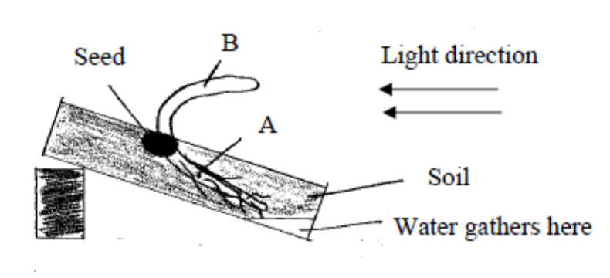

(b) Name the growth response shown by A. ___________________________________________
(c) Name the growth response shown by B. ___________________________________________
(d) Suggest a benefit to the plant of the growth response shown by B.
____________________________________________________________________________
____________________________________________________________________________
(e) Give an example of a regulator in plants that inhibits growth. ___________________________
(f) Give two uses of plant growth regulators in horticulture.
1. __________________________________________________________________________
2. __________________________________________________________________________
Answer

Ordinary Level

2004 OL
1. (a) The hepatic portal vein carries blood from the alimentary canal to the …………………………..
(b) A tendon joins ………………………………………… to bone.
(c) Phototropism is the growth response of a plant to ………………………………….…………….
(d) Hormones are secreted by ……………………………………………………………..… glands.
(e) Gas exchange between a leaf and the atmosphere takes place through the ………………………
Answer

2009 OL
6.
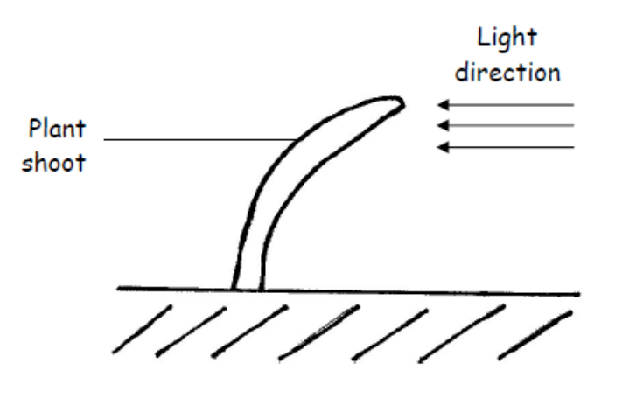

(a) Give the term used for the growth response shown by the plant shoot in the diagram above.
____________________________________________________________________________
(b) Why is this growth response of benefit to plants?
____________________________________________________________________________
(c) Name the group of substances that controls such responses.
____________________________________________________________________________
(d) Name the tissue through which the substances named in (c) are transported in the plant.
____________________________________________________________________________
(e) Name another growth response found in plants.
____________________________________________________________________________
Answer

2011 OL
4. Indicate whether each of the following statements is true (T) or false (F) by drawing a circle
around T or F in each case.

Example: The liver produces bile T F

(a) The semicircular canals in the ear are involved in balance. T F
(b) The growth response of a plant to light is called phototropism. T F
(c) Tendons attach bone to bone. T F
(d) A motor neuron carries impulses to the brain. T F
(e) Rhizopus is a member of the animal kingdom. T F
(f) Xylem transports water in plants. T F
(g) A potato is a modified stem. T F
Answer

Nervous System
Higher Level Questions Ordinary Level Questions

Higher Level

SEC Sample Paper HL
6. The graph shows the variations in human body temperature over a number of days.

What was the minimum temperature recorded? ............................................................
What was the maximum temperature recorded?............................................................
Suggest a reason for the difference between body temperature during period X and the same period on the previous days...........................................................................................
What is the source of the heat that keeps the body at a fairly constant temperature?
State two responses that result when body temperature begins to drop.
1. .....................................................................................................................................................
.....................................................................................................................................................
2. .....................................................................................................................................................
.....................................................................................................................................................
Explain briefly how sweating assists in the shedding of excess heat . ..................................................
…………………………………………………………………………………………………………
…………………………………………………………………………………………………………
…………………………………………………………………………………………………………
…………………………………………………………………………………………………………
Possible Answer

2005 HL
3. Indicate whether the following are true (T) or false (F) by drawing a circle around T or F.
(a) Urea is formed in the kidneys. T F
(b) Motor neurons conduct impulses towards the central nervous system. T F
(c) Endocrine glands secrete hormones. T F
(d) Tendons join muscles to bones. T F
(e) The sino-atrial node (pacemaker) is located on the right side of the heart. T F
(f) A nucleus is absent from human red blood cells. T F
(g) Light is essential for the germination of seeds. T F
(h) Lenticels serve the same function as stomata. T F
(i) Parallel leaf veins are characteristic of monocotyledonous plants. T F
(j) Endosperm is a food reserve in some seeds. T F
Answer

2008 HL
4. The diagram shows a motor neuron.
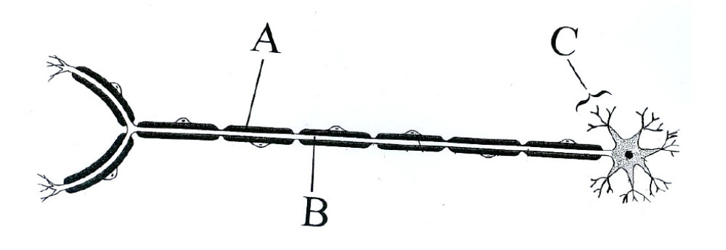

(a) Identify parts A, B and C.
A…………………………… B ……………………………… C……………………………..
(b) Give a function of A …………..………………………………………………………………….
……………………………………………………………………………………………………
(c) Place an arrow on the diagram to show the direction of the impulse.
(d) Give a function of C ……………………………………………………………………………..
……………………………………………………………………………………………………
(e) Place an X on the diagram at a point at which a neurotransmitter substance is secreted.
(f) What is the role of the motor neuron? …………………………………………………………..
……………………………………………………………………………………………………
Answer

Ordinary Level

2011 OL
4. Indicate whether each of the following statements is true (T) or false (F) by drawing a circle
around T or F in each case.

Example: The liver produces bile T F

(a) The semicircular canals in the ear are involved in balance. T F
(b) The growth response of a plant to light is called phototropism. T F
(c) Tendons attach bone to bone. T F
(d) A motor neuron carries impulses to the brain. T F
(e) Rhizopus is a member of the animal kingdom. T F
(f) Xylem transports water in plants. T F
(g) A potato is a modified stem. T F
Answer

Eye & Ear
Higher Level Questions Ordinary Level Questions

Higher Level

Ordinary Level

SEC Sample Paper OL
1. Complete the following sentence by putting one word in the blank space.
(a) The hammer (malleus) is a very small bone located in the ……………………………………
(b) Bile is secreted by the …………………………………………………………………….……
(c) Tiny holes called …………………………………… allow gases to enter and leave the leaf.
(d) Bones are joined to other bones by ..……………………………………………………..……
(e) An animal that eats both plants and animals is called an ………………………………….…..
Possible Answer

2010 OL
5. The diagram shows the external and internal structure of the human ear.

(i) Name the parts labelled A and B.
A. ______________________________________________________________________________
B. ______________________________________________________________________________
(ii) What is the function of B? ___________________________________________________________
(iii) What is connected to the middle ear by the Eustachian tube? ________________________________
(iv) What is the function of the Eustachian tube? _____________________________________________
(v) Name one disorder of the ear or of the eye and give a corrective measure for the disorder you have named.

Disorder. _________________________________________________________________________
Corrective measure. _______________________________________________________________________
Answer

2011 OL
4. Indicate whether each of the following statements is true (T) or false (F) by drawing a circle
around T or F in each case.

Example: The liver produces bile T F

(a) The semicircular canals in the ear are involved in balance. T F
(b) The growth response of a plant to light is called phototropism. T F
(c) Tendons attach bone to bone. T F
(d) A motor neuron carries impulses to the brain. T F
(e) Rhizopus is a member of the animal kingdom. T F
(f) Xylem transports water in plants. T F
(g) A potato is a modified stem. T F
Answer

2011 OL
6. The diagram shows a vertical section through the human eye.
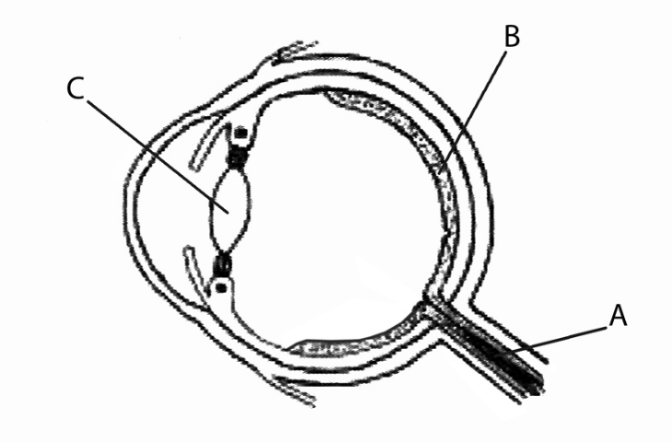
(a) Name the parts labelled A, B, C.
A. _____________________________________
B. _____________________________________
C. _____________________________________
(b) Name the coloured part of the eye.
____________________________________________________________________________________
(c) What is the function of the pupil in the eye?
____________________________________________________________________________________
(d) In which labelled part would you find the rods and cones?
____________________________________________________________________________________
(e) What is the function of the cones?
____________________________________________________________________________________
Answer

Endocrine System
Higher Level Questions Ordinary Level Questions

Higher Level

2005 HL
3. Indicate whether the following are true (T) or false (F) by drawing a circle around T or F.
(a) Urea is formed in the kidneys. T F
(b) Motor neurons conduct impulses towards the central nervous system. T F
(c) Endocrine glands secrete hormones. T F
(d) Tendons join muscles to bones. T F
(e) The sino-atrial node (pacemaker) is located on the right side of the heart. T F
(f) A nucleus is absent from human red blood cells. T F
(g) Light is essential for the germination of seeds. T F
(h) Lenticels serve the same function as stomata. T F
(i) Parallel leaf veins are characteristic of monocotyledonous plants. T F
(j) Endosperm is a food reserve in some seeds. T F
Answer

2013 HL
1. In the case of any five of the following pairs of terms, clearly distinguish between the first term and second
term by writing a brief sentence about each.
(d) Enzymes. _______________________________________________________________________
Hormones. ______________________________________________________________________
Answer

Ordinary Level

2004 OL
1. (a) The hepatic portal vein carries blood from the alimentary canal to the …………………………..
(b) A tendon joins ………………………………………… to bone.
(c) Phototropism is the growth response of a plant to ………………………………….…………….
(d) Hormones are secreted by ……………………………………………………………..… glands.
(e) Gas exchange between a leaf and the atmosphere takes place through the ………………………
Answer

Musculoskeletal System
Higher Level Questions Ordinary Level Questions

Higher Level

2005 HL
3. Indicate whether the following are true (T) or false (F) by drawing a circle around T or F.
(a) Urea is formed in the kidneys. T F
(b) Motor neurons conduct impulses towards the central nervous system. T F
(c) Endocrine glands secrete hormones. T F
(d) Tendons join muscles to bones. T F
(e) The sino-atrial node (pacemaker) is located on the right side of the heart. T F
(f) A nucleus is absent from human red blood cells. T F
(g) Light is essential for the germination of seeds. T F
(h) Lenticels serve the same function as stomata. T F
(i) Parallel leaf veins are characteristic of monocotyledonous plants. T F
(j) Endosperm is a food reserve in some seeds. T F
Answer

2009 HL
4. (a) The diagram shows a longitudinal section of a long bone.

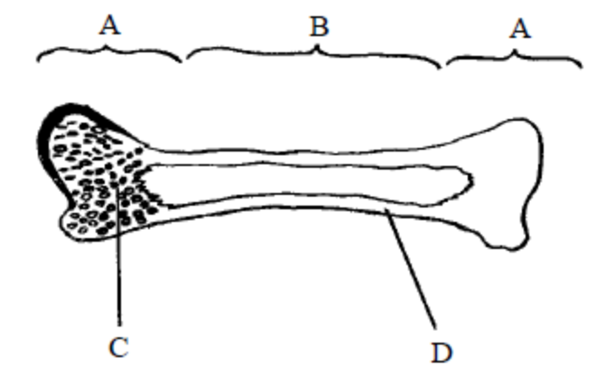

(i) Name the parts of the diagram labelled A, B, C, D.
A. __________________________________ B. _______________________________
C.___________________________________ D._______________________________
(ii) Where are the discs in the human backbone? ___________________________________
_______________________________________________________________________
(iii) What is the function of the discs in the human backbone? ________________________
_______________________________________________________________________
(b) Give a role for each of the following in the human body:
(i) Yellow bone marrow. _____________________________________________________
(ii) Red bone marrow. _______________________________________________________
Answer

2012 HL
3. (a) The diagram shows the macroscopic structure of part of a long bone.
(i) Name a long bone in the human body. __________________________________________
(ii) Name parts X, Y and Z in the diagram. X. _____________________________________
Y. _____________________________________
Z. _____________________________________
(iii) State a function of X. ________________________________________________________
(iv) State a function of Y. ________________________________________________________

(b) (i) Show clearly on the diagram where you would expect to find cartilage.
(ii) State one role of this cartilage. _________________________________________________
Answer

Ordinary Level

SEC Sample Paper OL
1. Complete the following sentence by putting one word in the blank space.
(a) The hammer (malleus) is a very small bone located in the ……………………………………
(b) Bile is secreted by the …………………………………………………………………….……
(c) Tiny holes called …………………………………… allow gases to enter and leave the leaf.
(d) Bones are joined to other bones by ..……………………………………………………..……
(e) An animal that eats both plants and animals is called an ………………………………….…..
Possible Answer

2004 OL
1. (a) The hepatic portal vein carries blood from the alimentary canal to the …………………………..
(b) A tendon joins ………………………………………… to bone.
(c) Phototropism is the growth response of a plant to ………………………………….…………….
(d) Hormones are secreted by ……………………………………………………………..… glands.
(e) Gas exchange between a leaf and the atmosphere takes place through the ………………………
Answer

2004 OL
4. The diagram shows the structure of one type of joint.
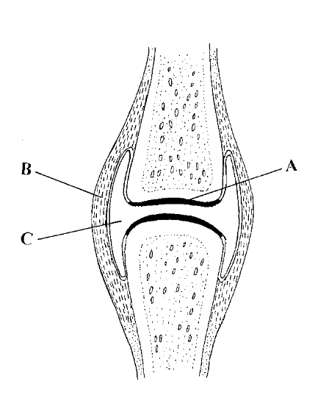
Name this type of joint. …………………………………………………………………………
Give one location in the human body of this type of joint. ……………………………………..
Name the following parts.
A ………………………………………
B ………………………………………
C ………………………………………
Name another type of joint found in the human body ………………………………………….
Answer

2007 OL
6. Study the diagram of a synovial joint and then answer the following questions
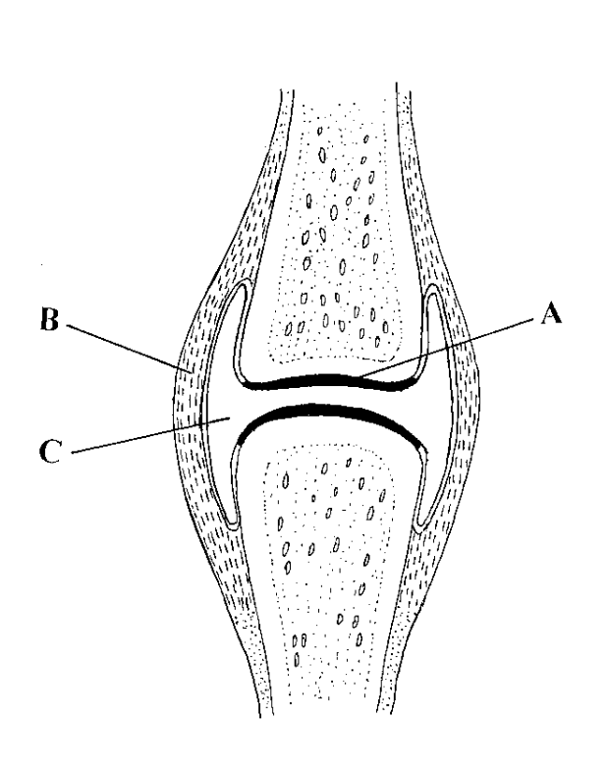
A
C
B
(a) Name tissue A ……………………………………………………….
(b) Give a function of A ……………………………………………………….
(c) Name tissue B ……………………………………………………….
(d) Name the fluid in C ……………………………………………………….
(e) Give a function of the fluid in C ……………………………………………………….
Answer

2011 OL
4. Indicate whether each of the following statements is true (T) or false (F) by drawing a circle
around T or F in each case.

Example: The liver produces bile T F

(a) The semicircular canals in the ear are involved in balance. T F
(b) The growth response of a plant to light is called phototropism. T F
(c) Tendons attach bone to bone. T F
(d) A motor neuron carries impulses to the brain. T F
(e) Rhizopus is a member of the animal kingdom. T F
(f) Xylem transports water in plants. T F
(g) A potato is a modified stem. T F
Answer

Defence System
Higher Level Questions Ordinary Level Questions

Higher Level

2006 HL
6. Distinguish between the members of each of the following pairs by making a brief comment on each.
(a) Tuber and bulb ………………………………………………………………………………
………………………………………………………………………………………………..
………………………………………………………………………………………………..
(b) Ureter and urethra …………………………………………………………………………….
…………………………………………………………………………………………………
…………………………………………………………………………………………………
(c) Hypha and mycelium …………………………………………………………………………
…………………………………………………………………………………………………
…………………………………………………………………………………………………
(g) Thigmotropism and chemotropism ……………………………………………………………
…………………………………………………………………………………………………
…………………………………………………………………………………………………
(e) Antigen and antibody …………………………………………………………………………
…………………………………………………………………………………………………
…………………………………………………………………………………………………
Answer

2010 HL
6. (c) During 2009 swine flu spread through the population of many countries. Younger people
were more at risk of becoming ill with swine flu than older people. Using your
knowledge of the immune system, suggest a reason for this.

…………………………………………………………………………………………………......……
………………………………………………………………………………………………………......
………………………………………………………………………………………………………......
Answer

Ordinary Level

Viruses
Higher Level Questions Ordinary Level Questions

Higher Level

2010 HL
6. The diagram shows a virus attached to a host cell.

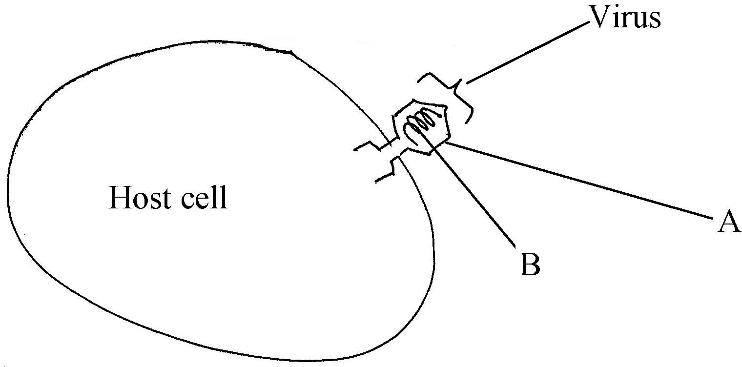

(a) (i) What is part A made of ? ………………………………………………………………………..
(ii) What is part B made of ? ………………………………………………………………………..
(b) Briefly describe how viruses reproduce ………………………………………………………………. ….……………………………………………………………………………………………………… …………………………………………………………………………………………………………. …………………………………………………………………………………………………………. ………………………………………………………………………………………………………….
(c) During 2009 swine flu spread through the population of many countries. Younger people
were more at risk of becoming ill with swine flu than older people. Using your
knowledge of the immune system, suggest a reason for this.

…………………………………………………………………………………………………......……
………………………………………………………………………………………………………......
………………………………………………………………………………………………………......
Answer

Ordinary Level

3.5 Responses to Stimuli

Section B

Plant Responses
Higher Level Questions Ordinary Level Questions

Higher Level

SEC Sample Paper HL
9. (a) State a location in a flowering plant where a growth regulator is secreted
……………………………………………………………………………………………………..
Give an example of the use of a synthetic growth regulator
……………………………………………………………………..………………………………
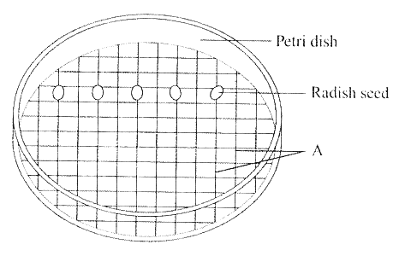
(b) The diagram shows apparatus that may be used to investigate the effect of the growth regulator IAA.

Name A. .......................................................................................................................
What is the purpose of A in this experiment? .............................................................................
How would you make up solutions of different concentrations from a stock solution of IAA ……………………………………………………………………………………………………
……………………………………………………………………………………………………
……………………………………………………………………………………………………
……………………………………………………………………………………………………
……………………………………………………………………………………………………
……………………………………………………………………………………………………
……………………………………………………………………………………………………
……………………………………………………………………………………………………
After preparation the dishes are placed standing on their edges for a number of days. What is the reason for this? ……………………………………………………………………………………
………………….…………………………………………………………………………………
Describe the results that you would expect in this experiment. .....................................................
……………………………………………………………………………………………………
……………………………………………………………………………………………………
Possible Answer

2006 HL
7. (b) In the case of each of the following state:
1. An investigation in which you used it,
2. The precise purpose for its use in the investigation that you have indicated.

(i) IAA
1 ……….………………………………………………………………………………………
2 .………………………………………………………………………………………………
…………………………………………………………………………………………………
…………………………………………………………………………………………………
Answer

2008 HL
8. Growth regulators in plants can promote growth or inhibit it.
(a) Give an example of each of the following:
(i) A growth regulator that promotes growth ………………………………………………
(ii) A growth regulator that inhibits growth …………………………………………………

(b) In the course of your studies you investigated the effect of a growth regulator on plant tissue.
Answer the following questions in relation to that investigation.
(i) Name the plant that you used ..…………………………………………………………
(ii) Describe how you carried out the investigation ……………………………………………
………………………………………………………………………………………………
………………………………………………………………………………………………
………………………………………………………………………………………………
………………………………………………………………………………………………
………………………………………………………………………………………………
………………………………………………………………………………………………
………………………………………………………………………………………………
………………………………………………………………………………………………
………………………………………………………………………………………………
………………………………………………………………………………………………
………………………………………………………………………………………………
………………………………………………………………………………………………
………………………………………………………………………………………………
………………………………………………………………………………………………
………………………………………………………………………………………………
………………………………………………………………………………………………
………………………………………………………………………………………………
………………………………………………………………………………………………

(iii) Give a safety precaution that you took while carrying out the investigation ……………....
………………………………………………………………………………………………
………………………………………………………………………………………………
………………………………………………………………………………………………
(iv) State the results that you obtained ………………………………………………………….
………………………………………………………………………………………………
………………………………………………………………………………………………
………………………………………………………………………………………………
………………………………………………………………………………………………
Answer

2010 HL
9. (a) (i) What is a tropism? ....................................…………………………………………………….
…………………………………………………………………………………………………
(ii) What is a plant growth regulator? …………………………………………………………….
…………………………………………………………………………………………………
(b) Answer the following in relation to an investigation that you carried out into the effect of the growth
regulator IAA on plant tissue.
(i) What plant tissue did you use? ………………………………………………………………...
(ii) Describe how you carried out the investigation.
………………………………………………………………………………………………………….
………………………………………………………………………………………………………….
………………………………………………………………………………………………………….
………………………………………………………………………………………………………….
………………………………………………………………………………………………………….
………………………………………………………………………………………………………….
………………………………………………………………………………………………………….
………………………………………………………………………………………………………….
(iii) Describe the control that you used.
………………………………………………………………………………………………………….
………………………………………………………………………………………………………….
………………………………………………………………………………………………………….
(iv) Compare the results that you obtained in the experiment and in the control.
………………………………………………………………………………………………………….
………………………………………………………………………………………………………….
………………………………………………………………………………………………………….
………………………………………………………………………………………………………….
………………………………………………………………………………………………………….
………………………………………………………………………………………………………….
………………………………………………………………………………………………………….
………………………………………………………………………………………………………….
Answer

2012 HL
7. (a) In relation to the scientific method, explain each of the following:
(i) Data. _____________________________________________________________________
(ii) Replicates. ________________________________________________________________
(b) Answer the following by reference to some of the investigations that you carried out in the course of
your studies.
(i) How did you expose the semi-lunar valves when dissecting the sheep’s or ox’s heart?
________________________________________________________________________________
(ii) How did you show that alcohol was present when investigating the production of alcohol by
yeast?
________________________________________________________________________________
________________________________________________________________________________
(iii) What type of agar plates did you use when investigating the digestive activity of seeds?
________________________________________________________________________________
(iv) How did you demonstrate that digestive activity had taken place in the investigation referred
to in part (iii)?
________________________________________________________________________________
________________________________________________________________________________
(v) How did you demonstrate the requirement for oxygen when investigating the factors
necessary for seed germination?
________________________________________________________________________________
________________________________________________________________________________
(vi) What did you use as the selectively permeable membrane in your investigation of
osmosis?
________________________________________________________________________________
(vii) What growth regulator did you use when investigating plant growth?
________________________________________________________________________________
(viii) A microscope has an eyepiece lens marked ×10 and an objective lens marked ×20.
What is the total magnification of the image?
________________________________________________________________________________
Answer

Ordinary Level

2011 OL
8. (b) For what purpose did you use each of the following in the course of your practical
activities?

(i) Fehling’s solution or Benedict’s solution.
Purpose. _________________________________________________________________
(ii) Anaerobic jar.
Purpose. _________________________________________________________________
(iii) Cover slip.
Purpose. _________________________________________________________________
(iv) Buffer solution.
Purpose. _________________________________________________________________
(v) Methylene blue.
Purpose. _________________________________________________________________
(vi) Sodium alginate.
Purpose. _________________________________________________________________
(vii) IAA.
Purpose. _________________________________________________________________
(viii) Freezer-cold alcohol.
Purpose. _________________________________________________________________
Answer

3.5 Responses to Stimuli

Section C

Plant Responses
Higher Level Questions Ordinary Level Questions

Higher Level

2004 HL
15. (b) (i) What is an auxin? State a site of auxin secretion. How may the action of an auxin
be considered similar to the action of a hormone in the human body?
(ii) Define tropism. List three types of tropism.
(iii) Relate the role of an auxin to one of the tropisms that you have listed in (ii)
Answer

2005 HL
14. (b) The graph shows the effect of varying auxin concentration on the root and shoot of a plant.
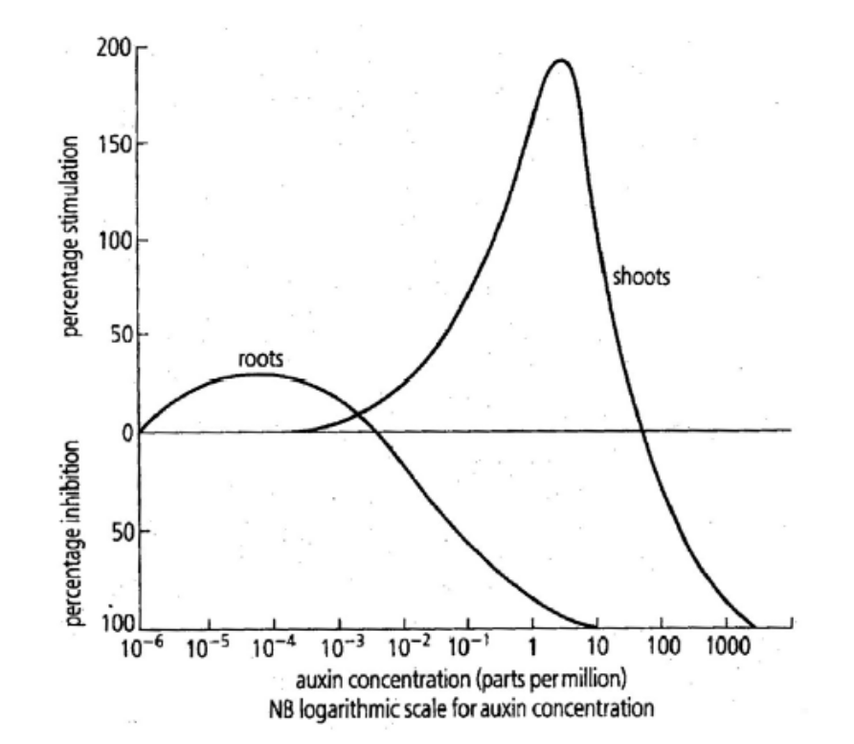
(i) What is an auxin?
(ii) At what approximate auxin concentration does the root receive maximum stimulation?
(iii) At what approximate auxin concentration does the shoot receive maximum stimulation?
(iv) What is the effect on the root of an auxin concentration of 10⁻² parts per million?
(v) Give two examples of uses of synthetic (man-made) auxins.
(vi) Describe three methods used by plants to protect themselves from adverse external environments.
Answer

2011 HL
11. (a) (i) What do you understand by the term adverse external environment?
(ii) Give two ways in which plants protect themselves from adverse external environments. (9)

(b) (i) Name the group of substances in plants which control responses to external stimuli.
(ii) 1. What name is given to the regions in plants in which these substances are produced?
2. Give locations for two of these regions.
(iii) Most plant shoots are positively phototropic. Explain the underlined term.
(iv) How does the plant benefit from this response?
(v) Explain the mechanism of response by a plant to a named external stimulus. (27)

(c) (i) What is a hormone?
(ii) State two ways in which hormones are similar to the group of substances referred to in (b)(i).
(iii) 1. What is meant by feedback in relation to hormone action?
2. Give a brief account of the feedback mechanism for a named hormone.
(iv) Describe one deficiency symptom of a named hormone. (24)
Answer

2013 HL
10. (a) (i) What term is used for glands that secrete hormones?
(ii) How do these glands differ from those that do not secrete hormones?
(iii) Explain why the pancreas may be described as a dual-function gland.

(b) Answer the following by reference to hormones, other than sex hormones, which you have
encountered in the course of your studies.
(i) What is the chemical nature of many hormones?
(ii) In the case of each of two named hormones secreted in the human body state:
1. The precise location of the gland that secretes it.
2. A function of the hormone.
(iii) In the case of one of the hormones referred to in part (b) (ii):
1. Give a deficiency symptom.
2. Give a symptom of excess secretion.
3. Give a corrective measure for either its deficiency or its excess, clearly stating which you
have chosen.
(iv) Explain why hormonal responses are slower than nervous responses.

(c) (i) State two ways in which growth regulators in plants are similar to hormones in animals.
(ii) Name a plant growth regulator that promotes growth and give a precise location for a site of its
action.
(iii) Through which part of a stem are growth promoters transported?
(iv) Outline two uses of growth promoters in horticulture.
(v) Give an example of a growth regulator that inhibits growth.
Answer

Ordinary Level

2010 OL
15. Answer any two of the parts (a), (b), (c). (30, 30)
(a) Water is vital for the survival of living things. Plants absorb water from the soil.
(i) Through which microscopic structures does water enter a plant from the soil?
(ii) By what process does water enter a plant?
(iii) Name the tissue that water travels through in a plant.
(iv) Draw a labelled diagram of one cell of the tissue referred to in (iii) above.
(v) Name one process that causes water to move upwards in a plant.
(vi) Consider that night has fallen and the plant is in darkness.
Suggest what will happen to the amount of water moving through the plant and give a reason
for your answer.
(vii) State two ways by which plants have adapted to protect themselves.
Answer

2012 OL
15. Answer any two of the parts (a), (b), (c). (30, 30)

(b) (i) In relation to plant responses:
1. What name is given to a plant’s response to light?
2. Name one growth regulator produced in plants.
3. Where in a plant are growth regulators produced?
4. Give one way by which plants can protect themselves from attack.

(ii) In relation to animal responses:
1. Name the two main parts of the central nervous system in humans.
2. Messages are carried around the body by neurons (nerve cells).
Name any two types of neuron.
3. What name is given to the area where one neuron ends and another begins?
4. Name the type of chemical that carries messages between two neurons.
5. What happens to this chemical once the messages have been transmitted?
Answer

Nervous System
Higher Level Questions Ordinary Level Questions

Higher Level

2004 HL
15. Answer any two of (a), (b), (c). (30,30)
(a) (i) Draw and label sufficient of two neurons to show a synaptic cleft.
(ii) Describe the sequence of events that allows an impulse to be transmitted across a synapse from one neuron to the next.
(iii) Suggest a possible role for a drug in relation to the events that you have outlined in (ii).
Answer

2005 HL
14. Answer any two of (a), (b), (c). (30,30)
(c) Answer the following questions in relation to systems of response to stimuli in the human body.
(i) The pancreas is both an exocrine gland and an endocrine gland. Explain the underlined terms.
(ii) Name a product of the endocrine portion of the pancreas and state one of its functions.
(iii) Name a disorder other than cancer for each of the following and indicate a possible cause and a means of treatment:
1. Musculoskeletal system
2. Nervous system.
Answer

2006 HL
14. Answer any two of (a), (b) and (c). (30, 30)
(b) (i) What is a neuron?
(ii) Distinguish between sensory, motor and interneurons (association neurons).
(iii) Briefly explain the role of neurotransmitter substances.
(iv) State a function for 1. Schwann cells, 2. Myelin sheath.
(v) In relation to Parkinson’s disease or paralysis give:
1. A possible cause,
2. A method of treatment.
Answer

2010 HL
11. (a) (i) Name a disorder of the human nervous system.
(ii) In the case of the disorder referred to in part (i) state:
1. A possible cause.
2. A means of prevention or a treatment. (9)

(b) (i) What is a reflex action?
(ii) Give one example of a reflex action.
(iii) Suggest an advantage of reflex actions.
(iv) The parts of the nervous system involved in a reflex action make up a reflex arc.
- Draw a large labelled diagram to show the structures involved in a reflex arc.
- Place arrows on your diagram to show the direction of impulse transmission in the reflex
arc. (27)

(c) (i) What term is used to describe the glands that secrete hormones in the human body?

(ii) 1. Name a hormone-producing gland in the human body.
2. Where in the body is the gland located?
3. Name a hormone that this gland secretes.
4. State a role of this hormone.
5. Describe what happens if the body experiences a deficiency of this hormone.

(iii) Give two examples of the use of hormone supplements. (24)
Answer

2012 HL
13. (a) (i) Distinguish between the central nervous system and the peripheral nervous system.
Include a clear reference to each in your answer.
(ii) Give one way in which a nervous response differs from a hormonal response. (9)

(b) (i) Draw a large labelled diagram of a motor neuron.
(ii) Give one function each of any two parts found only in neurons.
(iii) Place an arrow on or near your diagram to indicate the direction of impulse transmission.
(iv) Name and state the role of any two types of neuron, other than the motor neuron. (27)

(c) (i) State one function for each of the following parts of the human brain.
Cerebrum;
Hypothalamus;
Cerebellum;
Medulla oblongata.
(ii) In relation to the nervous system, distinguish between grey matter and white matter.
Include a clear reference to each in your answer.
(iii) In the case of either paralysis or Parkinson’s disease state:
1. a possible cause, other than accident;
2. a method of treatment. (24)
Answer

Ordinary Level

2007 OL
15. Answer any two of (a), (b), (c). (30,30)
(a) The diagram shows part of a reflex arc.

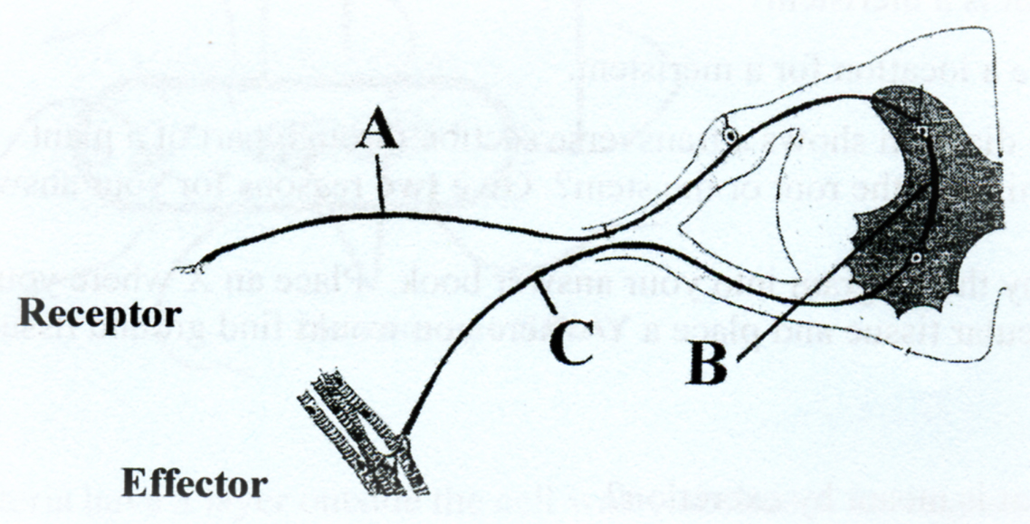

(i) Name neurons A, B and C.
(ii) In which direction is the impulse transmitted A → B → C or C → B → A ?
(iii) Name the small gaps between neurons.
(iv) Neurons produce neurotransmitter substances. What is their function?
(v) Give an example of a reflex action in humans.
(vi) Why are reflex actions important in humans?
Answer

2012 OL
15. Answer any two of the parts (a), (b), (c). (30, 30)

(b) (i) In relation to plant responses:
1. What name is given to a plant’s response to light?
2. Name one growth regulator produced in plants.
3. Where in a plant are growth regulators produced?
4. Give one way by which plants can protect themselves from attack.

(ii) In relation to animal responses:
1. Name the two main parts of the central nervous system in humans.
2. Messages are carried around the body by neurons (nerve cells).
Name any two types of neuron.
3. What name is given to the area where one neuron ends and another begins?
4. Name the type of chemical that carries messages between two neurons.
5. What happens to this chemical once the messages have been transmitted?
Answer

Eye & Ear
Higher Level Questions Ordinary Level Questions

Higher Level

2009 HL
15. (b)
The diagram shows the human eye.
(i) Name the parts labelled V, W and X.
(ii) Give the functions of parts Y and Z.
(iii) 1.Suspensory ligaments. 2. Cones. 3. Optic nerve. 4. Brain.
Outline the roles in vision of any three of the above structures.
(iv) Explain how the iris works.
(v) Suggest a reason why two eyes are better than one.
Answer

(c) Write notes on three of the following topics:
(i) The role of lymphocytes.
(ii) Neurotransmitters.
(iii) Homeostasis.
(iv) Adaptations of wind-pollinated flowers.
(v) The economic and medical importance of viruses.
Answer

2011 HL
15. Answer any two of (a), (b), (c). (30, 30)

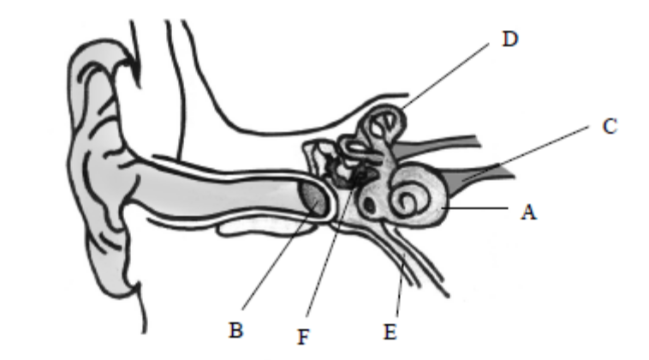

(a) (i) The diagram above shows the internal structure of the human ear.
1. Name the structures labelled A, B, C.
2. Give the functions of parts D and E.
3. Which letters denote the parts of the ear in which nerve impulses are generated?
(ii) In what part of the eye are nerve impulses generated?
(iii) Suggest one way by which the ear may be protected.
(iv) Explain how a corrective measure for a named defect of hearing or vision works.
Answer

Ordinary Level

2004 OL
15. (a) The diagram shows the structure of the human ear.

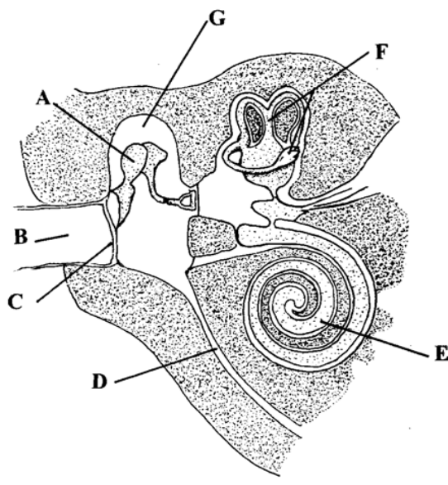

(i) Name the parts A, B, C, D, E, F.
(ii) What is connected to the ear by D?
(iii) Which is present in G, gas or liquid?
(iv) State the function of E.
(v) State the function of F.
Answer

2006 OL
15. (b) The diagram shows a vertical section through the human eye.
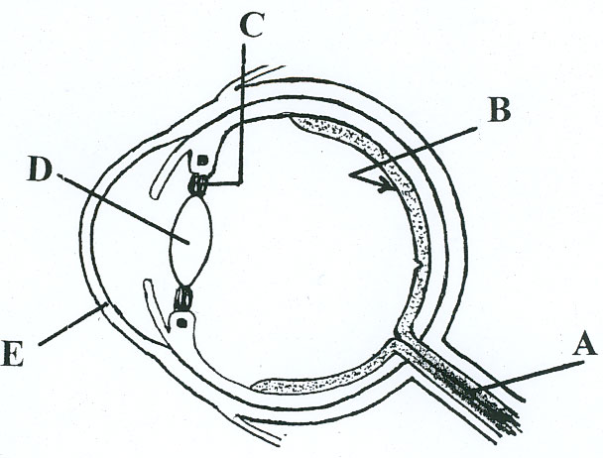

(i) Name A, B, C, D and E.
(ii) In which of these parts would you find rods and cones?
(iii) Give one function of rods and one function of cones.
(iv) What is the function of A?
(v) What type of lens is used to correct long sight? (30)
Answer

2008 OL
14. (b) (i) Copy the diagram of the front of the eye into your answer book and label the iris and the pupil.

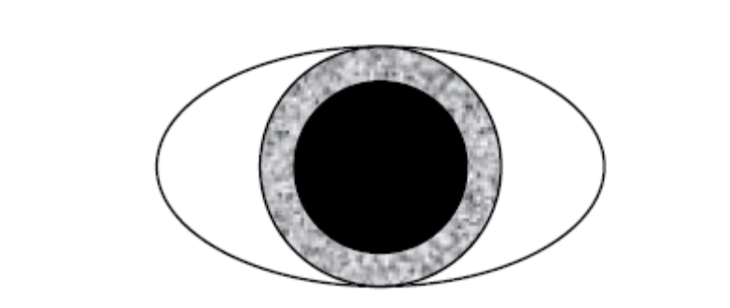
(ii) Is the eye shown in the diagram above adapted for dim light or bright light?
Explain your answer.
(iii) Where in the eye is the retina located?
(iv) Two types of cells that receive light are found in the retina. Name each of these.
(v) Give one difference between the two types of cell that receive light.
(vi) The optic nerve is attached to the eye. What is the function of the optic nerve?
Answer

2013 OL
14. Answer any two of (a), (b), (c). (30, 30)

(a) The diagram shows a synovial joint.

(i) Name the parts labelled A, B and C.
(ii) Give two functions of the human skeleton.
(iii) Vertebrae in the neck are called the cervical vertebrae.
Name and give the exact location of two other types of vertebrae.
(iv) Name one disorder of the musculoskeletal system.

(b) (i) Blood is made up of plasma and blood cells. What is plasma?
(ii) What is the function of white blood cells?
(iii) Where in the body are white blood cells produced?
(iv) Some people may have the blood group B Positive (B+).
What factor is present in their blood that makes it positive?
(v) The heart pumps blood around the body.
1. Name the structure in the heart that controls the heartbeat.
2. Where is this structure located in the heart?
(vi) What causes the sound of a heartbeat?
(vii) Name the blood vessels that supply the heart cells with blood.
(viii) Mention two ways to maintain a healthy heart.

(c) The diagram shows the human ear.

(i) Name the parts labelled A and B.
(ii) What is the function of part A?
(iii) What is the function of part B?
(iv) What is connected to the middle ear by the Eustachian tube?
(v) What surrounds the bones in the middle ear?
(vi) The ear is an example of a sense organ.
Name two sense organs, other than the ear and the eye, in the human body.
(vii) Name one disorder of the ear or of the eye and give a corrective measure for the
disorder referred to.
Answer

Endocrine System
Higher Level Questions Ordinary Level Questions

Higher Level

2005 HL
14. Answer any two of (a), (b), (c). (30,30)
(c) Answer the following questions in relation to systems of response to stimuli in the human body.
(i) The pancreas is both an exocrine gland and an endocrine gland. Explain the underlined terms.
(ii) Name a product of the endocrine portion of the pancreas and state one of its functions.
(iii) Name a disorder other than cancer for each of the following and indicate a possible cause and a means of treatment:
1. Musculoskeletal system
2. Nervous system.
Answer

2007 HL
15. Answer any two of (a), (b) and (c). (30, 30)
(b) (i) Other than the secretion of hormones, how does an endocrine gland differ from an exocrine
gland?
(ii) State two ways in which hormone action differs from nerve action.
(iii) Copy the following table into your answer book and fill each of the empty boxes.

Endocrine Gland | Location | Hormone | Role of Hormone
 | Pancreas | Insulin
Thyroid Gland
 |  |  | “fighr or flight”

(iv) In the case of a named hormone give:
1. a deficiency symptom,
2. a corrective measure.
Answer

2010 HL
11. (a) (i) Name a disorder of the human nervous system.
(ii) In the case of the disorder referred to in part (i) state:
1. A possible cause.
2. A means of prevention or a treatment. (9)

(b) (i) What is a reflex action?
(ii) Give one example of a reflex action.
(iii) Suggest an advantage of reflex actions.
(iv) The parts of the nervous system involved in a reflex action make up a reflex arc.
- Draw a large labelled diagram to show the structures involved in a reflex arc.
- Place arrows on your diagram to show the direction of impulse transmission in the reflex
arc. (27)

(c) (i) What term is used to describe the glands that secrete hormones in the human body?

(ii) 1. Name a hormone-producing gland in the human body.
2. Where in the body is the gland located?
3. Name a hormone that this gland secretes.
4. State a role of this hormone.
5. Describe what happens if the body experiences a deficiency of this hormone.

(iii) Give two examples of the use of hormone supplements. (24)
Answer

2011 HL
11. (a) (i) What do you understand by the term adverse external environment?
(ii) Give two ways in which plants protect themselves from adverse external environments. (9)

(b) (i) Name the group of substances in plants which control responses to external stimuli.
(ii) 1. What name is given to the regions in plants in which these substances are produced?
2. Give locations for two of these regions.
(iii) Most plant shoots are positively phototropic. Explain the underlined term.
(iv) How does the plant benefit from this response?
(v) Explain the mechanism of response by a plant to a named external stimulus. (27)

(c) (i) What is a hormone?
(ii) State two ways in which hormones are similar to the group of substances referred to in (b)(i).
(iii) 1. What is meant by feedback in relation to hormone action?
2. Give a brief account of the feedback mechanism for a named hormone.
(iv) Describe one deficiency symptom of a named hormone. (24)
Answer

2013 HL
10. (a) (i) What term is used for glands that secrete hormones?
(ii) How do these glands differ from those that do not secrete hormones?
(iii) Explain why the pancreas may be described as a dual-function gland.

(b) Answer the following by reference to hormones, other than sex hormones, which you have
encountered in the course of your studies.
(i) What is the chemical nature of many hormones?
(ii) In the case of each of two named hormones secreted in the human body state:
1. The precise location of the gland that secretes it.
2. A function of the hormone.
(iii) In the case of one of the hormones referred to in part (b) (ii):
1. Give a deficiency symptom.
2. Give a symptom of excess secretion.
3. Give a corrective measure for either its deficiency or its excess, clearly stating which you
have chosen.
(iv) Explain why hormonal responses are slower than nervous responses.

(c) (i) State two ways in which growth regulators in plants are similar to hormones in animals.
(ii) Name a plant growth regulator that promotes growth and give a precise location for a site of its
action.
(iii) Through which part of a stem are growth promoters transported?
(iv) Outline two uses of growth promoters in horticulture.
(v) Give an example of a growth regulator that inhibits growth.
Answer

2013 HL
12. (c) (i) Distinguish clearly between antibodies and antibiotics by writing a note about each.
(ii) In relation to antibodies, distinguish between active and passive immunity.
(iii) Using your knowledge of antibiotics and bacteria, suggest why a person is more likely to pick up an
infection in hospital than at home.
Answer

Ordinary Level

2004 OL
15. (b) (i) What is a hormone?
(ii) Draw an outline diagram of the human body and indicate on it the location of the following hormone-producing glands by using the following letters:
W Pituitary
X Thyroid
Y Pancreas (Islets of Langerhans)
Z Adrenals
(iii) In the case of one of the hormone-producing glands that you have located in your diagram, state:
1. the gland and a hormone that it produces.
2. a function of this hormone.
3. a deficiency symptom of this hormone.
(iv) State one way in which hormone action differs from nerve action.
Answer

2011 OL
14. Answer any two of (a), (b0, (c) (30,30)
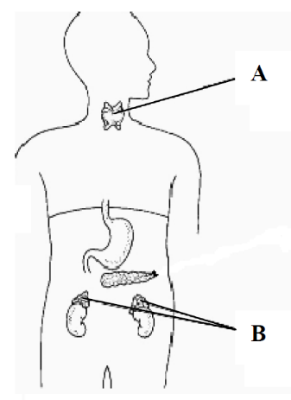
(b) (i) The diagram shows some parts of the human endocrine system.
Name the glands labelled A and B.
(ii) Name any one hormone produced by the body.
(iii) Give a deficiency symptom of the hormone named
in (ii) above.
(iv) Give one example of the use of hormone supplements.
(v) The central nervous system is made up of two main parts.
Name each part.
(vi) Name a disorder of the nervous system.
Give one cause of the disorder and suggest a means of
treating the disorder.
Answer

Musculoskeletal System
Higher Level Questions Ordinary Level Questions

Higher Level

2005 HL
14. Answer any two of (a), (b), (c). (30,30)
(c) Answer the following questions in relation to systems of response to stimuli in the human body.
(i) The pancreas is both an exocrine gland and an endocrine gland. Explain the underlined terms.
(ii) Name a product of the endocrine portion of the pancreas and state one of its functions.
(iii) Name a disorder other than cancer for each of the following and indicate a possible cause and a means of treatment:
1. Musculoskeletal system
2. Nervous system.
Answer

2006 HL
15. Answer any two of (a), (b) and (c). (30, 30)
(a) (i) Draw a diagram to show the structure of a synovial joint. Label three parts of the joint
that you have drawn, other than bones.
(ii) Explain the functions of the three parts that you have labelled.
(iii) Name a disorder of the musculoskeletal system.
(iv) Give a possible cause of the disorder that you have named in (iii) and suggest a treatment for it.
Answer

2008 HL
15. (a) Answer the following questions in relation to the human musculoskeletal system.
(i) Give three roles of the skeleton.
(ii) Explain what is meant by the axial skeleton.
(iii) Give a function for each of the following:
1. Red marrow, 2. Cartilage, 3. Tendon.
(iv) Explain what is meant by an antagonistic muscle pair and give an example in the human body.
(v) Suggest a treatment for a named disorder of the musculoskeletal system.
Answer

Ordinary Level

2006 OL
15. (c) (i) State two functions of the human skeleton.
(ii) The vertebrae form part of the axial skeleton. Name the vertebrae found in:
1. The neck,
2. The small of the back.
(iii) Name the part of the central nervous system that runs through the vertebrae.
(iv) Name the three bones that form the human arm.
(v) Write a short note (about five lines) on one of the following:
arthritis or osteoporosis. (30)
Answer

2010 OL
15. Answer any two of the parts (a), (b), (c). (30, 30)
(b) The diagram shows the bones of the human arm.
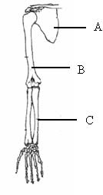
(i) Name the parts labelled A, B and C.
(ii) What structures attach a muscle to a bone?
(iii) Which upper arm muscle contracts to raise the lower arm?
(iv) What is meant by the term antagonistic pair in reference to muscles?
(v) Name the type of joint at the elbow.
(vi) Apart from movement, give one other function of the skeleton.
(vii) Suggest one reason why the bones of birds are almost hollow.
Answer

2013 OL
14. Answer any two of (a), (b), (c). (30, 30)

(a) The diagram shows a synovial joint.

(i) Name the parts labelled A, B and C.
(ii) Give two functions of the human skeleton.
(iii) Vertebrae in the neck are called the cervical vertebrae.
Name and give the exact location of two other types of vertebrae.
(iv) Name one disorder of the musculoskeletal system.
Answer

(b) (i) Blood is made up of plasma and blood cells. What is plasma?
(ii) What is the function of white blood cells?
(iii) Where in the body are white blood cells produced?
(iv) Some people may have the blood group B Positive (B+).
What factor is present in their blood that makes it positive?
(v) The heart pumps blood around the body.
1. Name the structure in the heart that controls the heartbeat.
2. Where is this structure located in the heart?
(vi) What causes the sound of a heartbeat?
(vii) Name the blood vessels that supply the heart cells with blood.
(viii) Mention two ways to maintain a healthy heart.

(c) The diagram shows the human ear.

(i) Name the parts labelled A and B.
(ii) What is the function of part A?
(iii) What is the function of part B?
(iv) What is connected to the middle ear by the Eustachian tube?
(v) What surrounds the bones in the middle ear?
(vi) The ear is an example of a sense organ.
Name two sense organs, other than the ear and the eye, in the human body.
(vii) Name one disorder of the ear or of the eye and give a corrective measure for the
disorder referred to.

Defence System
Higher Level Questions Ordinary Level Questions

Higher Level

SEC Sample Paper HL
15. Answer any two of (a), (b), (c). (30,30)

(b) (i) What is meant by the term immunity? Distinguish between active and passive immunity.
(ii) Describe two ways in which the skin helps to defend the body against pathogenic micro-organisms.
(iii) Lymphocytes play a vital role in the body's immune system. To which group of blood cells do lymphocytes belong? Name two types of lymphocyte and state a role of each.
(iv) What is the purpose of vaccination?
Possible Answer

2005 HL
15. Answer any two of (a), (b), (c). (30,30)

(a) (i) Comment briefly on the difficulty in classifying viruses as living organisms.
(ii) Name two diseases of humans caused by viruses.
(iii) Name two types of lymphocyte and state a role of each when viruses or other micro-organisms enter the blood.
(iv) “Immunity that results from vaccination is effectively the same as the immunity that develops following an infection". Do you agree with this statement? Explain your answer.
Answer

2007 HL
14. Answer any two of (a), (b) and (c). (30, 30)

(c) (i) What is meant by the term immunity?
(ii) Outline briefly the role of B lymphocytes in the human immune system.
(iii) Distinguish between active and passive immunity.
(iv) “Vaccination gives rise to active immunity”. Explain this statement.
(v) In certain situations a person is given a specific antibody rather than being vaccinated.
1. Is this an example of active or passive immunity?
2. Under what circumstances might an antibody, rather than a vaccination, be given?
3. Comment on the duration of immunity that follows the administration of an antibody.
Answer

20120 HL
15. Answer any two of (a), (b), (c). (30, 30)

(b) (i) State two ways, other than colour, in which red blood cells differ from white blood cells.
(ii) Name a group of white blood cells, other than lymphocytes.
(iii) Lymphocytes may be divided into B cells and T cells. B cells produce antibodies.
1. What is the role of antibodies in the body?
2. Name any three types of T cell.
3. State a role of each of the T cell types that you named in part 2.
Answer

Ordinary Level

2011 OL
15. Answer any two of (a), (b0, (c) (30,30)

(c) The diagram shows the structure of a type of virus.
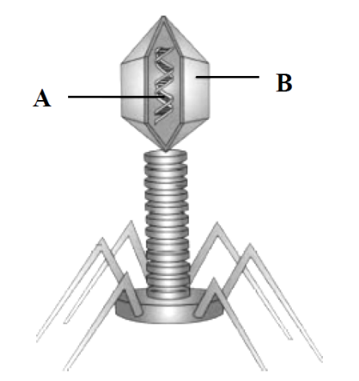
(i) Name the parts labelled A and B.
(ii) State two harmful effects of viruses.
(iii) What is meant by the term immunity?
(iv) The skin is an important part of our immune system.
Outline two ways in which the skin provides immunity.
(v) To help the immune system, many people receive vaccinations during their lifetime.
What is meant by the term vaccination?
(vi) Antibiotics are usually not given to a person suffering from a viral infection.
Suggest a reason for this.
Answer

Viruses
Higher Level Questions Ordinary Level Questions

Higher Level

SEC Sample Paper HL
15. Answer any two of (a), (b), (c). (30,30)

(c) (i) Comment on the difficulty of describing a virus as a living organism.
(ii) Name the two main chemical components of a virus.
(iii) Describe how virus reproduction takes place in a host cell.
(iv) Name a virus whose activity poses a major threat to human health. In the case of this virus explain the following:
1. How it is transmitted
2. How it affects the human body
3. How its spread is controlled.
Possible Answer

2005 HL
15. Answer any two of (a), (b), (c). (30,30)

(a) (i) Comment briefly on the difficulty in classifying viruses as living organisms.
(ii) Name two diseases of humans caused by viruses.
(iii) Name two types of lymphocyte and state a role of each when viruses or other micro-organisms enter the blood.
(iv) Immunity that results from vaccination is effectively the same as the immunity that develops following an infection". Do you agree with this statement? Explain your answer.
Answer

2007 HL
14. Answer any two of (a), (b) and (c). (30, 30)

(b) (i) Comment on the difficulty of defining viruses as living organisms.
(ii) What are the two main biochemical components of a virus particle?
(iii) Name two diseases caused by viruses.
(iv) Give an example of a beneficial application of a virus.
(v) What is an antibiotic?
(vi) Antibiotics should not be prescribed for a person suffering from a viral infection.
Suggest a reason for this.
Answer

2008 HL
15. (b) Just over fifty years ago the myxoma virus was brought to Ireland. The disease for which it is
responsible in rabbits, myxomatosis, quickly decimated the wild population. Now, however, the disease is much less common and is responsible for far fewer deaths.
(i) Why do you think that the rabbit population was decimated when the myxoma virus was first brought to Ireland?
(ii) Suggest a reason why myxomatosis is no longer a major threat to the Irish rabbit population.
(iii) The use of one species to control the population of another species is called biological control. Suggest one advantage and one disadvantage of biological control.
(iv) The human immunodeficiency virus (HIV) is responsible for AIDS in the human population. Would you expect a similar trend to that shown by myxomatosis as time passes? Explain your answer.
(v) Outline briefly how a virus replicates (reproduces).
Answer

2009 HL
15. (c) Write notes on three of the following topics:
(v) The economic and medical importance of viruses.
Answer

2010 HL
12. (c) In your answer book, say whether each of the following statements is true or false and give a reason
for your choice in each case:

(i) Food chains are usually short.
(ii) The herbivores in an ecosystem normally live long lives.
(iii) The only remaining natural ecosystems in Ireland, for example mountain land above the heather
line and salt marsh, are ones for which mankind has no use.
(iv) HIV / AIDS has orphaned many children in sub-Saharan Africa. (24)
Answer

2013 HL
12. (a) (i) A virus has been described as a piece of genetic material that has escaped from a cell.
Give one piece of evidence that supports this description.
(ii) Viruses are examples of obligate parasites. Explain why this is the case.
(iii) Give an example of how a virus might be beneficial to mankind.
Answer
(b) (i) Name the kingdom to which bacteria belong.
(ii) Draw a large diagram of a bacterial cell to show:
1. The relative positions of the cell wall, cell membrane and capsule.
2. A plasmid.
Label each of the above structures.
(iii) 1. Under what circumstances does a bacterial cell form an endospore?
2. Describe briefly how an endospore forms.
(iv) Name two types of heterotrophic nutrition used by bacteria.

(c) (i) Distinguish clearly between antibodies and antibiotics by writing a note about each.
(ii) In relation to antibodies, distinguish between active and passive immunity.
(iii) Using your knowledge of antibiotics and bacteria, suggest why a person is more likely to pick up an
infection in hospital than at home.

Ordinary Level

2009 OL
12. (c) (i) Explain why it is difficult to classify viruses as living organisms.
(ii) Give the two main chemical components of a virus.
(iii) Briefly describe how viruses reproduce.
(iv) Give one way in which viruses are beneficial and one way in which they are harmful.
(24)
Answer

2011 OL
15. Answer any two of (a), (b0, (c) (30,30)

(c) The diagram shows the structure of a type of virus.
(i) Name the parts labelled A and B.
(ii) State two harmful effects of viruses.
(iii) What is meant by the term immunity?
(iv) The skin is an important part of our immune system.
Outline two ways in which the skin provides immunity.
(v) To help the immune system, many people receive vaccinations during their lifetime.
What is meant by the term vaccination?
(vi) Antibiotics are usually not given to a person suffering from a viral infection.
Suggest a reason for this.
Answer

3.6 Reproduction and Growth – Plant

Need to Know

3.6.1 Reproduction in Flowering Plant
3.6.1 Vegetative Propagation
3.6.3.H Sexual Reproduction in the Flowering Plant

At the end of this section students should be able to:

Reproduction in Flowering Plant
- State the structure & function of the floral parts including: Sepal, Petal, Stamen, Carpel.
- State that the Pollen grain produces male gamete.
- State that the Embryo sac produces an egg cell & polar nuclei.
- Define the terms: pollination, self-pollination.
- Outline methods of pollination including: cross-pollination & self pollination.
- Define the term: fertilisation.
- Outline seed structure & function of following: testa, plumule, radicle, embryo and cotyledon.
- Explain embryo & food supply (endosperm or seed leaves).
- Classify plants as monocotyledon or dicotyledon & distinguish between them.
- Make reference to non-endospermic seed.
- Outline fruit formation.
- Outline seedless fruit production.
- Outline fruit & seed dispersal and give with examples of wind/water/animal/self dispersal.
- Explain & emphasise the need for dispersal.
- Define the term dormancy.
- State advantages of dormancy.
- Explain dormancy in agricultural & horticultural practice.
- Define the term: Germination.
- Explain the factors necessary for germination.
- Explain the role of digestion and respiration in germination.
- Outline the stages of seed development.

Vegetative Propagation
- State that vegetative propagation is asexual reproduction.
- Give one example of vegetative propagation from stem, root, leaf, bud.
- Compare reproduction by seed and by vegetative reproduction.
- Outline four methods of artificial propagation in flowering plants.

Sexual Reproduction in Flowering Plants
- Outline pollen grain development from microspore mother cells.
- Explain meiotic division of these cells.
- Explain mitotic division of these cells.
- Discuss generative and tube nuclei formation.
- Discuss formation of pollen grains.
- Outline embryonic sac development.
- Discuss meiotic division, cell disintegration.
- Outline the formation of the egg cell by mitotic division.

PowerPoint Presentations

3.6.1 a) Flower Structure & Gamete formation.ppt
3.6.1 b) Pollination & Fertilisation.ppt
3.6.1 c) Fruit formation & Dispersal.ppt
3.6.1 d) Dormancy & Germination.ppt
3.6.1 e) Asexual Reproduction.ppt
3.6.3.H Plants Reproduction.ppt

3.6 Reproduction and Growth – Plant

Section A

Sexual Reproduction
Higher Level Questions Ordinary Level Questions

Higher Level

2005 HL
3. Indicate whether the following are true (T) or false (F) by drawing a circle around T or F.
(a) Urea is formed in the kidneys. T F
(b) Motor neurons conduct impulses towards the central nervous system. T F
(c) Endocrine glands secrete hormones. T F
(d) Tendons join muscles to bones. T F
(e) The sino-atrial node (pacemaker) is located on the right side of the heart. T F
(f) A nucleus is absent from human red blood cells. T F
(g) Light is essential for the germination of seeds. T F
(h) Lenticels serve the same function as stomata. T F
(i) Parallel leaf veins are characteristic of monocotyledonous plants. T F
(j) Endosperm is a food reserve in some seeds. T F
Answer

2009 HL
2. The diagram shows a young plant growing in a tilted seed box.

(a) From which structure in the seed did A develop? __________________________________
Answer

Ordinary Level

2005 OL
3. The diagram shows the external structure of a stamen.
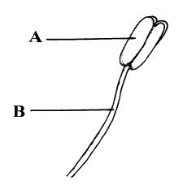
(a) Name A and B
A …………………………........… B ………………………………..
(b) Where is pollen produced, in A or in B? ………………………………..
(c) To which part of a flower is pollen carried? ………….……………………………
(d) What is meant by cross-pollination? ………………………………………..
………………………………………………………………………………………………………
(e) Name two methods of cross-pollination.
1. …………………………………………………………………………………………..…..
2. ……………………………………………………………………………………………....
Answer

Asexual Reproduction
Higher Level Questions Ordinary Level Questions

Higher Level

2006 HL
3. Distinguish between the members of each of the following pairs by making a brief comment on each.
(a) Tuber and bulb ………………………………………………………………………………
………………………………………………………………………………………………..
………………………………………………………………………………………………..
Answer

2013 HL
4. The diagram shows a strawberry plant from which a runner has given rise to a daughter plant.

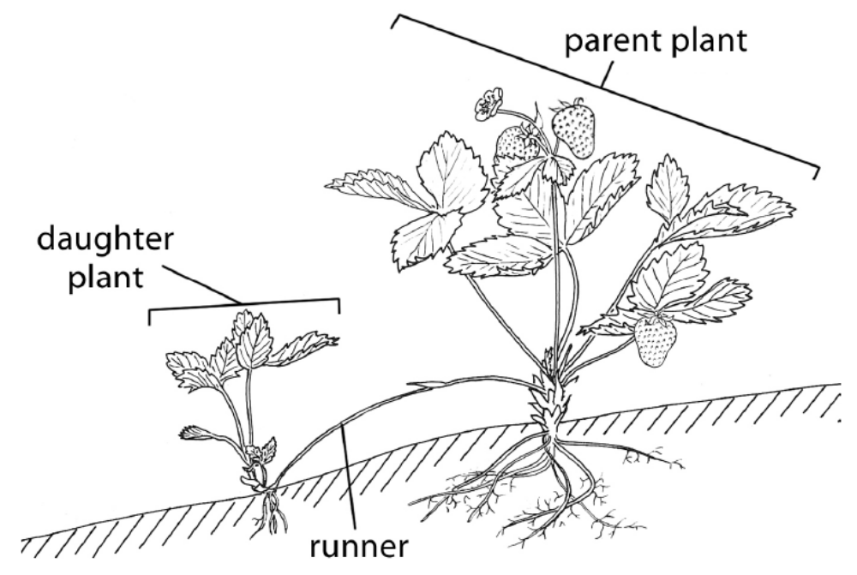

(a) The runner is a modified stem. How could you tell this from
1. external observation? ___________________________________________________________
2. viewing a thin section of it under the microscope?_____________________________________
(b) What term is used for the type of asexual reproduction that produced the daughter plant?
_______________________________________________________________________________
(c) Would you expect the daughter plant to be haploid or diploid? _____________________________
Explain your answer.______________________________________________________________
(d) What evidence is there in the diagram that sexual reproduction has also taken place?
________________________________________________________________________________
(e) Give one method, other than runners, and not involving seeds, that is used by horticulturists to
produce new plants.
________________________________________________________________________________
Answer

Ordinary Level

3.6 Reproduction and Growth – Plant

Section B

Plant Reproduction
Higher Level Questions Ordinary Level Questions

Higher Level

2006 HL
7. (b) In the case of each of the following state:
1. An investigation in which you used it,
2. The precise purpose for its use in the investigation that you have indicated.

(ii) Starch or skimmed milk agar plates.
1……………………………………………………………………………………………………
2……………………………………………………………………………………………………
…..…………………………………………………………………………………………………
……………………………………………………………………………………………….……
Answer

2009 HL
8. (a) (i) What is meant by germination? ______________________________________________
________________________________________________________________________
________________________________________________________________________
(ii) Why is digestion necessary in a germinating seed? _______________________________
________________________________________________________________________
________________________________________________________________________

(b) (i) Digestive activity during germination can be demonstrated by using agar plates.
What is an agar plate? _____________________________________________________
_______________________________________________________________________
(ii) An extra food material is added to the agar plate for this demonstration.
Give an example of such an extra food material. _________________________________
(iii) Outline the procedures that you carried out in setting up this demonstration.
________________________________________________________________________
________________________________________________________________________
________________________________________________________________________
________________________________________________________________________
________________________________________________________________________
________________________________________________________________________
(iv) What control did you use for this demonstration?
________________________________________________________________________
(v) What procedure did you carry out in order to show that digestive activity had taken place?
________________________________________________________________________
________________________________________________________________________
________________________________________________________________________
________________________________________________________________________
(vi) Describe the results that you obtained in:
1. The experimental plate. ________________________________________________
___________________________________________________________________
2. The control plate. _____________________________________________________
___________________________________________________________________
Answer

2011 HL
8. (b) (i) In the course of your practical studies you used a solution of iodine in different
investigations. State two different uses of the iodine solution.
Use 1. ____________________________________________________________________
Use 2. ____________________________________________________________________
(ii) State two different uses of a water bath in biological investigations.
Use 1. ____________________________________________________________________
Use 2. ____________________________________________________________________
Answer

2012 HL
7. (a) In relation to the scientific method, explain each of the following:
(i) Data. _____________________________________________________________________
(ii) Replicates. ________________________________________________________________
(b) Answer the following by reference to some of the investigations that you carried out in the course of
your studies.
(i) How did you expose the semi-lunar valves when dissecting the sheep’s or ox’s heart?
________________________________________________________________________________
(ii) How did you show that alcohol was present when investigating the production of alcohol by
yeast?
________________________________________________________________________________
________________________________________________________________________________
(iii) What type of agar plates did you use when investigating the digestive activity of seeds?
________________________________________________________________________________
(iv) How did you demonstrate that digestive activity had taken place in the investigation referred
to in part (iii)?
________________________________________________________________________________
________________________________________________________________________________
(v) How did you demonstrate the requirement for oxygen when investigating the factors
necessary for seed germination?
________________________________________________________________________________
________________________________________________________________________________
(vi) What did you use as the selectively permeable membrane in your investigation of
osmosis?
________________________________________________________________________________
(vii) What growth regulator did you use when investigating plant growth?
________________________________________________________________________________
(viii) A microscope has an eyepiece lens marked ×10 and an objective lens marked ×20.
What is the total magnification of the image?
________________________________________________________________________________
Answer

2013 HL
9. (a) (i) Explain the importance of double-blind testing in scientific experimentation.
________________________________________________________________________________
(ii) How does a hypothesis differ from a theory?
________________________________________________________________________________

(b) Answer the following in relation to investigations that you carried out in the course of your
practical studies.
(iv) When investigating digestive activity during seed germination:
1. How did you supply a substrate suitable for the digestive enzymes?
_________________________________________________________________________
2. How did you ensure that no digestive enzymes were available on the control plate?
_________________________________________________________________________
Answer

Ordinary Level

SEC Sample Paper OL
9. (a) What is meant by the germination of a seed? ………………………….……………………………
…………..……………………………………………………………………………………………
State three environmental factors that are necessary for germination
1. ……………………………………………………………………………………
2. ………………………………………………………………………………………
3. ………………………………………………………………………………………
(b) Answer the following in relation to an experiment that you carried out to investigate the effect of these factors on germination.
What seeds did you use? ………………………………………………………………………………
Draw a labelled diagram of the apparatus that you used.

Describe how you carried out the experiment
………………………………………………………………………………………………………………………………………………………………………………………………………………………………………………………………………………………………………………………………………………………………………………………………………………………………………………………………………………………………………………………………………………………………………………………………………………………………………………………………………………………………………………………………………………………………………………………………………………………………………………………………………………………………………………………………………………………………………………………………………………………………………………………………………………………………………………………………………………

State the results of your experiment …………………………………………………………………………………..
…………………………………………………………………………………………………………………………………………………………………………………………………………………………………………………………………………………………………………………………………………………………………………………………………………………………………………………………………………………………………………
Possible Answer

2005 OL
9. (a) (i) What is meant by the germination of a seed? ……….………………………………….………
………………………………………………………….……….………………………………
(ii) State one reason why water is needed for germination. ……………………………….………
………………………………………………………………………………………………….
(b) Answer the following questions in relation to an experiment that you carried out to investigate the effects of water, oxygen and temperature on germination.
(i) Draw a labelled diagram of the apparatus that you used.

(ii) Describe how you carried out the experiment. …………………………………………………
………………………………………..…………………………………………………………………
…………………………………..………………………………………………………………………
……………………………..……………………………………………………………………………
………………………..…………………………………………………………………………………
…………………..………………………………………………………………………………………
…………..………………………………………………………………………………………………
……..…………………………………………………………………………………………………….
…………………………………………………………………………………………………….………
…………………………………………………………………………………………….………………
…………………………………………………………………………………….………………………
………………………………………..………………………………………………………………….
(iii) Describe the results of this experiment, including the result of the control. …………………….
……………………………………………………………………………………………………………
…..……………………………………………………………………………………………………..…
…………………………………………………………………………………………………..……..…
……………………………………………………………………………………………………………
………………………..……………..……………………………………………………………………
……………………………………………………………………………………………………………
Answer

2006 OL
9. (a) (i) Give one location in a seed in which food is stored. ……………………………..……………
…………………………………………………………………………………………………..
(ii) Name a carbohydrate that you would expect to be present in this food store. …………………
…………………………………..………………………………………………………………

(b) In your practical work you investigated digestive activity during germination.
(i) What type of agar did you use in this investigation? …………………………………………..
…………………………………………….…………………………………………….........................
….................................……………………………………………….............…………………………
(ii) Describe how you carried out the investigation. Refer to a control in your answer.
…………………………............………………………………………………………………….…...…
……............………………………………………………………………………………….…….………
……............………………………………………………………………………….……….……………
……............………………………………………………………………….…………..…………………
……............………………………………………………………….……………..………………………
……............………………………………………………….…………............…………………………
……………………………………………………….…………............…..……………………………
………………………………………………….…………………............………………………………
………………………………………….………………………….............………………………………
………………………………….………………………............…………………………………………
………………………….…………………………………............………………………………………
………………….………………………………............….………………………………………………
………….……………………………………….........................................................................................
......................................................................................................................................................................
......................................................................................................................................................................
........………………………………………………………………………………………………………..
(iii) Describe the results of your investigation.
............…………………………………………………………………………………………….............…………………………………………………………………………………………….............…………………………………………………………………………………………….............…………………………………………………………………………………………….............…………………………………………………………………………………………….............…………………………………………………………………………………………….............………………………………………………………………………………………………………………………………………………………………………………………………………………………………………..……………………………………………………………………………………………………………………………………………………………………………………..
Answer

2008 OL
9. (a) (i) What is meant by the germination of seeds? ___________________________________
________________________________________________________________________
(ii) Seeds may remain inactive for a period before germination. What term is used to describe
this period of inactivity?____________________________________________________
(b) Answer the following questions about an investigation that you carried out on the effect of water, oxygen and temperature on germination.
(i) What seeds did you use? ___________________________________________________
(ii) Explain how you set up a control for the investigation.
________________________________________________________________________
________________________________________________________________________
________________________________________________________________________
________________________________________________________________________
________________________________________________________________________
________________________________________________________________________
(iii) How did you deprive some of the seeds of oxygen?
________________________________________________________________________
________________________________________________________________________
________________________________________________________________________
________________________________________________________________________
(iv) How did you ensure that some of the seeds were deprived of a suitable temperature for
germination? ____________________________________________________________
________________________________________________________________________
________________________________________________________________________
(v) State the results of the investigation, including those of the control.
________________________________________________________________________
________________________________________________________________________
________________________________________________________________________
________________________________________________________________________
________________________________________________________________________
________________________________________________________________________
________________________________________________________________________
Answer

2009 OL
9. (a) (i) What is meant by the term digestion?
_______________________________________________________________________
(ii) Why does digestion occur in seeds during germination?
_______________________________________________________________________
(b) Answer the following questions in relation to practical work you carried out to investigate
digestive activity in germinating seeds.
(i) Name a plant that provides suitable seeds for this investigation.
_______________________________________________________________________
(ii) The seeds were divided into two batches. One batch was used untreated.
How did you treat the other batch of seeds before using them in the investigation?
_______________________________________________________________________
(iii) Explain why you treated the second batch of seeds in the way described in (ii).
_______________________________________________________________________
_______________________________________________________________________
(iv) Describe how you carried out the investigation. In your description outline how you
demonstrated that digestion had occurred.
_______________________________________________________________________
_______________________________________________________________________
_______________________________________________________________________
_______________________________________________________________________
_______________________________________________________________________
_______________________________________________________________________
_______________________________________________________________________
(v) Give the results of your investigation.
_______________________________________________________________________
_______________________________________________________________________
_______________________________________________________________________
_______________________________________________________________________

Answer

2011 OL
8. (b) For what purpose did you use each of the following in the course of your practical
activities?

(i) Fehling’s solution or Benedict’s solution.
Purpose. _________________________________________________________________
(ii) Anaerobic jar.
Purpose. _________________________________________________________________
(iii) Cover slip.
Purpose. _________________________________________________________________
(iv) Buffer solution.
Purpose. _________________________________________________________________
(v) Methylene blue.
Purpose. _________________________________________________________________
(vi) Sodium alginate.
Purpose. _________________________________________________________________
(vii) IAA.
Purpose. _________________________________________________________________
(viii) Freezer-cold alcohol.
Purpose. _________________________________________________________________
Answer

3.6 Reproduction and Growth – Plant

Section C

Sexual Reproduction
Higher Level Questions Ordinary Level Questions

Higher Level

SEC Sample Paper HL
14. Answer any two of (a), (b), (c). (30,30)

(a) (i) From what does a seed develop?
(ii) Distinguish between endospermic and non-endospermic seeds.
(iii) Draw a diagram of a section through a named endospermic seed to show the structure of the embryo. Label three parts of the embryo and state a role for each part.
(iv) State one difference between the seeds of monocotyledons and dicotyledons other than the number of seed leaves.
Possible Answer

2004 HL
14. Answer any two of (a), (b), (c). (30,30)

(a) The diagram shows a vertical section through a carpel.
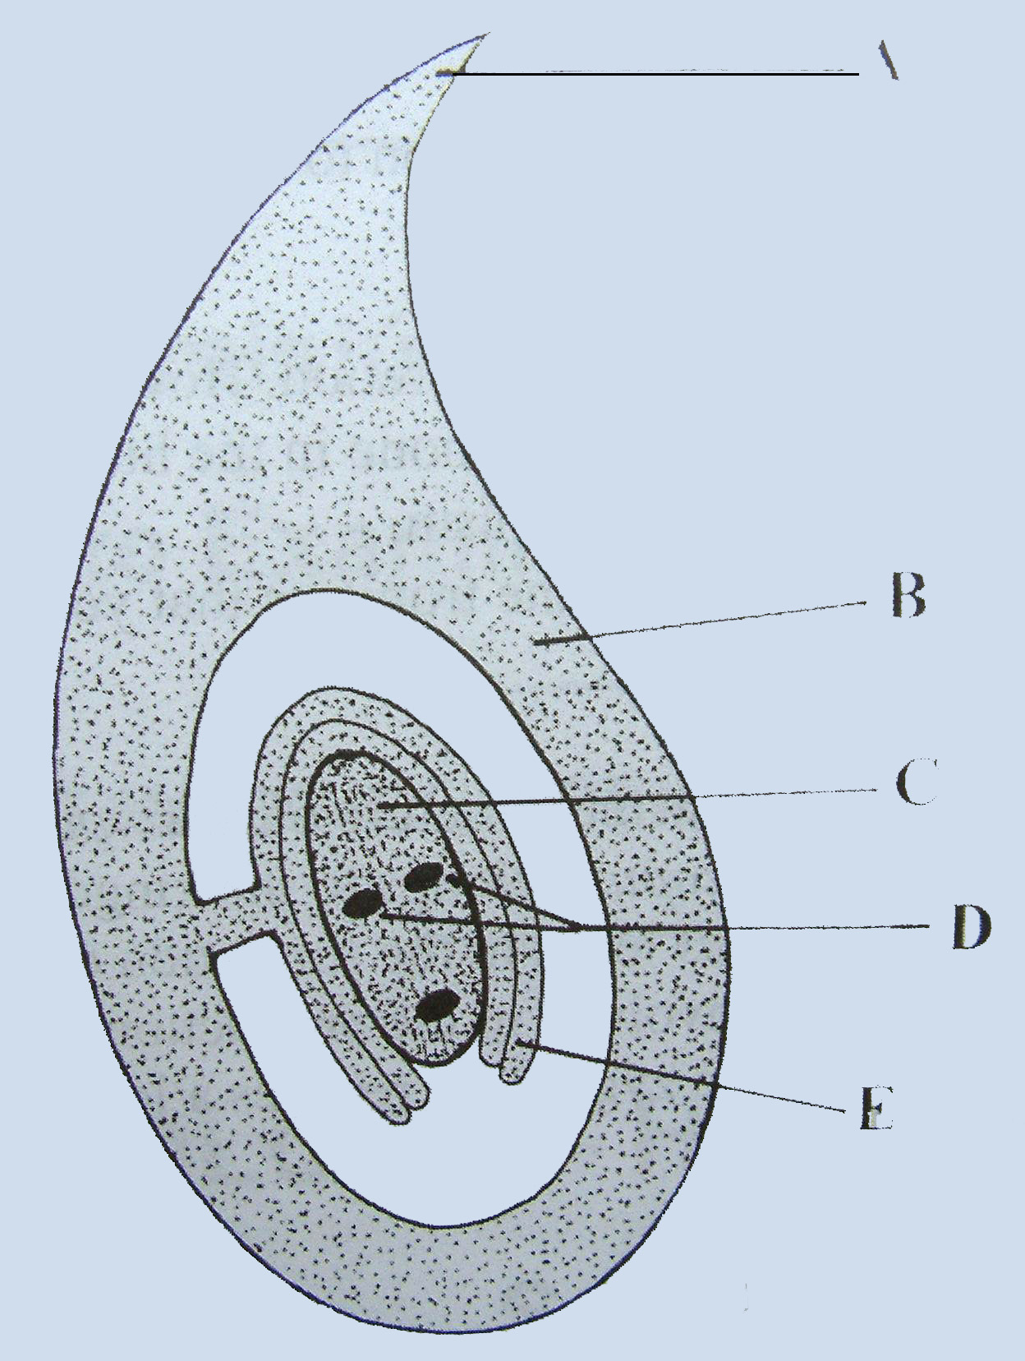
(i) Name A, B, C, D, E.
(ii) What happens to the two nuclei labelled D?
(iii) In the case of B and E state what may happen to each of them after fertilisation.
(iv) Copy the diagram into your answer book and add a pollen tube that has completed its growth. Label the nuclei in the pollen tube.
Answer

2006 HL
14. Answer any two of (a), (b) and (c). (30, 30)

(a) Answer the following in relation to sexual reproduction in flowering plants.
(i) State a role for each of the following: sepal, anther, stigma, ovary.
(ii) Distinguish between pollination and fertilization.
(iii) The two male gametes in the pollen tube are derived from the generative nucleus.
Do these gametes form as a result of mitosis or meiosis? Explain your answer.
(iv) Describe the fate of each of the male gametes.
(v) State one method that is used to produce seedless fruits.
Answer

2007 HL
14. Answer any two of (a), (b) and (c). (30, 30)

(a) (i) From what structure in the carpel does the seed develop?
(ii) State two locations in the seed where food may be stored.
(iii) The embryo plant within the seed has a number of parts. List two of these parts, apart from food stores, and give a role for each of them.
(iv) Following dispersal, the seed undergoes a period of dormancy. What is dormancy?
(v) Suggest two advantages of dormancy.
Answer

2009 HL
15. (a) (v) Seeds and fruits need to be dispersed.
Give:
1. Two methods of dispersal.
2. Two advantages of dispersal to the plant.
Answer

(c) Write notes on three of the following topics:
(i) The role of lymphocytes.
(ii) Neurotransmitters.
(iii) Homeostasis.
(iv) Adaptations of wind-pollinated flowers.
(v) The economic and medical importance of viruses.
Answer

2010 HL
13. (a) Give a role for each of the following parts of a flower: sepals, anther, stigma. (9)

(b) (i) Describe the development of pollen grains from microspore mother cells.
(ii) What is meant by the term fertilisation?
(iii) Give a brief account of the process of fertilisation in flowering plants. (27)

(c) (i) What is meant by the dormancy of seeds?
(ii) Give one way in which the dormancy of seeds is of benefit to plants.
(iii) Suggest one way in which a knowledge of dormancy is useful to farmers and gardeners.
(iv) Water, oxygen and a suitable temperature are all required for the germination of seeds.
In the case of each of these factors describe its effect on the process of germination.
(v) Which part of the embryo in a germinating seed gives rise to each of the following parts of
the seedling?
1. The root
2. The shoot. (24)
Answer

2012 HL
14. Answer any two of (a), (b), (c). (30, 30)

(a) (i) Give a brief account of the role of each of the following in flowering plant reproduction.
1. Petal.
2. Anther.
3. Stigma.
(ii) Name one structure through which the pollen tube grows in order to reach the embryo sac.
(iii) Within the pollen tube the generative nucleus divides to form two male gametes.
1. What type of division takes place?
2. With what does each male gamete fuse in the embryo sac?
3. Name the product of each fusion.
(iv) As the seed forms following fertilisation, a food store develops in one of two structures.
Name any one of these structures.

(b) Answer the following questions from your knowledge of early human development in the womb.
(i) 1. Name the three germ layers in the early human embryo.
2. For each germ layer name a structure in the adult body that develops from it.
(ii) From which tissues does the placenta develop?
(iii) 1. What is the amnion?
2. Explain the importance of the amnion for the foetus.

(c) (i) Answer the following questions in relation to sexual reproduction in the mould Rhizopus.
1. Sexual reproduction in Rhizopus is normally triggered by an adverse environmental
stimulus. Suggest one such stimulus.
2. Draw diagrams to show the main events of sexual reproduction in Rhizopus.
In your diagrams label three structures other than the zygospore.
3. Give two advantages to Rhizopus of zygospore formation.
(ii) Answer the following questions in relation to asexual reproduction in yeast.
1. What term is used to describe the process of asexual reproduction in yeast?
2. What happens to the new cells formed in the process?
3. How does asexual reproduction in Rhizopus differ from that in yeast?
Answer

Ordinary Level

SEC Sample Paper OL
12. (b) The diagram shows part of a root of a young plant.

(i) Make an outline copy of the diagram in your answer book and place the letters A, B, C on it to show the location of each of the following;
A = dermal tissue
B = ground tissue
C = vascular tissue
(ii) State three functions of a root.
(iii) From what part of the embryo plant within the seed does the root develop?
(iv) Where would you find a meristem in a root? (24)

(c) Flowering plants are classified as monocotyledons or dicotyledons.
(i) What is a cotyledon?
(ii) Name a monocotyledon.
(iii) Name a dicotyledon.
(iv) Copy the following table into your answer book and distinguish between monocotyledons and dicotyledons by completing the empty boxes. (27)

 | Monocotyledon | Dicotyledon
Distribution of veins leaf
Leaf shape
Distribution of vascular tissue in stem
Possible Answer

SEC Sample Paper OL
15. (c) The diagram shows a section through a flower.

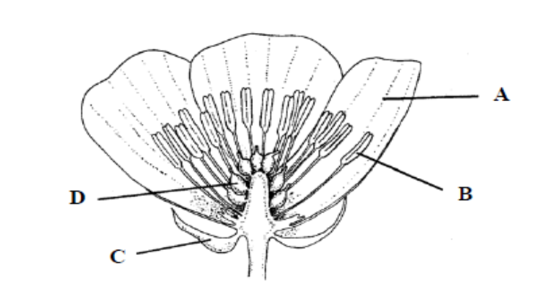

(i) Name the parts A, B, C, D.
(ii) State a function of the part labelled C.
(iii) In which part of the flower is pollen produced?
(iv) In which part of a flower does a seed form?
(v) Name a part of a flower that may develop into a fruit.
(vi) Some flowers have nectaries. How are these flowers pollinated? Explain your answer. (30)
Possible Answer

2004 OL
14. (a) (i) State a function of each of the following parts of a flower:
1. petal 2. sepal 3. anther.
(ii) Explain what is meant by pollination. What is the difference between self-pollination and cross-pollination?
(iii) Name two ways in which cross-pollination happens.
(iv) Suggest why cross-pollination is preferable to self-pollination.
Answer

(b) (i) Name a part of a flower from which a fruit develops.
(ii) In each of the following cases give one example of a plant that uses the stated method of seed dispersal:
1. wind
2. animal.
(iii) Why is it important for plants to disperse their seeds?
(iv) What is meant by the dormancy of seeds?
(v) Suggest an advantage of dormancy of seeds to a plant.
Answer

(c) (i) What is meant by germination?
(ii) List three factors that are essential for germination.
(iii) In the case of one of the factors that you have named in (ii), explain how it affects germination.
(iv) Describe an experiment to demonstrate that the factors you have named in (ii) are essential for germination. Include a diagram of the apparatus in your answer.
Answer

2006 OL
14. (c) The diagram shows a vertical section through a flower.

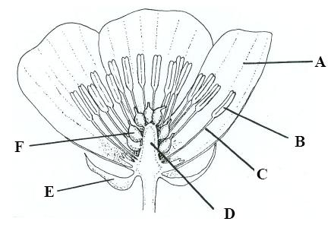

(i) Identify parts A, B, C, D, E and F.
(ii) What is the function of A? Give two ways in which it may be adapted for this function.
(iii) In which part is pollen produced?
(iv) Give two ways in which pollen may be transported to another flower.
(v) What forms in F after pollination and fertilization?
Answer

2007 OL
14. (c) (i) In the table below, which letter gives the correct order of events in the life cycle of a
flowering plant – A, B, C, D or E?

A | germination seed and fruit formation growth pollination fertilisation dispersal
B | germination fertilisation seed and fruit formation growth dispersal pollination
C | germination fertilisation growth seed and fruit formation pollination dispersal
D | germination growth pollination fertilisation seed and fruit formation dispersal
E | germination seed and fruit formation growth fertilisation dispersal pollination

(ii) Distinguish clearly between pollination and fertilisation.
(iii) State a location in the seed where food is stored.
(iv) What is germination?
(v) State three factors necessary for the germination of a seed.
Answer

2008 OL
14. (a) The diagram shows the structure of a flower.

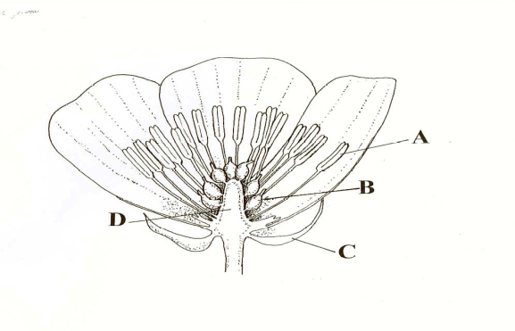

(i) Name the parts labelled A, B, C, D.
(ii) In which labelled part is pollen produced?
(iii) What is meant by pollination?
(iv) From the list below, choose three characteristics in each case of;
1. an insect-pollinated flower,
2. a wind-pollinated flower.
brightly coloured petals, feathery stigmas, anthers within petals, anthers outside petals, nectaries, petals reduced or absent.
(v) What process follows pollination in the life cycle of a flowering plant?
Answer

2009 OL
14. (c) (i) Name a part of the flower from which fruit forms.
(ii) Give three examples of the ways in which fruits are involved in seed dispersal.
(iii) Suggest why it is necessary for a plant to disperse its seeds.
(iv) Following dispersal most seeds enter a period of dormancy. What is dormancy?
(v) Give an advantage of dormancy.
(vi) Name the stage in the plant’s life cycle that follows dormancy.
(vii) State one way in which it is possible to produce seedless fruits in horticulture.
Answer

2010 OL
14. Answer any two of the parts (a), (b), (c). (30, 30)

(c) (i) What is meant by fertilisation?
(ii) Name the part of the flower in each case
1. Where fertilisation occurs
2. That becomes the fruit.
(iii) Each seed is made up of an embryo, a food store and a seed coat (testa). One function of fruit is to aid dispersal.
Explain each of the underlined terms.
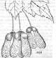
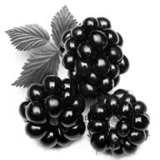

Blackberries Sycamore fruit
(iv) By which method are the seeds of each of the fruits shown above dispersed?
(v) What term is given to the growth of an embryo into a plant?
(vi) In order for this growth to be successful, certain environmental conditions must be
present. Name any two of these conditions.
Answer

2011 OL
15. Answer any two of (a), (b), (c) (30,30)

(a) (i) Draw a large labelled diagram to show the internal structure of a flower.
(ii) Give two ways by which pollen is transferred from one flower to another.
(iii) After fertilisation, what part of the flower becomes the fruit?
(iv) Many seedless fruits, e.g. grapes, are available in shops today.
State one way of forming seedless fruits.
(v) Sometimes artificial methods are used to propagate (reproduce) plants.
Name any two methods of artificially propagating plants.
Answer

2011 OL
15. Answer any two of (a), (b), (c) (30,30)

(b) The diagram shows a transverse section through a dicotyledonous (dicot) root.

(i) Name the parts labelled A, B and C.
(ii) State two functions of a root.
(iii) From what part of a seed does the root develop?
(iv) Give one example of a root modified for food storage.
(v) Plants can be monocotyledonous or dicotyledonous.
Give any one difference between a monocotyledonous plant and a dicotyledonous
plant.
(vi) Give one example of a monocotyledonous plant and one example of a
dicotyledonous plant.
Answer

2012 OL
12. (a) (i) Name the two main types of reproduction.
(ii) Explain the term fertilisation. (9)

(b) The flower is the organ of reproduction in many plants.
(i) What part of the flower produces pollen?
(ii) After fertilisation, what part of the flower becomes the fruit?
(iii) Give two methods of seed dispersal in plants.
(iv) Why is it necessary for plants to disperse their seeds?
(v) What is the advantage of dormancy to seeds?
(vi) Give three conditions necessary for seeds to germinate. (27)
Answer

2013 OL
15. Answer any two of (a), (b), (c). (30, 30)

(a) The diagram shows the structure of a flower.

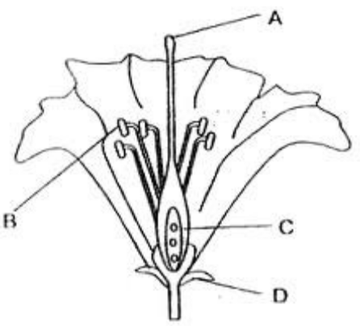

(i) Name the parts labelled A, B, C and D.
(ii) What is meant by the term pollination?
(iii) Give two methods of pollination in plants.
(iv) What is the next step after pollination in the lifecycle of the plant?
(v) Suggest a substance that flowers produce that may cause hay fever in some people.
Answer

Asexual Reproduction
Higher Level Questions Ordinary Level Questions

Higher Level

SEC Sample Paper HL
14. Answer any two of (a), (b), (c). (30,30)

(b) (i) In relation to flowering plants explain what is meant by vegetative propagation.
(ii) Clones are genetically identical individuals. Are the products of vegetative propagation clones? Explain your answer.
(iii) Give two examples of natural vegetative propagation that involve different parts of a plant.
(iv) Describe two techniques of artificial vegetative propagation that are used for flowering plants. Suggest a benefit of artificial propagation.
Possible Answer

2009 HL
15. (a) (i) What is meant by vegetative propagation?
(ii) Horticulturists use a number of methods to artificially propagate plants.
Suggest one advantage of artificial propagation.
(iii) Describe two methods used by horticulturists to artificially propagate plants.
(iv) Give two differences between vegetative propagation and propagation involving seeds.
(v) Seeds and fruits need to be dispersed.
Give:
1. Two methods of dispersal.
2. Two advantages of dispersal to the plant.
Answer

Ordinary Level

2005 OL
15. (b) (i) What is vegetative propagation?
(ii) Give one example of vegetative propagation and state whether it involves a stem, a root, a leaf or a bud.
(iii) How does vegetative propagation differ from reproduction by seed?
(iv) Artificial propagation is widely used in horticulture. Give two examples of artificial propagation.
(v) Suggest one advantage and one disadvantage of artificial propagation.
(30)
Answer

2013 OL
15. Answer any two of (a), (b), (c). (30, 30)

(b) (i) What is meant by the term vegetative propagation?
(ii) Give one example of vegetative propagation in plants and state whether it involve a stem, a
root, a leaf or a bud.
(iii) State two ways that vegetative propagation differs from reproduction by seed.
(iv) Artificial propagation is widely used in horticulture. Give two example of artificial propagation
carried out by gardeners or horticulturists.
(v) Give one advantage and one disadvantage of artificial propagation.
Answer

3.6 Reproduction and Growth – Human

Need to Know

3.6.2 Sexual Reproduction in the Human
3.6.4.H Human Embryo Development
3.6.5.H Menstrual Cycle and Hormonal Control

At the end of this section students should be able to:

Sexual Reproduction in Human
- Outline the general structure of the reproductive system (Male & Female).
- State the functions of the main parts of the reproductive system.
- Outline the role of meiosis to produce sperm & ova (egg) cells.
- Define the term secondary sexual characteristics.
- Outline the role of oestrogen, progesterone & testosterone.
- Outline the events & outline the role of oestrogen and progesterone in the menstrual cycle.
- Explain copulation.
- Outline the nature of birth control to include natural, mechanical, chemical and surgical methods
- State the location of fertilisation.
- Define infertility.
- State one cause of male infertility.
- State the availability of corrective measures for male infertility.
- State one cause female infertility.
- State the availability of corrective measures for female infertility.
- Explain implantation, placenta formation & function.
- Outline the birth process.
- Explain In-vitro fertilisation & implantation.
- Outline milk production & breastfeeding including biological benefits.

Human Embryo Development
- List the sequence of development of an embryo.
- Explain the term fertilized egg.
- Explain the term blastocyst.
- Explain the term amnion.
- Explain how the placenta is formed.
- Explain how the embryo develops up to the third month of gestation.

Menstrual Cycle and Hormonal Control
- Outline the stages in the menstrual cycle.
- Discuss the role of hormones in the menstrual cycle.
- Discuss the Cause/Prevention/Treatment for fibroids OR for endometriosis.

PowerPoint Presentations

3.6.2 a) Male Structure & Hormones.ppt
3.6.2 b) Female Structure & Hormones.ppt
3.6.2 c) Pregnancy, Birth & Breastfeeding.ppt
3.6.2 d) Infertility & Birth Control.ppt
3.6.4.H Human Embryo Development.ppt
3.6.5.H Menstrual Cycle & Hormones.ppt

3.6 Reproduction and Growth – Human

Section A

Human Reproduction
Higher Level Questions Ordinary Level Questions

Higher Level

2007 HL
4. The graphs illustrate changes in the levels of two hormones, A and B, which are involved in the development of the endometrium, during the human female menstrual cycle.

(a) Name one of these hormones ………………………………………………………………….
(b) What happens in the ovary around day 14 of the cycle?
………………………………………………………………………………………………….
(c) Apart from the two hormones illustrated, another hormone called FSH has a role in the cycle.
(i) Where is FSH produced? ……………………………………………………………….
(ii) Give one function of FSH ………………………………….…………………………
…………………………………………………………………………………………
(d) Which graph, A or B, represents the hormone secreted by the corpus luteum (yellow body)? …………………………………………………………………………………………..…..…
(e) Draw a line graph in the space above A and B to illustrate the changes that take place in the thickness of the endometrium over the course of the cycle.
Answer

2008 HL
6. The diagram shows the female reproductive system.
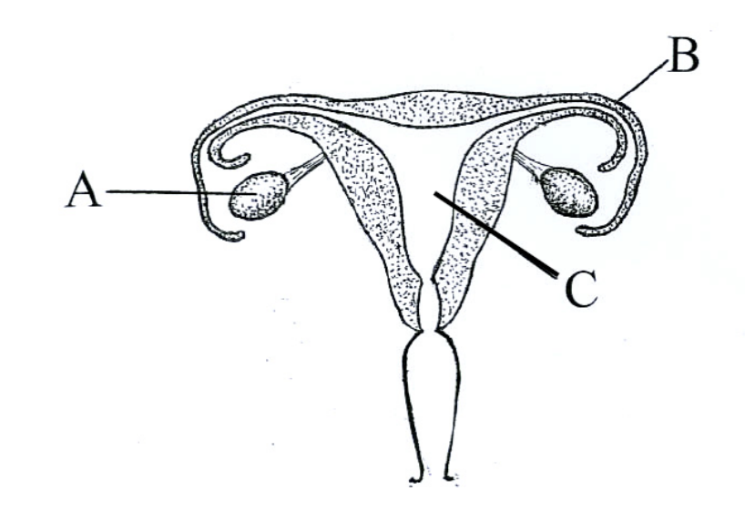

(a) Identify parts A, B and C.
A ………………………………… …
B …………………………………….
C …………………………………….
(b) Using the letters X, Y and Z and arrows, identify each of the following on the diagram:
endometrium (X), where fertilization normally occurs (Y), where meiosis occurs (Z).
(c) Which part of the female reproductive system is influenced by both FSH and LH?
.…………………………………………………………………………………………..
(d) Give two biological advantages of breastfeeding.
1………………………………………………………………………………………………………..
2………………………………………………..………………………………………………………
Answer

Ordinary Level

2006 OL
5. The diagram shows the reproductive system of a human female.
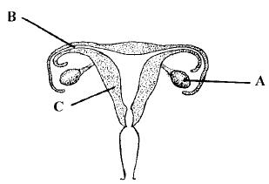
(a) Name A …………………………………………
B …………………………………………
C …………………………………………
(b) In which of the parts A, B or C is the ovum (egg) formed? …………………………………………
(c) What is meant by fertilization? ………………………..…………………………………………..…
………………………………………………………………………………………………………..
(d) In which of the parts A, B or C does fertilization occur? ……………………………………………
(e) Give one cause of female infertility. …………………………………………………………………
.……………………………………………………………………………………………………......

Answer

3.6 Reproduction and Growth – Human

Section C

Human Reproduction
Higher Level Questions Ordinary Level Questions

Higher Level

SEC Sample Paper HL
14. (c) (i) When may it be considered that the process of fertilisation is complete?
(ii) Where does fertilisation normally occur in the reproductive system of the human female?
(iii) Explain what is meant by germ layers and name the germ layers that appear in early human
development.
(iv) For each of the germ layers that you have named in (iii) name a tissue that it gives rise to.
(v) What is a placenta? From what tissues does a placenta form?
Possible Answer

2004 HL
14. (b) (i) Draw a labelled diagram of the reproductive system of the human female.
(ii) What is fertilisation? Indicate where fertilisation normally occurs on your diagram.
(iii) State one cause of infertility in the female and one cause of infertility in the male.
(iv) What is meant by in vitro fertilisation? What is done with the products of in vitro fertilisation?
Answer

(c) Answer the following questions from your knowledge of human embryology.
(i) What is a germ layer? List the three germ layers.
(ii) Relate each of the germ layers that you have listed in (i) to an organ or system in the adult body.
(iii) From what structures does the placenta develop? State three functions of the placenta.
(iv) Name a hormone associated with the maintenance of the placenta.
(v) Describe the amnion and state its role.
Answer

2005 HL
13. (a) (i) Where is testosterone secreted in the body of the human male?
(ii) Give a brief account of the role of testosterone. (9)

(b) (i) Draw a large labelled diagram of the reproductive system of the human male.
(ii) Where are sperm produced?
(iii) State two ways in which sperm differ from ova (eggs).
(iv) Name a gland that secretes seminal fluid.
(v) State a function of seminal fluid. (30)

(c) (i) What is meant by contraception?
(ii) Give an example of a surgical method of male contraception. Suggest an advantage and a disadvantage of the method that you have named.
(iii) List three methods of contraception other than surgical. In your answer you may refer to either or both sexes.
(iv) Suggest a possible effect on a human population that may result from an increased availability of contraception. (24)
Answer

2006 HL
15. (c) Write notes on three of the following.
(i) Menstruation and a disorder of menstruation.
(ii) Biological benefits of breastfeeding.
(iii) Survival times for sperm and ova.
(iv) Formation and functions of the placenta.
Answer

2007 HL
15. Answer any two of (a), (b) and (c). (30, 30)

(a) (i) Draw a detailed diagram of the reproductive system of the human male. Label the
following parts on your diagram: testis, seminal vesicle, urethra, sperm duct (vas deferens),
epididymis, prostate gland.
(ii) Place an X on your diagram where meiosis occurs.
(iii) Place a Y on your diagram where sperm are stored.
(iv) State two functions of testosterone.
(v) Give a cause of male infertility and suggest a corrective measure.
Answer

2009 HL
14. Answer any two of (a), (b) and (c). (30, 30)

(a) (i) Draw a diagram of the reproductive system of the human female.
On your diagram indicate where the following occur:
1. Meiosis.
2. Fertilisation.
3. Implantation.
(ii) Give an account of the role of either oestrogen or progesterone in the menstrual cycle.
(iii) Name a human female menstrual disorder. In the case of this disorder give:
1. A possible cause.
2. A method of treatment.
Answer

(b) (i) Give an account of the importance of the placenta during human development in the
womb.
(ii) From what tissues is the placenta formed?
(iii) Outline how birth occurs.
(iv) What is meant by in-vitro fertilisation?
(v) After implantation, the embryo first develops into a morula and then into a blastocyst.
Explain the terms in italics.
Answer

2010 HL
15. Answer any two of (a), (b), (c). (30, 30)
(a) (i) What is semen?
(ii) Draw a labelled diagram of the reproductive system of the human male.
On your diagram, indicate clearly and name the part at which each of the following occurs:
1. Production of sperm cells.
2. Maturing of sperm cells.
3. Mixing of fluid with sperm cells.
4. Transport of semen.
(iii) State two secondary sexual characteristics of the human male.
(iv) What maintains the secondary sexual characteristics in the adult human male?
Answer

2010 HL
15. Answer any two of (a), (b), (c). (30, 30)
(c) Suggest a biological explanation for each of the following observations:

(i) As long as a baby feeds regularly from its mother’s breast (or if a breast pump is regularly
used) the milk will continue to flow.
(ii) Doctors are reluctant to prescribe antibiotics to patients suffering from common cold-like
symptoms.
(iii) A person who has suffered from constipation may be advised to increase the amount
of wholegrain cereal in her/his diet.
(iv) After a long session of heavy exercise, an athlete’s urine is likely to be concentrated and
low in volume.
(v) A person’s fingers may turn white when exposed to low temperature for a period of time.
Answer
2012 HL
14. Answer any two of (a), (b), (c). (30, 30)

(a) (i) Give a brief account of the role of each of the following in flowering plant reproduction.
1. Petal.
2. Anther.
3. Stigma.
(ii) Name one structure through which the pollen tube grows in order to reach the embryo sac.
(iii) Within the pollen tube the generative nucleus divides to form two male gametes.
1. What type of division takes place?
2. With what does each male gamete fuse in the embryo sac?
3. Name the product of each fusion.
(iv) As the seed forms following fertilisation, a food store develops in one of two structures.
Name any one of these structures.

(b) Answer the following questions from your knowledge of early human development in the womb.
(i) 1. Name the three germ layers in the early human embryo.
2. For each germ layer name a structure in the adult body that develops from it.
(ii) From which tissues does the placenta develop?
(iii) 1. What is the amnion?
2. Explain the importance of the amnion for the foetus.

(c) (i) Answer the following questions in relation to sexual reproduction in the mould Rhizopus.
1. Sexual reproduction in Rhizopus is normally triggered by an adverse environmental
stimulus. Suggest one such stimulus.
2. Draw diagrams to show the main events of sexual reproduction in Rhizopus.
In your diagrams label three structures other than the zygospore.
3. Give two advantages to Rhizopus of zygospore formation.
(ii) Answer the following questions in relation to asexual reproduction in yeast.
1. What term is used to describe the process of asexual reproduction in yeast?
2. What happens to the new cells formed in the process?
3. How does asexual reproduction in Rhizopus differ from that in yeast?
Answer

2013 HL
13. (a) (i) In humans, widening of the female hips is one example of physical changes that distinguish
the sexes but are not essential for reproduction.
To what term does the definition in italics refer?
(ii) What term is used for the time in a young person’s life when such changes take place?
(iii) Name the hormone that maintains such changes throughout the life of a male.

(b) The diagram shows the reproductive system of the human female.
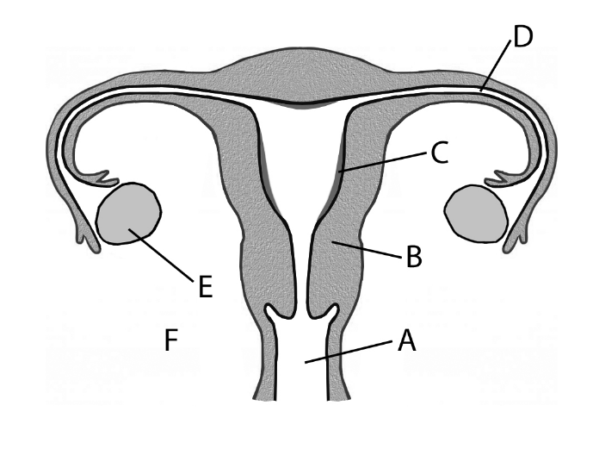
(i) Name the parts labelled A, B, C, D, E and F.
(ii) Using the letters from part (i), identify the following locations:
1. Where meiosis occurs.
2. Where zygote formation occurs.
3. Where implantation occurs.
(iii) Describe the role of oestrogen and progesterone in the control of the events of the menstrual
cycle.

(c) Answer the following questions in relation to the development of a human zygote.
(i) By which type of cell division does the zygote divide?
(ii) Further divisions result in the formation of a morula. What is the next developmental stage after
the morula?
(iii) The placenta forms from tissues of the mother and the foetus. Give two roles of the placenta.
(iv) Give one change experienced by the mother that indicates to her that the birth process is starting.
(v) Give a short account of the birth process.
Answer

Ordinary Level

2004 OL
11. (a) What are secondary sexual characteristics? Give an example of a human secondary sexual
characteristic. (9)

(b) The diagram shows the reproductive system of the human male.

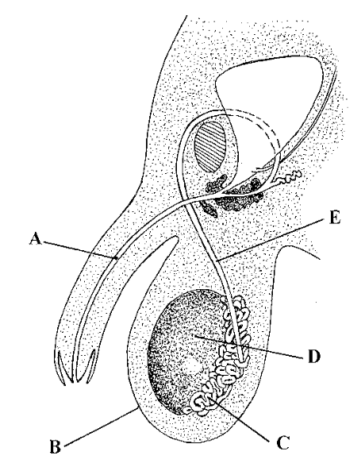

(i) Name the parts A, B, C, D, E.
(ii) Where are sperm produced?
(iii) What is the function of the prostate gland?
(iv) State one way in which a sperm differs from an ovum (egg). (24)

(c) (i) What is meant by infertility? State one cause of infertility in the human male.
(ii) Name three methods of contraception and, in each case, explain how the method prevents conception. (27)
Answer

2005 OL
14. (b) (i) Draw a large labelled diagram of the reproductive system of the human female.
(ii) Indicate on your diagram where each of the following events takes place;
fertilisation, implantation.
(iii) What is the menstrual cycle? Outline the main events of the menstrual cycle. (30)
Answer

2010 OL
14. Answer any two of the parts (a), (b), (c). (30, 30)
(a) The diagram shows the human male reproductive system.
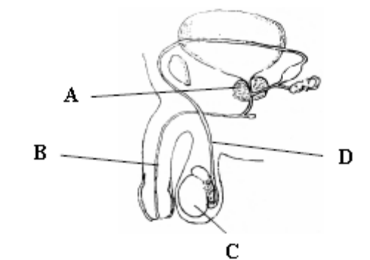
(i) Name the parts A, B, C and D.
(ii) What is the function of part D?
(iii) Name the principal male sex hormone.
(iv) Name two male secondary sexual characteristics.
(v) Draw a labelled diagram of a human sperm cell.
Answer

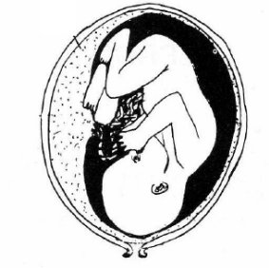
(b) The diagram shows a foetus in the uterus.
(i) From what tissues is the placenta formed?
(ii) Give two functions of the placenta.
(iii) Describe the process of birth.
(iv) Give any one biological benefit of breastfeeding.
(v) List two methods of contraception.
Answer

2011 OL
14. Answer any two of (a), (b), (c) (30,30)

(a) (i) Draw a large labelled diagram of the human female reproductive system.
(ii) Indicate clearly on your diagram where each of the following events takes place:
1. Ovulation
2. Fertilisation
(iii) What does the term infertility mean?
(iv) In vitro fertilisation is a method used to treat infertility.
What is meant by the term in vitro in relation to fertilisation?
(v) Give one cause of infertility in women.
(vi) As a result of fertility treatment, an embryo develops successfully from an in vitro
fertilisation. What is the next step for the embryo?
Answer

2012 OL
12. (c) The diagram shows a human sperm cell.
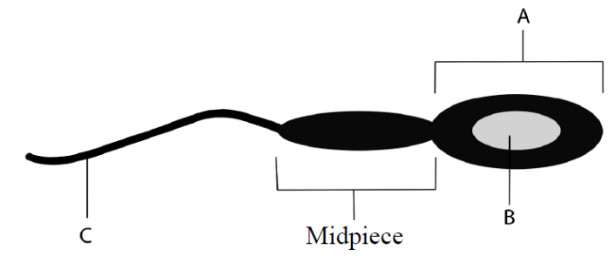
(i) Name the parts labelled A, B and C.
(ii) What is the function of the midpiece of the sperm?
(iii) Name the hormone responsible for sperm production.
(iv) Give one cause of infertility in men.
(v) Explain the term contraception.
(vi) Name two methods of contraception. (24)
Answer

2013 OL
12. (a) (i) Explain the term secondary sexual characteristics.
(ii) Give two examples of secondary sexual characteristics in males. (9)

(b) The diagram shows the foetus in the womb.

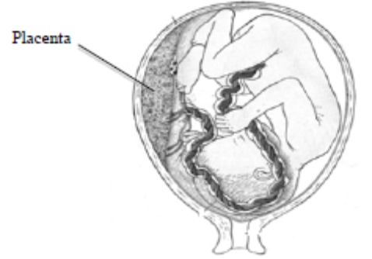

(i) Give two functions of the placenta.
(ii) Give the three stages of childbirth.
(iii) Many babies are breast fed after birth. Give two biological benefits of breastfeeding.
(iv) What is meant by the term infertility?
(v) In vitro fertilisation is a method used to treat infertility.
What is meant by in vitro fertilisation? (27)

(c) The diagram shows a regular female menstrual cycle.

/ 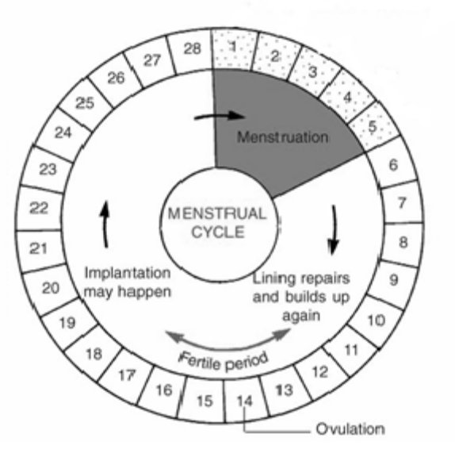

(i) What happens in the womb during menstruation (days 1 – 5)?
(ii) Explain the term ovulation.
(iii) What is meant by the fertile period?
(iv) Where does fertilisation occur in the female body?
(v) Explain the term implantation.
(vi) Name two female hormones that have a role in the menstrual cycle.
(vii) What happens to the menstrual cycle when a woman reaches the menopause? (24)
Answer

Answers

2004 HL Sample Q1
1. |  |  | 5(4)
 | (a) | protection/ boundary/ bears antigens/ controls exit and entry of substances
 | (b) | membrane –bound nucleus/ membrane-bound organelles
 | (c) | sperm/ egg/ sex cell/ gamete
 | (d) | catabolic
 | (e) | genotype
 | (f) | (Charles) Darwin/ (Alfred )Wallace

2004 HL Sample Q2
6(3)+2
A | B
DNA | Thymine
Ribosome | Protein
Vacuole | Sap
Fermentation | Ethanol
RNA | Uracil
Active Site | Enzyme
Variation | Mutation

2004 HL Sample Q3
3.
 |  | A on the left and B on the right |  | 2(2)
 |  | Features: thicker muscle wall/ smaller lumen |  | 2(2)
 |  | Tissues:  Muscle tissue:  Connective tissue:  Endothelial tissue:  Any two | Functions:  shunt/move blood along  prevent over expansion of walls/ support  protection  Any two | 2(2)  2(2)
 |  | Valves prevent a backflow of blood |  | 4

2004 HL Sample Q4
4. |  |  | 6(3)+2
 |  | An educated guess to explain an observation
 |  | A theory
 |  | Control acts as a standard against which the experiment can be compared/ acts as a comparison
Name: e.g. Enzyme factor experiments
Control: Use boiled enzyme instead of active enzyme OR
Name: in starch test:
Control: use water instead of test solution
 |  | In a report/ graph/ table (spreadsheet)/ list/ diagram Any two

2004 HL Sample Q5
5.
 |  | Quadrat = 0.5 x 0.5 m = 0.25 m²  In 10 quadrats there are 30 plants, i.e. in 2.5 m² there are 30 plants  Therefore in 1 m² there are 12 plants  The field has an area of 25,000 m²  Therefore there are 12 x 25,000 plants in the field, i.e. 300,000 | 5  5
 |  | Population = C1 x C2 / M2. 40 x 40 / 5 = 320.  320 in 2.5 ha, therefore there are 320/2.5 , i.e. 128 per ha. | 5  5

2004 HL Sample Q6
6. | (a) | min 35.7 | 3
 | (b) | max 37.5 | 3
 | (c) | period of exercise/ illness/ anxiety | 3
 | (d) | metabolic reactions/ in liver | 3
 | (e) | shivering/ blood vessels in skin constrict/ hairs rise/ sweating stops/ metabolism increases Any 2 | 3+2
 | (f) | sweat evaporates (causing body temperature to lower). | 3

2004 HL Sample Q7
7. | (a) | (i) | Proteins | 3
 |  | (ii) | Loss of function/ permanent change/ irreversible change of shape | 3
 | (b) |  | Catalase acts on Hydrogen peroxide [ amylase on starch] | 2(3)
 |  |  | Diagram with Labels | 3
 |  |  | By using different pH buffers, 4,7,9 | 3
 |  |  | Temperature/ enzyme concentration/ substrate concentration | 3
 |  |  | waterbath set at 25 ºC, same volume of enzyme/substrate | 3
 |  |  | labelled axes, pH on x, rate of reaction on y  Plot ( peak at 9 for catalase/ 7 for amylase) | 3  3

2004 HL Sample Q8
8. | (a) | (i) | Fungi | 3
 |  | (ii) | Baking/ brewing/ source of vitamin B | 3
 | (b) |  | Malt agar | 3
 |  |  | Contains all necessary ingredients for growth or provides energy for metabolism | 3
 |  |  | Ash/ sycamore/ privet | 3
 |  |  | Flamed forceps/ min opening of plate/ attached Vaseline to lid of dish/ flamed forceps/ min opening of plate/ attached leaf ( leaf discs) to Vaseline | 3(3)
 |  |  | Left dish with leaf suspended over the agar/ for 24 hours/ then inverted plates/ placed in incubator at 20 ºC / for 2-3 days | 2(3)

2004 HL Sample Q9
9. | (a) | (i) | Growing tips/ tip of shoot or root/ meristem at tip | 3
 |  | (ii) | Rooting powder/ weed killer/ ripen fruit | 3
 | (b) |  | Acetate grid | 3
 |  |  | To measure the length of roots and shoots | 3
 |  |  | Label Petri dishes ( bottles) as follows :10² ppm, 10 ppm, 1 ppm, 10⁻² ppm, 10⁻³ ppm, 10⁻⁴ ppm.  Using a syringe add 10 cm³ stock IAA solution to dish ( bottle) 1 ( 10² ppm). Use another syringe add 9 cm³ to each of the other dishes.  Using a different dropper each time transfer 1 cm³ solution from the 10² ppm dish to the 10 ppm, mix well, then transfer 1 cm³ from the 10 ppm dish to the 1 ppm dish and mix, and repeat with each of the remaining dishes, 10⁻² ppm,10⁻³ ppm, 10⁻⁴ ppm. | 3(3)
 |  |  | To prevent the roots from growing into the cotton wool / to allow the roots to grow down and the shoots to grow up/ make it easier to measure the shoot and root lengths | 3
 |  |  | Different concentrations of IAA have different effects on root and shoot growth/ v low concentrations stimulate root growth/ higher concentrations stimulate shoot growth. Control results described | 2(3)

2004 HL Sample Q10
10. | (a) | (i) | Carbon, Hydrogen, Oxygen |  |  | 3
 |  | (ii) | Ratio of elements is different/ less oxygen in fats/ more energy in fats |  |  | 3
 |  | (iii) | A phosphate replaces one of the three fatty acids |  |  | 3
 | (b) | (i) | Glucose. For energy |  |  | 2(3)
 |  | (ii) | Two sugar units |  |  | 3
 |  | (iii) | Chains of glucose molecules. Cellulose is found in cell walls |  |  | 2(3)
 |  | (iv) | Starch. Starch is a storage polysaccharide/ store of energy |  |  | 2(3)
 |  | (v) | Test: for starch. Add iodine solution/ positive result – turns blue-black |  |  | 2(3)
 | (c) |  |  | A reducing sugar | A protein | 8(3)
 |  | (i) | Reagent(s) used | Benedict’s/ Fehlings I and II | Biuret solution / CuSO₄ + NaOH
 |  | (ii) | Initial colour | Blue | Blue/ light blue
 |  | (iii) | Heat necessary? | Yes | No
 |  | (iv) | Positive colour | Brick-red/orange | Purple/ violet

2004 HL Sample Q11
11. | (a) | (i) | Segregation means separation, as in alleles separate at gamete formation |  | 3
 |  | (ii) | Aa ------ A or a |  | 2(3)
 | (b) | (i) | Either member of a pair of alleles can pass into a gamete with either member of another pair of alleles |  | 6
 |  | (ii) | 1 | RrSs x rrss | 2(3)
 |  |  | 2 | Red straight, red curly, black straight, black curly | 4(2)
 |  |  | 3 | Red curly and black straight ( the non-parentals) | 2(3)
 |  |  | 4 | Yes. If the genes are linked they tend to be inherited together and this will alter the expected ratios. Depending on the linkage the non-parentals would not occur | 3+4
 | (c) | (i) | The DNA molecule untwists at the site of the gene/ the message is copied (transcribed) into messenger RNA/ using RNA polymerase/ transcription occurs in the nucleus |  | 3(3)
 |  | (ii) | Three bases in sequence, e.g. GAC. Triplet codes for a specific amino acid |  | 2(3)
 |  | (iii) | tRNA carries an amino acid/ complementary to mRNA/ to the ribosome |  | 3(3)

2004 HL Sample Q12
12. | (a) | (i) | 6CO₂+6H₂O------chlorophyll + light --------C₆H₁₂O₆+6O₂ | 6,3,0
 |  | (ii) | chloroplast | 3
 | (b) | (i) | The light stage is light dependent, the dark stage is independent of light/  The light stage occurs in the grana, the dark stage in the stroma | 3(3)
 |  | (ii) | Adenosine Triphosphate  In the light stage | 3  3
 |  | (iii) | An electron that has absorbed as much energy as possible | 3
 |  | (iv) | NADP- accepts electrons/ hydrogen carrier/ for the dark stage | 2(3)
 |  | (v) | The dark stage | 3
 | (c) | (i) | It is easier to see the production of oxygen in an aquatic plant | 6
 |  | (ii) | Light intensity: bring lamp of fixed wattage stepwise nearer to the pondweed. Carbon dioxide: use different concentrations of carbon dioxide in the water | 6
 |  | (iii) | Bubbles of oxygen /per minute | 2(3)
 |  | (iv) | Axes x – light intensity/ carbon dioxide  Y – rate of photosynthesis.  Plot correct shape | 3  3

2004 HL Sample Q13
13. | (a) | (i) | Breathing is gas exchange. Respiration is the release of energy | 2(3)
 |  | (ii) | Carbon dioxide | 3
 | (b) | (i) | A: bronchus,  B: trachea (allow cartilage),  C: larynx,  D: bronchiole  E: alveolus. | 5(2)
 |  | (ii) | In the trachea/ nostrils. They move mucus upwards | 2(3)
 |  | (iii) | At E oxygen diffuses into the blood/ CO₂ diffuses out  E is adapted by being moist/ thin walled / has a large blood supply | 2(3)  3+2
 | (c) | (i) | Asthma: Cause: pet dander/ allergens/ exercise | 8
 |  | (ii) | Avoid the allergen/ don’t have pets | 8
 |  | (iii) | Use a bronciodilator | 8

2004 HL Sample Q14 (a)
14. | (a) | (i) | Fertilised ovule | 3
 |  | (ii) | Endospermic retain endosperm at maturity. Non-endospermic have used it up by maturity | 3
 |  | (iii) | name of seed, e.g. maize  Diagram  Labels – 3 parts of embryo, plumule, radical, hypocotyls, epicotyls  Functions: embryo shoot/ embryo root/ attachment of radical and cotyledon/ attachment of plumule and cotyledon | 3  3,0  3(2)  3(2)
 |  | (iv) | Monocots store their food in the endosperm  Dicotyledons store their food in the cotyledons | 3  3

2004 HL Sample Q14 (b)
14. | (b) | (i) | Asexual reproduction/ production of new plant from stem or root or leaf | 6
 |  | (ii) | Yes  Clones result from mitosis/ vegetative propagation is by mitosis | 3  2(3)
 |  | (iii) | Strawberry Runners- horizontal stems/ Potatoes stem tubers/ Dahlia root tubers/ Bryophyllum – leaf plantlets, Onion bulbs- buds Any two | 2(3)
 |  | (iv) | Cuttings ( or described)/ layering (or described)/ grafting (or described)/ Micro propagation ( or described). Any two  Benefit:Quick/ preserves desirable features/ cheap/ more reliable | 2(3)  3

2004 HL Sample Q14 (c)
14. | (c) | (i) | When the egg and sperm nuclei have fused | 3
 |  | (ii) | In the fallopian tube ( oviduct) | 3
 |  | (iii) | Germ layers: groups of cells in the embryo from which adult tissues and organs develop  Ectoderm, mesoderm and endoderm | 3  3(2)
 |  | (iv) | Ectoderm- skin / nervous system  Mesoderm- muscle/ bone/  Endoderm –linings of body tubes e.g. The trachea | 3  3  3
 |  | (v) | An organ that allows exchange of materials between the foetus and mother/ produces hormones.  Formed from tissues of the mother and the embryo | 3  3

2004 HL Sample Q15 (a)
15. | (a) | (i) | At the root hairs | 3
 |  | (ii) | Osmosis | 3
 |  | (iii) | No as osmosis is exclusive to water but, minerals move into the roots by diffusion, with the water | 2(3)
 |  | (iv) | Xylem  Lignified/ narrow/ hollow/ continuous pipe | 3  3
 |  | (v) | water evaporates from the surface of leaves ( transpiration)/ and is replaced / creating an upward pull or tension/the continuous stream/ ensures movement of water upwards/ the water column is hard to break | 4(3)

2004 HL Sample Q15 (b)
15. | (b) | (i) | The ability to resist infection or antigens  Active immunity results when you make the antibodies, passive is when you receive pre-made antibodies | 3  3
 |  | (ii) | Sweat is bacteriocidal/ protective barrier/ sebum is bacteriocidal | 2(3)
 |  | (iii) | White blood cells  T lymphocytes – recognise/and destroy infected cells/ memory  B- lymphocytes – make antibodies/ memory | 3  2(3)  2(3)
 |  | (iv) | to provide immunity/ introduce antigens / causes antibody production | 3

2004 HL Sample Q15 (c)
15. | (c) | (i) | Viruses are non-cellular/ no organelles/ only one type of nucleic acid/ no metabolism | 2(3)
 |  | (ii) | Protein and nucleic acid ( either DNA or RNA) | 2(3)
 |  | (iii) | Attachment/ (viral) nucleic acid into (host) cell/ uses host structures (or described)/ part(s) replicated/ virus assembly/ release (or lysis) | 3(3)
 |  | (iv) | Swine Flu or any other appropriate, e.g. HIV, rabies, yellow fever  - Droplet infection (or explained)/ contact with infected surfaces  - Attacs the respiratory membranes/ high temperature  - Good hand hygiene/ ‘catch it, kill it , bin it’/ antiviral drugs | 3  2  2  2

2004 OL Sample Q1
1. |  |  |  | 4(5)
 | (a) |  | Ear
 | (b) |  | Liver
 | (c) |  | Stoma (Stomata)
 | (d) |  | Ligaments
 | (e) |  | Omnivore

2004 OL Sample Q2
2. |  |  |  | 5(4)
 |  |  | Rods (Bacillus) Spheres (Cocci)
 |  |  | Binary fission
 |  |  | Spores (Endospores)
 |  |  | Disease causing

2004 OL Sample Q3
3. |  |  |  |  | 5(4)
 |  |  | Cell membrane | Lipid
 |  |  | Vacuole | Sap
 |  |  | Mutation | Variation
 |  |  | Organ | Liver
 |  |  | Gamete | Haploid

2004 OL Sample Q4
4.
 |  |  | 13 | 3
 |  |  | April / May / June | 3(3)
 |  |  | There is plenty of food/ it is warmer | 3
 |  |  | Lack of food / predation / temperature / decrease Any two | 3+2

2004 OL Sample Q5
5.
 | (a) |  | Vitamin: A or D or K | 3
 |  |  | Source: liver/ milk/ green vegetables | 3
 |  |  | Disease: Night blindness or rickets (osteomalacia) or reduced clotting of blood | 4
 | (b) |  | Minerals: Calcium and Iron | 2(3)
 |  |  | Calcium – for strong bones and teeth or blood clotting  OR Any one  Iron – for red blood cells or to make haemoglobin | 4

2004 OL Sample Q6
6. |  |  |  | 5(4)
 |  |  | Six
 |  |  | Two
 |  |  | Three
 |  | 1. | Reproduction
 |  | 2. | Growth / Repair

2004 OL Sample Q7
7. | (a) | (i) | A biological/ organic/ protein catalyst | 3
 |  | (ii) | Substrate | 3
 | (b) |  | Catalase or amylase (must match substrate) | 3
 |  |  | Hydrogen peroxide or starch (must match enzyme used) | 3
 |  |  | Diagram of set up  Labels: water bath(s)/ test tubes/ solutions/ | 6,3,0  3(1)
 |  |  | Water baths/ at different temperatures/ thermostat | 3
 |  |  | Volumes of foam/ per minute/ disappearance of blue colour/ per minute | 3

2004 OL Sample Q8
8. | (a) | (i) | Named ecosystem | 3
 |  | (ii) | Matching three plants | 3(1)
 | (b) |  | % frequency or % cover. Named plant  Position quadrat / at random / number of times / count plants / estimate cover / result / number per area / % frequency / % cover Any four | 3  4(3)
 |  |  | Results presented in words or a diagram or a graph or a table
 |  |  | Source of error: Lack of randomness/ insufficient quadrats/ species identification/ carelessness/ human error/ unsuitable equipment

2004 OL Sample Q9
9. | (a) |  | The growth of a seed/ sprouting/ re growth of the embryo plant | 3
 |  |  | Moisture (water) / warmth (correct temperature) / oxygen | 3(1)
 | (b) |  | Seed type: mustard/ cress/ radish/ peas | 3
 |  |  | Diagram: 4 dishes/ tubes. A- minus water/ B minus oxygen/ C with every thing/ D – minus correct temperature.  Labels to match diagrams. ( title may be considered a label) | 6,3,0  3
 |  |  | Set up apparatus as in sketch / placed A, B and C in incubator at 20 °C / place D in fridge / for 2-3 days | 3(3)
 |  |  | A, B, D – no germination  C – germination | 3  3

2004 OL Sample Q10
10. | (a) | (i) | 72 beats per minute ( allow 5 either side) | 3
 |  | (ii) | Decrease: sleep / rest / cold / drugs Any one  Increase: exercise / excitement / drugs Any one | 3  3
 | (b) | (i) | A- ventricle, B- bicuspid valve, C- atrium, D – aorta, E- pulmonary artery,  F – vena cava | 6(3)
 |  | (ii) | The lungs | 3
 |  | (iii) | To prevent backflow (of blood)/ from ventricle to atrium | 3
 |  | (iv) | Coronary ( cardiac) | 3
 | (c) | (i) | Plasma | 3
 |  | (ii) | Glucose / amino acids / vitamins / urea / hormones Any two | 2(3)
 |  | (iii) | To transport substances / act as a medium Any one | 3
 |  | (iv) | RBC- transport oxygen Any one  WBC- defence against disease / produce antibodies / engulf bacteria  Any one | 3  3
 |  | (v) | ABO and Rhesus systems | 2(3)

2004 OL Sample Q11
11. | (a) | (i) | Examining DNA / for a pattern or band / to compare | 3
 |  | (ii) | Forensic / paternity case s/ medical or examples | 2(3)
 | (b) |  | Gametes: X and X or Y  Genotypes: XX and XY ( 50% chance of either) | 3(4)  2(6)
  Gametes | X | Y
  X | XX | XY
  X | XX | XY
 | (c) | (i) | Change / producing new organisms / example | 6+3
 |  | (ii) | organisms have variations / that are inherited / beneficial / will reproduce / struggle for existence / pass on these variation s/ ‘survival / of fittest’ / origin of species Any four | 4(3)
 |  | (iii) | Fossils / comparative anatomy / embryos / DNA changes / horse / bones  Any two | 2(3)

2004 OL Sample Q12
12. | (a) | (i) | A group of similar cells | 3
 |  | (ii) | Xylem and Phloem | 2(3)
 | (b) | (i) | A, B and C correctly marked on the diagram | 3(3)
 |  | (ii) | Absorption of water (and minerals) / anchorage / food storage / asexual reproduction | 3(3)
 |  | (iii) | Radicle | 3
 |  | (iv) | At the tip | 3
 | (c) | (i) | A seed leaf / embryonic leaf | 3
 |  | (ii) | Daffodil / onion / any correct | 3
 |  | (iii) | Daisy / dandelion / buttercup / any correct | 3
 |  | (iv) |  | 6(3)
   | Monocotyledon | Dicotyledon
  Distribution of veins in leaf | parallel | Netted / reticulate
  Leaf shape | Strap | broad
  Distribution of vascular bundles in stem | No definite pattern | Definite pattern

2004 OL Sample Q13
13. | (a) | (i) | 6CO₂ + 6H₂O + energy | 2(3)
 |  | (ii) | Mitochondria | 3
 | (b) | (i) | To show that it is the mouse that releases the carbon dioxide | 3
 |  | (ii) | Lime water in 2 proves that any carbon dioxide in the incoming air has been removed.  Lime water in 3 proves that it is the mouse that releases the CO₂ | 3  3
 |  | (iii) | To act as a comparison/ a standard against which to compare.  The same set up but with no mouse ( organism) | 6  3
 |  | (iv) | No.  Photosynthesis by the plant would use up the CO₂ that the plant produces in respiration | 3  3
 | (c) | (i) | To remove the oxygen | 6
 |  | (ii) | To keep the system anaerobic/ to stop oxygen getting in | 6
 |  | (iii) | No.  The control would be the set up without the yeast. It is the yeast that is respiring. | 3  6
 |  | (iv) | Baking / brewing | 2(3)

2004 OL Sample Q14 (a)
14. | (a) | (i) | Nitrogen Cycle | 6
 |  | (ii) | Any named herbivore and carnivore related to an Irish ecosystem | 2(3)
 |  | (iii) | Proteins / nucleic acids / enzymes | 6
 |  | (iv) | Denitrification / death and decay / decomposition | 3
 |  | (v) | Nitrogen fixation | 3
 |  | (vi) | Bacteria / Rhizobia | 3
 |  | (vii) | To prevent washing excess nitrates into rivers and streams /causing pollution | 3

2004 OL Sample Q14 (b)
14. | (b) | (i) | The sun | 3
 |  | (ii) | Photosynthesis | 3
 |  | (iii) | Chlorophyll | 3
 |  | (iv) | Name of ecosystem  A – ( plant), B ( herbivore), C ( carnivore) | 3  3(3)
 |  | (v) | B.  Because the energy decreases / is lost as you move up through a food chain | 3  3
 |  | (vi) | Food web (must include A, B, C above) | 3

2004 OL Sample Q14 (c)
14. | (c) | (i) | Addition of harmful substance to the environment/ undesirable change | 6
 |  | (ii) | Any Example: release of toxic gases from manufacturing.  One Control: legislation / filters | 3  3
 |  | (iii) | 1. Bad odours / disease / unsightly / production of toxic chemicals / run off  2. Waste management: safe disposal of waste / reduce / reuse / recycle / example of waste / how managed / role of micro-organisms | 3  3
 |  | (iv) | Protection / preservation / wise management of the environment | 6
 |  | (v) | Conservation practice: net mesh size in fishing industry to allow young fish escape to breed | 6

2004 OL Sample Q15 (a)
15. | (a) | (i) | A – cortex, B- medulla ( pyramid), C – pelvis, D – ureter | 4(3)
 |  | (ii) | Bladder | 3
 |  | (iii) | In the cortex. ( A)/ nephron/ glomerulus/ Bowman’s capsule | 3
 |  | (iv) | Glucose/ amino acids/ vitamins/ red blood cells/ white blood cells  Any two | 2(3)
 |  | (v) | Put on a dialysis ( kidney) machine | 3
 |  | (vi) | Lungs / skin / liver Any one | 3

2004 OL Sample Q15 (b)
15. | (b) | (i) | Fungi | 3
 |  | (ii) | A- hypha ( stolon), B – rhizoid, C – sporangium | 3(3)
 |  | (iii) | Anchorage / absorption Any one | 3
 |  | (iv) | Asexual reproduction / production of spores / storage of spores  Any one | 3
 |  | (v) | Name: Mushrooms/ Truffles-  Benefit: for food/ fungi of decay – to decompose and recycle nutrients | 3  3
 |  | (vi) | Name: Destroying Angel/ Death Cap –  Harm: Is a poisonous fungus | 3  3

2004 OL Sample Q15 (c)
15. | (c) | (i) | A – petal,  B – anther,  C – sepal,  D – carpel | 4(3)
 |  | (ii) | C – protection / photosynthesis Any one | 3
 |  | (iii) | The anther / stamen | 3
 |  | (iv) | The carpel / ovary / ovule | 3
 |  | (v) | The ovary / ovary wall | 3
 |  | (vi) | By insects / animals.  The nectar is a ‘reward’ for the insect visiting the flower and at the same time transfers pollen | 3  3

2004 HL Q1
1. | any five |  | 2(7)+3(2)
 | (a) | Any named plant or named photosynthetic bacteria or cyanobacteria [allow grass,seaweed, fern, moss]
 | (b) | Respiration or digestion or deamination or any correctly described reaction  e.g. protein → amino acids or equation
 | (c) | (nitrogen) fixation
 | (d) | 2:1 [allow if correctly shown in formula e.g. C₆H₁₂O₆]
 | (e) | Mutualism or symbiosis
 | (f) | Keratin or myosin or elastin or collagen or other correct example [allow fibrin]

2004 HL Q2
2. |  |  | 2(4)+6(2)
 |  | Variation
Genetic or examples / environment or examples / age /
[NOTE – environment + food = 1 point] any two points
 |  | Yes or No or implied in text (on this line)
Explanation:
Weight is also determined by genetic or environmental factors [for ‘yes’ above]or valid reason e.g. reference to eating habits or exercise [if ‘no’ given above]
[Note: reason must match the Yes/No above]
 |  | Change in genetic makeup (or in DNA, in gene, in chromosome, etc.)
 |  | Radiation or chemical or viruses or carcinogens or named example of any one of these [allow smoking]
 |  | Down’s syndrome or other correct condition e.g. cancer or stripe in eye colour [any spontaneous change - one incorrect does not cancel]

2004 HL Q3
3. |  | PpCc ppcc | 4+4
 |  | Yes [or implied in statement] | 4
 |  | Parentals and non-parentals (i.e. all possible phenotypes)  or each allele can combine with either of the other pair /  in 1:1:1:1: ratio (or in equal numbers or some indication of this) | 4  4

2004 HL Q4
4. |  |  | 4+8(2)
 | (a) | A = stoma  B = guard cell  C = (epi)dermal cell
 |  | To allow movement (exchange) of gas (or air or water vapour) or transpiration
 |  | CO₂ (allow light or potassium ions or water)
 |  | Lenticels or stomata
 | (b) | Onion or tulip or daffodil or cabbage other correctly named plant
 |  | Starch or sucrose or cellulose or fructose or glucose [not ‘sugar’]
 |  | Rhizome or corm or tuber [allow stolon]

2004 HL Q5
5. |  |  | 2(5)+5(2)
 | (a) | Any harmful (undesirable) (addition to) the environment (or named ecosystem)
 |  | Any correct example of human activity
 |  | Counteracting method (must relate to example given above) [allow “clean up”]
 | (b) | Explain conservation: Retention of viable populations (e.g. stopping extinction) or their habitats or comment on management or any one explained [allow ‘wise use of environment]  (i) and (ii) NB any two reasons for conservation aesthetic / recreational / food supplies / possible sources of drugs /source of other materials / species right to existence / prevent extinction / biodiversity or balance / or any 2 correct examples  [Note: group term + example = 1 point; 2 examples = 2 points]
One conservation practice:
Control of fertiliser usage or control of mesh size or plant trees or any valid example explained

2004 HL Q6
6. |  |  | 2(5)+5(2)
 |  | Muscular activity or description e.g. contractions to move food [allow ‘movement of food’]
 |  | Kills germs or optimal pH for enzymes or hydrolysis of starch or other correct reason
 |  | Peristalsis or explained (e.g. bulk for movement) [accept reference to constipation or bowel cancer]
 |  | Lipase
 |  | Fatty acids or glycerol
 |  | Emulsification (must imply smaller globules produced) or pH effect or explained
 |  | Production of vitamins or inhibition of pathogens or (aids) digestion or example

2004 HL Q7
7. | (a) |  | Yes | 3
 |  |  | (Rate of) enzyme reaction (affected by temperature) | 3
 | (b) |  | Diagram  [must include evidence of anaerobic conditions and two correct labels for 3 marks] | 3, 0
 |  |  | Sugar or named sugar or starch | 3
 |  |  | Carbon dioxide or any product of glycolysis | 3
 |  |  | Yeast absent (or dead) in same set up | 3
 |  |  | Comparison or purpose described | 3
 |  |  | No more gas given off (no more bubbles) | 3
 |  |  | *NB - To test for alcohol – All candidates who attempt Q | 3
 |  |  | Water (allow other correct product from Kreb’s cycle) | 3

2004 HL Q8
8. | (a) |  | dermal / ground / meristematic any two  [allow correctly named tissue e.g. cambium] | 2(3)
 | (b) |  | Why:  Easier to cut (thin) sections or relevant comment on tissue arrangement (e.g. easier to see vascular bundles) | 3
 |  |  | Method described:  Cut thin / named instrument e.g. blade, microtome, scalpel / between nodes / named support e.g. pith, carrot, wax / at right angle (across) / any safety procedure stated / any two | 2(3)
 |  |  | To ensure light can pass through or to see (cells) clearly | 3
 |  |  | Diagram  [Diagram - section with vascular bundles in ring (4) or at least one bundle divided]  Labels: xylem and phloem in correct position | 3, 0  3
 |  |  | Functions:  Phloem:– transport of food (or minerals or auxins)  Xylem:– transport of water or minerals | 3  3

2004 HL Q9
9. | (a) | (i) | it can shorten or contract | 3
 |  | (ii) | left ventricle | 3
 | (b) |  | Dissection:  Identify sides (or front/back) / how identified / ventral side uppermost / on board or dish /named cutting instrument / described (location of) cut / any safety procedure stated e.g. gloves, goggles, white coat any three | 3(3)
 |  |  | Diagram  [4 chambers + indication of 2 valves]  labels (bicuspid and tricuspid valves in correct position) | 3, 0  3
 |  |  | Expose semilunar valve:  Cut aorta or cut pulmonary artery | 3
 |  |  | Function semi lunar valve:  Stops back flow of blood (into ventricle or from artery) | 3
 |  |  | Origin of coronary artery:  aorta or near semilunar valve | 3

2004 HL Q10
10. | (a) |  | Biosphere: Parts of the earth that support life  Habitat: Place where organism(s) live(s)  Niche: Role of organism (in an ecosystem) or explained e.g. ‘how it fits’ | 3  3  3
 | (b) | (i) | Abiotic factors are non-living and biotic factors are living | 3
 |  | (ii) | Example of abiotic factor named or group e.g. climatic  Named plant | 3  3
 |  | (iii) | Example of biotic factor named  Named animal  [If ecosystem not named or incorrectly named can only get either animal or plant mark, NOT both] | 3  3
 |  | (iv) | Pyramid of numbers: Shows numbers of different organisms in a food chain (or in trophic levels or named trophic levels)  Pyramid | 3  3
 |  | (v) | Producers or autotrophs | 3
 | (c) | (i) | 3.5 – 4.5 years | 3
 |  | (ii) | 33 – 39 | 3
 |  | (iii) | Predator: an animal (or organism) that eats another animal  Graph: showing lower numbers and out of phase | 3  3+3
 |  | (iv) | Why decline: food shortage / disease / migration/ correct climatic change or example /decrease in reproductive rate / other correct reason e.g. lack of space, competition, or human activity e.g. trapping, poisoning etc. any two | 2(3)
 |  | (v) | Why increase: (increased) food supply/ decline in predator numbers/  increase in reproductive rate / correct climatic change or example / migration / other correct example e.g. more space any two | 2(3)

2004 HL Q11
11. | (a) |  | Adenosine triphosphate  Role: P – P bond / holds or stores (energy) / passes on or releases (energy) or ATP → ADP + P / + energy (or the reverse reaction)  any two |  | 3  2(3)
 | (b) | (i) | Pathway 1.  Light energising electrons or light into chlorophyll / (e-) from chlorophyll / ATP formed / (e-) returned to chlorophyll  Pathway 2.  (e-) to NADP / photolysis (or H2O split) / H+ (protons) to NADP / NADPH formed / ATP formed / O2 formed / different electrons / (e-) back to chlorophyll/  [maximum 4 points from either pathway] |  | 6(3)
 |  | (ii) | Product  ATP  NADPH  O₂ | Fate  for dark phase or explained or any metabolic reaction  for dark phase or explained  respired or released (into atmosphere) any three | 3(3)
 | (c) | (i) | Why Elodea?: ease of measurement of rate or explained |  | 3
 |  | (ii) | How temp constant: water bath or described |  | 3
 |  | (iii) | Sources of CO₂: animal respiration / plant respiration / from air / bacterial respiration or decomposition /  [Note: respiration alone = 1 point] |  | 2(3)
 |  | (iv) | How varied: lamp / different distances (or different wattage) OR  sodium hydrogen carbonate / different amounts |  | 3+3
 |  | (v) | Precaution at each change: Allow time (before counting bubbles)  Reason: Plant adjusting or equilibration or explained |  | 3  3

2004 HL Q12
12. | (a) |  | Maintaining (a constant) internal environment or described  Role of kidneys: Maintaining salt balance or explained /  Maintaining water balance or explained /  [Note: Osmoregulation = 2 points] | 3  3  3
 | (b) | (i) | Diagram of nephron  Diagram of blood supply  labels | 3, 0  3, 0  3(1)
 |  | (ii) | Filtration:  Blood in arteriole / under pressure/ plasma (accept blood) or small molecules or named from (or in) glomerulus /in or into (Bowman’s) capsule /large molecules or named or cells or named cells cannot pass any three  Reabsorption:  Substance (or named) from (or in) tubule (or named part or from filtrate) / / into blood / active transport / diffusion / osmosis / mention of hormonal control any three | 3(3)  3(3)
 | (c) | (i) | Source: respiration or named site e.g. muscle, liver, kidney,  brain or named food e.g. carbohydrate or named | 3
 |  | (ii) | Two methods of insulation: fat (adipose tissue) / (trapped) air or hair | 2(3)
 |  | (iii) | When temp high: vasodilation (or explained) / (secretion of) sweat /  hairs lie flat or less air trapped any two | 2(3)
 |  | (iv) | Response when temp drops: receptor (or detection) / receptor in skin / receptor in medulla or brain / shiver / generates heat / hairs stand up or goose bumps / air trapped / vasoconstriction (or explained) / increased metabolic rate or increased respiration / any relevant comment on named hormone e.g. thyroxine increases metabolic rate or increases respiration any three | 3(3)

2004 HL Q13
13. | (a) |  | Completed diagram showing two additional sugar molecules and two more bases  diagram completed correctly or shapes of bases or show bonding  new bases named and matched  deoxyribose or phosphate labelled | 3, 0  3, 0  3, 0
 | (b) |  | mRNA(messenger RNA)  rRNA (ribosomal RNA)  tRNA (transfer RNA)  Functions:  mRNA: mRNA formed to match DNA (or transcription or explained) / leaves nucleus or into cytoplasm / (carries instructions) to ribosomes or for translation  rRNA: rRNA binds (holds) mRNA in place / for translation (or explained) / structure of ribosome  tRNA: tRNA carries an amino acid / complementary to mRNA / to ribosomes  any five functions  [must be at least one point from each RNA type] | 3  3  3  5(3)
 | (c) | (i) | Difference: egg cell is haploid or somatic cell is diploid or quote from passage line 6 and 7 | 3
 |  | (ii) | Advantage: any valid example e.g. same wool quality | 3
 |  | (iii) | Disadvantage: any valid example e.g. lack of variation or consequence e.g. prone to disease | 3
 |  | (iv) | Comment: valid / mitosis yields genetically identical nuclei / not all genes switched on / genetic potential to produce new organism or explained / comment on significance e.g. forensics  [If ‘not valid’ stated for one point, second point got from a reason why not e.g. not sex cells] any two | 2(3)
 |  | (v) | Implanted: attached (embedded) [allow inserted, placed or put] to the endometrium [allow uterus or womb] or explained | 3
 |  | (vi) | Why electric pulse: any reasonable suggestion e.g. to initiate cell division, keep alive, boost viability, energise. | 3
 |  | (vii) | Artificially fertilised: (diploid) nucleus / into ovum without nucleus / rather than from fusion of haploid nuclei (or gametes)  [These 2 points will be got by quoting from last paragraph] any two | 2(3)

2004 HL Q14(a)
14. | Answer any two of (a), (b), (c).
 | (a) | (i) | A = stigma or style  B = ovary  C = embryo sac (allow nucellus)  D = polar nuclei  E = ovule (allow integuments) | 2  2  2  2  2
 |  | (ii) | What happens to D:  Fuse / form diploid (or primary endosperm) / (then fusion) to triploid or fertilisation / endosperm nucleus | 2(3)
 |  | (iii) | E becomes the seed or testa  B becomes the fruit | 2  2
 |  | (iv) | Diagram  2 named nuclei labels | 6, 3, 0  2(2)

2004 HL Q14(b)
 | (b) | (i) | Diagram female:  labels | 6, 3, 0  3(2)
 |  | (ii) | Fertilisation: fusion of gametes  Indicate on diagram: location indicated correctly on diagram | 3  3
 |  | (iii) | Female infertility: any named pathological condition e.g. hormonal  or blockage or failure to ovulate  Male infertility: low sperm count or reason for / named pathological  condition / hormonal | 3  3
 |  | (iv) | In vitro: fertilisation outside the body or description  Fate: implanted in a womb or stored for future use or destroyed | 3  3

2004 HL Q14(c)
 | (c) | (i) | Germ layer:  Layer of cells / in the blastula (embryo) / (potential to) give rise to (specific) tissues (or organs) any two  Name 3 germ layers: ectoderm  endoderm  mesoderm | 2(2)  2  2  2
 |  | (ii) | Fate of 3 germ layers:  ectoderm – skin or nails or hair or nervous system  endoderm – (inner lining of) gut or named part of or liver or pancreas  mesoderm – muscles or skeleton or excretory system or respiratory  system or circulatory system (or blood) | 2  2  2
 |  | (iii) | Placenta origin: uterine tissue and embryonic tissue  [allow from mother and baby]  3 Functions:  produces hormones (or named) / allows passage of food (or named)/ and oxygen / antibodies / waste (or named) / acts as a barrier or explained any three | 2  3(2)
 |  | (iv) | Progesterone | 2
 |  | (v) | Amnion: sac or membrane  holds or produces fluid or protects embryo (or foetus) | 2  2

2004 HL Q15(a)
15. | Answer any two of (a), (b), (c).
 | (a) | (i) | Diagram of synaptic cleft:  3 labels | 6, 3, 0  3(2)
 |  | (ii) | Transmission of impulse: arrival of impulse / synaptic bulbs (or vesicles) / (secretes) transmitter (substance) / passage of neurotransmitter / impulse starts in next neuron / neurotransmitter broken down / by enzymes any five | 5(3)
 |  | (iii) | A drug may be used to inhibit or enhance transmission of impulse or  similar comment  [any reasonable suggestion] | 3

2004 HL Q15(b)
 | (b) | (i) | Auxin: a (growth) regulator in plants  Site: tip of shoot or buds or meristem / developing leaves or seeds or other correct location  Action similar to hormone:  Made in one place / transported to other part / causes response / slow acting /long lasting any two | 3  3  2(3)
 |  | (ii) | Tropism: growth response (of plant to a stimulus)  Types of tropisms:  thigmotropism/ phototropism/ geotropism (gravitropism) / hydrotropism / chemotropism any three | 3  3(3)
 |  | (iii) | Role of auxin: unequal distribution / caused by light or gravity /  unequal growth / results in bending or direction any two | 2(3)

2004 HL Q15(c)
 | (c) | (i) | Rhizopus diagram  3 labels  Why a fungus: stolon or rhizoids or mycelium or hyphae or sporangium or spores any one | 6, 3, 0  3(1)  3
 |  | (ii) | Diagram sexual reproduction:  (series of diagrams or 3 stages in one diagram)  3 labels | 6, 3, 0  3(1)
 |  | (iii) | Fate of zygospore:  meiosis / hypha grows / sporangium (produces) / (asexual) spores / released / spores germinate any three | 3(3)

2004 OL Q1
1. | any four |  | 2(8)+2(2)
 | (a) | liver
 | (b) | muscle
 | (c) | light or source
 | (d) | endocrine or ductless glands or name of gland
 | (e) | stomata or dermal tissue or named tissue

2004 OL Q2
2. |  |  | 2(7)+3(2)
 | Column A | Column B
 | a. Contains chlorophyll | chloroplast
 | b. Site of protein formation | ribosome
 | c. Site of energy release | mitochondrion
 | d. Site of storage of water, salts and sugars | vacuole
 | e. Allows osmosis to occur | cell membrane

2004 OL Q3
3. |  |  | 2(5)+5(2)
 | (a) | T
 | (b) | T
 | (c) | F
 | (d) | T
 | (e) | F
 | (f) | F
 | (g) | T

2004 OL Q4
4. |  |  | 5+5(3)
articulating joint (allow hinge joint) or explained example
(do not allow location i.e. knee)
 |  | location of any articulating joint (if type of articulating joint specified in first answer then location must match)
A = cartilage
B = ligament or capsule
C = synovial or fluid
 |  | fixed joint or non-articulating joint or any named joint not mentioned above

2004 OL Q5
5. |  |  | 2(5)+5(2)
 |  | glycerol
 |  | oil
 |  | two functions – insulation / energy/storage / cell membrane/ myelin sheath/  medium for vitamins/ protection/ structural | any two
 |  | vitamin A / vitamin D/ vitamin E/ vitamin K | any one
source
[vitamin A – milk/ butter/ egg / fish oil/ carrot/ etc.
vitamin D – sunlight (on skin)/ fish oil/ butter/ margarine/
vitamin E – egg/ green vegetables/ wheat germ/
vitamin K – fish oil/ spinach/ bacteria in gut]
or any other correct sources
deficiency
[vitamin A – night blindness/ hardening and thickening of skin/ kidney
stones
vitamin D – rickets
vitamin E – infertility (in rats)
vitamin K – lack of prothrombin/ bleeding/ slow clotting]
or any other correct sources
NOTE: Incorrect vitamin = 0
Correct source of incorrect vitamin = OK

2004 OL Q6
6. |  |  | 6, 3, 0+7(2)
Ash tree → caterpillars → robins →owls or
Ash tree → earthworms → robins → owls
(Any one error, then only allow 3 marks – two or more errors = 0)
 |  | ash tree
 |  | ladybirds/ robins/ owls |  | any two
 |  | greenflies/ mice/ caterpillars/ earthworms |  | any two
 |  | robin
 |  | ladybird/ owl |  | any one

2004 OL Q7
7. | (a) |  | A = eye piece  B = objective or lens or high power  (allow lens for A or B but not for both)  X 400 | 2  2  2
 | (b) | (i) | name of plant | 3
 |  | (ii) | description – peel off thin film of plant tissue with forceps / cut thin section of plant tissue with blade (or microtome) or any other correct method i.e. How = 3 plus instrument = 3 | 2(3)
 |  |  | name of stain | 3
 |  |  | application of stain – use dropper to place stain on tissue on slide or place tissue in stain or any other correct method. | 3
 |  |  | put on cover slip or remove excess stain any one | 3
 |  |  | cell wall/ chloroplasts or chlorophyll/ (large) vacuoles/ (starch) granules/ leucoplasts/ chromoplasts / shape any two | 2(3)

2004 OL Q8
8. | (a) |  | name of ecosystem  three animals | 3  3(1)
 | (b) |  | name of animal (mark already awarded above) | 0
 |  |  | two features including generic name of feature e.g. No. of legs  (allow marks for ‘other’ animal i.e. not from the 3 named earlier but from same ecosystem) | 2(3)
 |  |  | name of organism | 3
 |  |  | quantitative estimate – any appropriate description  Name of method  Description | 6+3
 |  |  | Graph (decrease / increase) | 2(3)

2004 OL Q9
9. | (a) |  | State which one (No mark – repeat of quest  Average rate at rest (Pulse 65 to 79 bpm or Breathing 11 to 21 bpm)  Raises rate | 0  3  3
 | (b) |  | measure of resting rate:  use pulse monitor / read result in bpm or use of finger or wrist (radial pulse) / use timer or calculate in bpm / observe / count / repeat / average / record | 2(3)
 |  |  | investigation:  (measure) resting rate/ description of exercise/ measure rate during (or immediately after) exercise/ repeat / compare or state result / record any three | 6+2(3)
 |  |  | graph (Showing increase – starting at origin is OK) | 6

2004 OL Q10
10. | (a) |  | solvent/ transport/ structural or other correct function including thirst quenching any three | 3(3)
 | (b) | (i) | carbon/ hydrogen/ oxygen (or symbols)  (Only take first 3 of a list) | 3(1)
 |  | (ii) | cellulose or other correct answer any one  cell wall or other correct answer any one  (location must correspond with carbohydrate) | 3  3
 |  | (iii) | energy store or other correct answer any one | 3
 |  | (iv) | Benedict’s/ Fehling’s any one | 3
 |  | (v) | dissolve sample in water or put in test tube / add reagent/ heat / don’t boil / observe change or state result (brick-red-orange precipitate) any three  [Note: If reagent is named in (v) but not in (iv) then allow 3 marks in both cases] | 3(3)
 | (c) | (i) | nitrogen (sulphur / phosphorus) any one | 3
 |  | (ii) | fish/ meat/ egg / milk /other correct dairy products/ pulses any two | 2(3)
 |  | (iii) | amino acids / peptides any one | 3
 |  | (iv) | structural (growth, repair, muscle, hair, nails) or  metabolic (enzymes) or immunity (antibodies) any one | 3
 |  | (v) | biuret test or named chemicals or other correct test | 3
 |  | (vi) | add biuret reagent (or sodium hydroxide and copper sulfate)/ to  sample/ heat or shake / observe or record colour change (purple-violet) any three | 3(3)

2004 OL Q11
11. | (a) |  | definition – features developing at puberty or features for sexual attraction.  example | 3  6
 | (b) | (i) | A = urethra  B = scrotum  C = epididymis  D = testis  E = vas deferens (sperm duct) | 5(3)
 |  | (ii) | testis (or D or Seminiferous tubule)) | 3
 |  | (iii) | (seminal) fluid or nutrition (of sperm) | 3
 |  | (iv) | is motile or has a tail or correct comment on shape or size or very little cytoplasm or may contain ‘Y’ chromosome or has more mitochondria. any one | 3
 | (c) | (i) | inability to produce (or release) gametes (or eggs or sperm) or inability to fertilise gamete (or egg ) or inability to conceive (or induce conception) or inability to reproduce any one  low sperm count or low sperm motility or hormonal or other correct  cause any one | 6  3
 |  | (ii) | name of method any three  method of prevention any three  [mechanical or example – prevents contact between sperm and egg  surgical or example – prevents contact between sperm and egg  chemical or example– prevents ovulation or hormone levels changed  natural - (safe period) – intercourse takes place avoiding ovulation] | 3(3)  3(3)

2004 OL Q12
12. | (a) |  | dominance – one allele masking the expression of its partner  genotype – all the genes of an individual or genetic makeup or genome or example e.g. Tt  phenotype – the expression of a genotype (the appearance or the characteristic(s) of an organism) | 3  3  3
 | (b) |  | genotypes of parents Pp pp  gametes P p p  genotypes of calves Pp pp  phenotypes of calves polled horned  (NOTE: This may be done in the Question Book) | 9(3)
 | (c) | (i) | (to look at) an organism’s pattern of DNA fragments  or genetic fingerprinting or (preparing) a pattern of DNA fragments | 6
 |  | (ii) | cells are broken down / how cells are broken down / DNA is released/ DNA is cut into fragments / by (restriction) enzymes / the fragments are separated / on the basis of their size any four | 4(3)
 |  | (iii) | forensic/ paternity/ medical or examples any two | 2(3)

2004 OL Q13
13. | (a) |  | metabolism – (chemical) reactions taking place in a cell or in an organism  enzymes are catalysts/ reactions in cells controlled by enzymes or  enzymes affect (initiate, speed up) chemical reactions | 3  2(3)
 | (b) | (i) | carbon dioxide or CO₂ | 3
 |  | (ii) | oxygen or O₂ | 3
 |  | (iii) | stated source or light | 3
 |  | (iv) | respiration or breathing/ combustion | 2(3)
 |  | (v) | used in respiration or inhaled/ released (into environment) | 2(3)
 |  | (vi) | near upper surface or other correct answer | 3
 |  | (vii) | autotrophic (photosynthesis) | 3
 | (c) | (i) | X = water Y = pondweed or aquatic plant – do not allow ‘plant’  on its own. | 2(3)
 |  | (ii) | number of bubbles or volume /in a fixed time | 2(3)
 |  | (iii) | carbon dioxide or light or other factor any one | 3
 |  | (iv) | addition of sodium hydrogen carbonate or changing distance of light  source (must correspond to (iii)) any one | 6
 |  | (v) | light or carbon dioxide or temperature  (not mentioned in (iii)) | 3

2004 OL Q14(a)
14. | Answer any two of (a), (b), (c).
 | (a) | (i) | 1. attraction of insects or feature of or platform for insects to land on  any one  2. protection (of flower)(bud) or photosynthesis any one  3. (production, storage, use of) pollen | 3  3  3
 |  | (ii) | transfer of pollen / to carpel (stigma) or to female  self pollination – occurs on same plant (or flower)  cross pollination – occurs between plants | 2(3)  3  3
 |  | (iii) | wind/animal any two | 2(3)
 |  | (iv) | cross pollination increases variation or reduces chance of genetic problems | 3

2004 OL Q14(b)
 | (b) | (i) | carpel/ ovary/ style / receptacle any one | 3
 |  | (ii) | wind dispersal e.g. dandelion/ sycamore any one  animal dispersal e.g. blackberry/ burdock any one | 3  3
 |  | (iii) | colonise new areas/ reduce competition/survival of species any two | 6+3
 |  | (iv) | period of very low metabolism or period before germination or period during which germination will not occur any one | 6
 |  | (v) | to prevent germination in unfavourable conditions or has longer period available for dispersal or (evolution has guaranteed) optimal germination conditions. any one | 6

2004 OL Q14(c)
 | (c) | (i) | (resumption of) growth of seed or explained any one | 3
 |  | (ii) | suitable temperature/ oxygen/ water | 3(3)
 |  | (iii) | oxygen – needed to respire or needed for energy  water – needed as medium for reactions or needed as solvent for food  store or needed for formation of new tissue or needed for splitting testa  or needed for absorbing minerals.  suitable temperature – optimal temp. for enzymes any one | 3
 |  | (iv) | diagram (showing vessel, seeds & cotton wool (at least one of which must be labelled)  (Any one missing only allow 3 marks – more missing = 0)  seeds/ experiment or one factor missing / explain how one factor was removed / control or all three factors present / identical conditions / leave for period/ observe or state result any three | 6, 3, 0  3(3)

2004 OL Q15(a)
15. | Answer any two of (a), (b), (c).
 | (a) | (i) | A = malleus (hammer) (allow bone or ossicle)  B = auditory canal or outer ear  C = tympanum (ear drum)(Tympanic membrane)  D = Eustachian tube  E = cochlea  F = semicircular canals | 6(3)
 |  | (ii) | pharynx (throat) | 3
 |  | (iii) | gas | 3
 |  | (iv) | hearing | 3
 |  | (v) | balance | 3

2004 OL Q15(b)
15. | (b) | (i) | a chemical / messenger / secreted by a ductless gland / transported in the blood / to a target area / causing a response any two | 2(3)
 |  | (ii) | diagram with correctly positioned labels (word or letter) | 4(3)
 |  | (iii) | 1. Name or letter of gland repeated  Hormone name  2. function  3. deficiency symptom | 0  3  3  3
 |  | (iv) | hormone vs nerve  slower to act or more sustained or chemical (cf. ionic or electrical) (comments taken to refer to hormone) any one | 3

2004 OL Q15(c)
 | (c) | (i) | A = xylem or vessel B = phloem | 2(3)
 |  | (ii) | transports substances | 6
 |  | (iii) | X = sieve plate (allow sieve tube)  Y = companion cell or cytoplasm | 3  3
 |  | (iv) | transport of water or minerals or support | 3
 |  | (v) | transport of food | 3
 |  | (vi) | vein or mid rib or bundle | 3
 |  | (vii) | lignin | 3

2005 HL Q1
1. | any five |  | 5(4)
 | (a) | Carbohydrate/polysaccharide
 | (b) | Fat
 | (c) | Carbon / C
 | (d) | Starch
 | (e) | Disaccharide
 | (f) | Excretion

2005 HL Q2
2. |  |  | 3(2)+2(7)
 | (a) | A (possible) explanation (for an observation) or explained e.g. assumption
 | (b) | (Set up for) comparison or explained
 | (c) | Measurements or observations or information gathered
 | (d) | A repeat of an experiment or procedure or explained
 | (e) | A supported hypothesis or explained

2005 HL Q3
3. |  |  | 5(1)+5(3)
 | (a) | False
 | (b) | False
 | (c) | True
 | (d) | True
 | (e) | True
 | (f) | True
 | (g) | False
 | (h) | True
 | (i) | True
 | (j) | True

2005 HL Q4
4. |  |  | 5(2)+2(5)
 | (a) | Rate (or photosynthesis) is increasing
 | (b) | Rate (or photosynthesis) is levelling off (is not increasing)
 | (c) | (Light or carbon dioxide) saturated or explained
 | (d) | Chloroplast or chlorophyll
 | (e) | Respiration / combustion or burning
 | (f) | Increased (artificial) lighting/ increased carbon dioxide / heating

2005 HL Q5
5. |  |  | Diagram (6,0) +7(2)
 | (a) | Diagram  Labels – spindle  – centromere | Diag 6,0
 | (b) | Reproduction
 | (c) | Growth/ repair/ reproduction (only if development of macrospore/microspore is given)
 | (d) | No reduction in chromosomes/ no homologous pairing during process/ resulting nuclei identical/ two cells
 | (e) | Carcinogen /mutation / mutagen / example 1 / example 2 / radiation or named / virus any two

2005 HL Q6
6. |  |  | 5(2)+2(5)
 | (a) | A = villus  B = lacteal or lymph vessel  C = muscle or wall
 | (b) | Large surface area / rich blood supply / microvilli / thin-walled / lacteal | any two
 | (c) | Diffusion (passive transport)
 | (d) | Fats / fatty acids /glycerol / lipids | any one

2005 HL Q7
7. | (a) | (i) | A vessel / container / named industrial example e.g. vat | 3
 |  | (ii) | (Enzyme) - can be recovered | 3
 | (b) | (i) | Name of enzyme / yeast | 3
 |  | (ii) | Diagram of apparatus (2 pieces) + one label | 3
 |  | (iii) | Use of apparatus e.g. beaker/ stirrer/ syringe  Names of solutions e.g sodium alginate/ calcium chloride  Purpose e.g. to trap enzyme/ form beads  Sodium alginate / calcium chloride are compulsory points  any four – at least one from each | 4(3)
 |  | (iv) | Named substrate or named product / comment on procedure | 2(3)

2005 HL Q8
8. | (a) | (i) | Making a copy | 3
 |  | (ii) | (Matching) RNA production  (notion of both DNA and RNA must be given) | 3
 | (b) | (i) | Name of plant | 3
 |  | (ii) | Break up of cell (walls) or release of cytoplasm | 3
 |  | (iii) | A few seconds only (max 6 secs) | 3
 |  | (iv) | To break down membrane(s) or membrane components | 3
 |  | (v) | Clumps (protects) DNA / to remove protein / separates DNA / separates protein | 3
 |  | (vi) | Breaks down (acts on) protein | 3
 |  | (vii) | Proteins are associated with DNA (histones or chromosomes) | 3
 |  | (viii) | (Ice) cold | 3

2005 HL Q9
9. | (a) | (i) | (Possesses) nucleus / membrane-bound organelles or named | 3
 |  | (ii) | Fungi | 3
 | (b) | (i) | Name of plant | 3
 |  | (ii) | Cut or pick /container or avoidance of contamination / prevent leaves being crushed or shaken | 3
 |  | (iii) | Storage details / cutting procedure / attach to lid / method of attachment/avoidance of contamination  any two | 2(3)
 |  | (iv) | Dishes (or agar) with additives (food or example)  To provide a medium or to allow growth | 3  3
 |  | (v) | Pink colonies (circles) or negative result qualified | 3
 |  | (vi) | Description of safe disposal | 3

2005 HL Q10
10. | (a) | (i) | Manipulation of genes or explained | 3
 |  | (ii) | Micro-organism - production of hormone or enzymes or named or interferon or other  Plant - slow ripening tomatoes / herbicide resistant plants/  freeze-resistant plants / other | 3  3
 | (b) | (i) | Recessive – its expression is masked by dominant (allele) /  expressed when homozygous only  Allele – form of a gene or explained | 3  3
 |  | (ii) | Dominant allele masks the expression of the recessive allele or explained | 3
 |  | (iii) | 25%  (Gametes) N n X N n  (Offspring Genotypes) NN Nn Nn nn  (Offspring Phenotypes) (Normal Normal Normal) Abnormal  (or cross explained 3(3)) | 3  3  3  3
 |  | (iv) | Testing (people) for the presence of a (specific) gene | 3
 |  | (v) | Selection of embryo or any valid role | 3
 | (c) | (i) | (Genes) on the same chromosome  Gene located on a sex (or X) chromosome | 3  3
 |  | (ii) | They are transmitted/ on the same chromosome or together | 2(3)
 |  | (iii) | 1. XXCc and XY c -  2. XXcc and XY C -  [In 1. and 2. if genes are correct in both parents – 3 marks  If genes and chromosomes are correct in both parents – 6 marks] | 2(3)  2(3)

2005 HL Q11
11. | (a) | (i) | Aerobic respiration requires oxygen or anaerobic respiration does not | 3
 |  | (ii) | C₆H₁₂O₆ + 6O₂ → 6H₂0 + 6CO₂ | 6, 3, 0
 | (b) | (i) | Cytoplasm | 3
 |  | (ii) | Uses energy / combines with phosphate / to form ATP/ ATP stores energy / high energy bond / energy transferred (by ATP)  any three | 3(3)
 |  | (iii) | Pyruvic acid (Pyruvate) | 3
 |  | (iv) | Mitochondrion | 3
 |  | (v) | Lactic acid | 3
 |  | (vi) | Increased breathing (deeper or faster) or reference to oxidation of lactic acid or increased oxygen | 3
 | (c) | (i) | Diagram - vessel plus anaerobic conditions  Label (comment) relating to anaerobic conditions | 3  3
 |  | (ii) | Sugar or named sugar or starch | 3
 |  | (iii) | First reagent(s) or test named / any procedural point / initial colour / final colour /  any three  (Potassium) dichromate / add acid or warm / orange / to green  Iodoform test or potassium iodide / add sodium hypochlorite or warm / colourless / to yellow | 3(3)
 |  | (iv) | Carbon dioxide | 3
 |  | (v) | No more bubbles given off | 3
 |  | (vi) | Alcohol kills yeast or yeast dies or sugar used up | 3

2005 HL Q12
12. | (a) | (i) | Rivalry (fight) for resource or named resource / organisms requiring  limited resources | 3
 |  | (ii) | True (stated or implied) / because requirements are the same or explained | 2(3)
 | (b) | (i) | ‘increase in day length’ | 3
 |  | (ii) | food / climate (weather) / to breed any two | 2(3)
 |  | (iii) | ‘fat’ | 3
 |  | (iv) | ‘beneath skin’ / ‘inside abdomen’ or around organs or named organ | 2(3)
 |  | (v) | converted to carbohydrate /used for energy (respiration) | 3
 |  | (vi) | ‘(growing) tips’ | 3
 |  | (vii) | meristematic tissue or explained / region of high metabolic activity | 3
 | (c) | (i) | Named plant  Choose sample area or transect (line or belt) / quadrat / random throw or along transect/ many times or at stations/ count or observe  any three  Method of recording data/ calculate percentage cover or frequency or density / presentation of results | 3  3(3)  3
 |  | (ii) | Any three valid effects | 3(3)

2005 HL Q13
13. | (a) | (i) | Testis | 3
 |  | (ii) | Development of secondary sexual characteristics or example named / development of sex organs /sperm production any two | 2(3)
 | (b) | (i) | Diagram (testis, associated duct, penis)  labels | 6, 3, 0  2(3)
 |  | (ii) | Testis | 3
 |  | (iii) | Size comment / shape or structural comment / motile (only if ‘tail or ‘flagellum’’ not given)/ chromosomal difference / does not (usually)  contribute mitochondrial DNA to zygote any two | 2(3)
 |  | (iv) | Cowper’s gland / seminal vesicle / prostate gland | 3
 |  | (v) | Allows sperm to swim / provides nutrients / lubricant / protects sperm | 3
 | (c) | (i) | Prevention of fertilisation (conception) or implantation or pregnancy | 3
 |  | (ii) | Vasectomy or described  Advantage – simple operation/ avoids side effects of hormonal  contraception / effective / single procedure  Disadvantage – not easily reversed / medical complications /  no protection against STIs | 3  3  3
 |  | (iii) | Any three examples | 3(3)
 |  | (iv) | Decrease (no increase) in population / demographic imbalance/ improved social conditions /comment on STIs / health issues | 3

2005 HL Q14(a)
14. | Answer any two of (a), (b) (c)
 | (a) | (i) | Osmosis / reference to different concentrations / membrane partially (selectively) permeable / comment on surface area of root hair(s) or no cuticle present any three | 3(3)
 |  | (ii) | No  Only water (solvent) moves by osmosis or other correct comment | 3  3
 |  | (iii) | Tubular or continuous lumen / reinforced (lignified) walls / end to end / pits / lateral movement of water / wetable lining / narrow (bore) any two | 2(3)
 |  | (iv) | (called) cohesion / water evaporates in leaf or transpiration / is replaced / upward pull or tension /continuous stream / ensures movement / water column hard to break any three | 3(3)

2005 HL Q14(b)
 | (b) | (i) | growth regulator / in plants or named plant or plant part | 2(3)
 |  | (ii) | 10⁻⁵ - 10⁻³ | 3
 |  | (iii) | 1 – 10 | 3
 |  | (iv) | Inhibition or explained | 3
 |  | (v) | Rooting powder / tissue culturing / weed killer / ripening of fruit / seedless fruits / other | 2(3)
 |  | (vi) | Thorns/ modified leaves e.g. pine needles /stinging (cells)/deep roots / heat shock proteins/ phytoalexins e.g. production of antimicrobial chemicals / use of seeds / leaf fall / perennating organs or examples /dormancy / succulent tissues / toxins / other any three | 3(3)

2005 HL Q14(c)
 | (c) | (i) | Exocrine: ducted or explained  Endocrine – ductless or hormone producing | 3  3
 |  | (ii) | Insulin or glucagon  Regulates blood sugar or regulates sugar (level) or correct explanation | 3  3
 |  | (iii) | 1. Name  Arthritis / osteoporosis  Cause  Arthritis – injury / hormonal imbalance / genetic /immune response  Osteoporosis- hormonal imbalance / lack of exercise / genetic / dietary /menopause  Treatment  arthritis – anti-inflammatory drugs/ analgesics/ rest / exercise/  replacement of joint / steroids or named/ immuno-suppressants  osteoporosis: HRT / exercise / diet / dietary supplements or named  2. Name  Paralysis/Parkinson’s disease/  Cause  Injury / genetic / disease / lack of dopamine  Treatment  Physiotherapy / dopamine or drugs to promote neurotransmitter production /  stem cell / implant | 3  3  3  3  3  3

2005 HL Q15(a)
15. | Answer any two of (a), (b) (c)
 | (a) | (i) | non-cellular / one nucleic acid / can reproduce in host cell only or obligate parasite / do not possess organelles or named organelle  any two | 2(3)
 |  | (ii) | Cold / ‘flu / polio / rabies / mumps / measles / AIDS (HIV) any two | 2(3)
 |  | (iii) | B-cells/ T-cells or two named T cells e.g. helper / killer / suppressor / memory any two  B-cells – produce antibodies/agglutination or lysis / memory  T-cells – recognise / destroy infected or damaged cells / memory / activation / suppress immune system  Helper T – stimulate B cells or stimulate killer T cells/ recognise antigens /  Killer T – Destroy infected or damaged cells /  Suppressor T – Switch off immune system or explained /  Memory T – memorise antigen  any two | 2(3)  2(3)
 |  | (iv) | yes  in both cases the result is the production of antibodies | 3  3

2005 HL Q15(b)
 | (b) | (i) | Diagram (wall, membrane)  Labels | 3, 0  2(3)
 |  | (ii) | Cell wall / size / capsule / flagellum / plasmid | 2(3)
 |  | (iii) | Produce spores | 3
 |  | (iv) | Disease-causing | 3
 |  | (v) | Substances produced by micro-organisms / inhibit (growth or reproduction) of bacteria or fungi  Misuse: survival of resistant strains / build up of resistant population | 2(3)  3

2005 HL Q15(c)
 | (c) | (i) | saprophytic – live on dead organisms (matter)  parasitic – living in or on another organism causing harm. | 3  3
 |  | (ii) | saprophytes – recycling (of nutrients) / decay  parasites – keep populations under control / natural selection | 3  3
 |  | (iii) | beneficial – yeast for brewing or baking / named edible fungus/ other  harmful – ringworm / athlete’s foot / potato blight / thrush /  dry rot / death cap / other | 3  3
 |  | (iv) | Rhizoid – anchors / digestion / absorption  Sporangium – produces spores / stores spores / asexual reproduction  Gametangium – produces gametes / sexual reproduction  Zygospore – survival / dispersal | 3  3  3  3

2005 OL Q1
1. | any four |  | 2(7)+2(3)
 | (a) | Biosphere – (part of earth) where life exists
 | (b) | Habitat – (part of environment) where organisms / plants / animals live
 | (c) | Consumer – organism that consumes another organism / heterotroph / end of food chain
 | (d) | Producer – organism producing food (organic material)/ autotroph / bottom of food chain
 | (e) | Niche – position of an organism in its ecosystem / functional role of organism

2005 OL Q2
2. |  | 5+5(3)
Strucure | Cytoplasm | Cell Wall | Chloroplast | Nucleus | Vacuole
Animal Cell |  |  |  | ✓ | ✓
Plant Cell |  | ✓ | ✓ | ✓ | ✓
N.B. One wrong cancels one right for Cell Wall and Chloroplast

2005 OL Q3
3. | 7 answers |  | 2(5)+5(2)
 | (a) | A = Anther B = Filament
 | (b) | A
 | (c) | carpel / stigma / female / ovary / style / ovule
 | (d) | Transfer of pollen from one flower / plant to another
 | (e) | Wind / animal / named animal any two

2005 OL Q4
4. | 5 answers |  | 2(7)+3(2)
 | (a) | A = chromosome (chromatid) B = spindle (fibre) / thread /cord
 | (b) | Chromosomes (chromatids) being pulled apart (going to opposite ends of cell)/anaphase
 | (c) | 2
 | (d) | Reproduction / growth / multiply

2005 OL Q5
5. | 10 answers | 2(6)+8(1)
 | Carbohydrate | Protein | Fat
Oxygen | Done | ✓ | ✓
Nitrogen | Done | ✓ | X
Hydrogen | ✓ | ✓ | ✓
Carbon | ✓ | ✓ | ✓

2005 OL Q6
6. | 10 answers |  |  | 2(6)+8(1)
 | (a) | (i) | A = contractile/ vacuole  B = cytoplasm / endoplasm  C = pseudopod / false foot  D = nucleus / organelle
 |  | (ii) | Protista / Protoctista
 | (b) | (i) | A = flagellum  B = DNA /chromosome/ nucleoid) not nucleus  C = cell wall / Membrane  D = capsule (slime layer)
 |  | (ii) | Monera (Prokaryotae)

2005 OL Q7
7. | (a) | (i) | Movement or diffusion of water | 3
 |  | (ii) | Allows some molecules through /Visking tubing / cell membrane | 3
 | (b) | (i) | Diagram (minimum = 2 solutions & membrane) 6, 3, 0  Label - (title may be considered a label) | 6, 3, 0  3
 |  | (ii) | water / water plus solute / membrane or tissue / observe or result / time  (If ‘set up as above’ – then diagram must be fully labelled accordingly | 4(3)
 |  | (iii) | tissue or membrane swollen / water movement | 3

2005 OL Q8
8. | (a) | (i) | organic/ biological/ protein catalyst |  | 3
 |  | (ii) | fits (substrate)/ active site / folded /can change shape |  | 3
 | (b) | (i) | name of enzyme | Matching answers | 3
 |  | (ii) | name of substrate | Matching answers | 3
 |  | (iii) | Diagram (minimum = beaker, solution, temp. reference)  Label – (title may be considered a label) |  | 6, 3, 0  3
 |  | (iv) | no more product/colour change / no more bubbles / no more foam |  | 3
 |  | (v0 | water bath/different temperature treatments / Bunsen / thermostat |  | 3
 |  | (vi) | graph (horizontal line or multi-peaked graph not acceptable) |  | 3

2005 OL Q9
9. | (a) | (i) | growth/sprouting | 3
 |  | (ii) | chemical (enzyme) reactions/ dissolve stored food/swell testa / a condition of germination | 3
 | (b) | (i) | Diagram (minimum = test tube, seeds, variable)  Control  Label – (title may be considered a label) | 6, 3, 0  3  3
 |  | (ii) | presence of variable / absence of variable | 2(3)
 |  | (iii) | results of experiment  results of controls | 3  3

2005 OL Q10
10. | (a) | (i) | organisms and their (non-living) environment | 3
 |  | (ii) | any two named ecosystems (e.g. sea-shore / hedgerow / forest / grassland / lake / terrestrial / land/ aquatic | 2(3)
 | (b) |  | A = Diving beetle  B = Water mite  C = Hydra  D = Pond snail  E = Nematode  F = Planarian  G = Leech  (NB – Check exam book for answers) | 7(3)
 | (c) | (i) | an undesirable change in the environment | 6
 |  | (ii) | any valid activity  prevention | 6  3
 |  | (iii) | conservation – protection / preservation /management of the environment | 6
 |  | (iv) | food source/ balance of nature/ biodiversity/ prevention of extinction/ health of planet/ aesthetic / recreational /O₂ / CO₂ (not “for clothes”) any three | 3(3)

2005 OL Q11
11. | (a) | (i) | C₆H₁₂O₆ + (6)O₂ (or words) | 2(3)
 |  | (ii) | chloroplast | 3
 | (b) | (i) | hydrogen (proton) /oxygen/ electron or energy or ATP | 3(3)
 |  | (ii) | Hydrogen /protons (released into pool & combine with CO2) to form glucose) / oxygen used in respiration OR released / electrons are passed to chlorophyll/ | 3(3)
 |  | (iii) | stoma / guard cells | 3
 |  | (iv) | increase day length / artificial light/ increase carbon dioxide level / increase in temperature level | 3
 | (c) | (i) | release of energy/ oxidation of food | 6
 |  | (ii) | to provide energy or named metabolic activity | 6
 |  | (iii) | respiration in presence of oxygen | 6
 |  | (iv) | aerobic | 3
 |  | (v) | allow any example of “industrial fermentation” | 2(3)
  Organism (3) | Product (3)
  Bacteria | beer/ wine/ yoghurt/ enzymes/ drugs/ hormones/ antibiotics/methane (biogas)/ etc.
  Fungus / Yeast | carbon dioxide/ wine/ beer/ single cell protein/ antibiotics

2005 OL Q12
12. | (a) | (i) | 1. Pulmonary artery  2. Pulmonary vein |  | 3  3
 |  | (ii) | carbon dioxide |  | 3
 | (b) | (i) | A = larynx (voice box)  B = trachea (wind pipe) | C = bronchus  D = bronchiole | 4(3)
 |  | (ii) | Alveolus |  | 3
 |  | (iii) | To produce sound or speech |  | 3
 |  | (iv) | To keep trachea open / prevent collapse of trachea / protection of trachea |  | 3
 |  | (v) | At the back of the throat / top of windpipe / oesophagus |  | 3
 |  | (vi) | To prevent food entering trachea / wrong way / prevent choking |  | 3
 | (c) | (i) | diaphragm/ intercostal |  | 6+3
 |  | (ii) | diaphragm contracts (lowers) / intercostal muscles contract /ribs move up and out / increased volume of thoracic cavity / pressure decreases / intercostals relax / air rushes in / diaphragm relaxes / volume decreases / pressure increases / air pushed out / inhale / exhale any two |  | 2(3)
 |  | (iii) | name/cause/prevention or treatment  Asthma/ allergic response or genetics or smoking or narrowing of bronchioles or infection or anxiety / use of inhaler or avoidance of allergens / exercise .  Bronchitis/ infection or narrowing of bronchi/ antibiotics (for bacterial infection) / cancer of the lungs / MS effecting diaphragm. |  | 3(3)

2005 OL Q13
13. | (a) | (i) | A and a | Any two points | 6+3
 |  | (ii) | AB Ab aB ab | Any two points | 6+3
 | (b) | (i) | adenine, thymine, guanine, cytosine or letters A,T,G,C |  | 4(3)
 |  | (ii) | three bases / code for one amino acid |  | 3
 |  | (iii) | information (code) is copied to RNA molecule |  | 3
 |  | (iv) | ribosome |  | 6
 | (c) | (i) | organisms now existing/ have descended from previous types/ by (genetic) change/ natural selection / response to environmental change/ over time any two |  | 2(3)
 |  | (ii) | organisms best suited to environment/ have greater chance of breeding/ and survive  [’survival of the fittest’ = 2(3)] any two |  | 2(3)
 |  | (iii) | Darwin / Wallace |  | 3
 |  | (iv) | - Fossil/series showing change or example/ change related to environment /common descent or ancestry or explained OR  - Anatomy / homologous structure or bones (or explained)/example of/adaptive radiation (or explained)/example of /common descent or ancestry OR  - Embryology/similarity between embryos/ two examples from fish, amphibians, reptiles, birds, mammals/ adult forms different/ common descent or ancestry  any two points from one of the above |  | 6+6

2005 OL Q14(a)
14. | Any two of (a), (b), (c).
 | (a) | (i) | A = cortex B = medulla/pyramid C = pelvis D = ureter |  | 4(3)
 |  | (ii) | bladder |  | 3
 |  | (iii) | cortex (A) / nephron /glomerulus / Bowman’s capsule |  | 3
 |  | (iv) | cortex (A) /medulla (B) /nephron/convoluted tubule / loop |  | 3
 |  | (v) | urea /water /salt |  | 3
 |  | (vi) | skin/lungs / liver  water/carbon dioxide/urea / salt / bile /sweat (not mentioned in (v)) |  | 3  3

2005 OL Q14(b)
 | (b) | (i) | diagram (ovaries/oviducts/uterus/vagina) |  | 6, 3, 0+2(3)
 |  | (ii) | fertilisation located in oviduct Implantation indicated in uterus | Pointed or mentioned | 3  3
 |  | (iii) | monthly cycle in female / menstruation or lining of uterus (endometrium)shed / blood discharged / F.S.H./ Graffian follicles with eggs / secrete oestrogen / endometrium thickens / L.H. / ovulation / corpus luteum / progesterone / (if no fertilisation then) lining breaks down/ any four |  | 4(3)

2005 OL Q14(c)
 | (c) | (i) | to prevent back flow of blood |  | 6
 |  | (ii) | blood is under pressure / blood from heart / blood pumped |  | 6
 |  | (iii) | vein |  | 6
 |  | (iv) | substances can diffuse easily/ in and out of blood / tissues/less fat content |  | 3
 |  | (v) | capillaries at both ends / joins two organs/ two named organs |  | 3
 |  | (vi) | 1. renal (arteries)  2. coronary or cardiac(arteries) |  | 3  3

2005 OL Q15(a)
15. | Any two of (a), (b), (c).
 | (a) | (i) | 2 |  | 3
 |  | (ii) | single or central vascular bundle (xylem)/ root hairs / endodermis |  | 2(3)
 |  | (iii) | A = ground tissue B = vascular tissue C = dermal tissue |  | 3(3)
 |  | (iv) | xylem/phloem  Xylem - lignified/ transports water/ vessels/ tracheids / dead  Phloem – transports food/ sieve tubes/ companion cells / living  any one difference |  | 2(3)  3
 |  | (v) | food storage/storage of waste/ photosynthesis / strength/ support |  | 3

2005 OL Q15(b)
 | (b) | (i) | asexual reproduction (in plants) / cloning |  | 6
 |  | (ii) | “Seed” potatoes  Runners of strawberries etc. Tuber of Dahlia  Bulb of onion  New plants from leaf  Artificial examples  Cuttings/grafts/layers | - stem  . - stem  - root  - stem/leaf/bud  - leaf  - stem, bud, stem  any one example | 3+3
 |  | (iii) | One parent / less variation in offspring /no pollination /no sexual reproduction |  | 6
 |  | (iv) | cutting /grafting /layering /micropropagation any two |  | 2(3)
 |  | (v) | Advantage – simple/fast/ same as parent / avoids competition  Disadvantage – lack of variation / diseases inherited |  | 3  3

2005 OL Q15(c)
 | (c) | (i) | A = Stolon / hypha B = rhizoid C = sporangium |  | 3(4)
 |  | (ii) | anchorage/ absorption / digestion/secretion of enzymes/ nutrition/ feeding |  | 3
 |  | (iii) | (produces) spores/ reproduction |  | 3
 |  | (iv) | heterotrophic/ saprotrophic /saprophytic /saprobic  decomposes / recycling |  | 3  3
 |  | (v) | Fungi |  | 3
 |  | (vi) | yeast/ mushroom/ etc. … |  | 3

2006 HL Q1
1. | any five |  | 5(4)
 | (a) | minerals or trace elements or inorganic nutrients
 | (b) | lignin
 | (c) | membrane or named membrane
 | (d) | Vitamin C or ascorbic acid / Vitamin B or named
 | (e) | correctly matched disorder
 | (f) | amino acid - [accept peptide]

2006 HL Q2
2.
 | (a) | where life can exist or all the ecosystems of the earth [must not define habitat] | 4
 | (b) | descriptive (survey) / species, or organisms, or types, present or implied | 4
 | (c) | food chain with four organisms | 4
 | (d) | predator / producer / secondary consumer / primary consumer | 4(2)

2006 HL Q3
3. |  |  | 6(3)+2
 | (a) | amylase [accept any correct enzyme]
 | (b) | mouth / small intestine or named part
 | (c) | matching carbohydrate product
 | (d) | pH 7 - 9
 | (e) | optimum
 | (f) | 35 ⁰C - 40 ⁰C
 | (g) | folded or described

2006 HL Q4
4. |  |  | 6(3)+2
 | (a) | glycolysis
 | (b) | pyruvic acid or pyruvate
 | (c) | 1. ethanol  2. lactic acid or lactate
 | (d) | carbon dioxide
 | (e) | Krebs or citric acid or tricarboxylic acid (cycle)
 | (f) | Mitochondrion

2006 HL Q5
5. |  |  | 6(3)+2
 | (a) | X: liver  Y: (hepatic) portal vein or portal system
 | (b) | Arrow 1 –  Arrow 2 –  Arrow 3 –
 | (c) | upper abdomen or under diaphragm or correctly related to stomach
 | (d) | (produces) bile or emulsification or (produces) NaHCO₃ or neutralizes acid

2006 HL Q6
6. |  |  | 5(2+2)
 | (a) | tuber: stem or root [2 for all who attempt question]  bulb: leaf or bud
 | (b) | ureter: from kidney or to bladder  urethra: from bladder or to outside
 | (c) | hypha: a filament or described  mycelium: a mass of hyphae or described
 | (d) | thigmotropism: a growth or response to touch  chemotropism: a growth or response to substances or chemicals
 | (e) | antigen: substance on cell membrane or surface of virus or bacteria or causes antibody production or foreign substance  antibody: produced in response to antigen or destroys antigen or defence protein or produced by lymphocytes

2006 HL Q7
7.
 | (a) | (i) | (for) protein | 3
 |  | (ii) | (for) reducing sugar or named | 3
 | (b) | (i) | 1. investigate effect on plant growth  2. to determine its effect on growth | 3  3
 |  | (ii) | 1. digestive or other enzyme activity  [accept culturing leaf yeasts or micro-organisms or bacteria]  2. supplies substrate or explained [accept medium] | 3  3
 |  | (iii) | 1. isolation of DNA  2. to separate DNA | 3  3
 |  | (iv) | 1. to investigate conditions for germination  2. to remove oxygen  [accept ‘without oxygen’] | 3  3

2006 HL Q8
8.
 | (a) | (i) | protein synthesis | 3
 |  | (ii) | selectively permeable or explained or containment or antigenicity or ‘barrier’ qualified or has receptors | 3
 | (b) | (i) | type of cell  how obtained | 3  3
 |  | (ii) | name of stain – methylene blue  how applied | 3  3
 |  | (iii) | to prevent drying out or to protect lens or easier to view or keeps cells in place | 3
 |  | (iv) | at an angle or described  to prevent trapping air or bubbles | 3  3
 |  | (v) | cytoplasm paler or nucleus darker or nucleus blue | 3

2006 HL Q9
9.
 | (a) | (i) | animals | 3
 |  | (ii) | a guide to identification or explained | 3
 | (b) | (i) | five plants | 2(2)+3(1)
 |  | (ii) | reasonable attempt at key design  [or distinguishing features shown or stated 5(1)] | 5
 |  | (iii) | five animals | 2(2)+3(1)
 |  | (iv) | reasonable attempt at key design  [or distinguishing features shown or stated 5(1)] | 5

2006 HL Q10
10.
 | (a) | (i) | lemmings increase as phosphorus increases  lemmings decrease as phosphorus decreases  (or phosphorus increases lemmings increase/  phosphorus decreases as lemmings decrease)  [population proportional to phosphorus = 6] | 3  3
 |  | (ii) | (forage) more nutritious with increased phosphorus / P allows increased survival rate / P allows increased reproductive rate / P important for energy or protein or named structure, or molecule, or process / lemmings releasing phosphorus / dietary requirement | 3
 | (b) |  | named animal  METHOD  matched ecosystem / capture / how / count / mark or tag / how/  release / where/ recapture / count marked ones / formula or calculation shown  OR  matched ecosystem / chose area or transect / quadrat / type / size or length of line / at random or stations / how or where / count or note presence / several times / calculation / how result expressed  any eight | 3  8(3)
 | (c) | (i) | harmful addition to the environment | 3
 |  | (ii) | name  effect of named pollutant | 3  3
 |  | (iii) | matching control | 3
 |  | (iv) | problems – may be toxic/ non-biodegradable/ pollute groundwater/ no land-fill available / costly / incineration (causes toxins) /valid example any two  minimising – reduce or example(s) or recycle or example(s) or  re-use or example(s) any two | 2(3)  2(3)

2006 HL Q11
11.
 | (a) | (i) | traps or uses light or explained | 3
 |  | (ii) | balanced equation (one error = 3) | 6, 3, 0
 | (b) | (i) | light not required | 3
 |  | (ii) | CO₂ | 3
 |  | (iii) | NADPH₍₂₎  ATP | 3  3
 |  | (iv) | NADPH₍₂₎: supplies hydrogen or mention of reduction or e⁻  ATP: supplies energy | 3  3
 |  | (v) | monosaccharides or polysaccharides or carbohydrates | 6
 | (c) | (i) | concentration gradient /root hair / osmosis / cell to cell / root pressure/ / xylem / cohesion or explained / adhesion or capillarity or explained / Dixon and Joly / transpiration or evaporation [accept water loss] / tension any six | 6(3)
 |  | (ii) | photolysis or split  Protons or H⁺ / electrons / oxygen | 3  2(3)

2006 HL Q12
12.
 | (a) | (i) | species: interbreeding results in fertile offspring  variation: difference between members of species or population | 3  3
 |  | (ii) | sexual reproduction / meiosis / mutation or agent | 3
 | (b) | (i) | female | 3
 |  | (ii) | 4 [accept 8] | 3
 |  | (iii) | Yes (stated or implied)  A and B on the same chromosome  or A and C not on same chromosome | 3  3
 |  | (iv) | No (stated or implied)  explained | 3  3
 |  | (v) | heterozygous | 3
 |  | (vi) | diagram:  XY chromosomes  AA, BB, CC | 3  3
 | (c) |  | account: high reproductive rate / variation / example / competition / survival / of the fittest / breeding / offspring survive/ traits passed on / those without advantage die out any five  Darwin  Wallace  one observation: large numbers of offspring / low survival /  populations constant / variation in offspring / specific example | 5(3)  3  3  3

2006 HL Q13
13.
 | (a) | (i) | marrow or named bone e.g. skull/ribs/long bones/sternum | 3
 |  | (ii) | no nucleus / haemoglobin / shape comment / size comment /  / no mitochondria / carries oxygen or CO₂ any two | 2(3)
 | (b) | (i) | plasma: liquid part of blood  glomerular filtrate: (plasma) that has entered Bowman’s capsule or has left the glomerulus or plasma less proteins | 3  3
 |  | (ii) | too big (to pass into Bowman’s capsule) | 3
 |  | (iii) | (glucose) small or passes through | 3
 |  | (iv) | reabsorbed or explained | 3
 |  | (v) | sweating or water loss or dehydration / blood volume drops or concentration increases /detected by receptors / brain alerted /  ADH secreted / from pituitary / (stimulates) reabsorption of water/  in distal tubule or collecting duct any four | 4(3)
 | (c) | (i) | (lymph) nodes / (lymph) vessels | 2(3)
 |  | (ii) | transport / defence / fluid collection / (transport) of fats / (transport) of hormones / (transport) of excretory matter / nodes filter / bacteria or pathogens / produce lymphocytes or antibodies / returns fluid to blood / absorbs fat / at lacteals / any six | 6(3)

2006 HL Q14(a)
14. | ANY TWO PARTS
 | (a) | (i) | sepal:  anther:  stigma:  ovary: | protection / photosynthesis / attracts insects  pollen - production or storage or release)  receives pollen  produces or contains ovule or embryo sac or female gametes/ becomes fruit / site of fertilisation | 3  3  3  3
 |  | (ii) | Pollination v fertilisation:  transfer (of pollen) versus fusion |  | 3
 |  | (iii) | mitosis  from haploid (generative nucleus) or chromosome  number retained or two (daughter cells) produced |  | 3  3
 |  | (iv) | one fuses with “egg” (nucleus)  other fuses with (primary) endosperm nucleus or polar nuclei |  | 3  3
 |  | (v) | growth regulator / selective propagation |  | 3

2006 HL Q14(b)
 | (b) | (i) | nerve cell |  | 3
 |  | (ii) | sensory: towards CNS or named part or from receptor or structural feature  motor: away from CNS or named part or to effector or  structural feature  inter: links two neurons |  | 3  3  3
 |  | (iii) | carries impulse / across synaptic cleft / triggers impulse in next neuron any two |  | 2(3)
 |  | (iv) | Schwann cell: produces myelin (sheath)  Myelin sheath: insulation or protection or speeds impulse |  | 3  3
 |  | (v) | Disorder:  Cause: injury / genetic / disease / lack of dopamine /  Treatment: physiotherapy / stem cell / dopamine or  drugs qualified |  | 3  3

2006 HL Q14(c)
 | (c) | (i) | 4 labels – P (phloem), G (ground tissue), X ( xylem),  D (dermal tissue) |  | 4(3)
 |  | (ii) | P (phloem) |  | 3
 |  | (iii) | protection or example of protection e.g. water loss, infection or comment on turgor |  | 3
 |  | (iv) | 1. blade or scalpel  2. pith / holder / hand or implied  3. mounted needle or section lifter or forceps or paintbrush |  | 3  3  3
 |  | (v) | Difference: vascular bundles scattered |  | 3

2006 HL Q15(a)
15. | ANY TWO PARTS
 | (a) | (i) | Diagram  labels (cartilage, fluid, capsule or membrane, ligament) | 6, 3, 0  3(2)
 |  | (ii) | cartilage: absorbs shock or reduces wear or protection or reduces friction  synovial fluid: friction-free movement or absorbs shock  ligaments: hold bones together  synovial membrane or capsule: secretes or contains synovial fluid  any three | 3(3)
 |  | (iii) | osteoporosis or arthritis | 3
 |  | (iv) | Disorder:  cause: genetic / hormonal / dietary / injury or wear and tear  treatment: anti-inflamatory drugs / hormonal or named / dietary supplements / pain killers / muscle relaxants / physiotherapy / exercise | 3  3

2006 HL Q15(b)
 | (b) | (i) | using light to make food or obtain energy  Make food or obtain energy using a chemical reaction  [accept ‘from chemicals’]  Example 1: role or implied role e.g. volcanic pools  Example 2: role or implied role e.g. in soil | 3  3  3  3
 |  | (ii) | parasitic / saprophytic | 2(3)
 |  | (iii) | substances produced by bacteria or fungi [accept micro-organisms]  treat infections or correct example | 3  3
 |  | (iv) | resistance: bacteria or fungi not killed by or inhibited by or  immune to (antibiotic)  how develops: natural selection has occurred or surviving  strains multiply or misuse comment or plasmid transfer | 3  3

2006 HL Q15(c)
 | (c) | ANY THREE TOPICS
 |  | (i) | menstruation: shedding of endometrium / in absence of fertilisation or low level of progesterone  disorder: Endometriosis or fibroids / comment | 4+2(3)
 |  | (ii) | Antibodies or immunity / less danger of infection/ uterus contracts /  may reduce risk of breast cancer / bonding / correct nutrients or  easier to digest / suitable temperature / delayed ovulation  any three | 4+2(3)
 |  | (iii) | sperm: up to 7 days  ova: up to2 days  one valid comment e.g. sperm nourished in female tract or longer survival time means greater chance of fertilisation | 4+2(3)
 |  | (iv) | formation: (placenta) formed from embryonic and uterine tissues  functions: connected to embryo by umbilical cord / (placenta) produces hormones /example of transfer / example of a barrier  any two | 4  2(3)

2006 OL Q1
1. | any four |  | 2(7)+2(3)
 | (a) | Autotroph or producer [allow (named) plant)]
 | (b) | Consumer or heterotroph [allow predator or carnivore or named animal]
 | (c) | Habitat or ecosystem
 | (d) | Sun or light
 | (e) | Biosphere

2006 OL Q2
2. |  |  | 6(3)+2(1)
 | (a) | A = cell wall [allow membrane]B = nucleus C = cytoplasm D = vacuole
 | (b) | (cell) wall/vacuole/chloroplast/definite shape
 | (c) | Sap or component e.g. water, glucose
 | (d) | Cellulose or no carbohydrate if ‘membrane’ given above

2006 OL Q3
3. |  |  | 5(3)+5(1)
 | (a) | Carbon/ hydrogen/ oxygen/ nitrogen [allow nitrate]
 | (b) | Sulphur/ phosphorus [allow phosphate]/ iron  or an element from (a) not listed in answer to (a)
 | (c) | Meat/fish/pulses/milk/egg (white) / vegetables or examples of meat & fish | any two
 | (d) | Biuret or NaOH and copper sulphate or KOH & copper sulphate
 | (e) | 1. blue  2. purple/violet
Page 3 of 24

2006 OL Q4
4. |  |  | 2(6)+4(2)
 | (a) | A on stoma and Stoma
 | (b) | Oxygen/ water (vapour) / carbon dioxide / nitrogen
 | (c) | B on palisade layer
 | (d) | Chloroplasts
 | (e) | Water [allow chlorophyll]

2006 OL Q5
5. |  |  | 6(3)+2
 | (a) | A = ovary  B = Fallopian tube (oviduct)  C = uterus / womb [allow muscle or endometrium]
 | (b) | A (ovary) – note follow on
 | (c) | Fusion (union) of gametes (gamete nuclei) or formation of zygote
 | (d) | B (Fallopian tube/oviduct) [allow C i.e. uterus/womb]
 | (e) | Genetic/ hormonal/ lack of ovulation / disease of endometrium/ collapsed Fallopian tubes or abuse of alcohol or abuse of drugs / anorexia / menopause / contraception / hysterectomy / fibroids /obesity / STD / smoking /stress

2006 OL Q6
6. |  |  | 2(6)+4(2)
 | (a) | A = vacuole (or lipid body or food reservoir)  B = cytoplasm
 | (b) | Budding / cloning [allow mitosis]
 | (c) | Mitosis
 | (d) | - Lack of oxygen or air  - Carbon dioxide [allow ATP]

2006 OL Q7
7. | (a) |  |  | 5+1
 |  | (i) | Left atrium (auricle)
 |  | (ii) | Pulmonary vein
 | (b) |  |  | 4(5)+4(1)
 |  | (i) | Scalpel / blade / scissors / knife
 |  | (ii) | Ventral side up (identify left and right)/ section or words to that effect / expose left ventricle / expose right ventricle /section to show aorta / pinning back/ [allow one]safety precaution | any three
 |  | (iii) | Diagram  Labels | any three

2006 OL Q8
8. | (a) |  |  | 5+1
 |  | (i) | Numbers or amount or how many organisms/species/communities
 |  | (ii) | square frame or diagram
 | (b) |  |  | 4(5)+2(2)
 |  | (i) | Named plant  Position quadrat / random / number of times / count plants / estimate cover/ average/ result/ ( number) per area or percentage cover | any three
 |  | (ii) | Description by word or diagram
 |  | (iii) | Lack of randomness/ insufficient quadrats/ species identification / carelessness / human error / unsuitable equipment

2006 OL Q9
9. | (a) |  |  | 5+1
 |  | (i) | Endosperm or cotyledon or (seed) leaf or nucellus or around the embryo
 |  | (ii) | Starch (allow sugar or named sugar)
 | (b) |  |  | 4(5)+4(1)
 |  | (i) | Starch or skimmed milk / malt / nutrient | any five
 |  | (ii) | (Named) seeds / soak seeds / some seeds killed / split seeds / live seeds in one plate/ dead seeds in other plate/ identical conditions/ number of days/remove seeds/ add iodine solution / observe /disinfect seeds.
 |  | (iii) | Agar stays red-brown where live seeds were placed/ agar turns blue-black in other plate  N.B. If skimmed milk agar is used then protein digestion is being tested so the Biuret test will be used and the result will be blue for live seeds and purple for dead seeds

2006 OL Q10
10. | (a) | (i) | Diagram showing (numbers at each) trophic or feeding level  (This can be answered by diagram) | 3
 |  | (ii) | Pyramid with named organisms at three levels | 3(2)
 | (b) | (i) | Declines in winter or early spring/ increases in summer/peaks in autumn/declines in autumn any two | 6+3
 |  | (ii) | Migration (immigration) or breeding (birth) or increased food | 3
 |  | (iii) | Starvation/predation/disease/migration (emigration) / death / cold weather / lack of shelter / competition any two | 2(3)
 |  | (iv) | Yes (or implied)  Same breeding pattern or same causes of mortality  (Allow ‘no’ followed by ‘valid reason’ but ‘no’ on its own = 0)  (e.g. do not migrate/ do not breed in area) | 6  3
 | (c) | (i) | Increasing population/ increasing consumption (prosperity)/ too little recycling /opposition to incinerators/shortage of landfill sites/ illegal dumping/ NIMBY / cost any two | 6+3
 |  | (ii) | Description of method (any one valid point)  - Agriculture e.g. Slurry / dilute / on dry land / a fertilizer.  - Fisheries e.g. Heads, neutralise waste / pulped and dried / fertiliser or pig feed.  - Forestry e.g. Small branches / humus / Large branches / wood products. | 3
 |  | (iii) | Reduce / Reuse / Recycle / bulk packaging/ biodegradable packaging/ incineration any two | 2(6)

2006 OL Q11
11. | (a) |  | Allele – alternative form of gene  Homozygous – identical pair of alleles  Genotype – total of individual’s genes or blueprint for phenotype or genes controlling a trait | 3(3)
 | (b) | (i) | 1. male XY 2. female XX | 2(3)
 |  | (ii) | gametes  offspring 2(3)  equal number of XX and XY correctly shown | 3(3)  2(3)  6
   | X | Y
  X | XX | XY
 | (c) | (i) | Artificial (manipulation) / alteration or change of a gene (or genotype / to produce a valuable substance or to confer a valuable trait  any two | 2(6)
 |  | (ii) | example of animal – e.g. “antifreeze” in farmed fish /pharmaceuticals from transgenic animals  example of plant – e.g. long life tomatoes/weed resistance in crops/ Vitamin A in rice | 6  6

2006 OL Q12
12. | (a) | (i) | i 2/2 c 1/1 pm 2/2 m 3/3  2 1 2 3 | 2
 |  | (ii) | Tooth type & function | 6+1
 | (b) |  |  | 8(3)+3(1)
 |  | (i) | A = duodenum (small intestine) B = liver C = stomach  D = pancreas E = colon(large intestine
 |  | (ii) | Enzyme or breaks down / starch  mouth or duodenum or ileum or small intestine  Anything between pH 7 and pH 9
 |  | (iii) | Digestion or produce vitamins or kills harmful bacteria
 |  | (iv) | Peristalsis or prevents constipation or prevents (colon) cancer or forms faeces
 | (c) | (i) | Movement (passage) / across membrane / into blood or lymph | 3+1
 |  | (ii) | (Small) intestine or ileum or villus  long/villi/ microvillus/ capillary network/lacteals or lymph vessels  any one | 6  1
 |  | (iii) | (hepatic) portal vein | 1
 |  | (iv) | Colon or rectum or stomach or duodenum or ileum  stores faeces or expels faeces or digestion or digestion or digestion  (Allow Intestine) | 6  6

2006 OL Q13
13. | (a) | (i) | X = oxygen Y = carbon dioxide | 5+1
 |  | (ii) | (energy release) not requiring oxygen or air or correct equation | 3
 | (b) |  |  | 4(5)+4(1)
 |  | (i) | Cytoplasm
 |  | (ii) | No
 |  | (iii) | Small amount
 |  | (iv) | Mitochondrion
 |  | (v) | Yes
 |  | (vi) | Large amount or much greater than first
 |  | (vii) | Muscular activity/ nerve impulse/ maintenance of body temperature/ reabsorption in kidney/respiration any two
 | (c) | (i) | diagram of apparatus  (Diagram with solution = 3 and correct label = 3)  (Description: Labels or points)  Container/yeast/ water/ sugar/ fermentation lock or Bunsen valve/ control/ incubate / boiling / cooling / oil / time /ethanol (alcohol) / CO₂ produced  any four | 6, 3, 0  4(5)
 |  | (ii) | Name of test or reagent / initial colour/final colour  H₂SO₄ (acidified) + Potassium (sodium) dichromate – orange to green  Iodoform test - brown to yellow | 1

2006 OL Q14(a)
14. | ANY TWO OF (a), (b), (c).
 | (a) |  |  |  |  |  | 5(5)+3+2
 |  |  | (i) | A = terminal or apical bud  B = leaf scar  C = scale, girdle or growth scar  D = lateral or axillary bud  [Allow “bud” once only] any two correct answers
 |  |  | (ii) | Growth region or region of mitosis
 |  |  | (iii) | Bud or cambium or under bark or stem tip
 |  |  | (iv) | Award marks for candidates who attempt this question
 |  |  | (v) | Transport/ support/ displays flower or leaf or fruit / photosynthesis / reproduction / gaseous exchange / storage / perennation any two

2006 OL Q14(b)
14. | (b) |  |  |  |  |  | 5(5)+5(1)
 |  |  | (i) | A = xylem B = phloem
 |  |  | (ii) | Vascular or complex
 |  |  | (iii) | L = companion cell M = sieve tube N = sieve plate
 |  |  | (iv) | Water/ named mineral or minerals
 |  |  | (v) | Glucose or amino acid or water or sap or food
 |  |  | (vi) | Support
 |  |  | (vii) | Centre or zone of differentiation or vascular bundle

2006 OL Q14(c)
14. | (c) |  |  | [this last mark of 2 is tied to part (v) below] | 4(5) + 8(1) + 2
 |  | (i) |  | A = petal  B = anther  C = filament  D = receptacle  E = sepal  F = carpel or ovary or pistil
 |  | (ii) |  | To attract insects or pollination  Colour/ scent/ size/ shape any two
 |  | (iii) |  | Anther or stamen
 |  | (iv) |  | Wind /insect or animal / artificial any two
 |  | (v) |  | Seed or zygote or embryo or food reserve

2006 OL Q15(a)
15. | ANY TWO OF (a), (b), (c).
 | (a) |  |  |  |  | 7(4)+2(1)
 |  | (i) |  | A = (erector) muscle  B = hair  C = capillaries [allow blood vessels or arterioles or arteries or venules  or veins]  D = sweat gland
 |  | (ii) |  | Has constant body temp. or warm blooded or can regulate temp.
 |  | (iii) |  | Carbohydrate (or named) or lipid or respiration or liver or muscle or food or metabolism
 |  | (iv) |  | Sweat / evaporates/ heat lost
 |  | (v) |  | Contract

2006 OL Q15(b)
15. | (b) |  |  |  |  |  | 4(6)+6(1)
 |  |  | (i) |  | A = (optic) nerve  B = retina  C = (suspensory) ligament  D = lens  E = cornea
 |  |  | (ii) |  | Retina
 |  |  | (iii) |  | Rods: black and white or vision in poor light  Cones: colour or vision in good light
 |  |  | (iv) |  | Carries impulse to brain
 |  |  | (v) |  | Award marks to candidates who attempt this question i.e. 15(b)

2006 OL Q15(c)
15. | (c) |  |  |  |  |  | 4(6)+6(1)
 |  |  | (i) |  | movement / support / shape/ muscle attachment / protection / makes blood cells any two
 |  |  | (ii) |  | 1. Cervical [allow “atlas and axis”)  2. Lumbar
 |  |  | (iii) |  | Spinal cord
 |  |  | (iv) |  | Humerus / radius / ulna
 |  |  | (v) |  | cause/ symptom/ treatment/prevention any two  Arthritis: e.g. injury/disease/ inflammation/ affects joints/ impairs movement/ joint replacement/ dietary supplement/etc.  OR  Osteoporosis: e.g. loss of bone tissue/ bones brittle/ common in older women/ HRT/ calcium deficiency / pain / exercise / lack of exercise

2007 HL Q1
1. | any five |  | 2(7)+2(3)
 | (a) | respiration or digestion or deamination or other correct process or named stage or example of chemical reaction (word or equation)
 | (b) | photosynthesis or protein synthesis or replication or other correct process or named stage or example of chemical reaction (word or equation)
 | (c) | Vitamin A or D or E or K or chemical name
 | (d) | glucose or maltose or other correct sugar
 | (e) | cellulose or starch or other correct polysaccharide
 | (f) | iron or copper or zinc

2007 HL Q2
2.
 | (a) | feeding level or energy level or position in food chain | 5
 | (b) | name A + B  C = parasite or scavenger or decomposer or correctly named | 3  2
 | (c) | A | 5
 | (d) | (producer) larger or consumer smaller | 5

2007 HL Q3
3.
 | (a) | A = chromosome [accept chromatid] B = centromere C = spindle | 3(2)
 | (b) | Stage: metaphase  Reason: chromosomes on equator | 2  3
 | (c) | four | 3
 | (d) | comment on inheritance e.g. to carry genes, genetic code, code for protein | 3
 | (e) | to produce gametes or to reduce or to halve chromosome number [allow variation] | 3

2007 HL Q4
4. |  |  |  | 2(5)+5(2)
 | (a) |  | oestrogen or progesterone | 3
 | (b) |  | ovulation or described | 3
 | (c) | (i) | pituitary | 3
 |  | (ii) | production or development of follicle (egg) or (stimulate) oestrogen production | 3
 | (d) |  | B | 3
 | (e) |  | curve descending [days 1 – 5, allow up to day 9]  curve ascending [after day 5] | 3  2

2007 HL Q5
5.
 | (a) |  | gene on sex chromosome or on X or on Y | 2
 | (b) | Parents | XY | 2
 |  | Gametes | 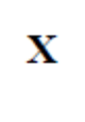 | 2+2
 |  | F1 | 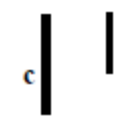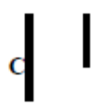 | 2+2
 |  | Sex | Female Female Male Male
 |  | Vision | Colour blind Normal Colour blind Normal  [accept carrier] | 4(2)

2007 HL Q6
6.
 | (a) | Xylem | 2
 | (b) | A = vessel B = tracheid | 2(6)
 | (c) | Lignin | 2
 | (d) | vascular bundle or next to phloem | 2
 | (e) | phloem [allow animal example] | 2

2007 HL Q7
7.
 | (a) | (i) | biological or organic or metabolic or protein catalyst or explained | 3
 |  | (ii) | keratin or myosin or other correct | 3
 | (b) | (i) | name of enzyme | 3
 |  | (ii) | name of matching substrate | 3
 |  | (iii) | pH or substrate concentration or enzyme concentration [allow amount] | 3
 |  | (iv) | buffer or same volume or same amount | 3
 |  | (v) | water baths or described or water bath at different temperatures or  described | 3
 |  | (vi) | time / change e.g. colour, foam, etc  or data logger / sensor named | 2(3)
 |  | (vii) | activity varies with temperature or reference to activity at a particular temperature | 3

2007 HL Q8
8.
 | (a) | (i) | Rhizopus or other | 3
 |  | (ii) | multicellular or mode of reproduction or size or structure | 3
 | (b) | (i) | material [or described] supplying food or material allowing growth | 3
 |  | (ii) | (malt) agar | 3
 |  | (iii) | free of (micro)organisms | 3
 |  | (iv) | cut leaves / attach to lid / how attached / sealed dish / invert / incubate / any aseptic technique / control described | 4(3)
 |  | (v) | pink (colonies) or if negative, result must be qualified | 3

2007 HL Q9
9.
 | (a) | (i) | supplies carbon or correct comment related to CO₂ | 3
 |  | (ii) | supplies hydrogen or protons (H⁺) or electrons or photolysis or described [allow formation of carbohydrate or named once] | 3
 | (b) | (i) | Elodea or other correctly named aquatic plant | 3
 |  | (ii) | lamp distance or wattage or quantity of NaHCO₃ | 3
 |  | (iii) | carbon dioxide or light or temperature | 3
 |  | (iv) | water bath or described or lamp distance or wattage or NaHCO₃ | 3
 |  | (v) | bubbles or volume / time  or data logger / sensor named | 2(3)
 |  | (vi) | vertical axis labelled rate + horizontal axis labelled [light or CO₂]  curve matching axes labels | 3  3

2007 HL Q10
10. | (a) | (i) | 1. adenine*  2. guanine* | 2(3)
 |  | (ii) | hydrogen (bonding) | 3
 | (b) | (i) | examining DNA / for a pattern or band / to compare | 2(3)
 |  | (ii) | DNA extracted or explained / DNA cut into fragments / using enzymes /  fragments separated / on basis of size / pattern analysed | 4(3)
 |  | (iii) | forensic science or explained / relationships or explained / medical or  explained | 2(3)
 |  | (iv) | to establish presence or absence of gene(s) | 3
 | (c) | (i) | chromosome contains DNA  mitosis maintains same chromosome number or cells derived from mitotic division | 3  3
 |  | (ii) | gamete or sex cell or named | 3
 |  | (iii) | chop plant into small pieces / add salt / add detergent / warm to 50 – 60 degrees / then cool / blend / any one correct time point / filter / add protease / add cold ethanol | 5(3)

2007 HL Q11
11. | (a) | (i) | Adenosine Triphosphate | 3
 |  | (ii) | stores or provides or described / energy | 2(3)
 | (b) | (i) | glycolysis* | 3
 |  | (ii) | cytoplasm* or cytosol | 3
 |  | (iii) | pyruvate* or pyruvic acid | 3
 |  | (iv) | no* | 3
 |  | (v) | lactic acid or ethanol | 3
 |  | (vi) | (begins with) acetyl co-enzyme A / Krebs cycle / release of carbon dioxide / H release / transport system / ATP formed / O₂ required / H₂O produced | 4(3)
 | (c) | (i) | attached or fixed or trapped / how or explained | 2(3)
 |  | (ii) | (calcium or sodium) alginate or other correct | 3
 |  | (iii) | enzyme can be reused / can be recovered / pure product / comment on cost or efficiency or stability or longer lasting | 2(3)
 |  | (iv) | enzyme name [allow yeast]  matching substrate name  matching product name or appplication | 3  3  3

2007 HL Q12
12. | (a) |  | niche: – role of organism or explained  edaphic factor: – soil factor  symbiosis: – (close) relationship between two species involving benefit | 3  3  3
 | (b) | (i) | to make (nitrogen) available or described / for use by organisms or described | 2(3)
 |  | (ii) | N₂ converted to compound or named | 3
 |  | (iii) | ammonia to nitrites or to nitrates or nitrites to nitrates | 3
 |  | (iv) | fixation / lightning / plant protein / animal protein / death or excretion / decomposition / ammonia produced / ammonia to nitrites / one role of bacteria / denitrification or explained | 5(3)
 | (c) | (i) | predator* | 3
 |  | (ii) | prey* | 3
 |  | (iii) | starvation or death / migration / decline in population / change food source/ [allow increased competition] | 2(3)
 |  | (iv) | famine or food availability / birth control / war / disease / birth rate / death rate or longevity / degree of medical care / natural disaster or example | 4(3)

2007 HL Q13
13. | (a) | (i) | pulmonary vein* | 3
 |  | (ii) | oxygen*  by (oxy)haemoglobin or by iron | 3  3
 | (b) | (i) | diagram [trachea, bronchus, alveoli, diaphragm or ribs]  [any one missing 3 marks]  labels [trachea, bronchus, lung] | 6, 3. 0  3(1)
 |  | (ii) | epiglottis: to close off trachea or described  larynx: to make sound | 3  3
 |  | (iii) | diaphragm contracts / lowers / intercostal muscles contract / rib cage up/ #volume of chest (cavity) increased / #decreased pressure / air in / to equalise pressure [# points compulsory] | #2(3)  2(3)
 | (c) | (i) | capillary network / moist surface / thin walled / elastic wall  [allow large surface area or one cell thick or thin membrane] | 3(3)
 |  | (ii) | diffusion or passive transport | 3
 |  | (iii) | asthma or bronchitis | 3
 |  | (iv) | 1. cause:  2. prevention:  3. treatment: | 3  3  3

2007 HL Q14(a)
14. | Any two of (a), (b) or (c).
 | (a) | (i) | ovule* | 3
 |  | (ii) | cotyledon / endosperm | 2(3)
 |  | (iii) | radicle / plumule  develops root / develops shoot | 2(3)  2(3)
 |  | (iv) | when it does not germinate (despite favourable conditions) or period of low metabolism or explained | 3
 |  | (v) | germination at suitable time / time for embryo to develop / survival of  plant during unfavourable conditions / increased dispersal | 2(3)

2007 HL Q14(b)

 | (b) | (i) | obligate parasite or explained / non-cellular / can be crystallised / no  metabolism / one nucleic acid | 2(3)
 |  | (ii) | DNA or RNA or nucleic acid / protein | 2(3)
 |  | (iii) | smallpox / chicken pox / measles / polio / ‘flu / common cold / leaf  mosaic / others [allow AIDS or HIV] | 2(3)
 |  | (iv) | bacteriophage or used in genetic engineering or vaccine production or  vector (in disease treatment) | 3
 |  | (v) | substance produced by micro-organisms / that kills (some) microorganisms or bacteria or fungi | 2(3)
 |  | (vi) | (antibiotics) have no effect (on viruses) or promote resistant bacteria | 3

2007 HL Q14(c)

 | (c) | (i) | resistance to infection or to antigens [allow disease] | 3
 |  | (ii) | recognition / produce antibodies / specific to antigens or in response to  antigens [allow memory cells] | 2(3)
 |  | (iii) | active immunity: body produces antibodies  passive immunity: antibodies introduced to body | 3  3
 |  | (iv) | vaccination introduces antigen or explained / causes antibody production | 2(3)
 |  | (v) | - passive*  - infection may already have occurred or possibility of dangerous infection or example or no vaccine available or vaccine too expensive  - short | 3  3  3

2007 HL Q15(a)
15. | Any two of (a), (b) or (c).
 | (a) | (i) | diagram [penis, urethra, sperm duct, testis]  labels | 6, 3, 0  6(1)
 |  | (ii) | X on testis | 3
 |  | (iii) | Y on epididymis | 3
 |  | (iv) | growth / development of primary sex characteristics or example /  development of secondary sex characteristics or example / sperm  production / comment on male behaviour | 2(3)
 |  | (v) | low sperm count or low sperm motility or hormonal imbalance or  explained or named chemical or smoking or drug abuse or erectile  dysfunction [accept unsuitable temperature (of testes) or cause described]  corrective measure matched | 3  3

2007 HL Q15(b)
 | (b) | (i) | ductless or secretes into blood stream | 3
 |  | (ii) | chemical transmission / slower action / longer lasting effect / many target organs | 2(3)
 |  | (iii) |  | 8(2)
  Endocrine Gland | Location | Hormone | Role of Hormone
  Islets of  Langerhans |  |  | regulates blood sugar or explained
   | neck or described | thyroxine | growth in young or (rate of) metabolism
  adrenal | on kidney | adrenalin(e)
 |  | (iv) | Named hormone:  1. deficiency symptom:  2. corrective measure: | 1  2  2

2007 HL Q15(c)
 | (c) | (i) | Homeostasis: maintenance / of constant internal environment or two  named factors constant  Reason: allows normal metabolic activities or example or keeps  temperature suitable for enzyme reactions | 2(3)  3
 |  | (ii) | diagram [top layer, hair follicle or sweat gland + 1 other]  labels [sweat gland, hair, arteriole, fat]  [allow temperature receptor] | 3, 0  2+1
 |  | (iii) | temperature drop / hair erects / traps air as insulator [or opposite]  or temperature drop / arteriole constricts / keeps heat [or opposite]  or temperature rises / sweat produced / sweat evaporates causing cooling or fat / insulates / from outside or inside | 3(3)
 |  | (iv) | body temperature varies / with environmental temperature  [allow ‘cold-blooded’ or explained for 3 marks] | 2(3)

2007 OL Q1
1. | any four |  | 4(5)
 | (a) | Oxygen
 | (b) | B or C
 | (c) | iodine or potassium iodide
 | (d) | water [allow cytoplasm or cytosol or plasmosol]
 | (e) | glycerol

2007 OL Q2
2. |  |  | 4(5)
biosphere |  | All parts of the earth and its atmosphere where life exists
ecosystem |  | A community of organisms and their environment
niche |  | The role of an organism in an ecosystem
habitat |  | Place where an organism lives

2007 OL Q3
3. |  |  | 5(4)
 | (a) | F
 | (b) | T
 | (c) | T
 | (d) | T
 | (e) | T

2007 OL Q4
4. |  |  | 5(4)
 | (a) | inheritance or heredity or chromosomes or genes or DNA
 | (b) | XY
 | (c) | 23
 | (d) | RNA
 | (e) | mutation [allow genetic engineering]

2007 OL Q5
5. |  |  | 6(3)+2
 | (a) | B = flower or named part of flower [allow leaf]  C = shoot or stem  E = fruit or tomato
 | (b) | A – photosynthesis or transpiration or gas exchange [allow storage of food or release of waste products]  D – anchorage or support or absorption of water or absorption of minerals or storage or reproduction
 | (c) | reproduction or seed dispersal [allow attract animals or food for animals]
 | (d) | xylem or vascular tissue[allow phloem]

2007 OL Q6
6. |  |  | 5(4)
 | (a) | ligament [allow capsule]
 | (b) | holds bones together [allow retains fluid]
 | (c) | cartilage
 | (d) | synovial
 | (e) | lubrication or shock absorption or protection

2007 OL Q7
7.
 | (a) | (i) | Protein | 3
 |  | (ii) | Ribosome | 3
 | (b) | (i) | name of enzyme | 6
 |  | (ii) | name of substrate [must match enzyme] | 3
 |  | (iii) | water bath or ice or thermostat | 3
 |  | (iv) | Buffer | 3
 |  | (v) | time / change (colour, height of foam, etc.)  OR  sensor / data logger | 2(3)
 |  | (Vi) | activity increases or enzyme has an optimum or graph showing increase | 3

2007 OL Q8
8.
 | (a) | (i) | growth or maintenance or repair or enzymes or antibodies or hormones [allow energy] | 3
 |  | (ii) | Nitrogen | 3
 | (b) | (i) | names of foods [allow any two substances containing protein] | 2(3)
 |  | (ii) | biuret (NaOH or KOH and copper sulphate) or other correct test  [allow 3 marks for one chemical] | 6
 |  | (iii) | No | 3
 |  | (iv) | Blue | 3
 |  | (v) | purple or violet | 3
 |  | (vi) | no | 3

2007 OL Q9
9.
 | (a) | (i) | quantity or number or amount or frequency or percentage | 3
 |  | (ii) | a square or (unit) area [allow diagram] | 3
 | (b) | (i) | random location or explained (e.g. throwing implies randomness)  counted or observed presence or absence or measured cover | 6  3
 |  | (ii) | more accurate or reduce error | 3
 |  | (iii) | key or diagrams or photos or reference to characteristic such as colour or shape | 3
 |  | (iv) | map or table or chart or report | 3
 |  | (v) | Yes or No  Yes if animal is sessile or slow moving  No if animal moves too fast or is too big  [if answer is No, accept alternative method for quantitative study of animals] | 3  3

2007 OL Q10
10.
 | (a) | (i) | sun [allow light] | 6
 |  | (ii) | Photosynthesis | 3
 | (b) | (i) | seaweed or plant plankton | 3
 |  | (ii) | plant plankton | 3
 |  | (iii) | mussels or fish | 3
 |  | (iv) | eat plants or are herbivores | 3
 |  | (v) | seaweed – periwinkles – crabs – fish or birds  plant plankton – animal plankton – mussels - birds  plant plankton – animal plankton – fish – seals or birds  [allow 6 marks for a correct food chain from another ecosystem] | 4(3)
 | (c) | (i) | name of ecosystem | 3
 |  | (ii) | name of animal  matching method (e.g. traps, nets, by hand, etc.) | 3  3
 |  | (iii) | description of adaptation of named organism (structural or behavioural) | 3
 |  | (iv) | environmental or non-living | 3
 |  | (v) | two abiotic factors | 2(3)
 |  | (vi) | how each measured | 2(3)

2007 OL Q11
11.
 | (a) | (i) | cells which have the same function or specialised cells | 3
 |  | (ii) | names of two tissues | 2(3)
 | (b) | (i) | growing cells or tissue (in a laboratory or in sterile conditions) | 6
 |  | (ii) | oxygen or air | 3
 |  | (iii) | 37 ⁰C (plus or minus 2 degrees) or body temperature | 6
 |  | (iv) | to prevent bacterial growth or contamination | 3
 |  | (v) | mitosis | 3
 |  | (vi) | plant breeding or micropropagation or cancer research or antibodies  [allow stem cells or cloning] | 3
 | (c) | (i) | unit or particle of heredity or code for protein or section of DNA | 3
 |  | (ii) | on a chromosome | 3
 |  | (iii) | allele – a form of a gene or example (e.g. B and b)  dominant – masks recessive allele or expressed in heterozygous condition or explained | 3  3
 |  | (iv) | Punnet square with all gametes  Genotypes: BB, Bb, bb  Phenotypes: brown and blue  association of any one genotype with correct phenotype | 3  3(2)  4  2
   | B | B
  B | BB | Bb
  b | Bb | Bb

2007 OL Q12
12.
 | (a) | (i) | release of energy/ from food or basic equation  (carbohydrate or named + oxygen/ carbon dioxide + water + energy) | 2(3)
 |  | (ii) | (aerobic respiration) needs oxygen or (anaerobic respiration) does not need oxygen | 3
 | (b) | (i) |  | 2(3)  3  2(3)
  Type of respiration | Energy Source | End products
  Aerobic respiration | Glucose | carbon dioxide/ water / ATP
  Anaerobic respiration in muscle | Glucose | lactic acid
  Anaerobic respiration by yeast | Glucose | alcohol/ carbon dioxide/ATP
 |  | (ii) | cytoplasm or cytosol | 3
 |  | (iii) | mitochondrion | 3
 |  | (iv) | stage 2 [allow aerobic] | 3
 | (c) | (i) | diagram (glass container, anaerobic method, solution)  [one missing 3 marks, two missing 0 marks]  labels | 6, 3, 0  3(2)
 |  | (ii) | to remove oxygen or air or to sterilise water or to prevent yeast death or to prevent enzyme denaturation | 3
 |  | (iii) | layer of oil or fermentation trap | 3
 |  | (iv) | reagent/ condition (heat or acidification) / result | 6+3

2007 OL Q13
13.
 | (a) | (i) | capsule or slime layer or mucilage  protection | 3  3
 |  | (ii) | flagellum or plasmid | 3
 | (b) | (i) | autotrophic nutrition – makes own food  heterotrophic – uses food already made (made by other organisms) | 3  3
 |  | (ii) | feed on dead matter | 3
 |  | (iii) | decompose dead organisms or recycle nutrients | 3
 |  | (iv) | obtain energy (make food) from chemical reactions | 3
 |  | (v) | host | 3
 |  | (vi) | TB/ syphilis/ cholera/ tetanus/ sore throat/ names of bacteria/ etc. | 2(3)
 | (c) | (i) | diagram (stolon, rhizoid, sporangiophore)  [one missing, 3 marks only]  labels | 6, 3, 0  3(2)
 |  | (ii) | sporangiophores grow upwards/ sporangium formed/ haploid/ spores produced/ dries up/ splits/ spores released/lands on substrate/ germinates to produce hypha | 3(2)
 |  | (iii) | A = gametangium B = zygospore [allow zygote or cyst] | 2(3)
 |  | (iv) | withstands unsuitable conditions or remains dormant or dispersal  or reproduction or survival or prevents desiccation | 3

2007 OL Q14(a)
14. | any two of (a), (b), (c). |  |  | 2(30)
 | (a) |  |  | 3(6)+6(2)
 |  | (i) | between dermal and vascular or in cortex or filling or packing (tissue)
 |  | (ii) | stores food or carries out photosynthesis or stores waste or gives support or strength or allows movement of water or gas
 |  | (iii) | region of mitosis or of cell division or of growth or dividing tissue
 |  | (iv) | root tip or shoot tip or vascular bundle or bud or under bark
 |  | (v) | root  shape of xylem/ root hairs/ single or central vascular bundle | any two
 |  | (vi) | X/ Y in correct positions

2007 OL Q14(b)
 | (b) |  |  | 6+2(5)+7(2)
 |  | (i) | getting rid of waste products
 |  | (ii) | carbon dioxide/ urine (urea or uric acid or urate)/ water/ sweat/ bile/ salt | any two
 |  | (iii) | skin or lungs or liver
 |  | (iv) | balancing salt or water concentration
 |  | (v) | 1. cortex [allow Bowman’s capsule]  2. medulla [allow cortex or Loop of Henle or convoluted tubule]  3. bladder  4. aorta
 |  | (vi) | urine [allow water]

2007 OL Q14(c)
 | (c) |  |  | 3(6)+6(2)
 |  | (i) | D
 |  | (ii) | pollination – transfer of pollen  fertilisation – fusion of gametes or of sex cells  [allow fusion of egg and sperm or of “pollen” and egg cell]
 |  | (iii) | endosperm or cotyledon or seed leaf
 |  | (iv) | growth / of embryo plant or of seed
 |  | (v) | oxygen/ water/ suitable temperature or warmth [allow light]

2007 OL Q15(a)
15. | any two of (a), (b), (c). |  |  |  | 2(30)
 | (a) |  |  |  | 6+2(5)+7(2)
 |  | (i) | sensory or receptor/ inter-or relay or connector/ motor or effector
 |  | (ii) | A → B → C
 |  | (iii) | synaptic cleft or synapse
 |  | (iv) | to carry impulse/ across gap
 |  | (v) | example of action  example of reaction
 |  | (vi) | fast response or defence against injury

2007 OL Q15(b)
 | (b) |  |  | 6, 3, 0 for diagram  + 2(6)+4(3)
 |  | (i) | diagram (epidermis or cuticle, rectangular cells, air spaces)  labels (stoma, guard cell)
 |  | (ii) | controls stomatal size [allow controls passage of gas or water vapour]
 |  | (iii) | carbon dioxide/ oxygen/ nitrogen/ water vapour  [allow maximum of 3 marks if air alone mentioned] |  | any two
 |  | (iv) | diffusion or passive transport

2007 OL Q15(c)
 | (c) |  |  |  | 6+2(5)+7(2)
 |  | (i)
  Stomach | an organ for churning of food to chime
  Peristalsis | waves of contractions passing along the gut
  Molar teeth | grind food into smaller pieces
  Lipase | an enzyme that turns fats to fatty acids and glycerol
  Bile salts | emulsify fats
  Symbiotic bacteria | produce vitamins
 |  | (ii) | absorption/ villi/ protein (or polypeptides or peptides or name protein or source of protein)/ carbohydrates (polysaccharides or disaccharides or sugar or named carbohydrate or source of carbohydrate)

2008 HL Q1
1. |  | 5(4) any FIVE points out of SEVEN
 | (a) | Carbohydrate or sugar or saccharide
 | (b) | solvent / transport / support / reaction medium/reactant / turgidity /  reference to changing concentration / movement of sperm / temperature  function or example
 | (c) | Catabolic
 | (d) | (fats are) solid or oils are liquid
 | (e) | Biuret or (sodium) hydroxide and copper sulfate or correct formulas
 | (f) | Cellulose

2008 HL Q2
2. | (a) | Interphase | 2
 | (b) | uncoiling / transcription / replication or duplication | 2(2)
 | (c) | Prophase / metaphase / anaphase/ telophase  correct order showing all four | 4(1)  4
 | (d) | anaphase or 3 stage | 2
 | (e) | Chromosomes in pairs (two sets of chromosomes) | 2
 | (f) | Cancer or named group of cancers or tumour | 2

2008 HL Q3
3. |  | 3(1) + 3(4) + 5
 | (a) | Hypothesis
 |  | Experiments
 |  | data or information or findings or outcomes
 | (b) | for comparison or reference to (biological) variability
 | (c) | no herbicide or implied
 | (d) | repeat of experiment
 | (e) | (scientific) journal or named journal [accept Internet]

2008 HL Q4
4. | (a) | A = myelin sheath or Schwann cell B = myelin sheath or axon  C = dendrite | 3(1)
 | (b) | A: (myelin sheath) insulates or protection or speeds up impulse (message)
 |  | A: (schwann cell) produces myelin (or sheath) or insulates or protection or  speeds up impulse (message) | 3
 | (c) | arrow (right to left) or from dendrites towards cell body | 3
 | (d) | receives impulse or carries impulse (message) to cell body | 3
 | (e) | X on terminal dendrites on left | 3
 | (f) | receive or carry impulse (message) and to muscle or gland or effector or  from CNS | 5,0

2008 HL Q5
5. |  | 6(3) + 2
 | (a) | C6H12O6 + 6O2 → 6CO2 + 6H2O (+energy)
 | (b) | cytoplasm minus organelles (or structures or particles) or liquid part of  cytoplasm
 | (c) | Small
 | (d) | anaerobic respiration or respiration that produces alcohol or respiration  that produces lactic acid
 | (e) | Mitochondrion
 | (f) | Yes
 | (g) | lack of oxygen or exercise or restricted blood supply

2008 HL Q6
6. | (a) | A = ovary  B = Fallopian tube (oviduct)  C = uterus (womb) | 3(2)
 | (b) | locations of X, Y, Z | 3(2)
 | (c) | Ovary or A or follicle | 2
 | (d) | (transfer of) antibodies / balanced diet / bonding / contraception / correct  temperature/ milk sterile / uterus recovers more quickly / reduced cancer  risk / psychological wellbeing | 2(3)

2008 HL Q7
7. | (a) | (i) | (place) where organism (or species) lives | 3
 |  | (ii) | organisms and their environment | 3
 | (b) | name of ecosystem: |  | 3
 |  | (i) | any three abiotic factors | 3(1)
 |  | (ii) | how investigated (what used or how) | 3(3)
 |  | (iii) | organism name matching ecosystem  adaptation feature matching organism | 3  3
 |  | (iv) | benefit | 3

2008 HL Q8
8. | (a) | (i) | auxin or IAA or NAA or ethylene (ethene) | 3
 |  | (ii) | auxin or IAA or NAA or abscisic acid or ethylene (ethene) | 3
 | (b) | (i) | name of plant | 3
 |  | (ii) | investigative procedure:  different concentrations / add regulator to / part of plant / how added /  replicates described / control described / suitable time reference | 4(3)
 |  | (iii) | safety precaution | 3
 |  | (iv) | result of experiment and result of control or  result of two different concentrations (or plant parts) | 6,0

2008 HL Q9
9. | (a) | (i) | (pH at which enzyme) works best | 3
 |  | (ii) | Loss of (enzyme) function (or activity) | 3
 | (b) | (i) | name of enzyme | 3
 |  | (ii) | name of substrate (must match if enzyme named) | 3
 |  | (iii) | how activity measured (must match enzyme or match substrate)  other procedures:  how heated / how long / addition (of or to substrate) / control described / suitable condition or example (for both experiment and control) | 3  3(3)
 |  | (iv) | Result of experiment and result of control | 6,0

2008 HL Q10
10. | (a) | (i) | struggle between organisms (animals or plants) for resource or for named resource (in short supply) | 3
 |  | (ii) | (contest) - one organism loses the resource and (scramble) - each organism gets some of resource | 6
 | (b) | (i) | B  smaller numbers or B peak occurs after A peak | 3  3
 |  | (ii) | predator-prey (relationship) or predation | 3
 |  | (iii) | reduced competition / predator eliminated or reduced / food available / development of resistance (to pesticide) / immigration | 2(3)
 |  | (iv) | biological control or genetically modified (GM) plant or example or crop rotation or example | 3
 |  | (v) | Pyramid:  strawberry plants at base  cyclamen mites and carnivorous mites in correct order and shape | 3  3
 |  | (vi) | disease or parasitism or food availability or pollution or other valid named factor | 3
 | (c) | (i) | disease / pollution / toxins / smell / unsightly / other valid named problem | 3(3)
 |  | (ii) | waste described or named  matched management described | 3  3
 |  | (iii) | reduce consumption / reduce packaging / recycle / reuse | 2(3)
 |  | (iv) | landfill sites / sewage treatment plants / digesters / compost heaps | 3

2008 HL Q11
11. | (a) |  | homozygous:  recessive:  phenotype: | identical alleles [accept identical genes]  allele whose expression is masked by dominant allele  physical appearance or expression of genotype  or result of genotype + environment | 3  3  3
 | (b) | (i) | * GgLl / Ggll / ggLl / ggll  grey, long / grey, vestigial / ebony, long /ebony, vestigial |  | 4(3)  4(3)
 |  | (ii) | they assort independently or greater variation |  | 3
 | (c) | (i) | located on sex- chromosome or on X- chromosome or on Y-chromosome |  | 4
 |  | (ii) | * X^{N}X^{n} / X^{n}X^{n} / X^{N}Y / ^{n}X  Y  normal (carrier) female/haemophilic female/ normal male/haemophilic male |  | 4(3)  4(2)

2008 HL Q12
12. | (a) | (i) | mechanical:  physical or grinding or cutting or churning or chewing or emulsifying  chemical:  enzyme or acidic action or molecular breakdown | 3  3
 |  | (ii) | tongue or oesophagus or stomach or small intestine or named part of small intestine | 3
 | (b) | (i) | A = oesophagus B = stomach C = small intestine or ileum  D = rectum E = appendix F = large intestine or colon | 6(2)
 |  | (ii) | emulsification or explained  neutralisation or raises pH or makes alkaline | 3  3
 |  | (iii) | 1. pancreas [allow duodenum]  2. duodenum or small intestine or ileum  3. 7 - 9 inclusive | 3  3  3
 | (c) | (i) | (bacteria that) live in (or on) another organism involving benefit | 6
 |  | (ii) | digestion / production of vitamins / benefit immune system / compete with other micro-organisms [allow one reference to harmful activity] | 2(3)
 |  | (iii) | 1. ileum or villi [allow duodenum or small intestine]  2. Colon [allow any named part from stomach onwards] | 3  3
 |  | (iv) | diffusion or passive transport | 3
 |  | (v) | large surface area (folding) or good blood supply or lymph supply or  (lining) one cell thick or long or villi or microvilli | 3

2008 HL Q13
13. | (a) | (i) | elimination of waste products of metabolism or explained |  | 3
 |  | (ii) | Urea:  carbon dioxide: | protein or amino acid  carbohydrate or named example or fat or named  example of fat or fatty acids | 3  3
 | (b) | (i) | A = arteriole B = Bowman's capsule C = proximal tubule  D = Loop of Henle E = collecting duct F = distal tubule or Loop of Henle |  | 6(1)
 |  | (ii) | renal artery or renal arteriole |  | 3
 |  | (iii) | *cortex |  | 3
 |  | (iv) | 1. Bowman's capsule or glomerulus or B  2. proximal tubule or C |  | 3  3
 |  | (v) | large surface area / porous capillary walls/ (lining) one cell thick / efferent arteriole narrower than afferent arteriole or arterioles in arteriole out or  arteriole to capillary network  NB not more than one arteriole point. |  | 2(3)
 |  | (vi) | proteins or named group of proteins |  | 3
 | (c) | (i) | infection / hot conditions or perspiration or exercise / high salt intake / low water intake / diuretic(s) |  | 2(3)
 |  | (ii) | *ADH (vasopressin)  *pituitary |  | 3  3
 |  | (iii) | distal tubule or collecting duct  in the blood |  | 3  3
 |  | (iv) | (makes walls) more permeable (resulting in) more absorption of water |  | 6

2008 HL Q14(a)
14. | Any two of (a), (b), (c) |  |  | (30, 30)
 | (a) | (i) | Stomata  light or CO2 or potassium ions (K) or wind or turgidity of guard  cells or water availability or high temperature | 3  3
 |  | (ii) | 1. water  2. light (dependent) stage  3. respiration  3. (diffuses) to atmosphere | 3  3  3  3
 |  | (iii) | 1. provides or stores energy / reduction of CO2 or glucose  formation or for dark stage  2. accepts electrons / hydrogen carrier / for the dark stage or  glucose formation or for dark stage | 2(3)  2(3)

2008 HL Q14(b)
 | (b) | (i) | Diagram  labels: deoxyribose or ribose, phosphate, base or named base | 3  3(2)
 |  | (ii) | Base or named base | 3
 |  | (iii) | three bases (triplet or codon) / in sequence / (codes for) one amino  acid /(base or triplet or codon) sequence / codes for protein | 3(3)
 |  | (iv) | does not code for a protein or for RNA  [allow not part of the genetic code or explained] | 3
 |  | (v) | (DNA) contains thymine or RNA contains uracil | 3
 |  | (vi) | Mitochondrion or chloroplast | 3

2008 HL Q14(c)
 | (c) | (i) | Diagram  Labels: dermal tissue, ground tissue, vascular tissue [accept xylem or  phloem for vascular] | 3,0  3(2)
 |  | (ii) | lower water concentration or higher solute concentration | 3
 |  | (iii) | movement of water (solvent) / along concentration gradient / through  a selectively permeable membrane | 2(3)
 |  | (iv) | membrane or plant tissue / 2 solutions indicated / different concentrations / result | 3(3)
 |  | (v) | diffusion or passive transport | 3

2008 HL Q15(a)
15. | Any two of (a), (b), (c) |  |  | (30, 30)
 | (a) | (i) | support / movement / protection / anchorage for muscle / gives shape /  blood production | 3(3)
 |  | (ii) | vertebral column and skull (and rib cage) | 3
 |  | (iii) | 1. formation of blood cells  2. protection (absorbs shock) or reduces friction or allows bone  elongation  3. joins muscle to bone | 3  3  3
 |  | (iv) | pair of muscles that have opposite effects or explained  biceps and triceps or other example | 3  3
 |  | (v) | treatment of named disorder | 3

2008 HL Q15(b)
 | (b) | (i) | no immunity in population / suitable vectors (e.g. fleas) / rapid spread  or high population | 2(3)
 |  | (ii) | natural immunity or Natural Selection or virus mutated | 3
 |  | (iii) | advantage:  environmentally friendly or specific or (may be) inexpensive  disadvantage:  upsets balance of nature (or described e.g. predator population will  fall when prey becomes scarce allowing prey to increase again or  introduced species may become a pest or predator may change to a  different prey) or (may be) expensive.  [Note: allow only one cost point] | 3  3
 |  | (iv) | Yes + plausible answer or No + plausible answer | 6
 |  | (v) | attaches to (host) cell / introduces nucleic acid (DNA or RNA) /  (host) DNA inactivated / viral DNA or RNA replicated / using  resources of host cell / protein coat formed / assembly (of virus) | 3(3)

2008 HL Q15(c)
 | (c) | (i) | A = population (size) of or number (of bacteria)  B = time | 3  3
 |  | (ii) | X = lag (phase)  adapting to environment or low reproductive rate | 3  3
 |  | (iii) | log or exponential (phase)  reproducing rapidly | 3  3
 |  | (iv) | curve showing flattening or falling  reproduction slows or some limiting factor mentioned or toxin builds  up or space limitations | 3  3
 |  | (v) | (batch) fixed amount of nutrients added at beginning or (bioreactor)  emptied at end of production and (continuous) nutrients continuously  fed into bioreactor or product removed continuously | 6

2008 OL Q1
1. |  | Answer any four |  | 2(7)+2(3)
 | (a) | caterpillar
 | (b) | decrease
 | (c) | Producer / food for caterpillar / 1st trophic level / Plant / Autotroph
 | (d) | blue tit/ sparrow hawk
 | (e) | Energy / food

2008 OL Q2
2. |  |  |  | 2(7)+2(3)
 |  | Column A | Column B
 |  | A protein present in blood | Haemoglobin
 |  | An element always present in proteins along with C H O | Nitrogen
 |  | A protein which changes reaction rates | Enzyme
 |  | The end product of protein digestion | amino acid
 |  | A structural protein | Keratin /  Haemoglobin

2008 OL Q3
3. |  |  |  | 2(7)+3+2+1
 | (a) | Stage 1 of respiration requires oxygen | F
 | (b) | Stage 1 of respiration takes place in the cytoplasm | T
 | (c) | Stage 2 of respiration also takes place in the cytoplasm | F
 | (d) | Some of the energy released in respiration is lost as heat | T
 | (e) | Lactic acid is a product of anaerobic respiration | T

2008 OL Q4
4. |  |  |  | 2(7)+3+2+1
 | (a) | Aorta
 | (b) | Oxygenated (watch follow on)
 | (c) | Ventricle
 | (d) | pumps further/ maintains blood pressure / greater activity
 | (e) | stops back flow (of blood) / blood from atrium to ventricle

2008 OL Q5
5. |  |  |  | 2(7)+3+2+1
 | (a) | adenine/ cytosine
 | (b) | triplet/codon / (part of) a gene / genotype [allow nucleotide]
 | (c) | nucleus/ chromosome (allow gene)
 | (d) | Gene / genetic (allow any term implying inheritance)

2008 OL Q6
6. |  |  |  | 2(7)+3+2+1
 | (a) | A = hair B = muscle
 | (b) | Location of X (opening of sweat duct)
 | (c) | urea/ salt/ named salt/ lipids/ hormones
 | (d) | (erect) hair / hair traps air/ arteriole contracts (and keeps  blood warm) / pores close / adipose (tissue)/Goose pimples

2008 OL Q7
7. | (a) |  |  | 5, 1
 |  | (i) | free from (micro)organisms or living things or named  organism
 |  | (ii) | autoclave/ heat qualified e.g. high or 100oC / boiling / steam / any anti-bacteria agent or named / U.V light
 | (b) |  |  | 4(5)+2(2)
 |  | (i) | Petri dish / (agar) plate
 |  | (ii) | (nutrient / malt) agar / (Allow ‘nutrients ‘ and ‘jelly’’)
 |  | (iii) | sterilise cork borer/ cut / pieces of leaf or (full) leaf/ use sterile forceps/ attach upper surface of leaf / to petroleum jelly on inside of lid /any one safety precaution | Any two
 |  | (iv) | (More than 2) days or 24 hours
 |  | (v) | pink or dots or reference to distribution

2008 OL Q8
8. | (a) |  |  | 5, 1
 |  | (i) | Any correct anatomical reference
 |  | (ii) | Any correct anatomical reference
 | (b) |  |  | 4(5)+4
 |  | (i) | Comparison /control / resting / normal / (breathing rate or pulse)
 |  | (ii) | Method described /count number of breaths or number of pulses /per unit time OR sensor (data logger)
 |  | (iii) | Exercise / description of exercise/ increased exercise/ breathing rate or pulse measured/ repeat/ average / compare / record / result | Any two
 |  | (iv) | Increases / comment on return to normal / different

2008 OL Q9
9. | (a) |  |  | 5, 1
 |  | (i) | Growth
 |  | (ii) | Dormancy
 | (b) |  |  | 4(5)+2(2)
 |  | (i) | type of seed (monocot or dicot or gymnosperm or angiosperm))/ name of seed
 |  | (ii) | Provide suitable condition(s)
 |  | (iii) | anaerobic jar or other
 |  | (iv) | put in fridge or cold environment (accept freezer or oven)
 |  | (v) | i. All conditions – growth (mandatory point)  one of the following  i. no oxygen – no germination  ii. or low temperature – no germination  iii. or no moisture – no germination | Two pts –  Mandatory + one other

2008 OL Q10
10. | (a) |  |  | 6,3
 |  | (i) | Producing nitrogen compounds
 |  | (ii) | Bacteria / monera / Lichens/ Clover / Legumes
 | (b) |  |  | 7(3) + 6
 |  | (i) | name of ecosystem
 |  | (ii) | two habitats | Any two
 |  | (iii) | named animal
 |  |  | adaptation
 |  | (iv) | named plant
 |  |  | transect / quadrat/ random/ count or cover/ repeat / identify / record / average | Any two
 | (c) |  |  | 4(3) + 2(6)
 |  | (i) | harmful change (to environment ) or example
 |  | (ii) | Example (other or same explained)
 |  | (iii) | two ways of prevention or control | Any two
 |  | (iv) | waste produced/ must be disposed safely/ recycled / re-used / reduce / example of waste/ how managed/ role of micro-organisms | Any two

2008 OL Q11
11. | (a) |  |  | 6,3
 |  | (i) | structure found in nucleus/ reference to DNA or genes  or hereditary material
 |  | (ii) | n / 23 / half of diploid/ single set of chromosomes / contains one of each type or pair of chromosomes / reference to meiosis, gamete, sex cell
 | (b) |  |  | 9(3)
 |  | (i) | allele – a form of a gene/ types of gene / Bb
 |  |  | Dominant -prevents expression of recessive / Bb / stronger / always wins out when present
 |  | (ii) | Seán – brown  Máire – red
 |  | (iii) | 1. B, b  2. Bb bb | Two pts  Two pts
 |  | (iv) | 50% or 1 in 2
 | (c) |  |  | 4(3) + 2(6)
 |  | (i) | change / producing new organisms / example
 |  | (ii) | Darwin / Wallace
 |  | (iii) | organisms have variations/ that are inherited/ beneficial / will reproduce/ struggle for existence / pass on these variations / ‘Survival /of fittest’ / origin of species | Any two
 |  | (iv) | fossils/ comparative anatomy/ embryos/ DNA changes/ Horse / bones | Any two

2008 OL Q12
12. | (a) |  |  | 6, 3
 |  | (i) | Leaf
 |  | (ii) | Chloroplast / granum / Stroma
 | (b) |  |  | 9, 3
 |  | (i) | Light / sun
 |  | (ii) | Lack of oxygen/ lack of food (energy)/ plants die / excess CO2 / animals die
 |  | (iii) | 1. protons (Hydrogen (ions)) / electrons/ oxygen /OH-  (Water splits into H+ & OH- merits 3(3))  2. electrons pass to chlorophyll / ATP /  protons stored / NADPH / used in dark phase  oxygen released into air/ respiration  OH- to water & O2
 | (c) |  |  | 6 + 6(3)
 |  |  | Diagram of Apparatus  (Plant, variable, container)  type of plant or named plant/ control/ factor kept constant/ how variable altered/ how rate was measured / time / thermometer / water bath / adjust / bubbles / lamp / ruler/ result /conclusion / record / repeat / average | 6, 3, 0  Six pts – written  or labelled

2008 OL Q13
13. | (a) |  |  | 3(3)
 |  | (i) | 1. liver  2. gall bladder
 |  | (ii) | Duodenum / (small) intestine / ileum
 | (b) |  |  | 6(2) + 3(5)
 |  | (i) | A = oesophagus B = stomach C = small intestine/ileum/ jejunum  D = rectum E = appendix F = large intestine/ colon / Bowel
 |  | (ii) | push food along gut / mechanical digestion / prevents constipation
 |  | (iii) | Stomach / ileum / intestine /villi / (colon) / shoulder vein
 |  | (iv) | by diffusion (into villi ) / (allow both active transport & osmosis) / absorption
 | (c) |  |  | 8(3)
 |  | (i) | B = acidic C = alkaline
 |  | (ii) | starch  maltose | Two pts
 |  | (iii) | digest cellulose/ produce (release) vitamins/ keep harmful bacteria at bay / immunity (reference to health) / formation of faeces | Two pts
 |  | (iv) | getting rid of (undigested food waste)  D [watch a possible follow-on here from (b) (i) ] | Two pts

2008 OL Q14(a)
14. | Answer any two of (a), (b), (c). |  |  | (30, 30, )
 | (a) |  |  | 6(1) + 8(3)
 |  | (i) | A = anther/stamen/ androecium B = carpel / ovary / ovule / gynoecium C = sepal / calyx D = receptacle | Four pts
 |  | (ii) | A (watch for follow-on)
 |  | (iii) | Transfer/ of pollen/ (allow anther to stigma) | Two pts
 |  | (iv) | 1. brightly coloured petals / anthers within petals, nectaries,  2. feathery stigmas, anthers outside petals, petals absent or  reduced. | Three pts  Three pts
 |  | (v) | fertilisation

2008 OL Q14(b)
 | (b) |  |  | 3(1)+5(3)+2(6)
 |  | (i) | diagram  labels (iris, pupil)
 |  | (ii) | dim light  pupil large / Iris small (watch follow-on)
 |  | (iii) | back of the eye / (accept behind lens)
 |  | (iv) | rods/ cones | Two pts
 |  | (v) | rods - more numerous/ detect black and white / work in dim light/ found all over retina  cones – less numerous/ detect colours / work in bright light only/ found mostly in fovea  (Relate to original order) | Any one pt
 |  | (vi) | carries message to brain

2008 OL Q14(c)
 | (c) |  |  | 6 + 4(1)+4(5)
 |  | (i) | Diagram  (Diagram to show, Trachea, Bronchus & Lungs)  labels (larynx, trachea, bronchus, bronchiole) | 6, 3, 0  Labels - Four pts
 |  | (ii) | exchange gases/ carbon dioxide out/ oxygen in / increase surface area / diffusion
 |  | (iii) | name of breathing disorder  (Asthma, Pleurisy, Bronchitis, Cancer, Hay Fever, Cystic Fibrosis, pneumonia…)
 |  | (iv) | Possible cause  Treatment | Two points

2008 OL Q15(a)
15. | Answer any two of (a), (b), (c). |  |  | (30, 30, )
 | (a) |  |  | 10(3)
 |  | (i) | movement of water (essential point)  through semi-permeable membrane / from region of high osmotic potential to low osmotic potential / from high concentration of water to low concentration of water / from dilute solution to concentrated solution | One Pt  Any one of these pts
 |  | (ii) | Describe or show - apparatus/ type of membrane/ dilute solution or (distilled) water/ concentrated solution or tissue/ time period/ how change was observed / control | Four pts
 |  | (iii) | Vascular tissue / xylem
 |  | (iv) | tube-like shape/ narrow / hollow / pits in walls/strong walls / lignin
 |  | (v) | phloem  sugar / named sugar / sap / water / food | Two pts

2008 OL Q15(b)
 | (b) |  |  | 10(3)
 |  | (i) | a - blood without cells/ watery liquid part of blood  b - carries dissolved substances /named substance / waste /hormones /gases /blood clotting agent/ water / antibodies / proteins / inorganic salts / fibrinogen / CO2 / Bicarbonate / Heat
 |  | (ii) | a - red blood cell / carries oxygen (also carries carbon dioxide)  b - white blood cell / defence  c – (allow Platelet / Blood Clotting ) | Any two types + function
 |  | (iii) | A/ B/ AB/ O  [Four correct 9,Three correct 6, two correct 3 ]
 |  | (iv) | transfusion/ to avoid reaction by mother to foetus/ to prevent loss of foetus

2008 OL Q15(c)
 | (c)
 |  | (i) | Fungi | 3
 |  | (ii) | Diagram (Stolon, Sporangiophore, Sporangium  labels (Three) | 6, 3, 0  3(1)
 |  | (iii) | Diagram (Structure like H showing zygote)  labels or show - hyphae + and -/ gametangia/ gametes/ fuse/ zygote/ zygospore/ meiosois / germinates/ sporangium/ spores/ dispersal / new fungus | 6, 3, 0  Three pts 3(2)
 |  | (iv) | Beneficial example (name or benefit)  Harmful example (name or disease) | 3  3

2009 HL Q1
1. |  | 5(4) any FIVE points out of SIX
 | (a) | Hydrogen and Oxygen
 | (b) | (Made up of) many sugar units
 | (c) | Starch [accept other correct named]
 | (d) | Cell wall
 | (e) | Benedict's or Fehling's
 | (f) | 2. (Heat but do not boil)

2009 HL Q2
2. |  | 6(3) + 2
 | (a) | Radicle
 | (b) | Hydrotropism [accept geotropism]
 | (c) | Phototropism
 | (d) | Photosynthesis or described
 | (e) | Ethene or abscisic acid [accept other correct named]
 | (f) | Rooting powder / selective weedkiller / fruit ripening / seedless fruit /tissue culture (micro propagation) (ANY TWO)

2009 HL Q3
3. |  | 6(3) + 2
 | (a) | Killing (or catching) and eating another animal
 | (b) | Predator named
 |  | Its prey named
 | (c) | Organism's role in ecosystem or explained
 | (d) | Photosynthesis or protein synthesis
 | (e) | (To do with) soil
 | (f) | Particle size or soil type or pH or air content or water content or mineral  content or temperature or humus content

2009 HL Q4
4. | (a) | (i) | A = Head (epiphysis)  B = Shaft (diaphysis)  C = Spongy bone  D = Compact bone | 2  2  2  2
 |  | (ii) | Between the vertebrae | 3
 |  | (iii) | Shock absorption or friction-free movement or prevention of wear  and tear | 3
 | (b) | (i) | Fat storage or can convert to red marrow | 3
 |  | (ii) | Blood cell formation | 3

2009 HL Q5
5. |  | 6(3) + 2
 | (a) | Anaphase
 | (b) | Chromosomes separated or chromosomes near poles
 | (c) | A = Spindle (fibre)  B = Chromosome
 | (d) | Reproduction
 | (e) | Growth or (cell) replacement or repair or renewal or spore formation
 | (f) | Meristematic tissue or root tips or shoot tips or buds or ovule or embryo  sac or pollen

2009 HL Q6
6. |  | 6(3) + 2
 | (a) | Manipulation or alteration of genes or of genotypes
 | (b) | Isolation / cutting (or restriction) / transformation (or ligation) / introduction  of base sequence (changes) / expression | Any three
 | (c) | 1. Micro-organism example:  2. Animal example:  3. Plant example:

2009 HL Q7
7. | (a) | (i) | Two embryonic leaves or two seed leaves | 3
 |  | (ii) | Any dicot named | 3
 | (b) | (i) | (Cut) thin (section) / (cut) away from self / with blade or scalpel or  microtome / how transferred to slide / cover slip / how applied / (use  of) water | 3(3)
 |  | (ii) | (Slide) onto stage / lamp on or mirror / adjust (light) / start with low  power lens / how focused | 3(3)
 |  | (iii) | Diagram:  Labels: | 3, 0  3(1)

2009 HL Q8
8. | (a) | (i) | Growth of seed (or embryo part or of embryo) | 3
 |  | (ii) | To make (food) soluble or to make (food) transportable | 3
 | (b) | (i) | Petri dish containing a jelly (or solid medium) | 3
 |  | (ii) | Starch or milk | 3
 |  | (iii) | Soak (seeds) / split (seeds) / how sterilised correctly / position  (seeds) on agar / keep plate warm or stated temperature (max. 35°C) | 2(3)
 |  | (iv) | Boiled seeds | 3
 |  | (v) | Starch agar: Iodine (solution) or milk agar: biuret solution. | 3
 |  | (vi) | 1. No blue-black (under seeds) or no purple (under seeds)  2. Blue-black (under seeds) or purple (under seeds) | 3  3

2009 HL Q9
9. | (a) | (i) | Proteins | 3
 |  | (ii) | Temperature or pH | 3
 | (b) | (i) | Named enzyme [accept yeast] / mix (or stir) / with alginate / add to  CaCl₂ soln. / how added / (allow to) harden | 3(3)
 |  | (ii) | Diagram: | 2,0
 |  |  | Labels: named substrate / enzyme [accept yeast] or beads / named  product / any one apparatus label | 2(2)
 |  | (iii) | Add substrate (to immobilised enzyme) / test for named product /  how tested / test at set intervals or control described | 3(3)

2009 HL Q10
10. | (a) | (i) | Two factors that separate at gamete formation (each gamete receiving one factor) | 3
 |  | (ii) | Mitochondrion / chloroplast | 2(3)
 | (b) | (i) | Alleles = Different forms of a gene  Dominant = An allele that masks its (recessive) partner or an allele  that is always expressed | 3  3
 |  | (ii) | Linked | 3
 |  | (iii) | Independent assortment (or described) can occur or more variation (in offspring) | 6
 |  | (iv) | BbSs Bbss bbSs bbss | 4(2)
 |  |  | black + long black+ short brown + short brown + long | 4(1)
 |  |  | Each excess incorrect cancels a correct answer
 | (c) | (i) | Interbreeding organisms / producing fertile offspring | 2(3)
 |  | (ii) | 1. Differences (between individuals)  2. Sexual reproduction / mutation / environment / meiosis | 3  2(3)
 |  | (iii) | Produces new genotypes or allows natural selection (or explained) | 6
 |  | (iv) | Fossils or embryos or anatomy or genetics or example Any ONE | 3

2009 HL Q11
11. | (a) | (i) | The management of the environment or of organisms | 3
 |  | (ii) | Example / conservation benefit | 2(3)
 | (b) | 1. | Occupying territory / defending territory / marking territory boundaries / hunting in family groups or foraging in family groups | 2(3)
 |  | 2. | With scent and urine | 3
 |  | 3. | By accompanying the parents (on hunting trips) | 3
 |  | 4. | They make waste food harder to get at or explained | 3
 |  | 5. | Eats plants and animals | 3
 |  | 6. | Avoids competition or more prey or enhance survival or less visible | 3
 |  | 7. | Valid reasoned argument | 6
 | (c) | (i) | 1. The types of organisms present  2. Numbers of individuals or number of species | 3  3
 |  | (ii) | Name of ecosystem  Quadrat / random / how random achieved / many times /  count or estimate / record  OR  Belt (or line) transect / stations / at intervals / place quadrat / count or estimate / record | 3  3(3)
 |  | (iii) | (Bar) chart or table or graph | 3
 |  | (iv) | Not enough samples taken or example of human error | 3

2009 HL Q12
12. | (a) | (i) | ADP | 3
 |  | (ii) | Energy | 3
 |  | (iii) | Capturing or transferring electrons or protons or hydrogen (ions) | 3
 | (b) | (i) | Glycolysis | 3
 |  | (ii) | 1. Lactate (lactic acid)  2. Ethanol (and CO₂) | 3  3
 |  | (iii) | Mitochondrion | 3
 |  | (iv) | Acetyl (Co-enzyme A) | 3
 |  | (v) | Krebs cycle  CO₂ or ATP or Hydrogen ions or protons | 3  3
 |  | (vi) | 1. Forming ATP (or described)  2. To oxygen or involved in H₂O formation | 3  3
 | (c) | (i) | Counted bubbles (or measure volume) per unit time or use a (datalogging) sensor | 3
 |  | (ii) | Light source at different distances (from plant) or different wattages or different concentrations of NaHCO₃ solution | 3
 |  | (iii) | Temperature / how  OR light (if not given in (c) (ii)) / how  OR CO₂ concentration (if not given in (c) (ii) ) / how | 2(3)
 |  | (iv) | Axes labelled correctly  Curve matching axes given | 3  3
 |  | (v) | Increasing ( or decreasing) / (more or less) light (energy) for light phase or (more or less) CO₂ for dark phase  OR  Levels off / saturation (or explained) | 2(3)

2009 HL Q13
13. | (a) | (i) | Pulmonary circuit  Systemic circuit |  | 3  3
 |  | (ii) | Systemic or described |  | 3
 | (b) | (i) | 1. Pulse:  2. Blood pressure: | contraction of (wall of) artery or expansion of artery or due to pumping of heart (or of left ventricle) or rate at which heart beats [accept relevant medical reference]  Force exerted by blood (or by heart)  [accept relevant medical reference] | 3  3
 |  | (ii) | 1. Comment on diet: Dietary factor + matching effect  2. Comment on exercise: Comment + matching effect |  | 3  3
 |  | (iii) | Contain haemoglobin / no nucleus (or other named organelle) / comment on shape |  | 2(3)
 |  | (iv) | Causes contraction (of heart muscle) or Pacemaker (or described) or impulse generation |  | 3
 |  | (v) | SA (In wall of) right atrium or indicated on diagram  AV In (or near) septum or near tricuspid valve or between  atrium and ventricle or indicated accurately on diagram |  | 3  3
 | (c) | (i) | A = Bronchiole  B = Alveolus  C = Arteriole or Capillary |  | 2  2  2
 |  | (ii) | Thin walled / moist surfaces / proximity (of alveoli and capillaries) / large surface area / large number (of alveoli or capillaries) |  | Any two  2(3)
 |  | (iii) | Named disorder  1. Cause  2. Prevention  3. Treatment |  | 3  2  2  2
 |  | (iv) | *CO₂ |  | 3

2009 HL Q14(a)
14. | Any two of (a), (b), (c) |  |  |  | (30, 30)
14. | (a) | (i) | Diagram  Indicate sites of:  Meiosis:  Fertilisation:  Implantation: | (Ovary) indicated on diagram  (Fallopian) tube indicated on diagram  (Uterus) indicated on diagram | 6, 3, 0  3  3  3
 |  | (ii) | Oestrogen: repairs endometrium / inhibits FSH / stimulates LH  OR  Progesterone: thickening (or maintenance of) endometrium / inhibits FSH / inhibits LH production |  | 2(3)
 |  | (iii) | Named menstrual disorder:  1. Cause  2. Treatment |  | 3  3  3

2009 HL Q14(b)
14. | (b) | (i) | Example of transport in (or out) / example of barrier / produces  progesterone |  | 2(3)
 |  | (ii) | Uterine and embryonic |  | 3
 |  | (iii) | Change in hormone levels (or correctly described) / contractions / waters break / cervix dilates / delivery / cord cut / afterbirth |  | 3(3)
 |  | (iv) | Sperm and egg fuse / outside the body (or described) |  | 2(3)
 |  | (v) | Morula:  Blastocyst: | (Solid) ball of cells  Fluid-filled (or hollow) ball of cells | 3  3

2009 HL Q14(c)
14. | (c) | (i) | Rhizopus |  | 3
 |  | (ii) | Fungi |  | 3
 |  | (iii) | A = Sporangiophore  B = Sporangium  C = Spore |  | 2  2  2
 |  | (iv) | 1. Comment on nutritional role or spreading  2. Secretes enzymes or absorbs products or growth (on substrate)  (Answers 1. and 2. must match) |  | 3  3
 |  | (v) | Saprophytic |  | 3
 |  | (vi) | Nucleus  Membrane-bound organelles or other named organelle |  | 3  3
 |  | (vii) | Prokaryotic |  | 3

2009 HL Q15(a)
15. | Any two of (a), (b), (c) |  |  |  |  | (30, 30)
15. | (a) | (i) | Production of new plant from root or from stem or from leaf or  plant asexual reproduction (or described) |  |  | 3
 |  | (ii) | Fast or preserves desirable features or cheap or more reliable |  |  | 3
 |  | (iii) | Cuttings (or described) / layering (or described) / grafting (or  described) / micro propagation (or described) |  |  | 2(3)
 |  | (iv) | No gametes (or one parent) / identical plants or example / rapid  production / no outside agent |  |  | 2(3)
 |  | (v) | 1. Wind / animal / self (or mechanical) / water  2. Colonisation / reduces competition / elaboration of competition |  |  | 2(3)  2(3)

2009 HL Q15(b)
15. | (b) | (i) |  | V = Iris  W = Pupil  X = Choroid |  | 2  2  2
 |  | (ii) |  | Function of Y (Lens):  Function of Z (Retina):  OR  Function of Z (Vitreous Humour): | To focus (light) onto the retina  To convert light into nerve impulses  or image forms on it  Gives shape (to eye) | 3  3
 |  | (iii) |  | 1. Holds lens in place or (involved in) changing shape of lens  2. (Detects) colour (or explained)  3. Brings impulses from retina or brings impulse to brain  4. Interprets information (received from retina) |  | Any three  3(3)
 |  | (iv) |  | (muscular) contraction  in response to light intensity or pupil size changes or allows more (or less) light in |  | 3  3
 |  | (v) |  | Increased visual field or to judge distance (depth) or 3D vision  (accept other reasonable suggestion) |  | 3

2009 HL Q15(c)
15. | (c) |  |  |  |  | Any three 3(4+3+3)
 |  | (i) |  | Immune system (or described) / B lymphocytes / produce  antibodies / T lymphocytes / any function of T lymphocyte
 |  | (ii) |  | Secreted by neuron (or vesicle) / presynaptic (neuron) / in  response to impulse / chemical transmission / across synaptic cleft / cause impulse in next neuron / destroyed by enzymes / recycled or reabsorbed by pre-synaptic neuron
 |  | (iii) |  | Maintenance of / constant internal environment / example how /  example why  (Example = pH, solute concentrations or examples of such solutes, temperature, water)
 |  | (iv) |  | Long stamens / long stigmas / feathery stigmas / large numbers of pollen grains / smooth pollen or light pollen / no showy colours or no scent or no nectar or small petals or no petals
 |  | (v) |  | At least one from each category:  Economic importance: Crop damage / example of viral crop  disease / animal disease / example of viral animal disease / human medical costs  Medical importance: Human diseases / examples of viral human  diseases / used in medical research /

2009 OL Q1
1. | Answer any four |  | 2(9)+2(1)
 | (a) | Carbon, Hydrogen, Oxygen / Symbols
 | (b) | Hydrogen, Oxygen
 | (c) | e.g. Cellulose
 | (d) | e.g. Energy, storage
 | (e) | Nitrogen

2009 OL Q2
2. |  |  | 2(9)+2(1)
 | Column A | Column B
 | Example: Where an organism lives | Habitat
 | All places where life is possible | Biosphere
 | Organism’s role in the ecosystem | Niche
 | Position in a pyramid of numbers | Trophic level
 | Organisms and their environment | Ecosystem

2009 OL Q3
3. |  |  |  | 9 +8 +3(1)
 | (a) |  | Survival of the fittest or explained e.g. best (adapted) survive
 | (b) |  | Darwin / Wallace
 | (c) | (i) | e.g. Radiation (any 2 examples in i and ii & allow chance)
 |  | (ii) | e.g. Chemicals
 | (d) |  | Fossils / Anatomy / Embryos/ Genetics or example

2009 OL Q4
4. |  |  |  | 9 +8 +3(1)
 |  |  | Example: The cells produced by meiosis are haploid | T
 |  |  | The cells produced by mitosis are identical | T
 |  |  | Meiosis gives rise to variation | T
 |  |  | Mitosis always produces four new cells | F
 |  |  | Meiosis is never involved in gamete formation | F
 |  |  | Single-celled organisms use mitosis for reproduction | T

2009 OL Q5
5. |  |  |  |  | 2(8) + 4(1)
 | (a) |  | Plasma
 | (b) | (i)  (ii) | Any two
 | (c) |  | (Red Blood Cells)  (White Blood Cells)  (Platelets) | Transport O₂ / CO₂  e.g. to make antibodies  e.g. Blood Clotting

2009 OL Q6
6. |  |  |  | 9 +8 +3(1)
 | (a) |  | Phototropism
 | (b) |  | More light
 | (c) |  | (Growth) Regulator / Promoters. Or example – allow  (Plant) Hormones
 | (d) |  | Vascular / Phloem
 | (e) |  | Geotropism / Hydro- /Thigmo- / Chemo-

2009 OL Q7
7. |  |  |  | 5 + 1
 | (a) | (i) | Component / Solvent / Medium / Reaction / Transport / (cell) shape / Temp. regulator / (allow reference to hydration)
 |  | (ii) | e.g. Sweating
 | (b)1 | (i) | Clinistix / Benedicts / Fehling’s / Copper sulphate | 2(9) + 6(1)
 |  | (ii) | (Clinistix) Orange to Blue or (others) Blue to Red
 |  | (iii) | Yes / (Clinistix – No)
 | (b)2 | (i) | Biuret Test / Sodium Hydroxide & Copper sulphate
 |  | (ii) | Blue to violet /purple / lilac
 |  | (iii) | No

2009 OL Q8
8. |  |  |  | 5 + 1
 | (a) | (i) | (Movement of) water through (semipermeable) membrane or reference to concentration
 |  | (ii) | Any indication of water movement between cells or soil to root
 | (b) | (i) | Diagram (2 solutions / membrane)  Any three labels | 2(9) + 6(1)
 |  | (ii) | Different solutions / Observe / Time / Control /Measure /safety precaution
 |  | (iii) | e.g. heavier after
 |  | (iv) | Reference to direction of water movement

2009 OL Q9
9. |  |  |  | 5 + 1
 | (a) | (i) | Breaking down food
 |  | (ii) | Soluble / for transport / allow ‘glucose for respiration’
 | (b) | (i) | Any suitable plant | 2(9) + 6(1)
 |  | (ii) | Boiling
 |  | (iii) | Destroys enzymes / allow ‘to kill seeds or cells’/ allow ‘control’
 |  | (iv) | e.g. agar plates / seeds on / test type
 |  | (v) | Experiment result  Control result

2009 OL Q10
10. |  |  |  | 8 + 1
 | (a) | (i) | Biotic: living features / Abiotic: non-living factors / defining either term is sufficient | Single point
 |  | (ii) | (Relating to) soil
 | (b) | (i) | Quantitative: How many are there  Qualitative: What is there | 2(3)
 |  | (ii) | Quadrat | 3
 |  | (iii) | Animals move | 3
 |  | (iv) | e.g. very large plant | 3
 |  | (v) | Throw or place / several times / random (belt) / how random achieved or equivalent for belt / count or estimate / identify | 2(3)
 |  | (vi) | e.g. chart / table | 3
 |  | (vii) | (Due to) human error / Changing conditions / Accidental discovery / Sample size | 3
 | (c) | (i) | Species: (Group of) interbreeding (organisms) / (Group) producing fertile offspring | 3
 |  | (ii) | Mauve stinger | 3
 |  | (iii) | France / Spain or any named Mediterranean country | 3
 |  | (iv) | Swelling / redness / oozing / allergy Any two | 2(3)
 |  | (v) | To kill prey / Defence Any one | 3
 |  | (vi) | e.g. Global warming / more food / tides | 3
 |  | (vii) | No free movement | 3

2009 OL Q11
11. | (a) |  |  | 7 + 2(1)
 |  | (i) | Heterozygous: having different alleles / Aa
 |  | (ii) | Incomplete Dominance: Neither allele masks the expression of the other
 |  | (iii) | Phenotype: Physical expression / interaction of genotype & environment Any one
 | (b) | (i) | Parents Rr x Rr  Gametes (R) (r) x (R) (r)  Offspring  Phenotypes: Red / Pink / White | 3  3(3)  3(3)
   | R | R
  R | RR | Rr
  r | Rr | rr
 |  | (ii) | 60 or 50%  Because of results shown or explanation | 2(3)
 | (c) | (i) | Making a pattern / explanation / accept (Genetic) Fingerprinting  Any one | 6
 |  | (ii) | Enzymes | 3
 |  | (iii) | Size / allow mass /weight / use of gel electrophoresis | 3
 |  | (iv) | Crime(forensic) / Medicine / Paternity / Archeology / Evolution  Any two | 2(3)
 |  | (v) | e.g. Onion | 3
 |  | (vi) | To separate the DNA | 3

2009 OL Q12
12. | (a) |  |  | 7 + 2(1)
 |  | (i) | Decaying / rotting Any one
 |  | (ii) | Bacteria  Fungi
 | (b) | (i) | A = Cell Wall / Cell Membrane / Capsule  B = DNA / Chromosome / Genetic material  C = Flagella (allow tail) | 3(1)
 |  | (ii) | Movement | 3
 |  | (iii) | Rod / Coccus / Spiral Any two | 2(3)
 |  | (iv) | (Binary) Fission / allow asexually | 3
 |  | (v) | Do not use Oxygen | 3
 |  | (vi) | Disease causing | 3
 |  | (vii) | e.g. Causes crop diseases / causes human diseases / biotechnology  Any two | 2(3)
 | (c) | (i) | Non-cellular / Only one type of Nucleic Acid / Don’t show characteristics of living things Any one | 3
 |  | (ii) | Protein (coat) / DNA or RNA | 2(3)
 |  | (iii) | Entry / Use cell’s components / Synthesis / Assembly / Release  Any three  Replication (using) / host – allow 2(3) only | 3(3)
 |  | (iv) | Beneficial – Disease control / specific example Any two  Harmful – Cause diseases / specific example | 3  3

2009 OL Q13
13. | (a) |  |  | 7 + 2(1)
 |  | (i) | Pulmonary (vein)
 |  | (ii) | Renal (artery)
 |  | (iii) | Hepatic Portal (vein)
 | (b) | (i) | Thorax |  | 3
 |  | (ii) | Rib cage |  | 3
 |  | (iii) | Atria / allow Auricle |  | 3
 |  | (iv) | Bicuspid (mitral) valve |  | 3
 |  | (v) | 69 - 75 |  | 3
 |  | (vi) | e.g. exercise / anxiety / drugs / infection Any two |  | 2(3)
 |  | (vii) | Coronary (arteries) / allow cardiac |  | 3
 |  | (viii) | They pump |  | 3
 | (c) |  |  |  | 12(2)
  Vessel | A | B | C
  Name | ARTERY |  | CAPILLARY
  Lumen |  | LARGE | SMALL
  Wall | THICK | THIN(NER) | (VERY) THIN
  Direction of blood flow | FROM HEART | TO HEART
  Valves present | NO | YES | NO

2009 OL Q14(a)
14. | (a) |  |  | 11 + 8(2) N.B. Part (iii)  labels 3(1)
 |  | (i) | (Vascular) bundles / more than one bundle / bundles in a ring Any one
 |  | (ii) | A = Xylem  B = Phloem
 |  | (iii) | Diagram e.g. 2 tubes – one wide & one narrow  Labels: Sieve tube / Sieve plate / Companion cell |  | 3(1)  Labels 3(1)
 |  | (iv) | 1. Dermal Tissue – e.g. to protect / absorb  2. Ground Tissue – e.g. to store / bulk –  allow ‘diffusion’
 |  | (v) | 1. Xylem  2. e.g. Narrow / tubes / continuous / hollow  3. Up

2009 OL Q14(b)
 | (b) |  |  |  | 11 +3 +8(2)
 |  | (i) | A = Cortex B = Medulla / Allow Pyramids  C = Ureter
 |  | (ii) | Bladder
 |  | (iii) | A / Cortex
 |  | (iv) | Getting rid of waste (products of metabolism)
 |  | (v) | Water / Salts / Urea - if urine than 1(3) only Any two
 |  | (vi) | Skin / Lungs / Liver Any two

2009 OL Q14(c)
 | (c) |  |  |  | 6 +11 + 6(2)  +1
 |  | (i) | Ovary / Carpel / Receptacle | 6 (This ‘6’ is affixed to Part (i) exclusively)
 |  | (ii) | Animal dispersal / Winged / Wind /Self dispersal / Water Dispersal / Human dispersal / or Examples Any three
 |  | (iii) | To avoid competition / colonisation
 |  | (iv) | Period of no growth
 |  | (v) | e.g. Survival / Avoid harsh winter weather
 |  | (vi) | Germination / allow Growth
 |  | (vii) | e.g. (Growth) regulators

2009 OL Q15(a)
Any two parts
15. | (a) |  |  |  |  | 6 +11 + 6(2) +1
 |  | (i) | 6CO₂ + 6H₂O → C₆H₁₂O₆ + 6O₂ | Perfect – 6  1 mistake – 3  2 mistakes- 0 | 6, 3, 0  (This ‘6,3,0’ is  affixed to Part  (i) exclusively)
 |  | (ii) | The sun
 |  | (iii) | Electrons, Protons or H (ions) /, Oxygen, accept OH⁻
 |  | (iv) | - Electrons – to chlorophyll / reference to energy / ATP  - Protons / H (ions) - Pathway 2 / Dark Stage / general proton pool  - Oxygen – Respiration / Excreted  - OH⁻ - forms water, releases electrons, releases oxygen
 |  | (v) | Chloroplasts

2009 OL Q15(b)
 | (b) |  |  |  |  | 6 +11 +6(2) +1
 |  | (i) | Using oxygen or energy release One point |  | 6 (This ‘6’ is  affixed to Part  (i) exclusively
 |  | (ii) | A – Stage 2  B – Stage 2  C – Stage 1  D – Stage 1
 |  | (iii) | A – Glucose solution  B – 15ºC to 40ºC (allow room temperature)  C – Bubbling stops / Yeast settles / Solution clears  D – e.g. Iodoform test or chemicals or bleach / Dichromate

2009 OL Q15(c)
 |  |  |  |  |  | 11 +3 +8(2)
 |  | (i) | Proteins
 |  | (ii) | Amino Acids
 |  | (iii) | Substrate – substance changed (by enzyme)  Catabolic – (Breakdown of) large molecules into smaller ones
 |  | (iv) | Binding enzyme / in inert substance or Trapping enzyme/ in beads (gel)
 |  | (v) | (Enzyme) mixed / with alginate / (mixture) dropped / into CaCl₂ (solution) Two points
 |  | (vi) | e.g. Easy to separate / reuse / cheap / (allows) continuous production / more stable
 |  | (vii) | e.g. may damage skin

2010 HL Q1
1. |  | 5(4) any FIVE points out of SIX
 | (a) | Small amount (needed) or indication of e.g. < 0.01%
 | (b) | e.g. Fe, Cu, Zn or other correct
 | (c) | Oil is liquid (at room temperature) or fat is solid or oils are unsaturated or explained
 | (d) | Fat-soluble  Water-soluble | (4, 2, 0)
 | (e) | Fat (or lipid or oil) unit (or molecule) or glycerol and three fatty acids or ester
 | (f) | Respiration or fermentation or glycolysis [allow digestion]

2010 HL Q2
2. |  | 4(5)
 | (a) | 100%
 | (b) | 50%
 | (c) | 75%
 | (d) | 50%

2010 HL Q3
3. | (a) | A = pseudopods (false feet); B = contractile vacuole; C = food vacuoles | 3, 2, 1, 0
 | (b) | Protista or Protoctista | 3
 | (c) | Eukaryotic | 3
 | (d) | Membrane-bound organelles or named membrane-bound organelle  [allow nucleus] | 3
 | (e) | Feeding (or explained) or movement | 3
 | (f) | - Osmoregulation or explained [allow excretion or homeostasis]  - Freshwater more hypotonic or more H₂O intake or reference to concentration difference | 3  2

2010 HL Q4
4. |  | 6 (3) + 2
 | (a) | Cells with common function (or with common structure)
 | (b) | Dermal or ground or vascular (or xylem or phloem) or meristematic
 | (c) | Function relevant to tissue named in (b)
 | (d) | Epithelial or Muscular or Connective or Nervous or named example
 | (e) | Function relevant to tissue named in (d)
 | (f) | Cells grown on (or in) medium or cells grown outside organism
 | (g) | Appropriate application

2010 HL Q5
5. |  | 6 (3) + 2
 | (a) | Part(s) of earth that supports life
 | (b) | Organisms and their (interactions with) environment
 | (c) | (Place) where a species (or an organism) lives
 | (d) | Relationship between (different) species in which at least one benefits
 | (e) | Living (organism’s influence on another organism)
 | (f) | Interconnected food chains or more than one species at each trophic level
 | (g) | Animals

2010 HL Q6
6. | (a) | A = protein;  B = Nucleic acid or DNA or RNA | 3  3
 | (b) | Attachment / (viral) nucleic acid into (host) cell / uses host structures (or described) / part(s) replicated / virus assembly / release (or lysis)  Any three | 3(3)
 | (c) | (Older people) previous exposure / antibodies (or active immunity or memory cells) | 3 + 2

2010 HL Q7
7. | (a) | (i)  (ii) | Thoracic or chest  Doesn’t tire [allow involuntary] | 3  3
 | (b) | (i) | Identify front (or back or left or right) / how identified / named cutting instrument / location of first cut / second cut described / locate (find or flag label) named structure / safety precaution described  (any of the above points can be got from labelled diagrams) | 4(3)
 |  | (ii) | Cut open aorta or cut open pulmonary artery | 3
 |  | (iii) | Diagram of dissection | 3, 0
 |  |  | Labels: Right atrium, tricuspid valve, right ventricle | 3(2)

2010 HL Q8
8. | (a) | (i) | Educated guess or (possible) explanation | 3
 |  | (ii) | Comparison (with experiment) | 3
 | (b) | (i) | As a stain or to see more clearly | 3
 |  | (ii) | To see (or measure ) gas (or bubbles)  [negative for terrestrial plants] | 3
 |  | (iii) | - (Detergent) breaks down membranes  - To separate (or see) the DNA | 3  3
 |  | (iv) | - To prevent contamination or described  - Attach leaves (or leaf parts) | 3  3
 |  | (v) | - Test for (soluble) protein  - Test for fat (or lipid or oil) | 3  3

2010 HL Q9
9. | (a) | (i) | Growth of a plant in response to a stimulus | 3
 |  | (ii) | Controls the growth (of a plant) | 3
 | (b) | (i) | Named plant tissue (or part) | 3
 |  | (ii) | Tissue or part(s) placed in apparatus / different concentrations / how IAA used / leave for time (min 2 days) / then measure (or observe) tissue or part(s) / replicates | 4(3)
 |  | (iii) | Water or no IAA | 3
 |  | (iv) | Test results described / control results described | 2(3)

2010 HL Q10
10. | (a) | (i) | *Guanine |  | 3
 |  | (ii) | (DNA) opens (or unzips) / new strands (made) |  | 2(3)
 | (b) | (i) | Transcription:  Translation: | making of (m)RNA using DNA (template)  making a protein using (m)RNA (code) | 3  3
 |  | (ii) | *Ribosome(s) |  | 3
 |  | (iii) | *Three |  | 3
 |  | (iv) | Start;  Adding an amino acid;  Stop |  | 3  3  3
 |  | (v) | *Transfer |  | 3
 |  | (vi) | *An amino acid |  | 3
 | (c) | (i) | Haploid:  Diploid: | (A nucleus having) one set of chromosomes  (or one copy of each chromosome)  (A nucleus having) Two sets of chromosomes  (or two copies of each chromosome) | 3  3
 |  | (ii) | Homozygous:  Heterozygous: | alleles the same  alleles different | 3  3
 |  | (iii) | Genotype:  Phenotype: | genetic make-up or genes (alleles) present  expression of genotype (and environment)  or physical make up | 3  3
 |  | (iv) | Segregation:  Independent assortment: | only one (member) of a pair of alleles (or chromosomes) enters a gamete  Either member of a pair of alleles (or chromosomes) can combine (or transmit) with either member of another pair (in gamete formation) | 3  3

2010 HL Q11
11. | (a) | (i) | Paralysis or Parkinson’s . . . | 3
 |  | (ii) | - Relevant cause  - Relevant means of prevention or treatment | 3  3
 | (b) | (i) | automatic / response to a stimulus / involuntary (or not controlled by brain)  Any two | 2(3)
 |  | (ii) | e.g. coughing, blinking, sneezing etc. | 3
 |  | (iii) | Protection or fast (response) | 3
 |  | (iv) | - Diagram  (sensory neuron, motor neuron, spinal cord and correct position of cell bodies for 6 marks)  Labels:  receptor (or named), sensory neuron, inter neuron,  motor neuron, cell body, effector (or named) Any three  - Arrow in (dorsal) + arrow out (ventral) | 6, 3, 0  3(2)  3
 | (c) | (i) | *Endocrine (or ductless) | 3
 |  | (ii) | - Name of a hormone-producing gland  - Location of named gland  - Hormone secreted by named gland  - Role of hormone  - Description of deficiency symptom [Accept named condition] | 3  3  3  3  3
 |  | (iii) | e.g. 1. Treatment of diabetes 2. Contraception | 2(3)

2010 HL Q12
12. | (a) | (i) | Base or bottom | 3
 |  | (ii) | Pyramid showing any inversion (at least two levels)  Any two named organisms in inverted relationship | 3  3
 | (b) | (i) | Monera or Prokaryotae | 3
Graph A |  | (ii) | Availability of organic effluent or sugar or more food | 3
 |  | (iii) | Decrease of organic effluent or sugar decreased or less food | 3
 |  | (iv) | (Oxygen demand) increases as bacteria increase  (Oxygen demand) decreases as bacteria decrease  [allow 6 marks for relationship is directly proportional] | 3  3
 |  | (v) | More bacteria need more O₂ or fewer bacteria need less O₂ | 3
Graph B |  | (vi) | Fish need O₂ (for respiration) | 3
 |  | (vii) | Agitation (weirs, waterfalls) / photosynthesis / from atmosphere | 2(3)
 | (c) | (i) | True  Energy lost at (or between) levels or described | 3  3
 |  | (ii) | False  Usually eaten by 2nd level consumers (or carnivores) | 3  3
 |  | (iii) | True  Use causes change or no abuse or no economic value  or  False  Valid reason | 3  3
 |  | (iv) | True  Premature death of parents or poor living conditions  or poor health care (or example) or poor education  or an example of a cultural reason | 3  3

2010 HL Q13
13. | (a) | Sepals:  Anthers:  Stigma: |  | protect flower (or bud) or photosynthesis or attract insects  produce pollen  traps (or catches) pollen [allow where pollen lands if qualified] |  | 3  3  3
 | (b) | (i) | Meiosis / 4 (or tetrad ) / haploid / micospores / (divides by) mitosis / tube and generative nucleus / pollen grain matures (or wall forms)  Any four |  |  | 4(3)
 |  | (ii) | Fusion of gametes or formation of zygote |  |  | 3
 |  | (iii) | Generative nucleus / mitosis / two male gametes (or nuclei) / one fuses with egg / to form zygote / other (male gamete or nucleus) fuses with (two) polar nuclei / to form endosperm  Any four |  |  | 4(3)
 | (c) | (i) | Period of reduced metabolism (or period of reduced activity) or period of no growth. |  |  | 3
 |  | (ii) | Survival or germination delayed until conditions suitable for growth or greater time for embryo development (or greater time for dispersal) or reduced competition |  |  | 3
 |  | (iii) | (Optimum) storage conditions or (optimum) sowing (or ploughing) time or (maximise) the growing season or seed treatment before sowing (or examples) |  |  | 3
 |  | (iv) | Water:  Suitable temp  Oxygen: |  | for enzyme action (or example of enzyme action) or as a solvent or transport of materials or bursting the testa [allow washing away inhibitors]  required for (optimum or increased) enzyme activity  needed for (aerobic) respiration | 3  3  3
 |  | (v) | - *Radicle  - *Plumule |  |  | 3  3

2010 HL Q14(a)
14. | (a) | (i) | Chloroplast |  | 3
 |  | (ii) | *Light (stage) |  | 3
 |  | (iii) | - Chlorophyll  - Pathway :  Pathway : | (Energised electrons) release energy / ATP formed / (electrons) return to chlorophyll  Any two  Electrons taken up by NADP / photolysis (or water splits) / NADPH (formed) /electrons from water to chlorophyll /ATP formed  Any two | 3  2(3)  2(3)
 |  | (iv) | - *Carbohydrates  - *Water (or H₂O) |  | 3  3
 |  | (v) | *Adenosine Triphosphate (or ATP) |  | 3

2010 HL Q14(b)
14. | (b) | (i) | Biological (or protein) catalyst (or explained) |  | 3
 |  | (ii) | (Enzyme) acts on only a particular substrate |  | 3
 |  | (iii) | Substrate / matching enzyme’s active site / active site changes shape / (formation of) enzyme-substrate complex / product(s) formed  Any three |  | 3(3)
 |  | (iv) | 1. Immobilisation:  2. Bioreactor: | attached to an inert substance (or example of inert substance) or fixed to each other  vessel in which products are made by cells (or organisms) | 3  3
 |  | (v) | Enzyme  Substrate (must match enzyme)  Product (must match enzyme or substrate) |  | 3  3  3

2010 HL Q14(c)
14. | (c) | (i) | Allowing some substances to pass through | 3
 |  | (ii) | Chloroplast / mitochondrion / nucleus / vacuole  [allow cell membrane] Any two | 2(3)
 |  | (iii) | - Movement of molecules (or substances)  from area of high concentration to area of low concentration  (or along a concentration gradient)  - Named molecule and location | 3  3  6
 |  | (iv) | Bacteria / lose water / by osmosis / inactivity or death  Any three | 3(3)

2010 HL Q15(a)
15. | (a) | (i) | Sperm (cells) and (seminal) fluid | 3
 |  | (ii) | Diagram (testis, sperm duct, urethra, penis)  Four parts located and named:  - Testis  - Epididymis  - Sperm duct or prostate gland [allow seminal vesicles]  - Urethra or sperm duct | 6, 3, 0  3  3  3  3
 |  | (iii) | Broken voice (or enlarged larynx) / body hair / more muscle / more bone enlargement of testes / enlargement of penis  Any two | 2(3)
 |  | (iv) | *Testosterone | 3

2010 HL Q15(b)
15. | (b) | (i) | Diagram (liver, connection, gut)  Labels (liver, intestine and portal vein) | 3, 0  3(2)
 |  | (ii) | Named food or CO₂ | 3
 |  | (iii) | *Hepatic artery | 3
 |  | (iv) | Above or to the right or behind | 3
 |  | (v) | *Gall bladder | 3
 |  | (vi) | Emulsify fats (or explained) or neutralise (or comment on pH) | 3
 |  | (vii) | Storage of (fat-soluble) vitamins (or glycogen or named mineral) / deamination / heat generation / detoxification / plasma protein production / cholesterol production  Any two | 2(3)

2010 HL Q15(c)
15. | (c) | (i) | (Sucking or pumping) stimulates (pituitary) / production of hormone (or correctly named hormone) / promotes milk flow  Any two | 2(3)
 |  | (ii) | Common cold is a viral disease / antibiotics do not affect viruses / (overuse of antibiotics) may lead to antibiotic resistance in bacteria (in patients)  Any two | 2(3)
 |  | (iii) | Adds fibre / fibre absorbs water / peristalsis encouraged / faster digestive transit  Any two | 2(3)
 |  | (iv) | Water lost by exhaling (or by sweating) / less water in blood / ADH secreted / causes collecting ducts (or distal tubes or kidney) / to reabsorb water  Any two | 2(3)
 |  | (v) | Arterioles / constrict / less blood (in fingers) / heat loss minimised  Any two | 2(3)

2010 OL Q1
1. | (a) |  | A = respiration / B = photosynthesis / C = consumption (eating) /  D = combustion (burning) [allow ‘decomposition’, allow ‘assimilation’] | 2(7) + 2 +  4(1)
 | (b) |  | Fossil fuel(s) or named example(s) of fossil fuel(s)
 | (c) |  | Limited supply or words to that affect or reused
 | (d) |  | e.g. bacteria or fungi or microorganisms or earthworms or insect

2010 OL Q2
2. | (i) |  | False | 2(7) + 2 + 4(1)
 | (ii) |  | True
 | (iii) |  | False
 | (iv) |  | False
 | (v) |  | True
 | (vi) |  | False
 | (vii) |  | True

2010 OL Q3
3. | (a) |  | Plant cell | 2(7) + 2 + 4(1)
 |  | 1.  2. | e.g. cell wall/definite shape/chloroplasts/(large) vacuole  (Two points)
 | (b) |  | A = (Large) vacuole; B = chloroplasts; C = (Cell) membrane
 | (c) |  | Water or sugar or sap or salt(s) or named gases or protein

2010 OL Q4
4. | (i) |  | Genotype | 2(7) + 3(2)
 | (ii) |  | Gamete
 | (iii) |  | Mutation
 | (iv) |  | Gene
 | (v) |  | Dominant

2010 OL Q5
5. | (i) |  | A = Semi-circular canals; B = Cochlea | 2(7) + 2 + 4(1)
 | (ii) |  | Hearing
 | (iii) |  | Throat or Pharynx [allow ‘back of mouth’]
 | (iv) |  | To equalise pressure (on the eardrum) or air in or air out or  protection
 | (v) |  | Disorder:
 |  |  | Corrective measure:

2010 OL Q6
6. | (i) |  | (Epi)dermal | 2(7) + 3(2)
 | (ii) |  | W is usually closer to the light
 | (iii) |  | Air or water (vapour) or O₂ or CO₂ or N₂ or chemicals - in and/or  out
 | (iv) |  | To allow gas exchange or transpiration or temperature control
 | (v) |  | Guard cells

2010 OL Q7
7. | (a) | (i) | Nucleus or chloroplasts or mitochondria |  | 5+1
 |  | (ii) | Analysing or examining a person’s DNA (to compare patterns with  others) or getting or providing, patterns or bands
 | (b) | (i) | To increase surface area or to burst cells or to break cell walls | 2(6)+6(2)
 |  | (ii) | To break down cell membranes or to burst cells
 |  | (iii) | In a water bath
 |  | (iv) | To inactivate enzymes
 |  | (v) | It would be shredded
 |  | (vi) | To digest the protein (in the chromosomes) [allow ‘to unravel  DNA’]
 |  | (vii) | In the filtrate or liquid or solution or test tube
 |  | (viii) | Add freezer-cold ethanol or alcohol [allow ‘ice-cold ethanol or  alcohol’]

2010 OL Q8
8. | (a) | (i) | A (biological) catalyst or explained |  | 5+1
 |  | (ii) | (A measure of) how acidic or alkaline a solution is [allow ‘neutral  or not’]
 | (b) | (i) | Name of enzyme: amylase or pepsin or catalase | 2(6) + 4(2) +1
 |  | (ii) | 1. Matching substrate
 |  |  | 2. Matching product
 |  | (iii) | Diagram: [minimum of test tube with substance in it] |  | 2, 0
 |  |  | Label: [one label] |  | 1
 |  | (iv) | Add acid or add base or add (different) buffers
 |  | (v) | Temperature
 |  | (vi) | Water bath
 |  | (vii) | Graph – any line that is not parallel to x axis and that is not ‘V’  shaped

2010 OL Q9
9. | (a) | (i) | A group of tissues (working together) |  | 5+1
 |  | (ii) | Electron microscope
 | (b) | (i) | Any named dicot plant | 2(6)+6(2)
 |  | (ii) | Make section: cut/scalpel or (backed) blade/thinly/safety point  (Two points)  Prepare for examination: section into water/onto slide/  cover slip on/how/stain/how (Two points)
 |  | (iii) | Light source/low power objective first/ look through eyepiece /move  to higher objective/coarse focus knob/fine focus knob  (Two points)
 |  | (iv) | B

2010 OL Q10
10. | (a) | (i) | Organisms/interacting/in their environment  (Any two points for full marks) | 7+2(1)
 |  | (ii) | The place where an organism lives
 |  | (iii) | The (functional) role (of an organism) or ‘occupation’ (of an organism)
 | (b) | (i) | Name of ecosystem: (One point)  Food chain: Must have at least three members and must match  named ecosystem. (Three points)  [N.B.: if chain does not match ecosystem, disallow the point with the lowest mark] | 3(5)+6(2)
 |  | (ii) | Feeding (level)
 |  | (iii) | A = producers; B = (primary) consumers or herbivores;  C = secondary consumers or carnivores or predators
 |  | (iv) | (Their number would) increase
 | (c) | (i) | Pollution: Harmful addition to an ecosystem  Conservation: Management of ecosystems (Two points) | 2(6)+6(2)
 |  | (ii) | Named pollutant  Effect must match named pollutant (Two points)
 |  | (iii) | Outline of one conservation measure (Two points)
 |  | (iv) | One problem associated with waste disposal
 |  | (v) | To consume waste

2010 OL Q11
11. | (a) | (i) | e.g. eye colour | 7+2(1)
 |  | (ii) | e.g. ability to roller skate
 |  | (iii) | Chromosomes or genes or DNA
 | (b) | (i) | White | 3(5)+6(2)
 |  | (ii) | 1. (Black parents): BB  (White parents): bb  2. (Kittens): Bb (Three points)
 |  | (iii) | *Heterozygous
 |  | (iv) | One of each type of allele or ‘Bb’
 |  | (v) | B and b [both letters must be given for any marks to be awarded]  (Two points)
 |  | (vi) | Different forms of the same gene or B,b
 | (c) | (i) | 1. Thymine or T  2. Cytosine or C | 2(6)+6(2)
 |  | (ii) | Nucleus
 |  | (iii) | Messenger or m (RNA)
 |  | (iv) | Ribosome
 |  | (v) | Amino acids
 |  | (vi) | It must fold (into its functional shape)
 |  | (vii) | One function

2010 OL Q12
12. | (a) | (i) | (The sum of all) the chemical reactions (in an organism)  or catabolism + anabolism | 7+2(1)
 |  | (ii) | e.g. For movement/for heat/for making products/for internal  transport  (Two points)
 | (b) | (i) | Aerobic/respiration  (Two points) | 3(5)+6(2)
 |  | (ii) | Stage 1. Cytoplasm  Stage 2. Mitochondria
 |  | (iii) | Large
 |  | (iv) | (Glucose →) Ethanol [allow ‘alcohol’]/ + CO₂ /+ energy  (Two points)
 |  | (v) | e.g. Brewing or bread making
 |  | (vi) | Lactic acid
 | (c) | (i) | Diagram [test tube + water + plant]  Labels [three labels] | 3,0  3(1)
 |  | (ii) | Vary light: lamp at different distances from plant  OR  Vary CO₂ conc.: different concs of NaHCO₃ solution | 3(5)+3(1)
 |  | (iii) | (Counted number of ) bubbles/per unit time  (Two points)
 |  | (iv) | As either light intensity or CO₂ conc. increases, the rate of photosynthesis increases
 |  | (v) | Extra CO₂ / increase temperature / growth promoters / increase light / add fertilizer  (Two points)

2010 OL Q13
13. | (a) | (i) | (One which contains) all the food types/in correct or suitable or  optimum proportions (Two points) | 7+2(1)
 |  | (ii) | Autotrophic nutrition: Food synthesised from simple molecules or produces own food (Either point answered)  Heterotrohic nutrition: Already synthesised food consumed from other organisms or food from other sources
 | (b) | (i) | The breaking down of food | 3(5)+6(2)
 |  | (ii) | 1. Cutting (food)  2. Chewing/grinding (food)
 |  | (iii) | (Muscular) contractions/in the walls of the alimentary canal/to move food (Two points)
 |  | (iv) | 1. Churned  2. pH changes or broken down by acid or broken down by enzymes or proteins → peptides
 |  | (v) | 0 − 3
 |  | (vi) | Duodenum or small intestine
 | (c) | (i) | 1. Pancreas: Makes enzymes or makes neutralising secretion or makes NaHCO₃  2. Gall bladder: Stores bile or releases bile | 2(6)+6(2)
 |  | (ii) | Small intestine or duodenum or jejunum or ileum
 |  | (iii) | (Hepatic) portal vein
 |  | (iv) | Heat generation / vitamin storage / iron storage / makes cholesterol / makes bile / deamination of amino acids / detoxification of poisons / makes plasma protein / breaks down blood cells  (Two points)
 |  | (v) | Synthesise vitamins / out-compete pathogens or complement immune system / break down fibre (Two points)

2010 OL Q14(a)
 | (a) | (i) | A = prostate; B = urethra; C = testis; D = vas deferens or sperm duct | 2(6)+6(2)
 |  | (ii) | To carry sperm [allow ‘to carry semen’]
 |  | (iii) | Testosterone
 |  | (iv) | Deep voice / enlarged testes / enlarged penis / facial hair / chest hair / underarm hair / pubic hair / extra sebum / distinctive musculature / increase sex drive (Two points)
 |  | (v) | Diagram [must have head and tail for 3 marks]  Labels [three labels] | 3, 0  3(1)

2010 OL Q14(b)
 | (b) | (i) | Mother’s and child’s (Single point) | 3(6)+6(2)
 |  | (ii) | To allow nutrients / O₂ / antibodies to pass to child / to allow CO₂ out / to allow waste to pass to mother / to synthesise progesterone / to prevent mixing of mother’s and child’s blood / to protect foetus from mother’s blood pressure (Two points)
 |  | (iii) | Oxytocin increases / progesterone decreases / uterus contracts / waters break / cervix dilates / baby out / usually head first / cord cut / placenta out (Three points)
 |  | (iv) | Ideal nutrient or antibodies or mother-baby bond or reduced infection
 |  | (v) | Condom / pill / IUD / cap / diaphragm / spermicide / mucus monitoring / sympto-thermal / vasectomy / tubectomy / surgical / chemical / mechanical / natural / rythym / implants (Two points)

2010 OL Q14(c)
 | (c) | (i) | Fusion of gametes or formation of zygote | 2(6) + 2(3) + 6(2)
 |  | (ii) | 1. Embryo sac or ovule or ovary or carpel  2. Carpel or ovary or receptacle
 |  | (iii) | Embryo: (part of seed that) becomes the new plant  Dispersal: spreading of seeds
 |  | (iv) | Blackberries: Animals  Sycamore fruit: Wind
 |  | (v) | Germination
 |  | (vi) | Suitable temperature/moisture/O2 [Allow ‘pH’ and allow ‘light’ if light is linked to ‘some seeds’ or specifically named seed]  (Two points)

2010 OL Q15(a)
 | (a) | (i) | Root hairs | 2(6) +6(2)
 |  | (ii) | Osmosis
 |  | (iii) | Xylem [allow dermal or ground or vascular or phloem]
 |  | (iv) | Diagram: [any two valid structures for three marks]  Labels: vessel or tracheid/pits or rings or spirals/lignin/hollow or dead [allow valid labels for other given tissue] [three labels] |  | 3, 0  3(1)
 |  | (v) | Root pressure or cohesion or adhesion or capillarity or transpiration
 |  | (vi) | Amount of water moving through the plant: decreases (One point)  Reason: photosynthesis stops or stomata close in darkness or nighttime is cooler (One point)
 |  | (vii) | Thorns / stings / bad taste / poison / mimicry / cuticle / heat shock proteins (Two points)

2010 OL Q15(b)
 | (b) | (i) | A = Shoulder blade; B = Humerus; C = Ulna | 3(6) + 6(2)
 |  | (ii) | Tendons
 |  | (iii) | Biceps
 |  | (iv) | (Two) muscles that work in opposition to each other
 |  | (v) | Hinge or synovial or moveable
 |  | (vi) | Protection or body support or shape or blood cell production or  muscle attachment
 |  | (vii) | To be light or to allow flight

2010 OL Q15(c)
 | (c) | (i) | Diagram: [hypha and sporangiophore as minimum]  Labels: hypha/sporangium/sporangiophore |  |  | 5, 3, 0  3(1)
 |  | (ii) | Secretes enzymes / onto bread / digests / absorbs products  (Two points) | 2(6) + 5(2)
 |  | (iii) | Saprophytic
 |  | (iv) | It breaks down dead organisms or recycling of nutrients or reusing
 |  | (v) | Fungi
 |  | (vi) | Name or effect: Rhizopus or mildew or rusts or smuts or blight or  dry rot (fungus) or athlete’s foot (fungus)
 |  | (vii) | Some could be poisonous [allow ‘would make you sick’]

2011 HL Q1
1. |  | 5(4) i.e. best FIVE answers from (a) – (f)
 | (a) | Fat (or oil or lipid)
 | (b) | Role matching named mineral
 | (c) | Orange or red
 | (d) | Component of membranes (or of named membrane) or storage or energy or solvent or reference to steroid or (formation of ) phospholipid (or lipoprotein)
 | (e) | Solvent (or example of solvent) or reaction medium or transport or reactant (or example of reaction) or reference to temperature maintenance or reference to temperature regulation or lubrication qualified or protection qualified
 | (f) | 20 (common amino acids)

2011 HL Q2
2. |  | 6(3) + 2
 | (a) | Reproduction
 | (b) | Cancer
 | (c) | Named carcinogen
 | (d) | Metaphase
 | (e) | Spindle
 | (f) | Plant (cell) or named example
 | (g) | Two (daughter) cells or identical (daughter) cells or (daughter cells) same chromosome number (as mother cell) or can occur in haploid cells

2011 HL Q3
3. |  | 6(3) + 2
 | (a) | Parasitism
 | (b) | Producers
 | (c) | Population
 | (d) | Decomposers
 | (e) | Symbiosis
 | (f) | Competition
 | (g) | Predation

2011 HL Q4
4. |  |  | 6 (3) + 2
 | (a) | (i) | (An animal that) produces its (or own or body) heat or (body) temperature independent of (temperature of) environment
 |  | (ii) | Ectotherms
 |  | (iii) | (Temperature always suitable) for good enzyme activity or maintains constant body temperature or activity independent of environmental temperature
 | (b) | (i) | 35.7°C to 37.6°C or 1.9°C or 36°C to 37.6° or 1.6°C
 |  | (ii) | (Any quoted time from) 3 a.m. to 6 a.m. inclusive
 |  | (iii) | Low metabolism (or explained) or sleep (or inactivity)
 |  | (iv) | High metabolism or growing (or more cell division) or more active or more infections or teething

2011 HL Q5
5. |  |  | 6 (3) + 2
 | (a) | (i) | The breakdown of food
 |  | (ii) | For solubility or for absorption or for transport
 |  | (iii) | Mechanical: physical or grinding or cutting or churning or chewing or emulsifying  Chemical: (action of) enzyme or named enzyme or (action of) acid or named acid
 | (b) | (i) | Duodenum or small intestine
 |  | (ii) | Gall bladder or liver
 |  | (iii) | Stomach
 |  | (iv) | (Produces) enzymes or named enzyme or neutralises (chyme)

2011 HL Q6
6. |  | 6(3) + 2
 | (a) | (i), (ii) Stage 1 does not require O₂ or is anaerobic  produces a small amount of energy (or ATP)
 | (b) | Cytoplasm or cytosol
 | (c) | Anaerobic or fermentation
 | (d) | Ethanol or lactic acid or CO₂
 | (e) | ATP
 | (f) | Oxygen or H⁺ (or protons)

2011 HL Q7
7. | (a) | (i) | Test of hypothesis or test of prediction | 3
 |  | (ii) | Hypothesis (or explained) supported (by experiment) | 3
 | (b) | (i) | To minimise (genetic) variation | 3
 |  | (ii) | - Heat (or method of heating) or named chemical or irradiation (or named)  - To kill organisms or to prevent contamination or to eliminate competition or to eliminate disease or described | 3  3
 |  | (iii) | As control (or described) | 3
 |  | (iv) | To have only one variable (or explained) | 3
 |  | (v) | Temperature / Light / pH / CO₂ / humidity / other minerals / H₂O  Any 2 | 2(3)
 |  | (vi) | To ensure (statistical) reliability | 3

2011 HL Q8
8. | (a) | (i) | To keep pH constant | 3
 |  | (ii) | To detect presence of protein | 3
 | (b) | (i) | Starch detection (or use of)  Examining cells (or described) | 3  3
 |  | (ii) | Keep temperature constant (or example) / to vary temperature (or example) / denaturing enzyme / heating Any 2 | 2(3)
 |  | (iii) | More energy (required) / more oxygen (required) / more CO₂ (produced) Any 2 | 2(3)
 |  | (iv) | Cutting: Cut thin (section) or (cut) away (from self)  or with scalpel (or blade or microtome)  Mounting: Placed onto slide with water or how cover slip applied | 3  3

2011 HL Q9
9. | (a) | (i) | Hydrogen bonds | 3
 |  | (ii) | Non-coding (or described) | 3
 | (b) | (i) | - Chop  - To disrupt structure (or described) or to increase surface area | 3  3
 |  | (ii) | To disrupt membranes | 3
 |  | (iii) | To clump the DNA (or described) or to protect DNA from other positive ions | 3
 |  | (iv) | - An enzyme that digests protein  - Because DNA is combined with protein | 3  3
 |  | (v) | - Added down the side of the test tube or added slowly  - To bring the DNA out of solution | 3  3

2011 HL Q10
10. | (a) | (i) | Contest: (Results in) winner takes all (of a limited resource)  Scramble: (Results in) each gets some (of a limited resource) | 3  3
 |  | (ii) | disease or parasitism or predation or hunting or reference to other named environmental condition | 3
 |  |  | 3(7) + 2(3)
 | (b) | (i) | Different prey
 |  | (ii) | (Host) immunity develops or comment on natural selection (or described) or most virulent strains die off or vaccination
 |  | (iii) | Hazards encountered on migration (or particular example of a hazard)
 |  | (iv) | (Grazing results in) reduced competition (or described)
 |  | (v) | Accept any biological knowledge-based statement that would provide a plausible rationale for a differential migratory pattern
 | (c) | (i) | Qualitative: What is present  Quantitative: How many present | 3  3
 |  | (ii) | Key(s) or illustrations | 3
 |  | (iii) | Quadrat / random / how random / count (or estimate) / many times / calculate (or record) Any 3  OR  Transect / stations / intervals / count (or estimate) / how (counted) / result described Any 3 | 3(3)
 |  | (iv) | Misidentification / non-random (quadrat distribution) / not enough times / unsuitable quadrat size / miscount (or miscalculation) Any 2 | 2(3)

2011 HL Q11
11. | (a) | (i) | Surroundings that are harmful to organism(s) | 3
 |  | (ii) | Thick cuticle / changed transpiration (rate) / leaf fall / toxic parts / thorns / stings / dormancy / perennating organs / heat shock proteins Any 2 | 2(3)
 | (b) | (i) | (Plant) growth regulators or auxins (or other named group) | 3
 |  | (ii) | - Meristems  - Root tip / shoot (or stem) tip / bud / embryo (or named part) / fruit / seed / between xylem and phloem (or vascular bundle)  Any 2 | 3  2(3)
 |  | (iii) | Growth towards light | 3
 |  | (iv) | Increased photosynthesis | 3
 |  | (v) | Named stimulus / diffusion of growth regulator / unequal distribution (of growth regulator) / one side grows faster / results in bending Any 3 | 3(3)
 | (c) | (i) | A chemical messenger or product of endocrine (or ductless) gland | 3
 |  | (ii) | Produced in one location / acts in different location / prolonged effect Any 2 | 2(3)
 |  | (iii) | - When the level of a hormone (in the blood)  controls (the production) of another (or itself) | 3  3
 |  |  | - Named hormone  inhibits (or causes production of) a named hormone | 3  3
 |  | (iv) | One deficiency symptom of a named hormone | 3

2011 HL Q12
12. | (a) | (i) | Eliminating waste  Made in the body | 3  3
 |  | (ii) | Diffusion or leaf fall or transpiration or through lenticels (or through stomata) | 3
 | (b) | (i) | Diagram:  Labels: cortex, medulla, pelvis | 3, 0  3(2)
 |  | (ii) | Position of reabsorption indicated | 3
 |  | (iii) | - *Renal artery  - *Aorta | 3  3
 |  | (iv) | *Abdominal (cavity) or *Abdomen | 3
 |  | (v) | Urea or salt or uric acid | 3
 |  | (vi) | Has ducts or does not produce hormones | 3
 | (c) | (i) | - 1 = Bowman’s capsule;  2 = glomerulus;  3 = afferent arteriole;  4 = efferent arteriole;  5 = proximal (convoluted) tubule;  6 = distal (convoluted) tubule;  - *1 or *2 or *1 and 2*  - Anti-diuretic hormone or ADH or vasopressin | 6(1)  3  3
 |  | (ii) | - *No  - Protein molecules too big (to pass into the filtrate)  Note: ‘Yes’ correctly qualified (e.g. low level or pregnancy) for 6m | 3  3
 |  | (iii) | - *No  - Glucose (in the filtrate should have been) reabsorbed | 3  3

2011 HL Q13

13. | (a) | (i) | (Inheritable) change within a population (or species) / in response to change in the environment / by natural selection / over time Any 2 |  |  |  |  | 2(3)
 |  | (ii) | Darwin or Wallace |  |  |  |  | 3
 | (b) | (i) | Independent assortment (or described) can occur or more variation (in offspring) |  |  |  |  | 3
 |  | (ii) | RrTt | Rrtt |  | rrTt | rrtt
 |  |  | OR
 |  |  | RWTt | RWtt |  | WWTt | WWtt | 4(3)
 |  |  | pink + tall | pink + short |  | white + tall | white + short | 4(3)
 |  |  | Phenotype must match a correct genotype
 |  |  | Each excess incorrect cancels a correct answer
 | (c) | (i) | Gene: |  | a section of DNA that codes for one polypeptide (or protein or trait) or unit of heredity |  |  | 3
 |  |  | Allele: |  | (an alternative) form of a gene |  |  | 3
 |  | (ii) | Homozygous: |  | identical alleles |  |  | 3
 |  |  | Heterozygous: |  | different alleles (of a gene) |  |  | 3
 |  | (iii) | Genotype: |  | genetic makeup or genes (alleles) present |  |  | 3
 |  |  | Phenotype: |  | the expression of the genotype (and environment) or physical makeup (or appearance) |  |  | 3
 |  | (iv) | Linkage: |  | genes on the same chromosome |  |  | 3
 |  |  | Sex-linkage: |  | (located) on sex-chromosome or on X- chromosome or on Y-chromosome |  |  | 3

2011 HL Q14(a)
14. |  |  |  |  |  | Any two of (a), (b), (c) | (30, 30)
14. | (a) | (i) | Aquatic plant or named (e.g. Elodea) |  |  |  |  | 3
 |  | (ii) | Counted bubbles (or measured volume) / per unit time  OR  datalogging / named sensor (or mention of time) |  |  |  |  | 2(3)
 |  | (iii) | Light (if CO₂ addressed) or CO₂ (if light addressed) or temperature |  |  |  |  | 3
 |  | (iv) | Fixed lamp distance (or wattage) or NaHCO₃ or water bath (or described) |  |  |  |  | 3
 |  | (v) | To ensure that any change is not due to that factor |  |  |  |  | 3
 |  |  | 1. | A | It does not increase any further or levels off |  |  | 3
 |  |  |  | B | It increases or does not level off |  |  | 3
 |  |  | 2. | A | Temperature is limiting or photosynthesis can not go any faster (at that temperature) |  |  | 3
 |  |  |  | B | Temperature is not limiting or increased temperature allows greater rate |  |  | 3

2011 HL Q14(b)
14. | (b) | (i) | (All) the chemical reactions in living cells | 3
 |  | (ii) | (Enzymes) are catalysts  (Enzymes) control rate of (metabolic) reactions | 3  3
 |  | (iii) | - *Anabolic  - *Anabolic  - *Anabolic | 3(3)
 |  | (iv) | High temperature or high (or low) pH or agitation (or described) or high salinity or alcohol | 3
 |  | (v) | Changed structure  Loss of function | 3  3
 |  | (vi) | Nitrogen | 3

2011 HL Q14(c)
14. | (c) | (i) | Immediately inside the cell wall |  | 3
 |  | (ii) | *Eukaryotic |  | 3
 |  | (iii) | *Prokaryotic |  | 3
 |  | (iv) | Only some substances are allowed through |  | 3
 |  | (v) | No (or little) energy (or ATP) required |  | 3
 |  | (vi) | Movement of water or (osmosis) requires a membrane |  | 3
 |  | (vii) | Diagram: | container + 2 solutions separated by a membrane | (3,0)
 |  | (vii) | Labels: | membrane or plant tissue / solution 1 indicated / solution 2 indicated | 3(1)
 |  |  | Result: | Shown in diagram or stated | 3
 |  | (viii) | Contractile vacuole |  | 3

2011 HL Q15(a)
15. |  |  |  | Any two of (a), (b), (c) | (30, 30)
15. | (a) | (i) | - A = cochlea  B = eardrum  C = auditory nerve  - Function of:  D = posture or balance  E = pressure equalisation  - A  D |  |  | 2  2  2  3  3  3  3
 |  | (ii) | Retina or named part of retina |  |  | 3
 |  | (iii) | Skull (or bone) or wax or wear ear protection or avoid noisy environments |  |  | 3
 |  | (iv) | Named defect  Corrective measure or how this works to correct named defect |  |  | 3  3

2011 HL Q15(b)
15. | (b) | (i) | *Xylem | 3
 |  | (ii) | Narrow or lignified (or rigid) or continuous lumen or wettable | 3
 |  | (iii) | In vascular bundles or next to phloem | 3
 |  | (iv) | Support or other transport function | 3
 |  | (v) | *Gravity | 3
 |  | (vi) | Water (molecules) stick together / (due to) H-bonding / continuous chain (of water molecules) / water tends to adhere to xylem walls / transpiration (or water loss) ‘pulls’ (the column of) water upAny 3 | 3(3)
 |  | (vii) | *Dixon  *Joly | 3  3

2011 HL Q15(c)
15 | (c) | (i) | A = rhizoids  Function = digestion or secretion or absorption or anchorage | 3  3
 |  | (ii) | B = sporangium  (Reproduction is asexual because)  (the spores all develop from) one parent or no gametes involved | 3  3
 |  | (iii) | - Feeding on dead matter  - Breakdown of dead matter or breakdown of organic matter or recycling | 3  3
 |  | (iv) | Obtains food from other organisms or does not make its own food | 3
 |  | (v) | Parasitic | 3
 |  | (vi) | Any two correct | 2(3)

2011 OL Q1
1. |  |  |  | 2(7) + 3(2)
 | (i) |  | Oxygen
 | (ii) |  | Glycerol
 | (iii) |  | A / D / E / K
 | (iv) |  | Cellulose
 | (v) |  | (Lean) Meat / Fish / Cheese / Eggs / Pulses  (Do not accept Dairy Products)

2011 OL Q2
2. |  |  |  | 3(4) +4 (2)
 | (i) |  | Any harmful addition to the ecosystem (e.g. not acceptable)
 | (ii) |  | Any relevant activity but not naturally occurring catastrophe
 | (iii) |  | - e.g. Finding land for landfill sites  - e.g. Litter / pollution or named form of pollution .
 | (iv) |  | - Reduce  - Reuse / Recycle … (or explained) / e.g’s OK (reward)
 | (v) |  | e.g. Breaks down waste / in sewage treatment plants

2011 OL Q3
3. |  |  |  | 2(7) + 3(2)
 | (a) |  | Chromosome (allow chromatid) (Do not allow DNA)
 | (b) |  | To contract / to separate chromosomes / chromatid / to attach
 | (c) |  | Mitosis
 | (d) |  | A group of tissues / Structure composed of two or more tissues
 | (e) |  | Leaf / Root / Stem / Bud / Tuber / Flower/ bulbs/ Rhizome …

2011 OL Q4
4. |  |  |  | 3(4) + 4(2)
 | (a) |  | The semicircular canals in the ear are involved in balance. T
 | (b) |  | Growth response of a plant to light is phototropism. T
 | (c) |  | Tendons attach bone to bone. F
 | (d) |  | A motor neuron carries impulses to the brain. F
 | (e) |  | Rhizopus is a member of the animal kingdom. F
 | (f) |  | Xylem transports water in plants. T
 | (g) |  | A potato is a modified stem. T

2011 OL Q5
5. |  |  |  | 2(7) + 3(2)
 | (i) |  | A substance required for aerobic respiration. Oxygen
 | (ii) |  | A product of anaerobic respiration in muscles. Lactic Acid
 | (iii) |  | A product of aerobic respiration. Water
 | (iv) |  | A product of anaerobic respiration in yeast. Alcohol
 | (v) |  | The cell structures in which Stage 2 occurs. Mitochondria

2011 OL Q6
6. |  |  |  | 3(4) + 4(2)
 | (a) |  | A = Optic Nerve  B = Retina  C = Lens
 | (b) |  | Iris
 | (c) |  | To allow light in
 | (d) |  | ‘B’ / The Retina
 | (e) |  | To detect colour / Colour vision / Bright light

2011 OL Q7
7. | (a) |  | Suitable diagram of cell showing nucleus and bud = 5 marks  (If either nucleus or bud is absent then only allow 2 marks - if both are missing then allow no marks) | 5,2,0 + 1  ( 1 mark for label)
 | (b) | (i) | Any valid plant e.g. Ash / Privet … | 2(6)+6(2)
 |  | (ii) | (nutrient) Agar
 |  | (iii) | Leaf (or leaf section) stuck to lid / tweezers / stuck with what /of Petri dish / Yeast-side down / dish left agar-side down / 24 hours Any 3
 |  | (iv) | ≥ 72 hours / 3 days
 |  | (v) | Pink colonies / spots
 |  | (vi) | Swab bench with disinfectant / sterilise instrument / Petri dish face downwards on bench

2011 OL Q8
8. | (a) | (i) | To verify results /(statistical) reliability/ minimise error |  |  | 5+1
 |  | (ii) | To compare (with experiment)
 | (b) | (i) | To check for Glucose / reducing sugar | 2(6) + 6(2)
 |  | (ii) | To see if O₂ is necessary for germination / to limit or reduce O₂
 |  | (iii) | To examine a specimen / to reduce evaporation / to hold specimen in place / to protect lens or microscope
 |  | (iv) | To keep pH constant
 |  | (v) | To stain (animal/plant) cells / nucleic acids
 |  | (vi) | To immobilise enzymes (or yeast cells) /to make beads
 |  | (vii) | (To examine the effect of) growth regulators (on plants) / to stimulate plant growth / to inhibit plant growth.
 |  | (viii) | To bring DNA out of solution / to isolate DNA

2011 OL Q9
9. | (a) | A | Eyepiece / Eye lens |  |  | 5+1
 |  | B | Platform / Stage
 | (b) | (i) | Any named plant | 2(6)+6(2)
 |  | (ii) | Cut or peel /with what / onto slide / into water //safety point / stain / cover slip / detail on cover slip Any 3  (At least 1 point ‘HOW’ and 1 point ‘PREPARE)
 |  | (iii) | Iodine solution.
 |  | (iv) | With a dropper / Under coverslip / method
 |  | (v) | 4X / Low Power
 |  | (vi) | Cell Wall / Chloroplast / (Large)Vacuole

2011 OL Q10
10. | (a) | (i) | Allele – alternative form of a gene |  | 7 + 2(1)
 |  | (ii) | Heterozygous–two alleles / Tt (2 genes not acceptable)
 |  | (iii) | Phenotype – genotype expressed / genotype +environment
 | (b) | (i) | (bb) | 2(6) + 6(2)
 |  | (ii) | One Parent – (B) / (b)  Other Parent - (b) |  |  | 3(Pts)
 |  | (iii) |  |  |  | 4(Pts)
   | b |  | Allow non-matching when vague i.e. genotypes are (Bb) & (bb) / Phenotypes are Blue & Brown.  If Punnett Square is incorrect, i.e. both parents have two types of gametes etc, allow no marks
  B | Bb | Brown
  b | bb | Blue
 | (c) | (i) | Control over cell division is lost |  | 3(5)+6(2)
 |  | (ii) | Any two causes e.g. Radiation / Smoking … |  |  | (2 Pts)
 |  | (iii) | Checking / for presence of specific gene |  |  | (2 Pts)
 |  | (iv) | - Enzyme  - Size  - Paternity or maternity / taxonomy / evolution |  |  | 3(Pts)
 |  | (v) | B

2011 OL Q11
11. | (a) | (i) | The Sun |  | 2(1) + 7
 |  | (ii) | - Biosphere – Everywhere life is possible  - Habitat – A place where organism(s) live
 | (b) | (i) | Oak or Blackberry | 6(2)+2(6)
 |  | (ii) | - Herbivore: Caterpillar / Mouse / Greenfly  - Carnivore: Hawk / Spider / Ladybird
 |  | (iii) | Thrush
 |  | (iv) | Increase (in number)
 |  | (v) | A survey in which the number of a particular species/organism is counted
 |  | (vi) | Pooter / Beating tray / Pitfall trap / Net… |  | (2 Pts)
 | (c) | (i) | 10 | 6(2)+3(5)
 |  | (ii) | Pipistrelle
 |  | (iii) | Moths / Insects |  | (2 Pts)
 |  | (iv) | Organism that kills & eats others (allow kills its prey)
 |  | (v) | Barn Owl / Cat |  | (1 Pt)
 |  | (vi) | To conserve energy or explained / lack of food |  | (1 Pt)
 |  | (vii) | Management of an ecosystem (not natural resource & not protection)
 |  | (viii) | Maintain hedgerows / cut use of pestcides/ don’t refurbish / Education / Bat Boxes / Don’t kill bats |  | (1 Pt)

2011 OL Q12
12. | (a) | (i) | The method by which plants make their own food |  | 7 + 2(1)
 |  | (ii) | CO₂ / Water Vapour
 |  | (iii) | Chloroplasts
 | (b) | (i) | 6CO₂ + 6H₂O C₆H₁₂O₆ + 6O₂  (Balancing correct = 1 point… any mistake = 0  Chemicals correct=2pts..1 mistake=1pt..2 mistakes=0 | 2(6) + 6(2)  (3 Pts)
 |  | (ii) | To absorb light / to convert light to chemical energy |  | (1 pt)
 |  | (iii) | 1. CO₂ (concentration) / light (intensity) / temperature  2. (Count) number of bubbles (of O₂ ) / per unit time |  | (2 pts)  (2 Pts)
 | (c) | (i) | A biological (or organic or protein) / catalyst | 3(5)+6(2)  (2 Pts)
 |  | (ii) | Enzyme: any enzyme  Substrate: must match enzyme  Product: must match substrate or enzyme |  | (3 Pts)
 |  | (iii) | Temperature / pH |  | (2 Pts)
 |  | (iv) | Attached to a (inert)substance/ trapped / in beads |  | (1 Pt)
 |  | (v) | Can be reused / pure product / cheaper |  | (1 Pt)

2011 OL Q13
13 | (a) | (i) | Plasma | 7 + 2(1)
 |  | (ii) | Any two factors
 | (b) | (i) | Aorta | 2(6)+6(2)
 |  | (ii) | Away from
 |  | (iii) | Right ventricle
 |  | (iv) | Blood from B must be pumped further / greater pressure | (1 Pt)
 |  | (v) | Coronary / Cardiac
 |  | (vi) | To prevent backflow (of blood)
 |  | (vii) | Returns fluid to blood / transport / lymphocytes(Immunity) | (2 Pts)
 | (c) | (i) | A=bronchus; B= trachea (allow cartilage for A or B) | 3(5)+6(2)  (2 Pts)
 |  | (ii) | Alveoli or Air sacs
 |  | (iii) | Thin walls / moist surfaces / surrounded by capillaries/ large surface area / expandable | (1 Pt)
 |  | (iv) | To make sound
 |  | (v) | Impulse from brain / (intercostal) muscles contract / diaphragm contracts / thoracic cavity increases or rib cage up and out or diaphragm flattens / pressure drops / air in (Any four points) | (4 Pts)

2011 OL Q14(a)
14. |  |  |  | Any two of (a), (b), (c) | (30, 30)
14. | (a) | (i) | Diagram must show at least three of the following:  Ovaries, Fallopian tube, Uterus, Vagina = 6 marks  (Any two missing then only 3 marks and any three missing then zero marks) |  |  | 6,3,0 + 3(2)  (3 Labels)
 |  | (ii) | 1. On ovary  2. In oviduct (not in uterus) |  |  |  | 6(3)  (2 Pts)
 |  | (iii) | The inability to produce offspring / gametes
 |  | (iv) | In a glass vessel / Test tube (Allow ‘outside body’)
 |  | (v) | Inability to ovulate / blocked oviducts / menopause or age / weight / excessive exercise …
 |  | (vi) | Implantation / Frozen

2011 OL Q14(b)
14. | (b) | (i) | A = Thyroid (allow parathyroid)  B = Adrenals | 2(7) + 8(2) 2(Pts)
 |  | (ii) | Any human hormone
 |  | (iii) | Deficiency symptom must match Hormone
 |  | (iv) | Any one use
 |  | (v) | Brain/spinal cord |  | (2 Pts)
 |  | (vi) | Named disorder/cause/treatment |  | (3 Pts)

2011 OL Q14(c)
14. | (c) | (i) | Getting rid of waste / made in the body | 2(7) + 8(2) (2 Pts)
 |  | (ii) | Urea/water/salt / urine |  | (2 Pts)
 |  | (iii) | A = kidney; B = ureter; C = bladder |  | (3 Pts)
 |  | (iv) | 1. Cortex  2. Medulla or Cortex |  | (2 Pts)
 |  | (v) | Lungs/skin/liver |  | (1 Pt)

2011 OL Q15(a)
15. |  |  |  | Any two of (a), (b), (c) | (30, 30)
15. | (a) | (i) | Diagram must show at least three of the following:  Sepals, Petals, Stamens, Carpels = 6 marks  (Any two missing then only 3 marks and any three missing then zero marks) |  |  | 6,3,0 + 3(2)  (3 Labels)
 |  | (ii) | Wind / insects / birds |  |  |  | 6(3)  2(Pts)
 |  | (iii) | Ovary (allow ‘carpel’)
 |  | (iv) | Genetic engineering / growth regulators / hormones / selective breeding
 |  | (v) | Grafting/cutting/layering... |  |  |  | 2(Pts)

2011 OL Q15(b)
15. | (b) | (i) | A = phloem; B = xylem; C = root hair | 2(7) + 8(2) 3(Pts)
 |  | (ii) | Absorb water/ absorb minerals / anchorage / food store / reproduction (qualfied) |  | 2(Pts)
 |  | (iii) | Radicles (allow embryo)
 |  | (iv) | Carrot / turnip / parsnip / root tuber ... |  | 1(Pt)
 |  | (v) | One cotyledon vs two cotyledons  Parallel venation vs reticulate venation/  Flower parts in multiples of 3 vs flower parts in multiples of 4 /5.  Scattered vs ring of vascular bundles in stems  Fibrous roots vs tap roots | 1 (Pt)  (One side of argument is sufficient)
 |  | (vi) | Example Monocot / Example dicot |  | 2(Pts)

2011 OL Q15(c)
15. | (c) | (i) | A = nucleic acid (or DNA or RNA);  B = protein/coat | 2(7) + 8(2) 2(Pts)
 |  | (ii) | Two harmful effects (Any two viral diseases) |  | 2(Pts)
 |  | (iii) | Defence against disease |  | 1(Pt)
 |  | (iv) | Barrier / sweat / scabs |  | 2(Pts)
 |  | (v) | ‘Safe dose’ of a pathogen / causing antibody production or causing an immune response |  | 2(Pts)
 |  | (vi) | Antibiotics have no effect on viruses

2012 HL Q1
1. | 2(7) + 3(2) i.e. best FIVE answers from (a) – (f)
 | (a) | Name of monosaccharide e.g. Glucose
 | (b) | Formula of monosaccharide from (a) e.g. C₆H₁₂O₆ for glucose
 | (c) | Polysaccharide from (a) e.g. starch (from glucose)
 | (d) | Contains N or contains –NH₂ or contains –COOH (group)
 | (e) | (mostly) composed of C, H and O
 | (f) | Different (fatty) acids or some are phosphorylated (or have phosphate)

2012 HL Q2
2. | 8 + 7 + 5(1)
 | (a) | (i) | A group of cells with the same function
 |  | (ii) | Example of animal tissue e.g. muscle, connective, epithelial, nervous
 |  | (iii) | Matching structural or physiological role of given animal tissue
 |  | (iv) | Matching structural or matching physiological adaptation of given animal tissue
 | (b) | (i) | Cells grown on (or in) medium or cells grown outside organism
 |  | (ii) | 1. | First example
 |  |  | 2. | Second example

2012 HL Q3
3. | 2(7) + 6(1)
 | (a) | (i) | Name of long bone e.g. femur, tibia, fibula, humerus, radius, ulna
 |  | (ii) | X = spongy bone or marrow; Y = medullary cavity or marrow;  Z = compact bone
 |  | (iii) | X: Strength (or rigidity) or lowers density or makes blood cells (or named) or makes marrow
 |  | (iv) | Y: Makes (yellow) marrow or stores fat or makes blood cells (or named)
 | (b) | (i) | Indication of cartilage on diagram
 |  | (ii) | Prevents bone damage or friction free movement or shock absorption

2012 HL Q4
4. | 2(7) + 6(1)
 | (a) | (i) | Management of environment or management of species (or organism(s))
 |  | (ii) | To allow species to develop or (maintaining) biodiversity  or prevent extinction or protection
 | (b) | (i) | Harmful addition to the environment (or named part of environment)
 |  | (ii) | Pollutant:  Effect: | Any relevant pollutant  Must match pollutant
 |  | (iii) | Matching control measure for pollutant from (ii)
 | (c) | (i) | Advantage: |  | Amount of waste greatly reduced or useable heat  or reduced landfill
 |  | (ii) | Disadvantage: |  | Harmful products

2012 HL Q5
5. | 8 + 7 + 5(1)
 | (a) | One seed leaf or one embryonic leaf
 | (b) | Example of monocot
 | (c) | Vascular bundles
 | (d) | (i) | More than one (vascular) bundle
 |  | (ii) | Bundles scattered or described
 | (e) | Parallel or described
 | (f) | Reticulate or net or branched or described

2012 HL Q6
6. |  | 2(7) + 6(1)
 | (a) | Differences (within a population or within a species or between individuals)
 | (b) | Sexual reproduction or meiosis or independent assortment or environmental
 | (c) | (i) | Gene (mutation)
 |  | (ii) | Chromosome (mutation)
 | (d) | (i)  (ii) | Example 1  Example 2
 | (e) | New phenotypes or new types or new features /
Better adapted or survival of the fittest (or advantageous)
or less well adapted (or disadvantageous)

2012 HL Q7
7. | (a) | (i) | Observations or results or other | 3
 |  | (ii) | Repeats (or copies) of experiment | 3
 | (b) | (i) | Cut (open) the aorta or cut (open) the pulmonary artery | 3
 |  | (ii) | Named chemicals or named test | 3
 |  | (iii) | Milk or starch | 3
 |  | (iv) | Does not give a positive result where digestive activity occurred or described | 3
 |  | (v) | Anaerobic jar (or described) or boiled water + oil  or one with O₂ and one without O₂ (and compare) | 3
 |  | (vi) | Visking tubing or named plant tissue | 3
 |  | (vii) | IAA | 3
 |  | (viii) | *200 | 3

2012 HL Q8
8. | (a) | (i) | *Eukaryotic | 3
 |  | (ii) | Chloroplast | 3
 | (b) | (i) | (Source of) nutrients or substrate (for growth) or medium or visibility | 3
 |  | (ii) | More leaves or more suitable temperature or more reproduction | 3
 |  | (iii) | Description of an aseptic technique in transfer (of leaf) or method of attachment of leaf to lid | 3
 |  | (iv) | To show that the yeast came from the leaf (or did not come from agar) | 3
 |  | (v) | Pink (colonies) | 3
 |  | (vi) | (Immerse in) disinfectant or autoclave | 3
 |  | (vii) | Lag  Log + stationary or log + decline | 3  3

2012 HL Q9
9. | (a) | (i) | Protein |  | 3
 |  | (ii) | Folded |  | 3
 | (b) | (i) | Name of enzyme |  | 3
 |  | (ii) | Matching substrate |  | 3
 |  | (iii) | To eliminate it as a possible influence on rate or only one variable |  | 3
 |  | (iv) | Buffer |  | 3
 |  | (v) | Water baths or water bath at different temperatures |  | 3
 |  | (vi) | Description of visible result matching enzyme (or substrate) |  | 3
 |  | (vii) | 1. | y-axis = Rate and x-axis = Temperature | 3
 |  |  | 2. | 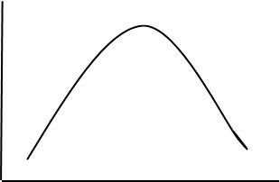 | 3

2012 HL Q10
10. | (a) | (i) | *Purines  *Pyrimidines |  |  |  | 3  3
 |  | (ii) | *A + T and *G + C |  |  |  | 3
 | (b) | (i) | Segregation:  Assortment: |  | Traits are governed by pairs of factors (or alleles or genes) / that separate at gamete formation (each gamete receiving one factor)  Either member of a pair of alleles (or factors or genes or chromosomes) can combine (or transmit) with either member of another pair (in gamete formation) |  | 2(3)  3
 |  | (ii) | 1.  2. | *SSYy or *ssYy  (SSYy) → Smooth + yellow  Or  (ssYy) → Wrinkled + yellow |  |  | 3  3
 |  | (iii) | *Smooth + yellow  *SSYY or *SsYY or *SSYy if not used above b(ii) 1. |  |  |  | 3  3
 |  | (iv) | *Sy  *sY |  |  |  | 3  3
 | (c) | (i) | Manipulation of genes or alteration of genes or alteration of genotypes |  |  |  | 3
 |  | (ii) | Isolation: |  |  | Locating or identififying or removal of a gene (or a piece of DNA or a plasmid) | 3
 |  |  | Cutting (restriction): |  |  | (Cutting) the DNA (or plasmid) with an (restriction) enzyme | 3
 |  |  | Transformation  OR  Ligation: |  |  | uptake of DNA (or plasmid or gene)  the joining of DNA (or plasmid or gene) | 3
 |  |  | Introduction of base sequence changes: |  |  | (the order of bases in) the host DNA is now different | 3
 |  |  | Expression: |  |  | the activation of the inserted gene (in its new position) or production of product | 3
 |  | (iii) | 1.  2. 3. | Animal example  Plant example  Micro-organism example Any two |  |  | 2(3)

2012 HL Q11
11. | (a) | (i) | Chain: |  |  | One species at each trophic (or feeding) level  or described or diagram |  | 3
 |  |  | Web: |  |  | Interconnected food chains or described or diagram or more than one species at each trophic (or feeding) level |  | 3
 |  | (ii) | (Diagram) that shows the number of organisms at each trophic level |  |  |  |  | 3
 | (b) | (i) | Food source or biological control or aesthetic or sporting or other |  |  |  |  | 3
 |  | (ii) | Failure to adapt / example of failure to adapt / preyed upon / insufficient numbers / dispersal / competition Any two |  |  |  |  | 2(3)
 |  | (iii) | Seed dispersal or fruit |  |  |  |  | 3
 |  | (iv) | 1.  2. |  | Increased competition or (increased) predation or example of increased competition or example of increased predation  Control of nuisance species or food or shelter or other |  |  | 3  3
 |  | (v) | 1. |  | Role of organism (in an ecosystem) or explained e.g. ‘how it fits’ |  |  | 3
 |  |  | 2+3. |  | Yes, because it is adapted (or is suited) or explained OR  No, because it is not adapted (or is not suited) or explained |  |  | 6, 0
 | (c) | Name of investigated ecosystem:
 |  | (i) | 1.  2. | *Plants  *Animals |  |  |  | 2  2
 |  | (ii) | Named animal (must match named ecosystem and method if given)  Details of method: |  |  |  |  | 2  6(2)
 |  | (iii) | More conspicuous (to predators) or social outcast or toxic marker |  |  |  |  | 2
 |  | (iv) | Natural:  Artificial |  |  |  | relevant matching example  elevant matching example | 2  2

2012 HL Q12
12. | (a) | (i) | *Autotrophic |  | 3
 |  | (ii) | (A =) *mitochondrion  (B =) *chloroplast |  | 3  3
 | (b) | (i) | 1. | *Violet  *Red | 3  3
 |  |  | 2. | *Blue | 3
 |  | (ii) | Not absorbed or little absorption or it is reflected |  | 3
 |  | (iii) | Able to absorb more light (or energy) or able to absorb more (or different) colours (or wavelengths) or increased photosynthesis (or increased food production) |  | 3
 |  | (iv) | Use violet (or blue or orange or red) light |  | 3
 |  | (v) | 1. | *Air (or atmosphere) or *respiration  NADP: to transport electrons / to transport energy / H-carrier  ATP: Energy source or energy store | 3  3  3
 | (c) | (i) | First stage of respiration / in cytoplasm (or in cytosol) / anaerobic / starts with glucose (or indicated) / produces pyruvate / low energy release |  | 2(3)
 |  | (ii) | Aerobic / formed from pyruvate / 2-carbon (group) / joins Krebs cycle / in mitochondrion |  | 2(3)
 |  | (iii) | High energy bonds (or high energy molecule) / energy store / releases energy / forming ADP (or formed from ADP) / large ATP production in stage 2 |  | 2(3)
 |  | (iv) | Aerobic / in mitochondrion / carries high-energy electrons / from NADH or from Krebs cycle / to protons / formation of water / ATP produced or high energy release |  | 2(3)

2012 HL Q13
13. | (a) | (i) | CNS:  PNS: |  | brain and spinal cord  nerves leading to and from CNS or nerves not in CNS |  |  |  |  | 3  3
 |  | (ii) | Faster or shorter-lived or electrical |  |  |  |  |  |  | 3
 | (b) | (i) | Diagram:  Labels: |  |  |  | cell body with dendrites + axon + terminal dendrites shown  Diagram of a sensory neuron gets 0 marks  Cell body / dendrites / axon / myelin sheath / Schwann cells / (neurotransmitter) vesicles (or swellings) |  |  | 6, 3, 0  6(1)
 |  | (ii) | Function first named part  Function of second named part |  |  |  |  |  |  | 3  3
 |  | (iii) | *Arrow |  |  |  |  |  |  | 3
 |  | (iv) | Sensory neuron carry impulses to CNS (or to named part of CNS)  Interneuron carry impulses within CNS or Interneuron carry impulses  from sensory to motor neuron or connect sensory and motor neurons |  |  |  |  |  |  | 3  3
 | (c) | (i) | Cerebrum:  Hypothalamus:  Cerebellum:  Medulla oblongata: |  |  |  |  |  | language or reason or consciousness or senses or memory or intelligence or emotions or other  homeostasis or example of homeostasis or endocrine function or other  movement or balance or coordination or example  involuntary muscle control or example | 3  3  3  3
 |  | (ii) | Grey:  White |  |  | few axons or little myelin or mostly cell bodies  many axons or much myelin or few cell bodies |  |  |  | 3  3
 |  | (iii) | 1. | Cause: |  |  |  | Parkinson’s – lack of dopamine or genetic or toxins OR  Paralysis – damage to spinal cord or other |  | 3
 |  |  | 2. | Treatment: |  |  |  | Parkinson’s  levodopa or drugs that mimic dopamine or physiotherapy or exercise OR  Paralysis – surgery or psysiotherapy |  | 3

2012 HL Q14(a)
14. | (a) | (i) | 1.  2.  3. | Attracts insects (or other pollinators)  (Site of) pollen manufacture or (site of) pollen release  Pollen lands on it or pollen sticks to it or pollen germination | 3  3  3
 |  | (ii) | Stigma or style or ovary or micropyle |  | 3
 |  | (iii) | 1.  2. | *mitosis  egg [allow ovum or female gamete]  polar nuclei | 3  3  3
 |  |  | 3. | *zygote  endosperm (nucleus) | 3  3
 |  | (iv) | Endosperm or cotyledon (or seed leaf or embryonic leaf) |  | 3

2012 HL Q14(b)
14. | (b) | (i) | 1.  2. | Ectoderm  Mesoderm  Endoderm  ectoderm: e.g nervous system  mesoderm: e.g skeletal system  endoderm: e.g. digestive system | 3  3  3#  3  3  3
 |  | (ii) | Embryonic  Uterine or endometrium |  | 3  3
 |  | (iii) | 1.  2. | A membrane (or sac) that surrounds the embryo (or foetus)  It contains (or secretes) (amniotic) fluid or protects embryo | 3  3

2012 HL Q14(c)
14. | (c) | (i) | 1.  2.  3. | Dehydration or other named  Diagrams:  Labels:  + and - / progametangia / gametangia / hypha / zygote  Can survive drought (or named adverse condition) / dispersal | 3  6, 3, 0  3(2)  2(3)
 |  | (ii) | 1.  2.  3. | *Budding  Forms a colony or break away (from the mother cell)  (Rhizopus) produces spores | 3  3  3

2012 HL Q15(a)
15. | (a) | (i) | (X =) *Villus  (Y =) *Lacteal |  | 3  3
 |  | (ii) | *Peristalsis |  | 3
 |  | (iii) | *Alkaline |  | 3
 |  | (iv) | *Pancreas  *Liver |  | 3  3
 |  | (v) | 1.  2. | (Bacteria) living on or in another organism involving benefit  Vitamin production / compete with pathogens / reference to digestion / inhibits cancer cells | 3  2(3)
 |  | (vi) | *Colon or *large intestine |  | 3

2012 HL Q15(b)
15. | (b) | (i) | Smaller / more of them / biconcave / disc (shape) / no nucleus (when mature) / no mitochondria / transport oxygen / contain haemoglobin / transport CO₂ |  |  | 2(3)
 |  | (ii) | Phagocytic (white cells) or monocytes |  |  | 3
 |  | (iii) | 1. | To inactivate antigens (or described) |  | 3
 |  |  | 2. | Helper / killer / suppressor / memory Any three |  | 3(3)
 |  |  | 3. | Helper:  Killer:  Suppressor:  Memory | recognise antigens or secrete interferon or stimulate B-cell (or antibody production) or activate killer cell  attack infected cells or secrete perforin  stop immune responses  long term protection or remember antigens (to which they have been exposed) or explained  Any three | 3(3)

2012 HL Q15(c)
15. | (c) | (i) | homeostasis: |  | Maintenance of a constant internal environment | 3
 |  | (ii) | diffusion:  osmosis:  active transport: |  | movement of substances with (along) a concentration gradient or explained  movement of water through a selectively permeable membrane from a high water concentration to a low concentration  movement of molecules against a concentration gradient or movement of molecules using energy | 3  3  3
 |  | (iii) | 1.  2.  3. | Absorption of glucose or release of glucose or heat generation  Excretion of water or excretion of CO₂ or release of heat  Excretion of water or reabsorption of water or excretion of salts (or ions) or reabsorbtion of salts (or ions) |  | 3  3  3
 |  | (iv) | Too hot:  Sweat / dilation of blood vessels / hair flat  Too cold:  Constriction of of blood vessels / hair stands up  Insulation by (subcutaneous) fat Any three |  |  | 3(3)

2012 OL Q1
1. |  |  |  | 2(1)+3(2)+2(6)
 | (a) | (i) | Tuna
 |  | (ii) | Crisps / “Butter” (on bread) [not ‘spread’]
 | (b) | (i) | B or C
 |  | (ii) | Bread or Sweetcorn / Apple
 | (c) |  | Keratin / Myosin / Collagen
 | (d) |  | Energy (storage) / Insulation / Cell Membranes/(Storage of fat soluble) vitamins/Protection
 | (e) |  | Metabolism

2012 OL Q2
2. |  |  |  | 2(1)+3(2)+2(6)
 | (a) |  | A = Contractile Vacuole B = Cytoplasm / Endoplasm C = Pseudopodium / False Foot  D = Nucleus
 | (b) |  | Function “A” = Water balance / Osmoregulation  Function “C” = Movement / Feeding / Egestion/ Homeostasis
 | (c) |  | e.g. Plant Cell has Cell Wall

2012 OL Q3
3. |  |  |  | 2(1)+3(2)+2(6)
 | (a) |  | F
 | (b) |  | T or F
 | (c) |  | F
 | (d) |  | T
 | (e) |  | T
 | (f) |  | F
 | (g) |  | F

2012 OL Q4
4. |  |  |  | 2(1)+3(2)+2(6)
 | (a) |  | Stem
 | (b) |  | Ground Tissue = A;  Dermal Tissue = C;  Vascular Tissue = B
 | (c) |  | Transport / Support
 | (d) | 1. | Xylem
 |  | 2. | Phloem

2012 OL Q5
5 |  |  |  | 3(2) + 2(7)
 | (a) |  | Pollution
 | (b) |  | Smell
 | (c) |  | Recycle
 | (d) |  | Conservation
 | (e) |  | Burning Fuel

2012 OL Q6
6. |  |  |  | 2(1)+3(2)+2(6)
 | (a) |  | Possible gametes: (T) (t) X (t) | (3pts)
 | (b) |  | Genotypes of offspring: (Tt) (tt) | (2pts)
 | (c) |  | Phenotypes of offspring: Tall & Dwarf (allow small) | (2pts)

2012 OL Q7
7. |  |  |  | - + 1
 | (a) | (i) | EG. Asthma | (1 pt)
 |  | (ii) | EG. Use of Inhaler (must match) | (1 pt)
 |  |  |  | 2(6)+6(2)
 | (b) |  | Ticking Breathing Rate/Pulse Rate | (0 pts)
 |  | (i) | Count pulse or breaths / time or rate  repeat or average | (2 pts)  (1 pt)
 |  | (ii) | Exercise / check rate | (2 pts)
 |  | (iii) | Exercise causes increase in rate | (1 pt)
 |  | (iv) | Yes / No | (1 pt)
 |  | (v) | Must match (iv) | (1 pt)

2012 OL Q8
8. |  |  |  | 5 + 1
 | (a) | (i) | A biological or organic or protein catalyst. | (1 pt)
 |  | (ii) | Ribosome | (1 pt)
 |  |  |  | 2(6) + 6(2)
 | (b) | (i) | EG. Catalase | (1 pt)
 |  | (ii) | EG. Hydrogen peroxide (Must match enzyme) | (1 pt)
 |  | (iii) | Waterbath | (1 pt)
 |  | (iv) | EG. Volume of froth / time (Depends on enzyme used) | (2 pts)
 |  | (v) | Buffer | (1 pt)
 |  | (vi) | Increasing activity with increasing temp / works best at certain temp / activity decreases above or below certain temp. (Can be shown by graph with one axis labelled) | (2 pts)

2012 OLQ 9
9. |  |  |  | 5+1
 | (a) | (i) | EG. Water is a good solvent. | (1 pt)
 |  | (ii) | EG. Water maintains its temperature well | (1 pt)
 |  |  |  | 2(6)+6(2)
 | (b) | (i) | Iodine (solution) | (1 pt)
 |  | (ii) | No | (1 pt)
 |  | (iii) | Blue/Black colour | (1 pt)
 |  | (iv) | Water instead of starch | (1 pt)
 |  | (v) | Biuret (solution) or named chemicals | (1 pt)
 |  | (vi) | Blue | (1 pt)
 |  | (vii) | No | (1 pt)
 |  | (viii) | Purple / violet / Pink | (1 pt)

2012 OL Q10
10 |  |  |  | 3(3)
 | (a) |  | Fox Carnivore  Rabbit Herbivore  Grass Producer | Correct shape - 3  One Ecosystem 3  Food chain 3  (3 pts)
 |  |  |  | 2(6) + 6(2) +3(1)
 | (b) | (i) | Biotic – concerned with the activities of living things  Abiotic – concerned with the non-living part of the environment | (2 pts)
 |  | (ii) | EG.  - Temperature – thermometer  - Soil pH – pH meter | (4 pts)
 |  | (iii) | A = Tribolium B = Planarian C = Nematode | (3 pts)
 |  | (iv) | EG. 1. Grasshopper 2. Green colour | (2 pts)
 |  |  |  | 2(6)+6(2)
 | (c) | (i) | Quantitative survey - The number of individuals present  Qualitative survey – Variety of organisms present | (2 pts)
 |  | (ii) | EG. 1. Daisy  2. Throw quadrat / note if daisies present /  random or repeat or calculate or scale up | (1 pt)  (2 pts)  (1pt)
 |  | (iii) | Plants and/or animal numbers increase and /or decrease (valid examples allowed) | (2 pts)

2012 OL Q11
11 |  |  |  | 6 + 3
 | (a) | (i) | Haploid = single set of chromosomes or half the diploid number | (1 pt)
 |  | (ii) | Chromosome = group of genes joined together or large DNA molecule | (1 pt)
 |  |  |  | 2(5) + 3+7(2)
 | (b) | (i) | White or lack of pigment / skin or fur  Pink or lack of pigment / eyes | (2 pts)
 |  | (ii) | Only expressed in homozygous state or not dominant | (1pt)
 |  | (iii) | Change (in the make-up) / in a gene or DNA or chromosome | (2 pts)
 |  | (iv) | - Change in a species (over time) or (reference to) natural selection  - Darwin or Wallace  - EG. Fossils | (3 pts)
 |  | (v) | Absence of melanin / speeds up sunburn or opposite | (2 pts)
 |  |  |  | 2(6)+6(2)
 | (c) | (i) | Manipulation or artificial / alteration /of genes or chromosomes | 3(pts)
 |  | (ii) | Isolation / Cutting / Ligation / Transformation / Cloning / Expression (Name or explain) | (3 pts)
 |  | (iii) | EG. Long-life tomatoes / Weedkiller-resistant crops | (2 Pts)

2012 OL Q12
12 |  |  |  | 2(3)+3(1)
 | (a) | (i) | Sexual & Asexual reproduction | (2 Pts)
 |  | (ii) | Fusion / of gametes / to produce a zygote | (3 pts)
 |  |  |  | 3(5) +6(2)
 | (b) | (i) | The anther or stamen | (1 pt)
 |  | (ii) | Ovary (accept carpel) | (1 pt)
 |  | (iii) | EG. Wind dispersal / Animal dispersal | (2 pts)
 |  | (iv) | To avoid competition or to avail of suitable conditions | (1 pt)
 |  | (v) | To overcome adverse conditions | (1 pt)
 |  | (vi) | Water / O₂ (Allow air) / suitable temperature | (3 Pts)
 |  |  |  | 3(4) + 6(2)
 | (c) | (i) | A = Head B = Nucleus C = Tail | (3 Pts)
 |  | (ii) | Respiration or to produce energy | (1 pt)
 |  | (iii) | Testosterone | (1 pt)
 |  | (iv) | EG. Low sperm counts | (1 pt)
 |  | (v) | Prevention of fertilisation or prevention of pregnancy | (1 pt)
 |  | (vi) | EG. Natural / Mechanical or examples | (2 pts)

2012 OL Q13
13 |  |  |  | 7 + 2(1)
 | (a) | (i) | EG. Identification | (1 pt)
 |  | (ii) | Monera | (1 pt)
 |  | (iii) | EG. Food Production | (1 pt)
 | (b) | (i) |  | D. 5,2,0 L.2(1)
 |  |  | Diagram to include:  Cell Memb/Cytoplasm + one other.  Labels: Any two valid labels | Diagram:  All three = 5  One absent = 2  Two absent = 0
 |  | ii-v | Pr | 2(6) + 4(2)
 |  | (ii) | Bacillus or rod shaped / Coccus or spherical (Round) / Spirillum or spiral shaped | (2 pts)
 |  | (iii) | Binary Fission or asexual [Not Mitosis] | (1 pt)
 |  | (iv) | Disease-causing | (1 pt)
 |  | (v) | Temp / O₂ (allow air)/ water/ food /pH / Waste | (2 pts)
 |  |  |  | 2(7) +5(2)
 | (c) | (i) | A = Stolon or Hypha; B = Rhizoid | (2 pts)
 |  | (ii) | Anchor / absorb / secretes enzymes | (2 Pts)
 |  | (iii) | (Release or production of) spores | (1 pt)
 |  | (iv) | Living on dead matter | (1 pt)
 |  | (v) | EG. Antibiotic Production | (1 pt)

2012 OL Q14(a)
14. |  |  |  | 2(5)+2(4)+4(1)
 | (a) | (i) | Breakdown of food or production of energy / in presence of O₂ | (2 pts)
 |  | (ii) | - Cytoplasm  - Mitochondria | (2 pts)
 |  | (iii) | Aerobic (Respiration) | (1 pt)
 |  | (iv) |  | D. 5,2,0 L. 3(1)
 |  |  |  | Diagram:  All three = 5  One absent = 2  Two absent = 0
  Diagram must include:  - Container  - Liquid  - Oil or Airlock | Labels required:  - Glucose  - Yeast  - Oil or Airlock
 |  |  | - CO₂  - Bubbles  - Bubbling stops | (3 pts)

2012 OL Q14(b)
14. |  |  |  | 2(5)+2(3)+7(2)
 | (b) | (i) | Chlorophyll | (1 pt)
 |  | (ii) | (Movement of) H₂O / through semi-permeable memb / from low to high conc (or high to low water conc) | (3 pts)
 |  | (iii) | 1. O₂ / H⁺ / e⁻  2. Light Stage | (3 pts)  (1 pt)
 |  | (iv) | Stoma | (1 pt)
 |  | (v) | EG. extra CO₂ / more light | (2 Pts)

2012 OL Q14(c)
14. |  |  |  | 2(5) + 2(4) + 5(1)
 | (c) | (i) | Group of cells / with a common function | (2 Pts)
 |  | (ii) | Oxygen | (1 pt)
 |  | (iii) | To avoid contamination | (1 pt)
 |  | (iv) | Mitosis | (1 pt)
 |  | (v) | Cancer | (1 pt)
 |  | (vi) | EG. Radiation / smoking | (2 pts)
 |  | (vii) |  | D. 5,2,0 L. 2(1)
  Diagram to include:  - Cycle  - Proportionality | Two correct = 5 marks  One Correct = 2 marks  None = 0 marks
Labels:
Any two correct labels
 |  | (viii) | Reduction (halving) of Chromosome numbers or to produce gametes (Allow reduction division) | (1pt)

2012 OL Q15(a)
15. |  |  |  | 2(5)+2(4)+6(2)
 | (a) | (i) | A = Hair B = Sweat gland C = Blood vessels | (3 pts)
 |  | (ii) | EG. Sweat | (1 pt)
 |  | (iii) | EG. Protection / Melanin production | (2 pts)
 |  | (iv) | EG. Kidney / Urine | (2 pts)
 |  | (v) | Maintaining constant internal conditions | (1 pt)
 |  | (vi) | Produces heat (internally) or warm blooded | (1 pt)

2012 OL Q15(b)
15. | (b) |  |  | 2(5)+2(3)+7(2)
 | (i) | 1 | Phototropism | (1 pt)
 |  | 2 | EG. Auxin | (1 pt)
 |  | 3 | Growing tip or apical meristem | (1 pt)
 |  | 4 | EG. Sting | (1 pt)
 | (ii) | 1 | Brain & Spinal Cord | (2 pts)
 |  | 2 | Motor Neuron / Sensory Neuron/ Interneuron | (2 Pts)
 |  | 3 | Synapse | (1 pt)
 |  | 4 | (Neuro) Transmitter | (1 pt)
 |  | 5 | Destroyed or reused | (1 pt)

2012 OL Q15(c)
15. | (c) |  |  | 2(5)+2(4)+6(2)
 |  | (i) | A = Duodenum or Small Intestine  B = Colon or Large Intestine  C = Stomach | (3 pts)
 |  | (ii) | Molecules or food broken down | (1 pt)
 |  | (iii) | EG. Incisor / to cut | (2 pts)
 |  | (iv) | EG. Kills bacteria | (1 pt)
 |  | (v) | EG. Bile | (1 pt)
 |  | (vi) | Produces enzymes or named enzyme /  Produces Insulin | (1 pt)  (1 pt)

2013 HL Q1
1. | 5(4, 2, 0) i.e. best five answers from (a) – (f)
 | (a) | Starch | – polysaccharide (or explained) or polymer or correct test
 |  | Glucose | – monosaccharide (or explained) or monomer or correct test
 | (b) | Amino Acid | – building block of protein or monomer or unit of protein
 |  | Protein | – polymer (of amino acids) or chain of (or many) amino acids
 | (c) | Cellulose | – carbohydrate or polysaccharide or (found in plant) cell wall
 |  | Keratin | – protein or (found in human) hair (or nails or skin)
 | (d) | Enzyme | – a catalyst (or explained)
 |  | Hormone | – a (chemical) messenger (or explained)
 | (e) | Biuret | – (test for) protein
 |  | Benedict’s / Fehling’s | – (test for) reducing sugar (or glucose or maltose)
 | (f) | Fats | – (lipids) solid at room temp
 |  | Oils | – (lipids) liquid at room temp

2013 HL Q2
2. | 6(3) + (2)
 | (a) | First (level)
 | (b) | Primary consumer(s) or herbivore(s)
 | (c) | (Large) energy loss (from one level to next) or small energy transfer
 | (d) | Producers are large or primary consumers are parasites
 | (e) | (i) | No
 |  | (ii) | (Parasites) are not producers or (parasites) are consumers (or explained)
 | (f) | Heat

2013 HL Q3
3. | 6(3) + (2)
 | (a) | X
 |  | Dog’s body temperature is (relatively) stable or correct reference to graph
 | (b) | Endothermic
 | (c) | Respiration or metabolism or carbohydrate (or named carbohydrate) or fat (or named fat)
 | (d) | (Temperature always suitable) for good enzyme activity or metabolism or activity independent of environment
 | (e) | Ectothermic
 | (f) | Environment or the sun or metabolism

2013 HL Q4
4. | 6(3) + (2)
 | (a) | 1. | Bud(s) or node(s) or leaf
 |  | 2. | Vascular bundles [plural only]
 | (b) | Vegetative propagation
 | (c) | Diploid
 |  | Product of mitosis or genetically identical (to parent) or clone
 | (d) | Fruit or (straw)berries or seeds
 | (e) | Cuttings or layering or grafting or micro-propagation or tissue culture

2013 HL Q5
5. | 1 + 1 + 8 + 6 + 4(1)
 | (a) | (i) | Only certain substances (or named) allowed through
 |  | (ii) | Substances can be kept in (or out) or substances can be let in (or out)
 |  | (iii) | Oxygen / glucose / water / amino acids / phosphate (or P) / iron Any two
 | (b) | (i) | Pressure / of cell contents (or described) / on cell wall Any two
 |  | (ii) | Vacuole or cell wall or cell sap
 |  | (iii) | Support (or described)

2013 HL Q6
6. |  | 1 + 1 + 8 + 6 + 4(1)
 | (a) | (i) | Each base has a (different) corresponding (or matching) (base)
 |  | (ii) | 1. | Uracil or U
 |  |  | 2. | Guanine or G
 |  | (iii) | Ribose or deoxyribose
 |  | (iv) | Phosphate (group) or P
 | (b) | (i) | Messenger
 |  | (ii) | RNA has ribose or RNA is single stranded  or DNA has deoxyribose or DNA is double stranded
 |  | (iii) | Joins nucleotides together (to give mRNA product) or to make RNA

2013 HL Q7
7. | (a) | (i) | Where an organism (or plant and animal) lives | 3
 |  | (ii) | Organisms (interacting) with their environment | 3
 | (b) | (i) | Factor | 3
 |  |  | How investigated | 3
 |  | (ii) | Key or (guide) book or illustrations | 3
 |  | (iii) | Method described must demonstrate randomness | 3
 |  | (iv) | Named animal + adaptation | 3
 |  |  | Named plant + adaptation | 3
 |  | (v) | Named (species) of carnivore or of omnivore or of parasite | 3
 |  | (vi) | Matching named prey | 3

2013 HL Q8
8. | (a) | (i) | Product(s) | 3
 |  | (ii) | Working at maximum rate | 3
 | (b) | (i) | Named enzyme | 3
 |  |  | Matching substrate | 3
 |  | (ii) | Temperature ≥ 60ºC for ≥ 5 min or boil / water bath or described / untreated enzyme / as control / no activity in denatured enzyme / (matching method of) observe activity / control result / named factor (kept constant) / how kept constant | 5(3)
 |  | (iii) | Any attempt | 3

2013 HL Q9
9. | (a) | (i) | Avoidance of bias |  |  | 3
 |  | (ii) | Hypothesis can develop into a theory or explained |  |  | 3
 | (b) | (i) | 1. | CO₂ – | vary NaHCO₃ conc. | 3
 |  |  |  | OR |  | 3
 |  |  |  | Light – | vary lamp (or plant) distance or vary lamp wattage | 3
 |  |  | 2. | Graph with labelled axes (rate on y-axis) + rise |  | 3
 |  | (ii) | 1. | As a selectively permeable membrane |  | 3
 |  |  | 2. | Change (increase or decrease) in mass (volume) or described |  | 3
 |  | (iii) | 1. | e.g. Iodine → yellow (or orange or brown) |  | 3
 |  |  | 2. | Dropper or use of filter paper |  | 3
 |  | (iv) | 1. | Milk agar or starch agar |  | 3
 |  |  | 2. | Boiled seeds |  | 3

2013 HL Q10
10. | (a) | (i) | *Endocrine |  | 3
 |  | (ii) | Ductless |  | 3
 |  | (iii) | Hormone (or insulin) secretion & non-hormone (enzyme) secretions or has endocrine and exocrine function (or described) |  | 3
 | (b) | (i) | Protein |  | 3
 |  | (ii) | Hormone name |  | 2(2)
 |  |  | 1. | Gland location | 2(2)
 |  |  | 2. | Hormone function | 2(2)
 |  | (iii) | 1. | Deficiency symptom | 2
 |  |  | 2. | Excess symptom | 2
 |  |  | 3. | Corrective measure | 2
 |  | (iv) | Hormones travel in blood or are chemical  electrical transmission in nerves |  | 3  3
 | (c) | (i) | Made at one site & function at another / Transport slow / in vascular tissue or in blood and phloem (or xylem) / chemical (nature) |  | 2(3)
 |  | (ii) | e.g. IAA (auxin)  Just behind shoot (or root) tip or meristem or zone of elongation |  | 3  3
 |  | (iii) | Vascular bundles or vascular tissue or phloem or xylem |  | 3
 |  | (iv) | (Encourage) rooting (in cuttings) / promote ripening / weed killer / seedless fruit / micro-propagation or tissue culture |  | 2(3)
 |  | (v) | IAA / auxin / ethene (ethylene) / abscisic acid |  | 3

2013 HL Q11
11. | (a) | (i) | Fossils or embryology or anatomy or adaptation of plant or animal or genetics |  |  |  | 3
 |  | (ii) | Any two points from evidence selected above:  e.g. Fossils: structure / changing / over time / related to environment  e.g. Embryology: different organisms / similar embryo / similar development pathways  e.g. Anatomy: Named structure / expansion point |  |  |  | 2(3)
 | (b) | (i) | Heterosomes or sex chromosomes |  |  |  | 3
 |  | (ii) | Female Male  XX XY |  |  | Male  Female | 3,0  3,0
 |  | (iii) |  |  |  | Gametes shown  Cross shown  F₁ genotypes shown | 3  3  3
   | X
  X | XX
  Y | XY
 |  | (iv) | 1. | Gene(s) on sex or on X or on Y chromosome |  |  | 3
 |  |  | 2. | Haemophilia / colour blindness |  |  | 2(3)
 | (c) | (i) | *Interphase |  |  |  | 3
 |  | (ii) | Replication or growth or protein synthesis or respiration or photosynthesis |  |  |  | 3
 |  | (iii) | Diagram:  spindle (or outline of cell) + chromosomes on equator  + 6 double chromosomes  Labels:  Chromosome(s) / spindle / centromere(s) / cell membrane |  |  |  | 6,3,0  3(1)
 |  | (iv) | 1. |  | Function |  | 3
 |  |  | 2. |  | How function is carried out |  | 3
 |  | (v) | Cancer |  |  |  | 3

2013 HL Q12
12. | (a) | (i) | Composed of nucleic acid (or DNA or RNA) |  | 3
 |  | (ii) | Can only replicate (or reproduce) inside a cell (or host) |  | 3
 |  | (iii) | Genetic engineering or vaccine (production) or cancer treatment or pest control or disease control |  | 3
 | (b) | (i) | *Monera |  | 3
 |  | (ii) | 1 + 2 | Diagram: wall + membrane + capsule + plasmid shown | 5, 3, 0
 |  |  |  | Labels: | 4(1)
 |  | (iii) | 1. | Harsh conditions or example | 3
 |  |  | 2. | DNA replicates / thick wall (or described) / encloses / shrinkage (or water loss) / of cytoplasm | 2(3)
 |  | (iv) | *Saprophytic |  | 3
 |  |  | *Parasitic |  | 3
 | (c) | (i) | Antibodies – proteins / produced by body / in response to antigen (or to infection)
 |  |  | Antibiotics – produced by micro-organisms / kill (or destroy or stop growth of) other micro-organisms / do not affect viruses |  | 4(3)
 |  | (ii) | Active - antibodies produced in body |  | 3
 |  |  | Passive – antibodies given |  | 3
 |  | (iii) | Antibiotic resistance strains / more pathogens / more people (or poor hygiene) / patients weaker |  | 2(3)

2013 HL Q13
13. | (a) | (i) | *Secondary sexual characteristics |  | 3
 |  | (ii) | *Puberty |  | 3
 |  | (iii) | *Testosterone |  | 3
 | (b) | (i) | A. | Vagina
 |  |  | B. | Uterus (or Womb)
 |  |  | C. | Endometrium (or lining of uterus or lining of womb)
 |  |  | D. | Fallopian Tube (or Oviduct)
 |  |  | E. | Ovary
 |  |  | F. | Cervix | 6(1)
 |  | (ii) | 1. | *E | 3
 |  |  | 2. | *D | 3
 |  |  | 3. | *C | 3
 |  | (iii) | Oestrogen: Endometrium repair / stimulates LH / inhibits FSH |  | 2(3)
 |  |  | Progesterone: Endometrium maintenance / inhibits LH / inhibits FSH |  | 2(3)
 | (c) | (i) | *Mitosis |  | 3
 |  | (ii) | *Blastocyst |  | 3
 |  | (iii) | Makes progesterone / barrier or one (barrier) example / material transfer (or one example) |  | 2(3)
 |  | (iv) | (Mucus) show or contractions or waters break |  | 3
 |  | (v) | Contractions or amniotic sac breaks or cervix dilates |  | 3
 |  |  | Baby delivered |  | 3
 |  |  | Afterbirth delivered |  | 3

2013 HL Q14(a)
14. | (a) | (i) | *Light (dependent stage) |  | 3
 |  | (ii) | 1. | (electrons) picked up by acceptor / passed through carriers / back to chlorophyll / (electrons) lose energy | 2(3)
 |  |  | 2. | H₂O split / protons to pool / NADP⁻ formed / NADPH formed / (electrons) picked up by acceptor / passed through carriers / O₂ released / ATP produced | 2(3)
 |  | (iii) | *Dark (stage) (or *light-independent stage) |  | 3
 |  | (iv) | Light not needed |  | 3
 |  | (v) | Product (or named product) (of 1st stage) required. |  | 3
 |  | (vi) | Sugar formed from CO₂ |  | 3
 |  |  | ATP provides energy or NADPH provides hydrogen (or H) |  | 3

2013 HL Q14(b)
14. | (b) | If any ‘note’ consists only of a word diagram, flow-chart or chemical equation, then a maximum of two scoring points may be awarded.
 |  | (i) | Metabolism: (The sum of) all reactions in cell (or organism) / controlled by enzymes / catabolism explained or catabolism + example / anabolism explained or anabolism + example | 4+2(3)
 |  | (ii) | Krebs Cycle: occurs in second stage of respiration / in mitochondria / when O₂ present (or aerobic) / starts with Acetyl Co-enzyme A / ATP produced / hydrogen (pairs) produced or energised electrons / CO₂ produced | 4+2(3)
 |  | (iii) | ADP: Adenosine Di-phosphate / a low energy (molecule) / + phosphate (P) / + energy / ATP formed | 4+2(3)

2013 HL Q14(c)
14. | (c) | (i) | Anaerobic respiration |  |  | 3
 |  | (ii) | Yeast |  |  | 3
 |  | (iii) | *Fungi |  |  | 3
 |  | (iv) | Any named carbohydrate |  |  | 3
 |  | (v) | 1. | Bioprocessing: | using micro-organisms (or enzymes) / to form product(s) | 2(3)
 |  |  |  | Immobilised: | fixed to inert material (or named material) or fixed to each other or trapped in gel (or named material) | 3
 |  |  | 2. | Can be re-used (or recovered) or pure product (or described) |  | 3
 |  |  | 3. | Alginate |  | 3
 |  |  | 4. | Bioreactor |  | 3

2013 HL Q15(a)
15. | (a) | (i) | Finch (or sparrow) + (blood sucking) mites | 3
 |  | (ii) | (Organism living on) host (or explained) / causing damage | 2(3)
 |  | (iii) | Disease or death or weakened (birds) | 3
 |  | (iv) | Readily available or shortage of normal material or similar to normal building material or suitable material or insulator | 3
 |  | (v) | Repulsion (or described) or attraction (or described) | 3
 |  | (vi) | Tar or nicotine (or other named substance) or bacteria | 3
 |  | (vii) | By weighing it | 3
 |  | (viii) | Control (or explained) | 3
 |  | (ix) | No (mite)-repelling (or mite-killing) chemicals or absence of named chemical | 3

2013 HL Q15(b)
15. | (b) | (i) | - Nitrogen gas to usable compounds /  - Plant protein to animal protein /  - Excretion releasing N compounds /  - Death and decomposition /  - Dead matter to Ammonium  - Ammonium to nitrite /  - Nitrite to nitrate /  - Nitrates to plant protein /  - Nitrogen compounds to nitrogen gas /  - One example of bacterial involvement /  - Role of lightning Any six |  |  | 6(2)
 |  | (ii) | fixation (or explained) / bacteria (or micro-organisms) involved / death and decay /nutrition (or described) / excretion |  |  | 2(2)
 |  | (iii) | To be able to detect change(s) or to remedy effect of change or to detect levels of pollutants (or example) |  |  | 2
 |  | (iv) | 1. | Contest: | one gets all (of the resource) | 2
 |  |  |  | Scramble: | all get some (of the resource) | 2
 |  |  | 2. | Edaphic: | to do with soil | 2
 |  |  |  | Aquatic: | to do with water | 2
 |  |  | 3. | Climate: | Long-term (prevailing) conditions | 2
 |  |  |  | Weather: | Short-term (atmospheric) conditions | 2

2013 HL Q15(c)
15. | (c) | (i) | Graph: | Out of sync | 3
 |  |  |  | most prey peaks higher than predator peaks | 3
 |  | (ii) | Explanation of time lag |  | 3
 |  |  | Explanation of bigger prey numbers |  | 3
 |  | (iii) | Yes (or No) + Explanation |  | 3
 |  | (iv) | Population control |  | 3
 |  | (v) | Name predator 1 |  | 3
 |  |  | Adaptive technique |  | 3
 |  |  | Name predator 2 |  | 3
 |  |  | Adaptive technique |  | 3

2013 OL Q1
1. |  |  |  | 5(4)
 | (a) |  | Nitrogen | 4
 | (b) |  | Carbohydrate/ monosaccharide/ sugar | 4
 | (c) |  | A/ D/ E/ K | 4
 | (d) |  | Benedict’s (solution)/ Fehling’s (solution) | 4
 | (e) |  | Minerals / elements | 4

2013 OL Q2
2. |  |  |  | 6(3) + 2
 | (a) |  | A = Stem or internode B = Leaf or midrib C = Root | (3 pts)
 | (b) |  | Function of A: e.g. photosynthesis/support/ transport/ (food) storage  Function of B: e.g. photosynthesis/ transpiration/ gaseous exchange/ (food) storage  Function of C: e.g. anchorage/ absorption (of water or minerals)/ (food) storage | (3 pts)
 | (c) |  | Sexual | (1 pt)

2013 OL Q3
3. |  |  |  | 6(3) + 2
 | (a) |  | T
 | (b) |  | F
 | (c) |  | F
 | (d) |  | F
 | (e) |  | T
 | (f) |  | T/F
 | (g) |  | F

2013 OL Q4
4. |  |  |  | 6(3) + 2
 | (a) |  | Cell division = A; Interphase = B | (2 pts)
 | (b) |  | - Mitosis 2. Meiosis (any order) | (2 pts)
 | (c) |  | Two causes: e.g. viruses/ radiation/ (cigarette) smoking/ named pollutant | (2 pts)
 | (d) |  | A treatment: e.g. chemotherapy/ radiotherapy/ surgery | (1 pt)

2013 OL Q5
5. |  |  |  | 5(4)
 | (a) |  | Proteins | (1 pt)
 | (b) |  | Temperature | (1 pt)
 | (c) |  | Immobilised | (1 pt)
 | (d) |  | Substrate | (1 pt)
 | (e) |  | Reusable | (1 pt)

2013 OL Q6
6. |  |  |  | 6(3) + 2
 | (a) |  | A = Cortex B = Medulla/ Pyramid C = Ureter | (3 pts)
 | (b) |  | Bladder | (1 pt)
 | (c) |  | Urine/ Urea/ Water/ Salt | (1 pt)
 | (d) |  | Cortex/ Bowman’s capsule/ glomerulus/ ‘A’ if correctly named in (a) | (1 pt)
 | (e) |  | e.g. Dialysis/ transplant | (1 pt)

2013 OL Q7
7. | (a) |  |  | 1 + 5
 |  | (i) | Chloroplast | (1 pt)
 |  | (ii) | Oxygen | (1 pt)
 | (b) |  | If parts (ii), (iii), (iv) and (vi) are not consistent from answer to answer then go with version that yields the greater marks. | 8(3)
 |  | (i) | Name of plant (must be aquatic) | (1 pt)
 |  | (ii) | Increased or decreased lamp-beaker distance  OR  Different concs of NaHCO₃ | (1 pt)
 |  | (iii) | e.g. Temperature/ light intensity if CO₂ ticked/ CO₂ conc. if light intensity ticked | (1 pt)
 |  | (iv) | Water bath if temperature/ (same) lamp at same distance if light intensity/ same conc NaHCO₃ if CO₂ conc. | (1 pt)
 |  | (v) | (Count) bubbles/ per unit time | (2 pts)
 |  | (vi) | Greater light intensity or higher CO₂ conc./ → higher rate of photosynthesis  OR  Opposite statement | (2 pts)

2013 OL Q8
8. | (a) |  |  | 1 + 5
 |  | (i) | Water | (1 pt)
 |  | (ii) | Diffusion/ active transport | (1 pt)
 | (b) | (i) | Diagram + 3 labels | D. 6,3,0 L.3(2)
 |  |  |  | 4(3)
 |  | (ii) | Same concentrations e.g. only water (in bag) | (1 pt)
 |  | (iii) | e.g. increase (or decrease) in mass or volume of Visking tubing | (1 pt)
 |  | (iv) | Water moved into (or out of) tubing | (1 pt)
 |  | (v) | To compare (with the experiment) | (1 pt)

2013 OL Q9
9. | (a) |  |  | 1 + 5
 |  | (i) | Wise management of natural resources | (1 pt)
 |  | (ii) | To prevent extinction/ (to maintain) biodiversity/ (to maintain) the balance of nature | (1 pt)
 | (b) |  |  | 8(3)
 |  | (i) | Apparatus 1name  Named animal  Diagram  Apparatus 2 name  Named animal  Diagram | (6 pts)
 |  | (ii) | Quadrat | (1 pt)
 |  | (iii) | Quantitative surveys e.g. distribution, frequency, cover | (1 pt)

2013 OL Q10
10. | (a) |  |  | 7 + 2(1)
 |  | (i) | Unit of heredity/ functional section of DNA | (1 pt)
 |  | (ii) | Alternative form of a gene | (1 pt)
 |  | (iii) | Genetic makeup (of organism) | (1 pt)
 | (b) |  |  | 3(5) + 6(2)
 |  | (i) | X = Thymine or (T) Y = Cytosine or © | (2 pts)
 |  | (ii) | Nucleus only - (allow chromosomes) | (1 pt)
 |  | (iii) | mRNA | (1 pt)
 |  | (iv) | Treating a DNA sample/ revealing a pattern/ unique to species or individual or compare with other pattern | (2 pts)
 |  | (v) | Enzymes | (1 pt)
 |  | (vi) | e.g. forensics/ paternity or maternity testing | (2 pts)
 | (c) |  |  | 2(6) + 6(2)
 |  |  | Punnett square or other scheme shown | (1 pt)
 |  |  | Cross completed correctly | (1 pt)
 |  | (i) | XX = Female / XY = Male | (2 pts)
 |  | (ii) | Female gametes → X / Male gametes → X and Y | (3 pts)
 |  | (iii) | XX and XY | (1 pt)

2013 OL Q11
11. | (a) |  |  | 7 + 2(1)
 |  | (i) | Organism that makes its own food | (1 pt)
 |  | (ii) | Role or ‘occupation’ of organism (in its habitat) | (1 pt)
 |  | (iii) | Where an organism lives | (1 pt)
 | (b) |  |  | 3(5) + 6(2)
 |  | (i) | Carbon dioxide / methane / water vapour | (1 pt)
 |  | (ii) | They traps some of sun’s heat (inside the atmosphere) | (1pt)
 |  | (iii) | Any harmful addition to the environment | (1 pt)
 |  | (iv) | e.g. More trees / fewer cattle / burn less fossil fuel | (1 pt)
 |  | (v) | A= Decay; B= Photosynthesis; C= Combustion;  D= Eaten by; E= Respiration  If no explicit matching is given then accept as fully correct either of the following sequences: (α) B; E; D; C; A.  (β) Decay; Photosynthesis; Combustion; Eaten by; Respiration. Also accept parts of such sequences that place any of the above letters or terms in the correct position in their proper sequence e.g. “D” in third position or “Eaten by” in fourth position in their respective sequences. | (5 pts)
 | (c) |  |  | 2(6) + 6(2)
 |  | (i) | e.g. air pollution/ water pollution/ ground pollution | (2 pts)
 |  | (ii) | - Example of waste  - How waste is managed | (2 pts)
 |  | (iii) | e.g. Reduce/ Reuse / Recycle [Not multiple examples from same category] | (3 pts)
 |  | (iv) | e.g. to consume waste e.g. sewage breakdown | (1 pt)

2013 OL Q12
12. | (a) |  |  | 7 + 2(1)
 |  | (i) | Features that develop at or after puberty (but are not directly involved in reproduction) | (1 pt)
 |  | (ii) | Facial hair/ broader shoulders/ larger larynx or deeper voice/ greater bone density/ greater bone strength/ pubic hair/ enlargement of genitals | (2 pts)
 | (b) |  |  | 3(5) + 6(2)
 |  | (i) | Makes progesterone/ conducts food to embryo (foetus)/ conducts O₂ to embryo (foetus)/ conducts antibodies to embryo (foetus)/ removes CO₂ from embryo (foetus)/ removes urea from embryo (foetus)/ keeps the mother's and embryo's (foetus') blood apart. | (2 pts)
 |  | (ii) | - Contraction of uterus or waters break or dilation of cervix [accept labour]  - Baby delivered  - Afterbirth delivered | (3 pts)
 |  | (iii) | Benefit for baby: mother-baby bonding/ antibodies in milk/ laxative in milk/ mother’s milk encourages growth of mutualistic bacteria in large intestine/ milk sterile/ milk at body temperature  Benefit for mother: bonding/ uterus recovers faster/ natural contraceptive/ reduces risk of breast cancer | (2 pts)
 |  | (iv) | Inability to produce offspring | (1 pt)
 |  | (v) | Fusion of gametes [accept fertilisation] outside the body (e.g. in a Petri dish) | (1 pt)
 | (c) |  |  | 2(6) + 6(2)
 |  | (i) | Loss of blood/ loss of endometrium | (1 pt)
 |  | (ii) | Release of egg (from ovary) | (1 pt)
 |  | (iii) | (Time) when fertilisation is possible [accept “when you can get pregnant”] / when egg is in oviduct | (1 pt)
 |  | (iv) | Oviducts | (1 pt)
 |  | (v) | Embedding of embryo in endometrium | (1 pt)
 |  | (vi) | Oestrogen/ progesterone/ FSH/ LH | (2 pts)
 |  | (vii) | It stops | (1 pt)

2013 OL Q13
13. | (a) |  |  | 3(3)
 |  | (i) | Diagram - three labels | 3,0 + 3(1)
 |  | (ii) | Electron microscope | (1 pt)
 | (b) |  |  | 3(5) + 6(2)
 |  | (i) | Holds cell together/ selectively permeable/ displays antigens | 2(pts)
 |  | (ii) | A = Lipid / B = Protein *7 marks to be allocated here as long as any part of 13 (b) attempted – this is not part of a sliding scale | 7 marks i.e.  5 + 2
 |  | (iii) | Mitochondrion | (1 pt)
 |  | (iv) | To allow passage of materials [allow diffusion?] – allow (to make it) permeable | (1 pt)
 |  | (v) | Plant cells have a wall/ large vacuole/ chloroplast | (2 pts)
 |  | (vi) | Sun/ light | (1 pt)
 | (c) |  |  | 8(3)
 |  | (i) | Energy release (from food)/ without oxygen | (2 pts)
 |  | (ii) | Cytoplasm | (1 pt)
 |  | (iii) | Diagram and one label | 3,0 + 3
 |  | (iv) | Ethanol (alcohol)/ carbon dioxide (CO₂) | (2 pts)
 |  | (v) | Bubbling stopped | (1 pt)

2013 OL Q14(a)
14. | (a) |  |  | 10(3)
 |  | (i) | A = Ligament  B = Cartilage  C = Synovial fluid | (3 pts)
 |  | (ii) | Strength/ support/ shape / mobility/ protection/ muscle attachment [accept blood cell production] | (2 pts)
 |  | (iii) | Thoracic - back of chest  Lumbar - small of back  Sacral - back of pelvis  Caudal or coccyx - tail end | (4 pts)  Any two pairs
 |  | (iv) | e.g. arthritis/ osteoporosis | (1 pt)

2013 OL Q14(b)
14. | (b) |  |  | 10(3)
 |  | (i) | Liquid (part of blood) | (1 pt)
 |  | (ii) | Fight disease | (1 pt)
 |  | (iii) | e.g. bone (marrow) | (1 pt)
 |  | (iv) | Rhesus | (1 pt)
 |  | (v) | - Pacemaker  - Right atrium | (2 pts)
 |  | (vi) | Valves closing | (1 pt)
 |  | (vii) | Coronary [accept cardiac] arteries | (1 pt)
 |  | (viii) | e.g. eat less fat/ exercise regularly/ avoid excess stress/ eat less salt/ don’t smoke/ avoid inheriting bad genes | (2 pts)

2013 OL Q14(c)
14. | (c) |  |  | 10(3)
 |  | (i) | A =Semicircular canals B = Cochlea | (2 pts)
 |  | (ii) | Balance | (1 pt)
 |  | (iii) | Hearing | (1 pt)
 |  | (iv) | Throat | (1 pt)
 |  | (v) | Air | (1 pt)
 |  | (vi) | Skin/ tongue/ nose | (2 pts)
 |  | (vii) | Disorder  Corrective measure | (2 pts)

2013 OL Q15(a)
15. | (a) |  |  | 10(3)
 |  | (i) | A = Stigma B = Anther C = Ovary D= Sepal | (4 pts)
 |  | (ii) | Transfer of pollen/ (from anther) to stigma | (2 pts)
 |  | (iii) | Wind/ insect/ other animal/ self | (2 pts)
 |  | (iv) | Fertilisation | (1 pt)
 |  | (v) | Pollen | (1 pt)

2013 OL Q15(b)
15. | (b) |  |  | 10(3)
 |  | (i) | Asexual / reproduction | (2 pts)
 |  | (ii) | One example/ whether stem-root-leaf-bud | (2 pts)
 |  | (iii) | Spread/ limited spread/ offspring all susceptible to same diseases | (2 pts)
 |  | (iv) | e.g. Cuttings/ layering/ budding/ grafting | (2 pts)
 |  | (v) | Advantage: e.g. can control production of desirable features  Disadvantage: e.g. offspring all susceptilble to same diseases | (2 pts)

2013 OL Q15(c)
15. | (c) |  |  | 10(3)
 |  | (i) | A = Xylem  B = Phloem | (2 pts)
 |  | (ii) | A or Xylem | (1 pt)
 |  | (iii) | B or Phloem | (1 pt))
 |  | (iv) | Dead | (1 pt)
 |  | (v) | Support | (1 pt)
 |  | (vi) | e.g. root pressure/ cohesion/ adhesion/ transpiration stream | (1 pt)
 |  | (vii) | Stomata | (1 pt)
 |  | (viii) | Ground/ epidermal/ meristematic | (2 pts)

